Damyan Rachev (dr447), Pavan Singh (ru60), Tosin Akinfe (ta643), Alwaleed Balushi (AA2677)
Supervised by: | Nzechukwu Otuneme
Technical Report
Group 32 - BiteBook

Contents
Abstract 2
Project Description: 2
Methodology and Tools: 2
Evaluation: 2
Introduction 3
Background 3
Review of Existing Apps 4
Requirements Analysis 5
Use Case functionality 5
Use Cases 6
User Stories 6
Development Plan 7
Extreme Programming 7
Git and GitLab 7
Design 8
Lo-Fi Designs 8
Hi-Fi Designs 9
Figma And Final Design 9
Implementation 10
System Structure 10
API and Integration 10
Technology Stack 11
Hosting and Infrastructure 12
Libraries 12
Code Refactoring 12
Quality Assurance 13
Unit Testing 13
User Acceptance Testing 13
Evaluation 13
App Performance 13
Account Creation 13
Browsing Experience 13
Safety and Trust 14
Admin Features 14
Mobile and Desktop Experience 14
Working as a group 14
Limitations 14
Future 15
Expanding Beyond Canterbury 15
Community section 15
Better discovery 15
User lists 15
In-app bookings 15
Offline support for lists and saved places. 15
Accessibility improvements 15
2 Factor authentication 16
Bibliography 16
Appendices 16

Abstract

Project Description:
BiteBook was created in response to a shared challenge within our group: finding reliable recommendations for new restaurants. Many students struggle to discover new dining locations as trustworthy reviews or first-hand experiences are hard to find. To address this issue, we developed BiteBook, a digital platform designed to simplify restaurant discovery while building a community-driven review system.
The objective of BiteBook is to create a user-friendly environment, helping users explore restaurants nearby and discover new dining experiences. Key features include reviews, image uploads, ratings, bookmarks, and live map highlighting trending restaurants. The overall aim is to create a unified community platform where users share their experiences to help others expand their restaurant choices.

Methodology and Tools:
During development, we have used several tools such as React Native, Node.js, Express.js, MongoDB, Mongoose, Figma, Git, and Cloudinary.
We adopted Extreme Programming (XP) as our methodology, dividing the team into pairs, which resulted in strong team collaboration and efficient task distribution. Fast iteration is essential for an application, enabling rapid identification and resolution of issues. The flexibility of XP ensured steady progress even when some members were unavailable.

Evaluation:
BiteBook successfully achieved its primary objective of providing a user-friendly environment that connects users for better social connections and exposure to dining locations through reviews and recommendations. Core features such as a user profile, authentication, filter, and bookmark have been implemented.
BiteBook was designed with simplicity and intuitive navigation in mind. The interface follows a clear layout with consistent design elements, allowing users to search, filter and bookmark restaurants. The live map feature displays the locations, which helps with accessibility and visibility. Icons were added for improved navigation and recognisability.
However, full integration between the front and backend is in progress. Additionally, functionality will be implemented using JavaScript.

Introduction
Students, especially those at the university level, love to go out to eat and to study in public. In doing so, they face a couple of challenges in doing so, one being that students moving away from home to live at their university, particularly international students, find it significantly harder to find a place around to go out to, eat and/or study. This can impact their quality of life as they may find it easier to sit at home alone instead of going out. First-year students particularly are at risk of this, as they may have never been to their campus before starting their course, resulting in the students not knowing what is around, what places are good to eat, what places are student-friendly, good for studying or offer student discounts.
BiteBook aims to develop a mobile application and a website that aim to solve these challenges.
BiteBook allows students to see all bars, coffee shops, restaurants and pubs near them, with an accompanying live map which will show their location and all surrounding places near them, with an option for students to filter to see all the places near them which are highly rated by other students, which places are student-friendly in the sense of studying, and which offer student discounts.
We aim to promote a better quality of life for students struggling to find places to eat and study, and promote local businesses which meet the needs of the students.
BiteBook will be made using a variety of tools and languages, including git, MongoDB, React, NoSQL and Figma, etc.
Our service will allow admins to delete any reviews which are reported, seen as inappropriate or irrelevant, monitor all information about places to see if it is legitimate and the ability to remove and add restaurants/places.
Users will be able to browse and filter all places, along with viewing a live map which shows their location along with everything close to them. They will also be able to save restaurants to their favourites page, along with leaving reviews and posting pictures to their reviews.
To complete this, we will use extreme programming methodology as we collectively agreed that is the best course of action going forward, as it allows us to collaborate, help each other, and when one person is unable to do their task, the other can do it for them, meaning we will not fall behind schedule.

Background
As students who have been through this commotion, we understand the annoyance of struggling to find a good place to study that is not your accommodation or the library.
At the initiation of our project, we gathered applications like our idea to analyse and assess what they do well, where they let users down and what features we can use in our app, as sorts to combine the best features of all apps into one. After analysing a variety of similar apps, including the likes of Beli App and Truffle App, we gathered a strong understanding of the competing market and what our potential customers look for.
In total, we looked at a few apps, evaluating their respective strengths and weaknesses. We then discussed all our discoveries in our meeting and collectively agreed on what we want to implement into BiteBook.
Through this process, we agree on some of the following ‘Must Include’ requirements, these being the ability to upload photos, live location of user and restaurants, bookmarks, notifications, rating system, live map, unique filter system which include filter for student friendly options, privacy and security, and only registered users being able to make posts, comments and the ability to like posts.
We acknowledge that the app is specifically aimed at students and their needs, which is why we aim to have the review and comment feature, where fellow students can leave their review and let others know if the specific place is student-friendly or not and if they offer any student discounts.
We also acknowledge the fact that unmoderated online platforms can cause a bad environment, which is why we aim to implement an admin-specific feature of deleting comments, photos and whole posts, ensuring we keep a safe and friendly community.
Additionally, we observed user-friendly interface features of each application, which we aim to replicate and further improve upon, ensuring BiteBook is user-friendly and easy to use.
As there are many international students present in universities, we aim to accommodate as many as possible by having different language features. English (UK) will be set as the default language.
Upon this research, we finalised 3 user types, those being registered users, guest users (No Account), and Administrators, all with varying abilities and use of features.

Review of Existing Apps
In our initial meetings, after gathering an idea of the problem we are trying to solve, we actively looked at existing apps we can take inspiration from, identified a few apps of interest, and decided to split each of our members to look at a different app and note down what we like and what not and then discuss at our next meeting.
Acting upon this information, we improved our front-end design by including and excluding features, along with them being implemented in the backend.
Some of the things that stood out to us through our research were the declaration of terms and conditions, privacy policies and cookie policies, which we investigated further. We realised we needed to investigate it, as we will be holding personal information for users, we will need to comply with government regulations such as the UK General Data Protection Regulation and the Data Protection Act 2018.
The UK GDPR and the Data Protection Act 2018 state that “Everyone responsible for using personal data must follow strict rules called 'data protection principles’ unless an exemption applies”. (UK Government, 2025). We acknowledge the importance of keeping our users safe and complying with government regulations, which is why we aim to provide cybersecurity features that also increase customer trust and safety.
Implementing a privacy policy that is visible to everyone, users and admins, which states that only administrators can view all their information for privacy and security purposes, it will also inform users how their data will be used and processed.
Building on that, we also noticed many apps that allow users to create accounts and offer 2-step authentication, a security method that adds a second layer of identity verification. Instead of relying on just a password, 2 factor authentication requires you to confirm your identity using two distinct factors. This reduces the risk of unauthorised access, even if a password is compromised (Microsoft, 2024). This is why we would also add this to BiteBook in the future.
We also learned that the feedback and comment features are not basic features but rather the one feature which makes BiteBook work, as without it, students who have been to these places can and are encouraged to leave reviews which then other students can view, read and decide whether that place is what they are looking for or not. However, we decided that only users with registered accounts can use this feature to make sure all the reviews are as authentic as possible.
Also, we observed the popularity of simplicity and minimalism; websites such as Lettboxd have a clean and basic user interface, keeping features to a minimum, making it easy to use. Another app we looked at and took inspiration from is Just Eat, which has a simple design that we agreed was suitable for BiteBook to promote a better user experience.
The table from our research is in Appendix 1, which shows the primary apps we studied and what we like about them.

Requirements Analysis
BiteBook’s primary objective was to assist students at the University of Kent with finding suitable places to study while eating. We aimed to meet the students' needs by infusing productivity and dining, eliminating time-consuming research on locations in Canterbury, and combining them into one application for efficiency.

Use Case functionality
Requirement analysis plays a critical role in BiteBook as it identifies both the functions and constraints that need to be clearly present for the user. The IEEE Computer Society (2017) highlights the importance of these aspects in creating successful software through the explanation of the foundations, such as the functional and non-functional requirements. Therefore, the analysis of these requirements assisted us with BiteBook, ensuring it provides correct features and functions for users with the addition of reliability, security and performance. As a group, we have set targets for BiteBook to accomplish the requirements. We have discussed multiple requirements, both functional and non-functional, that are needed to meet the user’s standards. Functional requirements depict the main actions and features that BiteBook provides for its users; describes what BiteBook does. On the other hand, non-functional requirements focus on the performance and quality of the system.

Use Cases
The use case functionality highlights the main interactions between the users of BiteBook and the system. It is essential for BiteBook as we are implementing functionality and interactions where the user can navigate through our app. With the use case functions, each type of user has access to the system while supporting BiteBook’s aim of helping students find reliable places to eat, study and socialise.
There are three types of users on BiteBook: guest users, registered users and administrators. We have detected the main interactions and applied them to a user role accordingly.
For the guests, they are able to browse through different restaurants and cafes, find student-friendly places, view different reviews, view ratings of locations and check locations on the live map. This allows guests to explore BiteBook and understand the platform’s purpose before deciding to register. However, there are limitations, such as not being able to post, upload, rate, etc.
For the registered users, they can do everything the guest users are capable of in addition to posting reviews, uploading images, rating locations, bookmarking places and post interaction. These additions are applied to registered users, as all these functionalities require an account to increase the reliability and accountability of BiteBook. Hence, this will assist in the reduction of inappropriate use, such as spam, fake reviews, and unreliable/fake ratings.
Admins can view the reported content, update information on restaurants and monitor Bitebook’s content to increase security. This ensures BiteBook remains reliable and up to date if there are changes in existing restaurants or new locations. This benefits the users because we are gaining their trust, which is a key factor in building an application such as BiteBook. Monitoring and security play a critical role in the safety of our users, as we can eliminate any threats to our community.

User Stories
During development, we took on the roles of interviewers, representing the dedicated perspective of the developers while simultaneously viewing BiteBook from a user’s perspective. Additionally, we acted as interviewees to visualise the user’s perspective. As a result, this led to the exposure of the criteria that BiteBook needed to align with the requirements of the user. Additionally, it revealed to us the importance of having different perspectives on BiteBook to ensure all parties are satisfied. This enhanced BiteBook in a way that the decision-making and technical approaches were substantially considered in the process.
The user stories convey how admins, guests and registered users function in BiteBook’s system. The user stories can be viewed in the appendix (See Appendix 10)

Development Plan

Extreme Programming
Extreme programming is an agile methodology that improves quality and responsiveness to changing requirements through short development cycles (Agile Alliance 2017). We have discussed multiple development plans, such as Agile/Scrum and the waterfall methods however, as a group, extreme programming (XP) was the most suitable for each individual as it complements BiteBook’s goals. Moreover, with XP, we can backtrack to improve/fix bugs, making it flexible for us. Additionally, XP supports working in pairs, allowing us to cover each other’s work if an individual is unavailable. This leads to fewer inaccuracies in development as we can check each other’s work to eliminate any errors and make changes where necessary with any new additions to BiteBook. This method aligns with our principle of user satisfaction through communication and feedback to deliver high quality and a strong relationship between the users and us.
As we are a group of four, we have split the work into two parts: frontend and backend. Damyan and Alwaleed had the front-end development, while Pavan and Tosin had the back-end. Furthermore, we also agreed to hold weekly meetings to discuss and share the progress and accomplishments, followed by outlining the next week's phase and workload. XP allowed this because of its emphasis on communication, collective ownership and continual development. For instance, the front-end pair could review how a feature should look to the end user, while the back-end pair could verify that the necessary functionality, such as the login, live locations, ratings, etc., was supported, including the database. With XP, both sides of the application could be worked on simultaneously since they were developed together.
XP also allowed us to be adaptable to issues or changes that arose while we were working. If something was not up to par, we can analyse it and make the necessary changes during the next development phase. Since BiteBook had features that required constant updates, such as a live location map, this was helpful as we modified BiteBook and made changes that were necessary to satisfy the user. XP helped our group be efficient by allowing us to work together and providing us with the tools to give frequent feedback, adapt to changes and make consistent progress.

Git and GitLab
Git is an open-source version control system designed to handle everything (Git 2024). We have selected Git as everyone in BiteBook is familiar with the system. However, we found out that the most efficient way of sharing our progress was through meetings and direct interactions. We can ask any enquiries on specific features, functions, design and implementation. Moreover, we chat online in relation to BiteBook’s progress in development, and if any necessary notes were missed out during the meetings and interactions.
GitLab was created for BiteBook to link and show our commitments in one location to be organised. As our collaboration and chemistry working together was effective, we communicated and showed commitments throughout our weekly meetings with our supervisor (Nze), texting and direct communication. Any changes made were notified to each individual and were approved and checked by Nze with comments on improvement.
Extreme programming worked in synergy with our decision of having direct interactions and meetings, as this methodology stabilised the progress of BiteBook. Pavan and Tosin had the task of back-end, and on the other hand, Damyan and Alwaleed worked on the front-end. This influenced the positive and linear progress of our project, with us preferring the latter.

Design
Design is one of the most important stages of development as it dictates how the finished product will look; it will also be the reason behind how user-friendly the interface is, as bad design will lead to bad optimisation and overall negative user experience. To combat this, we went through a few processes to ensure our final design is something were happy with, ranging from paper drawings to interactive prototypes.

Lo-Fi Designs
First step in our design process was looking at existing apps, and potential competitors and following that meeting decided to give two of our group members to come up with a design, which was presented, and we discussed what we liked and what we did not. We identified flaws in each design, noted what we liked, and then moved on to our hi-fi designs using the feedback.
To further improve our designs, we needed to discuss and agree on a colour, as we acknowledged that colour plays a vital role. We did some research and, as a group, decided on orange, as it stimulates the brain, increasing mental activity and often stirring up a sensation of hunger. Many healthy foods are orange, such as butternut squash, carrots, oranges, and pumpkins. Orange is a colour that makes people feel welcome, and when someone is comfortable, eating sounds like a great idea (Onlystables, 2016). This is why we decided upon orange, along with just being a colour we all liked.
After this we moved onto making wireframes on our design on Figma which shows the basic layouts of our apps pages, we focused on including our features, usability, simplicity and minimalism, making sure our pages are user friendly, the main goal of this is us achieving a solid base we can use for our hi-fi designs, where we expand on, interactives, branding, fonts and fill in any gaps missed while sticking to our principles of easy to use UI.
For our paper prototyping, see Appendix 2, and for our lo-fi wireframe, see Appendix 3.
Now that we have initial app designs, we need a logo. To carry on our design element of simplicity and minimalism, we came up with a few logos (see Appendix 4), and in our meetings, we discussed which logo we liked and how it could be improved for our final logo.

Hi-Fi Designs
After finalising our low-fidelity wireframes and discussing any last improvements, we moved on to our high-fidelity designs on Figma, where we primarily focused on making the prototype functional, as this will allow us to see how our app will work and from there we will see what we can improve usability-wise, as we are building this app with users' experiences and simplicity in mind.
To achieve this, we focused on improving readability and overall app flow by making buttons and other interactive elements clear and using specific icons for the buttons to clearly state to the user what they do. Next, we ensured our branding was clear by placing our app name at the top and using orange throughout the app. Next, we introduced animations to provide users with a smooth and dynamic experience, such as overlays popping up.
Next, we wanted BiteBook to be usable across a variety of devices, which is why we make sure our design also works across mobiles and pc’s.
After finalising all the details and producing our hi-fi wireframe on Figma (See Appendix 5), we have a solid understanding of what BiteBook will roughly look like and began building the front end using React.

Figma And Final Design
We decided to use Figma to make our wireframes and the backbone of our final app interface, due to previous experience using Figma and due to Figma’s ability for high-level prototyping for apps, allowing us to make BiteBook just how it would look on a phone, along with how it will function and the ability to be able to collaborate on one project with all our members at once.
When it comes to our design, it varies from our last Figma, due to ongoing testing and addition of features, and our constant strive to enhance user experience, where we consistently refined branding, fonts, icons, along with removing and subtracting features and components to produce a polished final product.
We stuck firm with our choice of colour as the bright colour, along with the physiological benefits, it is also bright, and garners your attention, which gives the app a modern and fun look, giving it the look we aim for, given our target market of university students, who tend to be younger adults who tend to like brighter colours. Fonts have been chosen with care to give the app an elegant yet minimalistic look while ensuring it aligns with our target market, along with feeling unique. Along with this, we also made sure the font size is appropriately proportioned to make everything readable and visible without being overdone, ensuring clarity and accessibility.
Imagery plays a key role in user engagement, so we aim for all imagery on BiteBook to be of high quality and made interactive where possible. To make sure all images work across a variety of devices, we ensure that they will be optimised for all screen proportions. To add interactivity, when selecting an image, it can take you directly to the restaurant’s details, which makes the app feel modern, fast and user-friendly without impacting performance.
Before making everything final, we conducted usability testing aiming to gather valuable criticism, which we can use to improve further. This approach allows us to refine the UI further, creating an appealing, easy-to-use and highly functional design.

Implementation
This assessment of implementation reveals the steps and tools BiteBook used to develop the mobile application, from its design and requirements, into a functional system. Moreover, it describes the connection of the database with the application and the integration of key features; front-end with back-end.
We also produced a class diagram (See Appendix 8) and a sequence diagram (See Appendix 9) to show how BiteBook works behind the scenes and how our code is structured.

System Structure
We developed BiteBook using a React + Vite frontend and a Node.js + Express backend (Mongoose for data access), organised with a modular, layered architecture to keep concerns separated and the codebase maintainable. The architecture consists of three components:
Frontend:
- Implemented with React and TypeScript; source in client.
- Component-driven, feature-folder layout with route-based code-splitting and lazy loading.
- Static assets live in public; use SWR/React Query or similar for client caching.
Backend:
- Built with Node.js + Express; code in Bitebook-backend (routes, models, middleware).
- Layered pattern: routes → controllers → services → data layer.
- Use worker queues (Redis/Bull) for background tasks and Redis for caching/session where needed.
Database:
- MongoDB (via Mongoose) is the primary datastore; ensure indexes for read-heavy queries (followers, restaurants) and consider Redis for hot-read caching.

API and Integration
BiteBook uses APIs and integrations to ensure the interactions remain smooth while simultaneously satisfying both the users and the front and back-end developers (us). For the back-end framework, the API used are Express.js and Node.js. Base URL was configured via VTTE. On the other hand, integrations consist of multiple resources such as Cloudinary, MongoDB + Mongoose, Leaflet, Canterbury OSM Data, Netlify and Authentication Flow and Search.

Technology Stack
Frontend Technologies
React 18 + TypeScript | The client is built with React for component-driven UI and TypeScript for stronger typing, safer refactors and clearer component contracts.
Vite | Fast development server and bundler used for local development and builds, improving iteration speed and reducing startup time.
Tailwind CSS | Utility-first CSS framework for consistent, responsive styling and rapid UI composition without a large custom stylesheet.
React Router DOM | Declarative routing for in-app navigation and route-level code organisation.
Lucide-react & UI primitives | Lightweight icon set and a set of small UI primitives/components to accelerate consistent interface construction.
pnpm + Vitest | pnpm for deterministic, fast package installs; vitest for lightweight unit and component tests to catch regressions early.
The front-end handles layout, client-side validation, optimistic UI updates and interaction patterns. React and TypeScript provide a structured way to compose pages and reusable components, while Tailwind keeps styling consistent and responsive across devices. Vite’s fast HMR keeps developer turnaround quick, and the test tooling supports continuous quality checks during development.
Backend Technologies
Node.js + Express | Server-side runtime and minimalist web framework for REST endpoints, middleware, and routing.
MongoDB (Mongoose) | Document database with Mongoose ODM for schema definitions, validations and convenient model APIs to persist user, restaurant, review and notification data.
Authentication (JWT) & Access Controls | Token-based authentication with role checks and sensible session handling to protect routes and enable admin capabilities.
Multer / File Storage + Cloudinary | File upload handling with Multer and external image/media hosting (Cloudinary) for scalable media storage and delivery.
Nodemailer | Email delivery for verification, password resets and notifications.
Input Validation & Security Middleware | Request validation (express-validator), password hashing, rate-limiting and HTTPS-ready patterns to mitigate common web threats.
Utilities & Scripts | Small backend scripts (for example, seeding scripts) and email/error helpers to support development and maintenance workflows.
On the backend, Express and Mongoose provide a pragmatic, maintainable way to model application behaviour and persist flexible JSON documents. Security and validation are applied at the API boundary, emails and media are offloaded to specialised services, and small operational scripts support reproducible seeding and imports.

Hosting and Infrastructure
Cloud Infrastructure
- Platform: Netlify (serverless/Jamstack)
- Compute: Node.js 18+ with Express
- Database: MongoDB with Mongoose ODM
- Storage: Cloudinary + Netlify edge network
System Configuration
- Operating System (OS): macOS(dev), Linux (production)
- Web Server: Express.js + Netlify Edge
- Domain: Netlify + custom domain option
- Security: JWT, bcryptjs, CORS, rate limiting, input validation
- Email: Nodemailer

Libraries
There are a handful of useful libraries that were present in BiteBook’s functionality. For the front-end, React was used frequently throughout the process as it helped in the conversion of our Figma designs and functionality into JavaScript. On the other hand, the back-end predominantly used mongoose and MongoDB for the database, as it was crucial for the live map storage and information about the locations. Some of the back-end libraries are: Cloudinary, Jsonwebtoken and Express. On the other hand, the front-end has multiple libraries used, such as React, Vite and Tailwindcss. To view the whole list of libraries, see Appendix 6.

Code Refactoring
To enhance our quality of code, Extreme Programming (XP) principles during the development process. The principles of pair programming and code refactoring lead to continuous improvement of quality as the code was clearer and more efficient through collaborative teamwork.
We considered the users' accessibility as we considered the principle of simple design, making BiteBook less confusing to navigate and use the functional assets. This process included the reorganisation of code.

Quality Assurance

Unit Testing
Unit testing tests small units of code, ensuring they function as expected. Implementing unit tests in our development process allows us to check that the system responds correctly to our test by comparing the results of the test to our expected results.
We used unit testing for both the front-end and back-end code, resulting in a total of 25-unit tests being conducted across 18 suites.
We produced a variety of tests (See Appendix 7) for the report.
Alongside unit testing, we perform physical testing, where we have potential users test out our UI and give us feedback on how to make it more user-friendly.

User Acceptance Testing
We used ourselves and our friends to test the interface and allow them and us to assess what is good and what is not. We viewed the app through all the possible ways (Admin, user and guest) to see all versions function as intended and have appropriate access. We used all the feedback to improve our interface further. During this, we identified many things that we needed to change.
Including highlighting the app icon depending on which section of the app you are in, for example, if you are on the profile page, the profile icon will be orange instead of black, smoother transitions such as the filters overlay and users wanted the ability to have a dark theme alongside a white theme.

Evaluation

App Performance
Core features were applied to satisfy the use cases. (See Appendix 9).

Account Creation
Creating an account with BiteBook is a simple process to avoid confusion for the user. The user has an option to continue as a guest or create an account. If the user wants to create an account, they navigate to the register button. Users input their email and their desired password for BiteBook. To ensure the account created is authentic, an email verification would be sent to the user to avoid the inappropriate use of accounts, such as exploitation, spam, and rating manipulation.

Browsing Experience
Bitebook aims to deliver a user-friendly navigation and interface system. The browsing experience is smooth to navigate with features such as filter, search, locate and view the trending spots. Each page will include the taskbar functionality buttons at the bottom: home, search, bookmark and profile. The live map page brilliantly highlights an overview of locations. Additionally, we have used icons to represent functions, as this eases the process of understanding what they do.

Safety and Trust
BiteBook implemented a password verification where the user gains access to their account if the correct password is entered. This is done through the process of checking if the hashed password exists in the database. To further secure the user, we integrated an email verification system where the user will be sent a verification code. This enhances the security and safety of the user’s account. Furthermore, it builds the reliability and trust towards the reviews through the elimination of spam accounts, bots and rating exploitation. On the administrative side, accounts can only be created strictly with an admin key. This negates access to unauthorised individuals as the database includes confidential information.

Admin Features
There are admin-specific features, which are mainly aimed at moderation of the app, preventing and deleting any inappropriate content and information. Admin features include the ability to add restaurants, delete reviews and monitor to prevent inappropriate use of BiteBook.

Mobile and Desktop Experience
BiteBook was developed as a mobile app first, and a website second. We built BiteBook with a mobile-first design methodology. However, both the desktop and the app versions work as intended, retaining all the functionality and features. This was done using a progressive web app (PWA), which allowed us to turn our app into a desktop version, and this was done quickly and easily, saving us a lot of development time. There is, of course, a difference between the mobile and desktop versions; for example, the layout is completely different, as a desktop allows for a much different viewing experience.

Working as a group
Working as a group was a pleasant experience, alongside our weekly meetings, with constant communication with our group members via messages, where we often discussed ideas, problems and helped each other, with everyone giving their opinion and view on things, helping shape BiteBook for the better. Every week and task we discussed and split the workload evenly, agreeing to split into 2 main teams, two people for the back-end development and 2 for the front-end development, while practising the extreme programming methodology, which allowed us to collaborate further and more effectively, fostering a problem-solving environment.
The more we worked together, the more trust grew between us and the better we worked as a team. In the end, we felt collectively that we worked well together without any issues or arguments. In fact, we all got along extremely well and looked out for each other. When someone needed help or was unable to do their work, the others helped without any issues.

Limitations
One major limitation we faced when attempting to implement a feature was allowing users to view their live location on the app and all the restaurants near you, we have added all the necessary software for that feature however, we are unable to fully implement it due to Bitebook being run locally, not on a public domain.

Future

Expanding Beyond Canterbury
Initially, our services are limited to Canterbury, but depending on how our launch and reviews go, we aim to expand nationally across the United Kingdom, offering our services to all universities, as that will increase our target market exponentially.

Community section
Currently, we have profile sections and the ability to comment, reply and like restaurants and other users' comments, giving the ability to interact with other users. We would like to expand upon that further by introducing a community-centred section aiming to bring the community and users together and discuss the best restaurants and opinions.

Better discovery
Introduce features allowing users to find restaurants through pictures, including menus, where users can post a picture in the search bar, sort of like Google search, and if that matches anything in our database, it will prompt users to the exact or similar restaurants.

User lists
Expanding upon the community section, we also want to give users the ability to create lists, for example best ‘Vegan options for students’, or ‘Cheapest student friendly restaurants’, and this lists can be chosen to be shared publicly or kept private, if public it will allow other users to see them and potentially visit the places and write reviews on the list and the restaurant.

In-app bookings
As we’re aimed at restaurant discovery, we want to integrate the ability to make bookings straight through our app, instead of having to go and do it through a third-party source. The ability to make bookings through our app will further drive user engagement and improve users' abilities and features.

Offline support for lists and saved places.
Once the list feature is implemented, alongside the already existing feature of favourite places, we would like to be able to make the viewable offline to make users' lives easier, for example, if they are out looking for a restaurant and want to view the details, and they do not have access to the internet, they can still view the necessary information.

Accessibility improvements
One of the key updates we would like to implement is accessibility improvements for impaired users, for example, text-to-speech for blind users, and the ability to increase font size for visually impaired users. Another feature we would like to include is colour contrast for colourblind users, allowing them to have a better experience.

2 Factor authentication
To further increase security and trust with our users, we would like to implement 2 factor authentication. This will add a further layer of protection, keeping users' personal data safe and keeping us within government regulations.

Bibliography
UK Government (2025). Data Protection Act. Gov.uk. Available at: https://www.gov.uk/data-protection.
Microsoft (2024). What is two-factor authentication (2FA)? | Microsoft Security. www.microsoft.com. Available at: https://www.microsoft.com/en-gb/security/business/security-101/what-is-two-factor-authentication-2fa
Agile Alliance (2017). What is Extreme Programming (XP)? | Agile Alliance. [online] www.agilealliance.org. Available at: https://agilealliance.org/glossary/xp/.
Onlystables (2016). Colours that affect your appetite…. Medium. Available at: https://medium.com/@onlystaples/colors-that-affect-your-appetite-cfdb8fecbd72
Deliveroo (2024). About us. Deliveroo. Available at: https://deliveroo.co.uk/about-us
IEEE Computer Society (2017) Software Requirements Specifications. Available at: https://www.computer.org/resources/software-requirements-specifications
Git (2024). Git. Git-scm.com. Available at: https://git-scm.com/

Appendices
App/Website | What is it | Features | colours | What we like
JustEat | Just Eat is a major global online food delivery marketplace that connects consumers with local restaurants, takeaways, and grocery stores through its websites and app. | - Search for restaurants by name  - Filter search results by best match, reviews, distance, estimated delivery time, minimum order amount and delivery cost  - Rating system  - Search for food by categories (Burgers, chicken, Kebab)  - Further Filtering systems, such as dietary options (Vegan, Vegetarian, etc.), offers and savings, new restaurants, if they're open now, free delivery, and the ability to sort results by passing hygiene rating.  - Further options such as Restaurants, Groceries, Health and beauty, alcohol, convenience, speciality, gifts, electronics and stationery.  - Also has a map showing your location and restaurants near you. | Orange and Black | - Layout of the UI  - Live Map  - Star Rating system  - Sort by feature
Deliveroo | Deliveroo is a UK-based online food delivery service. Deliveroo operates a hyperlocal three-sided marketplace, connecting local consumers, restaurants and grocers, and riders to fulfil a mission-critical, emotional purchase in under 30 minutes. By offering fast and reliable delivery, which consumers can track online (Deliveroo, 2024). | - Live tracking orders  - Search features  - Categories (Home, Restaurants, Groceries, Shopping, Offers and Pickup).  - Sort feature (Recommended, Distance, Quickest delivery and top-rated).  - Other features to filter results include Deliveroo’s choice, hygiene rating 5, Dishes (Burgers, Chicken, Curry, etc.), Dietary (Halal, Organic, Kosher, etc.), Pickup, under 30 minutes and offers. | Teal and White | - Expanded Dietary requirements  - Simplicity of the app and how it is now overdone
Beli App | A social media app designed to track, rate, and map restaurants they have visited. | - Live map with restaurant ratings  - Profile page  - Leaderboard  - Your lists  - Feed  - Ability to see where your friends are eating and their reviews  - Finding results through personalised recs and top lists | White and teal | - Profile page  - Leaderboard  - Feed page  - Your lists
Truffle App | A social restaurant tracking app aimed to help foodies organise their knowledge of restaurants and make that knowledge accessible and useful to everyone. | - Card integration  - Location integration  - Resy integration (Anytime you make a reservation on the Resy truffle app will track it for you)  - Restaurants you post on Instagram stories automatically get tracked on the app  - Ability to connect with friends or use Truffle as a restaurant journal  - Ability to import data straight into Truffle from Google Maps, notes, spreadsheets, and Yelp  - Profile page with the ability to have followers and follow people  - To-do list  - Favourites  - Search for restaurants  - Shows all restaurants you have tracked  - Live map showing all the restaurants you have liked, bookmarked and visited  - See where your friends have visited and liked | Predominantly black | - Social media integration  - Ability to import data automatically from Google Maps, notes, spreadsheets and Yelp.
LetterBoxd | It is a social network for film discussion and discovery | - Can be used as a diary to record and share your opinion about films, or just keep track of them  - You can showcase your favourites on your profile page.  - Ability to rate, review and tag films  - Find and follow friends and see what they have posted  - Ability to create watch lists  - Create and list collections.  - Members page showing key/popular members and what they have posted | Darker colours, mainly black
Pepper App | A social cooking platform which is designed to help users discover, share, and organise recipes, acting as a “Social cookbook” for home cooks and creators | - Blog page  - Ability to discover, organise and share recipes  - Newsletter showing recipes and food for thought  - Ability to be integrated with Instagram, Facebook, Pinterest, and recipe blogs  - Ability to make your own cookbook, share recipes, and learn from the community.  - Ability to import recipes from all over the internet in just 1 click.  - Share your creations with friends and family  - Organise recipes into collections  - Play the charcuterie board game to compete with the community  - Paste from notes  - Profile page with the ability to have followers and follow others  - Comment, like, send and favourite posts  - Discovery page | Orange and white | - Discovery page  - Organise into collections  - Newsletter
Appendix 1 Table of Findings
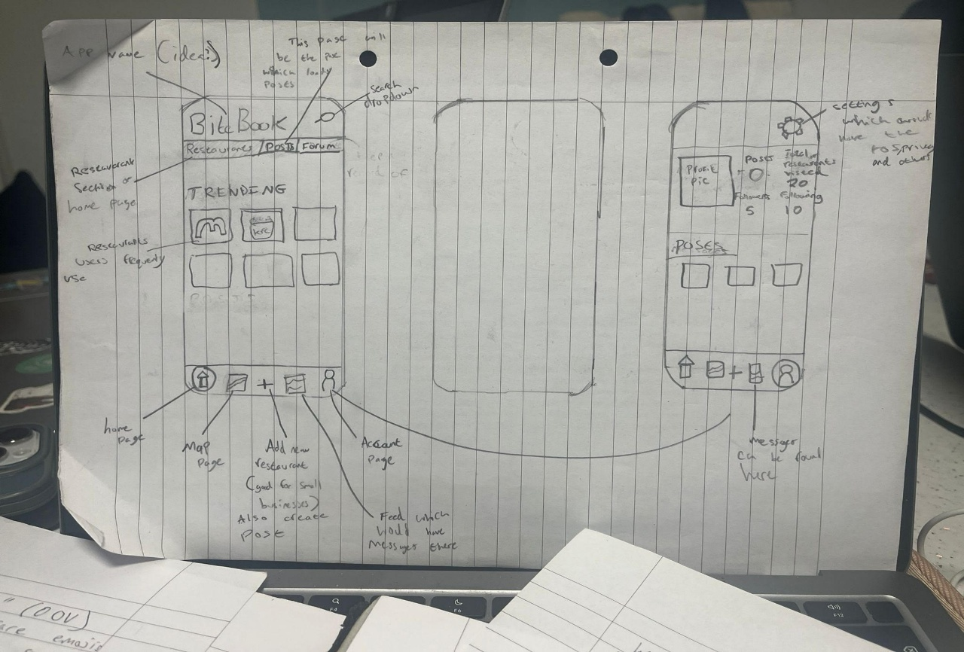
Appendix 2 Paper Prototype
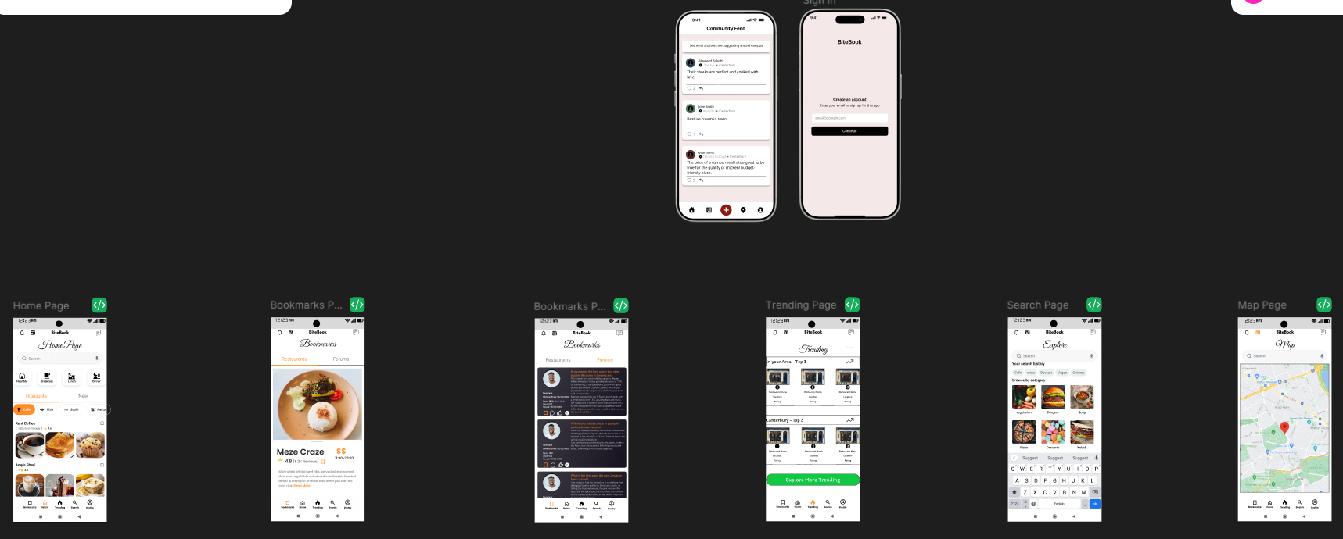
Appendix 3 Lo-Fi Prototype




Appendix 4 Logo Designs
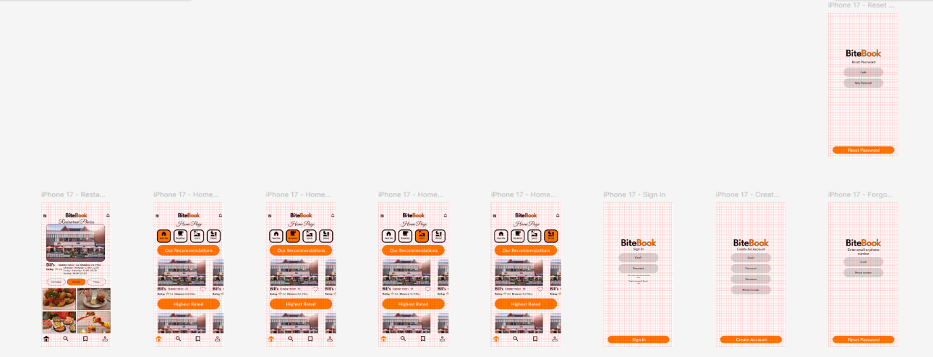
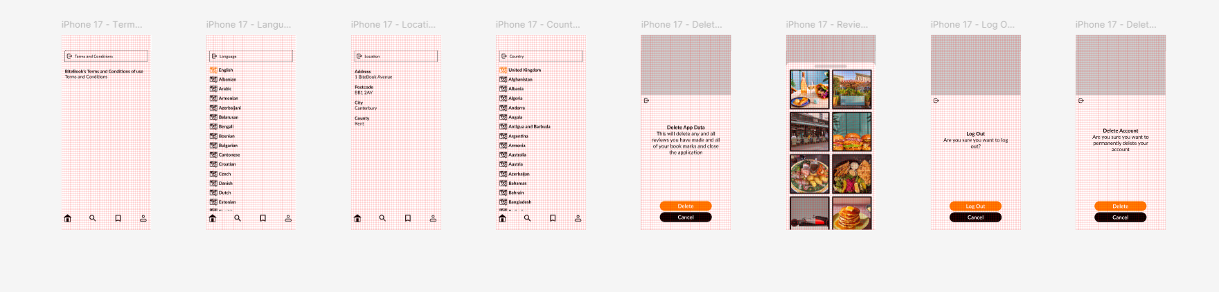
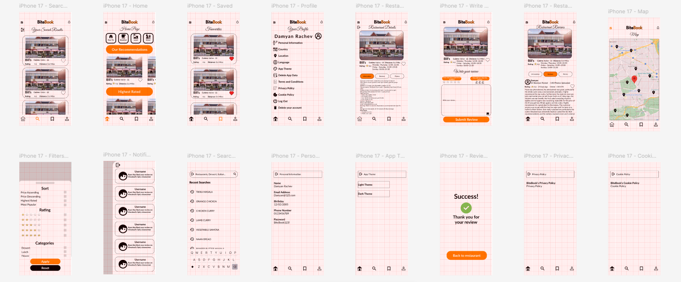
Appendix 5 Hi-Fi WireFrame

Front-end Libraries | Back-end Libraries
React | Express
React-dom | Mongoose
Vite | Mongodb
React-router-dom | Jsonwebtoken
Tailwindcss | Bcryptjs
@tanstack/react-query | Multer
Leaflet. markercluster | Cloudinary
Framer-motion | Express-validator
Lucide-react | Express-rate-limit
Sonner | Nodemailer
Vite-plugin-pwa | --------------------------------------------------------
Appendix 6 Table Of Libraries Used
BiteBook Unit Tests
Front-end tests | Back-end tests
File  Profile.section.spec.tsx ran 1 test (1 passed, 0 failed). Notable tests include opening the  followers dialogue and showing fetched users (passed, 0.649s). File Signup.system.spec.tsx  ran 1 test (1 passed, 0 failed). Notable tests include showing the shared password  policy error for weak passwords (passed, 0.242s). File menuItems.spec.ts ran 3 tests (3  passed, 0 failed). Notable tests include building menu items from cuisine (passed,  0.007s); matches cuisine search words in food tab (passed, 0.001s); matches direct  menu item search (passed, 0.001s). File passwordPolicy.spec.ts ran 3 tests (3 passed,  0 failed). Notable tests include accepts a valid password (passed, 0.012s); rejects weak  passwords (passed, 0.001s); exposes the shared error message (passed, 0.001s). File  utils.spec.ts ran 5 tests (5 passed, 0 failed). Notable tests include: should merge  classes correctly (passed, 0.017s); should handle conditional classes (passed, 0.001s);  should handle false and null conditions (passed, 0s). | File  socialUsers.section.test.mjs ran 4 tests (4 passed, 0 failed). Notable tests include:  returns empty list when search query is missing (passed, 0.054s); returns empty list for  signed-in users when the search query is missing (passed, 0.025s); returns followers for the  requested profile (passed, 0.01s). File authRegister.test.js ran 1 test (1 passed, 0  failed). Notable tests include rejects weak passwords before reaching the database  (passed, 0.13s). File menuItems.test.mjs ran 4 tests (4 passed, 0 failed). Notable tests  include: generates cuisine-specific menu items (passed, 0.014s); ensures menu items  exist when restaurant has none (passed, 0.001s); matches search terms from cuisine  (passed, 0.001s). File passwordPolicy.test.js ran 3 tests (3 passed, 0 failed). Notable  tests include accepts a password that meets all rules (passed, 0.007s); rejects  passwords that are too short or missing complexity (passed, 0.001s); exposes the  shared policy message (passed, 0.001s).
Appendix 7 Table of Unit Tests

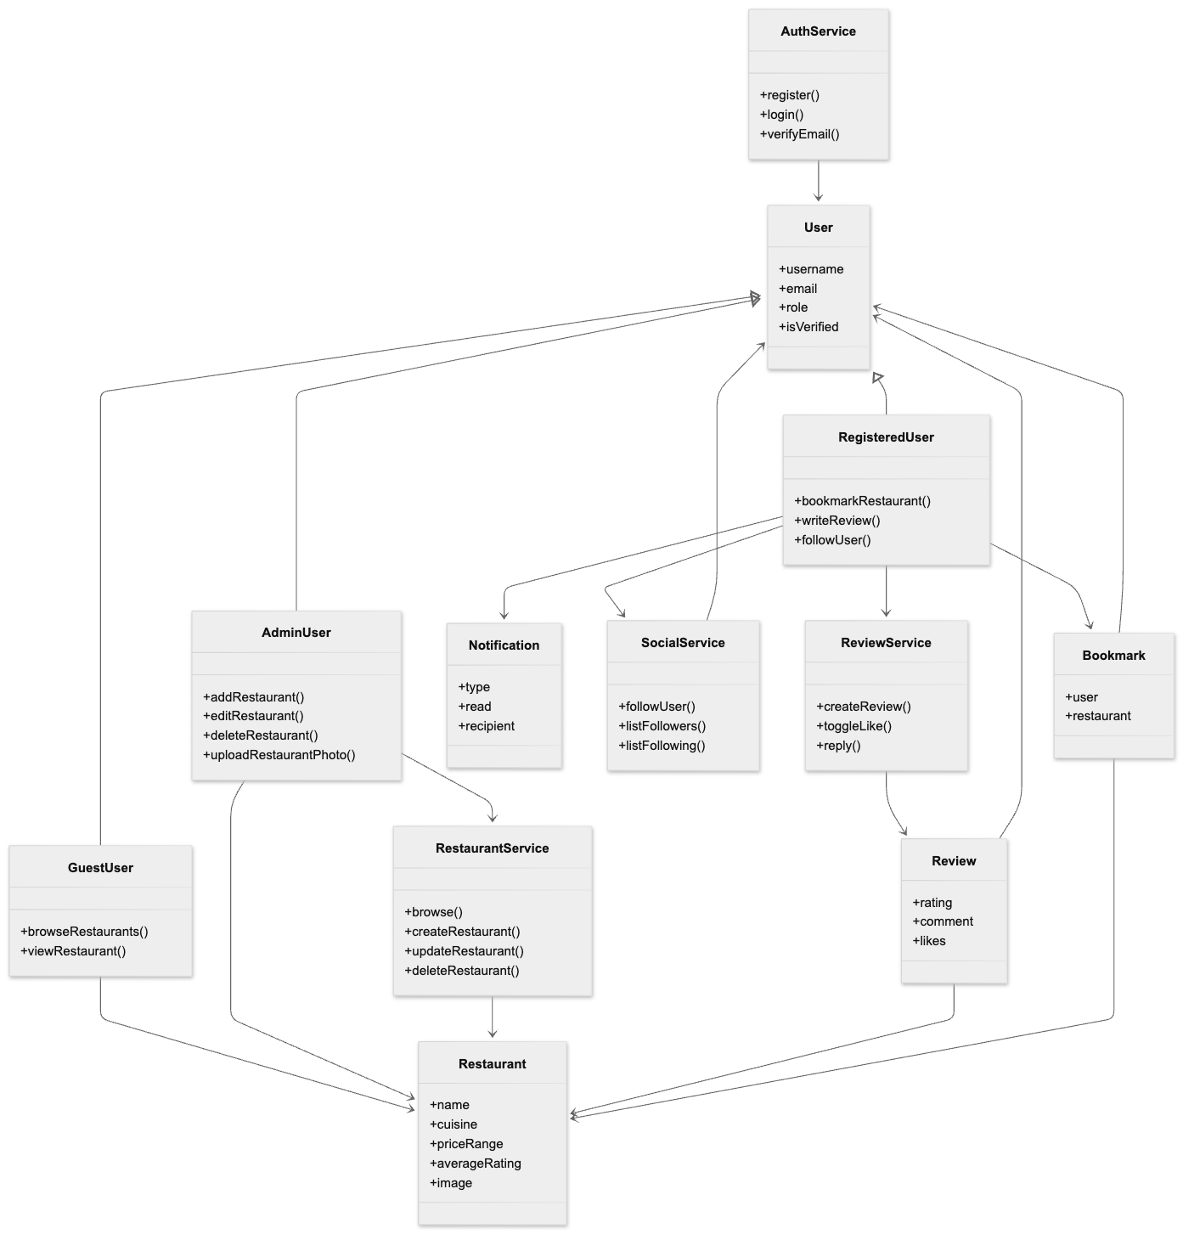
Appendix 8 Class Diagram

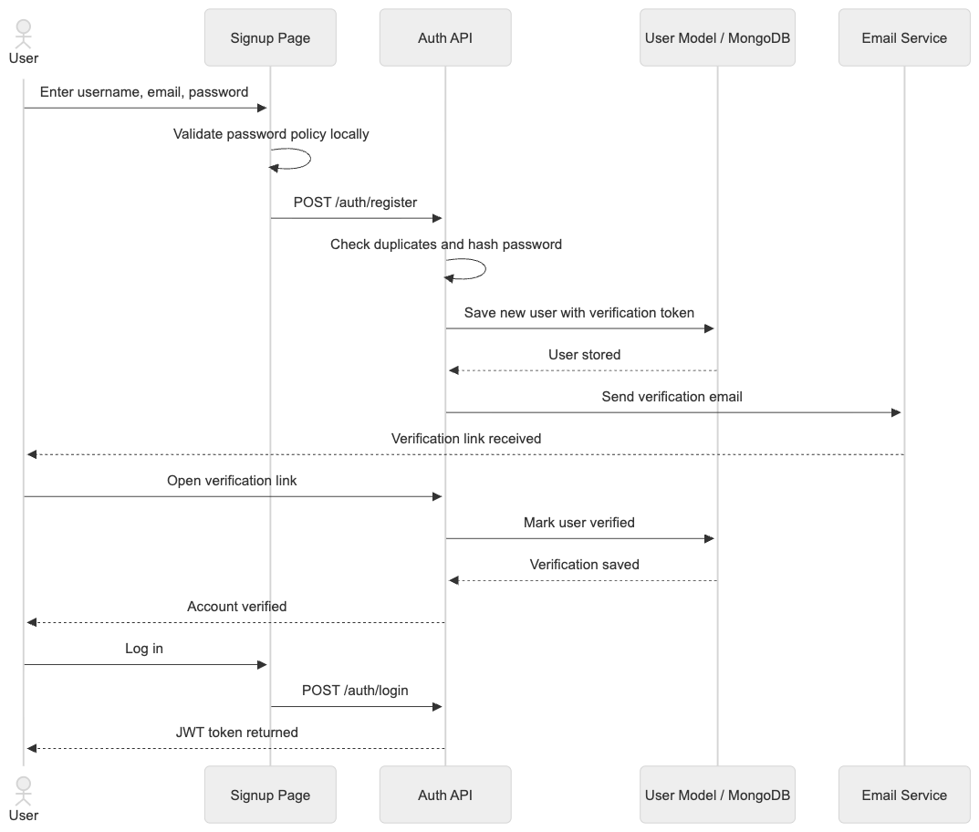
Appendix 9 Sequence Diagram

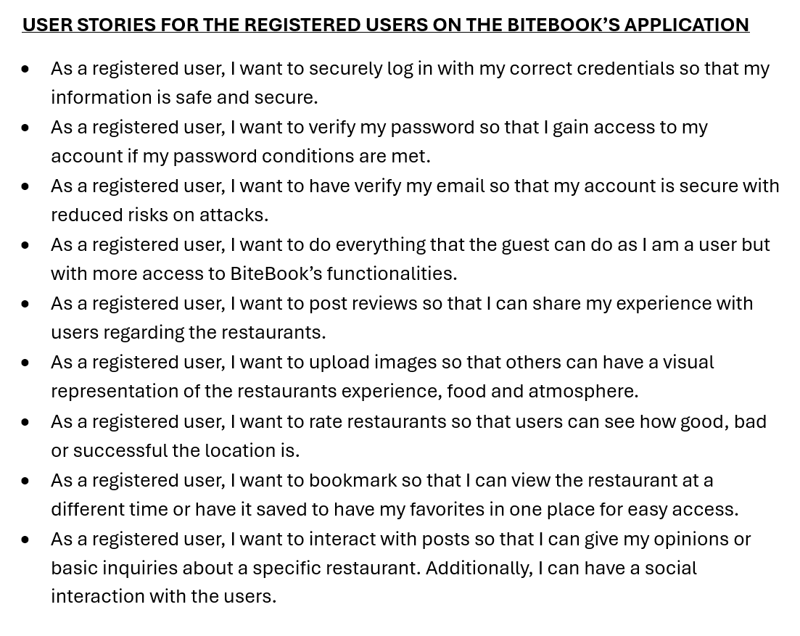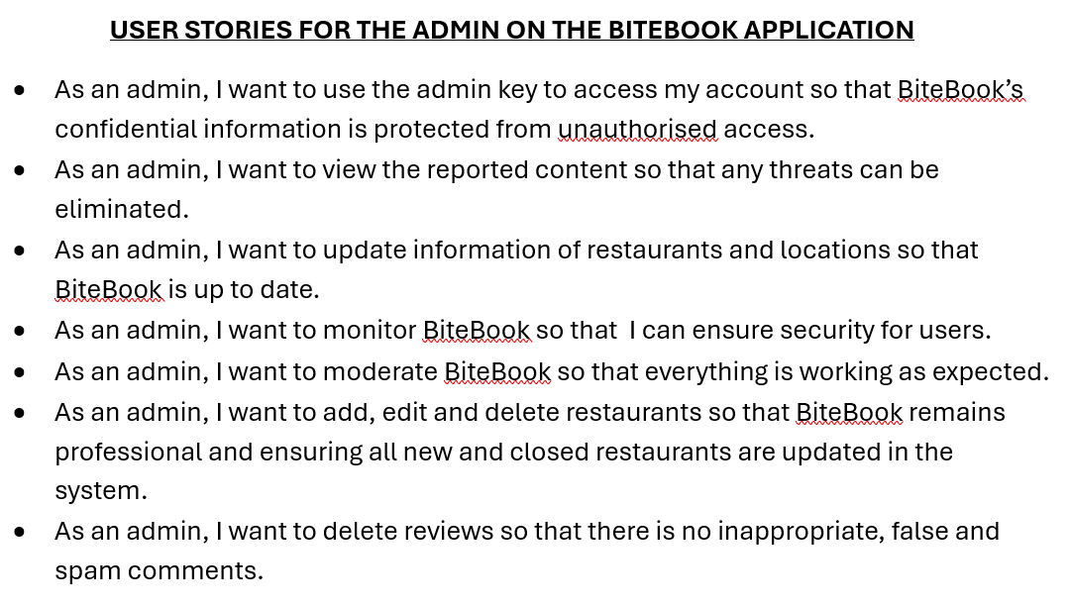
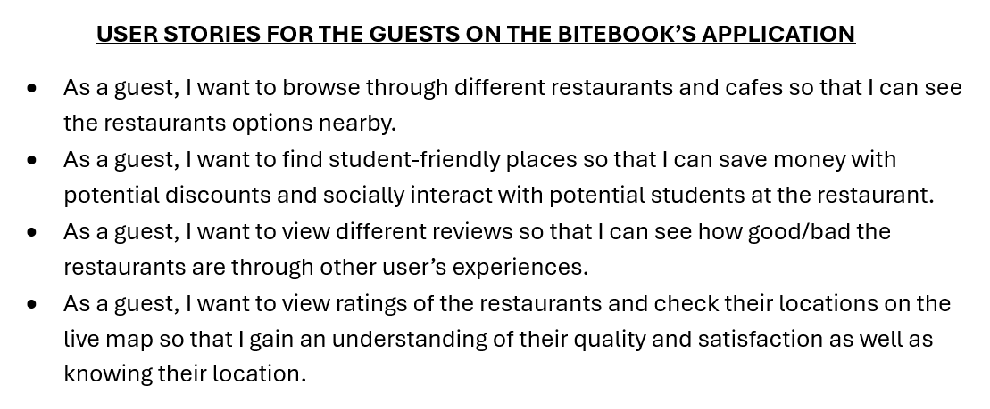
Appendix 10 User Stories

