Stress management strategy #1: Avoid unnecessary stress
Not all stress can be avoided, and it’s not healthy to avoid a situation that needs to be addressed. You may be surprised, however, by the number of stressors in your life that you can eliminate.
- Learn how to say “no” – Know your limits and stick to them. Whether in your personal or professional life, refuse to accept added responsibilities when you’re close to reaching them. Taking on more than you can handle is a guaranteed recipe for stress.
- Avoid people who stress you out – If someone consistently causes stress in your life and you can’t turn the relationship around, limit the amount of time you spend with that person or end the relationship entirely.
- Take control of your environment – If a particular TV show makes you anxious, turn the TV off. If traffic’s got you tense, take a longer but less-traveled route.
- Avoid hot-button topics – If you get upset over religion or politics, cross them off your conversation list. If you repeatedly argue about the same subject with the same people, stop bringing it up or excuse yourself when it’s the topic of discussion.
- Narrow down your to-do list – Analyze your schedule, responsibilities, and daily tasks. If you’ve got too much on your plate, distinguish between the “shoulds” and the “musts.” Drop tasks that aren’t truly necessary to the bottom of the list or eliminate them entirely.

Stress management strategy #2: Alter the situation
If you can’t avoid a stressful situation, try to alter it. Figure out what you can do to change things so the problem doesn’t present itself in the future. Often, this involves changing the way you communicate and operate in your daily life.
- Express your feelings instead of bottling them up. If something or someone is bothering you, communicate your concerns in an open and respectful way. If you don’t voice your feelings, resentment will build and the situation will likely remain the same.
- Be willing to compromise. When you ask someone to change their behavior, be willing to do the same. If you both are willing to bend at least a little, you’ll have a good chance of finding a happy middle ground.
- Be more assertive. Don’t take a backseat in your own life. Deal with problems head on, doing your best to anticipate and prevent them. If you’ve got an exam to study for and your chatty roommate just got home, say up front that you only have five minutes to talk.
- Manage your time better. Poor time management can cause a lot of stress. When you’re stretched too thin and running behind, it’s hard to stay calm and focused. But if you plan ahead and make sure you don’t overextend yourself, you can alter the amount of stress you’re under.

Stress management strategy #3: Adapt to the stressor
If you can’t change the stressor, change yourself. You can adapt to stressful situations and regain your sense of control by changing your expectations and attitude.
- Reframe problems. Try to view stressful situations from a more positive perspective. Rather than fuming about a traffic jam, look at it as an opportunity to pause and regroup, listen to your favorite radio station, or enjoy some alone time.
- Look at the big picture. Take perspective of the stressful situation. Ask yourself how important it will be in the long run. Will it matter in a month? A year? Is it really worth getting upset over? If the answer is no, focus your time and energy elsewhere.
- Adjust your standards. Perfectionism is a major source of avoidable stress. Stop setting yourself up for failure by demanding perfection. Set reasonable goals for yourself and others, and learn to be okay with “good enough.”
- Focus on the positive. When stress is getting you down, take a moment to reflect on all the things you appreciate in your life, including your own positive qualities and gifts. This simple strategy can help you keep things in perspective.

Stress management strategy #4: Accept the things you can’t change
Some sources of stress are unavoidable. You can’t prevent or change stressors such as the death of a loved one, a serious illness, or a national recession. In such cases, the best way to cope with stress is to accept things as they are. Acceptance may be difficult, but in the long run, it’s easier than railing against a situation you can’t change.
- Don’t try to control the uncontrollable. Many things in life are beyond our control— particularly the behavior of other people. Rather than stressing out over them, focus on the things you can control such as the way you choose to react to problems.
- Look for the upside. As the saying goes, “What doesn’t kill us makes us stronger.” When facing major challenges, try to look at them as opportunities for personal growth. If your own poor choices contributed to a stressful situation, reflect on them and learn from your mistakes.
- Share your feelings. Talk to a trusted friend or make an appointment with a therapist. Expressing what you’re going through can be very cathartic, even if there’s nothing you can do to change the stressful situation.
- Learn to forgive. Accept the fact that we live in an imperfect world and that people make mistakes. Let go of anger and resentments. Free yourself from negative energy by forgiving and moving on.

Stress management strategy #5: Make time for fun and relaxation
By having a take-charge approach and a positive attitude, you can reduce stress in your life by nurturing yourself. If you regularly make time for fun and relaxation, you’ll be in a better place to handle life’s stressors when they inevitably come.

Healthy ways to relax and recharge
- Go for a walk.


- Spend time in nature.


- Call a good friend.
- Sweat out tension with a good workout.
- Write in your journal.
- Take a long bath.
- Light scented candles

- Savor a warm cup of coffee or tea.


- Play with a pet.


- Work in your garden.


- Get a massage.


- Curl up with a good book.


- Listen to music.


- Watch a comedy


Don’t get so caught up in the hustle and bustle of life that you forget to take care of your own needs. Nurturing yourself is a necessity, not a luxury.
- Set aside relaxation time. Include rest and relaxation in your daily schedule. Don’t allow other obligations to interfere. This is your time to take a break from all responsibilities and recharge your batteries.
- Connect with others. Spend time with positive people who enhance your life. A strong support system will buffer you from the negative effects of stress.
- Do something you enjoy every day. Make time for leisure activities that bring you joy, whether it be reading, playing with your pet, or working on your bike.
- Keep your sense of humor. This includes the ability to laugh at yourself. The act of laughing helps your body fight stress in a number of ways.

Learn the relaxation response

You can control your stress levels with relaxation techniques that evoke the body’s relaxation response, a state of restfulness that is the opposite of the stress response. Regularly practicing these techniques will build your physical and emotional resilience, heal your body, and boost your overall feelings of joy and calmness.

Stress management strategy #6: Implement a healthy lifestyle
You can increase your resistance to stress by strengthening your physical health.
- Exercise regularly.
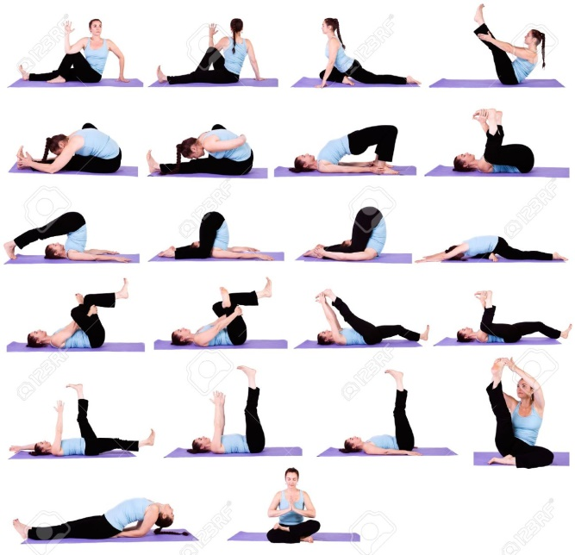
Physical activity plays a key role in reducing and preventing the effects of stress. Make time for at least 30 minutes of exercise, three times per week. Nothing beats aerobic exercise for releasing pent-up stress and tension.

- Eat a healthy diet.

Well-nourished bodies are better prepared to cope with stress, so be mindful of what you eat. Start your day right with breakfast, and keep your energy up and your mind clear with balanced, nutritious meals throughout the day.

- Reduce caffeine and sugar.
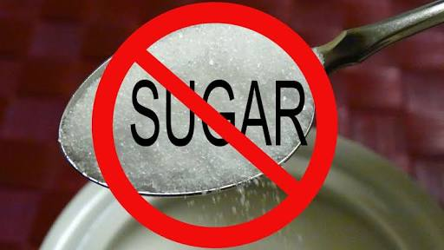
The temporary "highs" caffeine and sugar provide often end with a crash in mood and energy. By reducing the amount of coffee, soft drinks, chocolate, and sugar snacks in your diet, you’ll feel more relaxed and you’ll sleep better.

- Avoid alcohol, cigarettes, and drugs.
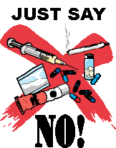
Self-medicating with alcohol or drugs may provide an easy escape from stress, but the relief is only temporary. Don’t avoid or mask the issue at hand; deal with problems head on and with a clear mind.

- Get enough sleep.

Adequate sleep fuels your mind, as well as your body. Try to get between 6 and 8 hours a night. Feeling tired will increase your stress because it may cause you to think irrationally.

Why is stress helpful?
Historically stress was our friend. It acted as a protective mechanism that warned us of danger; a natural reaction telling us when to run. This response is now referred to as the “fight or flight” response, or the “stress response”.

It’s believed that stress has remained part of the evolutionary drive because of its usefulness in helping us to survive. Since when it’s used at the right time, stress temporarily increases our awareness and improves physical performance (Van Duyne, 2003).
Why is stress harmful?
Repetitive exposure of the stress response on our body is proven to lead to long-lasting psychological and physical health issues, such as cardiovascular disease, diabetes, anxiety and depression (“How Does Stress Affect Us?”, 2016).

Stress versus burn out
So, what’s the difference between stress and burn out?
Stress is inevitable. Burn out isn’t.
While stress is our response, burn out is the accumulation of excessive stressors over time, which results in unmanageable stress levels.
American psychologist Herbert Freudenberger, first termed the word “burn out” in the 1970s when he referred to the effect of extreme stress and high ideals placed on “helping” professionals, such as doctors and nurses (“Depression: What is burnout?”, 2018).
Today, the word has evolved and is used more broadly to refer to the consequences of excessive stress placed on any individual, no matter their occupation. When we get to the point of no longer being able to cope, we’re referred to as being “burned out”.
This is where stress management comes back in, to avoid the experience of burn out.

14 Facts About Stress & Burn Out
If you’re not yet convinced about the need to prioritize stress management, the below 14 facts will get you over the line:
- Stress has been referred to as the “silent killer” as it can silently cause heart disease, high blood pressure, chest pain, and an irregular heartbeat (Chilnick, 2008).
- Telogen effluvium is the result of hair loss caused by stress that can happen up to three months after a stressful event (McEwen, 2003).
- Stress is believed to account for 30% of all infertility problems. In women, stress can cause spasms in the fallopian tubes and uterus. In men, it can effect the sperm count and cause erectile dysfunction (Bouchez, 2018).
- Researchers have found that stress worsens acne. More so, than the prevalence of oily based skin (Warner, 2002).
- Stress can be to blame for weight gain too. The stress hormone cortisol has been found to cause both the accumulation of abdominal fat and the enlargement of fat cells, causing what is referred to as “diseased” fat (Chilnick, 2008).
- Correlations have been found between stress and the top six causes of death: cancer, lung ailments, heart disease, liver cirrhosis, accidents, and suicide (“How Does Stress Affect Us?”, 2016).
- In children, chronic stress has been found to negatively impact their developmental growth due to a reduction of the growth hormone in the pituitary gland (Van der Kolk, B. et. al., 2007).
- The word itself, “stress” stems from the Latin word stringere, meaning “to draw tight” (McEwen, 2003).
- In the event of chronic stress, dominant hormones are released into our brain. These hormones are intended for short-term emergencies and in the event where they exist for extended periods they can shrink, impair and kill brain cells (Wallenstein, 2003).
- Stress can increase the likelihood of developing blood clots, since the blood prepares itself for injuries and becomes “stickier” (Chilnick, 2008).
- Chronic stress can place pressure on, and cause damage to arteries and organs. This occurs due to inflation in our bodies caused by cytokines (a result of stress) (McEwen, 2003).
- Stress is also responsible for altering our blood sugar levels, which can lead to fatigue, hyperglycemia, mood swings, and metabolic syndrome (“How Does Stress Affect Us?”, 2016).
- On a positive note, we can reduce our stress levels by laughing. Having a chuckle, lowers the stress hormones, including cortisol, epinephrine, and adrenaline, and strengthens our immune system by releasing positive hormones (Wallenstein, 2003).
- More good news, especially for chocolate lovers, dark chocolate has also been found to reduce our stress hormones (Wallenstein, 2003).

7 Tips for Stress Management
Before discussing stress management techniques, there are a few factors we must first consider.
The following 7 tips have been adapted from The American Psychological Association (“Check Out the Stress Tip Sheet”, 2018) to support individuals in getting the best out of a stress management plan:
- Understand your stress
How do you stress? This can be different for everybody. By understanding what stress looks like for you, you can be better prepared and reach for your stress management toolbox when needed.
- Identify your stress sources
What causes you to be stressed? Be it work, family, change or any of the other potential thousand triggers.
- Learn to recognize stress signals
We all process stress differently so it’s important to be aware of your individual stress symptoms. What are your internal alarm bells? Low tolerance, headaches, stomach pains or a combination from the above ‘Symptoms of stress’
- Recognize your stress strategies
What is your go-to tactic for calming down? These can be behaviors learned over years and sometimes aren’t the healthy option. For example self-medicating with alcohol or overeating.
- Implement healthy stress management strategies
It’s good to be mindful of any current unhealthy coping behaviors so you can switch them out for a healthy option. For example, if overeating is your current go to, you could practice meditation instead, or make a decision to phone a friend to chat through your situation. The American Psychological Association suggests that switching out one behavior at a time is most effective in creating positive change.
- Make self-care a priority
When we make time for ourselves, we put our well-being before others. While this can feel selfish to start, like the old plane analogy we must put our own oxygen mask on before we can help others. This is also true for effective stress management. The simplest things that promote well-being, such as enough sleep, food, downtime and exercise are often the ones overlooked. Make time for you.

1. Be assertive
Clear and effective communication is the key to being assertive. When we’re assertive we can ask for what we want or need and explain what is bothering us. The key is doing this in a fair and firm manner while still having empathy for others. Once you identify what you need to communicate you can stand up for yourself and be proactive in changing the stressful situation.

2. Reduce the noise
Switching off from technology and the constant stimuli thrown at us hourly, is an important way to slow down. How often do you go offline?
Make time for some quietness each day and you’ll notice how all those seemingly urgent things that we feel we need to do, become less important. Plus the to-do list will always be there. Remember – recharging is the most effective way of tackling stress.
3. Manage your time
If we let them, our days will consume us. Before we know it – the months have become overwhelmingly busy. When we manage our time we prioritize and organize our tasks creating a less stressful and more enjoyable life.

4. Creating boundaries
Boundaries are the internal set of rules that we create for ourselves. They outline what behaviors we will and won’t accept. Healthy boundaries are essential for a stress-free life. When we have healthy boundaries we respect ourselves and take care of our well-being by clearly expressing our boundaries to others.

5. Get out of your head
Sometimes it’s best not to even try contending with the racing thoughts. Sometimes you just need a break. Distract yourself. Watch a movie, phone or catch up with a friend or do something positive that you know takes your mind off things.

Emotion – Orientated Approaches
Emotion-oriented approaches are used to change the way we perceive stressful situations.
In the words of William James:
“The greatest weapon against stress is our ability to choose one thought over another”

6. Affirmations and imagery
The power of positive imagery and affirmations is now scientifically proven to increase positive emotion.
How? When you think of a positive experience, your brain perceives it to be a reality.
So, replace those negative thoughts with positive statements and challenge and change the way you see and experience the world.
7. Cognitive Restructuring
In the mid 1950’s psychologist Dr. Albert Ellis developed what is referred to as cognitive restructuring, a technique for understanding negative emotions and challenging these sometimes incorrect beliefs that cause them. Cognitive restructuring is a key component of Cognitive behavioral therapy (CBT). More about CBT

8. Diet and Exercise
You’ve heard it before – but you are what you eat. Be mindful of having a balanced and healthy diet. Making simple diet changes, such as reducing your alcohol, caffeine and sugar intake is a proven way of reducing anxiety.

Another guaranteed way to reduce stress is exercise. It’s proven to also be as effective as antidepressants in relieving mild depression.
So get moving.
9. Meditation and physical relaxation
Use techniques such as deep breathing, guided visualizations, yoga and guided body scans to relax the body.

10. Build resilience
Resiliency is our ability to bounce back from stressful or negative experiences.
To simplify, resilient people accept that the situation has occurred, they learn from what transpired and then they move on.

11. Talk it out
Don’t block it all inside. Talk to someone close to you about your worries or the things getting you down. Sharing worries is halving them.
And, most of our worries sound a lot less worrisome when we say them out loud.
If you don’t feel up to sharing, writing them down is also a great way to release them or by engaging an independent professional. There are plenty of services available, including free services, which you can quickly google to find what’s available in your city.
12. Sleep
Getting a good night sleep is fundamental for recharging and dealing with stressful situations in the best possible way. While it varies from individual to individual, on the exact amount of sleep needed, an uninterrupted sleep of approximately 8 hours is generally recommended. So, ensure that you get enough Zzzz’s for you.

Stress Management in the Workplace
Whether it be extended hours, near impossible deadlines, demanding colleagues or unappreciative bosses, workplace stress is something we’re all familiar with.
According to the World Health Organization’s definition, occupational or work-related psychosocial stress “is the response people may have when presented with work demands and pressures that are not matched to their knowledge and abilities and which challenge their ability to cope.” (Leka, Griffiths, & Cox, 2003)
But the effects of workplace stress aren’t simply isolated to the workplace. They spill over into our personal relationships, our home lives and our overall productivity.
Duke University found that workplace stress was responsible for over 70% of workplace accidents, 50% of absenteeism, and over $300 billion in associated costs (“Stress Facts in the Workplace”, 2018).
These figures require action.

Causes of workplace stress
The most and least stressful job report for 2018, conducted by CareerCast found that the top most stressful jobs of the year were – Enlisted Military Personnel, Firefighters, Airline Pilots and Police Officers. The least stressful jobs were – Diagnostic Medical Sonographer, hair stylist, audiologist and University professor (“CareerCast Rates Least and Most Stressful Jobs for 2018”, 2018).
While some jobs are undoubtedly more stressful than others, all workplaces are prone to stress of some degree.
The below diagram, obtained from the WSH Institute (2018) clearly shows the various factors that can lead to workplace stress along with the organization and individuals role in dealing with these hazards.

Symptoms of workplace stress

Symptoms of workplace stress can manifest physically (headaches, stomach aches, pains, fatigue or eating and sleeping disturbances), cognitively (trouble with concentrating, decision making, thinking or remembering), and emotionally (feeling down, tense and irritated).

Prevention of workplace stress
The prevention of workplace stress is most successful when a combination of both organization change and individual stress management is used.
That is, like any healthy relationship, both parties – the employee and the employer make an effort.

What can the company do to manage stress?
- Promote leave, rest and breaks
- Encourage exercise and meditation, both within and outside of work hours
- Ensure the workload is in line with workers’ abilities and resources
- Provide stimulation and opportunities for workers to use skills
- Boost workplace morale by creating opportunities for social interactions
- Clearly set out workers’ roles and responsibilities
- Encourage participation in decision making that affects individuals roles
- Encourage open communication
- Establish no tolerance policy for workplace discrimination
- Engage an external consultant to suggest a fresh approach to any existing issues
- Create family-friendly policies to encourage work-life balance
- Provide training for workplace stress management

What can the individual do to manage stress?
- Set realistic deadlines
- Take a lunch break
- Go home on time
- Take your holiday leave
- Leave work at work
- Participate in work functions
- Establish open and professional communication
- Respect other employees
- Do not tolerate discrimination of any sort, report any instances
- Sign up for workplace training programs to develop and improve your skills
- If required, seek therapy to manage and develop skills to cope with workplace stressors
- Develop a healthy work life balance, creating time for exercise

Stress management advantages
The below table, from the WHO (2018) illustrates the advantages of workplace stress management:
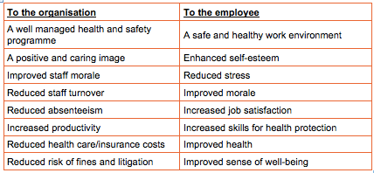
Today, companies are recognizing the link between productivity and health, and a conscious workplace. Some companies are going to great lengths to achieve this.
A recent survey conducted by CareerBliss, found that the happiest employees in America worked for the Austin, Texas Company, Keller Williams realty. The outcome was based on ten key factors, including their relationship with management, workplace environment, compensation, satisfaction with job function and growth opportunities (“Forbes Welcome”, 2018).
A staff member from the winning company explained, “One of the greatest benefits is how our company promotes from within. All employees are encouraged and supported to be in control of their growth and career paths.”

Symptoms of stress
Although we all experience stress differently, some common symptoms include:
- Difficulty sleeping
- Weight gain or weight loss
- Stomach pain
- Irritability
- Teeth grinding
- Panic attacks
- Headaches
- Difficulty concentrating
- Sweaty hands or feet
- Heartburn
- Excessive sleeping
- Social isolation
- Fatigue
- Nausea
- Feeling overwhelmed
- Obsessive or compulsive behaviors

