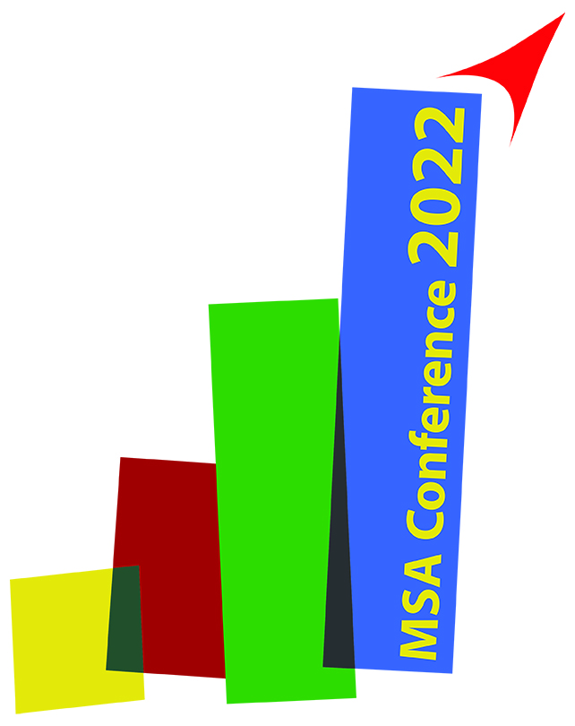


MSA – Female Researchers Award Verification

(For valid application hand in prior to 15th January 2022)

To participate in this years’ Female Researchers Award (FRA) the applicant,

(please print) Ms: MSA Ref.No: University/Faculty: City/Country:

fulfils all following criteria:

  - The researcher is a female at the time of the MSA conference within which you apply for the FRA.
  - The researcher has made an independent and reasonable contribution to

the work submitted for presentation.

  - The researcher has paid MSA Membership 2020 before 15th January 2022.

As applicant for this years’ Female Researchers Award I have read and understood the above listed FRA requirements and herewith confirm my compliance.

Date/signature – FRA applicant

As head of institute I, the undersigned, have read and understood the above listed FRA requirements

and herewith certify that Ms

(please print) fulfils all above listed

requirements to be accredited for this years’ MSA Female Researchers Award.

Official stamp of University/Faculty Date/signature – Head of Institute

Please note: For the final acceptance of your FRA application the following criteria need to be fulfilled as well!
- MSA Membership 2022 needs to be paid before 15th January 2022

- Conference registration fee paid before the deadline of registration for presenting authors
- Only one abstract has been submitted as first author to apply for FRA

- As previous FRA winner, you don’t take part in the same category again (Oral/Poster)
(e-mail to office@csakademija.me or fax to +382 40 235 200)

Montenegrin Sports Academy Đoka Miraševića 1/10, 81000 Podgorica
phone: +382 40 235 207
fax: +382 40 235 200
office@csakademija.me www.csakademija.me

