HEMPCRETE IS A SUSTAINABLE MATERIAL
Seminar report submitted to
APJ Abdul Kalam Technological University, Kerala
In partial fulfilment of the requirements for the award of the B Tech in

CIVIL ENGINEERING

By

ARYAN O S
(Reg No: SNM23CE003)

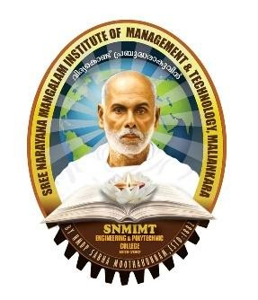

DEPARTMENT OF CIVIL ENGINEERING

SNM IMT ENGINEERING COLLEGE, MALIANKARA
MOOTHAKUNNAM, ERNAKULAM- 683516

APJ ABDUL KALAM TECHNOLOGICAL UNIVERSITY, KERALA

2026
DEPARTMENT OF CIVIL ENGINEERING

SNM IMT ENGINEERING COLLEGE, MALIANKARA

CERTIFICATE

This is to certify that the seminar report entitled “HEMPCRETE IS A SUSTAINABLE MATERIAL” submitted by ARYAN O S (Reg no: SNM23CE003) in partial fulfilment of the requirements for the award of B.Tech in civil engineering under APJ Abdul Kalam Technological University, Kerala. This is a bonafide record of the seminar work carried out by her under our guidance and supervision. This report in any form has not been submitted to any other universities or institutions for any purpose.

MARY RESHMA LAKSHMY KAKKANATT
Seminar Guide Seminar coordinator

JESNA KU
Head of Department

