1. Created a repo  
   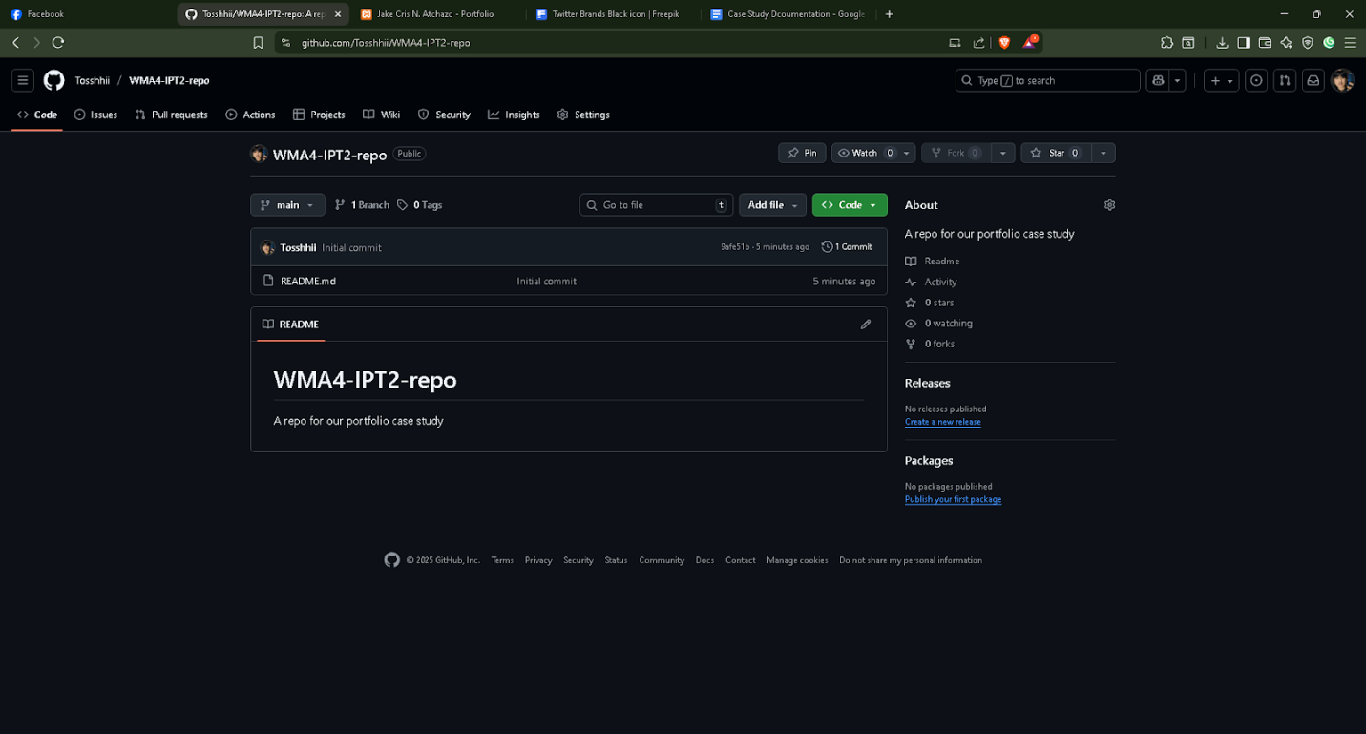
2. Connecting remote repo to a local repo or folder  
   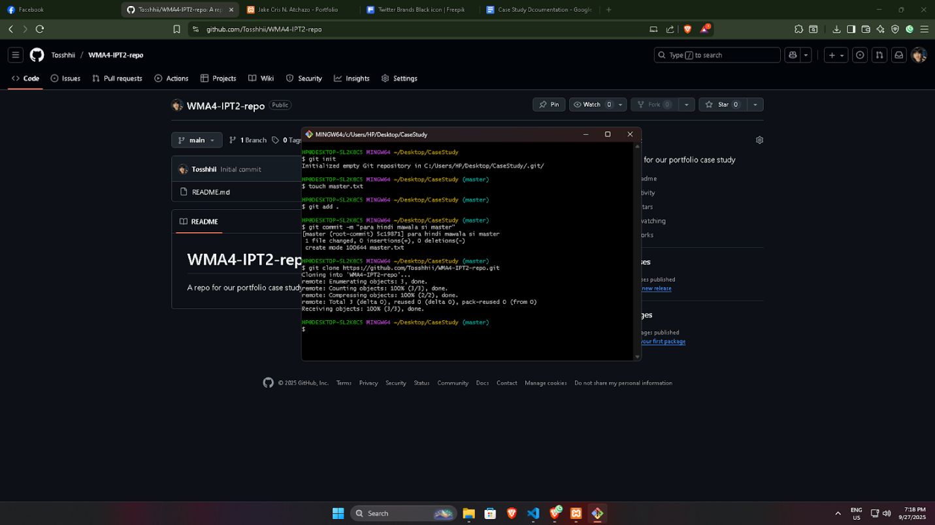
3. Creating required initial files for landing page (I wasn’t able to take a screenshot of the gitbash) attached image shows the created file  
   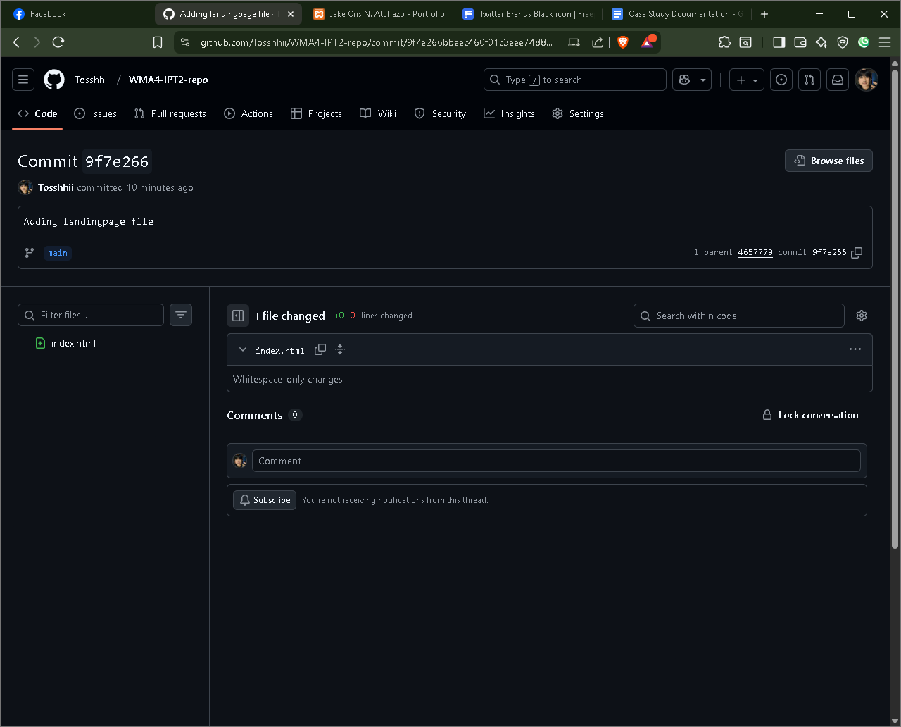
4. Creating Jake_Atchazo branch and adding initial file for my portfolio while pushing it into remote main  
   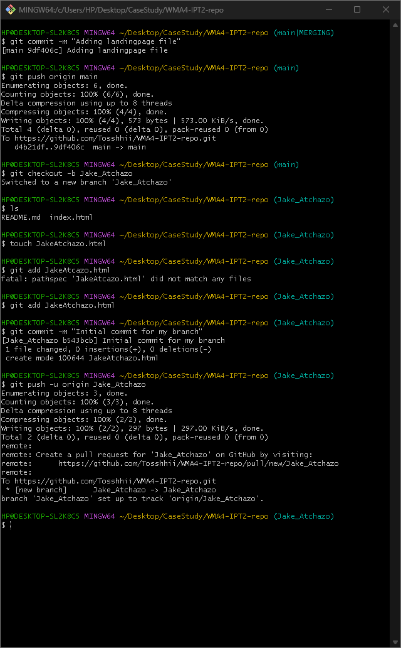
5. Added static code for the landing page  
   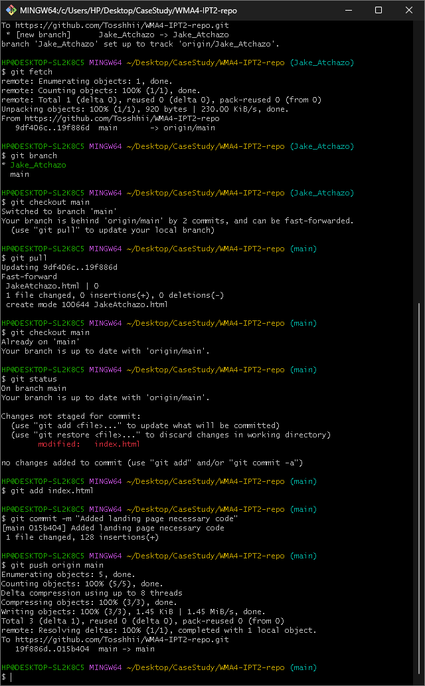
6. Image below is the preview of the latest landing page [7]  
   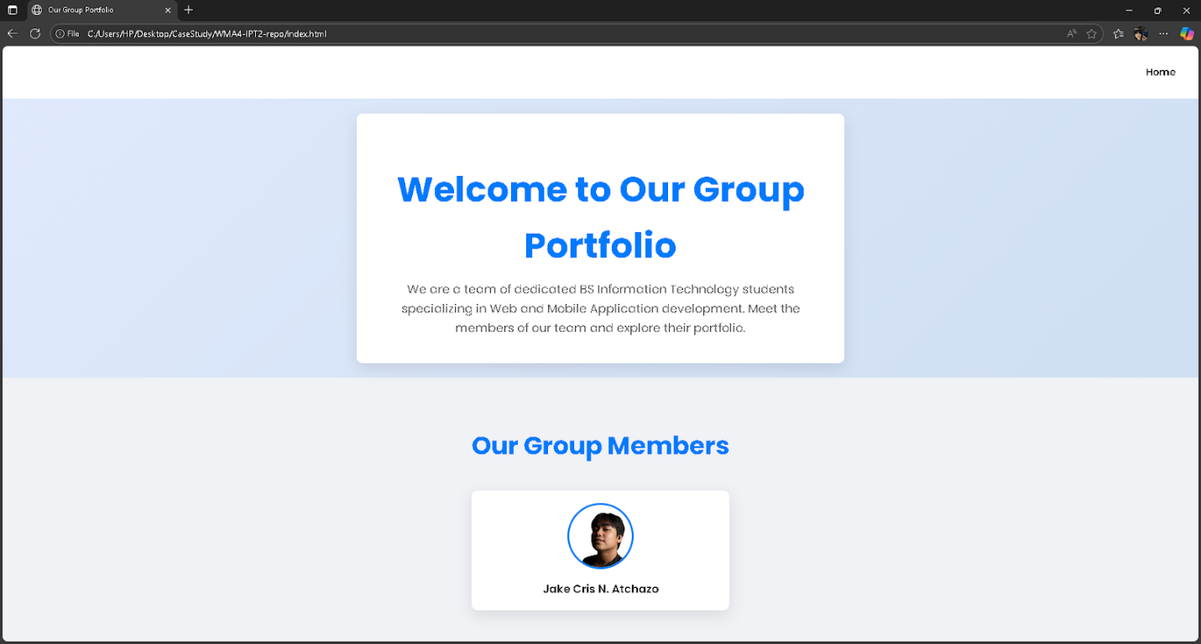
7. Made tweak to index.html, created folder images to store used photos.  
   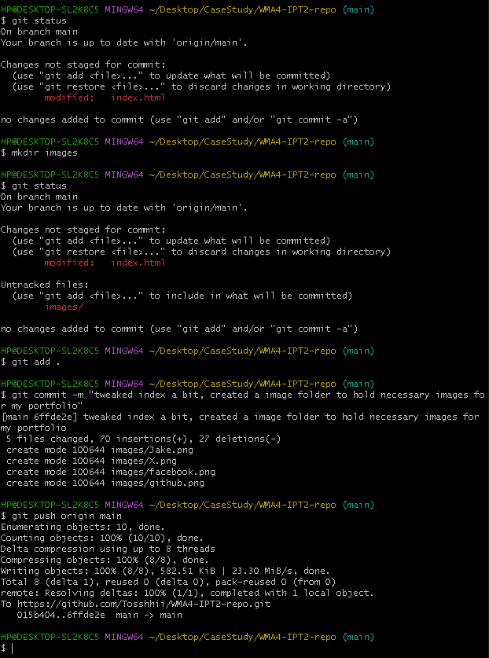
8. Applied my portfolio code to JakeAtchazo.html  
   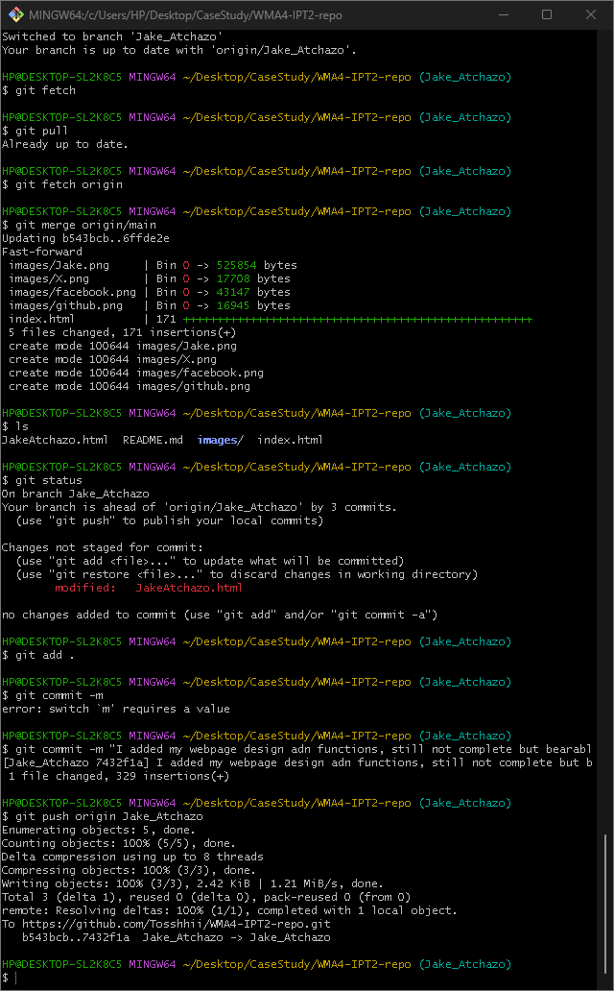  
   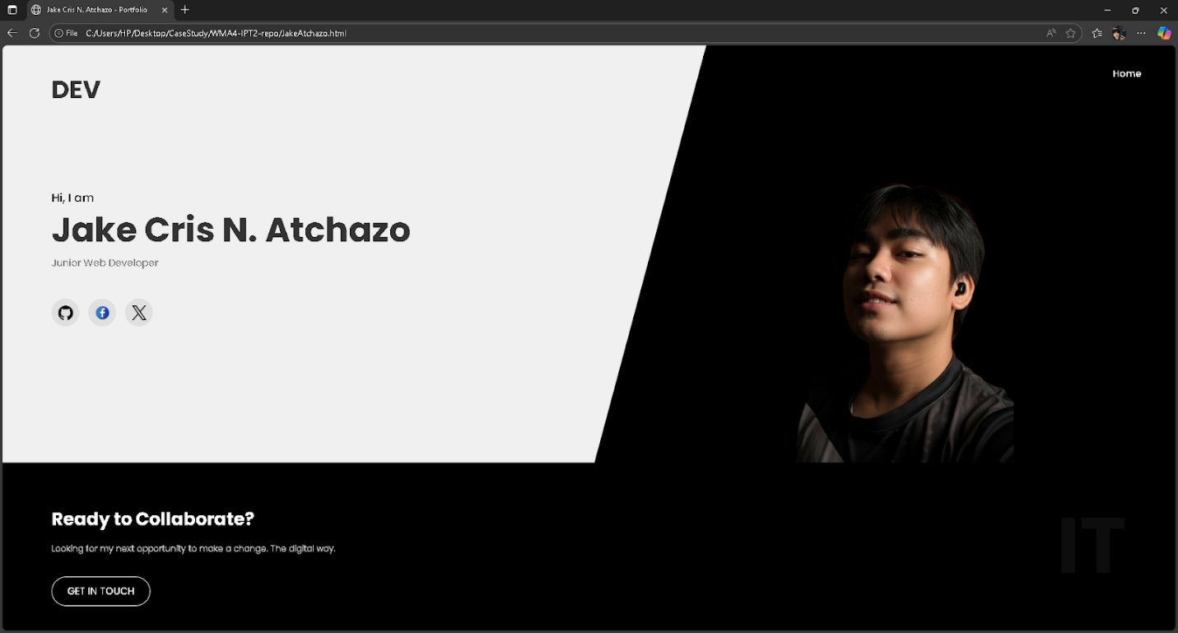
9. Theme is already Up so I changed my portfolio theme and as instructed structure it as a resume portfolio.   
   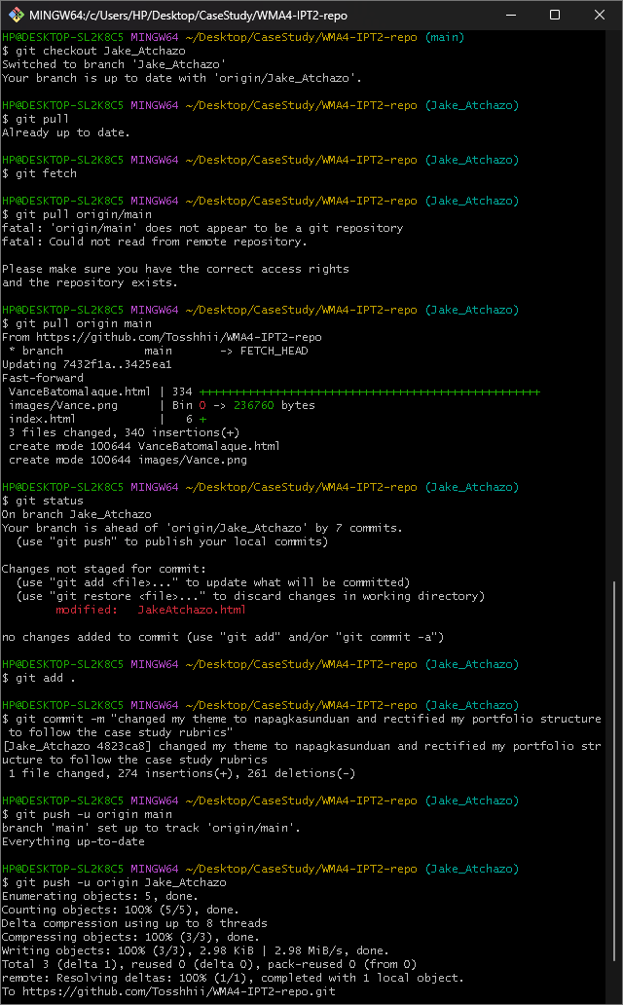  
   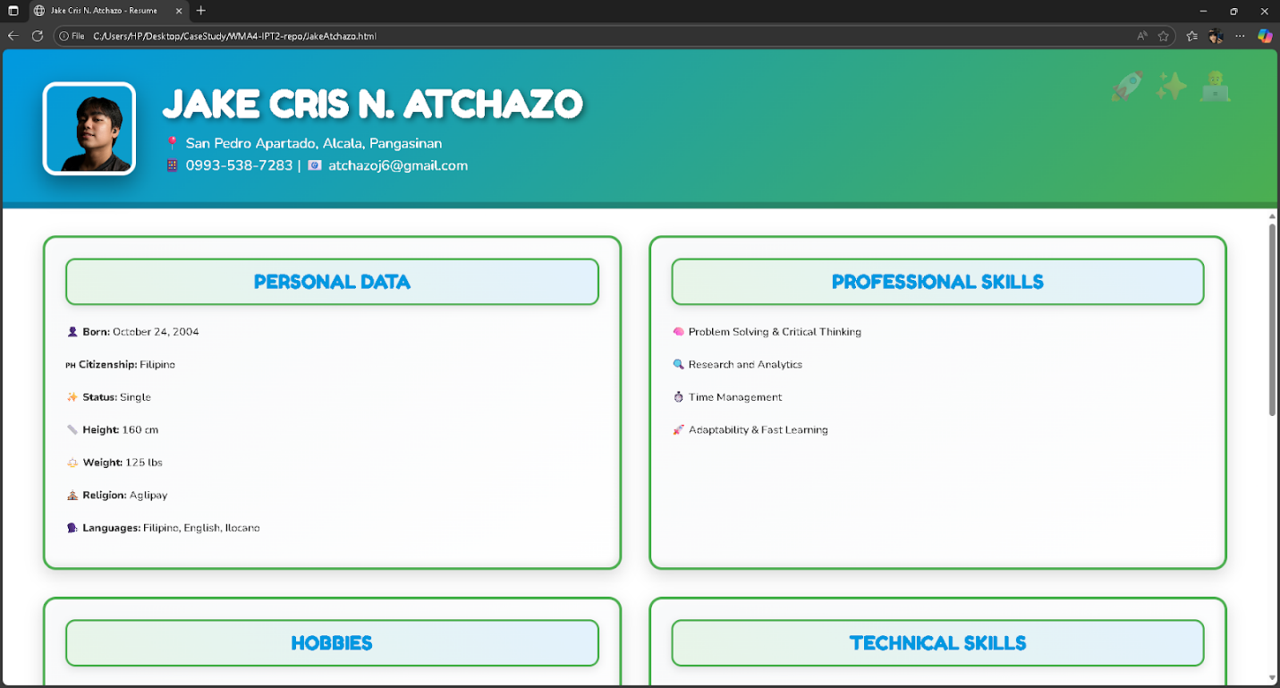
10. I've refined my portfolio design to be visually comfortable and easy to view.  
    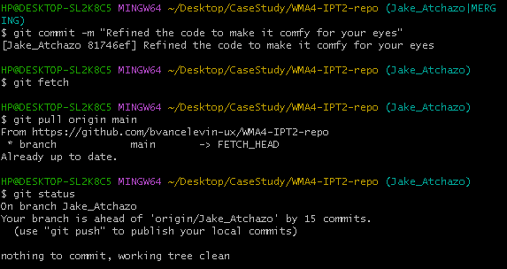  
    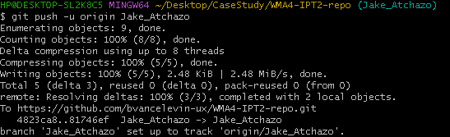  
    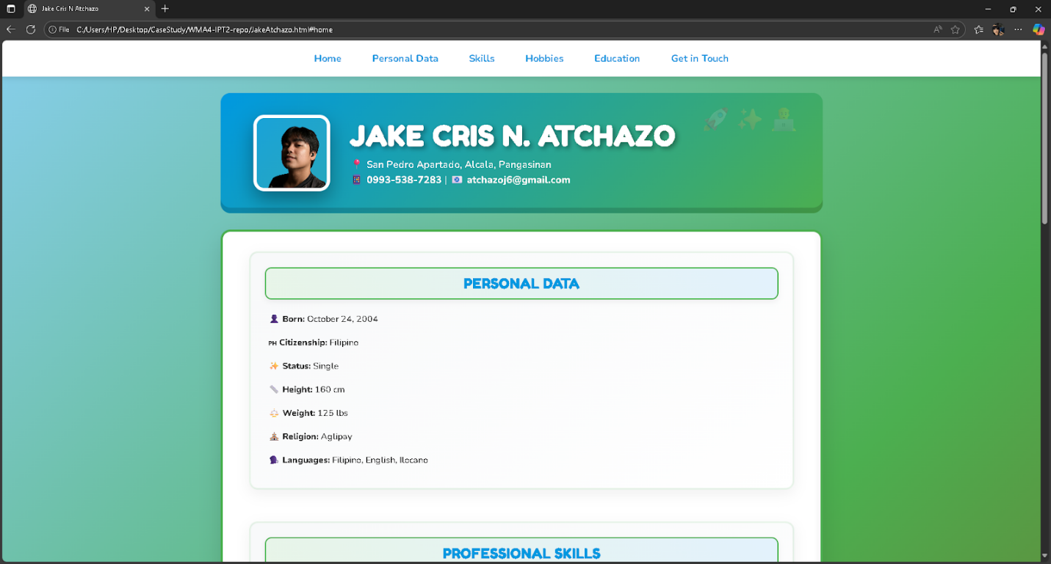
11. Issued myself to improve nav bar and to modify the not updated member tag  
      
    