Improvement in joint-specific scores one year after hip and knee replacement: a two-site cohort study
  - Synthetic data for teaching. Every patient in this report is invented.

Aim
To compare the improvement in joint-specific patient-reported scores from before surgery to 1 year after primary total hip arthroplasty (THA) and total knee arthroplasty (TKA), and to describe the cumulative incidence of revision.

Methods
Patients and data. We studied 120 primary THAs and TKAs performed at two sites (60 at each) between January 2015 and November 2024. Patients’ characteristics, the procedure and patient-reported scores were abstracted from the medical record into a standard sheet. Follow-up for revision and death came from the joint registry, linked by study ID.
Outcomes. The primary outcome was the change in the joint-specific score from before surgery to 1 year: the HOOS JR after THA and the KOOS JR after TKA, each scored from 0 to 100 (higher is better). Because the two are different instruments, the comparison is of points on each joint’s own scale. The secondary outcome was revision of any component.
Statistical analysis. Continuous variables are reported as mean (SD) and categorical variables as n (%); differences between procedures at baseline are described with standardized mean differences. The change in score was compared between procedures with Welch’s t test in patients with both scores, and summarized as the mean difference with its 95% CI and Hedges’ g. For revision, time was measured from the date of surgery to revision, death without revision (a competing event) or the end of registry follow-up (censored). Median follow-up was estimated with the reverse Kaplan-Meier method. The cumulative incidence of revision was estimated with the Aalen-Johansen method, treating death as a competing risk. Tests were two-sided. Analyses used R 4.6 and Python 3.13.

Results
Of the 120 patients, 53 (44.2%) had a THA and 67 (55.8%) a TKA (Table 1). THA patients were more often women (38 of 53, 71.7%, against 33 of 67, 49.3%; SMD 0.47), and TKA patients started with a pre-op score 2.9 points higher (51.0 against 48.1 points; SMD 0.26).
Both scores were available for 93 patients (77.5%): 46 of 53 after THA (86.8%) and 47 of 67 after TKA (70.1%). The score improved by a mean of 42.4 points (SD 13.0) after THA and 33.4 points (SD 13.9) after TKA, a difference of 9.0 points (95% CI 3.5 to 14.6; Hedges’ g 0.66, 95% CI 0.25 to 1.08; p = 0.002). At 1 year, 15 of 46 THA patients (32.6%) and 7 of 47 TKA patients (14.9%) had the maximum score.
Over a median follow-up of 6.05 years (IQR 4.16 to 8.27), 18 patients had a revision and 18 died without one. The cumulative incidence of revision was 3.4% (95% CI 1.1% to 7.8%) at 2 years and 12.6% (95% CI 7.0% to 19.8%) at 5 years (Figure 1).
Table 1: Patients’ characteristics before surgery, by procedure. Mean (SD) or n (%); SMD, absolute standardized mean difference.
Characteristic | THA  N = 53¹ | TKA  N = 67¹ | SMD²
Age, years | 64.4 (9.5) | 64.9 (8.0) | 0.05
Sex |  |  | 0.47
Female | 38 (72%) | 33 (49%)
Male | 15 (28%) | 34 (51%)
BMI, kg/m² | 29.6 (5.6) | 29.6 (5.0) | 0.00
Missing | 4 | 4
ASA class |  |  | 0.29
1 | 7 (13%) | 5 (7.7%)
2 | 29 (56%) | 32 (49%)
3 | 16 (31%) | 28 (43%)
Missing | 1 | 2
Diabetes | 3 (5.7%) | 5 (7.5%) | 0.07
Hypertension | 30 (57%) | 34 (51%) | 0.12
Sleep apnea | 7 (13%) | 17 (25%) | 0.31
Site |  |  | 0.03
Site A | 27 (51%) | 33 (49%)
Site B | 26 (49%) | 34 (51%)
Pre-op score (HOOS JR or KOOS JR), points | 48.1 (11.5) | 51.0 (11.8) | 0.26
Missing | 0 | 5
¹Mean (SD); n (%)
²Standardized Mean Difference
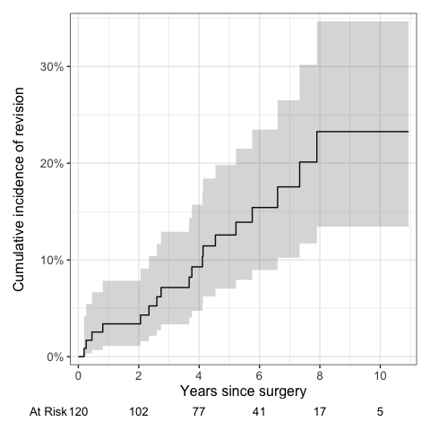
Figure 1: Cumulative incidence of revision, with death as a competing risk. The shaded band is the 95% CI.

