# Lab: Iterators and Comparators

Problems for the ["C# Advanced" course @ Software University](https://softuni.bg/trainings/4376/csharp-advanced-january-2024)  
You can check your solutions in [Judge](https://judge.softuni.org/Contests/1489/Iterators-and-Comparators-Lab)

## Library

**Note**: Put your classes in the namespace IteratorsAndComparators. Also your Visual Studio project should be named “IteratorsAndComparators”, as well as your assembly name (it is inherited from the Visual Studio project name).

Create a class **Book**, which should have the following public properties:

* **string Title**
* **int Year**
* **List<string> Authors**

Authors can be **zero (anonymous), one or many**. A **Book** should have only **one** **constructor**.

Create a class **Library**, which should store a collection of books and implement the **IEnumerable<Book>** interface.

* **List<Book> books**

A **Library** could be initialized **without books** or with **any number of books** and should have only **one** **constructor**.

### Examples

|  |
| --- |
| StartUp.cs |
| public static void Main()  {  Book bookOne = new Book("Animal Farm", 2003, "George Orwell");  Book bookTwo = new Book("The Documents in the Case", 2002,   "Dorothy Sayers", "Robert Eustace");  Book bookThree = new Book("The Documents in the Case", 1930);  Library libraryOne = new Library();  Library libraryTwo = new Library(bookOne, bookTwo, bookThree);  } |

### Solution

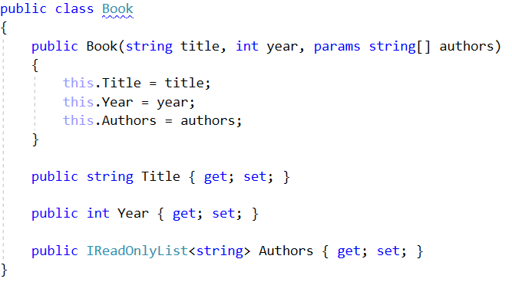

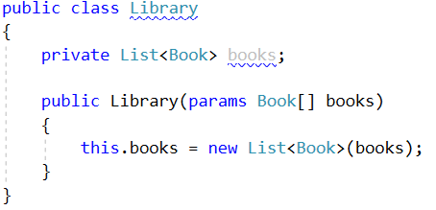

## Library Iterator

**Note**: Put your classes in the namespace IteratorsAndComparators.

Extend your solution from the previous task. Inside the **Library**, create a **nested class** **LibraryIterator,** which should implement the **IEnumerator<Book>** interface. Try to implement the bodies of the inherited methods by yourself. You will need two more members:

* **List<Book> books**
* **int currentIndex**

Now you should be able to iterate through a Library in the Main method.

### Examples

|  |
| --- |
| StartUp.cs |
| public static void Main()  {  Book bookOne = new Book("Animal Farm", 2003, "George Orwell");  Book bookTwo = new Book("The Documents in the Case", 2002,  "Dorothy Sayers", "Robert Eustace");  Book bookThree = new Book("The Documents in the Case", 1930);  Library libraryOne = new Library();  Library libraryTwo = new Library(bookOne, bookTwo, bookThree);  foreach (var book in libraryTwo)  {  Console.WriteLine(book.Title);  }  } |

This is the expected **output** from the above code:

|  |
| --- |
| **Output** |
| Animal Farm  The Documents in the Case  The Documents in the Case |

### Solution

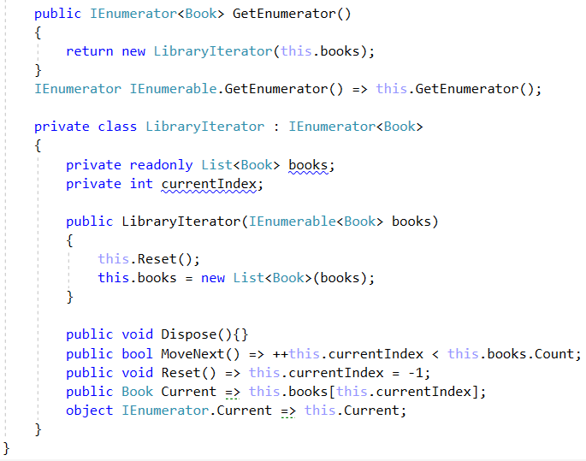

## Comparable Book

**NOTE**: You need the namespace IteratorsAndComparators.

Extend your solution from the previous task. Implement the **IComparable<Book>** interface in the existing class **Book**. The comparison between the two books should happen in the following order:

* First, sort them in **ascending chronological** order (by **year**).
* If two books are published in the **same year**, sort them **alphabetically.**

Override the **ToString()** method in your Book class, so it returns a string in the format:

* **"{title} - {year}"**

Change your **Library** class, so that it stores the books in the correct order.

### Examples

|  |
| --- |
| StartUp.cs |
| public static void Main()  {  Book bookOne = new Book("Animal Farm", 2003, "George Orwell");  Book bookTwo = new Book("The Documents in the Case", 2002, "Dorothy Sayers", "Robert Eustace");  Book bookThree = new Book("The Documents in the Case", 1930);  Library libraryOne = new Library();  Library libraryTwo = new Library(bookOne, bookTwo, bookThree);  foreach (var book in libraryTwo)  {  Console.WriteLine(book);  }  } |

### Examples

|  |
| --- |
| **Output** |
| The Documents in the Case - 1930  The Documents in the Case - 2002  Animal Farm - 2003 |

### Solution

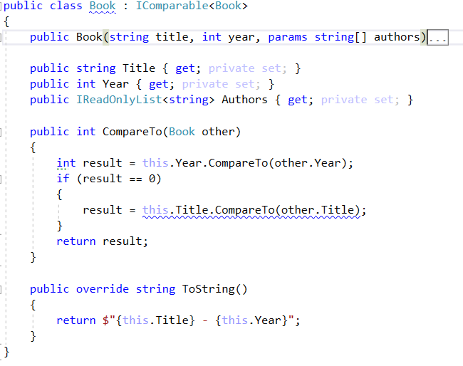

## Book Comparator

**NOTE**: You need the namespace IteratorsAndComparators.

Extend your solution from the prevoius task. Create a class **BookComparator,** which should implement the **IComparer<Book>** interface and thus include the following method:

* **int Compare(Book, Book)**

**BookComparator** must **compare** two books by:

1. Book title - **alphabetical order**
2. Year of publishing a book - **from the newest to the oldest**

Modify your **Library** class once again to implement the **new sorting**.

### Examples

|  |
| --- |
| Startup.cs |
| public static void Main()  {  Book bookOne = new Book("Animal Farm", 2003, "George Orwell");  Book bookTwo = new Book("The Documents in the Case", 2002, "Dorothy Sayers", "Robert Eustace");  Book bookThree = new Book("The Documents in the Case", 1930);  Library library = new Library(bookOne, bookTwo, bookThree);  } |

|  |
| --- |
| **Output** |
| Animal Farm - 2003  The Documents in the Case - 2002  The Documents in the Case - 1930 |

### Solution

