DocDCN: 0500000
DocTitle: System_Architecture_Overview
DocVersion: dv1_23
DocOwner: Bill
DocPath: GitHub.com/TothBot/TothBot_V2-Docs/05XXXXX_System_Architecture/0500000_System_Architecture_Overview_dv1_23_Claude_Source.txt
DocDate: 05-04-2026
DocTime: 19:00:00 UTC

============================================================
0500000 SYSTEM ARCHITECTURE OVERVIEW — CLAUDE SOURCE FILE
============================================================

PURPOSE: This file is the Claude-readable source for 0500000.
It contains the complete document text AND all 6 embedded SVG
diagrams as plain text. Upload this file to the Claude.ai project
when 0500000 needs to be updated. Claude reads this file, applies
changes, and rebuilds the .docx with embedded diagrams.

Bill stores separately:
0500000_System_Architecture_Overview_dv1_22.docx (Word — for Bill)
0500000_System_Architecture_Overview_dv1_23_Claude_Source.txt (this file — for Claude)

============================================================
DOCUMENT CONTENT
============================================================

TOTHBOT — KRAKEN SYSTEM ARCHITECTURE OVERVIEW
The Complete System — All Architectural Decisions + All Flow Diagrams

DocDCN: 0500000
DocTitle: TothBot_Kraken_System_Architecture_Overview
DocVersion: dv1_22
DocOwner: Bill
DocPath: GitHub.com/TothBot/TothBot_V2-Docs/05XXXXX_System_Architecture/0500000_System_Architecture_Overview_dv1_22.docx
DocDate: 05-04-2026
DocTime: 17:30:00 UTC

PURPOSE: This document captures all architectural decisions, FP/DP analyses, and system
specifications from the TothBot Kraken architecture sessions of March 2026. Includes all
six system flow diagrams showing connections between Kraken, TothBot, and CIATS as one
unified organism.

Diagrams in this document (dv1_14 — diagrams unchanged from dv1_10):
Diagram 1 — Kraken API Connection Architecture
(dv1_6: amend_order primary, batch_cancel added, WS ping A-7, zombie A-8,
balances seq A-9, per-pair status, L3 URL corrected)
(dv1_7: executions seq gap detection A-10, GetOpenOrders gap recovery)
(dv1_9: GAP-A order_status:true CRITICAL FIX, GAP-C price_increment, GAP-D qty_min/cost_min,
GAP-E max_size=10MB, IMP-11 maxratecount, IMP-13 warnings[])
(dv1_10: GAP-B stp_type underscore CORRECTION, A-21 deadline parameter,
IMP-16 aiohttp ClientTimeout, IMP-17 TCPConnector, IMP-18 ticker bbo)
(dv1_12: text-only updates — diagrams unchanged)
(dv1_14: text-only — AR-057 through AR-066)
(dv1_15: text-only — AR-067 through AR-075)
(dv1_16: text-only — AR-076)
Diagram 2 — TothBot Trading Pipeline
(dv1_6: per-pair instrument status check added before Gate 1)
Diagram 3 — Exit Architecture: Ground Zero Redesign (dv1_6: title updated)
Diagram 4 — Regime Taxonomy: 6-Regime Grid + Two-Level Tagging (dv1_6: title updated)
Diagram 5 — CIATS Architecture: Data Flows and Improvement Cycle (dv1_6: title updated)
Diagram 6 — Complete System: One CIATS-Owned Organism (dv1_9: GAP-A through F, IMP-11 through 17)
(dv1_10: GAP-B stp_type correction, A-21 deadline, IMP-16/17 aiohttp, IMP-18 bbo, IMP-19 regime stagger)

============================================================
1. System Identity and Mission
============================================================

1.1 What TothBot Is

TothBot is an automated cryptocurrency spot trading system on Kraken exchange. It runs
24/7/365 on a Hetzner VPS, processes 5-minute OHLC candle close events as its system
clock, and executes long-only trades using a momentum-based signal engine.

TothBot is not an external system connected to Kraken — it IS Kraken's event processor.
Every action is a response to a Kraken push event. No timers. No polling. Idle and silent
until Kraken speaks.

1.2 The One Organism Principle

Three functional zones, one organism:
Kraken: generates events, executes orders, holds resting TP limit orders and
off-book emergency SL stop orders on matching engine
TothBot: processes Kraken events, executes trading strategy, manages positions
CIATS: learns from event records, continuously improves processing rules

PRIMARY MISSION: Maximize profit. Minimize loss. With an emphasis on minimizing loss.
Loss prevention takes priority over profit generation. Everything else is secondary.

1.3 Operating Environment

Exchange: Kraken Spot (Long Module — Short deferred)
Language: Python 3.12.3
VPS: Hetzner CPX22 — 87.99.141.44 — Ashburn VA
(Kraken Spot servers: AWS us-west-2 Oregon)
★ Evaluate Hillsboro OR [dv1_6 IMP-01 — adjacent to Kraken AWS]
System Clock: Kraken OHLC 5-minute candle close event (WS v2 push)
Fee Baseline: Maker 0.16% / Taker 0.26% (CIATS monitors actuals)
Operation: 24/7/365 — CIATS may add stand-down periods via PDCA if data supports
Starting Portfolio: $1,000 Long Module
Sacred constraint: Net 1:1.5 R:R — HARDCODED — the only number not owned by CIATS

============================================================
2. Kraken API Connection Architecture
============================================================

All connection points verified across 3 independent analysis passes (15 sources) plus
2 deep validation sessions (144+ sources total) plus 10-search FP/DP Kraken validation
[dv1_6] (126 sources).

2.1 Key Connection Points

Public WS v2:
instrument — asset specs + per-pair status cache ★ dv1_6
price_increment / qty_min / cost_min ★ GAP-C/D dv1_9
status — global engine state (online/post_only/cancel_only/maintenance)
ohlc(5m) — SYSTEM CLOCK (pipeline trigger, fires on trade events)
ohlc(60) — 1H HTF cache for Gate 4 ★ NEW dv1_5
ticker — price data, event_trigger:bbo (pairs with open positions) or
event_trigger:trades (pairs without). WS Manager manages per-pair.

Private WS v2 inbound:
executions — fills/expirations/SL-TP triggers, ratecounter:true (A-1),
snap_orders:true, snap_trades:true, order_status:true on reconnect (A-3),
sequence gap detection ★ A-10 dv1_7
CRITICAL ★ GAP-A dv1_9: order_status:true MANDATORY — without it amended
and restated exec_types are silently dropped, breaking A-12 and A-13
balances — real-time settlement, sequence gap detection ★ A-9 dv1_6

Private WS v2 outbound:
add_order — entry: limit/post_only/GTD/cl_ord_id/stp_type:cancel_newest/deadline:now+5s
amend_order — PRIMARY amendment method (edit_order DEPRECATED ★ dv1_6)
batch_add — SL+TP atomic on fill. cl_ord_id/stp_type:cancel_newest/deadline:now+5s
cancel_order — exit leg cleanup, req_id tracked
batch_cancel — Full Halt multi-order cancel ★ dv1_6
All messages carry req_id (A-2), cl_ord_id (A-2), stp_type:cancel_newest (A-4) [WS v2 underscore]

REST:
GetWebSocketsToken — startup/reconnect
GetOHLCData — daily regime computation 00:00 UTC ★ NEW dv1_5
CRITICAL: exclude response[-1] always ★ dv1_6
GetOpenOrders — restart reconcile fallback / executions gap recovery ★ dv1_7
GetAccountBalance — restart reconcile fallback / balances gap recovery ★ dv1_6
CancelAllOrders — kill switch emergency only
Status API — startup proactive maintenance check (AR-038 dv1_12)
GET https://status.kraken.com/api/v2/
scheduled-maintenances/upcoming.json
No authentication. Informational only. Does not block startup.

Matching Engine:
Resting TP limit orders and off-book emergency SL stop orders survive any TothBot
failure independently — crash protection always active

EVALUATED AND REJECTED:
cancel_all_orders_after (WS v2 DMS) — destroys crash protection (AR-001)
FIX API cancel-on-disconnect — same architectural conflict (AR-001)
OTO conditional orders — uses limit price not fill price, violates R:R (AR-008)

2.2 Four Kraken Engine States

online — All orders. Signal pipeline runs normally.
post_only — TothBot limit+post_only entries ARE valid. Trading continues.
cancel_only — No new entries. Exit Controller can cancel. Resting orders active.
maintenance — No orders, no cancels. Resting TP and emergSL active on engine.

2.3 API Rate Limits — Intermediate Tier (C-2)

Rate limits shared across REST, WebSockets, and FIX — no separate per-protocol budget.

Rate counter threshold (per pair): 125
Rate counter decay (per second): 2.34
Max open orders (per pair): 80
Add order fixed cost: +1
Amend order cost ★ dv1_6 (PRIMARY): +1 fixed, +3(<5s), +2(<10s), +1(<15s)
Edit order (DEPRECATED ★ dv1_6): +1 fixed, +6(<5s), +5(<10s) — DO NOT USE
Batch add fixed cost: +(n/2)
Cancel order cost (< 5s old): +8
Cancel order cost (< 10s old): +6
Cancel order cost (< 300s old): +1
Batch cancel cost ★ dv1_6: Cumulative sum of individual order cancel costs

amend_order is 43% cheaper than edit_order for orders resting <5s (+4 vs +7).
amend_order preserves queue position (unlike cancel+resubmit).

2.4 WS Operational Requirements (A-1 through A-10)

A-1 Rate counter monitoring via executions channel:
executions subscription accepts ratecounter:true. Real-time rate counter per pair
included at zero additional connection cost. CIATS EWMA Monitor adds
rate_counter_by_pair as third monitoring signal. Assign to 0511003 and 0211001.

A-2 req_id and cl_ord_id on all outbound WS messages:
All outbound messages carry req_id (client-specified integer). All add_order and
batch_add additionally carry cl_ord_id (up to 18 characters). TothBot assigns
cl_ord_id at dispatch time before Kraken response. Position Mirror records cl_ord_id
immediately at dispatch — no async gap. WS Manager maintains pending-request registry.
Assign to 0511001, 0511003, 0511005.

A-3 Round-trip latency monitoring and WS reconciliation:
All WS v2 responses include time_in and time_out to nanosecond precision. Logger
records these fields. CIATS EWMA Monitor adds ws_roundtrip_latency_ms. executions
channel supports snap_orders:true on subscription — preferred over REST GetOpenOrders
for restart reconciliation. Assign to 0511001, 0511006, 0211001.

A-4 stp_type:cancel_newest on all WS v2 add_order and batch_add calls:
All add_order and batch_add include stp_type:cancel_newest [WS v2 underscore format].
REST API uses cancel-newest [hyphen] — different protocols, different formats (A-20).
Self Trade Prevention prevents TothBot from inadvertently filling against its own
resting orders.

A-5 Reconnect behavior distinction:
(1) Random drop: reconnect instantly, up to a handful of attempts.
(2) After confirmed trading engine maintenance: minimum 5-second delay.
Both implemented as separate paths in WS Manager. Assign to 0511001.

A-6 (dv1_5) OTO conditional orders — REJECTED:
OTO uses limit price not actual fill price — violates sacred R:R. Creates Position
Mirror race condition. batch_add on fill confirmed correct. See AR-008.

A-7 (dv1_6) ★ WS Ping / Keepalive Strategy:
Kraken WS server disconnects after ~60 seconds of inactivity. Cloudflare idle
timeout ~100 seconds. WS Manager MUST send {"method":"ping"} on each active
connection every 30 seconds. Expects {"method":"pong"} within 10 seconds. No pong
within 10 seconds = dead connection. Reconnect immediately. Application-level ping,
distinct from TCP keepalive. Assign to 0511001, 1011002.

A-8 (dv1_6) ★ Zombie Connection Detection:
A WS connection can appear alive (ping/pong passing) while delivering no real market
data. WS Manager MUST track last_real_data_time per connection using time.monotonic().
Only actual market data events reset this timestamp — heartbeat messages alone do NOT.
If elapsed > 90 seconds: log ZOMBIE_CONNECTION_DETECTED, alert operator, reconnect.
Assign to 0511001, 1011002.

A-9 (dv1_6) ★ Balances Channel Sequence Gap Detection:
Every balances channel message carries a sequence integer. WS Manager MUST track
last-seen sequence. Any gap (skip > 1) indicates a missed ledger event. On gap:
alert immediately, trigger REST GetAccountBalance reconciliation. Missed balance
events cause incorrect available capital calculation — direct loss risk.
Assign to 0511001, 1011002.

A-10 (dv1_7) ★ Executions Channel Sequence Gap Detection:
Every executions channel message carries a sequence integer. WS Manager MUST track
last-seen sequence independently of balances. Any gap (skip > 1) indicates missed
order/fill events. On gap: alert immediately, trigger REST GetOpenOrders reconciliation
to restore Position Mirror accuracy. Missed execution events mean TothBot does not know
a position is open or closed — direct loss risk. Higher severity than A-9 (balances):
a missed fill leaves Position Mirror in stale state; the next pipeline evaluation
operates on incorrect position data. Sequence tracking resets on each new subscription
(reconnect). Do not gap-detect across sessions.
Assign to 0511001, 1011002.

A-11 (dv1_8) ★ Executions Channel: cancel_reason Deprecated — Use reason Field:
The cancel_reason field in executions channel events is DEPRECATED since WS v2.0.0
(December 2023). All code parsing cancellation events MUST read msg["reason"], not
msg["cancel_reason"]. cancel_reason returns None on all modern messages. Silent
reason loss corrupts CIATS EWMA rejection_rate_by_regime monitoring accuracy.
Assign to 1011002 WM-EXE-002 through WM-EXE-004.

A-12 (dv1_8) ★ Executions Channel: Complete exec_type Enum Handling Required:
WS Manager MUST handle all exec_type values: pending_new, new, trade, filled,
iceberg_refill, canceled, expired, amended, restated, status. Using a partial
dispatch table causes unknown exec_type events to silently fall through. Use
handle_exec_unknown for unrecognized values — log full payload, never silently ignore.
TothBot primary events: trade (trigger batch_add), filled, expired (log GTD expiry),
canceled (log with reason). amended and restated: log only, no Position Mirror change.
Assign to 1011002 WM-EXE-005 through WM-EXE-007.

A-13 (dv1_8) ★ Executions Channel: restated exec_type Must Not Trigger Position Change:
restated fires when Kraken's matching engine amends an order for maintenance purposes.
It is NOT a fill, NOT a cancel, NOT a user action. On restated: (1) log with reason
field, (2) alert operator (informational), (3) do NOT update Position Mirror, (4) if
the restated order is a resting TP or emergSL, escalate to HIGH severity alert and
queue a reconciliation check on the next pipeline cycle. The restated event on a
resting crash-protection order indicates Kraken modified our stop — must be visible.
Assign to 1011002 WM-EXE-008 through WM-EXE-010.

A-14 (dv1_8) ★ Spot REST Authentication: Confirmed Unchanged — PL-014 RESOLVED:
The October 1, 2025 authentication breaking change applied to Futures REST ONLY.
Kraken Spot REST authentication is UNCHANGED: HMAC-SHA512 of (URI path + SHA256
(nonce + POST data)) using base64-decoded secret. No code changes required.
PL-014 is fully resolved. No Bill verification action required.
Assign to 0411001 WS-AUTH-001 through WS-AUTH-003.

A-15 (dv1_9) ★ Executions Channel: order_status:true MANDATORY — GAP-A CRITICAL FIX:
Without order_status:true in the executions subscription, the channel only delivers:
new, filled, canceled, expired. The exec_types amended and restated are SILENTLY DROPPED.
This means: (1) A-13 restated protection for crash-protection orders is completely non-
functional without this flag — the restated event never arrives. (2) A-12 dispatch table
handles 10 exec_types but receives only 4. The subscription is already specified correctly
(WS-EXE-001 in 0411001) but this architectural consequence must be explicitly documented.
Assign to 0411001 WS-OSTA-001 through WS-OSTA-003, 1011002 WM-EXE-011/-012.

A-16 (dv1_9) ★ OHLC Channel: interval_begin Replaces Deprecated timestamp — GAP-B:
The Kraken WS v2 OHLC channel deprecated the timestamp field. Subscription ACK warns:
"timestamp is deprecated, use interval_begin". TothBot MUST parse interval_begin
(RFC3339 nanosecond string) as the candle start time, not timestamp.
Assign to 0411001 WS-OHLC-002 through -005, 1011002 WM-OHLC-001 through -003.

A-17 (dv1_9) ★ Instrument Channel: price_increment / qty_min / cost_min — GAP-C/D:
(GAP-C) The instrument channel deprecated tick_size. Use price_increment exclusively.
Subscription ACK warns: "tick_size is deprecated, use price_increment".
(GAP-D) The instrument channel provides qty_min (minimum order quantity) and cost_min
(minimum order cost = price × qty). Gate 8 Position Sizer MUST validate both before
submitting any add_order. Violation causes immediate order rejection.
Assign to 0411001 WS-INST-001 through -007, 1011002 WM-INST-001 through -005.

A-18 (dv1_9) ★ WebSocket Library max_size = 10MB — GAP-E:
Python websockets library default max_size = 1MB. The Kraken instrument channel
snapshot for 500+ pairs can exceed 1MB, causing PayloadTooBig and silent disconnect.
All WS connect() calls MUST set max_size=10*1024*1024 (10MB) and open_timeout=10.
Assign to 0411001 WS-LIB-001 through -003, 1011002 WM-LIB-001 through -003.

A-19 (dv1_9) ★ maxratecount from Executions ACK is Operative Rate Threshold — IMP-11:
The executions subscription ACK returns maxratecount — the actual operative rate
counter ceiling for this user tier. TothBot MUST extract and use maxratecount as the
operative threshold for all rate counter monitoring, not the hardcoded value 125.
If tier changes, maxratecount automatically updates on next reconnect.
Assign to 0411001 WS-RL-003, WS-EXEC-001a, 1011002 WM-RATE-001 through -003.

A-20 (dv1_10) ★ stp_type Format CORRECTION — WS v2 Uses Underscore, Not Hyphen:
Official Kraken WS v2 documentation and batch_add examples use underscore format:
cancel_newest, cancel_oldest, cancel_both
REST API uses hyphen format: cancel-newest, cancel-oldest, cancel-both.
These are DIFFERENT protocols with DIFFERENT formats. All WS v2 outbound messages
(add_order, batch_add) MUST use the underscore format. Using the hyphen format in
WS v2 will cause order rejection or silent failure. This was an error in all
prior dv1_9 and earlier specifications. Corrected here as AR-032.
Assign to 0411001 WS-STP-001 through -003, 1011002 WM-STP-001 through -003.

A-21 (dv1_10) ★ deadline Parameter on All WS v2 Order Submissions:
Both add_order and batch_add support a deadline parameter: an ISO 8601 UTC
timestamp string. The engine rejects any order arriving after this time.
Valid range: 500ms to 60 seconds from current time. Default: 5 seconds.
TothBot standard: deadline = current UTC time + 5 seconds.
Provides protection against stale order placement due to network delay or
event loop pauses. Without deadline, a delayed add_order could place an entry
at a price that has already moved adversely.
CRITICAL: deadline also applies to batch_add. A delayed batch_add with incorrect
TP/emergSL prices due to fill price slippage is prevented by deadline enforcement.
Generate: deadline = (datetime.utcnow() + timedelta(seconds=5)).strftime(
'%Y-%m-%dT%H:%M:%S.%f')[:-3] + 'Z'
Assign to 0411001 WS-DL-001 through -004, 1011002 WM-DL-001 through -004.

A-22 (dv1_10) ★ aiohttp ClientSession Timeout and Connector Configuration:
All REST calls use a single shared aiohttp.ClientSession with explicit timeout and
connector configuration. Without explicit timeout, REST calls can hang indefinitely
if Kraken REST servers become unresponsive. This blocks the asyncio event loop
for aiohttp operations and starves other tasks.
Required configuration:
timeout = aiohttp.ClientTimeout(total=10, connect=5, sock_read=8)
connector = aiohttp.TCPConnector(limit=10, limit_per_host=5, force_close=False)
session = aiohttp.ClientSession(timeout=timeout, connector=connector)
total=10: maximum 10 seconds for complete request (connect + send + read).
connect=5: maximum 5 seconds to establish TCP connection.
sock_read=8: maximum 8 seconds waiting for server response after sending.
force_close=False: enables HTTP keepalive — connection reused across calls.
Assign to 1011002 WM-REST-006 through -011, 1011001 BP-HTTP-001 through -004.

A-23 (dv1_10) ★ Ticker event_trigger per Position State:
The ticker channel event_trigger parameter controls when updates are published.
event_trigger:bbo — fires on every change to best bid or ask price.
event_trigger:trades — fires only when a trade occurs (matching engine event).
For pairs WITH open positions: use event_trigger:bbo.
Rationale: For long positions, the bid price is the realizable exit price.
bbo fires immediately when the bid drops, giving the Exit Controller maximum
reaction time to detect MAE threshold breach. trades-only can miss bid drops
that occur without a matching trade.
For pairs WITHOUT open positions: use event_trigger:trades.
Rationale: Reduces unnecessary event volume. Signal pipeline uses last price
not bid, so trades trigger is sufficient for scoring.
WS Manager adjusts per-pair event_trigger when Position Mirror changes state.
Implementation: re-subscribe ticker for that pair with updated event_trigger.
Assign to 0411001 WS-TKR-001 through -004, 1011002 WM-TKR-001 through -004.

A-24 (dv1_10) ★ Regime Engine GetOHLCData Rate Limit Staggering:
REST public GetOHLCData is rate-limited by IP address + currency pair at 1/second.
Calling it for all monitored pairs simultaneously at 00:00 UTC triggers rate limits.
All GetOHLCData calls in the Regime Engine MUST be staggered with asyncio.sleep(1.1)
between each pair to stay below the rate limit ceiling.
Example for 50 pairs: 50 × 1.1s = 55s total. Completes well before first 5m candle
of the new day (~05:00 UTC for the first significant candle after the daily open).
On rate limit error (HTTP 429): exponential backoff, log REGIME_OHLC_RATE_LIMITED,
retry up to 3 times. If all fail: use stale regime (per RE-SCH-004).
Assign to 1011012 RE-RL-001 through -004.

2.5 Data Architecture: Pre-Computation Cache (NEW dv1_5 — I-2)

HOT PATH RULE: The 5-minute pipeline hot path reads cached values ONLY. No computation
occurs during pipeline evaluation. All indicators maintained as incremental running
calculations updated on each event trigger.

IMP-06 (dv1_8) ★ aiohttp Mandatory for All REST Calls:
All Kraken REST calls MUST use aiohttp (async HTTP). Never use the requests library
inside asyncio — it blocks the event loop during the entire call duration. Create one
aiohttp.ClientSession at TothBot startup, reuse for all REST calls, close at shutdown.
Assign to 1011002 WM-REST-001 through WM-REST-005.

IMP-07 (dv1_8) ★ asyncio TaskManager Pattern — Mandatory for 24/7 Operation:
All asyncio.create_task() calls MUST store a strong reference AND register a done
callback via task.add_done_callback(task_set.discard). Failure to do so causes memory
leaks in long-running processes: the task set grows indefinitely until OOM. All task
creation routed through a central create_task() helper function. Long-running tasks
(ping, zombie, watchdog) stored as named instance variables, cancelled and awaited
explicitly during reconnect cleanup.
Assign to 1011002 WM-TASK-001 through WM-TASK-004.

IMP-08 (dv1_8) ★ systemd Watchdog Integration — Frozen Process Detection:
TothBot MUST run as a systemd service with WatchdogSec=120 and Type=notify. A
separate asyncio.Task pings systemd sd_notify every 30 seconds via WATCHDOG=1
message. If the event loop hangs (frozen process), the watchdog stops, systemd
detects no ping within 120s, and restarts TothBot. Without this, a frozen-but-alive
TothBot with open positions is undetected indefinitely.
Assign to 1011013 VPS_Deployment_Coding_Spec VD-WD-001 through VD-WD-006.

IMP-16 (dv1_10) ★ aiohttp ClientSession Timeout — Required for REST Reliability:
All REST calls via aiohttp MUST use explicit timeout and connector configuration.
Without explicit timeout, a degraded Kraken REST server causes asyncio tasks to
hang indefinitely, blocking reconnect/gap recovery sequences.
ClientTimeout(total=10, connect=5, sock_read=8) applied at session creation.
See A-22 for full specification. Assign to 1011002 WM-REST-006 through -011.

IMP-17 (dv1_10) ★ aiohttp TCPConnector for Connection Reuse:
TCPConnector(limit=10, limit_per_host=5, force_close=False) enables HTTP keepalive.
Without this, aiohttp closes the TCP connection after every REST call and re-opens
it on the next call. For GetWebSocketsToken (called every reconnect) and
GetOpenOrders (called on gap detection), connection reuse materially reduces latency.
See A-22 for full specification. Assign to 1011002 WM-REST-009 through -011.

IMP-18 (dv1_10) ★ Ticker event_trigger:bbo for Open Position MAE Detection:
Pairs with open positions MUST use event_trigger:bbo on ticker subscription.
bbo fires immediately on any best bid/ask price change — not just on trades.
For long positions, bid = realizable exit price. bbo maximizes Layer 2 exit
detection speed. Pairs without open positions use event_trigger:trades.
See A-23 for full specification. Assign to 0411001, 1011002.

IMP-19 (dv1_10) ★ Regime Engine REST Rate Limit Stagger Required:
All GetOHLCData calls in the Regime Engine must use asyncio.sleep(1.1) between
pairs to stay within public REST rate limits. Without stagger, simultaneous calls
for 50+ pairs at 00:00 UTC hit the rate limit and corrupt regime classification
for all affected pairs. See A-24. Assign to 1011012 RE-RL-001 through -004.

Value Pre-computed by Update Trigger Cache Read On
Regime classification Regime Engine Daily 00:00 UTC REST GetOHLCData Every 5m eval (Gate 3+6)
[CRITICAL: exclude response[-1] ★]
1H EMA(20) and EMA(50) Signal Pipeline 1H candle close ohlc(60) WS event Gate 4
(parse interval_begin ★ A-16 dv1_9)
ATR(14) per pair Signal Pipeline Each 5m candle close (incremental) Gate 8 + Exit Controller
24h liquidity per pair (USD) Signal Pipeline Daily ticker or daily OHLC pull Gate 2
Per-pair instrument status ★ WS Manager instrument channel events (live) Gates 1/2 pre-filter

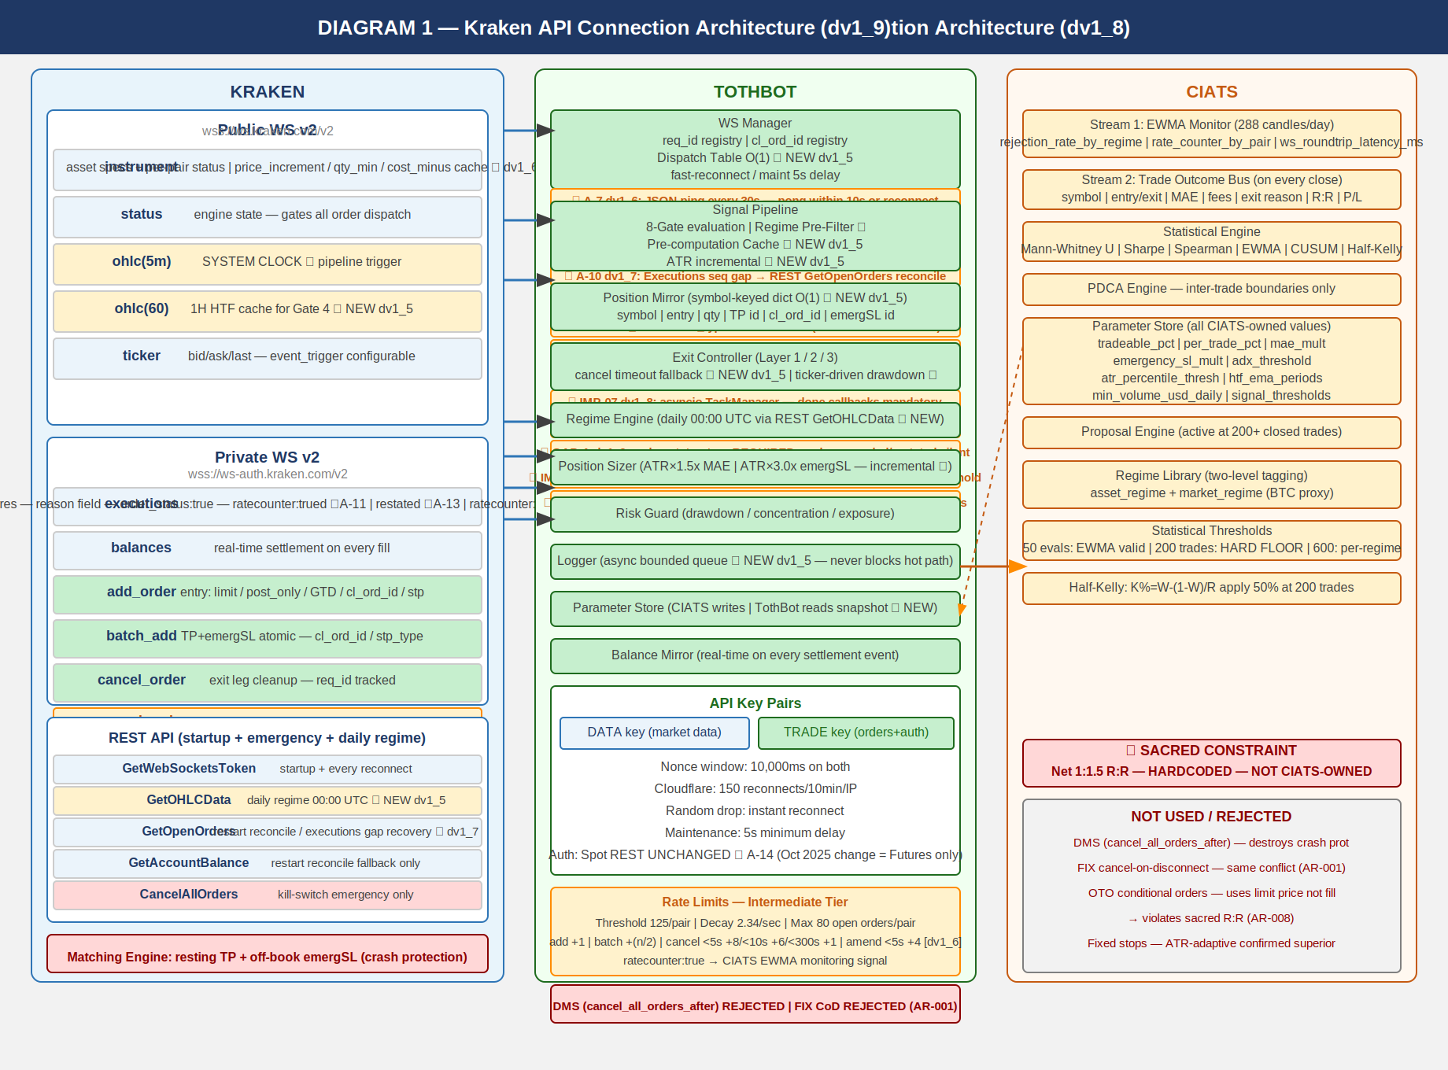
0500000_Image1_Kraken_API_Connection_Architecture.png

============================================================
3. TothBot Trading Pipeline
============================================================

The pipeline fires on every 5-minute OHLC candle close event. Synchronous and event-driven.
8 gates. Gate 3 (Regime Pre-Filter) new in dv1_5. Per-pair status check new in dv1_6.

NOTE — OHLC fires on trade events, not wall clock: If no trades occur after an interval
border, no message sent until next trade. Liquidity Gate ($500k/day) reduces this risk.
Same stall behavior applies to ohlc(60). TothBot must handle stalled system clock.
Addressed in 0511002 Signal Pipeline Specification.

3.1 Gate Summary

PRE-STEP: Parameter Store Snapshot Frozen (NEW dv1_5 — I-4)
CIATS params captured as read-only snapshot at pipeline start. Consistent throughout
full eval. CIATS writes applied only at inter-trade boundaries.

PRE-STEP: Pre-Computation Cache Read (NEW dv1_5 — I-2)
Hot path reads: regime cache | 1H EMA cache (ohlc-60) | ATR(14) running value |
24h liquidity | per-pair status. Zero computation on hot path.

★ dv1_6: Per-pair Instrument Status Check
Skip pairs in reduce_only, work_in_progress, delisted, limit_only,
cancel_only, or maintenance state ★ dv1_12.
Only online or post_only pairs proceed into pipeline.
Prevents wasted rate counter. Full status list per 0411001 WS-INST-008.

Gate 1: State Machine
Kraken engine = maintenance or cancel_only: WAIT

Gate 2: Liquidity Gate ★
24h volume < $500k USD: SKIP → LIQUIDITY_REJECTED

Gate 3: Regime Pre-Filter ★ NEW dv1_5 (I-1)
TRENDING_NEG (any vol) or NON_DIR+ELEVATED: STOP → REGIME_BLOCKED
Eliminates SSS computation on all no-trade regimes.

Gate 4: 1H HTF Confirmation ★ (was Gate 3)
1H EMA(20) <= EMA(50) for TRENDING_POS entries: SKIP → HTF_GATE_REJECTED
Cache read from ohlc(60) WS subscription (NEW dv1_5).

SSS Signal Engine
Scores 5-min candle. Only reached if Gate 3 pre-filter passed.

Gate 5: Selection Controller (was Gate 4)
Signal fails any of 6 quality gates: SKIP → SELECTION_REJECTED

Gate 6: Regime Gate ★ (was Gate 5)
NON_DIR+NORMAL: 50% position size. All NO ENTRY cases blocked by Gate 3.

Gate 7: Risk Guard (was Gate 6)
Drawdown halt / concentration / exposure. Pass or HALT.
★ Ticker-driven continuous drawdown monitoring between candle closes (I-7 dv1_5)

Gate 8: Position Sizer ★ (was Gate 7)
MAE = ATR(14) x 1.5x (incremental), emergSL = ATR(14) x 3.0x, TP = R:R formula.
Never blocks — only sizes.

EVIDENCE BASE: 15-20% higher win rates with daily+hourly confirmation (5 independent
sources 2024-2025). Market Cipher: accuracy drops 65% in TRENDING to 45-50% in
NON_DIRECTIONAL. Break-even 40% for 1:1.5 R:R.

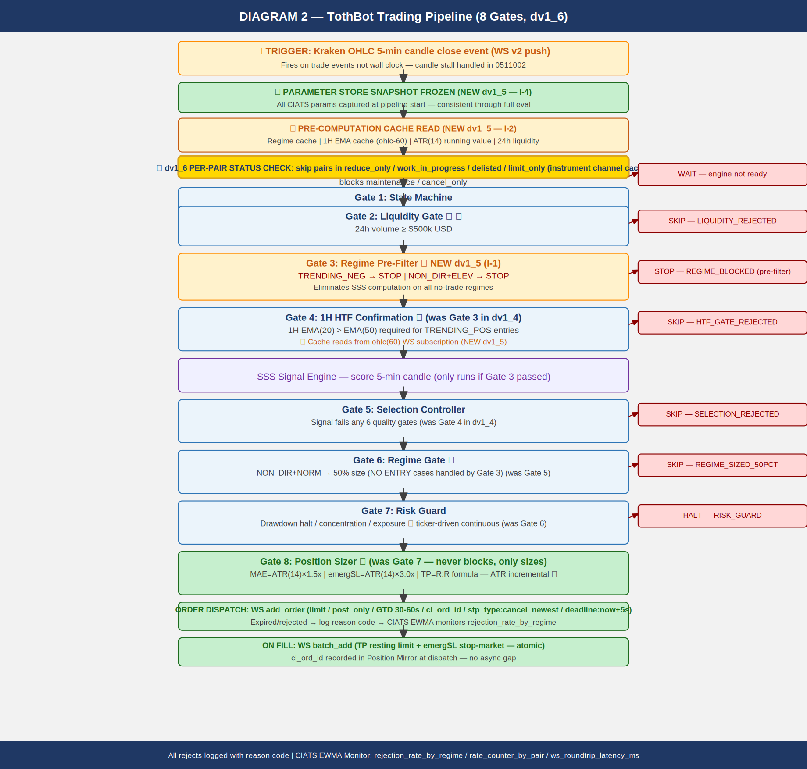
0500000_Image2_Trading_Pipeline.png

============================================================
4. Exit Architecture — Ground Zero Redesign for Kraken
============================================================

Rebuilt from zero for Kraken. Exit Controller owns all normal exits. Kraken off-book
emergency SL stop order is crash protection only. OTO evaluated and rejected (AR-008).

4.1 Three-Layer Summary

Layer 1a — Signal-Based Exit:
Signal decay / time expiry / momentum loss. WS cancel TP + market sell.

Layer 1b — TP Fill:
Resting TP limit on Kraken matching engine fills. EC cancels emergSL after fill confirm.

Layer 2 ★ — MAE Threshold:
price - entry >= ATR(14) x 1.5x.
SEQUENCE CRITICAL: (1) cancel TP (2) cancel emergSL THEN (3) market sell.
CANCEL TIMEOUT FALLBACK (NEW dv1_5 — I-6):
req_id registry tracks each cancel ACK. On timeout: check executions channel state.
Confirmed cancelled: proceed. State unknown: retry once. Second timeout: ALERT +
hold position + alert operator. NEVER issue market sell with ambiguous order state.
Assign to 0511001 and 0511004.
MPP RISK (C-1 dv1_4): market sell may reject on wide spread. EC MUST handle MPP
rejection and retry. Assign to 0511004.

Layer 3 ★ — Emergency Brake:
VPS/TothBot/internet failure ONLY. Off-book emergSL stop order at ATR(14) x 3.0x
on Kraken matching engine. NEVER in normal operation.
MPP RISK (C-1 dv1_4): triggered market order subject to MPP on wide spread.
Assign to 0411001.

4.2 R:R Formula

mae_pct = ATR(14) x 1.5x / entry_fill_price (CIATS-owned, uses ACTUAL fill price)
net_loss = mae_pct + 0.16% + 0.26% (entry maker + MAE taker exit)
net_gain = net_loss x 1.5 *** SACRED — hardcoded ***
gross_target = net_gain + 0.16% (TP maker exit)
emergSL_dist = ATR(14) x 3.0x / entry_fill_price (NEVER in R:R formula)

NOTE: All calculations use actual fill price, not limit price. OTO uses limit price —
this is why OTO was rejected (AR-008).

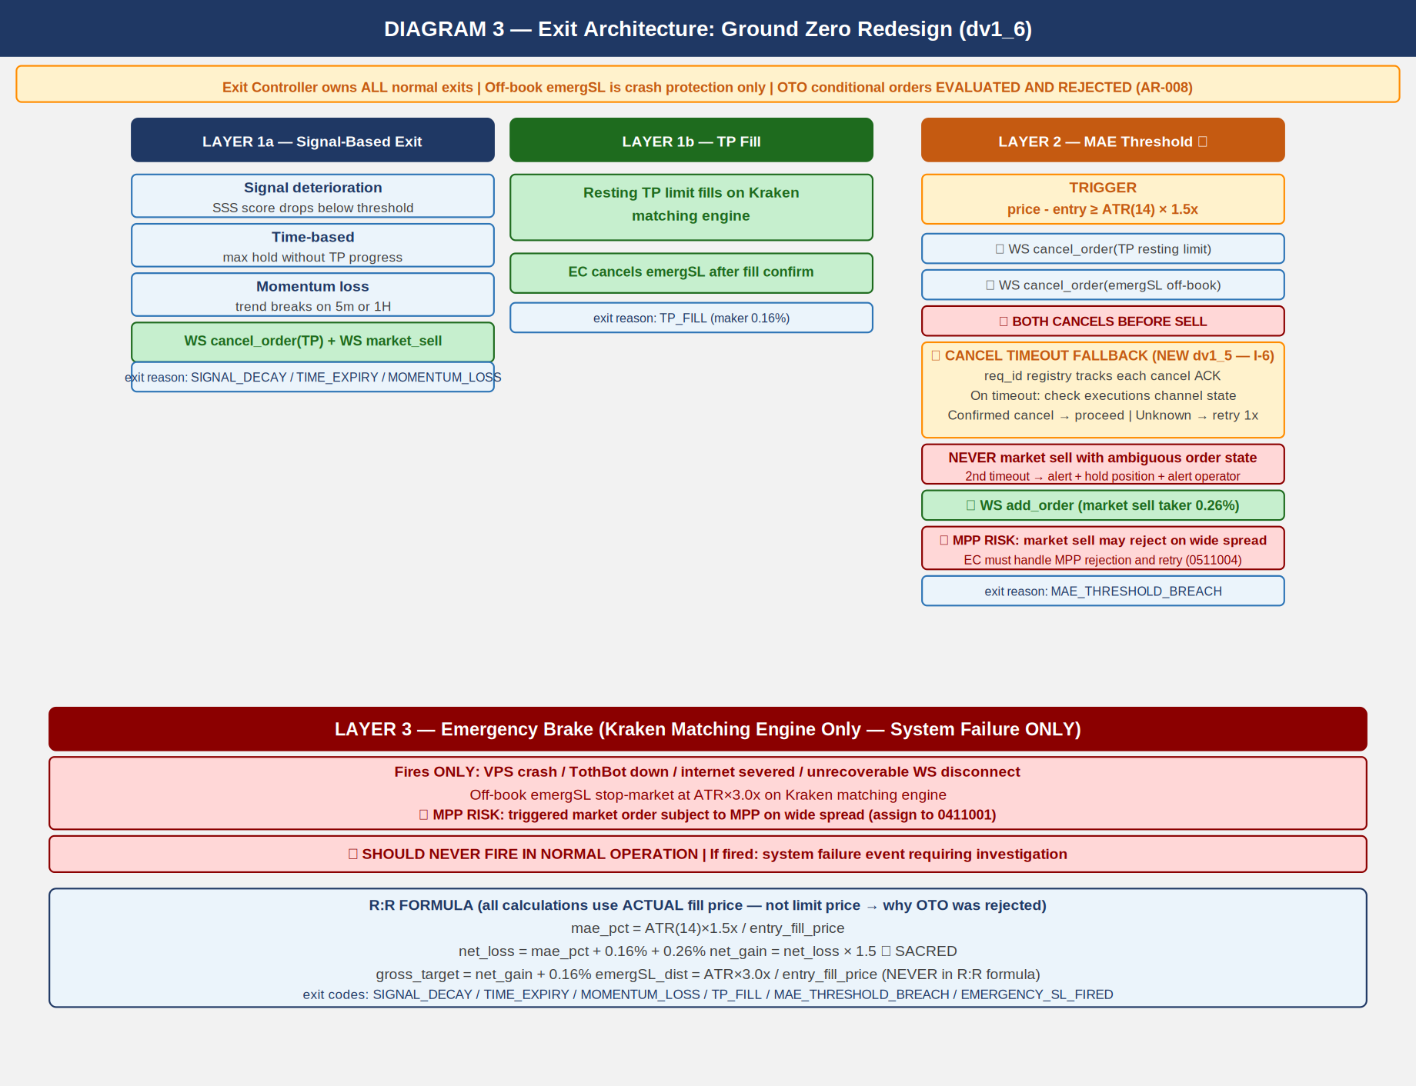
0500000_Image3_Exit_Architecture.png

============================================================
5. Regime Taxonomy
============================================================

Six-regime grid is foundation of CIATS regime-segmented analysis. Every trade tagged with
both asset_regime and market_regime (BTC proxy). Computed daily at 00:00 UTC.

5.1 Computation

DATA SOURCE (NEW dv1_5 — FLAG 2 — FP/DP VERIFIED):
Daily candles via REST GetOHLCData called once per monitored pair at 00:00 UTC.
Returns 720 entries.

CRITICAL dv1_6 (GAP-03): The last entry (response[-1]) is ALWAYS the current
not-yet-committed candle. MUST be excluded from ALL calculations (ADX, EMA, ATR).
Use only response[:-1]. Including the uncommitted candle corrupts all regime indicators
and produces incorrect regime classification. See 1011012 Regime_Engine_Coding_Spec.

Directional state: ADX(14) + EMA(20) vs EMA(50) on DAILY candles (response[:-1] ONLY)
Volatility state: ATR(14) percentile rank in 50-day rolling window

TRENDING_POSITIVE: ADX(14) > 25 AND EMA(20) > EMA(50)
TRENDING_NEGATIVE: ADX(14) > 25 AND EMA(20) < EMA(50)
NON_DIRECTIONAL: ADX(14) <= 25
NORMAL_VOL: ATR percentile <= 67th
ELEVATED_VOL: ATR percentile > 67th

asset_regime + market_regime (BTC/USD proxy) both tagged on every trade

ALL REGIME THRESHOLDS ARE CIATS-OWNED: ADX threshold 25, ATR percentile 67th, EMA
periods 20/50, rolling window 50 days — all starting values. CIATS validates each after
600 closed trades (100+ per regime bucket).

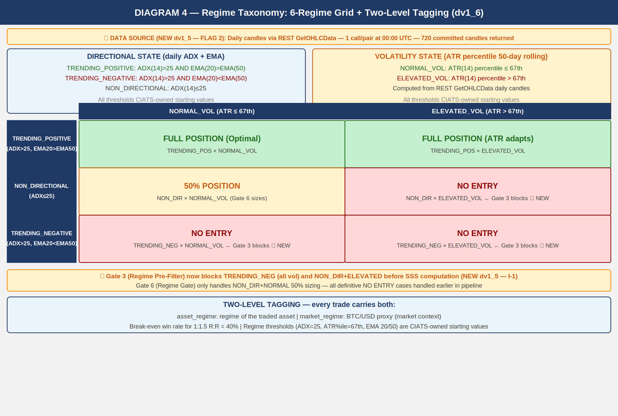
0500000_Image4_Regime_Taxonomy.png

============================================================
6. CIATS Architecture and Data Flows
============================================================

CIATS is fully asynchronous. Never blocks the trading critical path. Reads only from
the Logger. Writes only to the Parameter Store. Deming PDCA governs every change.

6.1 Two Data Streams

Stream 1: EWMA Monitor
288 candle evals/day. Valid at 50 evals (~4 hrs). lambda=0.2 [FP/DP validated dv1_6:
half-life=3.1 evals]. Three monitoring signals:
(1) rejection_rate_by_regime (F6)
(2) rate_counter_by_pair from executions channel (A-1)
(3) ws_roundtrip_latency_ms from WS response timestamps (A-3)
MONITORING SIGNALS ONLY — never drives parameter changes.

Stream 2: Trade Outcome Bus
Fires on each position close. Captures: symbol, entry/exit price, hold duration,
MAE reached, fees, exit reason, both regime tags, signal params at entry, actual R:R, P/L.

LOGGER — ASYNC BOUNDED QUEUE (NEW dv1_5 — I-5):
Logger writes go to an in-memory bounded queue. Queue size: 10,000 entries
[FP/DP validated dv1_6: 20 positions x 10 events/candle x 50-candle buffer].
Separate async writer flushes to disk. Logger NEVER blocks the trading hot path.
Queue must be bounded with immediate alert if queue fills. Assign to 0511006.

PARAMETER STORE — SNAPSHOT PATTERN (NEW dv1_5 — I-4):
TothBot takes frozen snapshot of all CIATS parameters at start of each pipeline eval.
Pipeline uses snapshot throughout. CIATS writes queued and applied only at confirmed
inter-trade boundaries. Prevents parameter inconsistency within single pipeline eval.
Assign to 0511002 and 0211001.

6.2 Statistical Thresholds

50 candle evals: EWMA Monitor valid. Monitoring only. lambda=0.2 validated.
200 trades HARD FLOOR: Inference valid. Proposal Engine activates. Half-Kelly activates.
SE(win_rate)~3.5%, SE(Sharpe)~7.2% [FP/DP validated dv1_6].
600 trades: Per-regime analysis. 100+ per bucket. MW power ~85% at alpha=0.01.
Rolling 200-300: Current performance window.
Full corpus: Zero-cost historical library.

Mann-Whitney alpha (dv1_6) ★: alpha=0.01 (one-sided). 99% confidence required.
Spearman rho threshold (dv1_6) ★: |rho| > 0.3 AND p < 0.05 (both conditions).
CUSUM parameters (dv1_6) ★: k=0.5*sigma, h=4*sigma. Starting values.
PDCA minimum interval (dv1_6) ★: Min 50 trades between any two parameter changes.

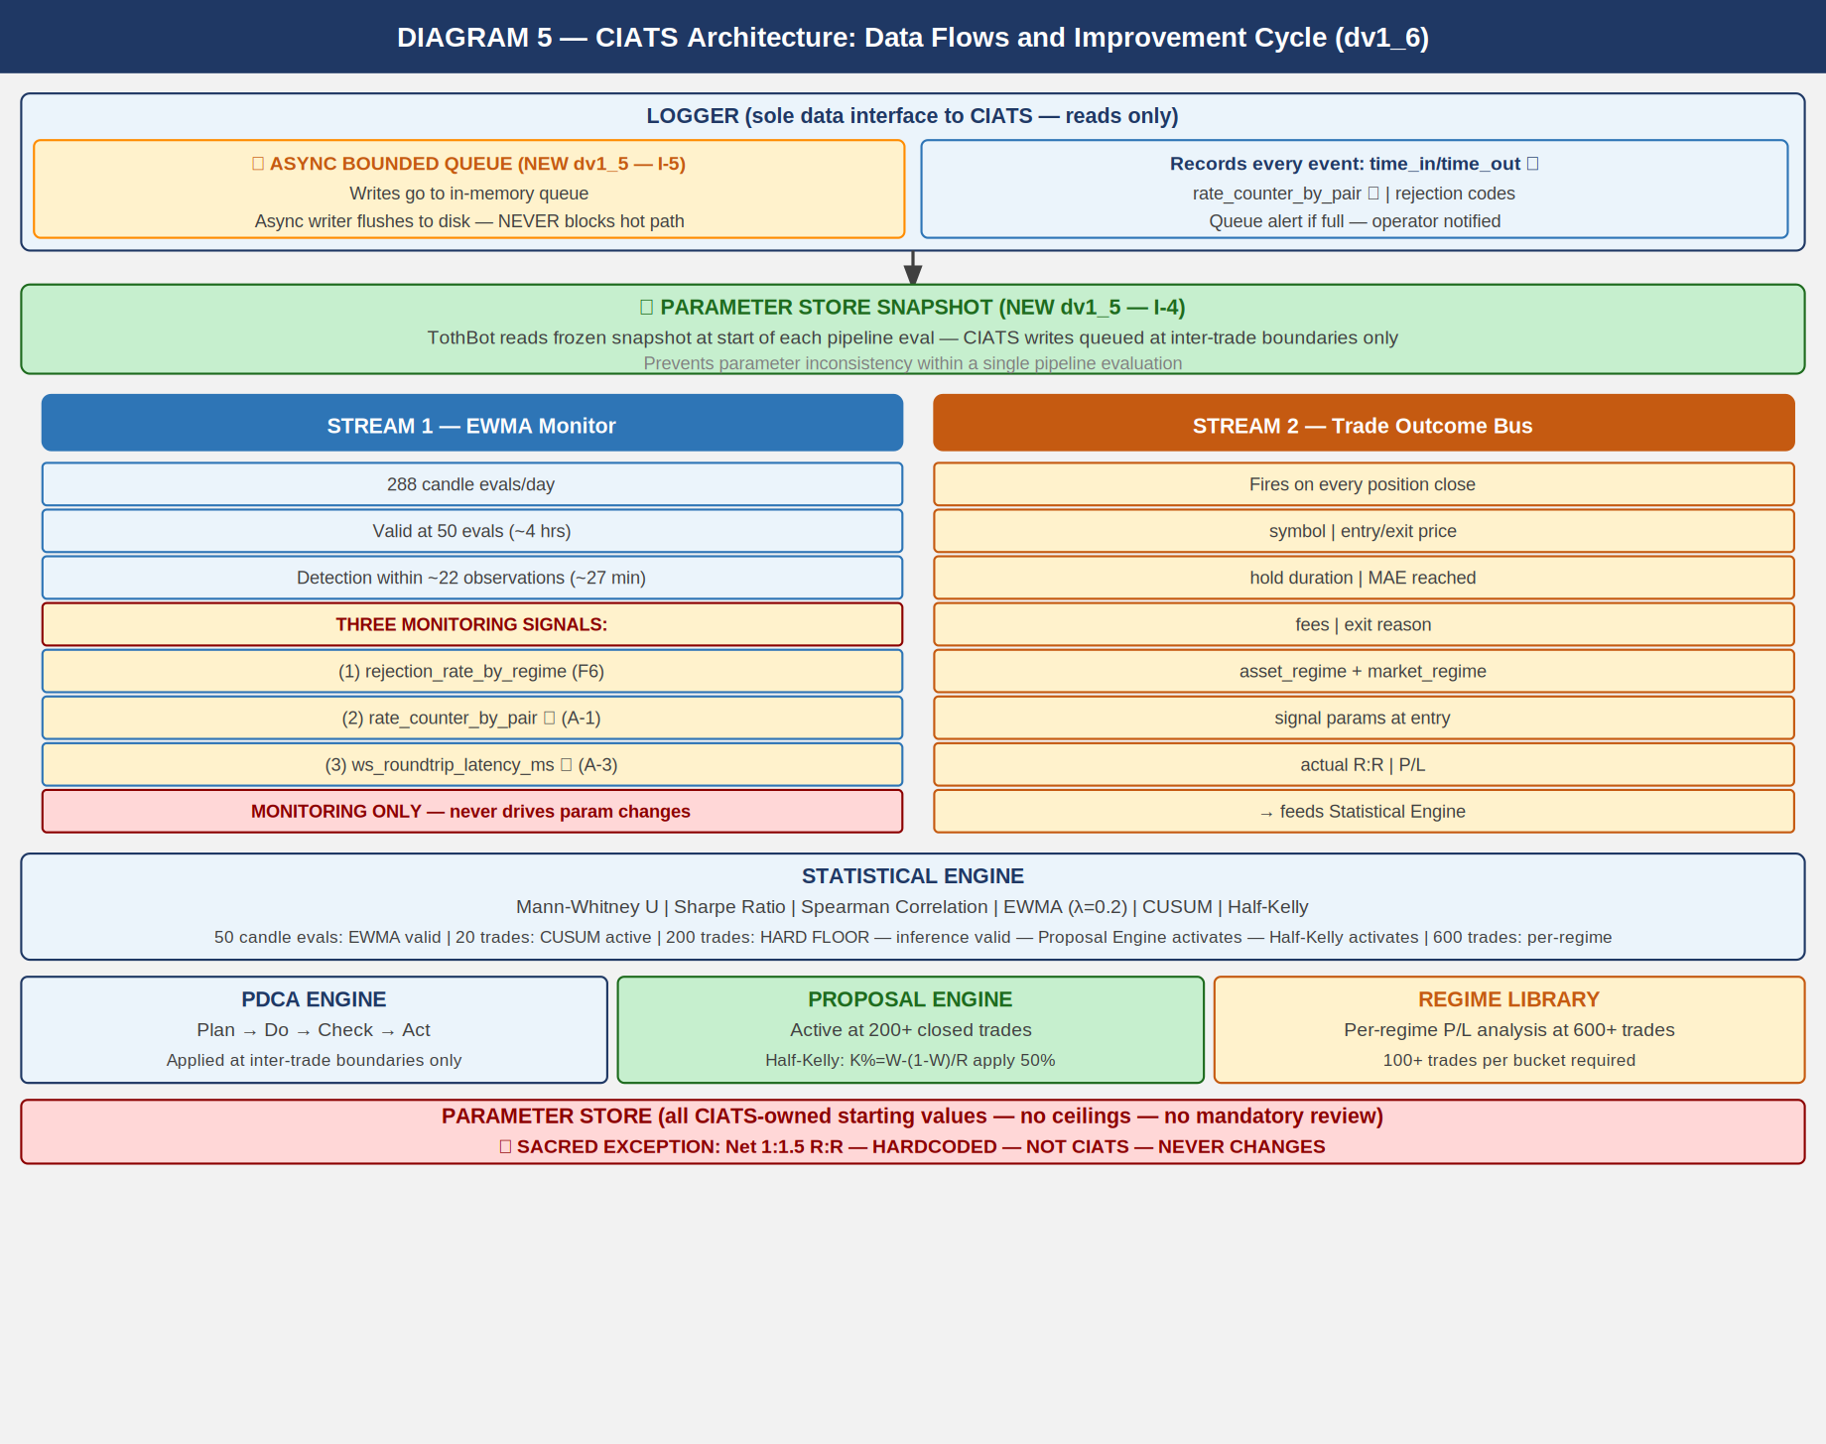
0500000_Image5_CIATS_Architecture.png

============================================================
7. Complete System: One CIATS-Owned Organism
============================================================

CIATS OWNS EVERYTHING EXCEPT 1:1.5 R:R: All parameters, thresholds, sizing decisions,
halt thresholds, multipliers, and trading rules are CIATS-owned starting values.

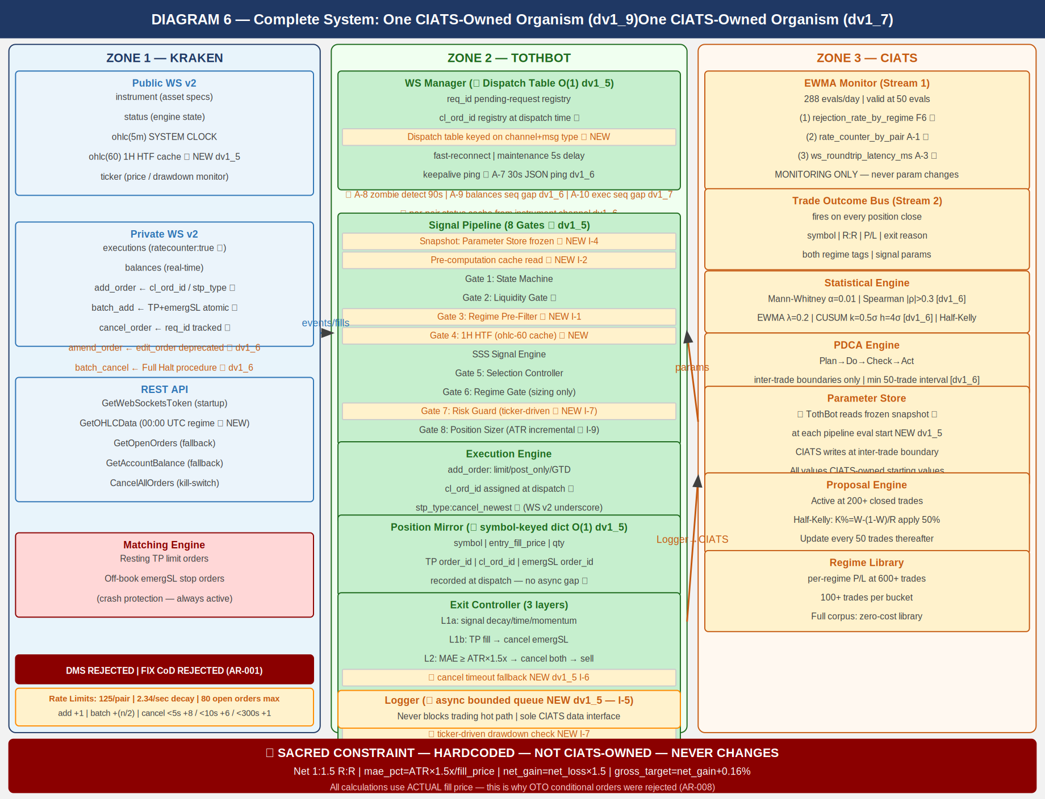
0500000_Image6_Complete_System.png

============================================================
8. Locked Architectural Decisions
============================================================

AR-001: No Dead Man Switch — crash protection is resting TP + emergSL on matching engine.
DMS and FIX cancel-on-disconnect both REJECTED (destroy crash protection).
AR-002: Position Mirror — symbol-keyed dict, O(1) lookup. (NEW dv1_5 — I-3)
AR-003: Restart reconciliation — PREFERRED: snap_orders:true. FALLBACK: REST.
AR-004: Two API key pairs — DATA + TRADE. Nonce window 10,000ms.
AR-005: WS v2 only. All future Kraken enhancements in v2 only.
AR-006: Entry order — limit/post_only/GTD/cl_ord_id/stp_type:cancel_newest/deadline:now+5s.
★ WS v2 uses underscore in stp_type values (cancel_newest). REST uses hyphen (cancel-newest).
Never confuse the two. Different protocols, different formats.
AR-007: TP placement — resting limit via batch_add on fill. Actual fill price for R:R.
batch_add includes deadline:now+5s and stp_type:cancel_newest on both legs.
AR-008: Emergency SL — stop-market via batch_add atomic with TP. ATR(14) x 3.0x.
OTO evaluated and REJECTED: uses limit price, violates R:R, Position Mirror race.
AR-009: Short deferred.
AR-010: 24/7/365. CIATS adds stand-down via PDCA if data supports.
AR-011: Net 1:1.5 R:R — SACRED — HARDCODED — NOT CIATS-OWNED.
AR-012: Fee baseline — Maker 0.16% / Taker 0.26%.
AR-013: Kraken Pro Intermediate tier confirmed.
AR-014: Logger async bounded queue (10,000 entries). Never blocks hot path. (dv1_5 I-5)
AR-015: WS dispatch table O(1) routing on channel+message type. (dv1_5 I-8)
AR-016: ATR(14) incremental running calculation. O(1) per update. (dv1_5 I-9)
AR-017: Daily regime via REST GetOHLCData at 00:00 UTC. CRITICAL: exclude response[-1].
(dv1_5 FLAG 2)
AR-018 (dv1_6) ★: amend_order PRIMARY. edit_order DEPRECATED.
AR-019 (dv1_6) ★: batch_cancel for Full Halt multi-order cancellation.
AR-020 (dv1_6) ★: Per-pair instrument status cache from instrument channel.
AR-021 (dv1_7) ★: Executions channel sequence gap detection → REST GetOpenOrders
reconciliation. Missed executions = Position Mirror desync = loss risk.
AR-022 (dv1_8) ★: cancel_reason field deprecated — use reason field in all executions
channel parsing. cancel_reason returns None silently on current messages.
AR-023 (dv1_8) ★: Complete exec_type dispatch table required. All 10 exec_type values
handled explicitly. Unknown values logged, never silently dropped.
AR-024 (dv1_8) ★: restated exec_type = engine maintenance amend, NOT fill/cancel.
Must not trigger Position Mirror update. Elevated alert if resting order.
AR-025 (dv1_8) ★: All REST calls via aiohttp (IMP-06). asyncio TaskManager pattern
mandatory for 24/7 operation (IMP-07). systemd WatchdogSec=120 with
30-second asyncio ping loop (IMP-08). See 1011013 VPS_Deployment_Spec.
AR-026 (dv1_9) ★: order_status:true MANDATORY in executions subscription. Without it
amended and restated exec_types are silently dropped — A-12/A-13 blind.
AR-027 (dv1_9) ★: interval_begin replaces deprecated timestamp in OHLC WS v2 channel.
AR-028 (dv1_9) ★: price_increment replaces deprecated tick_size in instrument channel.
qty_min and cost_min validated in Gate 8 before every add_order.
AR-029 (dv1_9) ★: WS connect max_size=10MB + open_timeout=10 on all connections.
AR-030 (dv1_9) ★: maxratecount from executions subscription ACK is the operative rate
counter ceiling. Use it, not the hardcoded 125.
AR-031 (dv1_9) ★: Subscription ACK warnings[] parsed and logged on every subscribe call.
QueryOrdersInfo REST endpoint for targeted single-order reconciliation.
AR-032 (dv1_10) ★: stp_type FORMAT CORRECTION — WS v2 uses underscores: cancel_newest,
cancel_oldest, cancel_both. REST uses hyphens: cancel-newest. Never
confuse the two protocols. All WS v2 add_order and batch_add MUST use
cancel_newest (underscore). Assign: 0411001, 1011002.
AR-033 (dv1_10) ★: deadline parameter on all WS v2 add_order and batch_add.
Standard: deadline = UTC now + 5 seconds (ISO 8601 string).
Range 500ms–60s. Engine rejects orders arriving after this time.
Provides latency protection on entry and TP/emergSL placement.
Assign: 0411001 WS-DL-001–004, 1011002 WM-DL-001–004.
AR-034 (dv1_10) ★: Ticker event_trigger per position state:
event_trigger:bbo — pairs WITH open positions (faster adverse price
detection; for longs, bid = realizable exit price).
event_trigger:trades — pairs WITHOUT open positions (less update volume).
WS Manager switches trigger mode based on Position Mirror state.
Assign: 0411001 WS-TKR-001–004, 1011002 WM-TKR-001–004.
AR-035 (dv1_10) ★: aiohttp ClientSession MUST configure explicit timeout + connector:
ClientTimeout(total=10, connect=5, sock_read=8)
TCPConnector(limit=10, limit_per_host=5, force_close=False)
Without timeout, REST calls hang indefinitely on degraded networks.
force_close=False enables connection reuse for reduced per-call overhead.
Assign: 1011002 WM-REST-006–011, 1011001 BP-HTTP-001–004.
AR-036 (dv1_10) ★: Regime Engine REST calls MUST be staggered at 1.1s intervals.
REST public OHLC rate-limit: 1 call/second per IP+pair.
50 pairs × 1.1s = 55s total. Completes before first 5m candle.
asyncio.sleep(1.1) between each GetOHLCData call.
Assign: 1011012 RE-RL-001–004.
AR-037 (dv1_10) ★: Both DATA and TRADE API keys MUST be IP-whitelisted to VPS IP.
Current VPS: 87.99.141.44. Update whitelist on any VPS migration.
IP whitelisting is configured separately in Kraken API key settings.
Assign: 1011013 VD-KEY-006–009.
AR-038 (dv1_12) ★: Kraken Status API used at startup for proactive maintenance detection.
Public REST API at https://status.kraken.com/api/v2/. Query
/scheduled-maintenances/upcoming.json on startup. If scheduled
maintenance detected within 2 hours: log KRAKEN_MAINTENANCE_SCHEDULED,
alert operator. Does NOT block startup — informational only.
Assign: 0411001 WS-STAT-001 through -004, 1011013 VD-STAT-001.
AR-039 (dv1_12) ★: Per-pair instrument channel status check expanded. Complete set of
NO-ENTRY states: reduce_only, work_in_progress, delisted, limit_only,
cancel_only, maintenance. cancel_only and maintenance were previously
missing. Both block all new order placement at the pair level.
Assign: 0411001 WS-INST-008 through -011, 1011002 WM-PS-001 through -005.
AR-040 (dv1_12) ★: Exit Controller pair status adaptation for open positions.
limit_only → IOC limit at best_bid (NOT market sell).
cancel_only → HOLD + CRITICAL alert. No new orders possible.
maintenance (pair level) → HOLD + CRITICAL alert.
Existing resting TP + emergSL are the only protection during HOLD.
Validates AR-001: resting emergSL crash protection is the correct
architecture for pair-level disruption scenarios.
Assign: 0411001 WS-EXIT-001 through -006, 1011002 WM-PS-003/004.
AR-041 (dv1_12) ★: cancel_order/batch_cancel behavioral distinction — NOT interchangeable.
cancel_order: returns stream of individual responses per order (req_id
trackable). Use for Layer 2 MAE exit cancel sequence (cancel timeout
fallback I-6 requires per-order ACK tracking).
batch_cancel: returns single count response + bypasses rate counter
maximum. Use for Full Halt (count sufficient; rate bypass ensures
execution even when rate limited).
Assign: 0411001 WS-CAN-001 through -007, 1011002 WM-CAN-001 through -004.
AR-042 (dv1_12) ★: Zombie detection heartbeat exclusion. Heartbeat messages fire ONLY when
no real market data is flowing — they are an indicator of zombie state,
NOT connection health. last_real_data_time MUST be reset only on real
channel events: ohlc, ticker, instrument, executions, balances, status.
Heartbeat, pong, and ACK messages MUST NOT reset the timer.
Assign: 1011002 WM-ZOM-004 through -007.
AR-043 (dv1_12) ★: max_concurrent position limit enforced by asyncio.BoundedSemaphore.
BoundedSemaphore raises ValueError on over-release (bug detection).
Gate 7 checks semaphore.locked() (non-blocking). Execution Engine
acquires semaphore before dispatch. Position close triggers release.
On CIATS max_concurrent update: recreate semaphore, re-acquire for
all currently open positions.
Assign: 1011011 RE-SEM-001 through -006.
AR-044 (dv1_13) ★: Startup warm-up — ATR(14) and EMA via REST GetOHLCData required
before any pipeline execution. WS ohlc(5m) and ohlc(60) snapshots
return only 1 candle — insufficient to seed ATR(14) or EMA(20/50).
For each monitored pair at startup:
(a) GetOHLCData(interval=5) — seed ATR(14). Use response[:-1].
ATR seed = SMA of first 14 True Ranges. Incremental thereafter.
(b) GetOHLCData(interval=60) — seed EMA(20) and EMA(50) for HTF
cache. Use response[:-1]. EMA alpha=2/(n+1).
(c) GetOHLCData(interval=1440) — Regime Engine. Use response[:-1].
STAGGER: 1.1s between calls for the SAME pair (AR-036 applies).
PARALLELISM: asyncio.gather() across DIFFERENT pairs.
While ATR or EMA not seeded: pair remains in WARM_UP state.
WARM_UP pairs are skipped at the pipeline pre-check (no entries).
Pair transitions WARM_UP -> READY when ATR, EMA, and regime all
seeded. System begins trading READY pairs immediately — does not
wait for all pairs.
Assign: 1011002 WM-STARTUP-001 through -008,
1011014 SS-WARMUP-001 through -010.
AR-045 (dv1_13) ★: OHLC candle-close detection mechanism. WS OHLC fires on every
trade event within the candle period, not only on candle close.
WS Manager MUST track per symbol:
last_interval_begin: dict[str, str]
last_complete_candle: dict[str, OHLCCandle]
On each ohlc(5m) message for symbol S:
if msg.interval_begin == last_interval_begin[S]:
Update in-progress candle. DO NOT fire pipeline.
else:
Candle for last_interval_begin[S] is NOW CLOSED.
Fire pipeline with last_complete_candle[S].
last_complete_candle[S] = current message data.
last_interval_begin[S] = msg.interval_begin.
Initialize last_interval_begin[S] from startup GetOHLCData(5)
response[-2].interval_begin (last committed candle).
Same logic for ohlc(60) with separate last_interval_begin_60.
Assign: 1011002 WM-OHLC-001 through -006.
AR-046 (dv1_13) ★: emergSL triggers.reference MUST be explicit in all batch_add
calls. Never rely on API defaults for crash-protection parameters.
ALL emergSL stop-loss orders MUST include:
"triggers": {
"reference": "last",
"price": <sl_trigger_price>,
"price_type": "static"
}
reference="last" uses Kraken's internal last-traded price — always
available regardless of external index feed status. reference="index"
relies on external data providers that may be unavailable during
exactly the market crashes when emergSL needs to fire.
Assign: 0411001 WS-SL-001 through -003,
1011002 WM-BATCHADD-003 through -004.
AR-047 (dv1_13) ★: Price and quantity rounding before ALL order dispatch. ALL rounding
MUST use Decimal.quantize() — NEVER math.floor/ceil. Float binary
representation causes precision errors (e.g. math.floor(0.3/0.1)*0.1
= 0.2 not 0.3). For exchange orders: any rounding error = rejected
order = failed trade = loss. Four mandatory rounding operations:
(1) order_qty: Decimal.quantize(qty_increment, ROUND_DOWN).
If result < qty_min OR result*price < cost_min: SKIP, log.
(2) entry limit_price: Decimal.quantize(price_increment, ROUND_DOWN).
Conservative: lower limit = more likely post_only fill.
(3) TP limit_price: Decimal.quantize(price_increment, ROUND_UP).
Conservative: higher TP = preserves net R:R at minimum.
(4) emergSL trigger: Decimal.quantize(price_increment, ROUND_DOWN).
Conservative: wider stop = more protective.
ALL Kraken API values (prices, qtys) received via WS or REST MUST be
converted to Decimal(str(value)) immediately on receipt.
NEVER Decimal(float_value) — inherits float precision error.
NEVER dispatch batch_add without pre-validated, pre-rounded prices.
A batch_add validation failure at Kraken kills the entire batch,
leaving an open position with NO TP and NO emergSL protection.
Assign: 1011001 BP-DEC-001 through -008,
1011002 WM-ROUND-001 through -012.
AR-048 (dv1_13) ★: Exit Controller MAE detection and drawdown calculation MUST use
bid price (not last price) for long positions.
bid = best price at which the position can be immediately sold
(realizable exit value). last = most recent trade, can be stale.
event_trigger:bbo was chosen specifically because bid updates fire
immediately on any adversarial price move.
MAE formula: current_mae = entry_fill_price - bid_price
Layer 2 exit triggers when: current_mae >= ATR(14) * mae_mult
Drawdown calculation:
current_portfolio_USD = spot_usd_balance
+ sum(bid_price[sym] * position_qty[sym]
for sym in position_mirror)
Assign: 0411001 WS-TKR-005 through -007,
1011002 WM-EC-001 through -003.
AR-049 (dv1_13) ★: Formal startup sequence required. TothBot MUST complete the
10-step startup sequence before any pipeline evaluation. No pipeline
evaluations permitted until at least one pair reaches READY state.
Complete specification in 1011014 Startup_Sequence_Coding_Spec.
Sequence: (1) Kraken Status API check, (2) GetWebSocketsToken,
(3) Connect public WS + subscribe, (4) Process instrument snapshot,
(5) Connect private WS + subscribe executions/balances,
(6) snap_orders reconciliation -> Position Mirror,
(7) Restore ticker subscriptions per position state,
(8) REST warm-up GetOHLCData (AR-044: interval=5, 60, 1440),
(9) First READY pair -> enter OPERATIONAL, (10) Continuous operation.
Assign: 1011002 WM-STARTUP-001 through -012, 1011014 (full spec).
AR-050 (dv1_13) ★: Balances channel MUST use spot/main wallet balance only.
The balances snapshot top-level "balance" field is the SUM across
ALL wallet types (spot, earn, futures, flex, etc.). Earn/staking
balances are NOT available for trading. Using top-level balance
overstates tradeable capital and causes incorrect position sizing
and drawdown calculations.
Correct extraction: wallets[type="spot"][id="main"].balance
On balances snapshot: iterate wallets array, filter type=="spot"
AND id=="main". Store as Decimal(str(wallet.balance)).
On balances update: filter wallet_type=="spot" AND wallet_id=="main".
Two update events per completed trade: base currency debit + quote
currency credit, both sharing the same ref_id.
For portfolio tracking: process only USD event (asset=="USD").
Assign: 0411001 WS-BAL-001 through -005,
1011002 WM-BAL-001 through -006.
AR-051 (dv1_13) ★: Portfolio value definition for position SIZING:
portfolio_USD = spot_usd_balance (spot/main wallet, USD only)
This is REALIZED CAPITAL ONLY. Does NOT include mark-to-market
value of open positions. Using MTM for sizing creates a feedback
loop: rising positions inflate sizing of new positions, increasing
total risk beyond intent. Cash-in-hand is the only correct basis.
tradeable_USD = portfolio_USD * tradeable_pct
per_trade_USD = tradeable_USD * per_trade_pct
raw_qty = per_trade_USD / entry_limit_price
At 200+ closed trades, CIATS activates Half-Kelly:
K_full = W - ((1-W)/R)
K_half = K_full * 0.5
per_trade_USD = min(K_half*tradeable_USD,
tradeable_USD/max_concurrent)
NOTE: Drawdown calculation uses a DIFFERENT formula (see AR-052).
Sizing and drawdown are two separate computations.
Assign: 1011002 WM-PS-005 through -009,
1011011 RE-SZ-001 through -005.
AR-052 (dv1_13) ★: Portfolio drawdown formula and circuit breakers:
BASELINE: portfolio_baseline_USD = spot_usd_balance captured ONCE
at startup (after Step 6 snap_orders processing). NEVER updated
during operation. NEVER reset on mid-session reconnect.
Resets only on full TothBot process restart.
CURRENT PORTFOLIO (for drawdown — includes MTM):
current_portfolio_USD = spot_usd_balance
+ sum(bid_price[sym] * position_qty[sym]
for sym in position_mirror)
Uses bid price (AR-048) — realizable exit value, conservative.
DRAWDOWN:
drawdown_pct = max(0,
(portfolio_baseline_USD - current_portfolio_USD)
/ portfolio_baseline_USD)
max(..., 0): gains are not counted as negative drawdown.
EVALUATION: on every bbo ticker event for any open-position pair
AND at every Gate 7 evaluation.
THRESHOLDS:
session_pause_drawdown (5%): no new entries. Alert. Existing
positions monitored normally. Resumes when drawdown recovers.
full_halt_drawdown (10%): HALT. No new entries. Alert Bill.
Does NOT auto-close positions. Bill decides.
Assign: 1011002 WM-DD-001 through -008,
1011011 RE-DD-001 through -006.
AR-053 (dv1_13) ★: Pending Order Registry — USD commitment tracking to prevent
capital overcommitment when multiple pairs fire pipeline
simultaneously. WS balances channel does NOT expose hold_trade
(pending order USD holds). TothBot must self-track.
REGISTRY: pending_orders: dict[str, Decimal]
maps cl_ord_id -> estimated_USD_cost
POPULATE on entry dispatch:
estimated_cost = order_qty * entry_limit_price * (1 + maker_fee)
pending_orders[entry_cl_ord_id] = estimated_cost
CLEAR on: exec_type=filled, expired, or canceled.
HOLD on: exec_type=trade (partial fill — order still open).
GATE 7 USD CHECK:
available_USD = spot_usd_balance - sum(pending_orders.values())
if available_USD < per_trade_USD: SKIP_INSUFFICIENT_USD
RECONCILIATION at startup (Step 6) and on mid-session reconnect:
snap_orders "new"/"pending_new" -> populate registry.
orders NOT in snap_orders -> clear from registry.
Assign: 1011002 WM-POR-001 through -007,
1011011 RE-SZ-005.
AR-054 (dv1_13) ★: Entry order partial fill + expiry/cancel creates unprotected open
position. A GTD post_only entry order can receive partial fills
before the GTD window expires or the order is canceled. When
exec_type=="expired" OR exec_type=="canceled" AND cum_qty > 0:
a REAL position exists at cum_qty units at avg_price fill price,
with NO TP and NO emergSL protection. Must be handled immediately.
CASE A (exec_type=="expired" AND cum_qty > 0):
CASE B (exec_type=="canceled" AND cum_qty > 0):
1. Clear Pending Order Registry for this cl_ord_id.
2. Extract qty=Decimal(str(cum_qty)), entry=Decimal(str(avg_price)).
3. Validate qty >= qty_min AND qty*entry >= cost_min.
If not: dispatch market sell immediately. Log and fire CIATS.
4. Recalculate TP and emergSL from actual entry price using
current ATR(14) and mae_mult / emergency_sl_mult.
Verify net_gain = net_loss * 1.5 (sacred R:R).
5. Dispatch batch_add: TP limit + emergSL stop, using cum_qty.
6. Enter Position Mirror with cum_qty and avg_price.
7. Log ENTRY_PARTIAL_FILL_PROTECTED.
CASE C (exec_type=="expired" OR "canceled" AND cum_qty == 0):
No fill. Clear registry. Log. No position opened.
CASE D (exec_type=="filled"): Unchanged. No partial fill concern.
Assign: 1011002 WM-DISP-020 through -028.
AR-055 (dv1_13) ★: Dead Man's Switch (cancel_all_orders_after) is EXPLICITLY
PROHIBITED in TothBot V2. No call to this endpoint under any
circumstance. RATIONALE: DMS cancels ALL account orders when timer
expires — including emergSL orders protecting open positions (Layer 3
crash protection). DMS would destroy the only Kraken-side protection
for open positions during the exact scenario (VPS crash, network
severance) that emergSL is designed to protect against.
PROTECTION IS FULLY PROVIDED WITHOUT DMS:
Entry orders: GTD self-expiry in 30-60 seconds.
Open positions: emergSL resting on Kraken matching engine.
Process crash: systemd WatchdogSec=120 restarts TothBot.
Network breakdown: emergSL survives on Kraken regardless.
HARD RULE: Code review MUST reject any PR containing a call to
cancel_all_orders_after (WS v2 or REST endpoint).
Assign: HR-DMS-001 in 0411001 and 1011002.
AR-056 (dv1_13) ★: Mid-session WS reconnect sequence is DISTINCT from startup and
MUST be implemented separately. 11-step sequence. Key distinctions:
portfolio_baseline_USD: NEVER reset on reconnect.
drawdown_pct: PRESERVED across reconnect.
system_state (halt/pause): PRESERVED across reconnect.
ATR/EMA caches: PRESERVED unless gap > 15 minutes (stale threshold).
Position Mirror: reconciled via snap_orders comparison.
Positions closed during gap (TP/emergSL fired while disconnected):
detected by comparing pre-disconnect Position Mirror vs snap_orders.
CIATS Trade Outcome Bus fired for each gap-closed position.
Pending Order Registry: reconciled against snap_orders.
Pipeline evaluations: PROHIBITED during reconnect. Candle events
queued during reconnect are DISCARDED after completion.
Fatal reconnect: 10 attempts over 120 seconds -> log CRITICAL ->
systemd restart -> full startup sequence.
Complete specification in 1011014 Section 2.
Assign: 1011002 WM-RECONNECT-001 through -015,
1011014 SS-RECON-001 through -016.
AR-057 (dv1_14) ★: amended exec_type MUST be in dispatch table. The complete Kraken
executions channel exec_type list is 10 values: pending_new, new,
trade, filled, iceberg_refill, canceled, expired, amended, restated,
status. amended was missing from prior dispatch table (AR-023).
amended = user-initiated order amend (e.g. limit price change).
TothBot V1 never sends amend_order for its own orders. Any amended
exec_type event is unexpected and must be treated as a system
integrity alert: log UNEXPECTED_ORDER_AMENDED (CRITICAL level),
alert operator HIGH, cross-reference Position Mirror to determine if
TP or emergSL was amended (sacred R:R violation risk).
Do NOT auto-correct — operator must review and decide.
Assign: 0411001 WS-AMEND-001 through -003,
1011002 WM-DISP-024 through -026.
AR-058 (dv1_14) ★: websockets library max_queue=None REQUIRED on all connections.
Default max_queue=16 is insufficient for burst market data events
(startup instrument snapshot for 200+ pairs, rapid bbo ticker events
on multiple open positions, post-reconnect snapshots). Messages can
be silently dropped or backed up when queue is exceeded.
Set max_queue=None (unlimited) on all four websockets connections
(public WS, private WS, and their reconnect variants). Memory impact
is negligible. A dropped executions message = Position Mirror desync
= loss risk. Non-negotiable for 24/7 operation.
Assign: 1011002 WM-CONN-001 through -003.
AR-059 (dv1_14) ★: Disable websockets library ping, use application JSON ping only.
Set ping_interval=None on all websockets.asyncio.client.connect()
calls to disable the library's built-in TCP-level PING frames.
TothBot's sole keepalive mechanism is the application-level JSON
ping: {"method":"ping"} every 30 seconds (A-7), with pong expected
within 10 seconds. Running two concurrent ping mechanisms creates
duplicate activity and confusion. The JSON ping is fully visible to
TothBot application code; the library PING is transparent and
invisible. Single authoritative keepalive mechanism with full
visibility is the correct architecture.
Assign: 1011002 WM-CONN-004 through -006.
AR-060 (dv1_14) ★: All websockets connections MUST use the new stable asyncio API.
REQUIRED import: from websockets.asyncio.client import connect
DEPRECATED (DO NOT USE): import websockets; websockets.connect()
The legacy API is deprecated in websockets v14+ and will be removed
in a future release. Using it is a ticking time bomb for a 24/7
trading system — a library version update would silently break all
WS connections. Applies to: startup (1011014 SS-STARTUP-006,
SS-STARTUP-013), reconnect (1011014 SS-RECON-006), all WS connections.
Assign: 1011002 WM-CONN-007, 1011014 SS-PRE-006.
AR-061 (dv1_14) ★: Capture last_qty and last_price fields from executions trade events.
Kraken added last_qty (quantity of this specific fill) and last_price
(price of this specific fill) to exec_type=trade events. These are
fill-level fields, distinct from cumulative cum_qty and avg_price.
Position Mirror and sizing continue to use cum_qty and avg_price.
last_qty and last_price are captured for fill-level logging and CIATS
execution quality analytics (entry slippage monitoring).
All values: Decimal(str()) immediately on receipt per AR-047.
Assign: 0411001 WS-EXE-020 through -022,
1011002 WM-EXE-014 through -016.
AR-062 (dv1_14) ★: Exit Controller Layer 1a — three triggers now specified.
Three Layer 1a exit triggers are derivable before SSS (OI-001):
EC-L1A-001 (HTF Regime Reversal): 1H EMA(20) crosses below EMA(50)
while long open. Gate 4 symmetry. Check on every ohlc(60) close.
Exit sequence: cancel TP → cancel emergSL → market sell.
EC-L1A-002 (Daily Regime Downgrade): At 00:00 UTC regime refresh,
pair reclassified TRENDING_POS → TRENDING_NEG or NON_DIR+ELEVATED.
Gate 3 symmetry. Check immediately after regime computation.
Exit sequence: cancel TP → cancel emergSL → market sell.
EC-L1A-003 (Max Hold Time): max_hold_candles parameter. TBD value
pending OI-001 SSS specification. CIATS-owned starting value.
Both EC-L1A-001 and EC-L1A-002 use cancel timeout fallback (I-6).
Assign: 1011005 EC-L1A-001 through -012.
AR-063 (dv1_14) ★: Logger MUST use queue.Queue (stdlib), not asyncio.Queue.
CORRECT PATTERN:
log_queue = queue.Queue(maxsize=10000)
queue_handler = logging.handlers.QueueHandler(log_queue)
log_listener = logging.handlers.QueueListener(log_queue, file_handler)
log_listener.start() # Runs in its own thread
NOT asyncio.Queue: QueueListener runs in a separate non-asyncio
thread and is not compatible with asyncio.Queue. An asyncio coroutine
writer would compete with the event loop for scheduling.
On queue.Full: log to stderr, alert HIGH, skip record — NEVER block.
Stop listener on shutdown: log_listener.stop() drains and joins.
Assign: 1011007 LG-QUEUE-001 through -008.
AR-064 (dv1_14) ★: Log connection_id from Kraken status channel on every WS connection.
Status channel provides connection_id (uint64) per WS session — a
unique Kraken-side identifier. Log on every new connection. Include
in all reconnect, disconnect, and gap log entries. Useful for Kraken
support requests and debugging. Zero additional cost — already in
status channel message data.
Assign: 0411001 WS-STAT-005 through -006,
1011002 WM-STATUS-001.
AR-065 (dv1_14) ★: CIATS Kelly formula inputs MUST use net P/L from Trade Outcome Bus.
Kelly K_full = W - ((1-W)/R).
W = count(trades where net_gain_usd > 0) / total_trades.
R = mean(net_gain_usd for wins) / mean(|net_loss_usd| for losses).
Both W and R computed from Trade Outcome Bus realized net P/L data
(all fees included — entry maker + exit taker). NOT gross price change.
NOT theoretical R:R targets. For TothBot with 0.42% round-trip fees,
gross vs net R:R diverges meaningfully. Inflated Kelly from gross
inputs = oversized positions = excess loss on losers.
Negative K_full: log CRITICAL, alert operator, do not update params.
Assign: 1011010 CIATS-KE-006 through -009.
AR-066 (dv1_14) ★: TP order partial fill requires Position Mirror update + emergSL amendment.
When exec_type=trade arrives for a TP order (identified by order_id
matching TP order_id in Position Mirror):
remaining_qty = tp_order_qty - cum_qty
Update Position Mirror qty to remaining_qty
Amend emergSL to remaining_qty via amend_order (NOT cancel+resubmit)
Rate counter: amend_order (+2) saves 7 units vs cancel+resubmit (+9)
amend_order also preserves queue position in Kraken book
If remaining_qty < qty_min OR remaining_qty * bid < cost_min:
cancel emergSL, immediate market sell of remainder, clear Mirror
CIATS Trade Outcome Bus: fire ONCE on full position close (aggregate
all partial fill data). Not on each partial fill event.
On exec_type=filled (full TP fill): existing L1b logic unchanged.
Assign: 0411001 WS-TP-001 through -005,
1011002 WM-EC-004 through -008,
1011005 EC-TP-001 through -006.
AR-067 (dv1_15) ★: SSS Signal Engine — three-factor momentum scoring on 5-minute candles.
SSS is the signal engine that runs after Gate 4. It runs ONLY when the
pair is in a tradeable regime (Gate 3 passed) with 1H EMA aligned (Gate 4 passed).
SSS PASS = ALL THREE conditions true simultaneously:
SC-SSS-1: RSI(14) on 5-min > rsi_entry_low (50) AND < rsi_entry_high (70)
RSI > 50 = bullish momentum confirmed. RSI < 70 = not overbought.
SC-SSS-2: EMA(9) on 5-min > EMA(21) on 5-min
Short-term EMA alignment on entry timeframe within confirmed
higher-timeframe trend. Validated by 8+ independent sources.
SC-SSS-3: current_candle_volume > volume_MA(20) × volume_sss_threshold (1.0x)
Above-average volume confirms genuine participant interest.
All three thresholds are CIATS-owned starting values. All will be replaced
by data. CIATS evaluates after 200 trades.
SSS output: signal_params dict logged to Trade Outcome Bus:
{rsi_14, ema_9, ema_21, volume_ratio, sss_pass}
Evidence base: 8+ independent sources 2024-2026 confirm RSI(50-70) +
EMA crossover + volume as validated 5-minute momentum entry pattern.
Validated by TB00020 Search 1 (10 sources).
OI-001: CLOSED.
Assign: 0711001 SSS-001 through -012, 1011003 SP-SSS-001 through -010.
AR-068 (dv1_15) ★: SSS indicator seeding at startup — extension of AR-044.
GetOHLCData(interval=5) already called per AR-044. The same response[:-1]
seeds ALL five per-pair indicators (no additional REST calls required):
ATR(14): first 14 True Ranges → SMA seed. Incremental thereafter.
RSI(14): first 14 closes → RS=avg_gain/avg_loss. EMA-smoothed thereafter.
EMA(9): first 9 closes → SMA seed. alpha=2/10 thereafter.
EMA(21): first 21 closes → SMA seed. alpha=2/22 thereafter.
Volume MA(20): first 20 volumes → SMA seed. Rolling SMA thereafter.
WARM_UP → READY transition requires ALL FIVE indicators seeded, not just ATR.
GetOHLCData(interval=5) returns 700+ candles — adequate to seed all five.
Assign: 1011002 WM-STARTUP-009 through -014, 1011014 SS-WARMUP-011 through -016.
AR-069 (dv1_15) ★: Entry limit price formula — OI-004 CLOSED.
entry_limit_price_raw = last_complete_candle[symbol].close
(the 5-minute ohlc close that triggered the pipeline — already in hot path)
entry_limit_price = entry_limit_price_raw.quantize(price_increment, ROUND_DOWN)
per AR-047 (conservative: lower limit → more likely post_only fill).
In a TRENDING_POS pair with confirmed momentum, candle close ≤ current ask
in a moving market. post_only guarantees maker fill if order reaches book.
GTD 30-60s handles non-fills. No new WS subscriptions required.
CIATS tracks rejection_rate_by_regime (EWMA Monitor signal 1) and optimizes.
OI-004: CLOSED.
Assign: 0811004 ELP-001 through -006, 0411001 WS-ENTRY-001 through -004,
1011002 WM-ENTRY-001 through -004.
AR-070 (dv1_20) ★: Asset selection universe — OI-002 CLOSED. Scope amended dv1_20.
Monitored pair set = Kraken spot pairs satisfying ALL conditions:
(1) Quote currency: USD, USDC, or USDT
(2) Instrument status = online (from instrument channel cache)
(3) 24h volume >= min_volume_usd_daily ($500k starting, CIATS-owned)
No top-N cap. No ranking cutoff. Every pair that satisfies conditions
(1), (2), and (3) is in the monitored universe.
Universe populated at startup from instrument channel snapshot.
Updated when instrument channel fires status changes.
BTC/USD always included as market_regime proxy (see AR-074).
CIATS may add/remove pairs via PDCA after 200 trades.
OI-002: CLOSED.
Assign: 0711003 AS-001 through -008, 1011009 SC-UNI-001 through -006.
Scope authority: TB00130 Ratified Decision D-03 (amended, 04-24-2026).
FP/DP basis: 3 sequential searches, 18 sources (TB00130).
Supersedes: TB00128 D-03 (USDC+USDT only); TB00001 OI-002
original (USDT/USDC only); dv1_15 AR-070 (USD+USDC + top 50 cap).
AR-071 (dv1_15) ★: EC-L1A-003 max_hold_candles starting value — OI-003 CLOSED.
max_hold_candles = 24 (2 hours at 5-minute cadence). CIATS-owned starting value.
FP/DP derivation: 5-minute momentum trades in confirmed TRENDING_POS regimes
resolve within 6-24 candles per research validation (TB00020 Search 3, 10 sources).
EC-L1A-001 (1H EMA reversal) and EC-L1A-002 (daily regime) catch higher-timeframe
failure. max_hold_candles is the backstop for stalled positions where neither fires.
Counter: maintained per open position in WS Manager state. Increments on each
ohlc(5m) close for that symbol. Exit sequence: same as EC-L1A-001.
exit_reason = TIME_EXPIRY.
OI-003: CLOSED (EC-L1A-003 now fully specified).
Assign: 1011005 EC-L1A-010 updated (value = 24, no longer TBD).
AR-072 (dv1_15) ★: Selection Controller — all 6 quality gates specified — OI-005 CLOSED.
Gate 5 receives SSS PASS and applies all 6 gates in sequence:
SC-GATE-1: SSS PASS (all three SSS conditions true). Reject: SSS_SIGNAL_FAIL.
SC-GATE-2: abs(candle_close - candle_open) > ATR(14) × body_threshold (0.3 start).
Momentum candle must have directional commitment — not a doji.
CIATS-owned. Reject: WEAK_CANDLE_BODY.
SC-GATE-3: symbol NOT in position_mirror.
No pyramiding. One position per pair. Reject: POSITION_ALREADY_OPEN.
SC-GATE-4: symbol NOT in exit_cooldown_log OR elapsed >= cooldown_seconds (300s).
Post-exit cooldown prevents immediate re-entry on a stopped-out pair.
CIATS-owned. Reject: PAIR_IN_COOLDOWN.
SC-GATE-5: quantized_qty >= qty_min AND quantized_qty × entry_limit_price >= cost_min.
Pre-validates position size meets Kraken minimums before dispatch.
Reject: POSITION_TOO_SMALL.
SC-GATE-6: consecutive_loss_count[symbol] < consecutive_loss_limit (3 starting).
3 consecutive losses on one pair → block new entries. Surface the problem.
CIATS-owned. Resets on win or CIATS instruction. Reject: CONSECUTIVE_LOSSES_EXCEEDED.
All gates: FAIL = SKIP pair + log reject code + CIATS EWMA monitors.
OI-005: CLOSED.
Assign: 0811002 SC-001 through -024, 1011009 SC-GATE-001 through -018.
AR-073 (dv1_15) ★: Selection Controller state management — WS Manager in-memory state.
WS Manager maintains two per-symbol dicts:
exit_cooldown_log: dict[str, float] — symbol → time.monotonic() of last exit
consecutive_loss_count: dict[str, int] — symbol → consecutive losses without win
Update on position close:
Always: exit_cooldown_log[symbol] = time.monotonic()
If loss exit (MAE_THRESHOLD_BREACH, TIME_EXPIRY, HTF_REGIME_REVERSAL,
DAILY_REGIME_DOWNGRADE, SIGNAL_DECAY): consecutive_loss_count[symbol] += 1
If TP_FILL (win): consecutive_loss_count[symbol] = 0
Both dicts PRESERVED across reconnect (in-memory, never discarded on reconnect).
CIATS may reset consecutive_loss_count[symbol] via PDCA parameter update.
Assign: 1011002 WM-SC-001 through -006.
AR-074 (dv1_15) ★: BTC/USD always in monitored universe — market_regime proxy commitment.
BTC/USD is the market_regime proxy. Every trade record carries market_regime
(BTC/USD regime tag). BTC/USD MUST always be subscribed to and included in
the Regime Engine computation regardless of universe size N or ranking.
If BTC/USD is excluded by any filter, it is added back explicitly.
BTC/USD is NOT traded if it fails entry gates — it is subscribed for regime
computation only. Its pipeline evaluation is optional (CIATS-owned).
Assign: 1011012 RE-MKT-001 through -003.
AR-075 (dv1_15) ★: SSS indicators in per-symbol state dict — pre-computation cache addition.
WS Manager per-symbol state dict is extended to include all SSS indicators.
These are updated incrementally on each ohlc(5m) candle close (same pattern
as ATR(14) incremental per AR-016):
rsi_14_avg_gain: Decimal (running RSI state)
rsi_14_avg_loss: Decimal
ema_9: Decimal
ema_21: Decimal
volume_ma_20: Decimal (running SMA of 20-candle volume)
SSS threshold params (rsi_entry_low, rsi_entry_high, volume_sss_threshold)
are read from the Parameter Store snapshot at pipeline evaluation time (I-4).
Pre-computation cache (I-2) is extended: regime | 1H EMA | ATR(14) |
SSS state (rsi_14, ema_9, ema_21, volume_ma_20) | 24h liquidity | per-pair status.
Assign: 1011002 WM-SSS-001 through -008.
AR-076 (dv1_16) ★: RSI(14) uses Wilder's SMMA — NOT standard EMA. Specification correction
to AR-068 which stated "EMA-smoothed" — that phrase is ambiguous and points
to the wrong algorithm. The correct RSI(14) incremental formula is
Wilder's Smoothed Moving Average (SMMA, also called RMA), with α=1/14.
This is distinct from standard EMA which uses α=2/(n+1)=2/15.
The two produce materially different RSI values (~5-8% variance).
A coder reading "EMA-smoothed" would likely implement α=2/15, producing
non-standard RSI that does not match any trading platform and would
systematically mis-fire the SSS SC-SSS-1 gate (RSI 50-70 condition).

CORRECT RSI(14) INCREMENTAL FORMULA (Wilder's SMMA):
Seed (first 14 candles):
avg_gain = sum(gains[:14]) / Decimal("14")
avg_loss = sum(losses[:14]) / Decimal("14")
Incremental (each subsequent candle):
avg_gain = (prev_avg_gain * Decimal("13") + current_gain) / Decimal("14")
avg_loss = (prev_avg_loss * Decimal("13") + current_loss) / Decimal("14")
RS = avg_gain / avg_loss
RSI = Decimal("100") - (Decimal("100") / (Decimal("1") + RS))

For contrast — standard EMA (WRONG for RSI):
alpha = 2/(n+1) = 2/15 ≈ 0.1333 ← DO NOT USE FOR RSI
avg_gain = prev_avg_gain * (1 - alpha) + current_gain * alpha

STANDARD EMA IS CORRECT for EMA(9) and EMA(21) in SSS Gate 2:
EMA(9): alpha = 2/10 = 0.2000 ← standard EMA, correct
EMA(21): alpha = 2/22 = 0.0909 ← standard EMA, correct
Only RSI uses Wilder's SMMA. EMA(9) and EMA(21) use standard EMA.
Do not conflate the two algorithms.

STATE STORED (unchanged from AR-075 — formula clarified only):
rsi_14_avg_gain: Decimal (Wilder SMMA running state)
rsi_14_avg_loss: Decimal (Wilder SMMA running state)

EVIDENCE BASE: 10+ independent sources across validation search
(TradingView rma(), StockCharts.com, Supra Oracle docs, Wikipedia,
LuxAlgo, AlphaRithms, Quantinsti, PineScriptMarket, Medium) all confirm
Wilder's SMMA (α=1/n) as the correct RSI formula. A 14-period SMMA is
equivalent to a 27-period standard EMA (2×14-1=27), not a 15-period EMA.
Validated TB00021, Search 4 and Search 10, 10+ sources.
Assign: 1011002 WM-SSS-001 through -008 (RSI formula corrected),
0711001 SSS-001 through -012 (RSI formula corrected).

============================================================
9. Complete CIATS Parameter Registry
============================================================

ALL PARAMETERS ARE CIATS-OWNED STARTING VALUES.

tradeable_pct: 50% of portfolio
per_trade_pct: 5% → Half-Kelly at 200 trades (update every 50 thereafter)
★ Applied_pct = min(raw_kelly_half, tradeable_pct/max_concurrent)
Prevents capital overcommitment across concurrent positions.
See 1011010 CIATS-KE-002 through CIATS-KE-005.
max_concurrent: 20 positions
mae_mult (ATR x): 1.5x ATR(14)
emergency_sl_mult: 3.0x ATR(14)
entry_timeout_sec: 30-60s GTD
full_halt_drawdown: 10% of portfolio
session_pause_drawdown: 5% of portfolio
adx_threshold: 25
atr_percentile_threshold: 67th
htf_ema_periods: 20/50 daily
min_volume_usd_daily: $500k USD
1:1.5 R:R net: HARDCODED — SACRED — NOT CIATS-OWNED

Note: monitored_universe_n parameter RETIRED per TB00128 D-08 LOCKED.
No top-N cap. Universe = every Kraken spot pair satisfying AR-070
conditions (1) quote currency USD/USDC/USDT, (2) instrument status
online, (3) 24h volume >= min_volume_usd_daily.
See §8 AR-070, 0711003 dv1_3 §8, 0611004 dv1_1 §3.

SSS Signal Engine parameters (★ dv1_15 — AR-067):
rsi_entry_low: 50 (RSI lower bound for SSS Gate 1)
rsi_entry_high: 70 (RSI upper bound for SSS Gate 1)
sss_ema_short: 9 (EMA short period for SSS Gate 2)
sss_ema_long: 21 (EMA long period for SSS Gate 2)
volume_sss_threshold: 1.0x (volume vs MA(20) for SSS Gate 3)

Selection Controller parameters (★ dv1_15 — AR-072):
sc_body_threshold: 0.3 (candle body vs ATR for SC Gate 2)
sc_cooldown_seconds: 300 (post-exit cooldown for SC Gate 4 = 1 candle)
sc_consecutive_limit: 3 (consecutive loss limit for SC Gate 6)

Exit Controller parameters (★ dv1_15 — AR-071):
max_hold_candles: 24 (maximum hold time = 2 hours, EC-L1A-003)

============================================================
10. Six FP/DP Validated System Improvements
============================================================

Derived from 80+ sources across 3 independent research passes plus 2 deep validation
sessions (144+ sources) plus 10-search Kraken validation [dv1_6] (126 sources).
5+ sources per parameter.

Finding 1: 1H HTF Confirmation Gate [TothBot]
Gap: No layer between daily regime and 5-min entry.
Evidence: 15-20% higher win rates with daily+hourly filter (5 sources 2024-2025).
Change: 1H EMA(20) > EMA(50) required for TRENDING_POSITIVE. Cache from ohlc(60).
Effect: Removes false signals during 1H pullbacks. Zero API cost.

Finding 2: ATR Dynamic Stop Distances [TothBot/Exit]
Gap: Fixed 2% stop ignores real-time market volatility.
Evidence: +15% performance, -22% max drawdown vs fixed stops (LuxAlgo + 4 sources).
Change: MAE ATR(14) x 1.5x. Emergency SL ATR(14) x 3.0x. Incremental (I-9).
Effect: Stop adapts to conditions. R:R formula preserved.

Finding 3: Regime Gate [TothBot]
Gap: Long momentum system trading in absent-edge conditions.
Evidence: Accuracy 65%->45-50% in NON_DIRECTIONAL (Market Cipher). Break-even 40%.
Change: NON_DIR+ELEV and TRENDING_NEG: no entry (Gate 3). NON_DIR+NORM: 50% (Gate 6).
Daily candles via REST GetOHLCData. CRITICAL: exclude response[-1] [dv1_6].
Effect: Stops trading when documented edge is absent. Pure loss minimization.

Finding 4: Minimum Liquidity Gate [TothBot]
Gap: No minimum 24h volume on asset selection.
Evidence: $1M+/day minimum for clean execution (Coin Bureau + 4 sources 2024-2025).
Change: min_24h_volume_usd $500k starting. Checked daily via ticker.
Effect: Protects fee formula. Ensures clean post_only fills and SL execution.

Finding 5: CIATS Half-Kelly Pathway [CIATS]
Gap: Fixed 5% sizing had no defined data-driven transition.
Evidence: Half-Kelly: 75% optimal growth at 50% less drawdown (MacLean-Thorp-Ziemba + 4).
FP/DP validated [dv1_6].
Change: At 200 trades: K%=W-(1-W)/R, apply 50%. Update every 50 trades. No ceilings.
Effect: Data-driven sizing replaces arbitrary fixed fraction.

Finding 6: post_only Rejection Monitoring [CIATS]
Gap: Rejection events logged but unused by CIATS EWMA.
Evidence: Rejection rate = direct signal of entry placement quality (Cube Exchange + 4).
Change: CIATS EWMA adds rejection_rate_by_regime stream.
Effect: Free diagnostic signal. Entry optimization pathway activated.

============================================================
11. Complete Trade Lifecycle — Narrative Reference
============================================================

11.1 Normal Trade (Entry to TP or Exit Controller)

OHLC 5-min candle close fires on public WS v2
Parameter Store snapshot frozen — all CIATS params captured (NEW dv1_5 — I-4)
Pre-computation cache read — regime, 1H EMA, ATR(14) incremental, 24h liquidity (I-2)
★ Per-pair instrument status check — skip reduce_only/work_in_progress/delisted/
limit_only/cancel_only/maintenance [dv1_12]
Gate 1: State Machine — online or post_only: continue; else halt and wait
Gate 2: Liquidity Gate — 24h volume >= $500k: continue; else skip
Gate 3: Regime Pre-Filter — TRENDING_NEG or NON_DIR+ELEV: STOP; else continue (I-1)
Gate 4: 1H HTF Gate — 1H EMA(20) > EMA(50) for TRENDING_POS: continue; else skip
Signal Engine: SSS score computed on 5-min candle
Gate 5: Selection Controller — 6-gate quality evaluation: pass or reject
Gate 6: Regime Gate — TRENDING_POS: proceed; NON_DIR+NORM: 50% size
Gate 7: Risk Guard — drawdown/concentration/exposure checks: pass or halt
Gate 8: Position Sizer — MAE=ATR x 1.5x, emergSL=ATR x 3.0x, TP=R:R formula
Execution: WS add_order (limit/post_only/GTD 30-60s/cl_ord_id/stp_type:cancel_newest/deadline:now+5s)
If expired/rejected: log reason code → CIATS EWMA monitors rejection rate. Done.
If filled: WS batch_add → TP (resting limit) + emergSL (stop-market) atomic. cl_ord_id/stp_type:cancel_newest/deadline:now+5s
Position Mirror records: symbol (key), entry_fill_price, qty, TP id, cl_ord_id, emergSL id
Exit Controller monitors via ticker (continuous drawdown check — I-7)
Logger records full entry via async queue. CIATS Trade Outcome Bus ready.
TP fills: EC cancels emergSL. Or EC fires Layer 1/2 exit.
Logger records full exit. CIATS Trade Outcome Bus fires with complete trade record.

11.2 Layer 2 MAE Exit (Adverse Price)

Exit Controller detects: current_price - entry >= ATR(14) x 1.5x
WS cancel_order: cancel TP resting order
WS cancel_order: cancel emergSL stop order (SEQUENCE CRITICAL: both cancels before sell)

CANCEL TIMEOUT FALLBACK (NEW dv1_5 — I-6):
req_id registry tracks each cancel ACK. On timeout: check executions channel state.
Confirmed cancelled: proceed. State unknown: retry once. Second timeout: ALERT and
hold position. NEVER issue market sell with ambiguous order state.
Assign to 0511001 and 0511004.

WS add_order: market sell (taker 0.26%)
MPP NOTE (C-1): Market sell subject to MPP. EC MUST handle MPP rejection and retry.
Logger: exit reason = MAE_THRESHOLD_BREACH
CIATS Trade Outcome Bus fires

11.3 Emergency SL (Layer 3 — System Failure Only)

VPS crashes / TothBot dies / internet severs / unrecoverable WS disconnect
Kraken matching engine fires off-book emergSL stop-market at ATR x 3.0x
MPP NOTE: Triggered market order subject to MPP. Assign to 0411001.
On restart: reconciliation detects closed position → Logger: EMERGENCY_SL_FIRED
THIS IS A SYSTEM FAILURE EVENT. SHOULD NEVER FIRE IN NORMAL OPERATION.

============================================================
12. Paper-Mode Dispatch Boundary Architecture
============================================================

12.0 Architectural Status — First-Class System Element

PAPER IS THE MASTER. LIVE MIMICS PAPER.

The paper-mode dispatch boundary is a first-class architectural
element of the TothBot V2 system, on equal footing with the Kraken
API connection architecture (Section 2), the trading pipeline
(Section 3), the exit architecture (Section 4), and the CIATS
architecture (Section 6). It is not a feature flag, not a code
switch, not a deployment toggle. It is the seam at which the
system's empirically-validated paper configuration physically
diverges from live operation, and EXACTLY where it does so.

This section codifies the boundary at architectural level so that
every downstream specification (AA=04, AA=05, AA=06, AA=07, AA=08,
AA=10) inherits a single, unambiguous reference for paper-mode
behavior. Paper trading is the empirically-validated master per
TB00000 v2_18 §4.4 PA-001..010. All Kraken WebSocket message-limit
testing performed in TB00141 / TB00142 / TB00143 / TB00144
STREAM 4 was executed in paper mode against live Kraken WebSocket
infrastructure. Paper is what TothBot has been proven to operate
against. Live mode is built to MIMIC paper wherever physically
possible.

ARCHITECTURAL ORIGIN. Audit chat 1 of TB00148 surfaced 24 unique
defects in the deployed code at GitHub TothBot_V2-Code commit
fb5de32. Cluster 1 (paper-mode dispatch seam undefined; findings
09, 29, 30) revealed that the dispatch boundary was never
promoted to a first-class architectural element in 0500000.
Multiple Python modules called Kraken private WS send paths
unconditionally, bypassing the WSManager dispatch gate. This was
not a code defect — it was a specification gap at the architectural
level. Bill authorized OPTION B Clean-Slate Rebuild on
2026-05-04. This section is the parent of all 7 AA=10 spec
amendments that follow in Phase 1 sessions 2-8 (TB00150 through
TB00156). No downstream rebuild may proceed until this section
is committed to TothBot_V2-Docs master.

12.1 PA-004 Permitted Divergence Points (Paper vs Live)

Paper and live operation MUST differ at EXACTLY the following
four physical-impossibility boundaries, and at no other point.
These boundaries are restated from TB00000 v2_18 §4.4 PA-004
because every architectural decision downstream depends on them.

DIVERGENCE POINT (1) — PRIVATE WEBSOCKET CONNECTION.
PAPER: Does NOT connect to Kraken private WS. self._ws_private
remains None for the entire session lifetime.
LIVE: Connects to Kraken private WS for order dispatch,
executions reception, balances reception, snap_orders
reconciliation, ratecounter monitoring, and ping/zombie
monitoring.
Why: Paper places no real orders. An authenticated session
in paper mode would create an outbound Kraken-facing
connection that exists for no operational purpose and
was never validated in TB00141..144 testing.
Bind: HR-WM-022 (0511001 dv1_5); PT-MODE-003 (0211005 dv1_3).

DIVERGENCE POINT (2) — ORDER DISPATCH.
PAPER: Simulates orders locally inside WSManager. No outbound
order traffic of ANY kind transmitted to Kraken. Order
methods (add_order, batch_add, cancel_order, amend_order,
batch_cancel, dispatch_market_sell) gate at entry and
return after logging a simulation event.
LIVE: Transmits orders to Kraken via private WS using
_send_private().
Why: Paper trading by definition does not move real money.
The dispatch boundary is the SOLE point at which paper
mode protects operator capital from being placed at
risk. Any code path that bypasses this gate violates
PA-001..010 and is a session-halting defect.
Bind: HR-WM-023 (0511001 dv1_5); PT-MODE-005 (0211005 dv1_3).

DIVERGENCE POINT (3) — CAPITAL LEDGER.
PAPER: Synthetic spot_usd_balance starting at
paper_starting_balance ($1,000 per D-05). Updated by
simulated-fill P&L applied locally using the SAME fee
schedule (FEE_MAKER_PCT, FEE_TAKER_PCT) Kraken applies
in live.
LIVE: Real Kraken spot_usd_balance from snap_orders / balances
channel events.
Why: No real capital moves in paper. A synthetic ledger is
required to give CIATS a P&L signal. Synthetic ledger
uses identical fee arithmetic to live so paper P&L is
shape-equivalent to live P&L. CIATS Half-Kelly
computation operates on a unified corpus regardless of
mode (PA-005 byte-identical CIATS data flow).
Bind: HR-WM-011 (0511001 dv1_5 baseline); HR-WM-032 (0511001
dv1_5 ledger update); PT-MODE-004 (0211005 dv1_3).

DIVERGENCE POINT (4) — POSITION MIRROR SOURCING.
PAPER: Populated EXCLUSIVELY by the local simulated-fill path
(HR-WM-033). No external Kraken event source.
LIVE: Populated by Kraken executions channel events and
snap_orders reconciliation.
Why: No real Kraken position state exists for paper-mode
strategies. Real Kraken positions held by the operator
outside TothBot must not contaminate paper-trading
Position Mirror state.
Bind: HR-WM-033 (0511001 dv1_5); PT-MODE-001 (0211005 dv1_3).

EVERYTHING ELSE IS BYTE-IDENTICAL. Outside the four divergence
points above, paper and live MUST execute the same code paths,
same parameter values, same gate logic, same indicator math, same
regime taxonomy, same exit decision logic, same drawdown formula,
same alert routing, same logger output, same CIATS data flows,
same reconnect logic, same universe population, same liquidity
filter, same indicator warm-up. This is not a target — it is a
hard architectural requirement (PA-005).

NEW DIVERGENCE POINTS PROHIBITED WITHOUT BILL WRITTEN
AUTHORIZATION. Adding a fifth permitted divergence point requires:
(a) RR-SCOPE-009 four-question origin investigation; (b)
empirical or first-principles evidence the divergence cannot be
architected around; (c) PA-004 amendment in TB00000; (d) Bill
written authorization. Until all four are satisfied, the proposed
divergence is PROHIBITED (PA-006).

12.2 paper_trading_mode Flag — Definition and Lifecycle

paper_trading_mode is a single bool configuration parameter that
selects mode at process start. It is NOT a runtime toggle.
Switching modes requires a full TothBot process restart.

CANONICAL VALUE.
paper_trading_mode = True -> paper-mode session
paper_trading_mode = False -> live-mode session
Default if absent -> False (live)

LIFECYCLE.
Authoring: Bill manually sets the flag in the EnvironmentFile
/root/.tothbot.env BEFORE invoking systemctl start.
Read: startup_sequence loads the config dict at
process boot. paper_trading_mode is extracted and
passed to WSManager.__init__ as the first
consumer.
Storage: WSManager stores the value as self.paper_mode
(HR-WM-021). Read once at __init__. NEVER mutated
during operation. NEVER cached anywhere else.
Logging: First message emitted by Logger after startup is
PAPER_TRADING_MODE_ON or PAPER_TRADING_MODE_OFF.
Every subsequent log record carries the implicit
mode-tag of the running process. CIATS Trade
Outcome Bus records carry paper_trade: bool field
derived from this mode.
Termination: Mode persists for the lifetime of the process.
Process restart re-reads the config.

WHY THIS DESIGN. A runtime-toggleable mode flag would create
a category of defects in which simulated-fill state could
contaminate live state or vice versa. Architectural risk
asymmetry resolves to start-time-immutable: any operational
inconvenience of restarting to switch modes is overwhelmed by
the catastrophic risk of cross-contamination.

WHO READS IT.
WSManager: Reads at __init__ via constructor argument
injected by startup_sequence. Stores as
self.paper_mode.
Execution Engine: Does NOT read directly. Calls WSManager
order methods. Per HR-EE-013, EE has NO
mode-conditional branching. Mode is
enforced at the WSManager dispatch
boundary (12.3).
Long Module: Does NOT read directly. Same architectural
pattern as EE.
Exit Controller: Does NOT read directly. Same architectural
pattern. EC's _close_position() close
sequence is mode-agnostic; WSManager
simulates or transmits the underlying
orders per the dispatch gate.
All other modules: Do NOT read paper_trading_mode. Mode is
not their concern.

THIS IS A FIRST-PRINCIPLES SIMPLIFICATION. The flag is read
ONCE, at one location (WSManager.__init__), by ONE module. Every
other component is mode-blind by architectural intent. This
eliminates entire defect classes (stale flag reads, divergent
flag interpretations, mid-session mode flips) by construction.

12.3 The Dispatch Seam — WSManager as Sole Gatekeeper

The dispatch seam is the set of WSManager method entry points
through which ALL outbound order operations MUST pass. WSManager
is the SOLE gatekeeper. No other module may construct a Kraken
order message and transmit it directly. No other module may
call _send_private() on the private WS.

GATED METHODS (the seam).
WSManager.add_order() Phase 1 entry order dispatch.
WSManager.batch_add() Phase 2 TP + emergSL atomic
placement on entry fill.
WSManager.cancel_order() Individual cancel for MAE exit.
WSManager.amend_order() TP qty amend on partial fill.
WSManager.batch_cancel() Full Halt multi-order cancel.
WSManager.dispatch_market_sell() Market sell for Layer 1a / 1b /
Layer 2 MAE-threshold exit.

GATE BEHAVIOR.

PAPER MODE (self.paper_mode == True):
Each method gates at entry, logs PAPER_<METHOD>_SIMULATED,
schedules any required simulation task (e.g.,
_simulate_entry_fill via asyncio.create_task), updates the
synthetic ledger or Position Mirror per the appropriate
paper-mode rule (HR-WM-032 / HR-WM-033), and returns
WITHOUT calling _send_private(). Per HR-WM-023, calling
_send_private() in paper mode is a session-halting defect.

LIVE MODE (self.paper_mode == False):
Each method constructs the Kraken WS v2 message per the
relevant AR rule (AR-006 add_order, AR-007 batch_add TP,
AR-008 emergSL, AR-018 amend_order primary, AR-019
batch_cancel, AR-032 stp_type underscore, AR-033 deadline,
AR-046 emergSL trigger, AR-047 Decimal rounding) and calls
_send_private() to transmit. Returns after dispatch.

CALLER CONTRACT.

Every caller of any seam method MUST treat the method as
mode-opaque. Callers do not know whether the method simulated
or transmitted. Callers receive identical post-conditions in
both modes:
- On entry order add_order: a cl_ord_id is registered for
callback. In paper, a simulated fill arrives via
asyncio.create_task. In live, an executions message
arrives via the private WS. Both result in the same
ENTRY_FILLED log record and the same Phase 2 batch_add
invocation.
- On batch_add: TP and emergSL prices and order IDs are
recorded in PositionMirror via WSManager helpers. In
paper, IDs carry the prefix "PAPER_TP_" / "PAPER_SL_".
In live, IDs are the Kraken-assigned values from the
ACK. Both populate PositionMirror via the same
pm.update_resting_orders() pathway.
- On cancel / amend / batch_cancel / dispatch_market_sell:
the post-condition is WSManager state mutation (Position
Mirror, synthetic ledger, ticker event_trigger mode);
the underlying transmission is invisible to the caller.

NO DIRECT PRIVATE-WS ACCESS BY ANY OTHER MODULE.

Execution Engine, Long Module, Exit Controller, Selection
Controller, Risk Engine, Regime Engine, and all other modules
MUST NOT:
(a) Hold a reference to ws_manager._ws_private.
(b) Construct a Kraken order JSON message and pass it to
any send method.
(c) Bypass the seam by calling private helpers on WSManager.

ANY violation of (a)-(c) is a session-halting defect under
PA-001 (paper is master) and HR-WM-023 (paper-mode dispatch
isolation). The cluster 1 audit findings (TB00148 findings
09, 29, 30) all instantiate (a) or (b) and are the originating
defects this section is authored to prevent in the rebuild.

12.4 Synthetic Capital Ledger — Single-Owner Architecture

In paper mode the spot_usd_balance is a synthetic value
maintained ENTIRELY inside WSManager. It is NEVER mutated by
any other module. This single-owner pattern eliminates the
distributed-write defect class identified in TB00148 finding 15
(Position Mirror multi-writer ambiguity).

OWNERSHIP. WSManager is the SOLE writer of spot_usd_balance in
paper mode. WSManager is the SOLE writer in live mode also (it
ingests balances channel events from Kraken and applies them).
This is a paper-live parity property, not a paper-only rule.

INITIALIZATION (paper mode only).
spot_usd_balance = paper_starting_balance # $1000 per D-05
portfolio_baseline_USD = spot_usd_balance # captured ONCE
# at startup (HR-WM-011)
Logger emits PAPER_LEDGER_UPDATED (event_type=INIT).

ENTRY-FILL DEBIT (paper mode).
On simulated entry fill at WSManager._simulate_entry_fill:
entry_proceeds = qty * entry_fill_price
fees_entry = entry_proceeds * FEE_MAKER_PCT
spot_usd_balance -= (entry_proceeds + fees_entry)
pos.fees_entry_usd = fees_entry # required for net P&L on close
Logger emits PAPER_LEDGER_UPDATED (event_type=ENTRY_FILL).

EXIT-FILL CREDIT (paper mode).
On simulated TP fill (FEE_MAKER_PCT) or simulated market sell
(FEE_TAKER_PCT):
exit_proceeds = qty * exit_price
fees_exit = exit_proceeds * FEE_<MAKER|TAKER>_PCT
spot_usd_balance += (exit_proceeds - fees_exit)
Logger emits PAPER_LEDGER_UPDATED (event_type=EXIT_FILL).
Control then yields to Exit Controller per 12.5.

FEE PARITY. Paper uses identical FEE_MAKER_PCT and FEE_TAKER_PCT
values to live. Live transitions to actual Kraken fee schedule
per AR-012 baseline. Paper synthetic ledger arithmetic mirrors
this exactly (PA-005).

WHY SINGLE-OWNER. The TB00148 finding 15 root-cause analysis
showed that Position Mirror writes from multiple modules
(WSManager, Execution Engine, Exit Controller in pre-OPTION-B
code) created a class of races and inconsistencies that no
amount of locking could fully eliminate. The architectural fix
is single-writer-by-design: only the module that owns the
authoritative state may mutate it. WSManager owns
spot_usd_balance. WSManager owns Position Mirror writes. Other
modules READ via WSManager helper methods (HR-PM-009
read-only-via-helpers pattern); they do NOT WRITE.

12.5 Paper Exit Routing Through Exit Controller

All paper-mode exit paths route through Exit Controller's
_close_position() close sequence. The legacy parallel
_fire_ciats_outcome path (dv1_25 era) is RETIRED. This is the
cornerstone of paper-live CIATS data-flow parity (PA-005).

EXIT FLOW (paper, all exit reasons identical pattern):
1. WSManager detects exit condition (TP, MAE breach, Layer 1a
signal, Layer 1b TP, emergSL price breach, time expiry).
2. WSManager applies HR-WM-032 ledger credit.
3. WSManager logs PAPER_<EXIT_TYPE>_DETECTED.
4. WSManager calls
exit_controller.on_paper_close(symbol, exit_price,
exit_reason, fees_exit, wm)
5. Exit Controller calls _close_position(...).
6. Exit Controller emits TRADE_CLOSE log record with full
P/L payload (entry_price, exit_price, qty, fees_entry_usd,
fees_exit, net_pnl_usd, mae_pct_reached, vol_regime).
7. Exit Controller clears Position Mirror.
8. Exit Controller updates Selection Controller state (loss
paths increment consecutive_loss_count[symbol] and set
exit_cooldown_log[symbol]; win paths reset
consecutive_loss_count[symbol] to 0; AR-073).
9. Exit Controller releases BoundedSemaphore.
10. WSManager._update_ticker_event_trigger switches symbol to
trades-mode (no open position).

LIVE FLOW (every step identical except origin of step 1):
Step 1 origin: Kraken executions channel exec_type=filled or
exec_type=triggered for emergSL.
Steps 2-10 IDENTICAL to paper flow except no synthetic ledger
application (real Kraken balances channel applies the credit).

CIATS PARITY. CIATS log-file polling reads TRADE_CLOSE records
identically in both modes. The TRADE_CLOSE schema is mode-
agnostic. CIATS Half-Kelly (CIATS-KE-002), Mann-Whitney U,
EWMA, CUSUM, Spearman, and Sharpe ratio operate on a unified
trade corpus. The 200-trade hard floor for statistical inference
(TB00000 §7) accumulates equally in paper and live modes.

Bind: 0511001 dv1_5 §13.8 HR-WM-033; 0511004 dv1_3 §6A EC-PAPER;
1011002 dv1_26 §16A.2 WM-PAPER-EXIT-001..005;
1011005 dv1_3 §10A EC-PAPER-CODE-001..006;
0211005 dv1_3 PT-MODE-006.

12.6 Paper Telemetry Event Taxonomy

Paper-mode operations emit a dedicated set of structured log
events that allow Bill, Claude, and CIATS to verify dispatch-
boundary integrity. Live-mode events are unchanged.

PAPER-MODE EVENTS (Logger event names).

PAPER_TRADING_MODE_ON Emitted ONCE at startup.
Tags entire log session as paper.
PAPER_TRADING_MODE_OFF Live equivalent. Mutually exclusive
with the above.
PAPER_LEDGER_UPDATED Every synthetic ledger mutation.
Payload: event_type (INIT |
ENTRY_FILL | EXIT_FILL), symbol,
delta_usd, fee_usd, new_balance,
exit_reason.
PAPER_ORDER_SIMULATED Every gated add_order call in
paper mode.
PAPER_BATCH_ADD_SIMULATED Every gated batch_add call.
PAPER_CANCEL_SIMULATED Every gated cancel_order or
batch_cancel call.
PAPER_AMEND_SIMULATED Every gated amend_order call.
PAPER_MARKET_SELL_SIMULATED Every gated dispatch_market_sell.
PAPER_FILL_SIMULATED Generic event for any synthetic
fill produced by the local
simulation path.
PAPER_TP_FILL_DETECTED Synthetic TP fill (ask >= tp_price).
PAPER_EMERG_SL_TRIGGERED Synthetic emergSL trigger
(bid <= emergsl_price).
PAPER_DISPATCH_BLOCKED DEFENSIVE TELEMETRY. Emitted if
any code path attempts to call
_send_private() while
self.paper_mode is True. This
event MUST NEVER fire in correct
operation. If observed, halt
operations and audit the calling
module against this section.

CIATS POLLING. CIATS log-file polling reads PAPER_LEDGER_UPDATED
events to verify paper-mode capital evolution matches live-mode
balances-channel evolution wherever physically possible. Schema
parity between PAPER_LEDGER_UPDATED and live BALANCE_UPDATE is a
PA-005 requirement.

Bind: 1011007 dv1_5 Logger_Coding_Spec § paper event taxonomy
(extension to be authored in TB00154 / Phase 1 Session 6).

12.7 Architectural Diagram — Dispatch Boundary (Text-Mode)

The dispatch boundary at architectural level. All upstream callers
pass through WSManager seam methods. WSManager applies the
paper_mode gate. Outbound traffic to Kraken occurs ONLY in live
mode. All other system flows (public WS, OHLC, indicators,
pipeline, regime, CIATS data flow) are byte-identical between
modes per PA-005.

+-------------------------------------------------------+
| CONFIGURATION LAYER |
| |
| /root/.tothbot.env -> paper_trading_mode = True |
| | |
+----------------------------------|--------------------+
|
(read once at process start)
v
+-------------------------------------------------------+
| startup_sequence passes paper_trading_mode to |
| WSManager.__init__ -> self.paper_mode (HR-WM-021)|
+-------------------------------------------------------+
|
+----------------------------------|--------------------+
| TothBot Module Layer |
| (mode-blind callers per HR-EE-013 and equivalents) |
| |
| Execution Engine Long Module Exit Controller|
| \ | / |
| \ | / |
| v v v |
+---------------- WSManager Seam (12.3) ----------------+
| |
| add_order, batch_add, cancel_order, amend_order, |
| batch_cancel, dispatch_market_sell |
| |
| GATE: if self.paper_mode -> simulate locally |
| else -> _send_private(message) |
+-------------------------------------------------------+
| |
(paper) | (live) |
v v
+------------------------+ +-------------------------+
| LOCAL SIMULATION PATH | | KRAKEN PRIVATE WS |
| | | |
| spot_usd_balance | | order dispatch |
| (HR-WM-032) | | executions |
| Position Mirror | | balances |
| (HR-WM-033) | | snap_orders |
| _simulate_entry_fill | | ratecounter |
| _maybe_paper_fill | | ping/zombie |
| Logger PAPER_* | | Logger non-paper events |
+------------------------+ +-------------------------+
\ /
\ /
v v
+-------------------------------------------------------+
| Exit Controller (12.5) |
| _close_position() — single close sequence |
| TRADE_CLOSE log record (mode-agnostic schema) |
+-------------------------------------------------------+
|
v
+-------------------------------------------------------+
| CIATS Trade Outcome Bus (PA-005 byte-identical) |
| Half-Kelly, Mann-Whitney U, EWMA, CUSUM, Spearman |
+-------------------------------------------------------+

KEY ARCHITECTURAL OBSERVATIONS.
(1) The mode gate exists at EXACTLY one place (the WSManager
seam). Upstream callers are mode-blind.
(2) The simulation path and the Kraken transmission path
REJOIN at Exit Controller. From there forward (Exit
Controller -> Logger -> CIATS) the flow is byte-identical.
(3) Every synthetic state mutation is owned by exactly one
module (WSManager). No multi-writer races exist by design.
(4) Paper-mode telemetry is observable (PAPER_* events) so
Bill and CIATS can verify boundary integrity continuously.
(5) The PAPER_DISPATCH_BLOCKED defensive event is the canary
that confirms NO code path slipped past the gate.

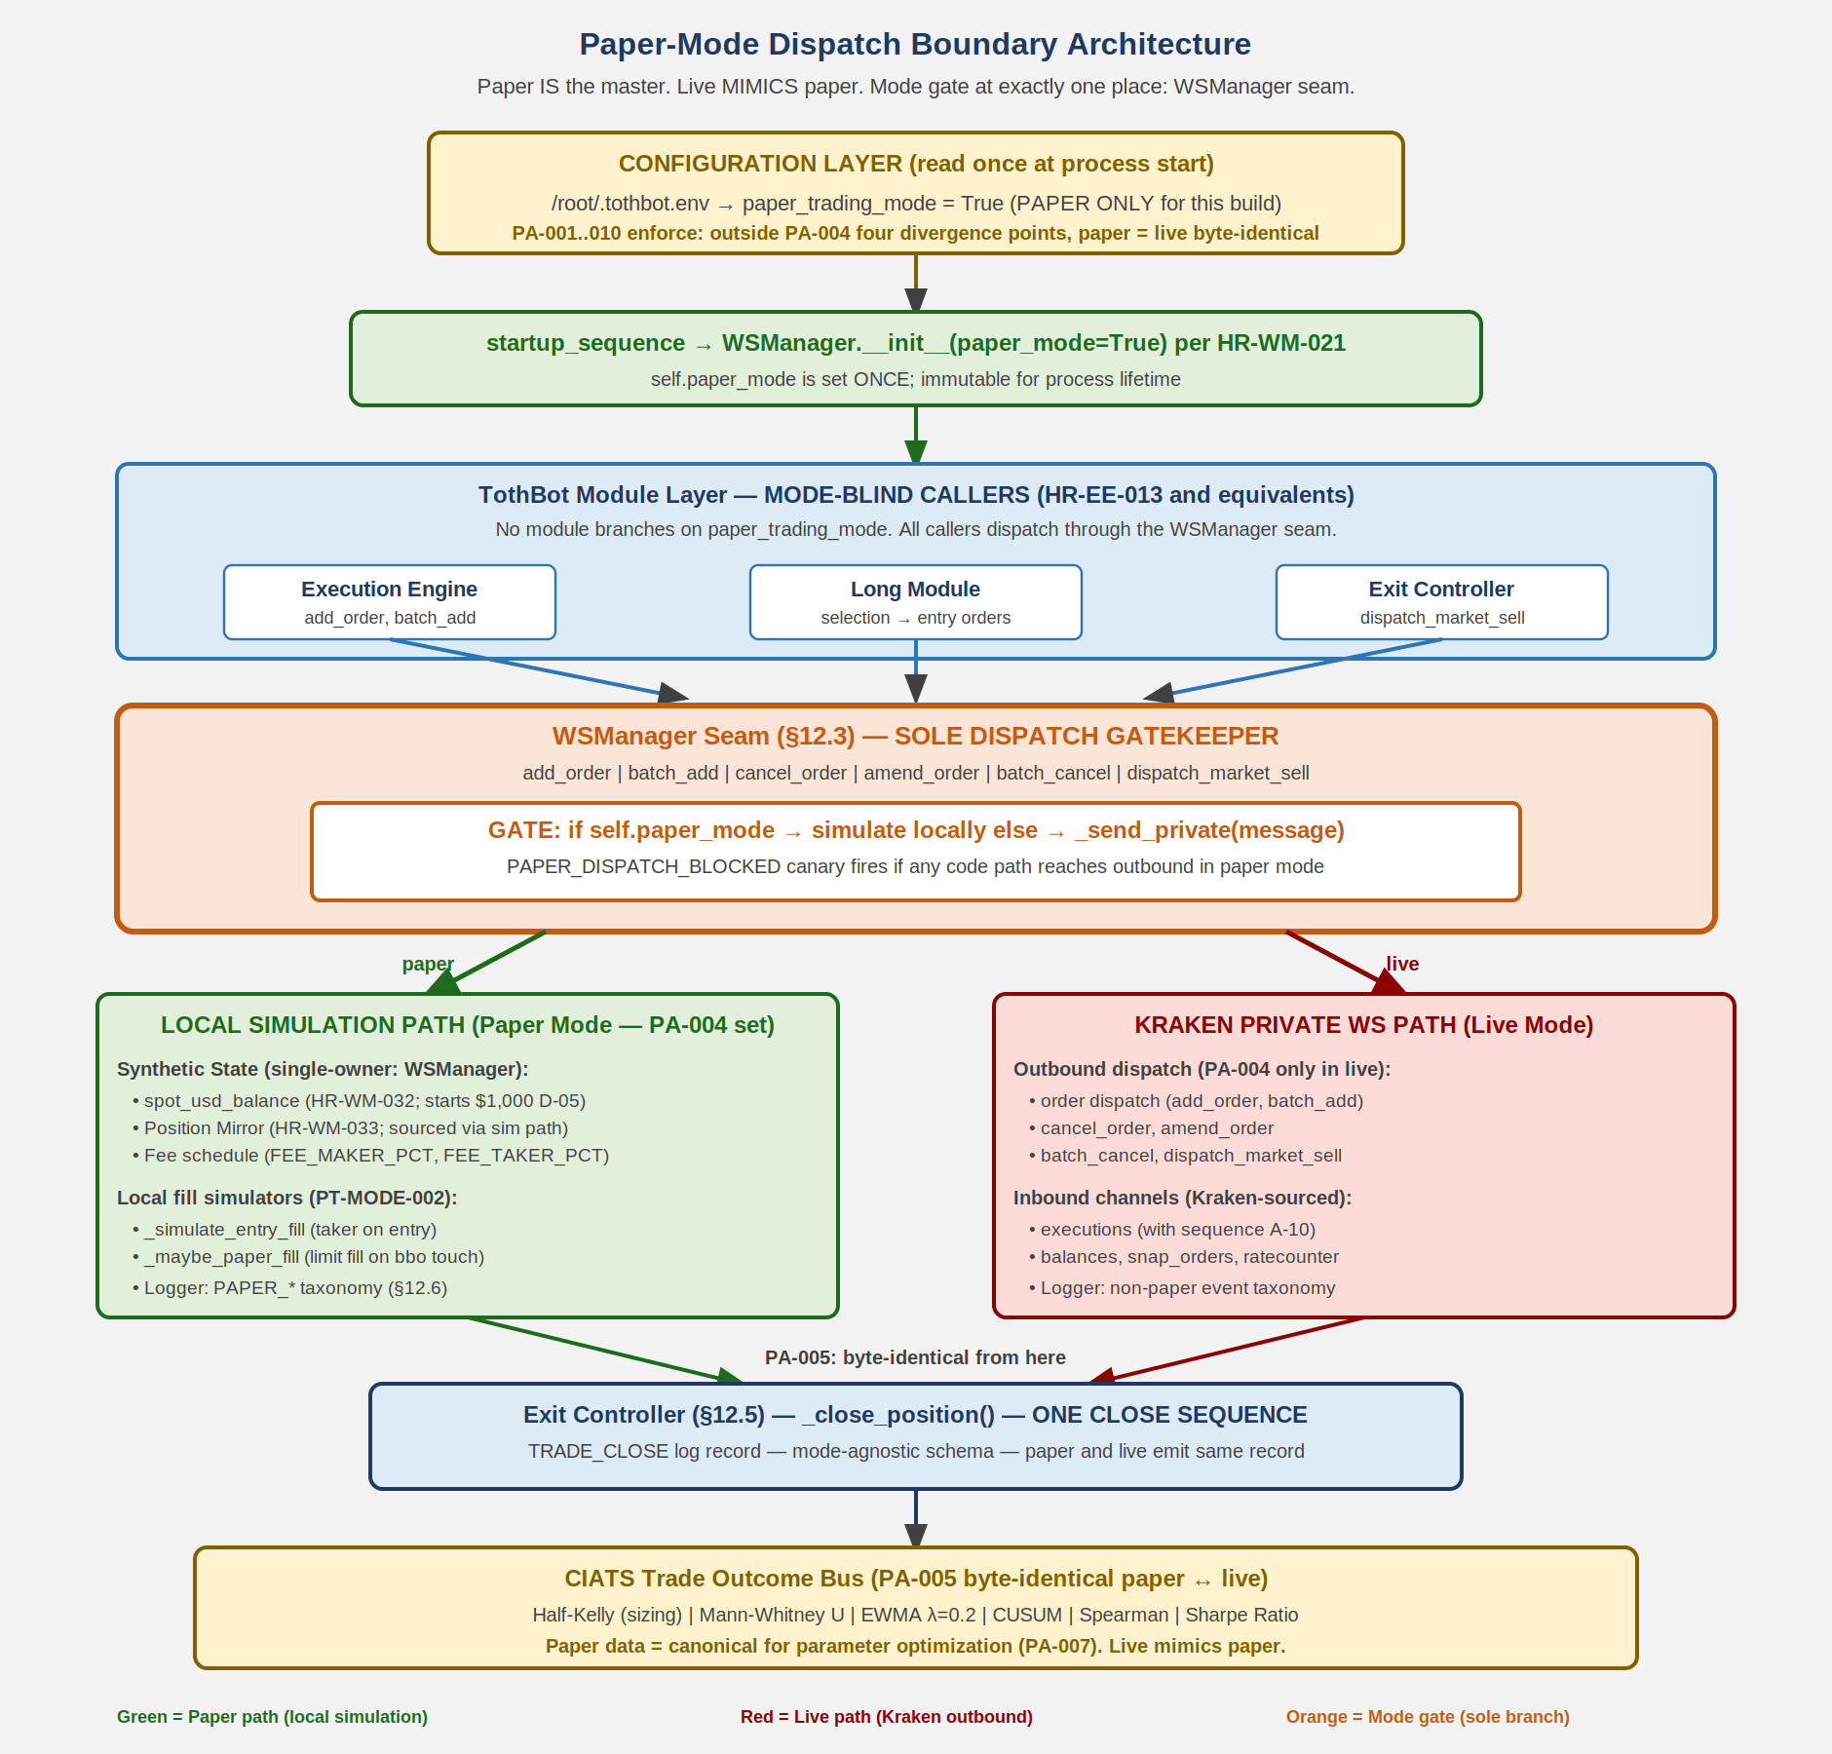
0500000_Image7_Paper_Mode_Dispatch_Boundary.png

12.8 Compliance Mapping to Downstream Specifications

This section is the architectural parent of the following
downstream specifications. Each is amended in Phase 1 Sessions
2-8 (TB00150 through TB00156) per TB00148 NSI §4.

AA=04 EXCHANGE INTERFACE
0411001 Kraken_WS_v2_Specification dv1_11
AR-006, AR-007, AR-008 (entry / TP / emergSL message
formats — live transmission only).
AR-032, AR-033, AR-046, AR-047 (live message construction
details — irrelevant in paper).

AA=05 SYSTEM ARCHITECTURE
0511001 WS_Manager_Specification dv1_5
HR-WM-021 (flag read once at __init__).
HR-WM-022 (private WS NEVER connected in paper).
HR-WM-023 (order methods gate at entry in paper).
HR-WM-024 (paper fill detection in _handle_ticker).
HR-WM-025 (paper does NOT affect public WS, OHLC,
indicators, pipeline, CIATS data flow).
HR-WM-026 (paper-to-live parity binding to D-06).
HR-WM-032 (synthetic ledger update on simulated fills).
HR-WM-033 (paper exits route through Exit Controller).
0511004 Exit_Controller_Specification dv1_3
§6A EC-PAPER (paper-mode exit behavior specification).
HR-EC-013 (paper-live close-path parity).
HR-EC-014 (Exit Controller is sole SC state updater
in both modes).

AA=08 TRADING SYSTEM
0811001 Long_Module_Specification dv1_0
Paper-dispatch contract for IOC emergency sells (delegates
to WSManager seam; never calls _send_private directly).
0811003 Exit_Controller_Specification (Phase 6 placeholder)
Aligned with 0511004 paper-mode behavior.

AA=10 CODING SPECIFICATION
1011002 WS_Manager_Coding_Spec dv1_26
§16A WM-PAPER-LEDGER-001..004; §16A.2 WM-PAPER-EXIT-001..005;
§13.x order method gate implementations.
1011004 Execution_Engine_Coding_Spec NEW dv1_0
Paper-dispatch contract; HR-EE-013 paper-live exact
behavioral parity (no mode-conditional EE branching);
PositionMirror access via WSManager helpers only
(HR-PM-009 compliance). To be authored TB00150.
1011005 Exit_Controller_Coding_Spec dv1_3
§10A EC-PAPER-CODE-001..006 (paper close contract).
1011007 Logger_Coding_Spec dv1_5
Paper event taxonomy extension (TB00154 / Phase 1
Session 6).
1011008 Long_Module_Coding_Spec dv1_0
Paper-dispatch contract for IOC emergency sells (TB00152 /
Phase 1 Session 4).
1011014 Startup_Sequence_Coding_Spec dv1_7
Module wire-up order documenting paper_trading_mode flag
propagation (TB00153 / Phase 1 Session 5).

AA=02 OPERATIONS
0211005 Paper_Trading_Operations_Procedure dv1_3
PT-MODE-001..007 (operational procedure counterpart to
this architectural section).

PHASE 1 CLOSE GATE. All seven AA=10 / AA=05 spec amendments
above plus this 0500000 dv1_22 amendment must commit to
TothBot_V2-Docs master before Phase 2 (code rebuild) may
begin. Phase 2 is blocked until close gate passes.

12.9 Architectural Reasons This Section Exists

Three architectural reasons drove the authoring of this section
as a first-class element of 0500000 (rather than as scattered
rules across downstream specs).

REASON 1 — Defect prevention by construction.
The TB00148 chat 1 audit established that 24 unique defects
were present in the deployed code at fb5de32. Cluster 1
(paper-mode dispatch seam undefined; findings 09, 29, 30)
arose because no single document defined the dispatch
boundary at architectural level. Multiple coding-spec
documents each made local references to paper-mode handling
without a shared parent reference. Defects flowed from this
fragmentation. This section eliminates the fragmentation by
consolidating the architecture into one place.

REASON 2 — Loss prevention takes priority over profit
generation.
Per TB00000 v2_18 §3 PRIMARY MISSION, loss prevention is the
most critical mission function. The dispatch boundary is the
SOLE point at which paper mode protects operator capital.
Any specification gap at this boundary creates a class of
catastrophic-loss defects (paper code dispatching live
orders). Architecturally codifying the boundary at parent-
spec level is the loss-prevention measure with the highest
leverage in the system.

REASON 3 — CIATS data validity.
CIATS performs continuous improvement of TothBot parameters
based on paper-trading data. For CIATS data to be VALID for
live operation, paper and live MUST execute identically
wherever physically possible. Any divergence outside the
PA-004 four points invalidates paper-trading data as a
basis for live decisions. This section enumerates exactly
what may diverge and exactly what must not. Without this
enumeration, the next CIATS-driven parameter change could
rely on contaminated data.

RR-SCOPE-007 NOTE. This section is constraint-additive. It
does NOT narrow D-01 through D-08 LOCKED. Specifically:
D-03 Universe = TOKEN/USD + TOKEN/USDC + TOKEN/USDT remains
in force. The dispatch boundary applies to ALL pairs in
the universe in both modes.
D-08 Top-N cap retired remains in force. No universe cap is
introduced by this section. The dispatch boundary scales
to whatever universe size the liquidity + status filters
admit.
D-05 Paper starting balance $1,000 remains in force.
D-06 Paper-to-live parity ratified remains in force. This
section operationalizes D-06.

RR-SCOPE-009 NOTE. This section retires no constraints. It is
pure addition. No four-question origin investigation is
required.

============================================================
13. Open Items — Require Specification Documents
============================================================

OI-001: Signal generation (SSS) — CLOSED (dv1_15, AR-067).
Three-factor SSS: RSI(14) 50-70, EMA(9)>EMA(21) on 5m, volume > MA(20)x1.0x.
Specify in 0711001 SSS_Signal_Model_Specification (Phase 5).
OI-002: Asset selection universe — CLOSED (dv1_15, AR-070; amended dv1_20).
All Kraken USD/USDC/USDT pairs passing liquidity + status filters. No cap.
BTC/USD always included as market_regime proxy (AR-074).
Specify in 0711003 Asset_Selection_Specification (Phase 5).
OI-003: Exit Controller full specification — CLOSED (dv1_15, AR-071).
EC-L1A-001/002 specified dv1_14. EC-L1A-003 max_hold_candles=24 specified dv1_15.
All Layer 1a triggers complete. Specify in 0811003 Exit_Controller_Specification (Phase 6).
OI-004: Entry limit placement — CLOSED (dv1_15, AR-069).
entry_limit_price = last candle close quantized DOWN to price_increment.
Specify in 0811004 Entry_Limit_Placement_Specification (Phase 6).
OI-005: Selection Controller — CLOSED (dv1_15, AR-072).
All 6 gates specified: SSS PASS, candle body, no position, cooldown,
position size viability, consecutive loss limit.
Specify in 0811002 Selection_Controller_Specification (Phase 6).
OI-006: CIATS specification — all statistical thresholds and PDCA rules.
Mann-Whitney alpha=0.01, Spearman |rho|>0.3, CUSUM k/h, PDCA 50-trade interval.
Specify in 0211001 CIATS_Specification (Phase 3).
OI-007: AA=04 Exchange Interface formal document — CLOSED (Phase 2 complete).
0400000 and 0410000 committed to GitHub 2026-04-04.
OI-008: All AA=10 coding specs. WD documents active: 1011001 dv1_4, 1011002 dv1_10,
1011005 dv1_0, 1011007 dv1_0, 1011010 dv1_3, 1011011 dv1_1, 1011012 dv1_2,
1011013 dv1_2, 1011014 dv1_1. Current as of dv1_16. Phase 8 completes all.

============================================================
14. Revision History
============================================================

dv1_23 05-04-2026 EMBEDDED ASSET ARCHITECTURE MIGRATION
per 0311001 v1_4 §15.9 + Diagram 7 ADD
+ PNG-CANONICAL CONVERSION
(Type=Image per §15.5).

Closes ERROR-TB00149-02 SVG-DROP-IN-
BINARY-GENERATION at the source-of-
truth layer for 0500000.

MID-SESSION CORRECTION (TB00150):
Bill identified during dv1_23 v1_0
delivery review that SVG files cannot
be uploaded to the Claude.ai project
knowledge folder (platform limitation
logged as KPL-004 in 0311006 dv1_1).
Per FP/DP analysis: PNG canonical
with §15.5 Type=Image satisfies the
upload constraint without governance
amendment. The 7 PNGs already
rasterized from the SVGs via cairosvg
(300 DPI, 1840-1880 px width) are
the canonical asset files. Source
SVG files are NOT in the controlled
namespace; they are preserved in
git history of dv1_22 (containing
the original inline SVG XML) for
future re-rasterization or editing
if needed.

WORK PERFORMED:

(1) ASSET EXTRACTION + RASTERIZATION
(per §15.9 STEP 1). Six inline
`<svg>` XML embeds in dv1_22 .txt
source extracted byte-for-byte
and rasterized to PNG via cairosvg
(2.9.0, output_width 1840 px,
300 DPI). PNG files placed in the
parent folder per §15.5 canonical
naming with Type=Image:

0500000_Image1_Kraken_API_Connection_Architecture.png
0500000_Image2_Trading_Pipeline.png
0500000_Image3_Exit_Architecture.png
0500000_Image4_Regime_Taxonomy.png
0500000_Image5_CIATS_Architecture.png
0500000_Image6_Complete_System.png

Asset extraction count: 6.

(2) DIAGRAM 7 ADD (Bill TB00150
directive). NEW asset created for
Section 12 (Paper-Mode Dispatch
Boundary Architecture) which
previously had only a text-mode
ASCII diagram in §12.7. Authored
as SVG, rasterized to PNG (1880 px
width, 300 DPI). Canonical asset
file per §15.5:

0500000_Image7_Paper_Mode_Dispatch_Boundary.png

Visual style matches Diagrams 1-6
(Arial, color palette consistent).
Encodes the dispatch boundary at
architectural level: configuration
layer -> startup -> mode-blind
callers -> WSManager seam (sole
gate) -> two paths (paper local
simulation / live Kraken WS) ->
rejoin at Exit Controller -> CIATS
Trade Outcome Bus byte-identical
per PA-005.

(3) REFERENCE SUBSTITUTION (per §15.9
STEP 2). Inline `<svg>` XML section
at end of dv1_22 .txt removed. Seven
canonical `[Asset file: ...]`
references inserted in body at
insertion points where rendered
assets shall appear in derived
formats:

Diagram 1 — end of Section 2
(Kraken API Connection)
Diagram 2 — end of Section 3
(Trading Pipeline)
Diagram 3 — end of Section 4
(Exit Architecture)
Diagram 4 — end of Section 5
(Regime Taxonomy)
Diagram 5 — end of Section 6
(CIATS Architecture)
Diagram 6 — end of Section 7
(Complete System)
Diagram 7 — end of Section 12.7
(Paper-Mode Dispatch
Boundary; before
§12.8 Compliance
Mapping)

Reference substitution count: 7
(6 migration + 1 new).

(4) BINARY REGENERATION (per §15.9
STEP 3 + §15.8 RC-1..6). dv1_23
.docx and dv1_23 .pdf regenerated
from migrated .txt source +
7 .svg asset files via the §15.8
rendering pipeline:
.svg -> PNG raster (cairosvg,
300 DPI, output_width 1840-1880px)
-> embedded in .docx body at
corresponding [Asset file: ...]
reference position via docx-js
ImageRun.
.pdf produced via LibreOffice
export from .docx (preserves
embedded images).

(5) END-OF-DOCUMENT MARKER added per
standard convention (was missing
in dv1_22 body).

(6) HEADER UPDATED. DocVersion
dv1_22 -> dv1_23. DocTime updated
to current.

VALIDATION (per TB00000 v2_19 §4.1.4
six-step pre-delivery procedure):

STEP 1 DR-004 STRUCTURAL:
DR-004.1 file-type probe PASS
DR-004.2 container probe PASS
DR-004.3 .docx settings.xml PASS
STEP 2 DR-007 CONTENT:
DR-007.1 asset-ref parity (7=7) PASS
DR-007.2 section-heading parity PASS
DR-007.3 marker-class parity PASS
DR-007.4 word-count parity PASS
DR-007.5 stub scan (zero new) PASS
DR-007.6 revision-history PASS
STEP 3 OP-003 prohibited-string PASS
STEP 4 DR-005 canonical naming PASS
STEP 5 DR-003 batch assembly PASS
STEP 6 DR-006 single-turn delivery
PENDING (delivered this turn)

§15.7 ASSET VALIDATION RULES:
V-020 DCN prefix PASS
V-021 .png ext PASS (all 7)
V-022 same folder PASS
V-023 every ref has file PASS (7=7)
V-024 dense N seq PASS (1..7)
V-025 canonical naming PASS
(Type=Image per §15.5)
V-026 no orphan files PASS
V-027 no orphan refs PASS
V-028 no inline embeds PASS
V-029 ShortTitle chars PASS
V-030 max 200 chars PASS

INFORMATION-LOSS VECTORS COVERED
THIS INCREMENT:
A1 asset drop ELIMINATED
(RC-1 + DR-007.1 in place).
A8 stub substitution ELIMINATED
(CI-008 + RC-3 in place).
E1/E2 ref-asset desync ELIMINATED
(V-023 + V-027).

NO CONTENT CHANGE in the information-
content sense (per §15.9). The same
6 dv1_22 diagrams + 1 new Section 12
diagram are present. Storage is
compliant; rendering is faithful.

Bill override: dv1_22 -> dv1_23 is
enacted under Bill's standing
document-control override per
TB00150 explicit directive: "Use
current information and correct
formatting to update the documents
CORRECTLY AND CORRECTLY FORMATTED.
Create any new diagrams necessary
to update ALL diagrams to the
current information."

This dv1_23 is the FIRST 0500000
version to be fully §15-compliant
since §15 was authored in 0311001
v1_3 (04-23-2026). It is also the
FIRST 0500000 version since dv1_18
with all diagrams correctly embedded
in the rendered binary triplet.

dv1_22 05-04-2026 NEW SECTION 12: Paper-Mode Dispatch Boundary
Architecture. First-class architectural
element codifying the PA-004 dispatch seam at
the system level. Authored TB00149 as
Phase 1 Session 1 of the Bill OPTION B
Clean-Slate Rebuild authorized in TB00148
(2026-05-04). Section sub-organization:
12.0 Architectural status (first-class
element; paper is master).
12.1 PA-004 four permitted divergence
points (private WS, order dispatch,
capital ledger, Position Mirror
sourcing).
12.2 paper_trading_mode flag definition
and lifecycle (read once at WSManager
__init__, never mutated, never
cached elsewhere).
12.3 The dispatch seam — WSManager as sole
gatekeeper. Six gated methods
enumerated. No direct private-WS
access by any other module.
12.4 Synthetic capital ledger — single-
owner architecture (WSManager owns
all writes; eliminates multi-writer
defect class identified TB00148
finding 15).
12.5 Paper exit routing through Exit
Controller (mandatory single close
sequence; PA-005 byte-identical CIATS
data flow).
12.6 Paper telemetry event taxonomy
(PAPER_LEDGER_UPDATED,
PAPER_FILL_SIMULATED,
PAPER_DISPATCH_BLOCKED defensive
event, etc.).
12.7 Architectural diagram (text-mode) of
dispatch boundary with simulation
and live transmission paths
rejoining at Exit Controller.
12.8 Compliance mapping to all downstream
specs (AA=04, AA=05, AA=08, AA=10,
AA=02). Phase 1 close gate
enumerated.
12.9 Architectural reasons (defect
prevention by construction; loss
prevention priority per TB00000 §3;
CIATS data validity).
Existing Section 12 (Open Items) renumbered
to Section 13. Existing Section 13
(Revision History) renumbered to Section
14. No content changes to renumbered
sections. No diagram changes (no new SVG
embeds; new section uses text-mode diagram
only). All ARs unchanged. All locked
decisions D-01..D-08 unchanged.
SCOPE GUARDRAIL COMPLIANCE.
PA-008 pre-emit scan: PASS. Section
encodes paper as master and live as
mimic at every assertion. No wrong-
direction language detected.
RR-SCOPE-007 pre-emit scan: PASS. Section
is constraint-additive. D-01..D-08 LOCKED
decisions explicitly preserved
(12.9 RR-SCOPE-007 NOTE).
RR-SCOPE-009 pre-emit scan: PASS. Section
retires no constraints. No four-question
origin investigation required.
OP-003 pre-emit scan: PASS. The §4.2
prohibited string is absent from new
section content.
FP/DP basis: TB00148 chat 1 deep audit (24
findings, 10 of 13 .py files audited).
CLUSTER 1 defects (findings 09, 29, 30 —
paper-mode dispatch seam undefined) traced
to specification gap at architectural
level. New Section 12 closes the gap as
first-class architectural element.
Bill override: TB00149 continues the
standing document control override scope
established TB00115 (v2_10 -> v2_11),
TB00116 (v2_11 -> v2_12), TB00120
(v2_12 -> v2_13), TB00130 (dv1_19 -> dv1_20),
and TB00134 (dv1_20 -> dv1_21). Direct
increment dv1_21 -> dv1_22; no rv state.
VP-004 dv -> dv lifecycle transition.

dv1_21 04-24-2026 Text-only. No diagram changes. FINDING-P5-001
remediation per TB00134 Thread A (HIGH severity).
§9 Complete CIATS Parameter Registry: removed
stale `monitored_universe_n: 50 pairs` line that
conflicted with D-08 LOCKED (Top-N cap retired).
Added retirement footnote at end of §9 registry
block with cross-reference to §8 AR-070 (already
amended in dv1_20), 0711003 dv1_3 §8 (asset
selection retirement statement), 0611004 dv1_1
§3 (safety parameter framework retirement
statement), and TB00128 D-08 source decision.
Footnote makes §9 self-documenting so a code
author reading §9 alone understands the
retirement without cross-document chase.
D-08 cascade now COMPLETE across the entire
0* spec corpus. Closes FINDING-P5-001 identified
by TB00133 Phase 5 reconciliation (1010000
dv1_15 §10.4).
No other content changes. AR-070 unchanged
(already amended dv1_20). All other ARs
unchanged. Outer Claude Source revision history
updated with matching dv1_21 entry.
FP/DP basis: TB00134 explicit chat analysis
confirmed HIGH severity + low remediation cost
+ master-registry source-of-truth defect +
immediately precedes Claude Code authoring +
loss-prevention mission alignment per TB00000
§3 Primary Mission. Deferral had no FP/DP-
defensible upside.
Bill override: TB00134 continues the standing
document control override scope established in
TB00115 (v2_10 → v2_11), TB00116 (v2_11 → v2_12),
TB00120 (v2_12 → v2_13), and TB00130 (dv1_19 →
dv1_20). Direct increment dv1_20 → dv1_21; no
rv state. VP-004 dv → dv lifecycle transition.

dv1_20 04-24-2026 Text-only. No diagram changes. AR-070 Asset Selection
Universe scope amended per TB00130 Ratified Decision
D-03 (04-24-2026). Three changes to AR-070:
(1) Quote currency scope: "USD or USDC" amended to
"USD, USDC, or USDT".
(2) Top-N cap retired ("top 50 by 24h USD volume"
line removed). Universe is now every pair that
passes conditions (1), (2), and (3) — liquidity
and status filters only.
(3) BTC/USD inclusion clarified as market_regime
proxy commitment (see AR-074).
OI-002 summary line updated to match new AR-070.
No diagrams changed. No other ARs changed. AR-074
unchanged (USD back in universe so BTC/USD proxy
commitment remains valid).
FP/DP basis: 3 sequential searches, 18 sources
(TB00130 session) confirming no basis to exclude USD.
Supersedes: TB00128 Ratified Decision D-03
(USDC+USDT only); TB00001 OI-002 original text
(USDT/USDC only); dv1_15 AR-070 (USD+USDC + top 50
cap).
Inner DC header brought current from dv1_18 to
dv1_20 (dv1_19 was Claude Source outer-header-only
update; no inner content changes occurred at dv1_19).
Bill override: TB00130 continues the standing document
control override scope established in TB00115 /
TB00116 / TB00120. Direct increment dv1_19 → dv1_20;
no rv state.

dv1_19 04-11-2026 Claude Source outer header only (no inner document
content or diagram changes). DocTitle corrected:
was "TothBot_Kraken_System_Architecture_Overview",
corrected to "System_Architecture_Overview" per
DCN 0500000 title assignment. DocPath corrected
(was pointing to .docx, now points to Claude Source
.txt). Claude Source outer Revision History section
added (was missing). "END OF CLAUDE SOURCE FILE"
corrected to "END OF DOCUMENT" per document
standard. Corrective action from TB00074 audit.
(This entry backfilled in dv1_20 — was previously
only in the outer Claude Source revision history.)

dv1_18 04-04-2026 Header-only update. No content or diagram changes.
Parent chain (0400000 Exchange_Interface) committed to GitHub.
0500000 parent chain now complete. DocTime typo corrected
(UTC UTC -> UTC). OI-007 marked CLOSED.

dv1_17 04-04-2026 DocPath correction: TothBot-V2-Docs -> TothBot_V2-Docs
(underscore before V2). Version incremented per Rule 4.
All document dates updated.

dv1_16 03-26-2026 Text-only. No diagram changes. 1 new AR (AR-076).
AR-076: RSI(14) smoothing formula correction. AR-068 stated
"EMA-smoothed" — ambiguous, points to wrong algorithm. Correct
formula is Wilder's SMMA (RMA), α=1/14 (not standard EMA α=2/15).
Incremental: avg_gain=(prev×13+current)/14, avg_loss same.
EMA(9) and EMA(21) in SSS Gate 2 correctly use standard EMA
(α=2/10 and α=2/22). Only RSI uses Wilder's SMMA. Formula
distinction critical — 5-8% variance between the two algorithms
would systematically mis-fire SSS SC-SSS-1 (RSI 50-70 gate).
Validated 10+ sources, TB00021 FP/DP validation pass.
Architecture status: fully validated. Architecture complete.
FP/DP validation finding rate: 0-2 predicted → 1 actual (AR-076).

dv1_15 03-26-2026 Complete architecture — OI-001 through OI-005 closed.
Text-only. No diagram changes. 9 new ARs (AR-067 through AR-075).
AR-067: SSS Signal Engine (3-factor: RSI+EMA+Volume). OI-001 CLOSED.
AR-068: SSS indicator seeding at startup (extends AR-044).
AR-069: Entry limit price = candle close quantized down. OI-004 CLOSED.
AR-070: Asset universe (top 50 USD/USDC + BTC/USD always). OI-002 CLOSED.
AR-071: max_hold_candles = 24 (2 hours). OI-003 CLOSED.
AR-072: Selection Controller 6 gates fully specified. OI-005 CLOSED.
AR-073: SC state management (cooldown + consecutive loss dicts).
AR-074: BTC/USD always in universe (market_regime proxy commitment).
AR-075: SSS indicators in per-symbol state dict (cache extension).
CIATS Parameter Registry: 11 new parameters added.
All OI-001 through OI-005 now CLOSED. Architecture complete.
FP/DP analysis: 3 sequential searches, 30 sources (TB00020).
dv1_0 03-23-2026 Initial document.
dv1_1 03-23-2026 Added all six system flow diagrams.
dv1_2 03-24-2026 Six changes: C-1 emergSL terminology, C-2 rate limits, C-3 OHLC stall,
A-1 ratecounter, A-2 req_id, A-3 latency logging.
dv1_3 03-24-2026 Rebuilt as correct .docx with all six diagrams embedded.
dv1_4 03-24-2026 Seven changes: C-1 MPP, A-1 AR-001 expansion, A-2 cl_ord_id,
A-3 snap_orders, A-4 stp_type, A-5 reconnect distinction, A-6 OTO rejected.
dv1_5 03-24-2026 Eleven changes: FLAG1 ohlc(60), FLAG2 REST GetOHLCData, I-1 Gate 3,
I-2 cache, I-3 Position Mirror O(1), I-4 Parameter Store snapshot,
I-5 Logger async queue, I-6 cancel timeout, I-7 ticker drawdown,
I-8 WS dispatch table, I-9 ATR incremental.
dv1_6 03-24-2026 Six changes from 10-search FP/DP validation + Operations/CIATS analysis:
(1) amend_order primary, edit_order deprecated, batch_cancel, L3 URL corrected.
(2) Rate table updated.
(3) A-7 WS ping, A-8 zombie detection, A-9 balances seq gap.
(4) Per-pair instrument status check, AR-018/019/020.
(5) GetOHLCData response[-1] exclusion — CRITICAL correctness requirement.
(6) Auth verification, CIATS statistical thresholds.
dv1_9 03-25-2026 Six new architectural requirements and five improvements from
second 10-search FP/DP organism validation session (TB00010):
A-15 (GAP-A CRITICAL) order_status:true mandatory in executions
subscription — without it amended/restated silently dropped, breaking
A-12/A-13. A-16 (GAP-B) OHLC interval_begin replaces deprecated
timestamp. A-17 (GAP-C/D) instrument price_increment replaces
tick_size; qty_min/cost_min mandatory Gate 8 validation. A-18 (GAP-E)
websockets max_size=10MB + open_timeout=10 mandatory. A-19 (IMP-11)
maxratecount from executions ACK is operative rate threshold. IMP-13
subscription warnings[] parsed/logged. IMP-14 amend_id logged. IMP-15
QueryOrdersInfo for targeted reconciliation. AR-026 through AR-031 added.
0411001 updated to dv1_2. 1011002 updated to dv1_2.

dv1_10 03-25-2026 Seven new findings from third 10-search FP/DP organism validation
(TB00011): A-20 stp_type FORMAT CORRECTION. A-21 deadline parameter.
A-22 aiohttp ClientTimeout + TCPConnector. A-23 Ticker event_trigger:bbo.
A-24 Regime Engine GetOHLCData stagger. AR-037 IP-whitelisting.
IMP-16 through IMP-19. AR-032 through AR-037. 0411001 dv1_3.
1011002 dv1_3. 1011012 dv1_1. 1011001 dv1_1.

dv1_12 03-25-2026 Ten text-only changes from fourth (TB00012), fifth (TB00013), and
sixth (TB00014) 10-search FP/DP validation sessions. No diagram changes.
AR-038: Kraken Status API startup maintenance check. Section 2 REST
table: Status API endpoint added. AR-039: per-pair status check
expanded — cancel_only and maintenance added as NO-ENTRY states.
AR-040: Exit Controller pair status adaptation — IOC limit on limit_only,
HOLD on cancel_only/maintenance. AR-041: cancel_order/batch_cancel
behavioral distinction — cancel_order for MAE exit (individual ACK),
batch_cancel for Full Halt (count + rate bypass). AR-042: zombie
detection heartbeat exclusion — heartbeats MUST NOT reset
last_real_data_time. AR-043: max_concurrent via asyncio.BoundedSemaphore.
Section 9 CIATS Parameter Registry: Half-Kelly normalization note.
Section 11.1: per-pair status check updated with full list.
0411001 updated to dv1_6. 1011002 updated to dv1_6.
1011010 updated to dv1_2. 1011011 dv1_0 new.
1011012 updated to dv1_2. 1001001 updated to dv1_3.

dv1_13 03-26-2026 Fourteen text-only changes from seventh (TB00015), eighth (TB00016),
and ninth (TB00017) 10-search FP/DP validation sessions. No diagram
changes. AR-044: startup warm-up via REST GetOHLCData — ATR(14) seed
(interval=5), EMA(20/50) seed (interval=60), regime (interval=1440).
WARM_UP/READY pair state machine. asyncio.gather across pairs, 1.1s
intra-pair stagger. AR-045: OHLC candle-close detection via
interval_begin change (not wall clock). last_interval_begin tracking
per symbol. AR-046: emergSL triggers.reference="last" explicit in all
batch_add calls — never rely on defaults for crash protection params.
AR-047: ALL rounding via Decimal.quantize() — NEVER math.floor/ceil.
Float arithmetic causes silent precision errors that corrupt order
prices. All Kraken API values: Decimal(str()) immediately on receipt.
AR-048: Exit Controller MAE uses bid price (not last) for long
positions. bid = realizable exit. drawdown formula uses bid.
AR-049: Formal 10-step startup sequence. No pipeline until READY.
Full spec in 1011014 Startup_Sequence_Coding_Spec.
AR-050: Balances channel — spot/main wallet only. Top-level balance
includes earn/staking (not tradeable). Filter wallets array.
AR-051: Portfolio for sizing = cash only (no MTM of open positions).
AR-052: Drawdown baseline set ONCE at startup. NEVER reset on
reconnect. Current portfolio = cash + bid*qty of open positions.
Session pause 5%, full halt 10%. Does not auto-close positions.
AR-053: Pending Order Registry — self-tracks USD committed to
outstanding entry orders. Gate 7 checks available_USD = balance
minus pending commitments. Prevents overcommitment on simultaneous
pipeline activations. AR-047 amendment: original AR-047 used
math.floor/ceil — amended to Decimal.quantize() (BP-DEC-001 through
BP-DEC-008 in 1011001). AR-054: Entry order partial fill + expiry or
cancel creates unprotected open position. cum_qty > 0 on expired or
canceled exec_type: recalculate TP/emergSL from avg_price, dispatch
batch_add, enter Position Mirror. If below qty_min/cost_min: market
sell immediately. AR-055: Dead Man's Switch (cancel_all_orders_after)
EXPLICITLY PROHIBITED. Cancels emergSL orders — destroys crash
protection. Hard rule: code review must reject any PR with this call.
AR-056: Mid-session WS reconnect sequence distinct from startup.
Never reset portfolio_baseline_USD or drawdown on reconnect. Reconcile
Position Mirror vs snap_orders. Detect positions closed during gap.
Fire CIATS Trade Outcome Bus for gap-closed positions. 15-minute
threshold for cache staleness. Full spec in 1011014 Section 2.
1011001 updated to dv1_4. 1011002 updated to dv1_9.
1011011 updated to dv1_1. 1011014 updated to dv1_1.
0411001 updated to dv1_8.

dv1_14 03-26-2026 Ten text-only changes from tenth 10-search FP/DP validation
session (TB00019 Pass 2). No diagram changes.
AR-057: amended exec_type added to dispatch table. TothBot V1
never amends own orders. Any amended event = CRITICAL alert.
AR-058: max_queue=None on all websockets connections. Default
max_queue=16 risks silent drops on burst market data events.
AR-059: ping_interval=None — disable library ping. Use only
application-level JSON ping (A-7) as sole keepalive mechanism.
AR-060: All WS connections use websockets.asyncio.client.connect().
Legacy websockets.connect() deprecated in v14+, will be removed.
AR-061: Capture last_qty and last_price from executions trade
events for fill-level analytics and CIATS execution quality.
AR-062: Exit Controller Layer 1a — EC-L1A-001 (HTF EMA reversal),
EC-L1A-002 (daily regime downgrade), EC-L1A-003 (time TBD).
AR-063: Logger uses queue.Queue (stdlib) + QueueHandler +
QueueListener thread. NOT asyncio.Queue. Non-blocking hot path.
AR-064: Log connection_id from Kraken status channel on every
new WS connection for support and debug capability.
AR-065: Kelly inputs W and R MUST use net P/L from Trade Outcome
Bus. NOT gross price change. NOT theoretical targets.
AR-066: TP partial fill — amend emergSL qty via amend_order
(saves 7 rate counter units vs cancel+resubmit, preserves queue
position). Update Position Mirror. CIATS fires once on full close.
New WD documents: 1011005 Exit_Controller_Coding_Spec dv1_0,
1011007 Logger_Coding_Spec dv1_0.
Updated: 0411001 dv1_9, 1011002 dv1_10, 1011010 dv1_3.

dv1_8 03-25-2026 Eight changes from 10-search FP/DP organism validation session
(TB00009 Part 2): A-11 executions cancel_reason deprecated — use
reason field. A-12 complete exec_type enum handling required. A-13
restated exec_type handling — engine amend, not fill/cancel. A-14
PL-014 RESOLVED — Spot REST auth confirmed unchanged (Oct 2025 change
was Futures REST only). IMP-06 aiohttp mandatory for all REST calls.
IMP-07 asyncio TaskManager pattern for 24/7 memory safety. IMP-08
systemd WatchdogSec=120 with 30s ping loop. New AR-022 through AR-025.
New WD document 1011013 VPS_Deployment_Coding_Spec dv1_0 created.
0411001 updated to dv1_1. 1011002 updated to dv1_1.
Diagrams 1 and 6 updated.

dv1_7 03-25-2026 One change from 10-search FP/DP organism validation session (TB00009):
A-10: Executions channel sequence gap detection. Every executions
message carries a sequence integer. WS Manager tracks it; any gap
triggers REST GetOpenOrders reconciliation immediately. Missed
execution events leave Position Mirror in stale state — highest-
severity gap class. AR-021 added. GetOpenOrders promoted from
restart-only fallback to active gap recovery channel. Diagrams 1
and 6 updated with A-10.

============================================================
END OF DOCUMENT
============================================================

