TOTHBOT — KRAKEN SYSTEM ARCHITECTURE OVERVIEW
The Complete System — All Architectural Decisions + All Flow Diagrams

1. System Identity and Mission

1.1 What TothBot Is

TothBot is an automated cryptocurrency spot trading system on Kraken exchange. It runs
24/7/365 on a Hetzner VPS, processes 5-minute OHLC candle close events as its system
clock, and executes long-only trades using a momentum-based signal engine.

TothBot is not an external system connected to Kraken — it IS Kraken's event processor.
Every action is a response to a Kraken push event. No timers. No polling. Idle and silent
until Kraken speaks.

1.2 The One Organism Principle

Three functional zones, one organism:
Kraken: generates events, executes orders, holds resting TP limit orders and
off-book emergency SL stop orders on matching engine
TothBot: processes Kraken events, executes trading strategy, manages positions
CIATS: learns from event records, continuously improves processing rules

PRIMARY MISSION: Maximize profit. Minimize loss. With an emphasis on minimizing loss.
Loss prevention takes priority over profit generation. Everything else is secondary.

1.3 Operating Environment

Exchange: Kraken Spot (Long Module — Short deferred)
Language: Python 3.12.3
VPS: Hetzner CPX22 — 87.99.141.44 — Ashburn VA
(Kraken Spot servers: AWS us-west-2 Oregon)
★ Evaluate Hillsboro OR [dv1_6 IMP-01 — adjacent to Kraken AWS]
System Clock: Kraken OHLC 5-minute candle close event (WS v2 push)
Fee Baseline: Maker 0.16% / Taker 0.26% (CIATS monitors actuals)
Operation: 24/7/365 — CIATS may add stand-down periods via PDCA if data supports
Starting Portfolio: $1,000 Long Module
Sacred constraint: Net 1:1.5 R:R — HARDCODED — the only number not owned by CIATS

2. Kraken API Connection Architecture
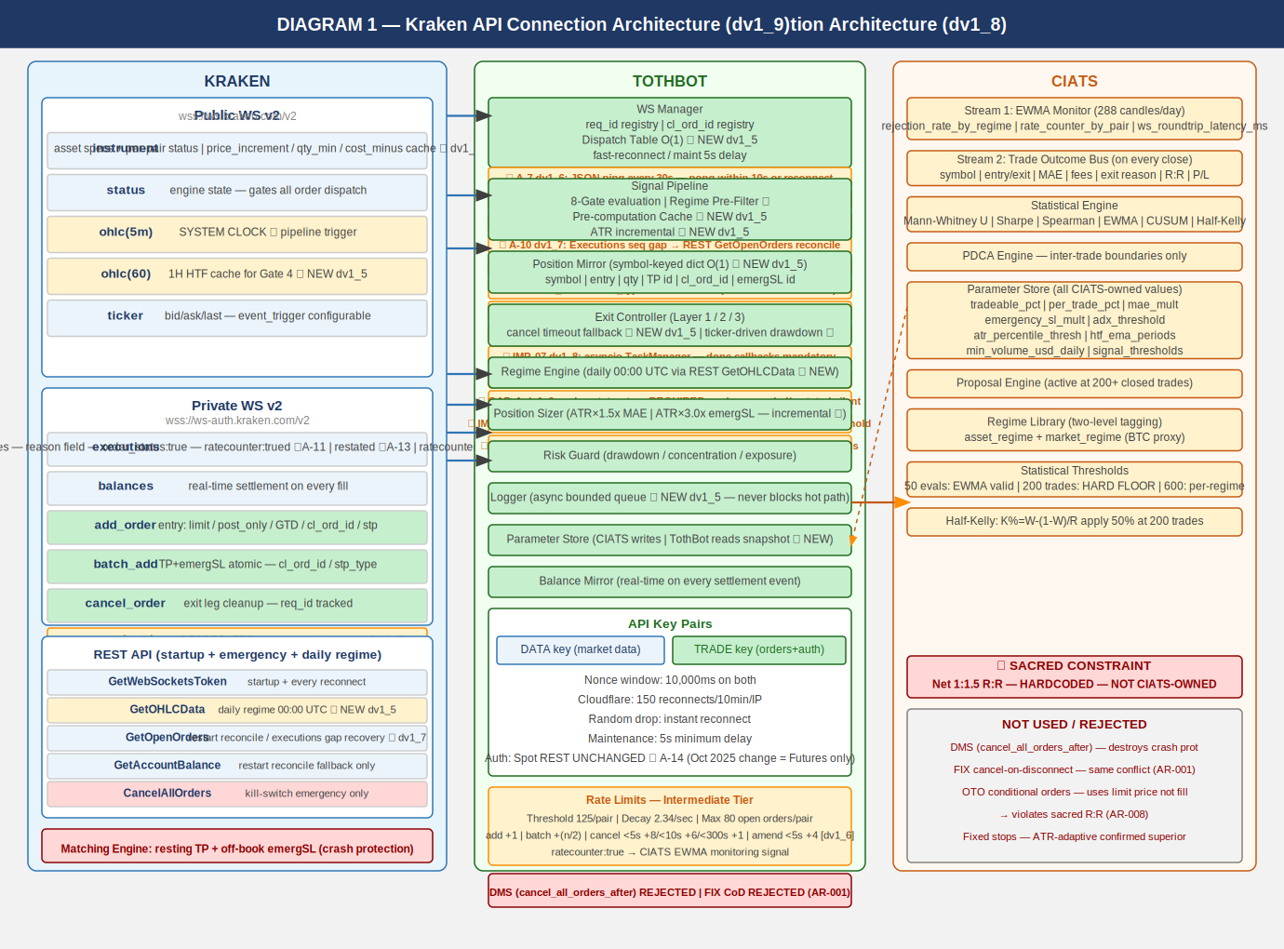

All connection points verified across 3 independent analysis passes (15 sources) plus
2 deep validation sessions (144+ sources total) plus 10-search FP/DP Kraken validation
[dv1_6] (126 sources).

2.1 Key Connection Points

Public WS v2:
instrument — asset specs + per-pair status cache ★ dv1_6
price_increment / qty_min / cost_min ★ GAP-C/D dv1_9
status — global engine state (online/post_only/cancel_only/maintenance)
ohlc(5m) — SYSTEM CLOCK (pipeline trigger, fires on trade events)
ohlc(60) — 1H HTF cache for Gate 4 ★ NEW dv1_5
ticker — price data, event_trigger:bbo (pairs with open positions) or
event_trigger:trades (pairs without). WS Manager manages per-pair.

Private WS v2 inbound:
executions — fills/expirations/SL-TP triggers, ratecounter:true (A-1),
snap_orders:true, snap_trades:true, order_status:true on reconnect (A-3),
sequence gap detection ★ A-10 dv1_7
CRITICAL ★ GAP-A dv1_9: order_status:true MANDATORY — without it amended
and restated exec_types are silently dropped, breaking A-12 and A-13
balances — real-time settlement, sequence gap detection ★ A-9 dv1_6

Private WS v2 outbound:
add_order — entry: limit/post_only/GTD/cl_ord_id/stp_type:cancel_newest/deadline:now+5s
amend_order — PRIMARY amendment method (edit_order DEPRECATED ★ dv1_6)
batch_add — SL+TP atomic on fill. cl_ord_id/stp_type:cancel_newest/deadline:now+5s
cancel_order — exit leg cleanup, req_id tracked
batch_cancel — Full Halt multi-order cancel ★ dv1_6
All messages carry req_id (A-2), cl_ord_id (A-2), stp_type:cancel_newest (A-4) [WS v2 underscore]

REST:
GetWebSocketsToken — startup/reconnect
GetOHLCData — daily regime computation 00:00 UTC ★ NEW dv1_5
CRITICAL: exclude response[-1] always ★ dv1_6
GetOpenOrders — restart reconcile fallback / executions gap recovery ★ dv1_7
GetAccountBalance — restart reconcile fallback / balances gap recovery ★ dv1_6
CancelAllOrders — kill switch emergency only
Status API — startup proactive maintenance check (AR-038 dv1_12)
GET https://status.kraken.com/api/v2/
scheduled-maintenances/upcoming.json
No authentication. Informational only. Does not block startup.

Matching Engine:
Resting TP limit orders and off-book emergency SL stop orders survive any TothBot
failure independently — crash protection always active

EVALUATED AND REJECTED:
cancel_all_orders_after (WS v2 DMS) — destroys crash protection (AR-001)
FIX API cancel-on-disconnect — same architectural conflict (AR-001)
OTO conditional orders — uses limit price not fill price, violates R:R (AR-008)

2.2 Four Kraken Engine States

online — All orders. Signal pipeline runs normally.
post_only — TothBot limit+post_only entries ARE valid. Trading continues.
cancel_only — No new entries. Exit Controller can cancel. Resting orders active.
maintenance — No orders, no cancels. Resting TP and emergSL active on engine.

2.3 API Rate Limits — Intermediate Tier (C-2)

Rate limits shared across REST, WebSockets, and FIX — no separate per-protocol budget.

Rate counter threshold (per pair): 125
Rate counter decay (per second): 2.34
Max open orders (per pair): 80
Add order fixed cost: +1
Amend order cost ★ dv1_6 (PRIMARY): +1 fixed, +3(<5s), +2(<10s), +1(<15s)
Edit order (DEPRECATED ★ dv1_6): +1 fixed, +6(<5s), +5(<10s) — DO NOT USE
Batch add fixed cost: +(n/2)
Cancel order cost (< 5s old): +8
Cancel order cost (< 10s old): +6
Cancel order cost (< 300s old): +1
Batch cancel cost ★ dv1_6: Cumulative sum of individual order cancel costs

amend_order is 43% cheaper than edit_order for orders resting <5s (+4 vs +7).
amend_order preserves queue position (unlike cancel+resubmit).

2.4 WS Operational Requirements (A-1 through A-10)

A-1 Rate counter monitoring via executions channel:
executions subscription accepts ratecounter:true. Real-time rate counter per pair
included at zero additional connection cost. CIATS EWMA Monitor adds
rate_counter_by_pair as third monitoring signal. Assign to 0511003 and 0211001.

A-2 req_id and cl_ord_id on all outbound WS messages:
All outbound messages carry req_id (client-specified integer). All add_order and
batch_add additionally carry cl_ord_id (up to 18 characters). TothBot assigns
cl_ord_id at dispatch time before Kraken response. Position Mirror records cl_ord_id
immediately at dispatch — no async gap. WS Manager maintains pending-request registry.
Assign to 0511001, 0511003, 0511005.

A-3 Round-trip latency monitoring and WS reconciliation:
All WS v2 responses include time_in and time_out to nanosecond precision. Logger
records these fields. CIATS EWMA Monitor adds ws_roundtrip_latency_ms. executions
channel supports snap_orders:true on subscription — preferred over REST GetOpenOrders
for restart reconciliation. Assign to 0511001, 0511006, 0211001.

A-4 stp_type:cancel_newest on all WS v2 add_order and batch_add calls:
All add_order and batch_add include stp_type:cancel_newest [WS v2 underscore format].
REST API uses cancel-newest [hyphen] — different protocols, different formats (A-20).
Self Trade Prevention prevents TothBot from inadvertently filling against its own
resting orders.

A-5 Reconnect behavior distinction:
(1) Random drop: reconnect instantly, up to a handful of attempts.
(2) After confirmed trading engine maintenance: minimum 5-second delay.
Both implemented as separate paths in WS Manager. Assign to 0511001.

A-6 (dv1_5) OTO conditional orders — REJECTED:
OTO uses limit price not actual fill price — violates sacred R:R. Creates Position
Mirror race condition. batch_add on fill confirmed correct. See AR-008.

A-7 (dv1_6) ★ WS Ping / Keepalive Strategy:
Kraken WS server disconnects after ~60 seconds of inactivity. Cloudflare idle
timeout ~100 seconds. WS Manager MUST send {"method":"ping"} on each active
connection every 30 seconds. Expects {"method":"pong"} within 10 seconds. No pong
within 10 seconds = dead connection. Reconnect immediately. Application-level ping,
distinct from TCP keepalive. Assign to 0511001, 1011002.

A-8 (dv1_6) ★ Zombie Connection Detection:
A WS connection can appear alive (ping/pong passing) while delivering no real market
data. WS Manager MUST track last_real_data_time per connection using time.monotonic().
Only actual market data events reset this timestamp — heartbeat messages alone do NOT.
If elapsed > 90 seconds: log ZOMBIE_CONNECTION_DETECTED, alert operator, reconnect.
Assign to 0511001, 1011002.

A-9 (dv1_6) ★ Balances Channel Sequence Gap Detection:
Every balances channel message carries a sequence integer. WS Manager MUST track
last-seen sequence. Any gap (skip > 1) indicates a missed ledger event. On gap:
alert immediately, trigger REST GetAccountBalance reconciliation. Missed balance
events cause incorrect available capital calculation — direct loss risk.
Assign to 0511001, 1011002.

A-10 (dv1_7) ★ Executions Channel Sequence Gap Detection:
Every executions channel message carries a sequence integer. WS Manager MUST track
last-seen sequence independently of balances. Any gap (skip > 1) indicates missed
order/fill events. On gap: alert immediately, trigger REST GetOpenOrders reconciliation
to restore Position Mirror accuracy. Missed execution events mean TothBot does not know
a position is open or closed — direct loss risk. Higher severity than A-9 (balances):
a missed fill leaves Position Mirror in stale state; the next pipeline evaluation
operates on incorrect position data. Sequence tracking resets on each new subscription
(reconnect). Do not gap-detect across sessions.
Assign to 0511001, 1011002.

A-11 (dv1_8) ★ Executions Channel: cancel_reason Deprecated — Use reason Field:
The cancel_reason field in executions channel events is DEPRECATED since WS v2.0.0
(December 2023). All code parsing cancellation events MUST read msg["reason"], not
msg["cancel_reason"]. cancel_reason returns None on all modern messages. Silent
reason loss corrupts CIATS EWMA rejection_rate_by_regime monitoring accuracy.
Assign to 1011002 WM-EXE-002 through WM-EXE-004.

A-12 (dv1_8) ★ Executions Channel: Complete exec_type Enum Handling Required:
WS Manager MUST handle all exec_type values: pending_new, new, trade, filled,
iceberg_refill, canceled, expired, amended, restated, status. Using a partial
dispatch table causes unknown exec_type events to silently fall through. Use
handle_exec_unknown for unrecognized values — log full payload, never silently ignore.
TothBot primary events: trade (trigger batch_add), filled, expired (log GTD expiry),
canceled (log with reason). amended and restated: log only, no Position Mirror change.
Assign to 1011002 WM-EXE-005 through WM-EXE-007.

A-13 (dv1_8) ★ Executions Channel: restated exec_type Must Not Trigger Position Change:
restated fires when Kraken's matching engine amends an order for maintenance purposes.
It is NOT a fill, NOT a cancel, NOT a user action. On restated: (1) log with reason
field, (2) alert operator (informational), (3) do NOT update Position Mirror, (4) if
the restated order is a resting TP or emergSL, escalate to HIGH severity alert and
queue a reconciliation check on the next pipeline cycle. The restated event on a
resting crash-protection order indicates Kraken modified our stop — must be visible.
Assign to 1011002 WM-EXE-008 through WM-EXE-010.

A-14 (dv1_8) ★ Spot REST Authentication: Confirmed Unchanged — PL-014 RESOLVED:
The October 1, 2025 authentication breaking change applied to Futures REST ONLY.
Kraken Spot REST authentication is UNCHANGED: HMAC-SHA512 of (URI path + SHA256
(nonce + POST data)) using base64-decoded secret. No code changes required.
PL-014 is fully resolved. No Bill verification action required.
Assign to 0411001 WS-AUTH-001 through WS-AUTH-003.

A-15 (dv1_9) ★ Executions Channel: order_status:true MANDATORY — GAP-A CRITICAL FIX:
Without order_status:true in the executions subscription, the channel only delivers:
new, filled, canceled, expired. The exec_types amended and restated are SILENTLY DROPPED.
This means: (1) A-13 restated protection for crash-protection orders is completely non-
functional without this flag — the restated event never arrives. (2) A-12 dispatch table
handles 10 exec_types but receives only 4. The subscription is already specified correctly
(WS-EXE-001 in 0411001) but this architectural consequence must be explicitly documented.
Assign to 0411001 WS-OSTA-001 through WS-OSTA-003, 1011002 WM-EXE-011/-012.

A-16 (dv1_9) ★ OHLC Channel: interval_begin Replaces Deprecated timestamp — GAP-B:
The Kraken WS v2 OHLC channel deprecated the timestamp field. Subscription ACK warns:
"timestamp is deprecated, use interval_begin". TothBot MUST parse interval_begin
(RFC3339 nanosecond string) as the candle start time, not timestamp.
Assign to 0411001 WS-OHLC-002 through -005, 1011002 WM-OHLC-001 through -003.

A-17 (dv1_9) ★ Instrument Channel: price_increment / qty_min / cost_min — GAP-C/D:
(GAP-C) The instrument channel deprecated tick_size. Use price_increment exclusively.
Subscription ACK warns: "tick_size is deprecated, use price_increment".
(GAP-D) The instrument channel provides qty_min (minimum order quantity) and cost_min
(minimum order cost = price × qty). Gate 8 Position Sizer MUST validate both before
submitting any add_order. Violation causes immediate order rejection.
Assign to 0411001 WS-INST-001 through -007, 1011002 WM-INST-001 through -005.

A-18 (dv1_9) ★ WebSocket Library max_size = 10MB — GAP-E:
Python websockets library default max_size = 1MB. The Kraken instrument channel
snapshot for 500+ pairs can exceed 1MB, causing PayloadTooBig and silent disconnect.
All WS connect() calls MUST set max_size=10*1024*1024 (10MB) and open_timeout=10.
Assign to 0411001 WS-LIB-001 through -003, 1011002 WM-LIB-001 through -003.

A-19 (dv1_9) ★ maxratecount from Executions ACK is Operative Rate Threshold — IMP-11:
The executions subscription ACK returns maxratecount — the actual operative rate
counter ceiling for this user tier. TothBot MUST extract and use maxratecount as the
operative threshold for all rate counter monitoring, not the hardcoded value 125.
If tier changes, maxratecount automatically updates on next reconnect.
Assign to 0411001 WS-RL-003, WS-EXEC-001a, 1011002 WM-RATE-001 through -003.

A-20 (dv1_10) ★ stp_type Format CORRECTION — WS v2 Uses Underscore, Not Hyphen:
Official Kraken WS v2 documentation and batch_add examples use underscore format:
cancel_newest, cancel_oldest, cancel_both
REST API uses hyphen format: cancel-newest, cancel-oldest, cancel-both.
These are DIFFERENT protocols with DIFFERENT formats. All WS v2 outbound messages
(add_order, batch_add) MUST use the underscore format. Using the hyphen format in
WS v2 will cause order rejection or silent failure. This was an error in all
prior dv1_9 and earlier specifications. Corrected here as AR-032.
Assign to 0411001 WS-STP-001 through -003, 1011002 WM-STP-001 through -003.

A-21 (dv1_10) ★ deadline Parameter on All WS v2 Order Submissions:
Both add_order and batch_add support a deadline parameter: an ISO 8601 UTC
timestamp string. The engine rejects any order arriving after this time.
Valid range: 500ms to 60 seconds from current time. Default: 5 seconds.
TothBot standard: deadline = current UTC time + 5 seconds.
Provides protection against stale order placement due to network delay or
event loop pauses. Without deadline, a delayed add_order could place an entry
at a price that has already moved adversely.
CRITICAL: deadline also applies to batch_add. A delayed batch_add with incorrect
TP/emergSL prices due to fill price slippage is prevented by deadline enforcement.
Generate: deadline = (datetime.utcnow() + timedelta(seconds=5)).strftime(
'%Y-%m-%dT%H:%M:%S.%f')[:-3] + 'Z'
Assign to 0411001 WS-DL-001 through -004, 1011002 WM-DL-001 through -004.

A-22 (dv1_10) ★ aiohttp ClientSession Timeout and Connector Configuration:
All REST calls use a single shared aiohttp.ClientSession with explicit timeout and
connector configuration. Without explicit timeout, REST calls can hang indefinitely
if Kraken REST servers become unresponsive. This blocks the asyncio event loop
for aiohttp operations and starves other tasks.
Required configuration:
timeout = aiohttp.ClientTimeout(total=10, connect=5, sock_read=8)
connector = aiohttp.TCPConnector(limit=10, limit_per_host=5, force_close=False)
session = aiohttp.ClientSession(timeout=timeout, connector=connector)
total=10: maximum 10 seconds for complete request (connect + send + read).
connect=5: maximum 5 seconds to establish TCP connection.
sock_read=8: maximum 8 seconds waiting for server response after sending.
force_close=False: enables HTTP keepalive — connection reused across calls.
Assign to 1011002 WM-REST-006 through -011, 1011001 BP-HTTP-001 through -004.

A-23 (dv1_10) ★ Ticker event_trigger per Position State:
The ticker channel event_trigger parameter controls when updates are published.
event_trigger:bbo — fires on every change to best bid or ask price.
event_trigger:trades — fires only when a trade occurs (matching engine event).
For pairs WITH open positions: use event_trigger:bbo.
Rationale: For long positions, the bid price is the realizable exit price.
bbo fires immediately when the bid drops, giving the Exit Controller maximum
reaction time to detect MAE threshold breach. trades-only can miss bid drops
that occur without a matching trade.
For pairs WITHOUT open positions: use event_trigger:trades.
Rationale: Reduces unnecessary event volume. Signal pipeline uses last price
not bid, so trades trigger is sufficient for scoring.
WS Manager adjusts per-pair event_trigger when Position Mirror changes state.
Implementation: re-subscribe ticker for that pair with updated event_trigger.
Assign to 0411001 WS-TKR-001 through -004, 1011002 WM-TKR-001 through -004.

A-24 (dv1_10) ★ Regime Engine GetOHLCData Rate Limit Staggering:
REST public GetOHLCData is rate-limited by IP address + currency pair at 1/second.
Calling it for all monitored pairs simultaneously at 00:00 UTC triggers rate limits.
All GetOHLCData calls in the Regime Engine MUST be staggered with asyncio.sleep(1.1)
between each pair to stay below the rate limit ceiling.
Example for 50 pairs: 50 × 1.1s = 55s total. Completes well before first 5m candle
of the new day (~05:00 UTC for the first significant candle after the daily open).
On rate limit error (HTTP 429): exponential backoff, log REGIME_OHLC_RATE_LIMITED,
retry up to 3 times. If all fail: use stale regime (per RE-SCH-004).
Assign to 1011012 RE-RL-001 through -004.

2.5 Data Architecture: Pre-Computation Cache (NEW dv1_5 — I-2)

HOT PATH RULE: The 5-minute pipeline hot path reads cached values ONLY. No computation
occurs during pipeline evaluation. All indicators maintained as incremental running
calculations updated on each event trigger.

IMP-06 (dv1_8) ★ aiohttp Mandatory for All REST Calls:
All Kraken REST calls MUST use aiohttp (async HTTP). Never use the requests library
inside asyncio — it blocks the event loop during the entire call duration. Create one
aiohttp.ClientSession at TothBot startup, reuse for all REST calls, close at shutdown.
Assign to 1011002 WM-REST-001 through WM-REST-005.

IMP-07 (dv1_8) ★ asyncio TaskManager Pattern — Mandatory for 24/7 Operation:
All asyncio.create_task() calls MUST store a strong reference AND register a done
callback via task.add_done_callback(task_set.discard). Failure to do so causes memory
leaks in long-running processes: the task set grows indefinitely until OOM. All task
creation routed through a central create_task() helper function. Long-running tasks
(ping, zombie, watchdog) stored as named instance variables, cancelled and awaited
explicitly during reconnect cleanup.
Assign to 1011002 WM-TASK-001 through WM-TASK-004.

IMP-08 (dv1_8) ★ systemd Watchdog Integration — Frozen Process Detection:
TothBot MUST run as a systemd service with WatchdogSec=120 and Type=notify. A
separate asyncio.Task pings systemd sd_notify every 30 seconds via WATCHDOG=1
message. If the event loop hangs (frozen process), the watchdog stops, systemd
detects no ping within 120s, and restarts TothBot. Without this, a frozen-but-alive
TothBot with open positions is undetected indefinitely.
Assign to 1011013 VPS_Deployment_Coding_Spec VD-WD-001 through VD-WD-006.

IMP-16 (dv1_10) ★ aiohttp ClientSession Timeout — Required for REST Reliability:
All REST calls via aiohttp MUST use explicit timeout and connector configuration.
Without explicit timeout, a degraded Kraken REST server causes asyncio tasks to
hang indefinitely, blocking reconnect/gap recovery sequences.
ClientTimeout(total=10, connect=5, sock_read=8) applied at session creation.
See A-22 for full specification. Assign to 1011002 WM-REST-006 through -011.

IMP-17 (dv1_10) ★ aiohttp TCPConnector for Connection Reuse:
TCPConnector(limit=10, limit_per_host=5, force_close=False) enables HTTP keepalive.
Without this, aiohttp closes the TCP connection after every REST call and re-opens
it on the next call. For GetWebSocketsToken (called every reconnect) and
GetOpenOrders (called on gap detection), connection reuse materially reduces latency.
See A-22 for full specification. Assign to 1011002 WM-REST-009 through -011.

IMP-18 (dv1_10) ★ Ticker event_trigger:bbo for Open Position MAE Detection:
Pairs with open positions MUST use event_trigger:bbo on ticker subscription.
bbo fires immediately on any best bid/ask price change — not just on trades.
For long positions, bid = realizable exit price. bbo maximizes Layer 2 exit
detection speed. Pairs without open positions use event_trigger:trades.
See A-23 for full specification. Assign to 0411001, 1011002.

IMP-19 (dv1_10) ★ Regime Engine REST Rate Limit Stagger Required:
All GetOHLCData calls in the Regime Engine must use asyncio.sleep(1.1) between
pairs to stay within public REST rate limits. Without stagger, simultaneous calls
for 50+ pairs at 00:00 UTC hit the rate limit and corrupt regime classification
for all affected pairs. See A-24. Assign to 1011012 RE-RL-001 through -004.

Value Pre-computed by Update Trigger Cache Read On
Regime classification Regime Engine Daily 00:00 UTC REST GetOHLCData Every 5m eval (Gate 3+6)
[CRITICAL: exclude response[-1] ★]
1H EMA(20) and EMA(50) Signal Pipeline 1H candle close ohlc(60) WS event Gate 4
(parse interval_begin ★ A-16 dv1_9)
ATR(14) per pair Signal Pipeline Each 5m candle close (incremental) Gate 8 + Exit Controller
24h liquidity per pair (USD) Signal Pipeline Daily ticker or daily OHLC pull Gate 2
Per-pair instrument status ★ WS Manager instrument channel events (live) Gates 1/2 pre-filter

3. TothBot Trading Pipeline
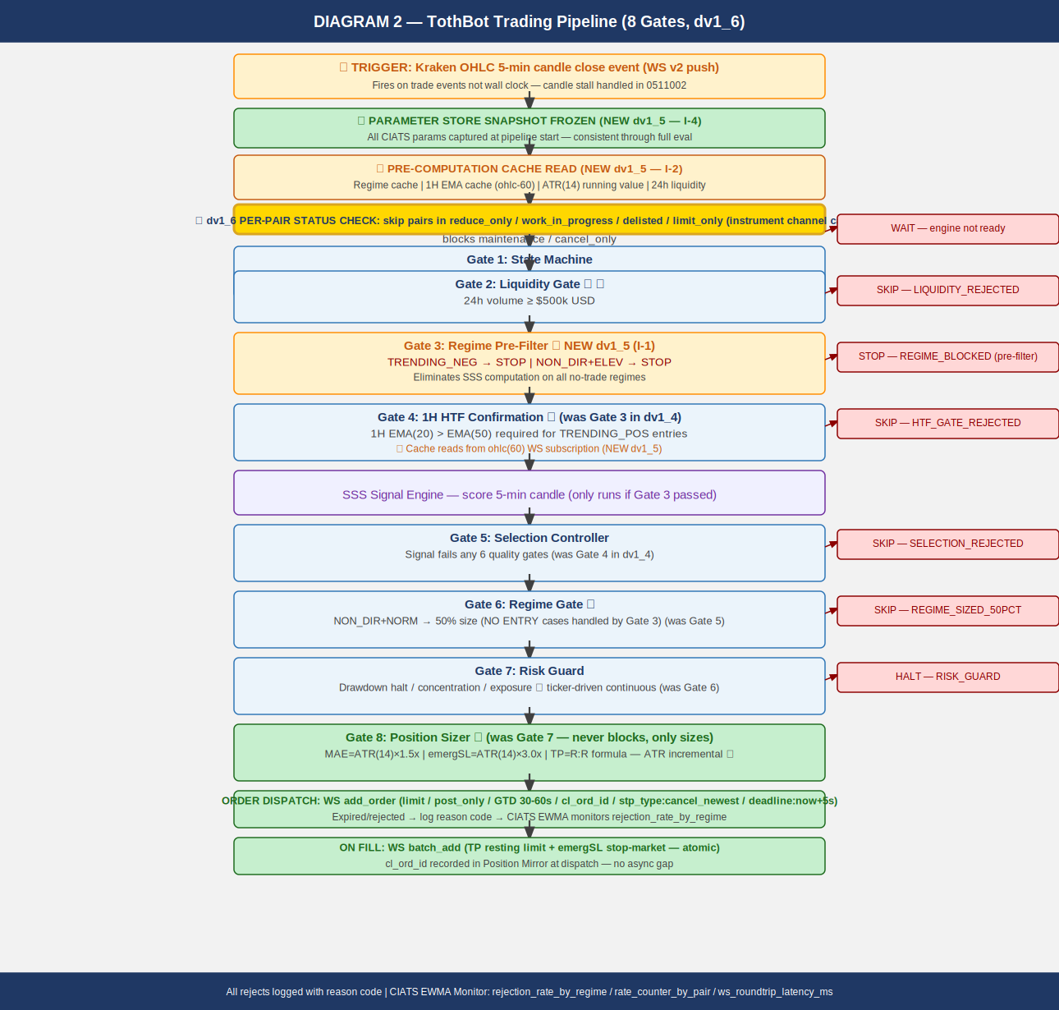

The pipeline fires on every 5-minute OHLC candle close event. Synchronous and event-driven.
8 gates. Gate 3 (Regime Pre-Filter) new in dv1_5. Per-pair status check new in dv1_6.

NOTE — OHLC fires on trade events, not wall clock: If no trades occur after an interval
border, no message sent until next trade. Liquidity Gate ($500k/day) reduces this risk.
Same stall behavior applies to ohlc(60). TothBot must handle stalled system clock.
Addressed in 0511002 Signal Pipeline Specification.

3.1 Gate Summary

PRE-STEP: Parameter Store Snapshot Frozen (NEW dv1_5 — I-4)
CIATS params captured as read-only snapshot at pipeline start. Consistent throughout
full eval. CIATS writes applied only at inter-trade boundaries.

PRE-STEP: Pre-Computation Cache Read (NEW dv1_5 — I-2)
Hot path reads: regime cache | 1H EMA cache (ohlc-60) | ATR(14) running value |
24h liquidity | per-pair status. Zero computation on hot path.

★ dv1_6: Per-pair Instrument Status Check
Skip pairs in reduce_only, work_in_progress, delisted, limit_only,
cancel_only, or maintenance state ★ dv1_12.
Only online or post_only pairs proceed into pipeline.
Prevents wasted rate counter. Full status list per 0411001 WS-INST-008.

Gate 1: State Machine
Kraken engine = maintenance or cancel_only: WAIT

Gate 2: Liquidity Gate ★
24h volume < $500k USD: SKIP → LIQUIDITY_REJECTED

Gate 3: Regime Pre-Filter ★ NEW dv1_5 (I-1)
TRENDING_NEG (any vol) or NON_DIR+ELEVATED: STOP → REGIME_BLOCKED
Eliminates SSS computation on all no-trade regimes.

Gate 4: 1H HTF Confirmation ★ (was Gate 3)
1H EMA(20) <= EMA(50) for TRENDING_POS entries: SKIP → HTF_GATE_REJECTED
Cache read from ohlc(60) WS subscription (NEW dv1_5).

SSS Signal Engine
Scores 5-min candle. Only reached if Gate 3 pre-filter passed.

Gate 5: Selection Controller (was Gate 4)
Signal fails any of 6 quality gates: SKIP → SELECTION_REJECTED

Gate 6: Regime Gate ★ (was Gate 5)
NON_DIR+NORMAL: 50% position size. All NO ENTRY cases blocked by Gate 3.

Gate 7: Risk Guard (was Gate 6)
Drawdown halt / concentration / exposure. Pass or HALT.
★ Ticker-driven continuous drawdown monitoring between candle closes (I-7 dv1_5)

Gate 8: Position Sizer ★ (was Gate 7)
MAE = ATR(14) x 1.5x (incremental), emergSL = ATR(14) x 3.0x, TP = R:R formula.
Never blocks — only sizes.

EVIDENCE BASE: 15-20% higher win rates with daily+hourly confirmation (5 independent
sources 2024-2025). Market Cipher: accuracy drops 65% in TRENDING to 45-50% in
NON_DIRECTIONAL. Break-even 40% for 1:1.5 R:R.

4. Exit Architecture — Ground Zero Redesign for Kraken
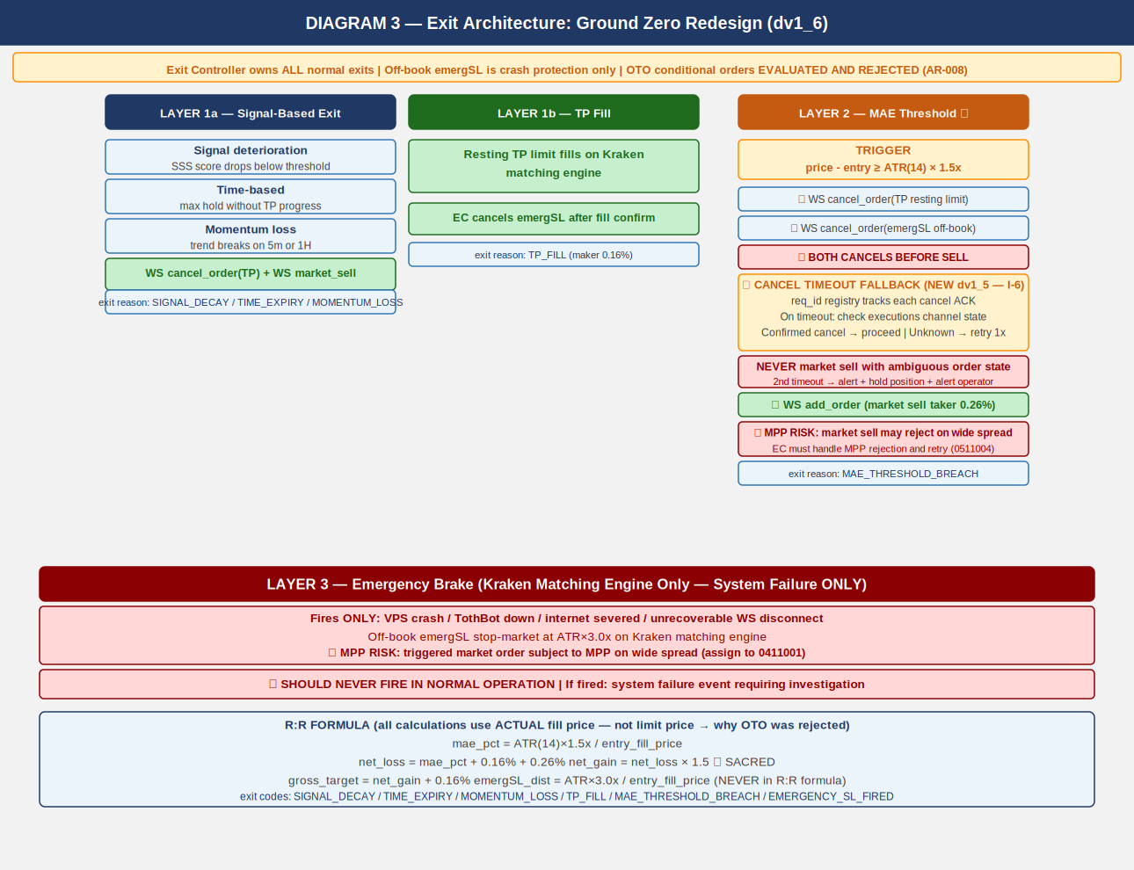

Rebuilt from zero for Kraken. Exit Controller owns all normal exits. Kraken off-book
emergency SL stop order is crash protection only. OTO evaluated and rejected (AR-008).

4.1 Three-Layer Summary

Layer 1a — Signal-Based Exit:
Signal decay / time expiry / momentum loss. WS cancel TP + market sell.

Layer 1b — TP Fill:
Resting TP limit on Kraken matching engine fills. EC cancels emergSL after fill confirm.

Layer 2 ★ — MAE Threshold:
price - entry >= ATR(14) x 1.5x.
SEQUENCE CRITICAL: (1) cancel TP (2) cancel emergSL THEN (3) market sell.
CANCEL TIMEOUT FALLBACK (NEW dv1_5 — I-6):
req_id registry tracks each cancel ACK. On timeout: check executions channel state.
Confirmed cancelled: proceed. State unknown: retry once. Second timeout: ALERT +
hold position + alert operator. NEVER issue market sell with ambiguous order state.
Assign to 0511001 and 0511004.
MPP RISK (C-1 dv1_4): market sell may reject on wide spread. EC MUST handle MPP
rejection and retry. Assign to 0511004.

Layer 3 ★ — Emergency Brake:
VPS/TothBot/internet failure ONLY. Off-book emergSL stop order at ATR(14) x 3.0x
on Kraken matching engine. NEVER in normal operation.
MPP RISK (C-1 dv1_4): triggered market order subject to MPP on wide spread.
Assign to 0411001.

4.2 R:R Formula

mae_pct = ATR(14) x 1.5x / entry_fill_price (CIATS-owned, uses ACTUAL fill price)
net_loss = mae_pct + 0.16% + 0.26% (entry maker + MAE taker exit)
net_gain = net_loss x 1.5 *** SACRED — hardcoded ***
gross_target = net_gain + 0.16% (TP maker exit)
emergSL_dist = ATR(14) x 3.0x / entry_fill_price (NEVER in R:R formula)

NOTE: All calculations use actual fill price, not limit price. OTO uses limit price —
this is why OTO was rejected (AR-008).

5. Regime Taxonomy
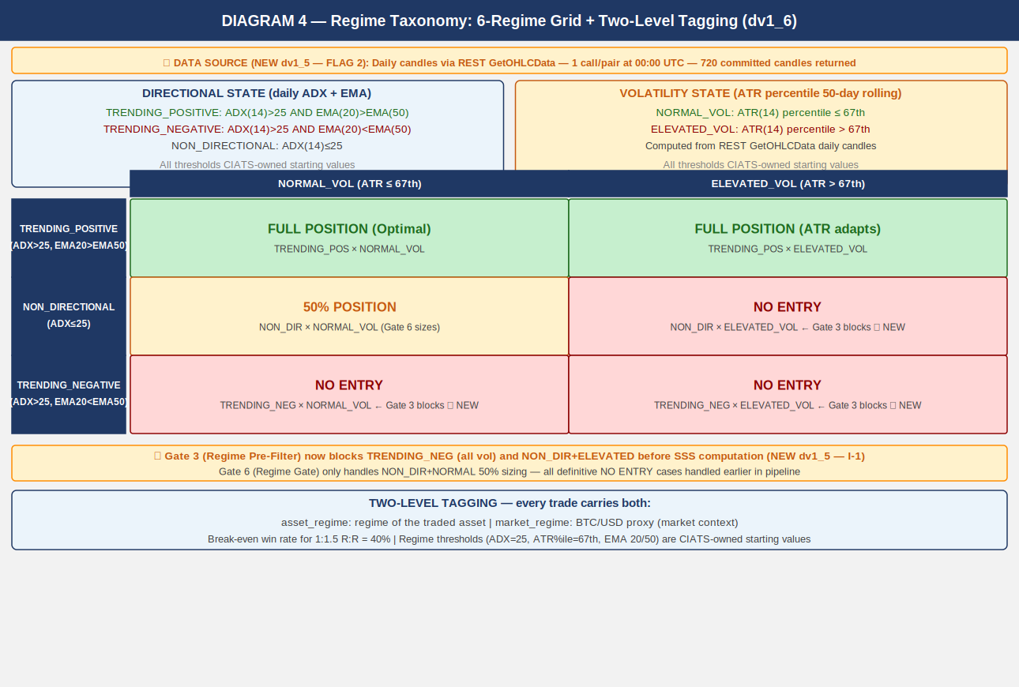

Six-regime grid is foundation of CIATS regime-segmented analysis. Every trade tagged with
both asset_regime and market_regime (BTC proxy). Computed daily at 00:00 UTC.

5.1 Computation

DATA SOURCE (NEW dv1_5 — FLAG 2 — FP/DP VERIFIED):
Daily candles via REST GetOHLCData called once per monitored pair at 00:00 UTC.
Returns 720 entries.

CRITICAL dv1_6 (GAP-03): The last entry (response[-1]) is ALWAYS the current
not-yet-committed candle. MUST be excluded from ALL calculations (ADX, EMA, ATR).
Use only response[:-1]. Including the uncommitted candle corrupts all regime indicators
and produces incorrect regime classification. See 1011012 Regime_Engine_Coding_Spec.

Directional state: ADX(14) + EMA(20) vs EMA(50) on DAILY candles (response[:-1] ONLY)
Volatility state: ATR(14) percentile rank in 50-day rolling window

TRENDING_POSITIVE: ADX(14) > 25 AND EMA(20) > EMA(50)
TRENDING_NEGATIVE: ADX(14) > 25 AND EMA(20) < EMA(50)
NON_DIRECTIONAL: ADX(14) <= 25
NORMAL_VOL: ATR percentile <= 67th
ELEVATED_VOL: ATR percentile > 67th

asset_regime + market_regime (BTC/USD proxy) both tagged on every trade

ALL REGIME THRESHOLDS ARE CIATS-OWNED: ADX threshold 25, ATR percentile 67th, EMA
periods 20/50, rolling window 50 days — all starting values. CIATS validates each after
600 closed trades (100+ per regime bucket).

6. CIATS Architecture and Data Flows
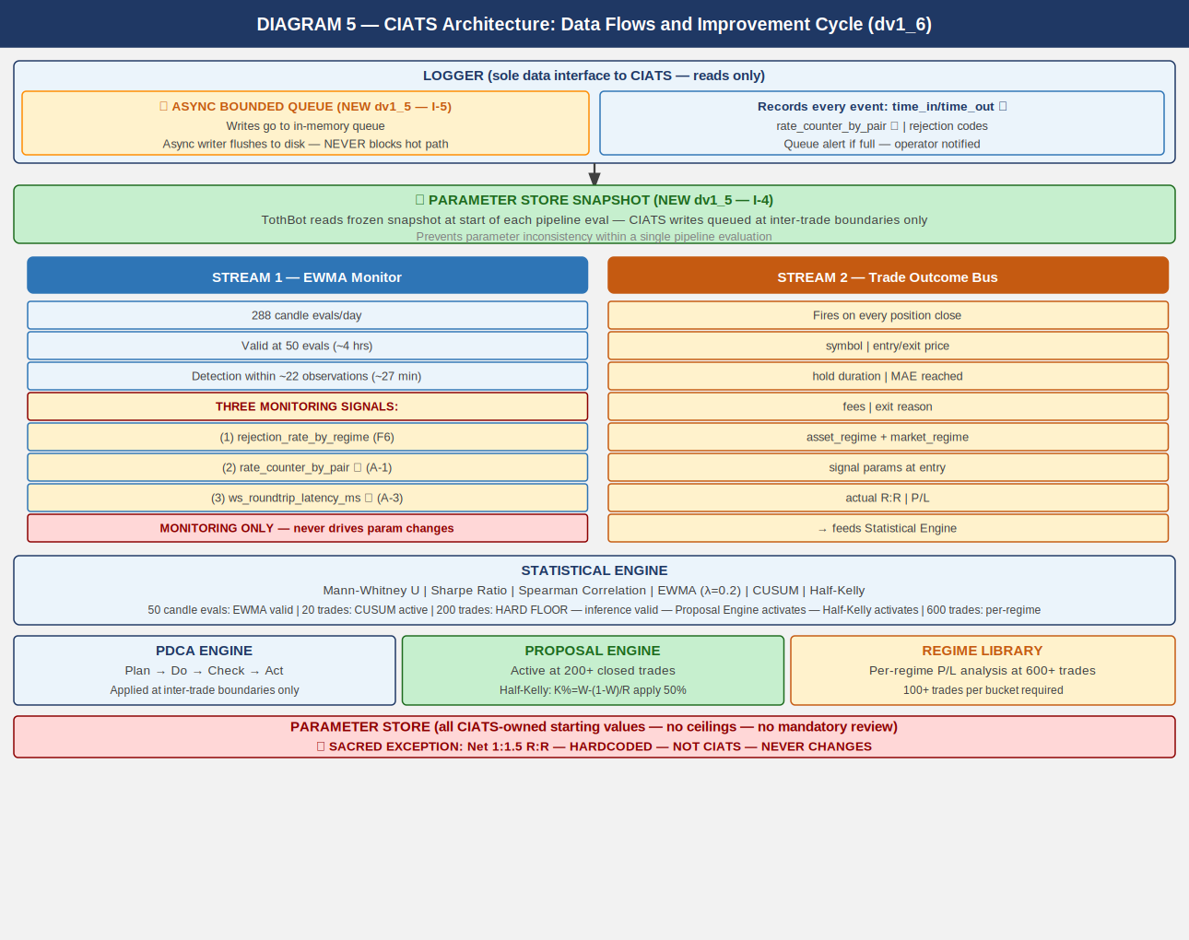

CIATS is fully asynchronous. Never blocks the trading critical path. Reads only from
the Logger. Writes only to the Parameter Store. Deming PDCA governs every change.

6.1 Two Data Streams

Stream 1: EWMA Monitor
288 candle evals/day. Valid at 50 evals (~4 hrs). lambda=0.2 [FP/DP validated dv1_6:
half-life=3.1 evals]. Three monitoring signals:
(1) rejection_rate_by_regime (F6)
(2) rate_counter_by_pair from executions channel (A-1)
(3) ws_roundtrip_latency_ms from WS response timestamps (A-3)
MONITORING SIGNALS ONLY — never drives parameter changes.

Stream 2: Trade Outcome Bus
Fires on each position close. Captures: symbol, entry/exit price, hold duration,
MAE reached, fees, exit reason, both regime tags, signal params at entry, actual R:R, P/L.

LOGGER — ASYNC BOUNDED QUEUE (NEW dv1_5 — I-5):
Logger writes go to an in-memory bounded queue. Queue size: 10,000 entries
[FP/DP validated dv1_6: 20 positions x 10 events/candle x 50-candle buffer].
Separate async writer flushes to disk. Logger NEVER blocks the trading hot path.
Queue must be bounded with immediate alert if queue fills. Assign to 0511006.

PARAMETER STORE — SNAPSHOT PATTERN (NEW dv1_5 — I-4):
TothBot takes frozen snapshot of all CIATS parameters at start of each pipeline eval.
Pipeline uses snapshot throughout. CIATS writes queued and applied only at confirmed
inter-trade boundaries. Prevents parameter inconsistency within single pipeline eval.
Assign to 0511002 and 0211001.

6.2 Statistical Thresholds

50 candle evals: EWMA Monitor valid. Monitoring only. lambda=0.2 validated.
200 trades HARD FLOOR: Inference valid. Proposal Engine activates. Half-Kelly activates.
SE(win_rate)~3.5%, SE(Sharpe)~7.2% [FP/DP validated dv1_6].
600 trades: Per-regime analysis. 100+ per bucket. MW power ~85% at alpha=0.01.
Rolling 200-300: Current performance window.
Full corpus: Zero-cost historical library.

Mann-Whitney alpha (dv1_6) ★: alpha=0.01 (one-sided). 99% confidence required.
Spearman rho threshold (dv1_6) ★: |rho| > 0.3 AND p < 0.05 (both conditions).
CUSUM parameters (dv1_6) ★: k=0.5*sigma, h=4*sigma. Starting values.
PDCA minimum interval (dv1_6) ★: Min 50 trades between any two parameter changes.

7. Complete System: One CIATS-Owned Organism
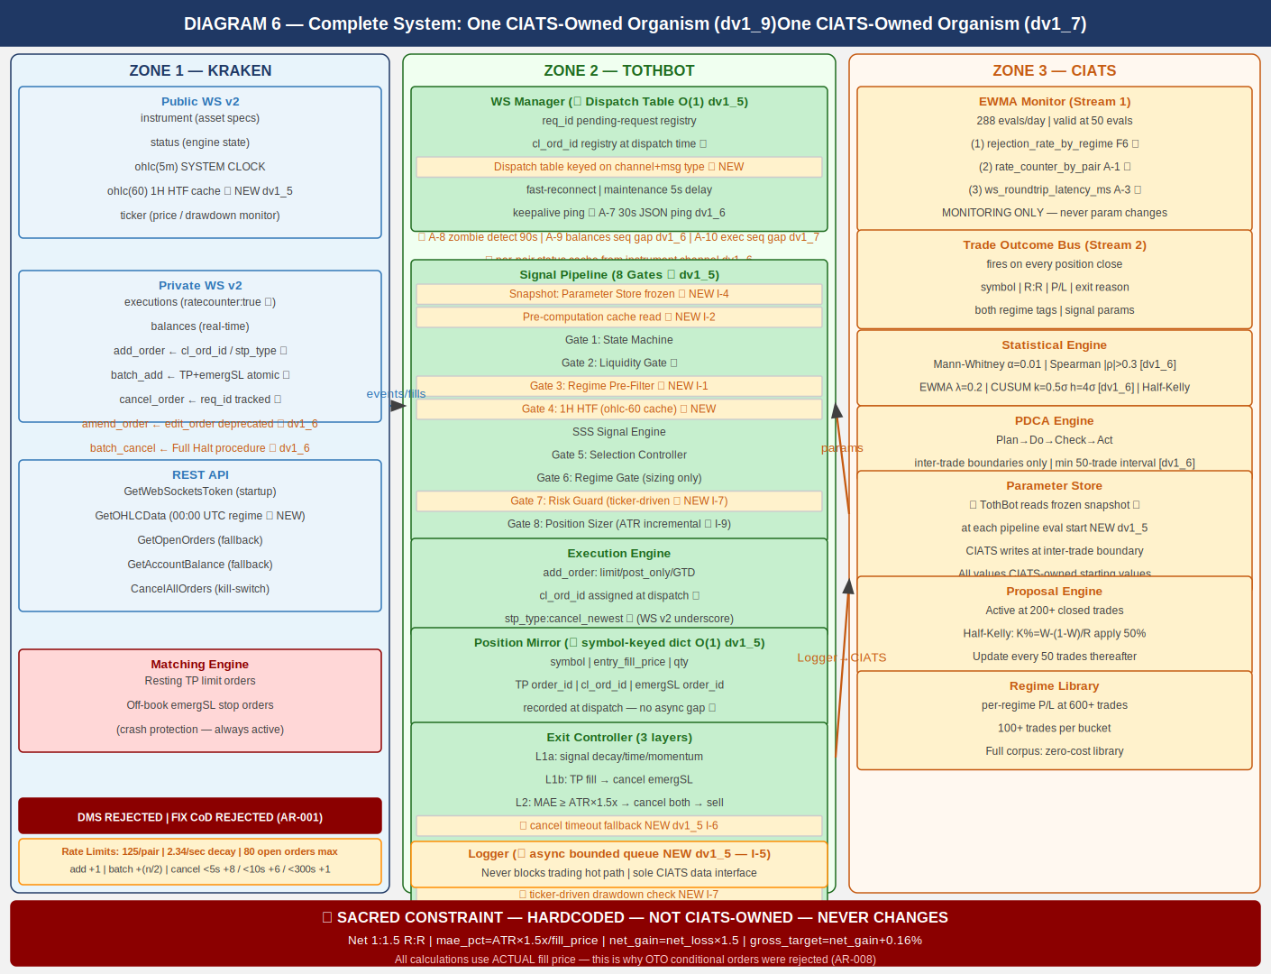

CIATS OWNS EVERYTHING EXCEPT 1:1.5 R:R: All parameters, thresholds, sizing decisions,
halt thresholds, multipliers, and trading rules are CIATS-owned starting values.

8. Locked Architectural Decisions

AR-001: No Dead Man Switch — crash protection is resting TP + emergSL on matching engine.
DMS and FIX cancel-on-disconnect both REJECTED (destroy crash protection).
AR-002: Position Mirror — symbol-keyed dict, O(1) lookup. (NEW dv1_5 — I-3)
AR-003: Restart reconciliation — PREFERRED: snap_orders:true. FALLBACK: REST.
AR-004: Two API key pairs — DATA + TRADE. Nonce window 10,000ms.
AR-005: WS v2 only. All future Kraken enhancements in v2 only.
AR-006: Entry order — limit/post_only/GTD/cl_ord_id/stp_type:cancel_newest/deadline:now+5s.
★ WS v2 uses underscore in stp_type values (cancel_newest). REST uses hyphen (cancel-newest).
Never confuse the two. Different protocols, different formats.
AR-007: TP placement — resting limit via batch_add on fill. Actual fill price for R:R.
batch_add includes deadline:now+5s and stp_type:cancel_newest on both legs.
AR-008: Emergency SL — stop-market via batch_add atomic with TP. ATR(14) x 3.0x.
OTO evaluated and REJECTED: uses limit price, violates R:R, Position Mirror race.
AR-009: Short deferred.
AR-010: 24/7/365. CIATS adds stand-down via PDCA if data supports.
AR-011: Net 1:1.5 R:R — SACRED — HARDCODED — NOT CIATS-OWNED.
AR-012: Fee baseline — Maker 0.16% / Taker 0.26%.
AR-013: Kraken Pro Intermediate tier confirmed.
AR-014: Logger async bounded queue (10,000 entries). Never blocks hot path. (dv1_5 I-5)
AR-015: WS dispatch table O(1) routing on channel+message type. (dv1_5 I-8)
AR-016: ATR(14) incremental running calculation. O(1) per update. (dv1_5 I-9)
AR-017: Daily regime via REST GetOHLCData at 00:00 UTC. CRITICAL: exclude response[-1].
(dv1_5 FLAG 2)
AR-018 (dv1_6) ★: amend_order PRIMARY. edit_order DEPRECATED.
AR-019 (dv1_6) ★: batch_cancel for Full Halt multi-order cancellation.
AR-020 (dv1_6) ★: Per-pair instrument status cache from instrument channel.
AR-021 (dv1_7) ★: Executions channel sequence gap detection → REST GetOpenOrders
reconciliation. Missed executions = Position Mirror desync = loss risk.
AR-022 (dv1_8) ★: cancel_reason field deprecated — use reason field in all executions
channel parsing. cancel_reason returns None silently on current messages.
AR-023 (dv1_8) ★: Complete exec_type dispatch table required. All 10 exec_type values
handled explicitly. Unknown values logged, never silently dropped.
AR-024 (dv1_8) ★: restated exec_type = engine maintenance amend, NOT fill/cancel.
Must not trigger Position Mirror update. Elevated alert if resting order.
AR-025 (dv1_8) ★: All REST calls via aiohttp (IMP-06). asyncio TaskManager pattern
mandatory for 24/7 operation (IMP-07). systemd WatchdogSec=120 with
30-second asyncio ping loop (IMP-08). See 1011013 VPS_Deployment_Spec.
AR-026 (dv1_9) ★: order_status:true MANDATORY in executions subscription. Without it
amended and restated exec_types are silently dropped — A-12/A-13 blind.
AR-027 (dv1_9) ★: interval_begin replaces deprecated timestamp in OHLC WS v2 channel.
AR-028 (dv1_9) ★: price_increment replaces deprecated tick_size in instrument channel.
qty_min and cost_min validated in Gate 8 before every add_order.
AR-029 (dv1_9) ★: WS connect max_size=10MB + open_timeout=10 on all connections.
AR-030 (dv1_9) ★: maxratecount from executions subscription ACK is the operative rate
counter ceiling. Use it, not the hardcoded 125.
AR-031 (dv1_9) ★: Subscription ACK warnings[] parsed and logged on every subscribe call.
QueryOrdersInfo REST endpoint for targeted single-order reconciliation.
AR-032 (dv1_10) ★: stp_type FORMAT CORRECTION — WS v2 uses underscores: cancel_newest,
cancel_oldest, cancel_both. REST uses hyphens: cancel-newest. Never
confuse the two protocols. All WS v2 add_order and batch_add MUST use
cancel_newest (underscore). Assign: 0411001, 1011002.
AR-033 (dv1_10) ★: deadline parameter on all WS v2 add_order and batch_add.
Standard: deadline = UTC now + 5 seconds (ISO 8601 string).
Range 500ms–60s. Engine rejects orders arriving after this time.
Provides latency protection on entry and TP/emergSL placement.
Assign: 0411001 WS-DL-001–004, 1011002 WM-DL-001–004.
AR-034 (dv1_10) ★: Ticker event_trigger per position state:
event_trigger:bbo — pairs WITH open positions (faster adverse price
detection; for longs, bid = realizable exit price).
event_trigger:trades — pairs WITHOUT open positions (less update volume).
WS Manager switches trigger mode based on Position Mirror state.
Assign: 0411001 WS-TKR-001–004, 1011002 WM-TKR-001–004.
AR-035 (dv1_10) ★: aiohttp ClientSession MUST configure explicit timeout + connector:
ClientTimeout(total=10, connect=5, sock_read=8)
TCPConnector(limit=10, limit_per_host=5, force_close=False)
Without timeout, REST calls hang indefinitely on degraded networks.
force_close=False enables connection reuse for reduced per-call overhead.
Assign: 1011002 WM-REST-006–011, 1011001 BP-HTTP-001–004.
AR-036 (dv1_10) ★: Regime Engine REST calls MUST be staggered at 1.1s intervals.
REST public OHLC rate-limit: 1 call/second per IP+pair.
50 pairs × 1.1s = 55s total. Completes before first 5m candle.
asyncio.sleep(1.1) between each GetOHLCData call.
Assign: 1011012 RE-RL-001–004.
AR-037 (dv1_10) ★: Both DATA and TRADE API keys MUST be IP-whitelisted to VPS IP.
Current VPS: 87.99.141.44. Update whitelist on any VPS migration.
IP whitelisting is configured separately in Kraken API key settings.
Assign: 1011013 VD-KEY-006–009.
AR-038 (dv1_12) ★: Kraken Status API used at startup for proactive maintenance detection.
Public REST API at https://status.kraken.com/api/v2/. Query
/scheduled-maintenances/upcoming.json on startup. If scheduled
maintenance detected within 2 hours: log KRAKEN_MAINTENANCE_SCHEDULED,
alert operator. Does NOT block startup — informational only.
Assign: 0411001 WS-STAT-001 through -004, 1011013 VD-STAT-001.
AR-039 (dv1_12) ★: Per-pair instrument channel status check expanded. Complete set of
NO-ENTRY states: reduce_only, work_in_progress, delisted, limit_only,
cancel_only, maintenance. cancel_only and maintenance were previously
missing. Both block all new order placement at the pair level.
Assign: 0411001 WS-INST-008 through -011, 1011002 WM-PS-001 through -005.
AR-040 (dv1_12) ★: Exit Controller pair status adaptation for open positions.
limit_only → IOC limit at best_bid (NOT market sell).
cancel_only → HOLD + CRITICAL alert. No new orders possible.
maintenance (pair level) → HOLD + CRITICAL alert.
Existing resting TP + emergSL are the only protection during HOLD.
Validates AR-001: resting emergSL crash protection is the correct
architecture for pair-level disruption scenarios.
Assign: 0411001 WS-EXIT-001 through -006, 1011002 WM-PS-003/004.
AR-041 (dv1_12) ★: cancel_order/batch_cancel behavioral distinction — NOT interchangeable.
cancel_order: returns stream of individual responses per order (req_id
trackable). Use for Layer 2 MAE exit cancel sequence (cancel timeout
fallback I-6 requires per-order ACK tracking).
batch_cancel: returns single count response + bypasses rate counter
maximum. Use for Full Halt (count sufficient; rate bypass ensures
execution even when rate limited).
Assign: 0411001 WS-CAN-001 through -007, 1011002 WM-CAN-001 through -004.
AR-042 (dv1_12) ★: Zombie detection heartbeat exclusion. Heartbeat messages fire ONLY when
no real market data is flowing — they are an indicator of zombie state,
NOT connection health. last_real_data_time MUST be reset only on real
channel events: ohlc, ticker, instrument, executions, balances, status.
Heartbeat, pong, and ACK messages MUST NOT reset the timer.
Assign: 1011002 WM-ZOM-004 through -007.
AR-043 (dv1_12) ★: max_concurrent position limit enforced by asyncio.BoundedSemaphore.
BoundedSemaphore raises ValueError on over-release (bug detection).
Gate 7 checks semaphore.locked() (non-blocking). Execution Engine
acquires semaphore before dispatch. Position close triggers release.
On CIATS max_concurrent update: recreate semaphore, re-acquire for
all currently open positions.
Assign: 1011011 RE-SEM-001 through -006.
AR-044 (dv1_13) ★: Startup warm-up — ATR(14) and EMA via REST GetOHLCData required
before any pipeline execution. WS ohlc(5m) and ohlc(60) snapshots
return only 1 candle — insufficient to seed ATR(14) or EMA(20/50).
For each monitored pair at startup:
(a) GetOHLCData(interval=5) — seed ATR(14). Use response[:-1].
ATR seed = SMA of first 14 True Ranges. Incremental thereafter.
(b) GetOHLCData(interval=60) — seed EMA(20) and EMA(50) for HTF
cache. Use response[:-1]. EMA alpha=2/(n+1).
(c) GetOHLCData(interval=1440) — Regime Engine. Use response[:-1].
STAGGER: 1.1s between calls for the SAME pair (AR-036 applies).
PARALLELISM: asyncio.gather() across DIFFERENT pairs.
While ATR or EMA not seeded: pair remains in WARM_UP state.
WARM_UP pairs are skipped at the pipeline pre-check (no entries).
Pair transitions WARM_UP -> READY when ATR, EMA, and regime all
seeded. System begins trading READY pairs immediately — does not
wait for all pairs.
Assign: 1011002 WM-STARTUP-001 through -008,
1011014 SS-WARMUP-001 through -010.
AR-045 (dv1_13) ★: OHLC candle-close detection mechanism. WS OHLC fires on every
trade event within the candle period, not only on candle close.
WS Manager MUST track per symbol:
last_interval_begin: dict[str, str]
last_complete_candle: dict[str, OHLCCandle]
On each ohlc(5m) message for symbol S:
if msg.interval_begin == last_interval_begin[S]:
Update in-progress candle. DO NOT fire pipeline.
else:
Candle for last_interval_begin[S] is NOW CLOSED.
Fire pipeline with last_complete_candle[S].
last_complete_candle[S] = current message data.
last_interval_begin[S] = msg.interval_begin.
Initialize last_interval_begin[S] from startup GetOHLCData(5)
response[-2].interval_begin (last committed candle).
Same logic for ohlc(60) with separate last_interval_begin_60.
Assign: 1011002 WM-OHLC-001 through -006.
AR-046 (dv1_13) ★: emergSL triggers.reference MUST be explicit in all batch_add
calls. Never rely on API defaults for crash-protection parameters.
ALL emergSL stop-loss orders MUST include:
"triggers": {
"reference": "last",
"price": <sl_trigger_price>,
"price_type": "static"
}
reference="last" uses Kraken's internal last-traded price — always
available regardless of external index feed status. reference="index"
relies on external data providers that may be unavailable during
exactly the market crashes when emergSL needs to fire.
Assign: 0411001 WS-SL-001 through -003,
1011002 WM-BATCHADD-003 through -004.
AR-047 (dv1_13) ★: Price and quantity rounding before ALL order dispatch. ALL rounding
MUST use Decimal.quantize() — NEVER math.floor/ceil. Float binary
representation causes precision errors (e.g. math.floor(0.3/0.1)*0.1
= 0.2 not 0.3). For exchange orders: any rounding error = rejected
order = failed trade = loss. Four mandatory rounding operations:
(1) order_qty: Decimal.quantize(qty_increment, ROUND_DOWN).
If result < qty_min OR result*price < cost_min: SKIP, log.
(2) entry limit_price: Decimal.quantize(price_increment, ROUND_DOWN).
Conservative: lower limit = more likely post_only fill.
(3) TP limit_price: Decimal.quantize(price_increment, ROUND_UP).
Conservative: higher TP = preserves net R:R at minimum.
(4) emergSL trigger: Decimal.quantize(price_increment, ROUND_DOWN).
Conservative: wider stop = more protective.
ALL Kraken API values (prices, qtys) received via WS or REST MUST be
converted to Decimal(str(value)) immediately on receipt.
NEVER Decimal(float_value) — inherits float precision error.
NEVER dispatch batch_add without pre-validated, pre-rounded prices.
A batch_add validation failure at Kraken kills the entire batch,
leaving an open position with NO TP and NO emergSL protection.
Assign: 1011001 BP-DEC-001 through -008,
1011002 WM-ROUND-001 through -012.
AR-048 (dv1_13) ★: Exit Controller MAE detection and drawdown calculation MUST use
bid price (not last price) for long positions.
bid = best price at which the position can be immediately sold
(realizable exit value). last = most recent trade, can be stale.
event_trigger:bbo was chosen specifically because bid updates fire
immediately on any adversarial price move.
MAE formula: current_mae = entry_fill_price - bid_price
Layer 2 exit triggers when: current_mae >= ATR(14) * mae_mult
Drawdown calculation:
current_portfolio_USD = spot_usd_balance
+ sum(bid_price[sym] * position_qty[sym]
for sym in position_mirror)
Assign: 0411001 WS-TKR-005 through -007,
1011002 WM-EC-001 through -003.
AR-049 (dv1_13) ★: Formal startup sequence required. TothBot MUST complete the
10-step startup sequence before any pipeline evaluation. No pipeline
evaluations permitted until at least one pair reaches READY state.
Complete specification in 1011014 Startup_Sequence_Coding_Spec.
Sequence: (1) Kraken Status API check, (2) GetWebSocketsToken,
(3) Connect public WS + subscribe, (4) Process instrument snapshot,
(5) Connect private WS + subscribe executions/balances,
(6) snap_orders reconciliation -> Position Mirror,
(7) Restore ticker subscriptions per position state,
(8) REST warm-up GetOHLCData (AR-044: interval=5, 60, 1440),
(9) First READY pair -> enter OPERATIONAL, (10) Continuous operation.
Assign: 1011002 WM-STARTUP-001 through -012, 1011014 (full spec).
AR-050 (dv1_13) ★: Balances channel MUST use spot/main wallet balance only.
The balances snapshot top-level "balance" field is the SUM across
ALL wallet types (spot, earn, futures, flex, etc.). Earn/staking
balances are NOT available for trading. Using top-level balance
overstates tradeable capital and causes incorrect position sizing
and drawdown calculations.
Correct extraction: wallets[type="spot"][id="main"].balance
On balances snapshot: iterate wallets array, filter type=="spot"
AND id=="main". Store as Decimal(str(wallet.balance)).
On balances update: filter wallet_type=="spot" AND wallet_id=="main".
Two update events per completed trade: base currency debit + quote
currency credit, both sharing the same ref_id.
For portfolio tracking: process only USD event (asset=="USD").
Assign: 0411001 WS-BAL-001 through -005,
1011002 WM-BAL-001 through -006.
AR-051 (dv1_13) ★: Portfolio value definition for position SIZING:
portfolio_USD = spot_usd_balance (spot/main wallet, USD only)
This is REALIZED CAPITAL ONLY. Does NOT include mark-to-market
value of open positions. Using MTM for sizing creates a feedback
loop: rising positions inflate sizing of new positions, increasing
total risk beyond intent. Cash-in-hand is the only correct basis.
tradeable_USD = portfolio_USD * tradeable_pct
per_trade_USD = tradeable_USD * per_trade_pct
raw_qty = per_trade_USD / entry_limit_price
At 200+ closed trades, CIATS activates Half-Kelly:
K_full = W - ((1-W)/R)
K_half = K_full * 0.5
per_trade_USD = min(K_half*tradeable_USD,
tradeable_USD/max_concurrent)
NOTE: Drawdown calculation uses a DIFFERENT formula (see AR-052).
Sizing and drawdown are two separate computations.
Assign: 1011002 WM-PS-005 through -009,
1011011 RE-SZ-001 through -005.
AR-052 (dv1_13) ★: Portfolio drawdown formula and circuit breakers:
BASELINE: portfolio_baseline_USD = spot_usd_balance captured ONCE
at startup (after Step 6 snap_orders processing). NEVER updated
during operation. NEVER reset on mid-session reconnect.
Resets only on full TothBot process restart.
CURRENT PORTFOLIO (for drawdown — includes MTM):
current_portfolio_USD = spot_usd_balance
+ sum(bid_price[sym] * position_qty[sym]
for sym in position_mirror)
Uses bid price (AR-048) — realizable exit value, conservative.
DRAWDOWN:
drawdown_pct = max(0,
(portfolio_baseline_USD - current_portfolio_USD)
/ portfolio_baseline_USD)
max(..., 0): gains are not counted as negative drawdown.
EVALUATION: on every bbo ticker event for any open-position pair
AND at every Gate 7 evaluation.
THRESHOLDS:
session_pause_drawdown (5%): no new entries. Alert. Existing
positions monitored normally. Resumes when drawdown recovers.
full_halt_drawdown (10%): HALT. No new entries. Alert Bill.
Does NOT auto-close positions. Bill decides.
Assign: 1011002 WM-DD-001 through -008,
1011011 RE-DD-001 through -006.
AR-053 (dv1_13) ★: Pending Order Registry — USD commitment tracking to prevent
capital overcommitment when multiple pairs fire pipeline
simultaneously. WS balances channel does NOT expose hold_trade
(pending order USD holds). TothBot must self-track.
REGISTRY: pending_orders: dict[str, Decimal]
maps cl_ord_id -> estimated_USD_cost
POPULATE on entry dispatch:
estimated_cost = order_qty * entry_limit_price * (1 + maker_fee)
pending_orders[entry_cl_ord_id] = estimated_cost
CLEAR on: exec_type=filled, expired, or canceled.
HOLD on: exec_type=trade (partial fill — order still open).
GATE 7 USD CHECK:
available_USD = spot_usd_balance - sum(pending_orders.values())
if available_USD < per_trade_USD: SKIP_INSUFFICIENT_USD
RECONCILIATION at startup (Step 6) and on mid-session reconnect:
snap_orders "new"/"pending_new" -> populate registry.
orders NOT in snap_orders -> clear from registry.
Assign: 1011002 WM-POR-001 through -007,
1011011 RE-SZ-005.
AR-054 (dv1_13) ★: Entry order partial fill + expiry/cancel creates unprotected open
position. A GTD post_only entry order can receive partial fills
before the GTD window expires or the order is canceled. When
exec_type=="expired" OR exec_type=="canceled" AND cum_qty > 0:
a REAL position exists at cum_qty units at avg_price fill price,
with NO TP and NO emergSL protection. Must be handled immediately.
CASE A (exec_type=="expired" AND cum_qty > 0):
CASE B (exec_type=="canceled" AND cum_qty > 0):
1. Clear Pending Order Registry for this cl_ord_id.
2. Extract qty=Decimal(str(cum_qty)), entry=Decimal(str(avg_price)).
3. Validate qty >= qty_min AND qty*entry >= cost_min.
If not: dispatch market sell immediately. Log and fire CIATS.
4. Recalculate TP and emergSL from actual entry price using
current ATR(14) and mae_mult / emergency_sl_mult.
Verify net_gain = net_loss * 1.5 (sacred R:R).
5. Dispatch batch_add: TP limit + emergSL stop, using cum_qty.
6. Enter Position Mirror with cum_qty and avg_price.
7. Log ENTRY_PARTIAL_FILL_PROTECTED.
CASE C (exec_type=="expired" OR "canceled" AND cum_qty == 0):
No fill. Clear registry. Log. No position opened.
CASE D (exec_type=="filled"): Unchanged. No partial fill concern.
Assign: 1011002 WM-DISP-020 through -028.
AR-055 (dv1_13) ★: Dead Man's Switch (cancel_all_orders_after) is EXPLICITLY
PROHIBITED in TothBot V2. No call to this endpoint under any
circumstance. RATIONALE: DMS cancels ALL account orders when timer
expires — including emergSL orders protecting open positions (Layer 3
crash protection). DMS would destroy the only Kraken-side protection
for open positions during the exact scenario (VPS crash, network
severance) that emergSL is designed to protect against.
PROTECTION IS FULLY PROVIDED WITHOUT DMS:
Entry orders: GTD self-expiry in 30-60 seconds.
Open positions: emergSL resting on Kraken matching engine.
Process crash: systemd WatchdogSec=120 restarts TothBot.
Network breakdown: emergSL survives on Kraken regardless.
HARD RULE: Code review MUST reject any PR containing a call to
cancel_all_orders_after (WS v2 or REST endpoint).
Assign: HR-DMS-001 in 0411001 and 1011002.
AR-056 (dv1_13) ★: Mid-session WS reconnect sequence is DISTINCT from startup and
MUST be implemented separately. 11-step sequence. Key distinctions:
portfolio_baseline_USD: NEVER reset on reconnect.
drawdown_pct: PRESERVED across reconnect.
system_state (halt/pause): PRESERVED across reconnect.
ATR/EMA caches: PRESERVED unless gap > 15 minutes (stale threshold).
Position Mirror: reconciled via snap_orders comparison.
Positions closed during gap (TP/emergSL fired while disconnected):
detected by comparing pre-disconnect Position Mirror vs snap_orders.
CIATS Trade Outcome Bus fired for each gap-closed position.
Pending Order Registry: reconciled against snap_orders.
Pipeline evaluations: PROHIBITED during reconnect. Candle events
queued during reconnect are DISCARDED after completion.
Fatal reconnect: 10 attempts over 120 seconds -> log CRITICAL ->
systemd restart -> full startup sequence.
Complete specification in 1011014 Section 2.
Assign: 1011002 WM-RECONNECT-001 through -015,
1011014 SS-RECON-001 through -016.
AR-057 (dv1_14) ★: amended exec_type MUST be in dispatch table. The complete Kraken
executions channel exec_type list is 10 values: pending_new, new,
trade, filled, iceberg_refill, canceled, expired, amended, restated,
status. amended was missing from prior dispatch table (AR-023).
amended = user-initiated order amend (e.g. limit price change).
TothBot V1 never sends amend_order for its own orders. Any amended
exec_type event is unexpected and must be treated as a system
integrity alert: log UNEXPECTED_ORDER_AMENDED (CRITICAL level),
alert operator HIGH, cross-reference Position Mirror to determine if
TP or emergSL was amended (sacred R:R violation risk).
Do NOT auto-correct — operator must review and decide.
Assign: 0411001 WS-AMEND-001 through -003,
1011002 WM-DISP-024 through -026.
AR-058 (dv1_14) ★: websockets library max_queue=None REQUIRED on all connections.
Default max_queue=16 is insufficient for burst market data events
(startup instrument snapshot for 200+ pairs, rapid bbo ticker events
on multiple open positions, post-reconnect snapshots). Messages can
be silently dropped or backed up when queue is exceeded.
Set max_queue=None (unlimited) on all four websockets connections
(public WS, private WS, and their reconnect variants). Memory impact
is negligible. A dropped executions message = Position Mirror desync
= loss risk. Non-negotiable for 24/7 operation.
Assign: 1011002 WM-CONN-001 through -003.
AR-059 (dv1_14) ★: Disable websockets library ping, use application JSON ping only.
Set ping_interval=None on all websockets.asyncio.client.connect()
calls to disable the library's built-in TCP-level PING frames.
TothBot's sole keepalive mechanism is the application-level JSON
ping: {"method":"ping"} every 30 seconds (A-7), with pong expected
within 10 seconds. Running two concurrent ping mechanisms creates
duplicate activity and confusion. The JSON ping is fully visible to
TothBot application code; the library PING is transparent and
invisible. Single authoritative keepalive mechanism with full
visibility is the correct architecture.
Assign: 1011002 WM-CONN-004 through -006.
AR-060 (dv1_14) ★: All websockets connections MUST use the new stable asyncio API.
REQUIRED import: from websockets.asyncio.client import connect
DEPRECATED (DO NOT USE): import websockets; websockets.connect()
The legacy API is deprecated in websockets v14+ and will be removed
in a future release. Using it is a ticking time bomb for a 24/7
trading system — a library version update would silently break all
WS connections. Applies to: startup (1011014 SS-STARTUP-006,
SS-STARTUP-013), reconnect (1011014 SS-RECON-006), all WS connections.
Assign: 1011002 WM-CONN-007, 1011014 SS-PRE-006.
AR-061 (dv1_14) ★: Capture last_qty and last_price fields from executions trade events.
Kraken added last_qty (quantity of this specific fill) and last_price
(price of this specific fill) to exec_type=trade events. These are
fill-level fields, distinct from cumulative cum_qty and avg_price.
Position Mirror and sizing continue to use cum_qty and avg_price.
last_qty and last_price are captured for fill-level logging and CIATS
execution quality analytics (entry slippage monitoring).
All values: Decimal(str()) immediately on receipt per AR-047.
Assign: 0411001 WS-EXE-020 through -022,
1011002 WM-EXE-014 through -016.
AR-062 (dv1_14) ★: Exit Controller Layer 1a — three triggers now specified.
Three Layer 1a exit triggers are derivable before SSS (OI-001):
EC-L1A-001 (HTF Regime Reversal): 1H EMA(20) crosses below EMA(50)
while long open. Gate 4 symmetry. Check on every ohlc(60) close.
Exit sequence: cancel TP → cancel emergSL → market sell.
EC-L1A-002 (Daily Regime Downgrade): At 00:00 UTC regime refresh,
pair reclassified TRENDING_POS → TRENDING_NEG or NON_DIR+ELEVATED.
Gate 3 symmetry. Check immediately after regime computation.
Exit sequence: cancel TP → cancel emergSL → market sell.
EC-L1A-003 (Max Hold Time): max_hold_candles parameter. TBD value
pending OI-001 SSS specification. CIATS-owned starting value.
Both EC-L1A-001 and EC-L1A-002 use cancel timeout fallback (I-6).
Assign: 1011005 EC-L1A-001 through -012.
AR-063 (dv1_14) ★: Logger MUST use queue.Queue (stdlib), not asyncio.Queue.
CORRECT PATTERN:
log_queue = queue.Queue(maxsize=10000)
queue_handler = logging.handlers.QueueHandler(log_queue)
log_listener = logging.handlers.QueueListener(log_queue, file_handler)
log_listener.start() # Runs in its own thread
NOT asyncio.Queue: QueueListener runs in a separate non-asyncio
thread and is not compatible with asyncio.Queue. An asyncio coroutine
writer would compete with the event loop for scheduling.
On queue.Full: log to stderr, alert HIGH, skip record — NEVER block.
Stop listener on shutdown: log_listener.stop() drains and joins.
Assign: 1011007 LG-QUEUE-001 through -008.
AR-064 (dv1_14) ★: Log connection_id from Kraken status channel on every WS connection.
Status channel provides connection_id (uint64) per WS session — a
unique Kraken-side identifier. Log on every new connection. Include
in all reconnect, disconnect, and gap log entries. Useful for Kraken
support requests and debugging. Zero additional cost — already in
status channel message data.
Assign: 0411001 WS-STAT-005 through -006,
1011002 WM-STATUS-001.
AR-065 (dv1_14) ★: CIATS Kelly formula inputs MUST use net P/L from Trade Outcome Bus.
Kelly K_full = W - ((1-W)/R).
W = count(trades where net_gain_usd > 0) / total_trades.
R = mean(net_gain_usd for wins) / mean(|net_loss_usd| for losses).
Both W and R computed from Trade Outcome Bus realized net P/L data
(all fees included — entry maker + exit taker). NOT gross price change.
NOT theoretical R:R targets. For TothBot with 0.42% round-trip fees,
gross vs net R:R diverges meaningfully. Inflated Kelly from gross
inputs = oversized positions = excess loss on losers.
Negative K_full: log CRITICAL, alert operator, do not update params.
Assign: 1011010 CIATS-KE-006 through -009.
AR-066 (dv1_14) ★: TP order partial fill requires Position Mirror update + emergSL amendment.
When exec_type=trade arrives for a TP order (identified by order_id
matching TP order_id in Position Mirror):
remaining_qty = tp_order_qty - cum_qty
Update Position Mirror qty to remaining_qty
Amend emergSL to remaining_qty via amend_order (NOT cancel+resubmit)
Rate counter: amend_order (+2) saves 7 units vs cancel+resubmit (+9)
amend_order also preserves queue position in Kraken book
If remaining_qty < qty_min OR remaining_qty * bid < cost_min:
cancel emergSL, immediate market sell of remainder, clear Mirror
CIATS Trade Outcome Bus: fire ONCE on full position close (aggregate
all partial fill data). Not on each partial fill event.
On exec_type=filled (full TP fill): existing L1b logic unchanged.
Assign: 0411001 WS-TP-001 through -005,
1011002 WM-EC-004 through -008,
1011005 EC-TP-001 through -006.
AR-067 (dv1_15) ★: SSS Signal Engine — three-factor momentum scoring on 5-minute candles.
SSS is the signal engine that runs after Gate 4. It runs ONLY when the
pair is in a tradeable regime (Gate 3 passed) with 1H EMA aligned (Gate 4 passed).
SSS PASS = ALL THREE conditions true simultaneously:
SC-SSS-1: RSI(14) on 5-min > rsi_entry_low (50) AND < rsi_entry_high (70)
RSI > 50 = bullish momentum confirmed. RSI < 70 = not overbought.
SC-SSS-2: EMA(9) on 5-min > EMA(21) on 5-min
Short-term EMA alignment on entry timeframe within confirmed
higher-timeframe trend. Validated by 8+ independent sources.
SC-SSS-3: current_candle_volume > volume_MA(20) × volume_sss_threshold (1.0x)
Above-average volume confirms genuine participant interest.
All three thresholds are CIATS-owned starting values. All will be replaced
by data. CIATS evaluates after 200 trades.
SSS output: signal_params dict logged to Trade Outcome Bus:
{rsi_14, ema_9, ema_21, volume_ratio, sss_pass}
Evidence base: 8+ independent sources 2024-2026 confirm RSI(50-70) +
EMA crossover + volume as validated 5-minute momentum entry pattern.
Validated by TB00020 Search 1 (10 sources).
OI-001: CLOSED.
Assign: 0711001 SSS-001 through -012, 1011003 SP-SSS-001 through -010.
AR-068 (dv1_15) ★: SSS indicator seeding at startup — extension of AR-044.
GetOHLCData(interval=5) already called per AR-044. The same response[:-1]
seeds ALL five per-pair indicators (no additional REST calls required):
ATR(14): first 14 True Ranges → SMA seed. Incremental thereafter.
RSI(14): first 14 closes → RS=avg_gain/avg_loss. EMA-smoothed thereafter.
EMA(9): first 9 closes → SMA seed. alpha=2/10 thereafter.
EMA(21): first 21 closes → SMA seed. alpha=2/22 thereafter.
Volume MA(20): first 20 volumes → SMA seed. Rolling SMA thereafter.
WARM_UP → READY transition requires ALL FIVE indicators seeded, not just ATR.
GetOHLCData(interval=5) returns 700+ candles — adequate to seed all five.
Assign: 1011002 WM-STARTUP-009 through -014, 1011014 SS-WARMUP-011 through -016.
AR-069 (dv1_15) ★: Entry limit price formula — OI-004 CLOSED.
entry_limit_price_raw = last_complete_candle[symbol].close
(the 5-minute ohlc close that triggered the pipeline — already in hot path)
entry_limit_price = entry_limit_price_raw.quantize(price_increment, ROUND_DOWN)
per AR-047 (conservative: lower limit → more likely post_only fill).
In a TRENDING_POS pair with confirmed momentum, candle close ≤ current ask
in a moving market. post_only guarantees maker fill if order reaches book.
GTD 30-60s handles non-fills. No new WS subscriptions required.
CIATS tracks rejection_rate_by_regime (EWMA Monitor signal 1) and optimizes.
OI-004: CLOSED.
Assign: 0811004 ELP-001 through -006, 0411001 WS-ENTRY-001 through -004,
1011002 WM-ENTRY-001 through -004.
AR-070 (dv1_15) ★: Asset selection universe — OI-002 CLOSED.
Monitored pair set = Kraken spot pairs satisfying ALL conditions:
(1) Quote currency: USD or USDC
(2) Instrument status = online (from instrument channel cache)
(3) 24h volume >= min_volume_usd_daily ($500k starting, CIATS-owned)
Starting monitored universe size: top 50 by 24h USD volume (CIATS-owned).
Universe populated at startup from instrument channel snapshot.
Updated when instrument channel fires status changes.
BTC/USD always included regardless of ranking (see AR-074).
CIATS may add/remove pairs via PDCA after 200 trades.
OI-002: CLOSED.
Assign: 0711003 AS-001 through -008, 1011009 SC-UNI-001 through -006.
AR-071 (dv1_15) ★: EC-L1A-003 max_hold_candles starting value — OI-003 CLOSED.
max_hold_candles = 24 (2 hours at 5-minute cadence). CIATS-owned starting value.
FP/DP derivation: 5-minute momentum trades in confirmed TRENDING_POS regimes
resolve within 6-24 candles per research validation (TB00020 Search 3, 10 sources).
EC-L1A-001 (1H EMA reversal) and EC-L1A-002 (daily regime) catch higher-timeframe
failure. max_hold_candles is the backstop for stalled positions where neither fires.
Counter: maintained per open position in WS Manager state. Increments on each
ohlc(5m) close for that symbol. Exit sequence: same as EC-L1A-001.
exit_reason = TIME_EXPIRY.
OI-003: CLOSED (EC-L1A-003 now fully specified).
Assign: 1011005 EC-L1A-010 updated (value = 24, no longer TBD).
AR-072 (dv1_15) ★: Selection Controller — all 6 quality gates specified — OI-005 CLOSED.
Gate 5 receives SSS PASS and applies all 6 gates in sequence:
SC-GATE-1: SSS PASS (all three SSS conditions true). Reject: SSS_SIGNAL_FAIL.
SC-GATE-2: abs(candle_close - candle_open) > ATR(14) × body_threshold (0.3 start).
Momentum candle must have directional commitment — not a doji.
CIATS-owned. Reject: WEAK_CANDLE_BODY.
SC-GATE-3: symbol NOT in position_mirror.
No pyramiding. One position per pair. Reject: POSITION_ALREADY_OPEN.
SC-GATE-4: symbol NOT in exit_cooldown_log OR elapsed >= cooldown_seconds (300s).
Post-exit cooldown prevents immediate re-entry on a stopped-out pair.
CIATS-owned. Reject: PAIR_IN_COOLDOWN.
SC-GATE-5: quantized_qty >= qty_min AND quantized_qty × entry_limit_price >= cost_min.
Pre-validates position size meets Kraken minimums before dispatch.
Reject: POSITION_TOO_SMALL.
SC-GATE-6: consecutive_loss_count[symbol] < consecutive_loss_limit (3 starting).
3 consecutive losses on one pair → block new entries. Surface the problem.
CIATS-owned. Resets on win or CIATS instruction. Reject: CONSECUTIVE_LOSSES_EXCEEDED.
All gates: FAIL = SKIP pair + log reject code + CIATS EWMA monitors.
OI-005: CLOSED.
Assign: 0811002 SC-001 through -024, 1011009 SC-GATE-001 through -018.
AR-073 (dv1_15) ★: Selection Controller state management — WS Manager in-memory state.
WS Manager maintains two per-symbol dicts:
exit_cooldown_log: dict[str, float] — symbol → time.monotonic() of last exit
consecutive_loss_count: dict[str, int] — symbol → consecutive losses without win
Update on position close:
Always: exit_cooldown_log[symbol] = time.monotonic()
If loss exit (MAE_THRESHOLD_BREACH, TIME_EXPIRY, HTF_REGIME_REVERSAL,
DAILY_REGIME_DOWNGRADE, SIGNAL_DECAY): consecutive_loss_count[symbol] += 1
If TP_FILL (win): consecutive_loss_count[symbol] = 0
Both dicts PRESERVED across reconnect (in-memory, never discarded on reconnect).
CIATS may reset consecutive_loss_count[symbol] via PDCA parameter update.
Assign: 1011002 WM-SC-001 through -006.
AR-074 (dv1_15) ★: BTC/USD always in monitored universe — market_regime proxy commitment.
BTC/USD is the market_regime proxy. Every trade record carries market_regime
(BTC/USD regime tag). BTC/USD MUST always be subscribed to and included in
the Regime Engine computation regardless of universe size N or ranking.
If BTC/USD is excluded by any filter, it is added back explicitly.
BTC/USD is NOT traded if it fails entry gates — it is subscribed for regime
computation only. Its pipeline evaluation is optional (CIATS-owned).
Assign: 1011012 RE-MKT-001 through -003.
AR-075 (dv1_15) ★: SSS indicators in per-symbol state dict — pre-computation cache addition.
WS Manager per-symbol state dict is extended to include all SSS indicators.
These are updated incrementally on each ohlc(5m) candle close (same pattern
as ATR(14) incremental per AR-016):
rsi_14_avg_gain: Decimal (running RSI state)
rsi_14_avg_loss: Decimal
ema_9: Decimal
ema_21: Decimal
volume_ma_20: Decimal (running SMA of 20-candle volume)
SSS threshold params (rsi_entry_low, rsi_entry_high, volume_sss_threshold)
are read from the Parameter Store snapshot at pipeline evaluation time (I-4).
Pre-computation cache (I-2) is extended: regime | 1H EMA | ATR(14) |
SSS state (rsi_14, ema_9, ema_21, volume_ma_20) | 24h liquidity | per-pair status.
Assign: 1011002 WM-SSS-001 through -008.
AR-076 (dv1_16) ★: RSI(14) uses Wilder's SMMA — NOT standard EMA. Specification correction
to AR-068 which stated "EMA-smoothed" — that phrase is ambiguous and points
to the wrong algorithm. The correct RSI(14) incremental formula is
Wilder's Smoothed Moving Average (SMMA, also called RMA), with α=1/14.
This is distinct from standard EMA which uses α=2/(n+1)=2/15.
The two produce materially different RSI values (~5-8% variance).
A coder reading "EMA-smoothed" would likely implement α=2/15, producing
non-standard RSI that does not match any trading platform and would
systematically mis-fire the SSS SC-SSS-1 gate (RSI 50-70 condition).

CORRECT RSI(14) INCREMENTAL FORMULA (Wilder's SMMA):
Seed (first 14 candles):
avg_gain = sum(gains[:14]) / Decimal("14")
avg_loss = sum(losses[:14]) / Decimal("14")
Incremental (each subsequent candle):
avg_gain = (prev_avg_gain * Decimal("13") + current_gain) / Decimal("14")
avg_loss = (prev_avg_loss * Decimal("13") + current_loss) / Decimal("14")
RS = avg_gain / avg_loss
RSI = Decimal("100") - (Decimal("100") / (Decimal("1") + RS))

For contrast — standard EMA (WRONG for RSI):
alpha = 2/(n+1) = 2/15 ≈ 0.1333 ← DO NOT USE FOR RSI
avg_gain = prev_avg_gain * (1 - alpha) + current_gain * alpha

STANDARD EMA IS CORRECT for EMA(9) and EMA(21) in SSS Gate 2:
EMA(9): alpha = 2/10 = 0.2000 ← standard EMA, correct
EMA(21): alpha = 2/22 = 0.0909 ← standard EMA, correct
Only RSI uses Wilder's SMMA. EMA(9) and EMA(21) use standard EMA.
Do not conflate the two algorithms.

STATE STORED (unchanged from AR-075 — formula clarified only):
rsi_14_avg_gain: Decimal (Wilder SMMA running state)
rsi_14_avg_loss: Decimal (Wilder SMMA running state)

EVIDENCE BASE: 10+ independent sources across validation search
(TradingView rma(), StockCharts.com, Supra Oracle docs, Wikipedia,
LuxAlgo, AlphaRithms, Quantinsti, PineScriptMarket, Medium) all confirm
Wilder's SMMA (α=1/n) as the correct RSI formula. A 14-period SMMA is
equivalent to a 27-period standard EMA (2×14-1=27), not a 15-period EMA.
Validated TB00021, Search 4 and Search 10, 10+ sources.
Assign: 1011002 WM-SSS-001 through -008 (RSI formula corrected),
0711001 SSS-001 through -012 (RSI formula corrected).

9. Complete CIATS Parameter Registry

ALL PARAMETERS ARE CIATS-OWNED STARTING VALUES.

tradeable_pct: 50% of portfolio
per_trade_pct: 5% → Half-Kelly at 200 trades (update every 50 thereafter)
★ Applied_pct = min(raw_kelly_half, tradeable_pct/max_concurrent)
Prevents capital overcommitment across concurrent positions.
See 1011010 CIATS-KE-002 through CIATS-KE-005.
max_concurrent: 20 positions
mae_mult (ATR x): 1.5x ATR(14)
emergency_sl_mult: 3.0x ATR(14)
entry_timeout_sec: 30-60s GTD
full_halt_drawdown: 10% of portfolio
session_pause_drawdown: 5% of portfolio
adx_threshold: 25
atr_percentile_threshold: 67th
htf_ema_periods: 20/50 daily
min_volume_usd_daily: $500k USD
monitored_universe_n: 50 pairs (top N by 24h USD volume)
1:1.5 R:R net: HARDCODED — SACRED — NOT CIATS-OWNED

SSS Signal Engine parameters (★ dv1_15 — AR-067):
rsi_entry_low: 50 (RSI lower bound for SSS Gate 1)
rsi_entry_high: 70 (RSI upper bound for SSS Gate 1)
sss_ema_short: 9 (EMA short period for SSS Gate 2)
sss_ema_long: 21 (EMA long period for SSS Gate 2)
volume_sss_threshold: 1.0x (volume vs MA(20) for SSS Gate 3)

Selection Controller parameters (★ dv1_15 — AR-072):
sc_body_threshold: 0.3 (candle body vs ATR for SC Gate 2)
sc_cooldown_seconds: 300 (post-exit cooldown for SC Gate 4 = 1 candle)
sc_consecutive_limit: 3 (consecutive loss limit for SC Gate 6)

Exit Controller parameters (★ dv1_15 — AR-071):
max_hold_candles: 24 (maximum hold time = 2 hours, EC-L1A-003)

10. Six FP/DP Validated System Improvements

Derived from 80+ sources across 3 independent research passes plus 2 deep validation
sessions (144+ sources) plus 10-search Kraken validation [dv1_6] (126 sources).
5+ sources per parameter.

Finding 1: 1H HTF Confirmation Gate [TothBot]
Gap: No layer between daily regime and 5-min entry.
Evidence: 15-20% higher win rates with daily+hourly filter (5 sources 2024-2025).
Change: 1H EMA(20) > EMA(50) required for TRENDING_POSITIVE. Cache from ohlc(60).
Effect: Removes false signals during 1H pullbacks. Zero API cost.

Finding 2: ATR Dynamic Stop Distances [TothBot/Exit]
Gap: Fixed 2% stop ignores real-time market volatility.
Evidence: +15% performance, -22% max drawdown vs fixed stops (LuxAlgo + 4 sources).
Change: MAE ATR(14) x 1.5x. Emergency SL ATR(14) x 3.0x. Incremental (I-9).
Effect: Stop adapts to conditions. R:R formula preserved.

Finding 3: Regime Gate [TothBot]
Gap: Long momentum system trading in absent-edge conditions.
Evidence: Accuracy 65%->45-50% in NON_DIRECTIONAL (Market Cipher). Break-even 40%.
Change: NON_DIR+ELEV and TRENDING_NEG: no entry (Gate 3). NON_DIR+NORM: 50% (Gate 6).
Daily candles via REST GetOHLCData. CRITICAL: exclude response[-1] [dv1_6].
Effect: Stops trading when documented edge is absent. Pure loss minimization.

Finding 4: Minimum Liquidity Gate [TothBot]
Gap: No minimum 24h volume on asset selection.
Evidence: $1M+/day minimum for clean execution (Coin Bureau + 4 sources 2024-2025).
Change: min_24h_volume_usd $500k starting. Checked daily via ticker.
Effect: Protects fee formula. Ensures clean post_only fills and SL execution.

Finding 5: CIATS Half-Kelly Pathway [CIATS]
Gap: Fixed 5% sizing had no defined data-driven transition.
Evidence: Half-Kelly: 75% optimal growth at 50% less drawdown (MacLean-Thorp-Ziemba + 4).
FP/DP validated [dv1_6].
Change: At 200 trades: K%=W-(1-W)/R, apply 50%. Update every 50 trades. No ceilings.
Effect: Data-driven sizing replaces arbitrary fixed fraction.

Finding 6: post_only Rejection Monitoring [CIATS]
Gap: Rejection events logged but unused by CIATS EWMA.
Evidence: Rejection rate = direct signal of entry placement quality (Cube Exchange + 4).
Change: CIATS EWMA adds rejection_rate_by_regime stream.
Effect: Free diagnostic signal. Entry optimization pathway activated.

11. Complete Trade Lifecycle — Narrative Reference

11.1 Normal Trade (Entry to TP or Exit Controller)

OHLC 5-min candle close fires on public WS v2
Parameter Store snapshot frozen — all CIATS params captured (NEW dv1_5 — I-4)
Pre-computation cache read — regime, 1H EMA, ATR(14) incremental, 24h liquidity (I-2)
★ Per-pair instrument status check — skip reduce_only/work_in_progress/delisted/
limit_only/cancel_only/maintenance [dv1_12]
Gate 1: State Machine — online or post_only: continue; else halt and wait
Gate 2: Liquidity Gate — 24h volume >= $500k: continue; else skip
Gate 3: Regime Pre-Filter — TRENDING_NEG or NON_DIR+ELEV: STOP; else continue (I-1)
Gate 4: 1H HTF Gate — 1H EMA(20) > EMA(50) for TRENDING_POS: continue; else skip
Signal Engine: SSS score computed on 5-min candle
Gate 5: Selection Controller — 6-gate quality evaluation: pass or reject
Gate 6: Regime Gate — TRENDING_POS: proceed; NON_DIR+NORM: 50% size
Gate 7: Risk Guard — drawdown/concentration/exposure checks: pass or halt
Gate 8: Position Sizer — MAE=ATR x 1.5x, emergSL=ATR x 3.0x, TP=R:R formula
Execution: WS add_order (limit/post_only/GTD 30-60s/cl_ord_id/stp_type:cancel_newest/deadline:now+5s)
If expired/rejected: log reason code → CIATS EWMA monitors rejection rate. Done.
If filled: WS batch_add → TP (resting limit) + emergSL (stop-market) atomic. cl_ord_id/stp_type:cancel_newest/deadline:now+5s
Position Mirror records: symbol (key), entry_fill_price, qty, TP id, cl_ord_id, emergSL id
Exit Controller monitors via ticker (continuous drawdown check — I-7)
Logger records full entry via async queue. CIATS Trade Outcome Bus ready.
TP fills: EC cancels emergSL. Or EC fires Layer 1/2 exit.
Logger records full exit. CIATS Trade Outcome Bus fires with complete trade record.

11.2 Layer 2 MAE Exit (Adverse Price)

Exit Controller detects: current_price - entry >= ATR(14) x 1.5x
WS cancel_order: cancel TP resting order
WS cancel_order: cancel emergSL stop order (SEQUENCE CRITICAL: both cancels before sell)

CANCEL TIMEOUT FALLBACK (NEW dv1_5 — I-6):
req_id registry tracks each cancel ACK. On timeout: check executions channel state.
Confirmed cancelled: proceed. State unknown: retry once. Second timeout: ALERT and
hold position. NEVER issue market sell with ambiguous order state.
Assign to 0511001 and 0511004.

WS add_order: market sell (taker 0.26%)
MPP NOTE (C-1): Market sell subject to MPP. EC MUST handle MPP rejection and retry.
Logger: exit reason = MAE_THRESHOLD_BREACH
CIATS Trade Outcome Bus fires

11.3 Emergency SL (Layer 3 — System Failure Only)

VPS crashes / TothBot dies / internet severs / unrecoverable WS disconnect
Kraken matching engine fires off-book emergSL stop-market at ATR x 3.0x
MPP NOTE: Triggered market order subject to MPP. Assign to 0411001.
On restart: reconciliation detects closed position → Logger: EMERGENCY_SL_FIRED
THIS IS A SYSTEM FAILURE EVENT. SHOULD NEVER FIRE IN NORMAL OPERATION.

12. Open Items — Require Specification Documents

OI-001: Signal generation (SSS) — CLOSED (dv1_15, AR-067).
Three-factor SSS: RSI(14) 50-70, EMA(9)>EMA(21) on 5m, volume > MA(20)x1.0x.
Specify in 0711001 SSS_Signal_Model_Specification (Phase 5).
OI-002: Asset selection universe — CLOSED (dv1_15, AR-070).
Top 50 USD/USDC pairs by 24h volume. BTC/USD always included (AR-074).
Specify in 0711003 Asset_Selection_Specification (Phase 5).
OI-003: Exit Controller full specification — CLOSED (dv1_15, AR-071).
EC-L1A-001/002 specified dv1_14. EC-L1A-003 max_hold_candles=24 specified dv1_15.
All Layer 1a triggers complete. Specify in 0811003 Exit_Controller_Specification (Phase 6).
OI-004: Entry limit placement — CLOSED (dv1_15, AR-069).
entry_limit_price = last candle close quantized DOWN to price_increment.
Specify in 0811004 Entry_Limit_Placement_Specification (Phase 6).
OI-005: Selection Controller — CLOSED (dv1_15, AR-072).
All 6 gates specified: SSS PASS, candle body, no position, cooldown,
position size viability, consecutive loss limit.
Specify in 0811002 Selection_Controller_Specification (Phase 6).
OI-006: CIATS specification — all statistical thresholds and PDCA rules.
Mann-Whitney alpha=0.01, Spearman |rho|>0.3, CUSUM k/h, PDCA 50-trade interval.
Specify in 0211001 CIATS_Specification (Phase 3).
OI-007: AA=04 Exchange Interface formal document — CLOSED (Phase 2 complete).
0400000 and 0410000 committed to GitHub 2026-04-04.
OI-008: All AA=10 coding specs. WD documents active: 1011001 dv1_4, 1011002 dv1_10,
1011005 dv1_0, 1011007 dv1_0, 1011010 dv1_3, 1011011 dv1_1, 1011012 dv1_2,
1011013 dv1_2, 1011014 dv1_1. Current as of dv1_16. Phase 8 completes all.

13. Revision History

dv1_18 04-04-2026 Header-only update. No content or diagram changes.
Parent chain (0400000 Exchange_Interface) committed to GitHub.
0500000 parent chain now complete. DocTime typo corrected
(UTC UTC -> UTC). OI-007 marked CLOSED.

dv1_17 04-04-2026 DocPath correction: TothBot-V2-Docs -> TothBot_V2-Docs
(underscore before V2). Version incremented per Rule 4.
All document dates updated.

dv1_16 03-26-2026 Text-only. No diagram changes. 1 new AR (AR-076).
AR-076: RSI(14) smoothing formula correction. AR-068 stated
"EMA-smoothed" — ambiguous, points to wrong algorithm. Correct
formula is Wilder's SMMA (RMA), α=1/14 (not standard EMA α=2/15).
Incremental: avg_gain=(prev×13+current)/14, avg_loss same.
EMA(9) and EMA(21) in SSS Gate 2 correctly use standard EMA
(α=2/10 and α=2/22). Only RSI uses Wilder's SMMA. Formula
distinction critical — 5-8% variance between the two algorithms
would systematically mis-fire SSS SC-SSS-1 (RSI 50-70 gate).
Validated 10+ sources, TB00021 FP/DP validation pass.
Architecture status: fully validated. Architecture complete.
FP/DP validation finding rate: 0-2 predicted → 1 actual (AR-076).

dv1_15 03-26-2026 Complete architecture — OI-001 through OI-005 closed.
Text-only. No diagram changes. 9 new ARs (AR-067 through AR-075).
AR-067: SSS Signal Engine (3-factor: RSI+EMA+Volume). OI-001 CLOSED.
AR-068: SSS indicator seeding at startup (extends AR-044).
AR-069: Entry limit price = candle close quantized down. OI-004 CLOSED.
AR-070: Asset universe (top 50 USD/USDC + BTC/USD always). OI-002 CLOSED.
AR-071: max_hold_candles = 24 (2 hours). OI-003 CLOSED.
AR-072: Selection Controller 6 gates fully specified. OI-005 CLOSED.
AR-073: SC state management (cooldown + consecutive loss dicts).
AR-074: BTC/USD always in universe (market_regime proxy commitment).
AR-075: SSS indicators in per-symbol state dict (cache extension).
CIATS Parameter Registry: 11 new parameters added.
All OI-001 through OI-005 now CLOSED. Architecture complete.
FP/DP analysis: 3 sequential searches, 30 sources (TB00020).
dv1_0 03-23-2026 Initial document.
dv1_1 03-23-2026 Added all six system flow diagrams.
dv1_2 03-24-2026 Six changes: C-1 emergSL terminology, C-2 rate limits, C-3 OHLC stall,
A-1 ratecounter, A-2 req_id, A-3 latency logging.
dv1_3 03-24-2026 Rebuilt as correct .docx with all six diagrams embedded.
dv1_4 03-24-2026 Seven changes: C-1 MPP, A-1 AR-001 expansion, A-2 cl_ord_id,
A-3 snap_orders, A-4 stp_type, A-5 reconnect distinction, A-6 OTO rejected.
dv1_5 03-24-2026 Eleven changes: FLAG1 ohlc(60), FLAG2 REST GetOHLCData, I-1 Gate 3,
I-2 cache, I-3 Position Mirror O(1), I-4 Parameter Store snapshot,
I-5 Logger async queue, I-6 cancel timeout, I-7 ticker drawdown,
I-8 WS dispatch table, I-9 ATR incremental.
dv1_6 03-24-2026 Six changes from 10-search FP/DP validation + Operations/CIATS analysis:
(1) amend_order primary, edit_order deprecated, batch_cancel, L3 URL corrected.
(2) Rate table updated.
(3) A-7 WS ping, A-8 zombie detection, A-9 balances seq gap.
(4) Per-pair instrument status check, AR-018/019/020.
(5) GetOHLCData response[-1] exclusion — CRITICAL correctness requirement.
(6) Auth verification, CIATS statistical thresholds.
dv1_9 03-25-2026 Six new architectural requirements and five improvements from
second 10-search FP/DP organism validation session (TB00010):
A-15 (GAP-A CRITICAL) order_status:true mandatory in executions
subscription — without it amended/restated silently dropped, breaking
A-12/A-13. A-16 (GAP-B) OHLC interval_begin replaces deprecated
timestamp. A-17 (GAP-C/D) instrument price_increment replaces
tick_size; qty_min/cost_min mandatory Gate 8 validation. A-18 (GAP-E)
websockets max_size=10MB + open_timeout=10 mandatory. A-19 (IMP-11)
maxratecount from executions ACK is operative rate threshold. IMP-13
subscription warnings[] parsed/logged. IMP-14 amend_id logged. IMP-15
QueryOrdersInfo for targeted reconciliation. AR-026 through AR-031 added.
0411001 updated to dv1_2. 1011002 updated to dv1_2.

dv1_10 03-25-2026 Seven new findings from third 10-search FP/DP organism validation
(TB00011): A-20 stp_type FORMAT CORRECTION. A-21 deadline parameter.
A-22 aiohttp ClientTimeout + TCPConnector. A-23 Ticker event_trigger:bbo.
A-24 Regime Engine GetOHLCData stagger. AR-037 IP-whitelisting.
IMP-16 through IMP-19. AR-032 through AR-037. 0411001 dv1_3.
1011002 dv1_3. 1011012 dv1_1. 1011001 dv1_1.

dv1_12 03-25-2026 Ten text-only changes from fourth (TB00012), fifth (TB00013), and
sixth (TB00014) 10-search FP/DP validation sessions. No diagram changes.
AR-038: Kraken Status API startup maintenance check. Section 2 REST
table: Status API endpoint added. AR-039: per-pair status check
expanded — cancel_only and maintenance added as NO-ENTRY states.
AR-040: Exit Controller pair status adaptation — IOC limit on limit_only,
HOLD on cancel_only/maintenance. AR-041: cancel_order/batch_cancel
behavioral distinction — cancel_order for MAE exit (individual ACK),
batch_cancel for Full Halt (count + rate bypass). AR-042: zombie
detection heartbeat exclusion — heartbeats MUST NOT reset
last_real_data_time. AR-043: max_concurrent via asyncio.BoundedSemaphore.
Section 9 CIATS Parameter Registry: Half-Kelly normalization note.
Section 11.1: per-pair status check updated with full list.
0411001 updated to dv1_6. 1011002 updated to dv1_6.
1011010 updated to dv1_2. 1011011 dv1_0 new.
1011012 updated to dv1_2. 1001001 updated to dv1_3.

dv1_13 03-26-2026 Fourteen text-only changes from seventh (TB00015), eighth (TB00016),
and ninth (TB00017) 10-search FP/DP validation sessions. No diagram
changes. AR-044: startup warm-up via REST GetOHLCData — ATR(14) seed
(interval=5), EMA(20/50) seed (interval=60), regime (interval=1440).
WARM_UP/READY pair state machine. asyncio.gather across pairs, 1.1s
intra-pair stagger. AR-045: OHLC candle-close detection via
interval_begin change (not wall clock). last_interval_begin tracking
per symbol. AR-046: emergSL triggers.reference="last" explicit in all
batch_add calls — never rely on defaults for crash protection params.
AR-047: ALL rounding via Decimal.quantize() — NEVER math.floor/ceil.
Float arithmetic causes silent precision errors that corrupt order
prices. All Kraken API values: Decimal(str()) immediately on receipt.
AR-048: Exit Controller MAE uses bid price (not last) for long
positions. bid = realizable exit. drawdown formula uses bid.
AR-049: Formal 10-step startup sequence. No pipeline until READY.
Full spec in 1011014 Startup_Sequence_Coding_Spec.
AR-050: Balances channel — spot/main wallet only. Top-level balance
includes earn/staking (not tradeable). Filter wallets array.
AR-051: Portfolio for sizing = cash only (no MTM of open positions).
AR-052: Drawdown baseline set ONCE at startup. NEVER reset on
reconnect. Current portfolio = cash + bid*qty of open positions.
Session pause 5%, full halt 10%. Does not auto-close positions.
AR-053: Pending Order Registry — self-tracks USD committed to
outstanding entry orders. Gate 7 checks available_USD = balance
minus pending commitments. Prevents overcommitment on simultaneous
pipeline activations. AR-047 amendment: original AR-047 used
math.floor/ceil — amended to Decimal.quantize() (BP-DEC-001 through
BP-DEC-008 in 1011001). AR-054: Entry order partial fill + expiry or
cancel creates unprotected open position. cum_qty > 0 on expired or
canceled exec_type: recalculate TP/emergSL from avg_price, dispatch
batch_add, enter Position Mirror. If below qty_min/cost_min: market
sell immediately. AR-055: Dead Man's Switch (cancel_all_orders_after)
EXPLICITLY PROHIBITED. Cancels emergSL orders — destroys crash
protection. Hard rule: code review must reject any PR with this call.
AR-056: Mid-session WS reconnect sequence distinct from startup.
Never reset portfolio_baseline_USD or drawdown on reconnect. Reconcile
Position Mirror vs snap_orders. Detect positions closed during gap.
Fire CIATS Trade Outcome Bus for gap-closed positions. 15-minute
threshold for cache staleness. Full spec in 1011014 Section 2.
1011001 updated to dv1_4. 1011002 updated to dv1_9.
1011011 updated to dv1_1. 1011014 updated to dv1_1.
0411001 updated to dv1_8.

dv1_14 03-26-2026 Ten text-only changes from tenth 10-search FP/DP validation
session (TB00019 Pass 2). No diagram changes.
AR-057: amended exec_type added to dispatch table. TothBot V1
never amends own orders. Any amended event = CRITICAL alert.
AR-058: max_queue=None on all websockets connections. Default
max_queue=16 risks silent drops on burst market data events.
AR-059: ping_interval=None — disable library ping. Use only
application-level JSON ping (A-7) as sole keepalive mechanism.
AR-060: All WS connections use websockets.asyncio.client.connect().
Legacy websockets.connect() deprecated in v14+, will be removed.
AR-061: Capture last_qty and last_price from executions trade
events for fill-level analytics and CIATS execution quality.
AR-062: Exit Controller Layer 1a — EC-L1A-001 (HTF EMA reversal),
EC-L1A-002 (daily regime downgrade), EC-L1A-003 (time TBD).
AR-063: Logger uses queue.Queue (stdlib) + QueueHandler +
QueueListener thread. NOT asyncio.Queue. Non-blocking hot path.
AR-064: Log connection_id from Kraken status channel on every
new WS connection for support and debug capability.
AR-065: Kelly inputs W and R MUST use net P/L from Trade Outcome
Bus. NOT gross price change. NOT theoretical targets.
AR-066: TP partial fill — amend emergSL qty via amend_order
(saves 7 rate counter units vs cancel+resubmit, preserves queue
position). Update Position Mirror. CIATS fires once on full close.
New WD documents: 1011005 Exit_Controller_Coding_Spec dv1_0,
1011007 Logger_Coding_Spec dv1_0.
Updated: 0411001 dv1_9, 1011002 dv1_10, 1011010 dv1_3.

dv1_8 03-25-2026 Eight changes from 10-search FP/DP organism validation session
(TB00009 Part 2): A-11 executions cancel_reason deprecated — use
reason field. A-12 complete exec_type enum handling required. A-13
restated exec_type handling — engine amend, not fill/cancel. A-14
PL-014 RESOLVED — Spot REST auth confirmed unchanged (Oct 2025 change
was Futures REST only). IMP-06 aiohttp mandatory for all REST calls.
IMP-07 asyncio TaskManager pattern for 24/7 memory safety. IMP-08
systemd WatchdogSec=120 with 30s ping loop. New AR-022 through AR-025.
New WD document 1011013 VPS_Deployment_Coding_Spec dv1_0 created.
0411001 updated to dv1_1. 1011002 updated to dv1_1.
Diagrams 1 and 6 updated.

dv1_7 03-25-2026 One change from 10-search FP/DP organism validation session (TB00009):
A-10: Executions channel sequence gap detection. Every executions
message carries a sequence integer. WS Manager tracks it; any gap
triggers REST GetOpenOrders reconciliation immediately. Missed
execution events leave Position Mirror in stale state — highest-
severity gap class. AR-021 added. GetOpenOrders promoted from
restart-only fallback to active gap recovery channel. Diagrams 1
and 6 updated with A-10.

