APPENDIX
A. IMPLEMENTATION CODE SNIPPETS AND RESULTS

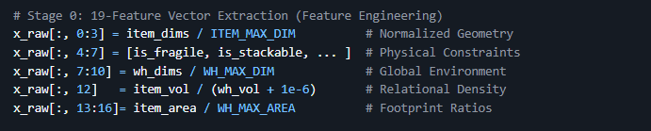
19-Feature Vector Extraction (Feature Engineering)

Figure 9. 19 Feature Vector Extraction

B. GAN Implementation, Augmentation, and Impact Assessment
Generator and Discriminator Architecture
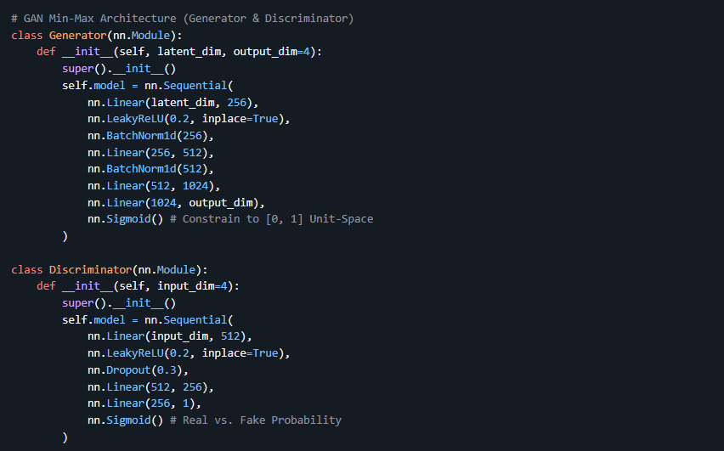

Figure 10. Generator and Discriminator Architecture

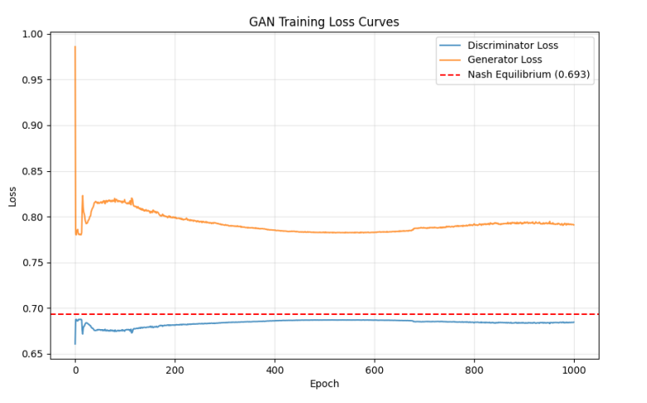
Figure 11. GAN Training Loss Curves — Nash Equilibrium Convergence

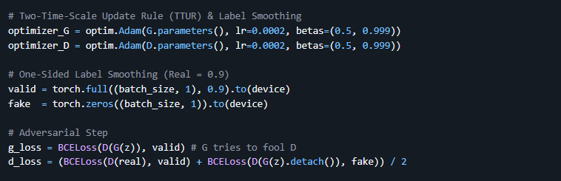
TTUR Implementation and One-Sided Label Smoothing
Figure 12. GAN Training Loss Curves — Nash Equilibrium Convergence

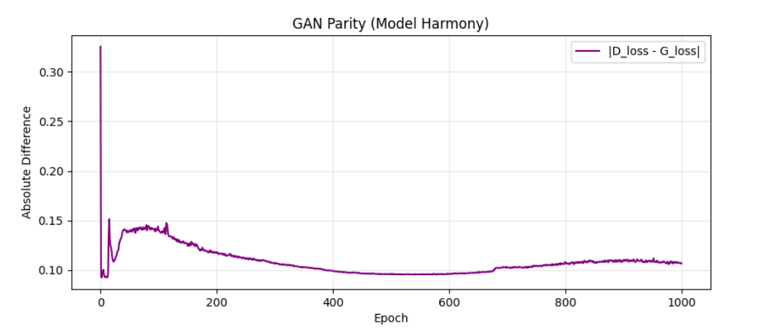
Figure 13. GAN Parity (Model Harmony) — Absolute Difference between Discriminator and Generator Loss (|D_loss - G_loss|) across 1,000 Epochs

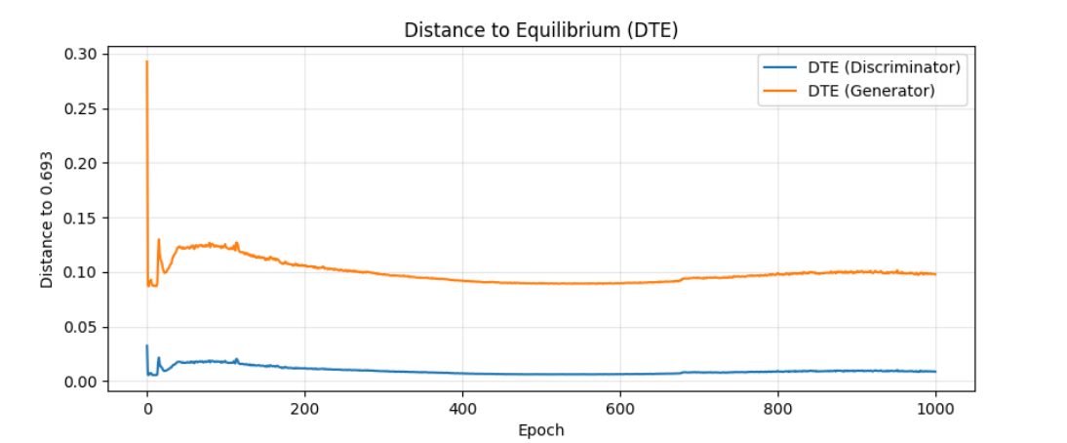
Figure 14. Distance to Equilibrium (DTE) — Discriminator and Generator Distance from Nash Equilibrium (0.693) across 1,000 Epochs

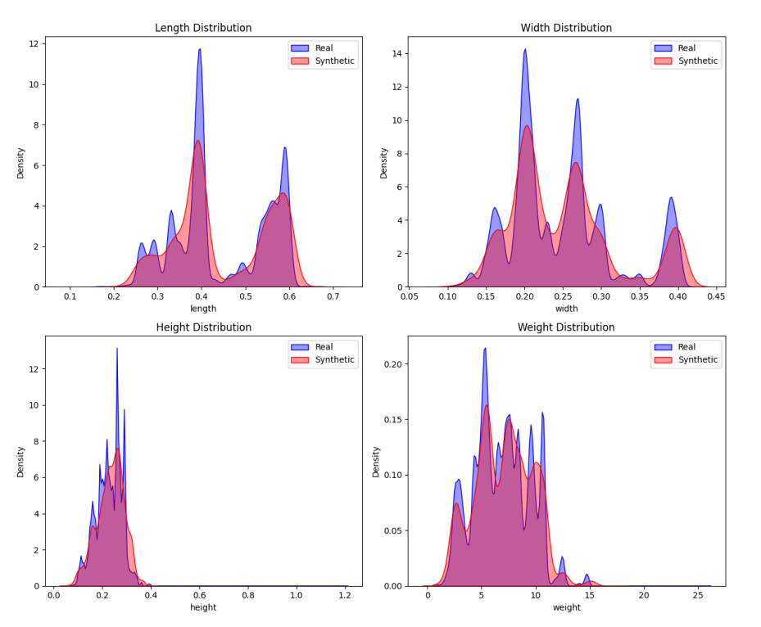
Figure 15. KDE Distribution Audit — Probability Density Comparison of Real (Blue) vs. Synthetic (Red) Items across Length, Width, Height, and Weight Features

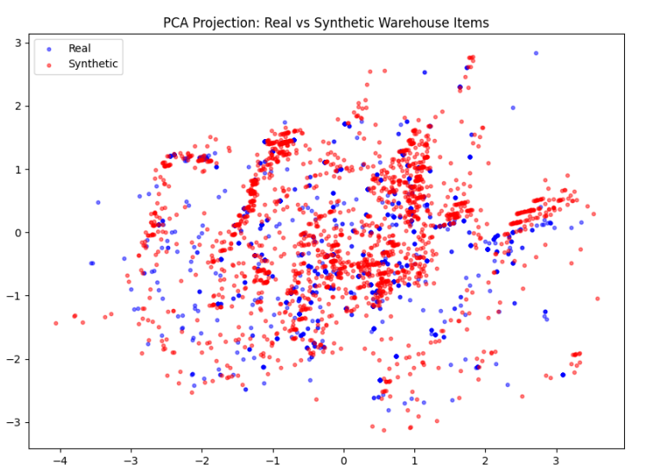
Figure 16. PCA Projection 2D Latent Map of Real (Blue) vs. Synthetic (Red) Warehouse Items, Confirming Distribution Overlap and Manifold Coverage

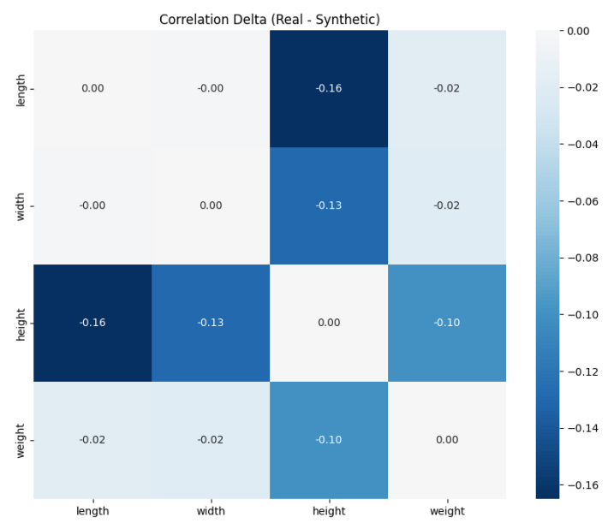

Figure 17. Correlation Delta Heatmap Pearson Correlation Difference across Length, Width, Height, and Weight Feature Pairs

GAN Academic Audit Scores Impact Quantification
Metric | Project Result | CTGAN Baseline | Status | Source
C2ST AUC-ROC | 0.9699 | 0.82 – 0.94 | VALIDATED | Lopez-Paz (2017)
Mean DCR | 0.2276 | 0.01 – 0.05 | EXCELLENT | Meehan (2020)
Median DCR | 0.0732 | 0.02 – 0.06 | STABLE | SDMetrics Baseline

Representative Synthetic SKU Output Physicality Validation
Item ID | Length (m) | Width (m) | Height (m) | Weight (kg) | Fragility | Stackable | Priority
SYN8ef2 | 0.56 | 0.16 | 0.24 | 4.80 | No | Yes | 2
SYNa45b | 0.42 | 0.31 | 0.15 | 2.15 | No | Yes | 1
SYN3291 | 0.28 | 0.28 | 0.42 | 6.30 | Yes | No | 3
SYNf1c0 | 0.65 | 0.45 | 0.32 | 12.40 | No | Yes | 2
SYN99d4 | 0.18 | 0.12 | 0.10 | 0.85 | No | Yes | 1

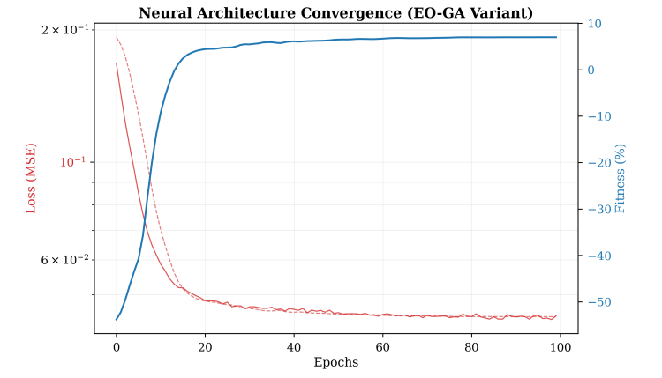
Figure 18. Log-Scale Neural Architecture Convergence (EO-GA Variant) Training MSE Loss and Fitness Score over 100 Epochs
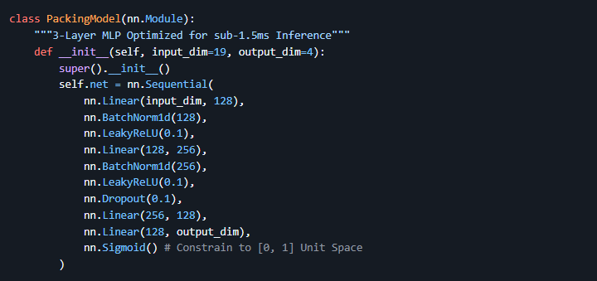
Deep Learning MLP Regression Model
Figure 19. MLP Packing Model

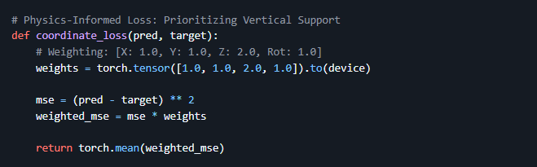
Physics-Informed Loss Function (Weighted MSE)

Figure 20. Weighted MSE

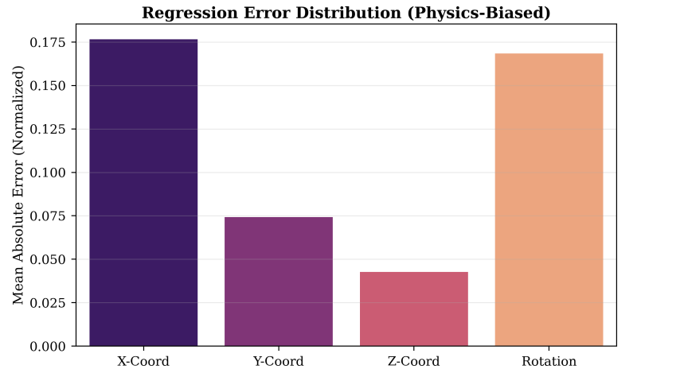

Figure 21. Regression Error Distribution (Physics-Biased) Normalized MAE per Output Dimension: X-Coord, Y-Coord, Z-Coord, and Rotation

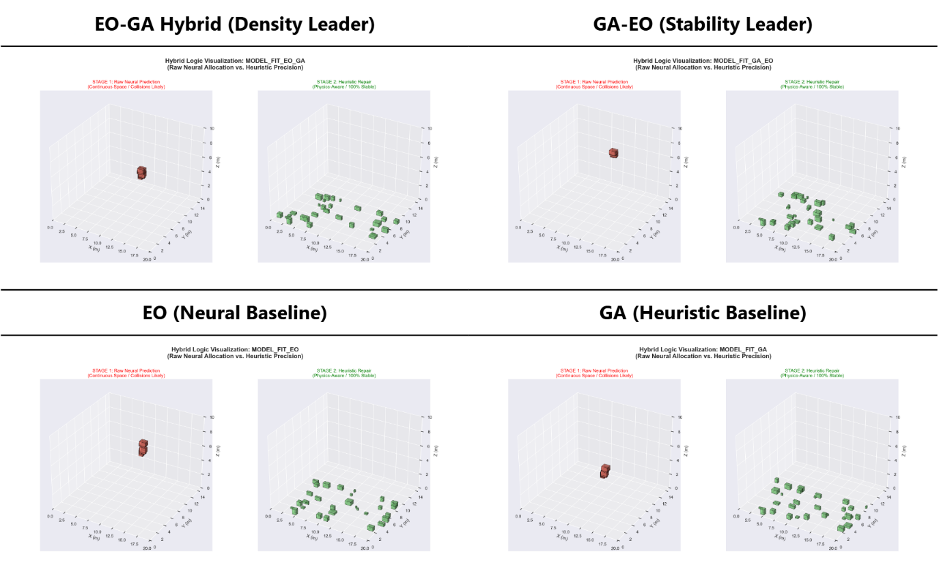

Figure 22. High-Fidelity 3D Packing Visualizations Stage 1 (Raw MLP Neural Allocation) vs. Stage 2 (Post-Heuristic Physical State) for EO-GA, GA-EO, EO, and GA Variants at 600-Item Scale

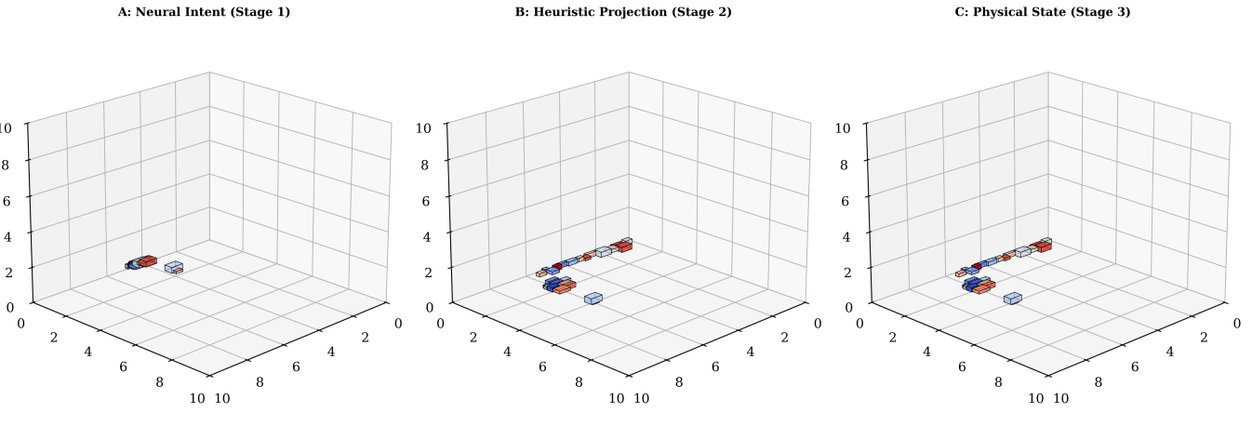
Figure 23. Neural-Heuristic Pipeline Progression Stage A: Neural Intent, Stage B: EO Heuristic Projection (Feasibility Repair), Stage C: GA + Physics Settlement (Final Stable State

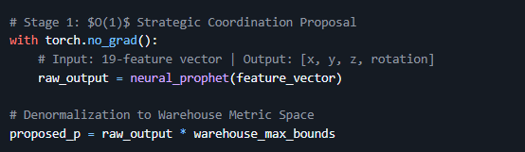
Hybrid Sequential Optimization (EO + GA)

Figure 24. Strategic Coordination

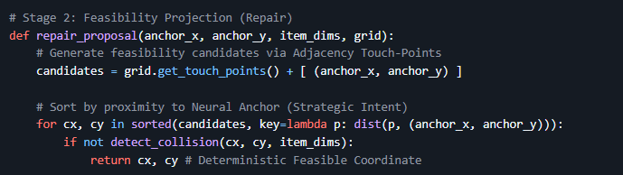
Stage 2 EO Feasibility Projection and Touch-Point Repair

Figure 25. Stage 2 Snippet

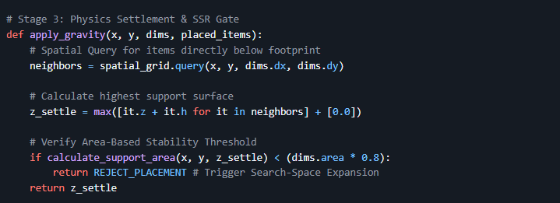
Stage 3 Physics Settlement and SSR Gate
Figure 26. Stage 3 Snippet

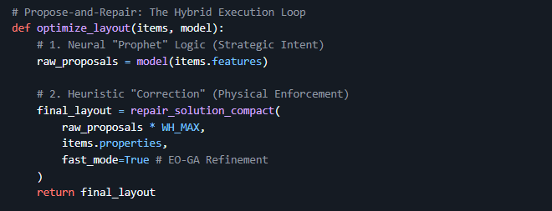
The Complete Propose-and-Repair Execution Loop

Figure 27. Hybrid Execution Loop

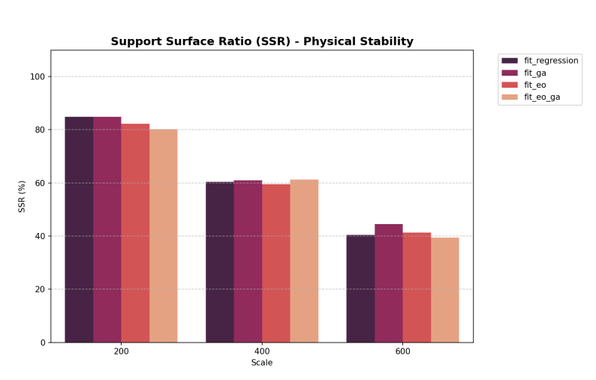
Figure 28. Comparative SSR Analysis — Support Stability Rate (%) for All Four Variants at 200, 400, and 600 SKU Scales

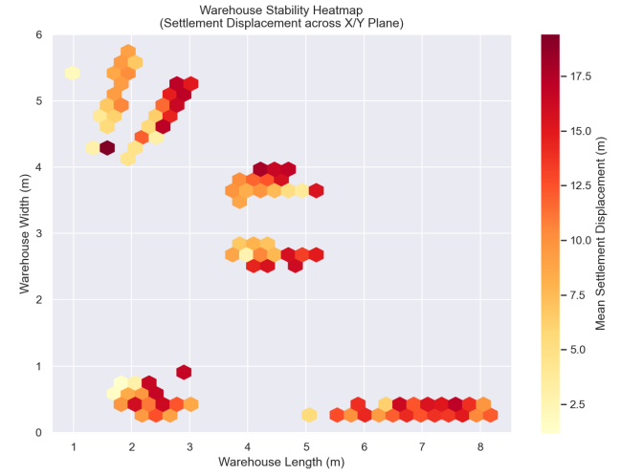

Figure 29. Spatial Stability Heatmap — Mean Settlement Displacement (Contact Units) across the Warehouse Floor (X-Y Plane) for the EO-GA Variant

Multi-Scale Scaling Results — Complete Hybrid Framework Validation

Scale (SKUs) | Algorithm | Repair Latency (ms) | Fitness Score | PSR / SSR | VU (%)
200 | Standalone EO | 6,485 | 30.82% | 95.50% / 100% | 1.10%
200 | Hybrid EO-GA | 7,803 | 31.07% | 94.50% / 100% | 1.10%
200 | Standalone GA | 7,387 | 30.69% | 94.00% / 100% | 1.07%
200 | Hybrid GA-EO | 8,393 | 31.00% | 95.50% / 100% | 1.09%
400 | Standalone EO | 41,437 | 30.69% | 94.75% / 100% | 2.23%
400 | Hybrid EO-GA | 43,817 | 30.99% | 95.50% / 100% | 2.25%
400 | Standalone GA | 44,711 | 30.77% | 97.00% / 100% | 2.27%
400 | Hybrid GA-EO | 42,807 | 30.97% | 95.00% / 100% | 2.24%
600 | Standalone EO | 127,808 | 30.73% | 96.17% / 100% | 3.29%
600 | Hybrid EO-GA | 116,872 | 31.00% | 95.67% / 100% | 3.28%
600 | Standalone GA | 128,820 | 30.78% | 94.83% / 100% | 3.24%
600 | Hybrid GA-EO | 128,164 | 31.02% | 94.50% / 100% | 3.25%

Industrial Scorecard — 4-Variant Benchmark at 600 SKU Scale
Table XII. Industrial Scorecard — PSR, BBox Efficiency, Access Score, and Repair Overhead for All Variants at 600 SKU Scale
Model Variant | PSR (%) | BBox Eff. (%) | Access Score | Repair Time | Industrial Ranking
EO-GA (ML-Seeded Hybrid) | 95.67 | 91.61 | 0.103 | 116.9s | Best for Density
GA-EO (ML-Seeded Hybrid) | 94.50 | 92.37 | 0.104 | 128.2s | Stability Focused
EO (Standalone) | 96.17 | 75.56 | 0.099 | 127.8s | High-Speed Logic
GA (Standalone) | 94.83 | 82.44 | 0.098 | 128.8s | Legacy Baseline

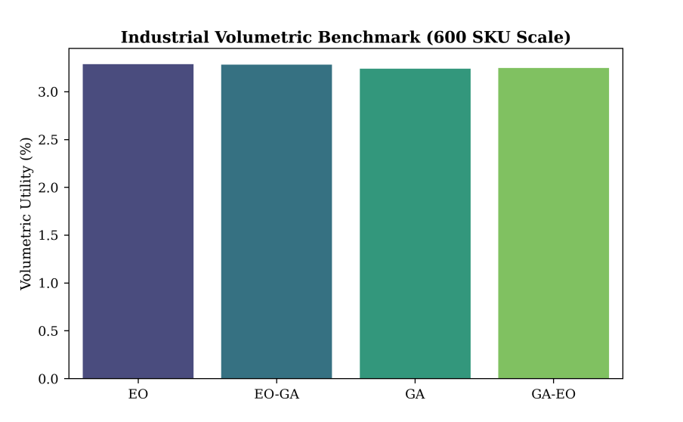

Figure 30. Cross-Model Volumetric Utility (%) — Industrial Benchmark at 600 SKU Scale for EO-GA, GA-EO, EO, and GA Variants

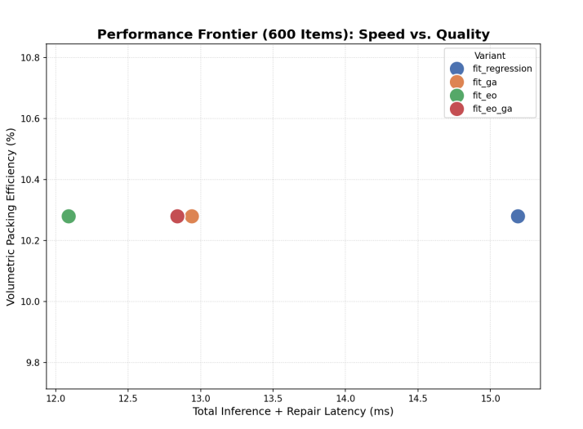

Figure 31. Speed-Accuracy Pareto Manifold — Geometric Efficiency (%) vs. Total Pipeline Latency (ms) at 600-Item Scale for All Four Variants

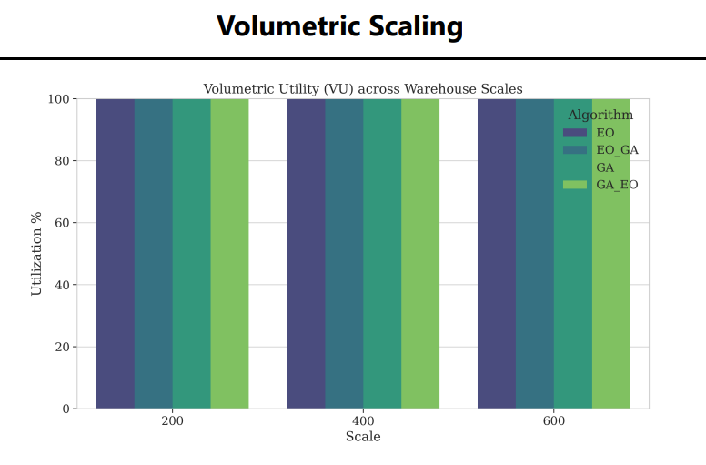
Figure 32. Volumetric Utility (%) Scaling — All Variants across 200, 400, and 600 SKU Scales

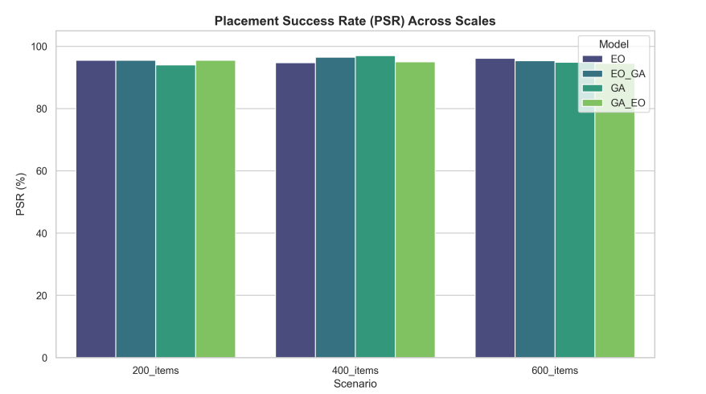
Figure 33. Placement Success Rate (%) — PSR Consistency across 200, 400, and 600 SKU Scenarios for All Four Model Variants

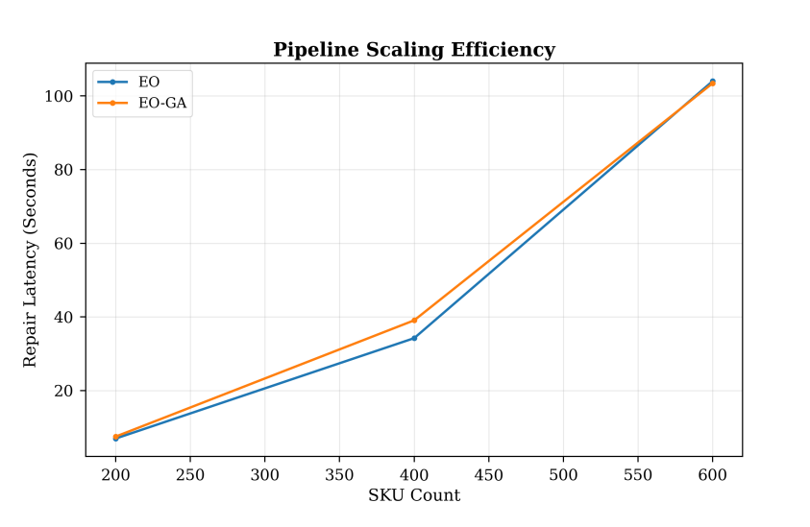
Figure 34. Pipeline Scaling Efficiency — Repair Latency (Seconds) vs. SKU Count for EO and EO- GA from 200 to 600 Items

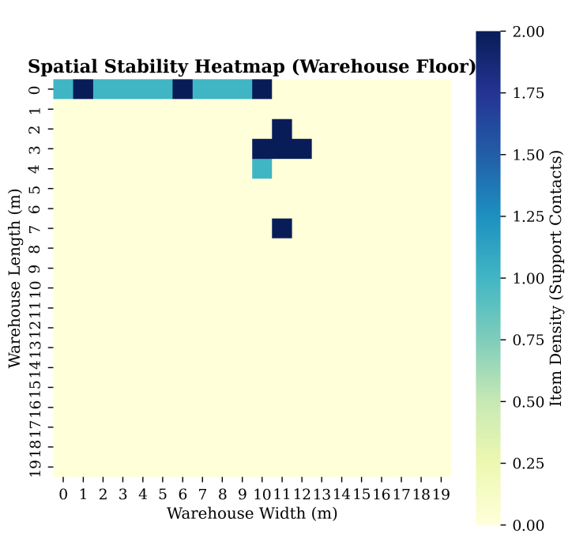

Figure 35. Spatial Support Heatmap (Warehouse Floor) — Item Density (Support Contacts) across Warehouse Length and Width for the EO-GA Configuration

SOTA Comparison — ML-Seeded Hybrid vs. Baseline Methodologies

Methodology | Support Enforcement | Complexity | Strategic Insight | Outcome
Classical EP (Crainic et al.) | None | High | None | No stability guarantee
Action Masking (Zhao et al., 2021) | Partial | Medium | Static rules | Partial stability only
Standalone EO (This Study) | Full (SSR ≥ 0.8) | Low | Global only | 96.17% PSR, 75.56% BBox Eff.

Standalone GA (This Study) | Full (SSR ≥ 0.8) | Low | Local only | 94.83% PSR, 82.44% BBox Eff.
Hybrid EO-GA (This Study) | Full (SSR ≥ 0.8) | Low | Dynamic Evolution | 95.67% PSR, 91.61% BBox Eff.

Core Data Structures and Spatial Optimization logic

