Tom Gilgenkrantz

# Relevant Projects & Activities (Tech)

**Personal Website Development** | *HTML, CSS, Javascript*

* Creation of a personal HTML website
* Animation with CSS/JavaScript
* Development of a responsive web design
* Deployment of the website on a cloud hosting platform (github)



**Board Game** | *Python, C*

* Implementation in C of a 2D Tetris-like game
* Implementation in Python of a 3D game
* Mathematical research documents on these games
* Research activities on automatic game algorithm

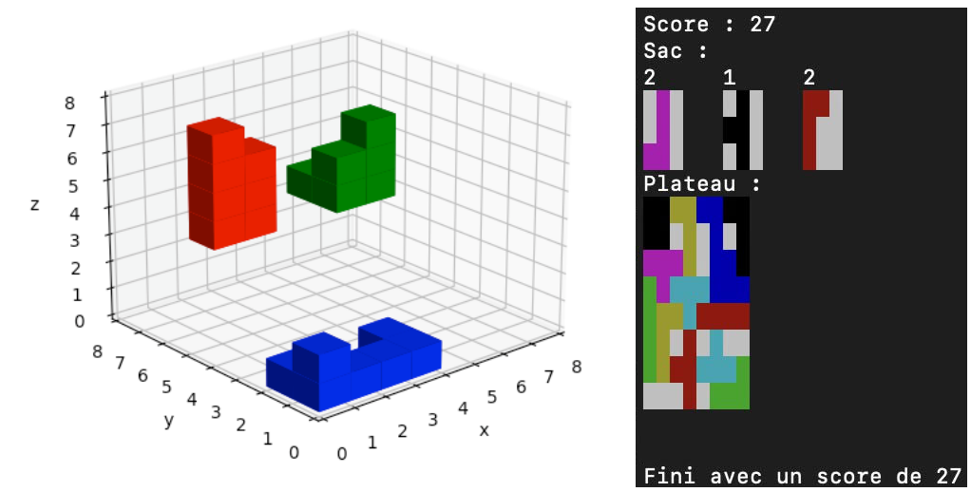

**Contact Management Software** | *Java*

* Application to manage contacts in an object-oriented language

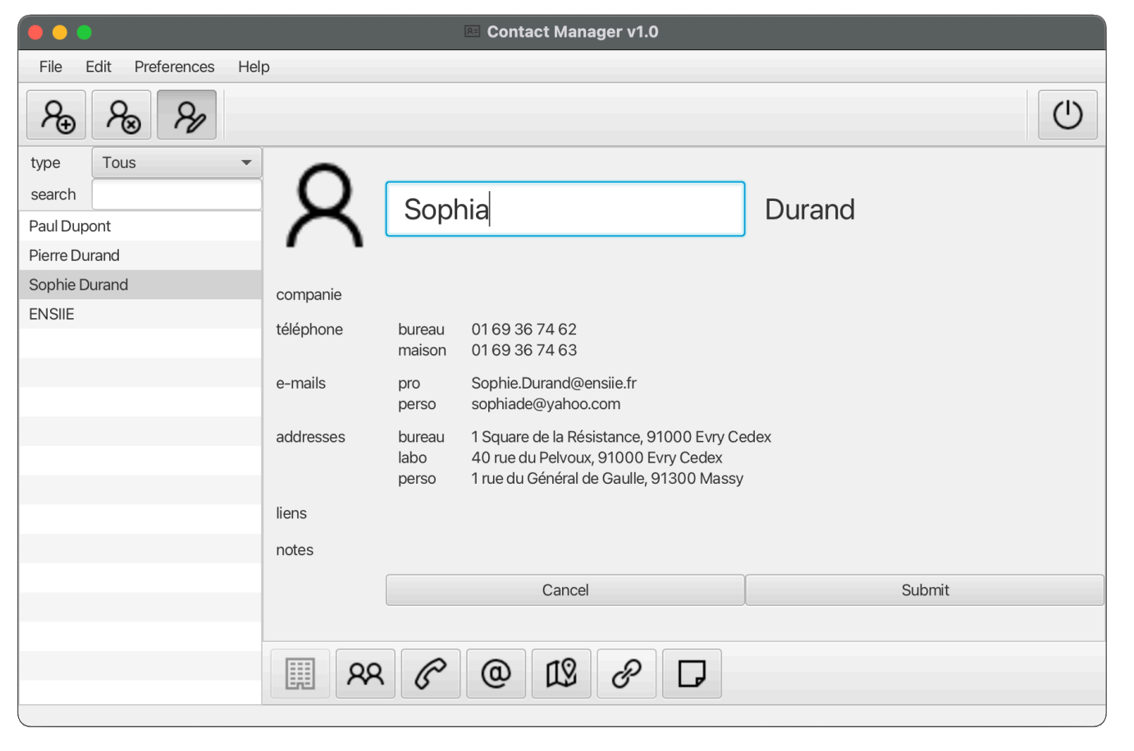

**Group classification using decision tree** | *Ocaml*

* Classification algorithm for datasets using quaternary trees
* Research documents on model performance

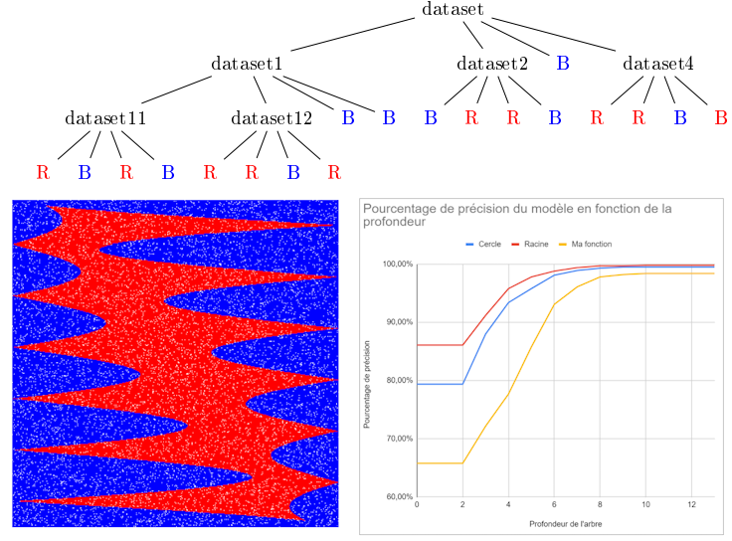

**Crowd simulation** | *Python*

* Use of Dijkstra and adaptation of A-star to manage people's behavior
* Development of a cellular automaton model
* Application to my high school and proposal to improve its emergency exits

