KABARAK UNIVERSITY
SCHOOL OF SCIENCE, ENGINEERING & TECHNOLOGY
DEPARTMENT OF COMPUTER SCIENCE AND INFORMATION TECHNOLOGY
[ UNIVERSITY CREST — insert Kabarak University logo ]
DESIGN AND EVALUATION OF THE KABARAK MEDICAL CENTER
DIGITAL QUEUE MANAGEMENT SYSTEM
(A Human-Computer Interaction / User-Centred Design Project)
PRESENTED
By:
Emmanuel Okoth Ouma — Reg. No: CS/MG/3350/09/22
Stephen Robert Ochieng Nyambok — Reg. No: CS/M/0113/01/24
Joseph Kihuria — Reg. No: INTE/M/1179/09/23
Kuku Butrous Ibrahim — Reg. No: INTE/M/0521/01/24

LECTURER: ____________________________
A practical HCI / User Interface Design project report submitted to the Department of
Computer Science and Information Technology, Kabarak University.
AUGUST 2026

CONTENTS
1. Problem Statement
2. Context of Use
3. Objectives
4. User Study Techniques
5. User Analysis Techniques
6. Prototyping
7. Storyboards
8. Evaluation of the Prototype
9. References
10. Conclusion
11. Appendices

1. PROBLEM STATEMENT
Kabarak University Medical Center provides outpatient services to a large population of students and staff. A typical visit moves through four stages: identification and registration at reception, vital-signs checks, clinical consultation with a doctor or clinical officer, and medication collection at the pharmacy. At present this journey is coordinated almost entirely through paper slips, verbal name-calling and the personal awareness of staff. These informal methods can cope at quiet times, but during peak periods they break down.
The central problem is that the Medical Center lacks a single, visible and accountable mechanism for managing patient flow from registration to medication collection. Routine check-in order is not consistently traceable, so patients cannot tell how far they are from being served and sometimes see people who arrived later being attended to first. This uncertainty pushes anxious patients to crowd around consultation doors, which in turn makes it even harder for staff to tell who is genuinely next. Paper tokens are easily lost or mixed up, and when several patients answer to a similar name, turns are missed.
The situation is complicated by the clinical reality that a purely first-come-first-served rule is unsafe: emergency and urgent cases must sometimes be seen ahead of routine patients. When such prioritisation happens without any shared record, other patients experience it as unfairness rather than clinical necessity. Calling patients aloud by name also exposes personal and health-related information to everyone in the waiting area, which conflicts with patients' reasonable expectation of privacy.
There is therefore a clear need for a user-centred digital queue and patient-flow system that records check-in order, makes progress visible to each patient in a private and understandable way, allows authorised clinical staff to prioritise emergencies through a logged and accountable decision, and continues to function through a documented manual fallback when power or network fails.

2. CONTEXT OF USE
The proposed system is a web-based interactive application designed for use within the Kabarak University Medical Center, a campus outpatient clinic in a Kenyan university setting. It is used across the reception desk, the vital-signs room, the consultation rooms, the pharmacy window and a shared waiting-area display screen. The environment is frequently busy, noisy and subject to interruption by genuine emergencies, and it must remain workable when staff numbers are limited and traffic peaks.
The primary users are patients — students and university staff seeking care. They range from confident, smartphone-owning students to elderly staff and first-time visitors who may be under stress, may have low digital confidence, may have a disability, or may not own a smartphone at all. Because of this diversity, the system cannot assume a personal device: it must communicate through a public screen, a printed token and an optional SMS or phone alert, using plain language. Patients only ever see their own token, current stage, number of people ahead and a cautious waiting range — never other patients' identities or any medical detail.
The operational users are the clinic staff, each with a distinct role and a distinct information need:
- Reception / records personnel register a patient, capture the check-in time, issue a token and operate the manual fallback and later reconciliation.
- Nurse / vital-signs (triage) staff view priority and stage, mark vitals complete, recall or skip a patient, and — as an authorised clinical role — may assign clinical priority.
- Doctors / clinical officers view the priority queue, conduct the consultation, assign emergency or urgent priority with a logged reason, return a patient after laboratory tests, and transfer the patient to pharmacy.
- Pharmacy personnel view the pharmacy queue and mark medicine ready, issued or unavailable before closing the visit.
Supporting users include Medical Center management, who review de-identified dashboards and the audit log, and authorised IT/support personnel. The context also imposes strong non-technical constraints: Kenya's Health Act, Data Protection Act and Digital Health Act require health information to be kept confidential, access to be role-based, and actions to be auditable, while WCAG 2.2 sets the accessibility standard the interface must meet.

3. OBJECTIVES

3.1 General Objective
To design and evaluate a user-centred digital queue and patient-flow management system that makes outpatient service order at the Kabarak University Medical Center fair, visible, private and accountable, from registration through to medication collection.

3.2 Specific Objectives
The specific objectives of this project are to:
- Investigate the current patient-flow process at the Medical Center in order to identify the queue-management, usability and privacy problems experienced by patients and staff.
- Analyse users, tasks and the context of use in order to establish clear functional and non-functional requirements for the proposed system.
- Design a system that records check-in order and serves routine patients fairly by that order within each service stage.
- Design mechanisms that communicate each patient's progress — token, stage, people ahead and a cautious waiting range — privately and in plain language.
- Design an accountable prioritisation feature that allows only authorised clinical staff to assign emergency or urgent priority, recording the role, time and a non-sensitive reason.
- Design for offline resilience through a documented manual fallback and later reconciliation, and for accessibility in line with WCAG 2.2.
- Develop low- and high-fidelity prototypes and evaluate them with representative users in order to refine the final design.

4. USER STUDY TECHNIQUES

4.1 Introduction
A user study is the process of gathering information from intended users in order to understand their needs, behaviours, constraints and context before design decisions are fixed. Following a User-Centred Design approach, the project selected each technique because it answered a specific project question rather than because it was convenient. Three complementary techniques were used: semi-structured interviews to explore experiences in depth, role-specific questionnaires to collect comparable structured responses, and observation to see how the current process actually behaves. Participation was voluntary and anonymous, and no names, diagnoses, symptoms or prescriptions were recorded.

4.2 Interviews
Semi-structured interviews were used as a qualitative technique to understand how patients and staff experience the current queue and where it fails them. Separate short interview guides were prepared for patients, reception and records personnel, clinical staff, and pharmacy personnel, so that each conversation stayed relevant to that person's part of the journey. Patients were asked about how they know their place in the queue, whether they have seen later arrivals served first, and how they feel about being called by name; staff were asked how they decide who is next, how they handle emergencies, and what happens when the power or system fails.
The interviews consistently pointed to the same underlying issues: an absence of shared, visible order; anxiety caused by not knowing how long the wait will be; discomfort with public name-calling; and the need for a safe way to prioritise genuine emergencies without appearing to treat routine patients unfairly. These findings directly shaped the requirement for a private, per-patient progress view and an accountable, logged prioritisation feature.

4.3 Questionnaires
Structured questionnaires were used to collect comparable, role-specific responses from the six key points along the patient journey — students seeking care, staff seeking care, reception/records, nurses/vital-signs, doctors/clinical officers and pharmacy personnel. Each form used simple tick-box items with an optional comment space, and each was tailored so that respondents were only asked about tasks they actually perform. Items probed the clarity of the current steps, whether patients are served in check-in order, which information would be most useful while waiting, preferred notification methods, attitudes to a queue number replacing name-calling, and support for authorised clinical prioritisation.
Because the study was exploratory and each role was represented by a small number of voluntary respondents, the questionnaire results were summarised descriptively rather than treated as statistically generalisable. They nonetheless gave a clear, convergent picture of user preferences that reinforced the interview findings and helped prioritise system features. Two representative questionnaire instruments are reproduced in Appendices A and B.

4.4 Observation
Observation and light contextual inquiry were used to study how the patient-flow process behaves in practice, rather than how people report it behaves. The observer noted, at each stage, how patients learn that it is their turn, where crowding forms, how staff track who is next, how emergencies are handled, and what happens during interruptions. Observation is valuable here because much of the current coordination is tacit — carried in staff memory and informal cues — and is therefore easy to miss in interviews alone.
The observations confirmed that waiting occurs several times in a single visit rather than once, that patients gravitate toward service doors to avoid missing a call, and that the current process depends heavily on paper and verbal calls with limited shared visibility. These insights motivated a single token that persists across all four stages and a design that distinguishes states such as “waiting for vitals,” “vitals complete” and “waiting for clinician.”

5. USER ANALYSIS TECHNIQUES
After collecting data through interviews, questionnaires and observation, the information was analysed to build a clear picture of the users, their goals and the tasks the system must support. Three analysis tools were used: evidence-based personas to represent the main user types, an empathy map to deepen understanding of the primary patient, and a use-case diagram to model how each actor interacts with the system. These outputs guided feature prioritisation and helped keep the design focused on real user needs.

5.1 Personas
Personas are realistic, evidence-based profiles built from user research to represent the goals, behaviours and constraints of the system's main users. They are design tools, not demographic stereotypes. Three personas were developed for this project: a primary persona representing the student patient, and two secondary personas representing a reception/records clerk and a nurse/triage officer. Each captures the recurring goals and frustrations that emerged from the field study and keeps the whole team aligned on who the design must serve.
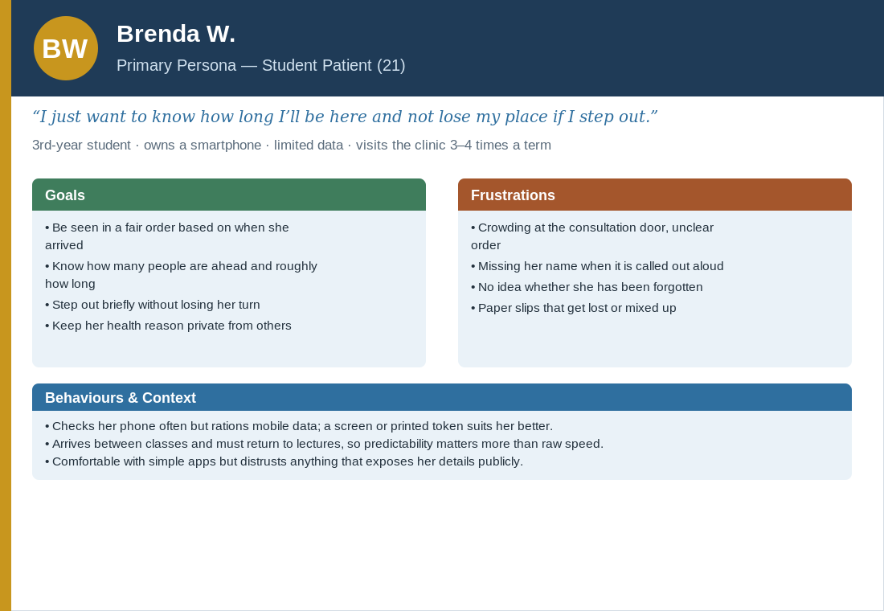
Figure 1: Primary persona — student patient.
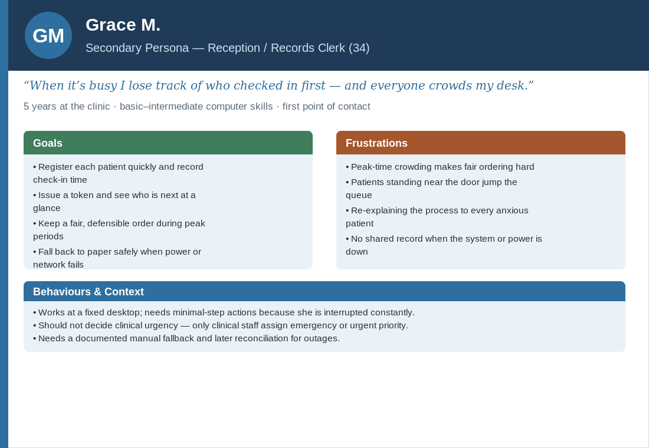
Figure 2: Secondary persona — reception / records clerk.
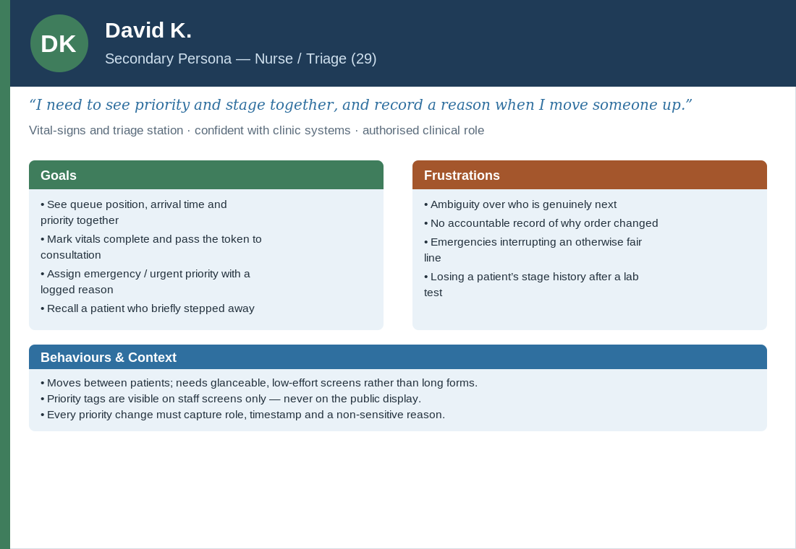
Figure 3: Secondary persona — nurse / triage officer.

5.2 Empathy Map
An empathy map is a user-analysis tool that organises what a user says, thinks, does and feels, helping the team see the experience from the user's point of view. The empathy map below focuses on the primary patient persona while she waits for care. It shows that she openly asks how many people are ahead and whether her number has been called, privately worries about missing her turn and about her health reason being overheard, copes by hovering near the door and repeatedly checking the display, and ultimately feels anxious and exposed until progress becomes visible. These pains and gains translate directly into the design goals of visible progress, fair order, privacy and the ability to keep one's place.
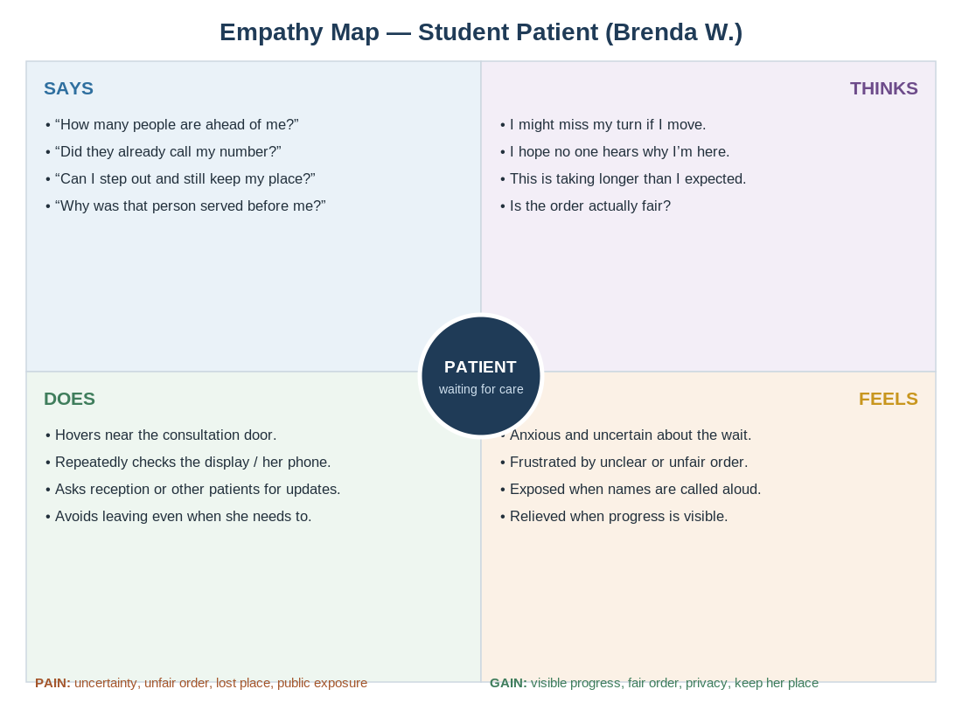
Figure 4: Empathy map for the primary patient persona.

5.3 Use Case Diagram
A use-case diagram is a UML model that shows how different actors interact with the functions of the system. The diagram separates patient information needs from staff actions and, crucially, restricts the assignment of clinical priority to authorised clinical roles. The patient can get and view a token, check queue status and receive notifications. Reception registers patients and issues tokens; the nurse marks vitals complete, calls or recalls patients and may assign priority; the clinician conducts the consultation, assigns emergency or urgent priority and transfers the patient onward; the pharmacist marks medicine ready or issued; and management reviews dashboards and the audit log.
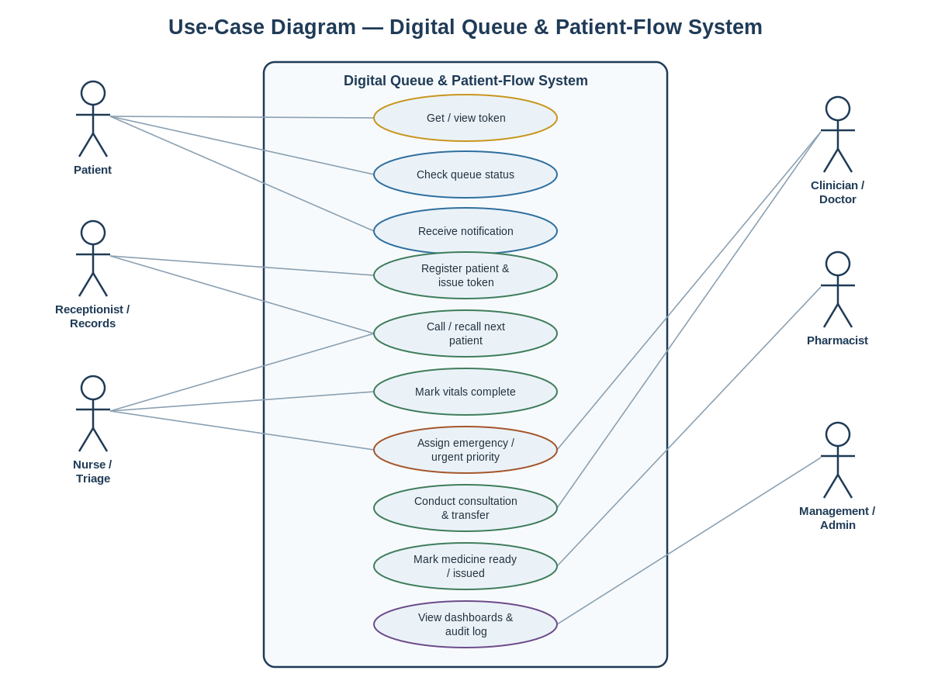
Figure 5: Use-case diagram for the digital queue and patient-flow system.

6. PROTOTYPING
Prototyping is the process of creating a visual representation of the system before full development begins, so that ideas can be tested and refined cheaply. Following the iterative User-Centred Design approach, the project moved from low-fidelity wireframes that fix structure and flow, to a high-fidelity interactive prototype that closely resembles the intended final interface. All prototype content uses fictional tokens and data only.

6.1 Low-Fidelity Prototype
The low-fidelity prototype consists of simple wireframe sketches that establish layout, content and navigation without visual styling. Three core screens were wireframed. The patient status screen shows the patient's token prominently at the top, the current stage on a four-step progress indicator (Registration → Vitals → Consultation → Pharmacy), the number of people ahead, a cautious waiting range and the time of the last update. The public waiting-room display shows a simple list of anonymous tokens and their destinations only, for example “T-041 → Consultation,” with no names or medical detail. The staff dashboard shows a role-specific queue list with arrival time, token, stage and — on staff screens only — a priority tag, together with minimal-step action buttons such as Call Next, Mark Complete and Recall.
[FIGURE 6: Low-fidelity patient status wireframe — insert sketch from group prototype]
[FIGURE 7: Low-fidelity staff dashboard wireframe — insert sketch from group prototype]

6.2 High-Fidelity Prototype
The high-fidelity prototype is a detailed, interactive representation that applies real layout, typography, colour and clickable navigation while remaining faithful to the wireframes. It is designed to WCAG 2.2 guidance — readable text, sufficient contrast, visible keyboard focus, adequate target sizes and clear error messages — and to work for users without smartphones through the shared screen and printed token. The interactive flow covers registration and token issue, the patient progress view, the anonymous waiting-room display, vitals completion, authorised priority assignment, consultation transfer, pharmacy readiness, missed-turn recovery, return after laboratory tests, the medicine-unavailable state, and the offline fallback message.
[FIGURE 8: High-fidelity patient token / progress screen — insert screenshot from group prototype]
[FIGURE 9: High-fidelity anonymous waiting-room display — insert screenshot from group prototype]
[FIGURE 10: High-fidelity role-based staff dashboard — insert screenshot from group prototype]

7. STORYBOARDS
A storyboard is a sequence of frames that shows, step by step, how a user interacts with the system in a realistic situation. The storyboard below follows Brenda, the primary patient persona, through a complete visit from token to pharmacy, illustrating how the design resolves the problems identified in the field study.
- Frame 1 — Arrival and registration. Brenda presents her student card at reception. The clerk registers her, the system records her check-in time and issues token T-041. She receives it on the screen and as a printed slip.
- Frame 2 — Waiting with visibility. Brenda sits down and checks the waiting-room display and her token view. It shows “Vitals — 3 people ahead — about 10–20 min.” She now knows she has time and does not need to crowd the door.
- Frame 3 — Stepping away safely. She briefly steps out. Her turn comes and she is marked temporarily away rather than missed; when she returns she is recalled and keeps her place.
- Frame 4 — Vitals and consultation. The nurse takes her vitals and marks them complete; her token moves to “Waiting for clinician.” An emergency arrives and a clinician assigns it emergency priority with a logged reason. The public screen still shows only anonymous tokens, so the reordering is accountable but not exposed.
- Frame 5 — Pharmacy and completion. After consultation, her token moves to pharmacy and shows “Medicine ready.” She collects her medication, the pharmacist marks it issued, and her visit is closed.
[STORYBOARD STRIP: Frames 1–5 — insert illustrated storyboard frames from group prototype]

8. EVALUATION OF THE PROTOTYPE
The prototype is evaluated to assess its usability, effectiveness and privacy before any wider pilot. The plan combines expert inspection with representative-user testing, using four complementary methods: usability testing, a post-test questionnaire, the think-aloud technique and heuristic evaluation. Evaluation is iterative — findings feed back into the design.

8.1 Usability Testing
Usability testing evaluates how effectively representative users can complete real tasks with the high-fidelity prototype. Participants are drawn from the actual user groups — students and staff acting as patients, and reception, nursing, clinical and pharmacy staff. Each participant attempts a set of core tasks, such as reading their token and waiting information, recovering a place after stepping away, a nurse marking vitals complete, a clinician assigning emergency priority with a reason, and a pharmacist marking medicine issued. The evaluation measures task completion rate, time on task, error rate, and observed points of confusion, with a particular focus on whether patients can correctly explain routine versus emergency priority and whether any privacy leak occurs.

8.2 Questionnaire
A short post-test questionnaire is administered immediately after each usability session to capture users' perceptions and satisfaction. It uses a five-point Likert scale to rate ease of use, clarity of the progress information, confidence in the fairness of the queue, comfort with privacy, and overall satisfaction, followed by an open comment field. Administering it right after the tasks keeps the experience fresh and allows subjective ratings to be compared against the observed task performance.

8.3 Think-Aloud Technique
In the think-aloud technique, participants verbalise their thoughts as they work through each task, saying what they expect, what they are looking for and where they hesitate. This exposes the reasoning behind errors and reveals mismatches between the users' mental model and the interface — for example, whether the four-stage progress indicator is understood, or whether a patient realises they can step away without losing their place. The commentary is recorded as observational notes and used to locate and prioritise specific design fixes.

8.4 Heuristic Evaluation
Heuristic evaluation is an expert inspection method in which evaluators judge the interface against established usability principles, using Nielsen's ten heuristics. The inspection pays particular attention to visibility of system status (token, stage, people ahead, waiting range), match between the system and the real world (plain, non-technical language), user control and freedom (recall and undo of a missed turn), consistency and standards, error prevention, and help and recovery — extended in this project with explicit checks on privacy (no health detail on public screens) and offline recovery. Each issue found is rated by severity so the team can address the most serious problems first.

8.5 Expected Outcomes
Following evaluation and refinement, the system is expected to make service order fair and visible, reduce crowding at service doors, lower patients' perceived waiting anxiety, protect privacy by replacing public name-calling with anonymous tokens, and provide an accountable record of every priority change. The target criteria are at least 80% successful completion of core tasks without assistance, no unresolved critical safety or privacy defect, a mean ease-of-use rating of at least 4 out of 5, and at least 80% of patient participants able to correctly explain the difference between routine and emergency priority.

9. REFERENCES
International Organization for Standardization. (2018). ISO 9241-11:2018 Ergonomics of human-system interaction — Part 11: Usability: Definitions and concepts. ISO.
International Organization for Standardization. (2019). ISO 9241-210:2019 Ergonomics of human-system interaction — Part 210: Human-centred design for interactive systems. ISO.
Kenya. (2017). Health Act (Cap. 241). Nairobi: Kenya Law.
Kenya. (2019). Data Protection Act (Cap. 411C). Nairobi: Kenya Law.
Kenya. (2023). Digital Health Act, No. 15 of 2023. Nairobi: Kenya Law.
Lazar, J., Feng, J. H., & Hochheiser, H. (2017). Research methods in human-computer interaction (2nd ed.). Morgan Kaufmann.
Nielsen, J. (1994). Usability engineering. Morgan Kaufmann.
Nielsen, J., & Mack, R. L. (Eds.). (1994). Usability inspection methods. John Wiley & Sons.
Norman, D. A. (2013). The design of everyday things (Revised and expanded ed.). Basic Books.
Preece, J., Sharp, H., & Rogers, Y. (2019). Interaction design: Beyond human-computer interaction (5th ed.). Wiley.
W3C Web Accessibility Initiative. (2023). Web Content Accessibility Guidelines (WCAG) 2.2. https://www.w3.org/TR/WCAG22/
World Health Organization. (2023). Interagency Integrated Triage Tool. Geneva: WHO. https://www.who.int/tools/triage

10. CONCLUSION
This project set out to address a common but consequential problem at the Kabarak University Medical Center: outpatient service order that is invisible, difficult to trace, uncomfortable for privacy and hard to reconcile with the clinical need to prioritise emergencies. Through interviews, role-specific questionnaires and observation, the study confirmed that the current paper-and-voice process provides too little shared visibility during busy periods, and it translated these findings into personas, an empathy map, a use-case model and a clear set of requirements.
The resulting design gives each visit a single anonymous token that persists across registration, vitals, consultation and pharmacy; serves routine patients fairly by recorded check-in time within each stage; communicates progress privately in plain language; restricts emergency and urgent prioritisation to authorised clinical staff through a logged, accountable decision; and remains usable offline through a documented manual fallback. The low- and high-fidelity prototypes demonstrate these mechanisms, and the evaluation plan sets measurable targets for usability, privacy and fairness.
As next steps, the group will complete the high-fidelity prototype screens and storyboards, carry out the planned usability testing and heuristic evaluation with representative users, and refine the design in response to the findings. This report is an HCI / user-centred design study; it deliberately keeps decisions at the design and user-experience level. Any move toward a real-data pilot would require institutional and clinical governance approval, a defined data controller, secure authentication, retention rules and an incident-response process, together with a decision on the technology and hosting approach, none of which are fixed here.

11. APPENDICES

Appendix A Data-Collection Questionnaire — Reception & Records Personnel
KABARAK UNIVERSITY MEDICAL CENTER
QUEUE MANAGEMENT AND PATIENT-FLOW QUESTIONNAIRE
Instructions: Tick the most appropriate response. Tick all relevant boxes where indicated. Do not record names, diagnoses or confidential medical details.
1. The current process records each patient’s check-in order accurately.
☐ Strongly agree ☐ Agree ☐ Neutral ☐ Disagree ☐ Strongly disagree
Comments / reason: ______________________________________________________________
2. It is easy to identify who should be served next.
☐ Strongly agree ☐ Agree ☐ Neutral ☐ Disagree ☐ Strongly disagree
Comments / reason: ______________________________________________________________
3. Patients standing near the consultation door affects who is served next.
☐ Often ☐ Sometimes ☐ Rarely ☐ Never
Comments / reason: ______________________________________________________________
4. Peak periods make it difficult to maintain a fair queue.
☐ Strongly agree ☐ Agree ☐ Neutral ☐ Disagree ☐ Strongly disagree
Comments / reason: ______________________________________________________________
5. A digital check-in time and queue number would improve queue order.
☐ Yes ☐ No ☐ Not sure
Comments / reason: ______________________________________________________________
6. Which information should reception staff see? (Tick all that apply.)
☐ Arrival time ☐ Queue number ☐ Current stage ☐ Priority status
Comments / reason: ______________________________________________________________
7. Authorised clinical staff, rather than reception alone, should assign emergency priority.
☐ Yes ☐ No ☐ Not sure
Comments / reason: ______________________________________________________________
8. Public displays should show queue numbers instead of patient names.
☐ Yes ☐ No ☐ Not sure
Comments / reason: ______________________________________________________________
9. A paper or manual backup is needed during power or system failure.
☐ Yes ☐ No ☐ Not sure
Comments / reason: ______________________________________________________________
10. Which reception feature is most important? (Tick all that apply.)
☐ Register patient ☐ Issue token ☐ Track stage ☐ Recall patient ☐ Other: __________
Comments / reason: ______________________________________________________________
Thank you for your participation.

Appendix B Data-Collection Questionnaire — Patients (Students & Staff Seeking Care)
KABARAK UNIVERSITY MEDICAL CENTER
QUEUE MANAGEMENT AND PATIENT-FLOW QUESTIONNAIRE
Instructions: Tick the most appropriate response. Tick all relevant boxes where indicated. Do not record names, diagnoses or confidential medical details.
1. The steps from registration to medication collection are clear.
☐ Strongly agree ☐ Agree ☐ Neutral ☐ Disagree ☐ Strongly disagree
Comments / reason: ______________________________________________________________
2. Patients are usually attended to in the order they checked in.
☐ Always ☐ Often ☐ Sometimes ☐ Rarely ☐ Never
Comments / reason: ______________________________________________________________
3. I have seen a person who arrived later being served before me.
☐ Yes ☐ No ☐ Not sure
Comments / reason: ______________________________________________________________
4. I can tell how far I am from being served.
☐ Always ☐ Often ☐ Sometimes ☐ Rarely ☐ Never
Comments / reason: ______________________________________________________________
5. A queue number would be better than calling patients by name.
☐ Yes ☐ No ☐ Not sure
Comments / reason: ______________________________________________________________
6. Which information would be most useful while waiting? (Tick all that apply.)
☐ Queue position ☐ People ahead ☐ Waiting time ☐ Next service stage
Comments / reason: ______________________________________________________________
7. Which notification method would you prefer? (Tick all that apply.)
☐ Display screen ☐ SMS ☐ Printed token ☐ Verbal call ☐ Other
Comments / reason: ______________________________________________________________
8. Emergency and urgent cases should be attended to before routine cases.
☐ Yes ☐ No ☐ Not sure
Comments / reason: ______________________________________________________________
9. The current process protects patient privacy.
☐ Strongly agree ☐ Agree ☐ Neutral ☐ Disagree ☐ Strongly disagree
Comments / reason: ______________________________________________________________
10. What is the most important improvement needed in the current process?
☐ Open response
Comments / reason: ______________________________________________________________
Thank you for your participation.

Appendix C Prototype Evaluation — Interview Questions
The following questions are used during the prototype evaluation sessions, immediately after each participant has attempted the assigned tasks. Responses to the rating items are recorded on a five-point Likert scale ranging from Strongly Disagree (1) to Strongly Agree (5); the open items are recorded as written notes.
Participants respond to questions such as:
☐ Was the patient token and progress information easy to understand?
☐ Could you tell how many people were ahead of you and roughly how long you would wait?
☐ Was the navigation between screens clear?
☐ Were the buttons and actions easy to identify?
☐ Were you able to complete all the assigned tasks without help?
☐ Did you understand the difference between routine, urgent and emergency cases?
☐ Did the public display feel private — could others see your details?
☐ Could you recover your place after stepping away from the queue?
☐ Did you experience any difficulty or confusion at any point?
☐ Which feature did you find most useful?
☐ What improvements would you recommend?
Thank you for your participation.

