ATDB Reference

# Intro

The ATDB is the in house database solution for the lab.

## tables

### Specimen table

As a *specimen* is entering the lab, it is recorded in the *specimen* table.

As the specimen is processed, slices and blocks are created and populated in respective tables. See relationships in the Figure below.



Figure 1: Relationships between specimen, slices and blocks.

The specimen table contain specimens from different species, typically Human or Mouse.

As a specimen is first created in the database, a specimen form is displayed: 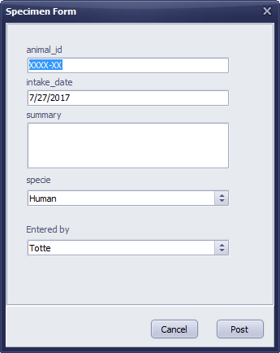

Figure 2: Specimen form and its fields.

### Slices table

The slices table captures information about (vibratome?) slices, obtained from a specimen.

# Appendix

## atdb tasks

As the database evolves, changes to the schema are inevitable. The following sections attempt to capture some common tasks supporting these changes.

### Moving a field from one table to another table

The workflow for moving a field from one table to another table depends on the field. If the field is a simple lookup, a move of the field, and its data is fairly simple:

1. Create the new field, using the proper type(!) in the destination table
2. Move the actual data from source table to destination table:  
   INSERT INTO ‘destination_table’(destcolumn)   
   SELECT existing_column   
   FROM ‘existing_table’
3. Delete data and field from source table
4. Setup foreign key for the field if necessary

## Changes

7/28/17

* Moving protocol fields and setting up foreign keys from blocks table to slices table
  + Preprocess_treatment
  + Fixative protocol
  + Fixation_protocol
  + Postfix_protocol
* Added *virus_dilution* field to slices table

7/27/17

* Renaming *cases* table to *specimen* table.
* Renaming *specimen* table to *slices* table.
* Dropped modification log table