DNS server
Introduction
A DNS (Domain Name Service) is used for the resolution of domain names to IP addresses. This means that a domain name is associated with an IP address. DNS allows us to transform complex IP addresses into easily memorable domain names. For example, the IP address 172.217.22.131 corresponds to the domain name google.com, which is much easier to remember.
In this article, we will install and configure a DNS server using BIND 9, which will manage the "sio.tp" zone and its reverse zone. We will also see how to declare two machines from our local network.
Installation and Configuration of BIND 9
Let's start by installing the BIND 9 service.
apt-get install bind9
Now we need to prepare our server before configuring Bind 9.
Our server will have the IP address: 172.16.94.241
Firstly, it is necessary to place the FQDN (Fully Qualified Domain Name) of our server (in this case, "maxime.sio.tp") in the file:
/etc/hostname
Next, you need to modify the /etc/hosts file to add the new server name and associate the IPv4 address of our DNS server with its FQDN.
Then, in the file /etc/resolv.conf :
Specify the domain and DNS search zone as shown below. This ensures that our server is integrated into the DNS zone we will configure later.
We will now go to the directory /etc/bind, which contains the configuration files for Bind9.
We need to declare our DNS zones, namely the "sio.tp" zone and its associated reverse zone "94.16.172.in-addr.arpa", so that IP addresses can be translated into domain names.
Therefore, we need to modify the file:
/etc/bind/named.conf.local
In our case, both zones are of type "master," which means the server will be the master for both zones.
Now we need to create our zones.
To do this, we need to create and modify the following file as shown below:
nano/etc/bind/db.sio.tp
We have just declared our server (FQDN + IP) as well as the DNS records for our other 2 machines: "ouessant" and "stationxp".
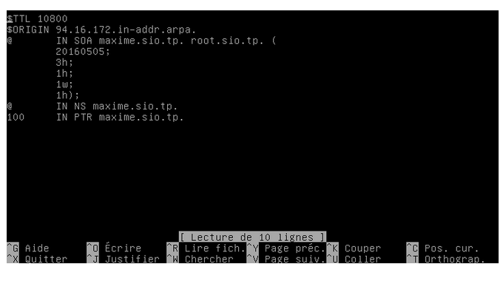
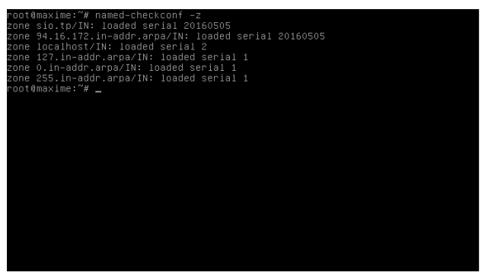
Now we need to configure the reverse DNS zones in the file.
/etc/bind/db.94.16.172.in-addr.arpa
To test our configuration, you can use the following command:

If everything is configured correctly, you will get this result. If not, you can easily correct any errors that will be indicated by this command.
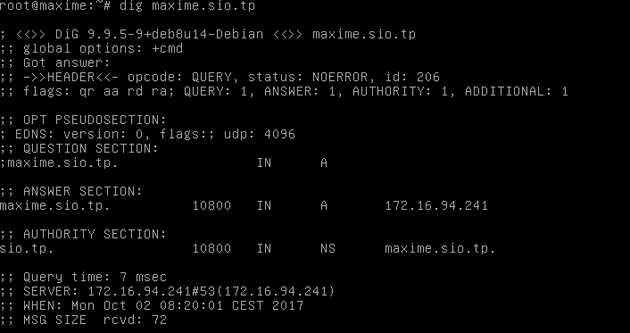
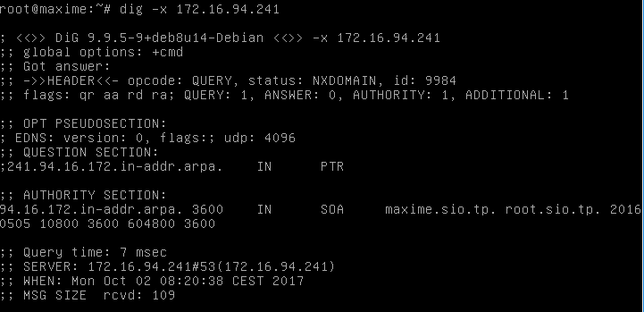
Before ensuring that our DNS server is working, we need to restart the server.
service bind9 restart
The command "dig" followed by the FQDN of our server allows us to test its proper functioning.
You need to add the option "-x" to test reverse DNS resolution:
Let's now try to ping one of the machines we declared earlier:
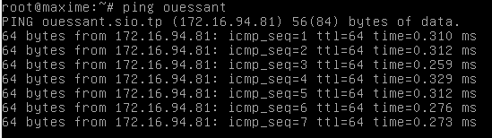
Our client machine responds, indicating that the DNS server successfully resolves the hostname (in this case, "ouessant") to its IP address.
Our DNS server is now configured and operational.
Mariadb
How to install MariaDB on Ubuntu 20.40?
Now that we know what MariaDB is, what it is used for, and what prerequisites we need, let’s look at how to install MariaDB on Ubuntu 20.04 server and get you started.

#Step 1: Install MariaDB by logging into your Ubuntu server
To get started, log into your Ubuntu 20.04 server and refresh the local repositories.
sudo apt update
Ubuntu repositories already provide MariaDB packages. The installation is straightforward using the PAT package manager as follows.
sudo apt install mariadb-server mariadb-client -y
However, the version of MariaDB provided by Ubuntu repositories is not the latest one. This installs MariaDB 10.3.24 at the time of penning down this guide. To install the latest version, use the official MariaDB repository.
First, install the prerequisite package.
sudo apt install -y software-properties-common
Next, import the GPG signing key.
sudo apt-key adv --fetch-keys 'https://mariadb.org/mariadb_release_signing_key.asc'
Once the GPG key is in place, add the MariaDB APT repository. The following repository is enabled for the MariaDB version 10.6. You may replace this value with the version that you intend to install.
sudo add-apt-repository 'deb [arch=amd64,arm64,ppc64el] https://mariadb.mirror.liquidtelecom.com/repo/10.6/ubuntu focal main'
Finally, refresh the local repositories and install the MariaDB server and client by using the APT package manager.
sudo apt update && sudo apt install -y mariadb-server mariadb-client
The command installs the specified version of the MariaDB database engine and client, alongside other additional packages and dependencies.
You can confirm the installed version of MariaDB as shown.
mariadb --version

#Step 2: Start And Enable MariaDB
By default, the MariaDB database engine starts automatically upon installation. You can verify this by running the command:
sudo systemctl status mariadb

From the above output, you can see that the MariaDB service is running. If for whatever reason, you find that the service is inactive or not running, you can start it as follows.
sudo systemctl start mariadb
Additionally, consider enabling MariaDB to start every time on system startup as shown.
sudo systemctl enable mariadb
The above command ensures that MariaDB starts automatically every time the server is rebooted or powered on.

#Step 3: Configure MariaDB
MariaDB ships with default settings that are considered weak and present loopholes which can potentially be exploited by nefarious parties leading to data breaches.
To remediate this issue, you need to go an extra step and harden your MariaDB instance. To improve the security of the MariaDB database engine, you need to run the mysql_secure_installation shell script as shown.
sudo mysql_secure_installation
The script walks you through a series of prompts that will require you to make changes to the security options that involve the MariaDB database engine.
The first prompt asks you to provide the current root password, and since none has been set up yet, simply hit ENTER on your keyboard.

Next, you will be prompted for the database root password. This ensures that no one can log in as the root user without authentication. So, type ‘Y’ and provide the database root password and confirm it.

Then press ‘Y’ for the subsequent prompts in order to configure the database engine according to the best security practices. This does the following:
- Removes anonymous users from the database server
- Disables remote root login. This ensures that the root user can only log in to the database server from “localhost”
- Remove the test database which comes with MariaDB by default.
- Reloads privilege tables for the changes t take effect immediately.

At this point, you have successfully completed the initial security configuration for MariaDB.

#Step 4: Configure A Password-authenticated Administrative User
In this section, you are going to create a new user account in the database server with password authentication and later assign administrative privileges to the user. So, login as the root user as follows:
sudo mariadb -u root -p
Next, create a regular user. Here, we are creating a user called admin_user. Be sure to replace secret_password with your preferred user’s password.
CREATE USER 'admin_user'@'localhost' IDENTIFIED BY 'secret_password';
Output
Query OK, 0 rows affected (0.000 sec)
Next, grant all privileges to admin_user. This effectively assigns all the database root user’s permissions to the user.
GRANT ALL PRIVILEGES ON *.* TO 'admin_user'@'localhost';
The *.* wildcard notation implies that the user has permission to execute any task on any database in the database server.
To apply the changes, flush the privileges.
FLUSH PRIVILEGES;
Finally, exit the database server.
EXIT;

#Step 5: Test MariaDB
With the MariaDB database server configured, you can now log in and run a few queries. Proceed and log in to the database server using the administrative user that you have just created.
sudo mariadb -u admin_user -p

Provide the password for the administrative user and hit ENTER. Just above the MariaDB shell some details about the database server including the connection id, server version, and copyright information will be displayed.
To check the existing databases, run the command:
SHOW DATABASES;
Output
+--------------------+
| Database |
+--------------------+
| information_schema |
| mysql |
| performance_schema |
+--------------------+
4 rows in set (0.002 sec)
To create a new database, run the following query. In this example, we are creating a database called test_db.
CREATE DATABASE test_db;
Output
Query OK, 1 row affected (0.000 sec)
To apply all the changes made without restarting or reloading MariaDB run the query:
> FLUSH PRIVILEGES
Output
Query OK, 0 rows affected (0.000 sec)
To list all the existing users in your database engine, run the following query.
SELECT host, user FROM mysql.user;
Output
+-----------+-------------+
| Host | User |
+-----------+-------------+
| localhost | admin_user |
| localhost | mariadb.sys |
| localhost | root |
+-----------+-------------+
3 rows in set (0.001 sec)
To exit the MariaDB prompt, simply run:
QUIT
Output
Bye
DHCP Server
Prerequisites
- Two systems running Ubuntu 20.04.
- A root password is configured on the server.

Install DHCP Server
By default, the DHCP server package is included in the Ubuntu default repository. You can install it with the following command:
apt-get install isc-dhcp-server -y
Once the installation is completed, start the DHCP service and enable it to start at system reboot with the following command:
systemctl start isc-dhcp-server
systemctl enable isc-dhcp-server

Configure DHCP Service
DHCP server default configuration file located at /etc/default/isc-dhcp-server. You will need to edit it and define your network interface.
You can edit it with the following command:
nano /etc/default/isc-dhcp-server
Define your network interface as shown below:
INTERFACESv4="eth0"
Save and close the file when you are finished then edit the /etc/dhcp/dhcpd.conf file and define DHCP lease:
nano /etc/dhcp/dhcpd.conf
Uncomment the following line:
authoritative;
Next, change the following lines:
default-lease-time 660;
max-lease-time 6300;

# range of subnet
range 192.168.0.2 192.168.0.20;

# gateway address
option routers 192.168.0.1;

# DNS server address
option domain-name-servers 8.8.8.8, 8.8.4.4;
}
Save and close the file when you are finished.
Configure DHCP Server to Assign Static IP to Client
By default, the DHCP server is configured to assign a dynamic IP address to all clients. In this section, we will configure the DHCP server to assign a fixed IP address based on the Client's Mac address.
For example, let's assign the IP address 192.168.0.5 to a client with MAc Address 4c:bb:58:9c:f5:55.
To do so, edit the /etc/dhcp/dhcpd.conf file with the following command:
nano /etc/dhcp/dhcpd.conf
Add the following lines:
host client1 {

hardware ethernet 4c:bb:58:9c:f5:55;

fixed-address 192.168.0.5;

}
Save and close the file when you are finished then restart the DHCP service to apply the changes:
systemctl restart isc-dhcp-server
Now, verify the status of the DHCP service with the following command:
systemctl status isc-dhcp-server
Configure DHCP Client to Obtain Static IP address
Next, you will need to configure your client machine to obtain a static IP address from the DHCP server.
Go to the client machine with Mac address 4c:bb:58:9c:f5:55 then edit the network interface file with the following command:
nano /etc/network/interfaces
Remove default lines and add the following lines:
auto eth0
iface ens33 inet eth0
Save and close the file then restart the Network Manager service to apply the changes:
systemctl restart network-manager
Now, run the following command to verify the IP address of the client machine:
ifconfig
You should get the following output:
eth0 Link encap:Ethernet HWaddr 4c:bb:58:9c:f5:55
inet addr:192.168.0.5 Bcast:192.168.0.255 Mask:255.255.0.0
inet6 addr: 2401:4900:1955:16a2:1d:1e7:518d:6481/64 Scope:Global
inet6 addr: fe80::4ebb:58ff:fe9c:f555/64 Scope:Link
inet6 addr: 2401:4900:1955:16a2:4ebb:58ff:fe9c:f555/64 Scope:Global
UP BROADCAST RUNNING MULTICAST MTU:1500 Metric:1
RX packets:280316 errors:0 dropped:0 overruns:0 frame:0
TX packets:179641 errors:0 dropped:0 overruns:0 carrier:0
collisions:0 txqueuelen:1000
RX bytes:321303950 (321.3 MB) TX bytes:36083350 (36.0 MB)
If you don't get any IP address from the DHCP server then run the following command to release/renew IP address:
dhclient –r -v
dhclient -v
Now, run the ifconfig command again to verify the IP address of the client.
Configure DHCP Client to Obtain Dynamic IP address
Next, go to the other client machine and configure it to obtain the IP address automatically from the DHCP server.
To do so, edit the network interface file with the following command:
nano /etc/network/interfaces
Add the following lines:
auto eth0
iface eth0 inet dhcp
Save and close the file then restart the Network Manager service to apply the changes:
systemctl restart network-manager
Next, run the following command to verify the IP address assigned by DHCP server:
ifconfig
You should get the following output:
eth0 Link encap:Ethernet HWaddr 56:84:7a:fe:97:99
inet addr:192.168.0.11 Bcast:192.168.0.255 Mask:255.255.0.0
UP BROADCAST MULTICAST MTU:1500 Metric:1
RX packets:0 errors:0 dropped:0 overruns:0 frame:0
TX packets:0 errors:0 dropped:0 overruns:0 carrier:0
collisions:0 txqueuelen:1000
RX bytes:561189 (561.1 KB) TX bytes:561189 (561.1 KB)

