After executed the below command the images are created

sbt dist/Docker/publishLocal

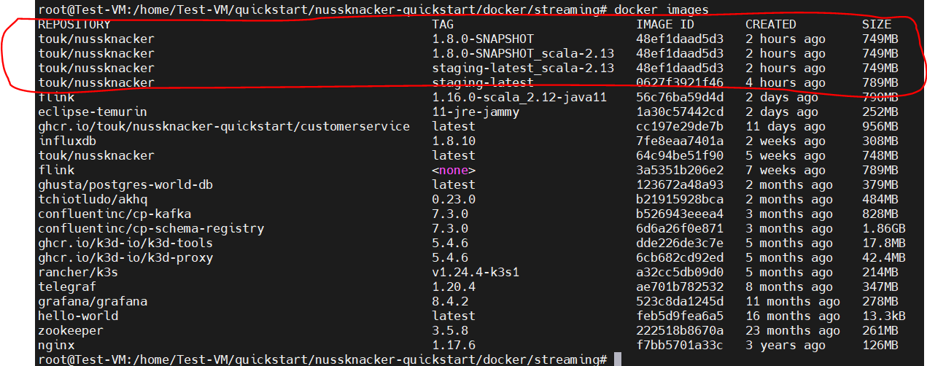

I have cloned the below project
https://github.com/TouK/nussknacker-quickstart

and updated the “.env” variable from “latest” to “staging-latest”
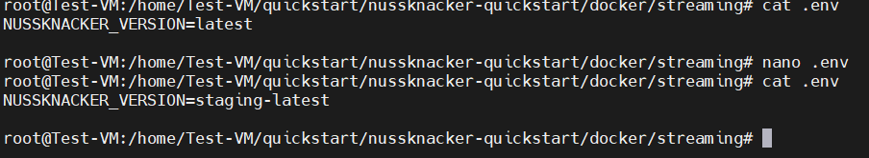

Executed /start.sh script
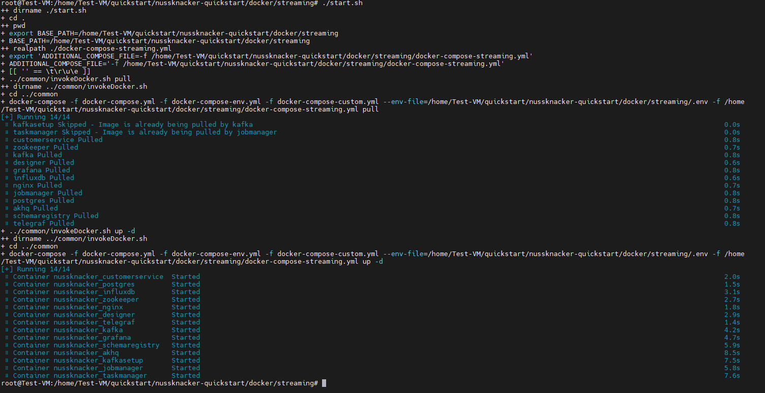

staging-latest image has been running in the designer
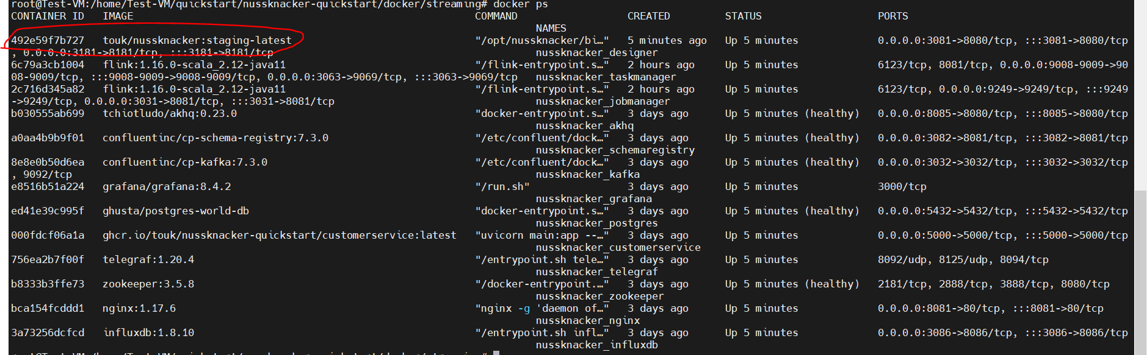

After if I try to access the designer. Getting below error
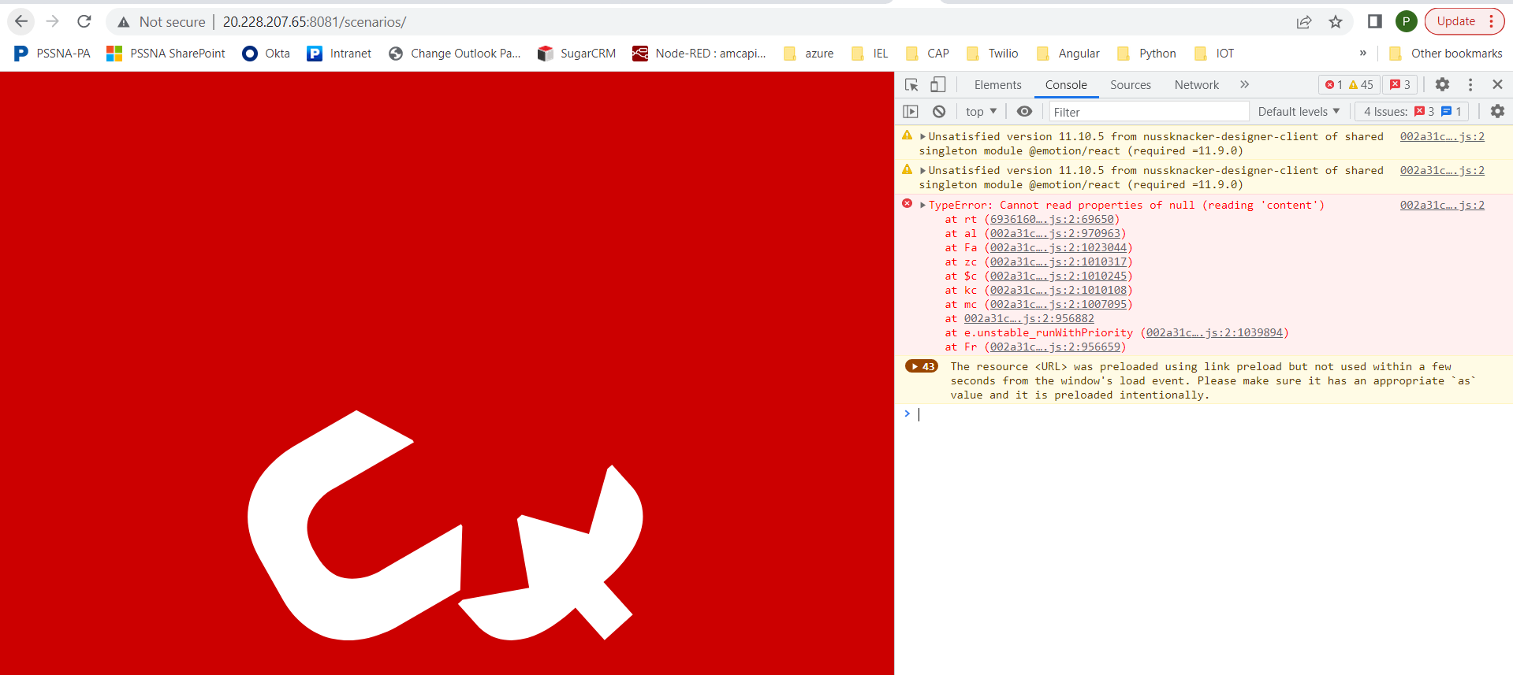

Docker log files:
I logged into container and got the logs
docker exec -ti 6507e6ad4f06 /bin/bash
Left hand side is the one which I built manually has 1.8.0 staging in the jar files.
Right hand side is the default one has 1.7.0 jar version
Development-test-manager.jar and devmodel.jar is available in the manually built image

