$sudo apt update
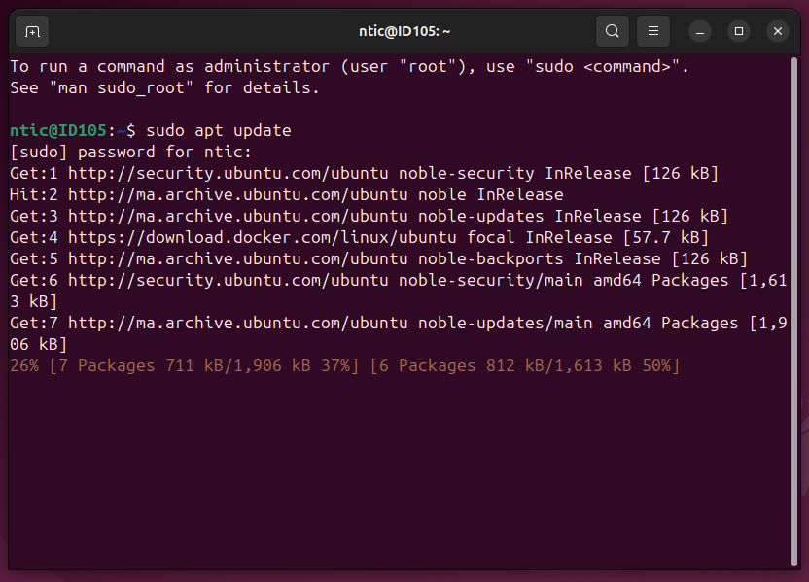
$sudo apt install apt-transport-https ca-certifi cates curl software-properties-common
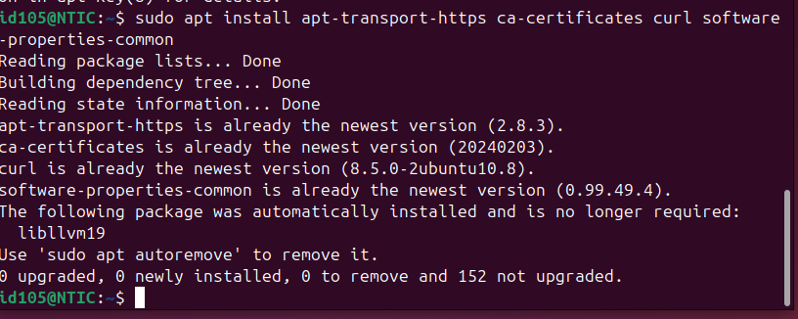
$curl -fsSL https://download.docker.com/linux/ubuntu/gpg | sudoapt-key add -
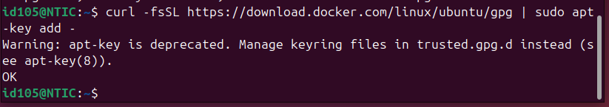
$sudo add -apt repository "deb[arch=amd64] https://download.docker.com/linux/ubuntu focal stable"
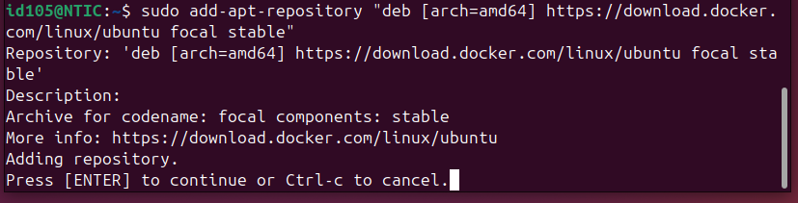
$sudo apt update
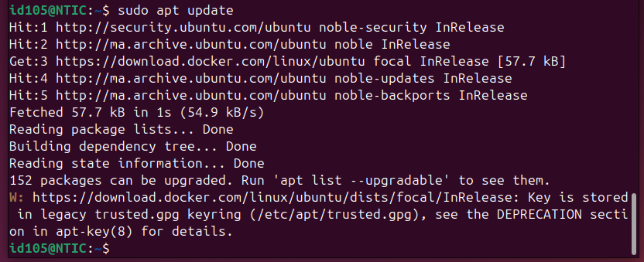
$sudo apt install docker-ce
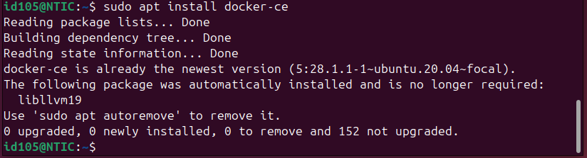
$sudo systemctl status docker
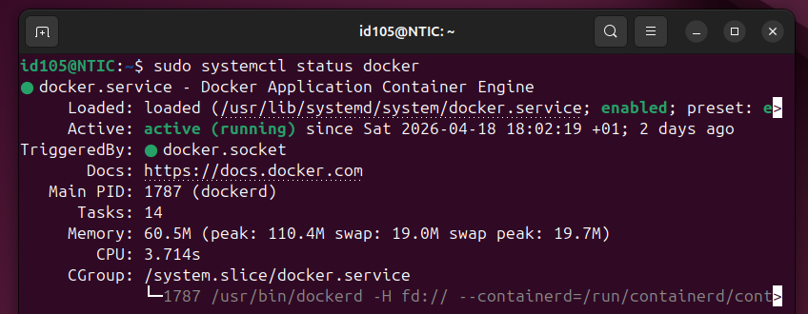
$sudo docker
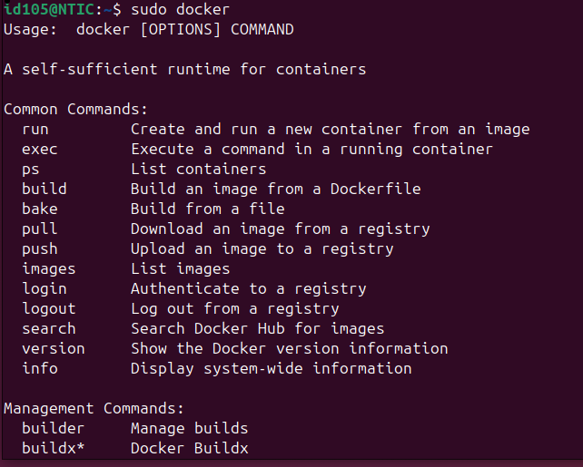
$sudo docker pull hello-world
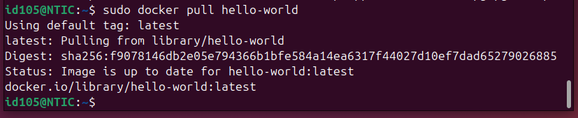
$sudo docker run hello-world
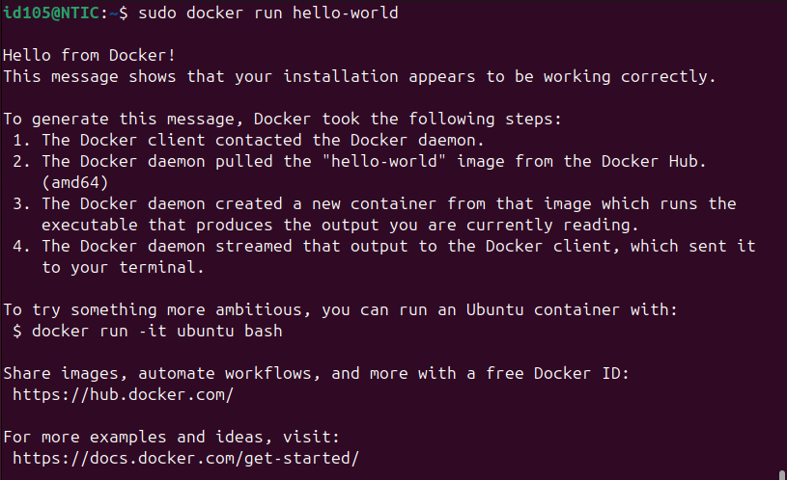

$sudo docker images
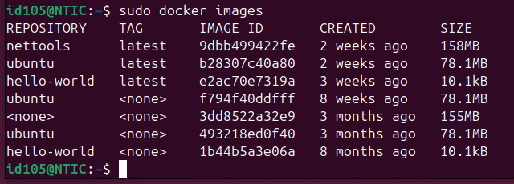
$sudo docker search ubuntu
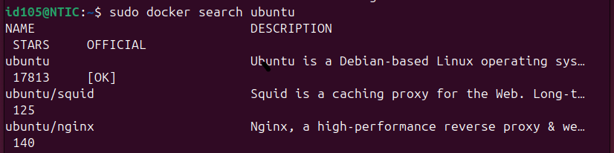
$sudo docker pull ubuntu
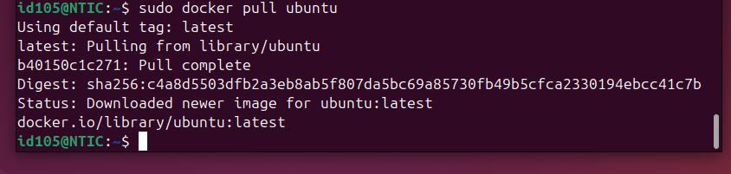
$sudo docker images
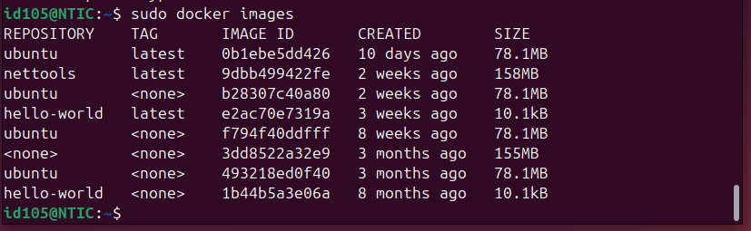

$sudo docker run -ti ubuntu
#apt update
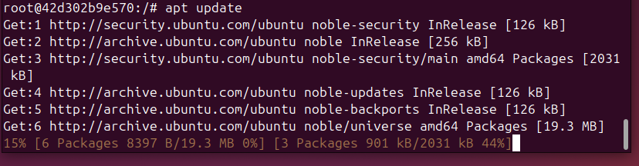
#apt install vim
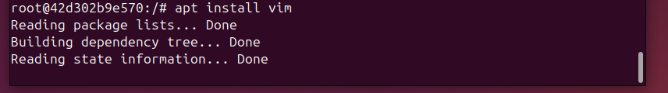
Do you want to continue [Y/n] Y
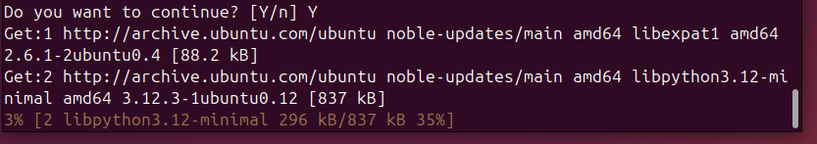
Geographic ares: 1
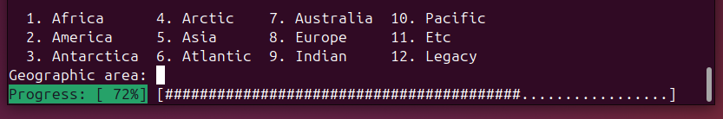

Time zone: 14
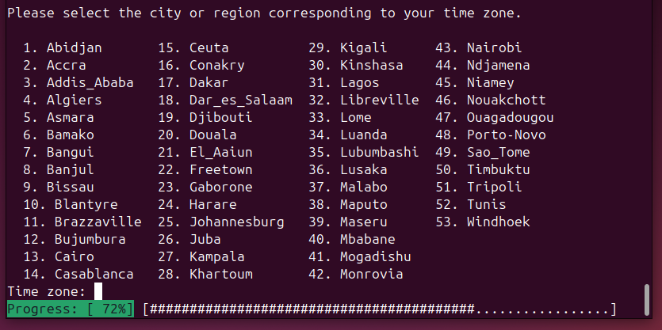
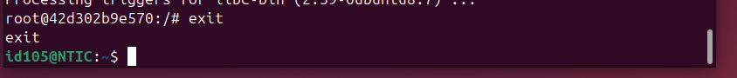
Exit

$sudo docker ps
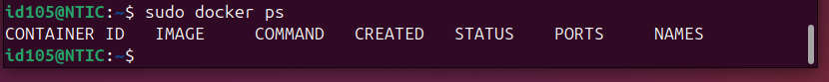
$sudo docker ps -a
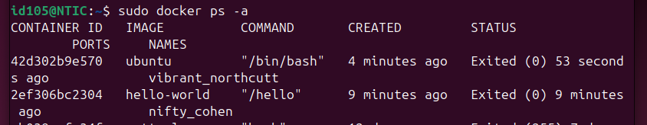
$sudo docker 42d302b9e570
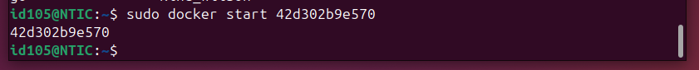
$sudo docker ps
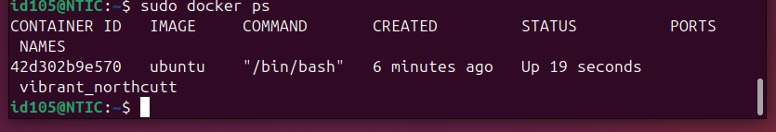
$sudo mkdir -p Docker/nettools
$cd Dcoker/nettools
$sudo nano dockerfile

FROM ubuntu:20.04
RUN apt update && apt install -y net-tools
CMD ["bash"]
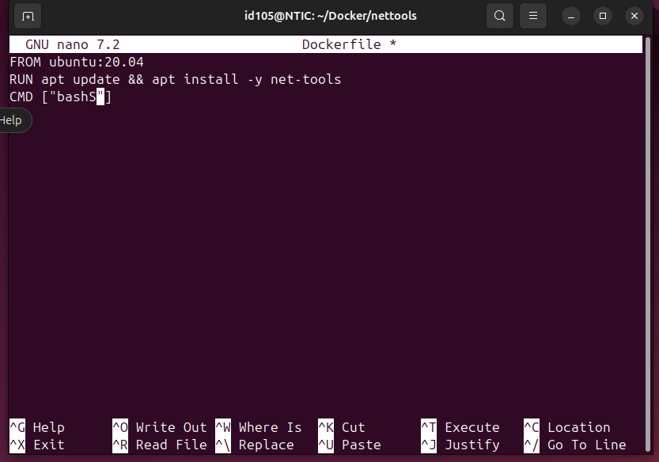
Ctrl + X
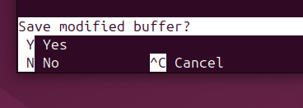 Y Enter
$sudo docker build -t nettools .
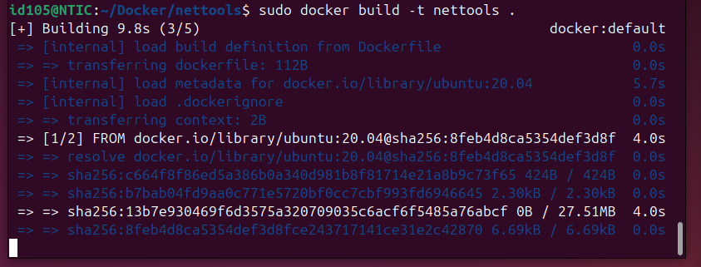
$sudo docker run -ti nettools bash
#apt update
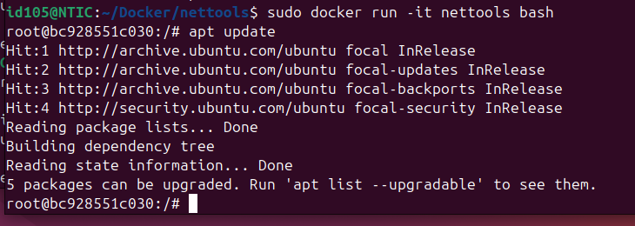
#apt install iproute2 -y
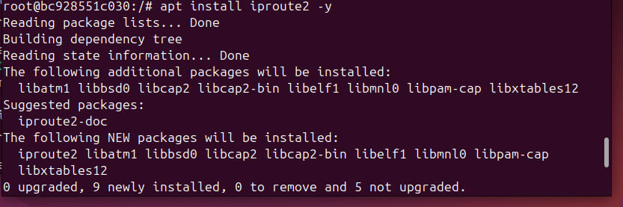

#Ip -c a
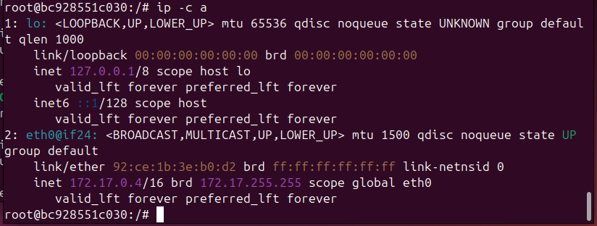
dans le deuxième terminal pour lancer le deuxième conteneur.
( fteh terminal zdid )
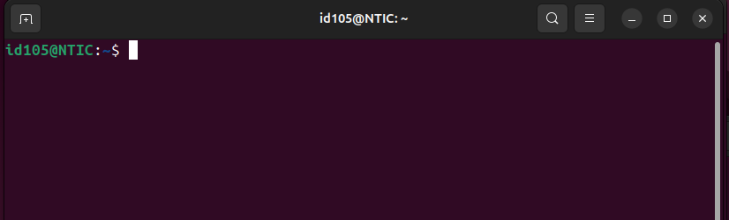
$sudo docker run -ti nettools bash
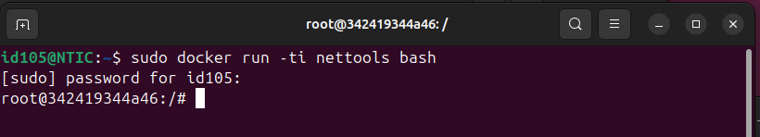
#apt update
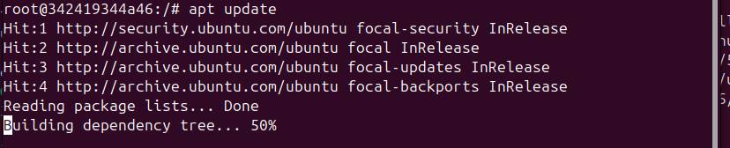

#apt install iproute2 -y
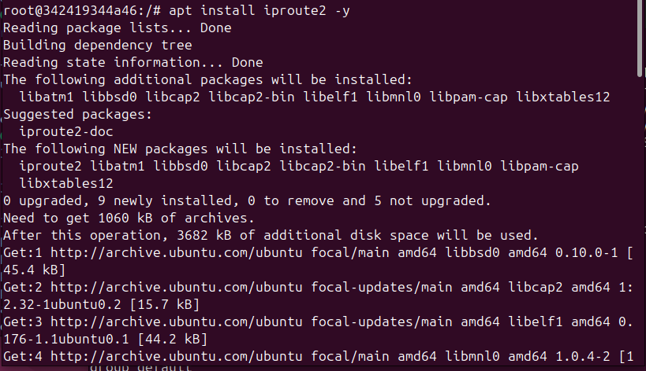
#Ip -c a
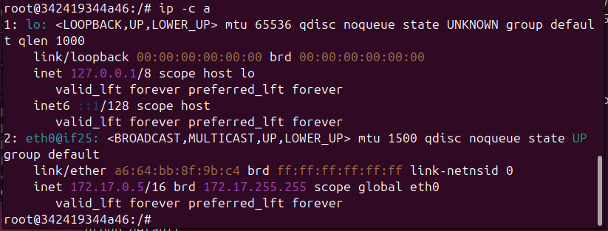
Ping 172.17.0.4 172.17.0.5
Ping 172.17.0.5 172.17.0.4

