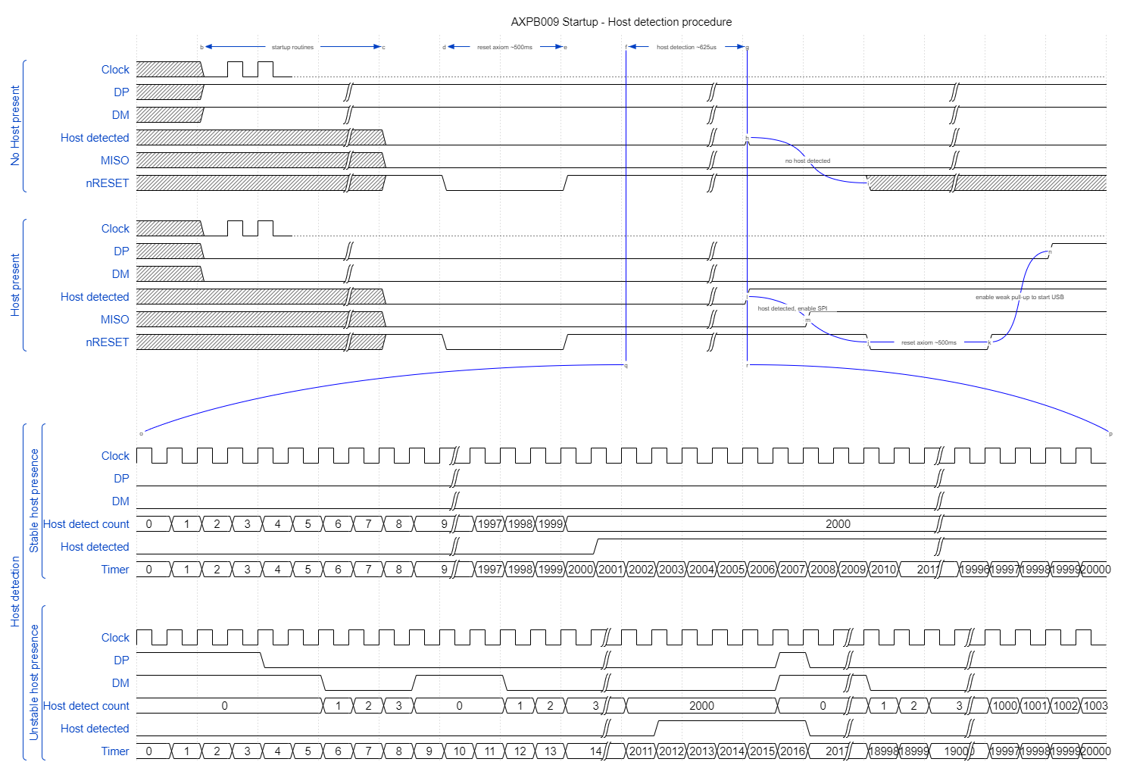

* First thing PB009 does after power up is to pull MISO low and send a reset signal to aXiom, putting it into I2C mode
* DP and DM are initialised as GPIOs
* PB009 goes into host detection state where it tries to identify if there is a host present (see bottom two timing diagrams)
* Once entered a timer starts counting to 20000
* A second counter, host_detect_counter, will increment whilst DP and DM are both low up to a maximum value of 2000. Once at 2000 the host_detected signal will be written with a 1, indicating the presence of a USB host
  + If at any point either, or both, USB signals go high the counter will reset to 0 and the host_detected signal will be set to 0 again
  + This reduces the chances of transient signals ‘tricking’ the bridge into thinking a host is connected
* Once the timer reaches 20000 the bridge will take the current state of host_detected and process accordingly:
  + Host present – pull MISO high and reset axiom, putting aXiom in SPI mode once more, enable the USB hardware peripheral and carry on with normal routines.
  + No host present – Keep MISO pulled low, release the nRESET line and then do nothing 🡪 we release nRESET in the event a new I2C host requires control over it. The bridge then does nothing until next reset.