**Tactio: A Modular Tactile Sensor Development Suite**

ECE4873 Senior Design Project

Team Touché

Advisor- Dr. Patricio Vela

Austin Keener, EE, akeener3@gatech.edu

Joseph Spall, EE, jspall3@gatech.edu

Joshua Oldenburg, CMPE, joldenburg@gatech.edu

Juan Elizondo-Villasis, EE, jelizondo7@gatech.edu

Varun Madabushi, EE, vmadabushi3@gatech.edu

Submitted

September 16, 2020

**Table of Contents**

**Executive Summary** 2

1. **Introduction** 3
2. **Project Description and Goals** .......6
3. **Technical Specification** 8
4. **Design Approach and Details** 9
   1. Design Concept Ideation, Constraints, Alternatives, and Tradeoffs 9
   2. Preliminary Concept Selection and Justification 15
   3. Engineering Analyses and Experiment 21
   4. Codes and Standards 23
5. **Project Demonstration** 24

1. **Schedule, Tasks, and Milestones** 25
2. **Marketing and Cost Analysis** 28
   1. Marketing Analysis 28
   2. Cost Analysis 29
3. **Current Status** 30
4. **Leadership Roles** 31
5. **References** 32

**Appendix A** 34

**Executive Summary**

When interacting with the world around us, humans rely heavily on their tactile senses to understand the weight, shape, and texture of the objects they hold. Robots similarly require additional sensors to understand contact forces and thus “feel” their environment.

  Robotic grippers can use tactile cues to adjust their grip on objects, and locomotion systems can use force measurements to understand contact interactions with the ground. Existing tactile solutions are effective but face a number of drawbacks, such as using many wires, having large footprints relative to sensor area, or requiring complex manufacturing methods. These factors present a barrier to widespread adoption in the applications research and hobbyist spaces.

  Our product, Tactio, will be composed of a series of affordable, modular tactile sensors. Each module will be capable of reporting the location and magnitude of contact forces within their sensing area using piezoresistive material. A key feature of our product is the ability to “tile” modules by placing them next to one another and wiring them up in a daisy-chain fashion, allowing use in whatever shape they wish. Key technical performance specifications include a force sensitivity of 2 to 100 N with an accuracy of 0.5 N and a sense point density of 1.78 points/cm2. Each sensor node will cost approximately $15.58 at a volume of 5000 units at a sales margin of 30%, with the development price of $30 per sensor at low volume.

The proof of concept will be 16 individual nodes chained together and mounted to various geometries that would interface with easy-to-use software for integrating this sensor into the end-user’s application software for visualization, processing, or control. Future work for the project would involve attaching the sensor to a robotics manipulator in order to inform a control algorithm with sensor readings.

**Tactio: Modular Tactile Sensor Development Suite**

**1. Introduction**

Team Touché is a team of 5 ECE undergrads with extensive embedded systems and robotics experience. We are requesting $500 to develop a modular tactile sensor suite to enable students, researchers, and hobbyists to give their projects the sense of touch.

1. When interacting with the world around them, humans rely heavily on their tactile senses to understand the weight, shape, and texture of the objects they hold. To improve robotic manipulation, the ability to sense the “feel” of interacting objects or surfaces is paramount. Our product, Tactio, will be composed of a series of tactile sensing modules. Each module will be capable of reporting the location and magnitude of contact forces within their sensing area. A key feature of Tactio is the ability to “tile” modules by placing them next to one another and wiring them up in a daisy-chain fashion. Existing tactile sensing solutions require many wires, large footprint, or complex manufacturing methods. Our product will be aimed at simplifying the integration of tactile sensors into user projects by making something that is small, simple to wire, and user-friendly.
2. The Tactio kit is intended to use on small- to medium-scale robotics projects, such as those done by students, electronics hobbyists, or researchers. These users likely desire plug-and-play hardware and software that easily integrates into existing robots and codebases. Our proposed sensors will be mounted onto robotic grippers, arms, or other mechanisms, enabling it to detect the location and magnitude of forces on that surface. These robots can then be used in a home or lab setting to conduct experiments or demos.
3. We anticipate a wide array of possible applications for this, so our mounting system must be flexible. Because end users desire an easy to use, plug-and-play system, a well documented, open-source code and a user-friendly application programming interface (API) are required. Arduino is one of the most popular kits for electronics education and prototyping. Since we are targeting electronics or robotics enthusiasts, compatibility with the Arduino ecosystem is a requirement. We also plan on including PC connectivity and a Python API to enable compatibility with Raspberry Pi (another popular electronics platform) and any user computers, such as those running Robot Operating System (ROS). We wish to make this product as flexible as possible so the only constraints are on the end-user’s imagination.
4. This sensor is primarily an educational product, targeted at students, hobbyists, and researchers. Similar to other educational electronics kits, our product will allow users to learn about embedded systems and robotics through hands on experience with tactile sensing. In addition, the rapid iteration and integration permitted through this product will allow researchers to explore the capability of tactile sensing in robotics areas such as grasping, locomotion, and human interaction. For example, Dr. Patricio Vela has identified a variety of uses for this sensor on the snake robot locomotion and gripper projects conducted at the IVALab at Georgia Tech. Once the product design is finalized, we wish to collaborate with hobby electronics retailers such as Sparkfun or Adafruit for marketing and sale. A collaboration will bring our product to the desired market and help further their mission of providing open-source electronics to the community.
5. One challenge of our product development lies with material selection. Our selected design uses a row/column grid of electrode contacts, separated by piezoresistive material. We have selected a number of candidate materials, which we must test and compare in terms of sensing performance, manufacturability, and reliability. In addition, communication and processing between a large amount of sensor units must be considered. We wish to create a low size, weight, and power (SWaP) digital system that reliably relays approximately 160 bits of information from each sensor unit’s analog-to-digital converter to the main PC or Arduino for visualization, processing, and control. As we wish to open-source our design, it is important that all software and hardware we incorporate is open-source as well, such that we may avoid licensing issues.
6. Each Tactio unit will comprise of a flexible circuit with electrically conductive rows, and a rigid circuit board with electrically conductive columns. Between them will be a layer of piezoresistive material. Applying forces to the top layer flexible circuit will compress the piezo material, creating a change in resistance which will be measured through a resistor bridge and analog-to-digital converter. The force measurements will be sent to the user PC or controller for visualization, measurement, and control. Sensors will be connected in a daisy chain to simplify wiring. We plan to support chains of 16 or more sensors. Their small size (40mm x 40mm) combined with the ease of wiring will allow the sensors to be assembled in any geometry and configuration. We will demonstrate this capability by outfitting a variety of curved and flat surfaces with our sensor units. We will then use our visualization software to show its interaction with contact forces and demonstrate its potential use in robotics.

Following sections will describe in more detail the construction, requirements, constraints, and timeline for this project.

**2. Project Description, Customer Requirements, and Goals**

The product, named Modular Tactile Sensor Development Suite, will be a set of small individual sensor units that independently measure the force applied at multiple points on their surface. These units will be tileable and chainable electrically so all values can be read off of a shared communication bus by a single host computer or microcontroller. The target for this product is hobbyists, students, researchers, and others creating prototype robots or actuators (such as grippers) that need to be able to measure the force the actuator is applying across a distributed set of points on the surface. The stakeholders are the Touché team members, Dr. Patricio Vela, and other hobbyists, students, and researchers who are creating prototype robots and actuators that need to measure contact forces.

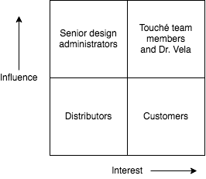

Figure 1 2x2 Stakeholder diagram

The customers of the product should be able to quickly and easily configure, mount, and integrate the sensor network into their own design. The communications method should be simple enough to reimplement easily if necessary but a library for communicating on one to two common platforms will be provided. As described in the detailed technical specifications section below, each node will be able to measure the force applied to it within a range of 2-100 N at all points in a grid across its surface.

As the intent of this is a generalized sensor node that can be applied to a wide variety of surfaces, there are not a significant number of external constraints put on the design. One significant constraint is that it must conform to the widely accepted CAN bus communication standard, with our network implementation of CAN described in Appendix A. The range of force sensitivity is also dependent on external inputs. The range of 2-100 N was determined as that is a reasonable range for small actuators.

1. **Technical Specifications**

Electrical:

|  |  |
| --- | --- |
| Supply Voltage | 5V |
| Operating Voltage | 3.3V |
| Maximum Rated Node Power Consumption | 1.25W |
| Maximum Bus Supply Current | 3A |

Table 1. Electrical Specifications

Sensing:

|  |  |
| --- | --- |
| Force Sensitivity | 2 - 100 N |
| Force Measurement Accuracy | $±$ 0.5 N |
| Force Measurement Resolution | 0.5 N |
| Spatial Resolution | 1.78 points/cm2 |
| Min Inter-node Sensing Null | 10mm |
| Node Sensing Area | 30mm x 30mm |

Table 2. Sensing Specifications

Mechanical:

|  |  |
| --- | --- |
| Sense Node Dimensions | 40mm x 40mm x 15mm |
| Mounting Method | Interchangeable Brackets |

Table 3. Mechanical Specifications

Interface:

|  |  |
| --- | --- |
| Bus Communication Protocol | CAN 2.0 |
| Maximum Polling Latency | 10ms @ 1 node  100ms @ 10 nodes  200ms @ 20 nodes |
| Unique Node Addresses | 255 |

Table 4. Interface Specifications

Firmware/Software:

|  |  |
| --- | --- |
| Interface Library Language | C++, Python |
| Source Code Version Control | git |
| Source Code Distribution | GitHub |

Table 5. Firmware and Software Specifications

1. **Design Approach and Details**
   1. **Design Concept Ideation, Constraints, Alternatives, and Tradeoffs**

Our sensor has the following functions it would need to fulfill:

* Sense a force with position and relative magnitude and translating to an electrical signal
* Cover a surface to measure said force
* Communicate sensed information to a final location in a chained method
* Have a construction that can be mounted on a surface

There are a few ways to solve the mentioned functions. Sensing a force electronically has two main methods: resistive touch and capacitive touch. Resistive touch relies on the changing of resistance of a surface contact point; capacitive touch similarly relies on the changing of capacitance of a surface at a contact point. The need to cover a surface to measure a force can take two major approaches: using many smaller sensors tiled or using a few or single larger sensor(s). Communication over a chained system sharing the same bus can take either an addressing polling scheme or chained shifting system. The construction of the sensor could be made of fully flexible materials, a mixed amount of flexible and rigid materials, or a fully rigid material.

There are many possible solutions with tradeoffs that fit the requirements of our project:

* Resistive touch tends to be cheaper for purchasing (as generic products), have better resistance to particulate like water or dust, and can function independent of material making contact. Some downsides to resistive touch are they have low touch sensitivity and are unable to support multi-touch (as generic products). Capacitive touch tend to have higher touch sensitivity and support multi-touch. Downsides to capacitive touch include not being able to be used with non-conductive materials, are more expensive, and do not work well with pointed objects [1]. Having resistive touch respond to multiple points of contact can be corrected by using a multiplexing system, requiring custom manufacturing of the sensor. A requirement for the sensor is to have contact registered regardless of the material it is touching, preventing interface limitations of the sensor.
* Resistive touch can be accomplished with materials that change resistance with force, which are known as piezoresistive material. Based on prior research on the subject, two strong possibilities for materials were Velostat and EX-STATIC [2, 3, 4]. Both are advertised as conductive materials, but have the property of changing resistance when compressed. This compression can be used to read the amount of force and position on the sensor surface. The material chosen must be thin, flexible, inexpensive, easy to modify the shape to be included in the sensor, and react differently relative to different magnitudes of force. Both materials mentioned are relatively inexpensive, thin, flexible, and easy to modify. Velostat is able to measurably change resistance based on the magnitude of force while EX-STATIC only changes resistance based on location of the force.
* Using many smaller sensors would require combining multiple sensor node readings distributed. Using larger sensor(s) would involve combining many readings on few nodes. Having many smaller sensors would lead to more dead zones if tiled adjacent across a surface. Mounting a rigid sensor will create a tangential contact surface, which is sufficient for a flat surface. If an individual sensor is too large and is being mounted at an angle, the tangential plane may greatly disrupt the initial geometry.
* Some protocols for addressing communication schemes that are often used by microcontrollers include I2C, CAN bus, and Ethernet. The chained scheme would need to be a custom protocol, but it could be built using UART or SPI. Some important aspects include high through-put, ease of implementation, minimal hardware infrastructure, commonality for implementation in embedded systems, flexibility for the sensor’s specific use-case, and tolerance over long wires. I2C has many of the features needed, but poor performance over long cables. Ethernet has a lot of over-head for negotiation and hardware. The chained scheme suffers from a lack of ease of implementation. CAN bus has all necessary aspects with the significant tradeoff of needing additional hardware for addressing and communication transceiver.
* For a fully flexible sensor construction, the sensing surface would be able to wrap around a curved surface for greater coverage. Some disadvantages of fully flexible is the difficulty of attaching electrical components (such as microcontrollers) in a location that will not flex and reading the stresses of the bent material versus actual external forces. A fully rigid surface would ease mounting significantly at the disadvantages of loosing the precise touch location being equally distributed around a large radius across the rigid sensor surface and limiting mounting on a curved surface. The mixed construction of flexible sensing material and rigid mounting material would ease mounting significantly (with the rigid component) and still maintain the force location distribution (with the flexible component), but it would have the disadvantage of limiting mounting to a curved surface.

A general initial solution from the given options and necessary requirements for the project has led to the team’s initial design. Based on specified interface requirements (primarily needing to interact with most materials and ease of manufacturing), a resistive touch sensor was settled on for the main sensing foundation. After experimenting with Velostat and EX-Static with various force and positions measurements, Velostat was determined to be a better correlation between resistance change and force amount placed. The initial design, shown in Figure 2, will consist of a rigid PCB, the Velostat, and a flexible PCB. The rigid PCB and flexible PCB will have row patterns at 90deg rotational offsets, forming a grid system. The system will measure resistance magnitude across the rows and grids will correlate to an approximate location on the sensor surface, with a change in magnitude of the resistance change indicating force amounts.

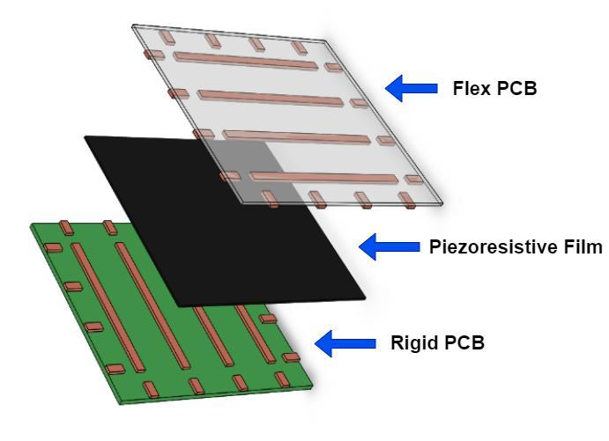

Figure 2. Sensor Stackup Concept

The sensors can be chained together to support coverage of any desired geometry as shown in Figure 3. The sensors communicate with a network controller using the controller area network (CAN) protocol, and each individual sensor is uniquely addressable on the network.

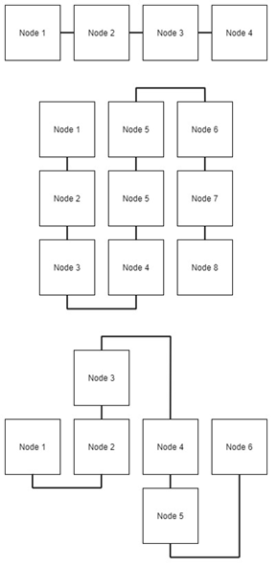

Figure 3. Monoaxis (top), grid (middle), and irregular shape (bottom) chaining configurations showing the flexibility of the interconnect system.

To facilitate flexible configuration, the mechanical mounting system for each node will support interchangeable backplates. Different backplates can be used to support mounting to different geometries, and the sensing nodes will have a standard method of attaching to the backplates. This system allows the end user to either use standard mounting backplates, or custom design one to best fit their specific application. A couple different mounting situations are shown below in Figure 3 to demonstrate the flexibility of the mounting method.

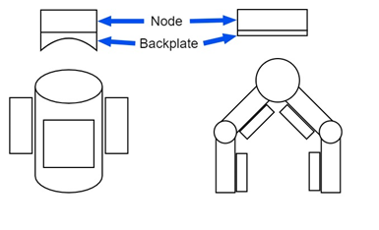

Figure 4. Demonstration of flexible mounting system with sensing nodes on a cylindrical surface (left) and a robotic gripper application (right).

Many design factors, such as global, cultural, economic, environmental, sustainability, manufacturability, ethical, health and safety, social, and political, were evaluated for importance and relevance to the project:

* Ethical, political, cultural, and social factors do not influence our design as the sensor is designed for a universal educational-enabling tool.
* Economic factors will be taken into consideration, with the goal to make the sensor cheap for use in hobbyist and educational fields. This leads to the need to investigate board manufacturing, component sourcing, and assembly labor.
* Manufacturability is important for the project since sensor needs to be assembled by our members with tools available given the COVID-19 restrictions, or possible new restrictions as time progresses, seen on campus for a demo. Additionally, the product is designed to operate at a volume with multiple sensors. This informed the component choice and PCB manufacturing methods.
* Environmental and sustainability, while not heavily driving design factors, were taken into consideration. The use of the product will fall into the common concerns with modern electronic waste at the end of life cycle in terms of recycling and proper disposal. However, no considerable design factors were considered for these purposes.
* Health and safety serves as an important factor, given the target audience of education and hobbyist. It cannot be assumed the user has heavy electrical engineering experience, so the failure cases for the sensors if put into risky use cases must be safe. This informed much of the PCB design and component specifications to have safety features or significant safety factor.
* Global factors were considered but were not a significant driver, with standards for electronics and software being universal IEEE or ISO ratings as appropriate. Initial documentation will be written in English, with the use of the product being able to be expanded to other markets as demand indicates.

Computing aspects will involve analog to digital conversion of the sensing grid, digital signal processing/filtering of the measured signals, and implementing a communications interface to send data from a sensing node to a central controller or interface. Of particular interest will be the communication scheme to interface with the sensors. Tradeoffs include number of physical wires, ease of software implementation, speed, noise immunity, node addressing, etc. These computing aspects will inform microcontroller selection, as the microcontroller will need to have adequate computational resources as well as contain the peripherals needed to perform sensing and implement the communication interfaces.

* 1. **Preliminary Concept Selection and Justification**

The selection process employed to identify promising concepts to be incorporated into the project followed a simple three phase approach as shown in Figure 5. The first phase of the selection process involved performing ideation and research to compile a list of existing solutions, research, novel ideas, and/or commercial of the shelf (COTS) products. The second phase of the selection process involved establishing a set of design specifications informed by the initial investigation and the project’s goals. Once the design specifications were completed, the list of possible solutions compiled in phase one was compared against the design specifications to eliminate any options that did not fulfill the design specifications. The resulting candidates then underwent an investigation phase involving further research and initial prototyping for critical elements in order to determine the feasibility of each solution. Based on the results of this investigation, a final solution was chosen.

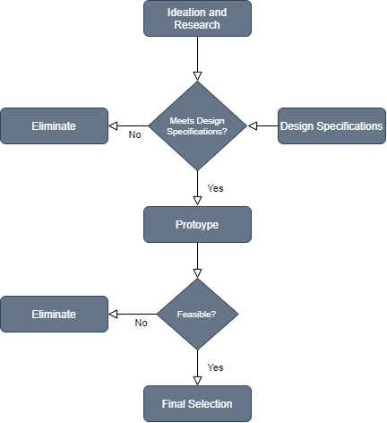

Figure 5. Selection Process

Several critical path items such as the sensing method and PCB design were identified early on in order to prioritize development efforts in the attempt to reduce risk. The sensing method was determined critical since it is solely responsible for several critical design specifications such as force sensitivity and accuracy, and it also plays a significant role in other critical specifications such as unit cost and ease of manufacturing. The initial evaluation of this method followed the selection process outlined in the proceeding section. Two different sensing methods using Velostat and EX-STATIC as the piezoresistive elements were investigated based on the initial research performed and fulfillment of the design specifications set forth. Initial prototypes using both materials were constructed and evaluated, and it was determined that Velostat was the most feasible option. The PCB design was also deemed a critical path item due to the lead time of manufacturing the PCBs. Thus, several design decisions, such as the bus communication protocol and microcontroller selection, that affected the PCB design needed to be determined early on. For the communications bus, initial research led to multiple potential candidates, but after evaluating those candidates against the design specifications, CAN and UART emerged as the viable candidates. For each of these candidates, a proposal was written describing it’s implementation including the electrical implementation, addressing, timing, firmware implementation of the corresponding peripherals, and how the application code would utilize the protocol. After discussion among the team members, CAN was eventually selected due to timing concerns with using UART. A similar process was performed for the microcontroller selection, where a list of candidates was formed from research and evaluation against the design specifications. The critical design specifications of interest were low cost, small footprint, and inclusion of ADC and CAN peripherals. Among the many commercially available options, the STM32F042 microcontroller met all of the outlined specifications and was subsequently selected.

Several components of the design have been decided on or prototyped at the time of this proposal. For the force sensing mechanism, a Velostat sheet sandwiched between two PCBs with intersecting rows and columns was chosen due to economical cost of materials, ease of manufacturing, and force sensitivity. The assembly method involves using a heat shrink material to contain the sensor stack in order provide ease of manufacturing and prevent the need for adhesives. A prototype using copper strips attached to a plastic sheet, shown in Figure 6, was created in order to determine the feasibility of this sensor design. Initial evaluation proved this design to be feasible, and the team decided to continue forward using the design.

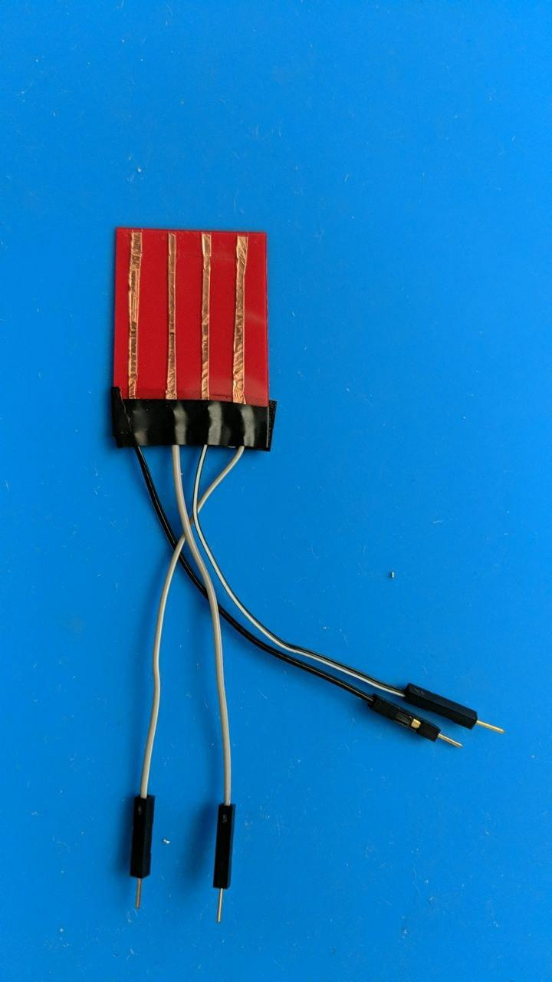

Figure 6. Prototype Flex PCB

Another component that has been decided on is the microcontroller to be used on each sensing node to provide analog to digital conversion and relay the measured data onto the communications bus. Based on required peripherals (such as ADC, UART, and CAN), low pin count, low cost, Mbed OS support, availability of an evaluation board, and small physical footprint, the STM32F042 was chosen to be the sensing node microcontroller. For the communications bus, CAN and UART were selected as the initial candidates based on criterion such as bus speed and ease of implementation. Initial investigation and prototyping lead the team to choose CAN as the bus communication protocol due to it’s ease of implementation, electrical properties, and ability to individually address nodes on the network.

Since the most critical aspect of the design, namely the sensing element, has already been prototyped and demonstrated to work, there is little associated risk of the design not working. There may be some risk in regards to implementation of the design, but we have several different methods that can be employed, thus minimizing associated risk. There is some risk associated with having a PCB manufactured as there is a relatively long turnaround time. If the design does not work successfully, there is sometimes the option to hot-fix the PCBs using small wires. If this is not a suitable fix, and there is sufficient time, a revised PCB could be manufactured. If there is not enough time for a PCB revision, our last case resort would be to manually etch the sensing components of the PCB and breadboard the remaining digital components such as the microcontroller and communications bus. For the communications bus, if there is difficulty in implementing CAN, there is the option to revert to other protocols such as UART, I2C, or SPI.

A couple aspects of the final design still need to be determined. One aspect that still needs to be determined is the details of the mounting system for the sensor nodes. Initial design involves a 3D printed enclosure and interchangeable backplates, but final design details have not yet been determined. Also needing to be decided on is the demonstration platform(s) to showcase the capabilities of the sensing network. Most likely, multiple configurations of sensors on different geometries will be used to demonstrate the flexibility and modularity of the system. Additionally, details regarding the demonstration software still need to be worked through. Preliminary discussions have leaned towards using Python to show a visualization of the sensor output.

The following outlines a set of detailed engineering design specifications based on the initial project goals, customer requirements, and specifications.

* + The sensing component of each node will be comprised of a Velostat sheet sandwiched between a flexible PCB and a rigid PCB, with the upper PCB having four rows, and the lower PCB having four columns to provide a total of 16 force measurement points. The entire stackup will be secured in place using heat shrink. The sensitivity range of the sensing element will be at least 2-100N, the measurement accuracy will be $±$ 0.5 N, and the measurement resolution will be 0.5N. The sensing area of each node will be 30x30 mm, which gives a spacial measurement resolution of 1.78 points/cm2. To allow for clearances between the sensing element and edge of the rigid PCB, there will be a minimum sensing null of 5 mm around the edge of the node, thus imposing a minimum inter-node sensing null of 10 mm.
  + The CAN communications network will allow for dynamic configuration and addressing of up to 255 sensor nodes to facilitate ease of node integration into the network. This is facilitated by a node discovery and addressing mechanism, as well as a polling method for extracting measurements from all the nodes on the network. Each additional node on the network will add no more than 10ms each to the polling latency of the chain. A detailed specification of the CAN implementation is provided in Appendix A - Controller Area Network Specification.
  + The interconnect system will allow for chaining so that network coverage across any geometry is achievable. To facilitate this, each node will have two connectors, each on opposing ends of the node, that provide connection to interconnect wiring carrying 5V power, ground, and the two CAN differential pair data lines. The mating connectors on the wiring assemblies will be field-wireable using inexpensive hand tools so that the end user can make the interconnect harnesses to any length to suit the configuration of the application. All connectors and wiring on the bus must be rated for 3A of current or more, and the power supply for the network must be capable of sourcing that current.
  + The 5V bus power coming into each node will be fused at 250 mA to provide a maximum rated power consumption of 1.25W per node and protect against over-current fault conditions. Each node will also have reverse polarity protection to prevent damage to the node in the case of user error in wiring.
  + To facilitate mounting to different geometries, the enclosure of each sensing node will have threaded inserts to provide a standard attachment point for connecting application specific mounting brackets. The enclosure will be attached to the rigid PCB using standoffs and machine screws to facilitate ease of assembly and disassembly. A complete sensing node without any mounting brackets will be no larger than 40x40x15 mm.
  + Open source C++ and Python software libraries will be developed in order to interface Tactio with third party platforms such as Arduino and PC python-based applications. A TactNET C++ library will also be developed to implement the network protocol specified in Appendix A - Controller Area Network Specification. These libraries will be version controlled and distributed to the public using GitHub.
  1. **Engineering Analysis and Experiment**

In the previous sections we defined our power, latency, and sensing requirements for an interconnected array of our sensors. Each of these requirements will be tested in the following ways:

1. The current draw of a sensor can be measured while powering it with a power supply capable of monitoring its output. Since we are interested in the maximum amount of power consumed by the sensor, the measurement will be taken while the sensor is continuously using its ADCs with a constant, even force applied across it, and while sending information through its CAN interface. The measurement then will be repeated for all our prototyped boards to get an average of the measurements. Since the input voltage to the board will be known, the power consumption can easily be calculated from the measured current draw and compared to our claimed maximum of 1.25W Also, the current measurements can then inform how many sensors can be in the array before surpassing the stated maximum of 3A.
2. The latency of the system will be tested by measuring how much time it takes to poll 1, 10, and the maximum amount of sensors we can support based on the power measurements. This process can be achieved by programming a microcontroller to poll all the sensors in the CAN network while timing the elapsed time between the first sent packet and the last received packet. We are expecting a maximum of 10ms of latency per node in the array.
3. The force sensing requirements can be split between distinguishing the location of forces inside the sensing grid and the measuring of those forces. The sensor will be secured on top of a scale to measure the force being applied to the sensor during the tests. The forces will be applied with a small, known diameter rod or probe such that the pressure applied in a location can be calculated.
   * + - * The measurement accuracy and range can be tested by pressing against the center of the sensor and comparing sensor measurements against the scale measurements over the sensing range of the sensor. This range is easily found by slowly increasing the force applied and finding when the measurements become stable on the low end and finding when the sensor starts to saturate on the high end. Lastly, the sensing resolution will be dependent on how the Velostat’s response to applied forces, but should be able to be quantized as we expect our measurement ADC’s to have more resolution that what the Velostat will exhibit. The measurements obtained from these tests will then be compared to our required 2-100N range, 0.5N accuracy, and 0.5N resolution.
         * To test the localization of forces, we will apply constant forces at each of the sensing intersections in the grid. The data gathered will be run through our algorithms to map the measured values to the location of the applied force. This should meet the requirement of 1.78points/cm2. since there are 4 rows and 4 columns in a grid of size 30mm x 30mm. Depending on the data we receive from the sensors, we might be able to interpolate between the sensing intersections to improve the sensing coverage.
   1. **Codes and Standards**

The controller area network (CAN) communications bus used in this this project utilizes the well-established ISO-11898 series of standards from the International Organization for Standardization (ISO). Specifically, ISO-11898-1:2015 defines the data link layer of the protocol and the physical signaling sublayer (PHS) [5]. This includes important specifications such as the CAN frame format and network architecture.  There are three implementation options: support of the Classical CAN frame format only, not tolerating the Flexible Data Rate frame format; support of the Classical CAN frame format and tolerating the Flexible Data Rate frame format; and support of the Classical CAN frame format and the Flexible Data Rate frame format. Of these, we are choosing the Classical CAN frame format. ISO-11898-2:2016 defines the high speed physical medium attachment (PMA) [6].

To adhere to the ISO-11898 series of standards, we added a MCP2562 chip on each sensor board. This chip is a CAN transceiver that fully meets the specified requirements of the standard. This way we can allow the user to interface with other CAN enabled devices without worrying about compatibility.

The final goal of the project is also for it to be open-sourced for firmware and software. We choose the Apache 2.0 license for the project, which allows for private and commercial use while maintaining liability, trademark use, and warranty limitations [7].

1. **Project Demonstration**

The key features of our product are the ability to locate and measure contact forces applied to the surface, the ability to support 16 or more sensor units wired in daisy chain, and the flexible mounting and wiring options to cover a variety of surfaces. Our product demo seeks to highlight each of these features.

For the demo, 16 sensors will be wired in a daisy chain fashion. This daisy chain will continue back to the “bridge ” circuit, which may feature a microcontroller using the Arduino or MBED platforms. The purpose of the bridge circuit is to pass data from the sensor chain to a PC where it will be visualized.

The core of our demonstration is our visualization software. This software will allow the user to see each sensor on a computer screen and view a heat map of each sensor grid, indicating the location and strength of contact forces. Here we will be able to show the force measurement capability across a large amount of sensors making up our daisy chain network.

The demo will feature these sensors arranged and mounted to a few selected surfaces. We plan to attach it to a flat surface (creating a touch panel) and a curved surface (such as a robotic “finger”). These examples will show the mounting and wiring capability of our sensor.

Force measurement accuracy can be demonstrated by placing the sensor on a scale, and applying a force to it. The measurement shown on the computer readout should match the reading of the scale. During this process, we can demonstrate the latency specification by measuring the frequency of updates shown in the visualization, and showing that it is more than the specified minimum. We can demonstrate power performance by adding a power meter in series to the chain. This will demonstrate that voltage and current specifications are met.

1. **Schedule, Tasks, and Milestones:**

This section will detail the specific engineering tasks required for finishing the tactile sensor project in time for Capstone Design Expo day on November 23, 2020, with target completion one week prior at a minimum. Based on estimations with the generated tasks and duration, the team has 95% probability that the tasks will be completed a week before Expo day based on our current time line.

The high level subdivisions of tasks are highlighted accordingly in Figure 7: green for Electrical, blue for Firmware, purple for Mechanical, red for Software, and orange for System Tests (more one sections). Electrical development will revolve primarily around the design and manufacturing for the flex PCB, handled by Juan, and the rigid PCB, handled by Juan, Joseph, and Joshua. Firmware development will involve writing firmware for the microcontrollers on the rigid PCBs for sensing, which will be handled by Varun, and communication between nodes, being written by Austin and Joshua. Mechanical development for mounting design and system integration of the sensor(s) on a platform will be led by Austin. Software development to allow both the communication of the sensors with the PC along with visualization will be handled by Joseph.

The critical paths for the project are primarily the electrical and firmware development, with the completion of the sensors and any revisions as necessary being crucial for all further steps leading to the demo while also requiring the most steps in the engineering process.

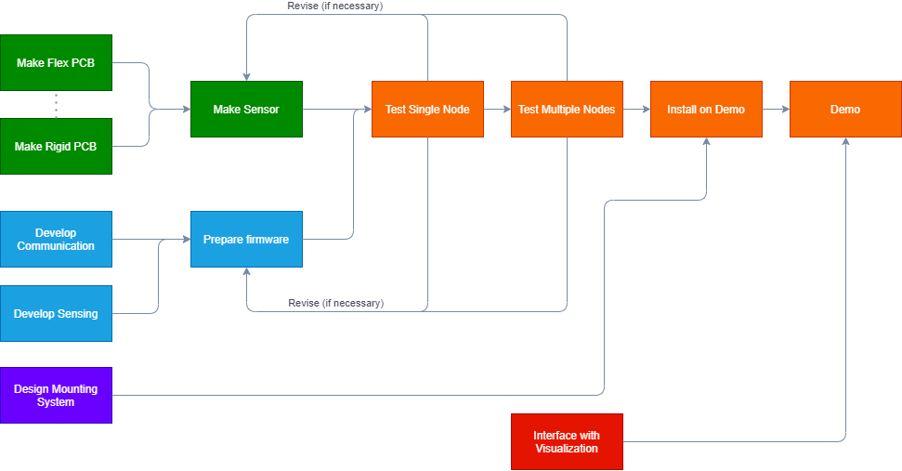

Figure 7. PERT Chart of high-level Engineering Tasks

The list of tasks is listed in Table 6, showing the difficulty, risk, and assignment. Each of the tasks presented have low to high difficulty (based on prior research) and have low to high risk for completion (based on cost of manufacturing and turn-around time), with each member who is working on the assigned task (in addition to other members on the team) having experience and understanding the general scope of the problem presented.

|  |  |  |  |
| --- | --- | --- | --- |
| Task | Difficulty | Risk | Assignment |
| Make Flex PCB | Medium | High | Juan |
| Make Rigid PCB | Low | High | Joseph, Joshua, Juan |
| Develop Communication | High | Low | Austin, Joshua |
| Develop Sensing | Medium | Medium | Varun |
| Design Mounting | Medium | Low | Austin |
| Make Sensor | High | Medium | Joseph, Juan, Varun |
| Prepare Firmware | Low | Low | Varun |
| Test Single Node | Medium | Medium | Joseph, Joshua, Juan, Varun |
| Test Multiple Nodes | Medium | Medium | Joseph, Joshua, Juan, Varun |
| Interface w/ Visual | Medium | Low | Joseph |
| Install on Demo | Medium | Low | Austin, Juan |
| Demo | Low | Medium | Austin, Joseph, Joshua, Juan, Varun |

Table 6. Details of high-level tasks, difficulty, risk, and assignment

Most of the initial engineering tasks can happen asynchronously, as seen in the Figure 8 of the Gantt chart. Early development will revolve primarily around the manufacturing of the sensor, focusing on electrical design and manufacturing along with firmware development. After the sensors are assembled, the mounting system will be designed to interface and firmware will be finalized for initial tests. Sensor node testing will begin along with multi-node tests while coinciding with communication and visualization developments on the PC side of software development. These will culminate into the demonstration installation and demonstration preparation / performance.

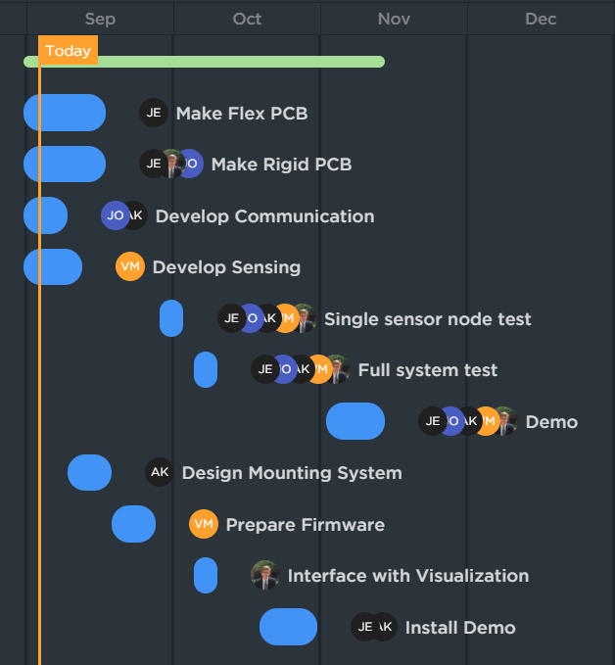

Figure 8. Gantt Chart of High-Level Engineering Tasks

1. **Marketing and Cost Analysis**
   1. **Marketing Analysis**

Tactio is targeted towards hobby and educational roboticists. We envision turning this product into a kit that could be sold on Sparkfun or Adafruit, as such we want it to be comparable in price to other tactile sensors sold in these electronics stores, like the ‘Robotic Finger Sensor v2’ sold by Sparkfun [8]. This specific competitor utilizes a different technology as ours to approach the tactile sensing problem in that they utilize the refraction of light by the applied pressure make measurements. The GelSight Tactile Sensor works in a similar, but is significantly more accurate [9]. Its drawbacks, however, are that it has a very small sensing area with a small sensing area. Therefore, its market availability is very limited.. There are other projects and products that share features of our own project, namely the MIT STAG project [10].

The MIT STAG project developed a knitted glove consisting of a piezoresistive film connected by a network of conductive thread electrodes that are passively probed. This approach proved effective in locating forces from grasped objects. However, it requires large amounts of wiring and computational power to get the multiple data points through the convolutional neural networks in a timely manner. The accompanying interface circuit boards are fairly large as well, and due to its design complexities its availability in the market is very limited.

Tactio design differs from all of these options in that it can be used in a modular, chain-able system of nodes, allowing for customizable sensing areas based on the application’s needs. This methodology also allows the required circuits to be simplified, giving individual nodes small form factors. These advantages allow us to bring Tactio to the hobby and educational roboticists markets at an affordable price while maintaining flexibility in design for the end users.

* 1. **Cost Analysis**

We started working on this project on the week of the 17th of August, and are scheduled to finish on November 23rd. For these 14 weeks, we expect to on average put in 8 hours of work each week, accounting for meetings, report preparation, and individual progress. At $35 an hour, the intellectual cost of producing this product is $3920. As for the assembly and test cost, we assumed an engineer would be able to go through 50 units in the span of 1 hour at the same salary as the engineering salary .

Under the assumption of selling 5000 units over the span of 5 years, the cost of producing 1 unit is outlined below in the table below:

|  |  |  |  |
| --- | --- | --- | --- |
| **Component** | **Quantity** | **Price Per Component** | **Price** |
| PCB Components | 1 | $5.03 | $5.03 |
| rigid PCB | 1 | $0.12 | $0.12 |
| flex PCB | 1 | $0.68 | $0.68 |
| Velostat | 1 | $0.04 | $0.04 |
| salaries | 5 | $0.88 | $4.41 |
| assembly/test | 1 | $0.70 | $0.70 |
| case+wires | 1 | $1.00 | $1.00 |
| sales margin (30%) | 1 | $3.60 | $3.60 |
| Total |  |  | **$15.58** |

Table 2. Contributing factors for final sales price.

We got PCB quotes for our designs from two different manufacturers: JLCPCB and PCBWay, for the rigid and flex PCB’s respectively. All of the PCB components were then taken from DigiKey at the 5000+ unit price-break. The Velostat we quoted from Adafruit’s page. They sell a 11”x11” sheet at $4.46 that can be used to get 121 sensors at our volume.

Given the above costs, we decided a sales margin of 30% would put our product at a comparable price range to other sensors in the market while keeping it profitable to produce.

1. **Current Status**

Much of the teams current work has been refining the engineering scope of the project and initial prototypes of designs. The rigid PCB is approximately 80% finished, reaching completion in the following week for ordering. The schematic is very close to being finished with a selected microncontroller and interfacing hardware, and the board layout is dependent on any schematic changes. Communication is at a 50% completion, given the narrowing down to use CAN bus as the protocol of choice. Implementation of the CAN bus protocol on our selected microcontroller (STM32F04) still needs to occur. Mounting systems is approximately 30% completed, with initial mockups generated. Finalization of the rigid and flex PCB will inform more constraints on the mounting system to get closer to completion. The flex PCB is 95% completed, with final mechanical designs on the rigid PCB being required for completion. Sensing is at 10% completion, with logical walk-through completed but lacking code implementation. The remaining tasks are at around 10% completion due to dependency on prior work. The subtasks that have been 100% completed are implementing project management through Clickup, materials research for piezoresistivity, communication bus decision, microcontroller decision, sensing architecture decision, and initial force-sensitive prototype completion. Overall, the general progress percentage is around 29.54% completion given equal weighting to designated tasks, with an expectation of steep acceleration once electrical design and manufacturing is completed.

1. **Leadership Roles**

Joseph Spall is the materials lead and project manager/documentation coordinator. Joshua Oldenburg is the digital design lead and webmaster. Juan Elizondo-Villasis is the analog design lead. Varun Madabushi is the software lead and expo coordinator. Austin Keener is the mechanical design lead.

These roles are defined as follows:

* The materials lead is responsible for selecting the materials used in the sensing array, including the force-sensitive material and the specifics of the flexible printed circuit board.
* The project manager/documentation coordinator is responsible for sending status report emails on a weekly basis to the advisor, scheduling meetings, managing deadlines, and ensuring the completeness and accuracy of all documentation and meeting notes.
* The digital design lead is responsible for the design of the microcontroller circuit, including the electrical implementation of communications and the programming interface.
* The analog design lead is responsible for the sensing circuitry and the design of any amplification or switching if necessary.
* The webmaster is responsible for creating and managing the team website.
* The software lead is responsible for all software development, from the firmware level up to the desktop computer interface library.
* The expo coordinator will ensure an adequate demonstration and adequate documentation of the project is prepared for the capstone design exposition.
* The mechanical design lead is responsible for the mechanical design and manufacturing of everything except the physical printed circuit boards, including how the circuit boards will interface mechanically with a separate project and prototyping a demo actuator to test with.

1. **References**

[1] B. Li, ‘Resistive Touch vs Capacitive Touch - What’s The Difference?’. [Online]. *Digi-Key*, 2018, Available: https://forum.digikey.com/t/resistive-touch-vs-capacitive-touch-whats-the- difference/1063. [Accessed September 8, 2020].

[2] D. Valle-Lopera, A. Castaño-Franco, J. Gallego-Londoño, and A. Hernández-Valdivieso, “Test and fabrication of piezoresistive sensors for contact pressure measurement”, *Revista Facultad de Ingeniería, Universidad de Antioquia,* no. 82, pp. 47-52. [Online]. Available: http://www.scielo.org.co/pdf/rfiua/n82/0120-6230-rfiua-82-00047.pdf. [Accessed September 8, 2020].

[3] 3M, Velostat Sheet Stock (Thermoformable). [Online]. Available: http://documents.staticcontrol.com/pdf/2004.pdf. [Accessed September 8, 2020].

[4] Filter EMF, *Ex-Static(TM) Conductive Fabric.* [Online]. Available: https://www.filteremf.com/buy/ex-static-conductive-fabric/. [Accessed September 8, 2020].

[5] ISO Standard *Road vehicles — Controller area network (CAN) — Part 1: Data link layer and physical signalling, ISO 11898-1:2015*

[6] ISO Standard *Road vehicles — Controller area network (CAN) — Part 2: High-speed medium access unit, ISO 11898-2:2016*

[7] “Apache License 2.0,” *Choose a License*. [Online]. Available: https://choosealicense.com/licenses/apache-2.0/. [Accessed September 14, 2020].

[8] “Robotic Finger Sensor v2,” *SPX-14687 - SparkFun Electronics*. [Online]. Available: https://www.sparkfun.com/products/14687. [Accessed: September 8, 2020].

[9] W. Yuan, R. Li, M. Srinivasan, and E. Adelson. *Measurement of Shear and Slip with a GelSight Tactile Sensor*. [Online]. Available: <http://persci.mit.edu/_media/publications/rui-icra2015.pdf>. [Accessed: September 8, 2020].

[10] S. Sundaram, P. Kellnhofer, Y. Li, J. Zhu, A. Torralba, and W. Matusik. *Learning the signatures of the human grasp using a scalable tactile glove*. [Online]. Available: http://stag.csail.mit.edu/. [Accessed: September 8, 2020].

**Appendix A - Controller Area Network Specification**

1. **Network Topology**

The network topology will consist of multiple tactile sensor nodes and a controller node sharing a common communications bus. The controller node is used for node commissioning and polling the nodes for sensor data. Figure 1. below shows how each of the nodes interconnect and interface with the controller on the network, and Figure 2. below shows the implementation of the physical and data link layers of the OSI model for a CAN node.

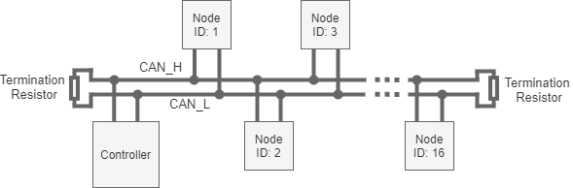

Figure 1. Tactile Sensor CAN Network

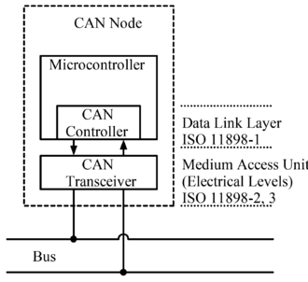

Figure 2. CAN Node Implementation

1. **Electrical Characteristics**

The communications bus will be physically implemented by a shared differential, 2-wire, half duplex serial bus terminated on each end by a 120Ω termination resistor. An ISO-11898 compliant CAN transceiver will be used to interface the CAN controller with the physical bus for each node[1][2].

Long inter-node connections should use twisted pair cabling to allow for higher bus speeds.

1. **Network Addressing**

Network addressing will be handled using the 11-bit message ID block of the CAN protocol[1]. Each device on the network will have a unique 8-bit node base address. The remaining 3 bits of the message ID block are used as an address offset to give each node a block of 8 network addresses to be used for various functions. Up to 255 nodes on the network are supported. The address block 0x7F8 to 0x7FF is reserved for the controller and network functions, and cannot be used for node addressing.

* 1. **Node Discovery**

A node discovery feature will be implemented to allow a controller to automatically detect all the nodes on the network. The discovery procedure is detailed below:

1. After power-up, each node immediately enters Discovery mode if it does not have a previously assigned node address. In Discovery mode, the node will periodically broadcast the lower 64 bits of its device ID at a 1 second interval to the reserved discovery message ID of 0x7FF. To prevent excessive bus contention if a chain of nodes is simultaneously powered up, the periodic broadcast will be start at a randomly seeded delay after boot-up.
2. The network controller node will monitor any messages sent to the reserved discovery message ID 0x7FF and save the device IDs to the array of discovered network devices.
3. The network controller will send a discovery acknowledgment message to the node along with a dynamically assigned 8-bit node address (determined according to the procedure set forth in the *Commissioning* subsection) that the controller and node can use for bidirectional communications.
4. The node will broadcast a ready message to the network controller and enter Normal operating mode.
   1. **Node Commissioning**

A commissioning procedure will be used to initialize nodes on the network and dynamically assign addresses to the nodes in either an automatic or manual fashion. The assigned node address will be saved to the node’s on-chip non-volatile flash shortage so that the address only has to be assigned once and will be persistent across power cycles. A mechanism will be provided to reset the node in order to restart the commissioning procedure if desired.

* + 1. **Automatic**

If commissioning is set to automatic mode, each node in the chain will be assigned a node address from 0 to 254 in first-come first-serve fashion. To sequentially commission nodes, connect a node to the network, power on the network, wait for the node to be assigned an address, power down the network, and repeat the whole process for each additional node.

* + 1. **Manual**

If commissioning manually, the user will define a node address from 0-254 for each node. If you know the device IDs of each of the nodes in the network, you can directly assign node address to the corresponding discovered device IDs in the network controller. Otherwise, to sequentially commission nodes first plug in a node into the network, power on the network, assign the newly discovered node a node address, power down the network, and repeat the whole process for each additional node.

1. **Polling**

The procedure for reading out the force measurements from each node is detailed as follows:

1. The controller issues a request for data to the node of interest and specifies which columns should be read back.
2. The node will take the most recent acquired and filtered measurements of the requested columns and pack the data of each column into an 8 byte packet. The node will then write the packets onto the network using the upper four message ID’s out of the eight assigned to that node, one for each column.
3. The controller will monitor the network for messages with one of the four previously mentioned message ID’s, and will copy the received data into a 16 element array corresponding to that node.

In order to read all of the sensor nodes, the network controller will poll each discovered node on the network sequentially using the above procedure. Each node will no more than 10 ms to the polling latency of the chain.

1. **References**

[1] ISO Standard *Road vehicles — Controller area network (CAN) — Part 1: Data link layer and physical signalling, ISO 11898-1:2015*

[2] ISO Standard *Road vehicles — Controller area network (CAN) — Part 2: High-speed medium access unit, ISO 11898-2:2016*