Bike Buyers Dashboard Project

**Prepared by:** Toufeeq Qader

1. Introduction

2. Raw Data Overview

3. Data Cleaning & Preparation

4. Analytical Metrics & Calculations

5. Dashboard Design

# 1. Introduction

This document outlines the complete workflow I followed to build a comprehensive Excel dashboard for the Bike Buyers dataset. It is intended for potential clients on Upwork and Fiverr to showcase my ability to transform raw data into actionable insights through professional data analysis and visualization techniques.

# 2. Raw Data Overview

The original dataset contains **1000 records** with 14 columns.

Key Columns:

* - ID
* - Material status
* - Gender
* - Income
* - Children
* - Education
* - Occupation
* - Home Owner
* - Cars
* - Commute Distance
* - Region
* - Age
* - Age Brackets
* - Purchased Bike

**Screenshot: Raw Data**

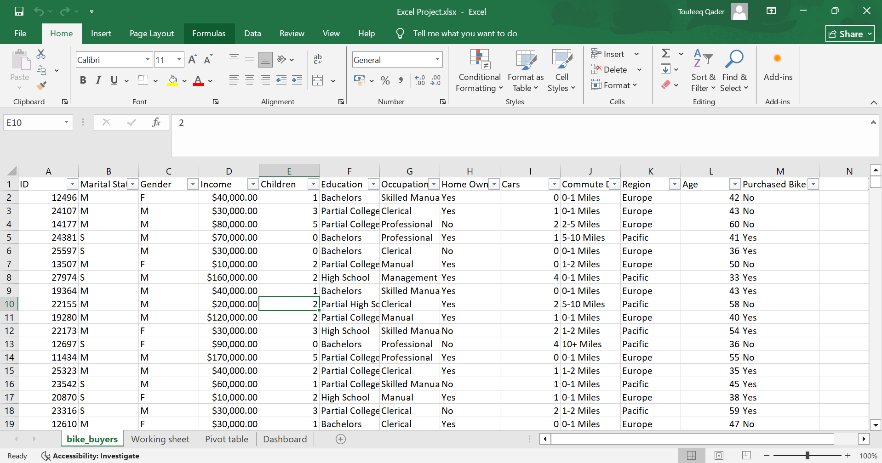

# 3. Data Cleaning & Preparation

Key cleaning actions performed:

* - Renamed ambiguous column headers (e.g., corrected 'Marriedarital SingletatuSingle' to 'Material status').
* - Removed duplicate records and validated unique IDs.
* - Handled missing values appropriately (filled, removed, or flagged).
* - Created derived columns such as 'Age Brackets' for demographic segmentation.
* - Standardized categorical values (e.g., ensured 'Yes/No' are consistent).

**Screenshot: Data Cleaning in action**

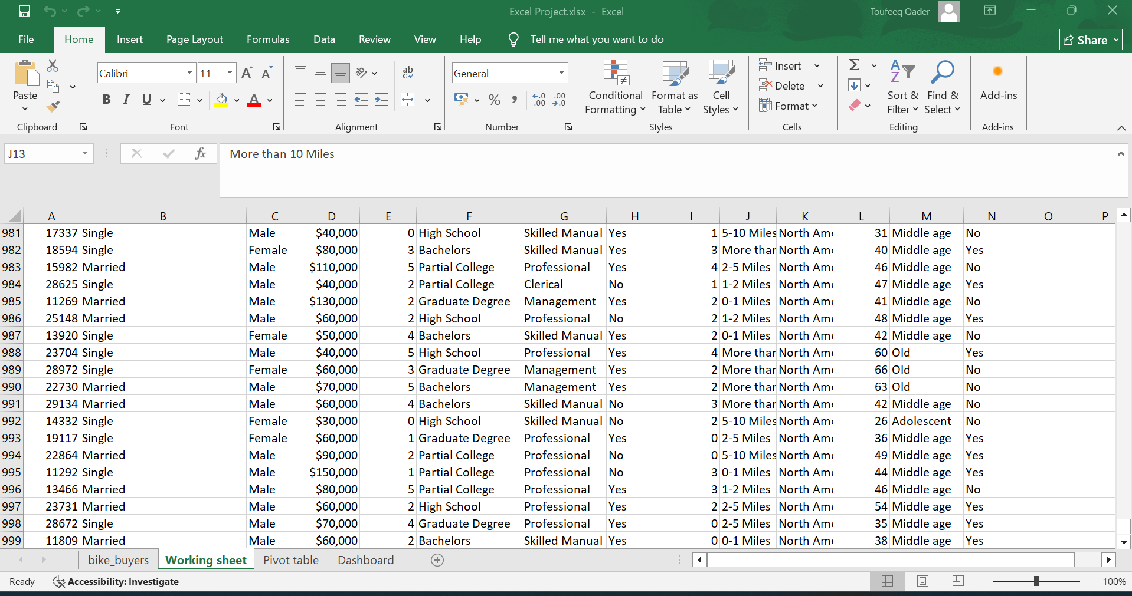

# 4. Analytical Metrics & Calculations

Summary metrics extracted from the cleaned dataset:

- Purchased Bike – Yes: **481**

- Purchased Bike – No: **519**

- Average Income: **$56360.00**

- Gender Distribution: {'Male': 511, 'Female': 489}

- Age Brackets Distribution: {'Middle age': 701, 'Old': 189, 'Adolescent': 110}

**Screenshot: Pivot Table**

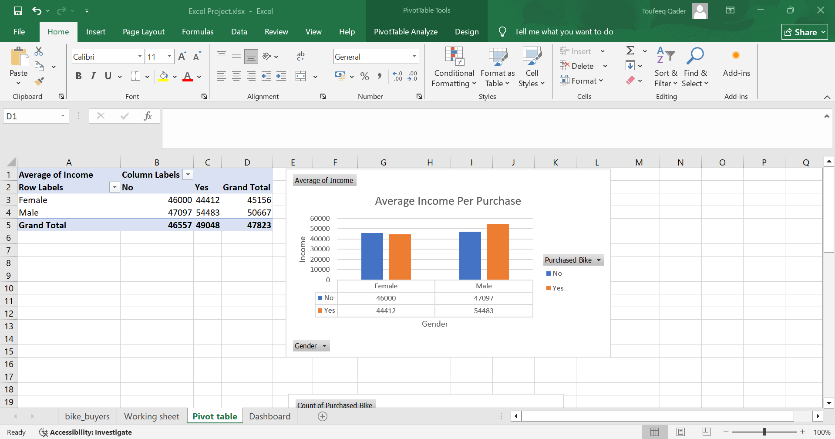

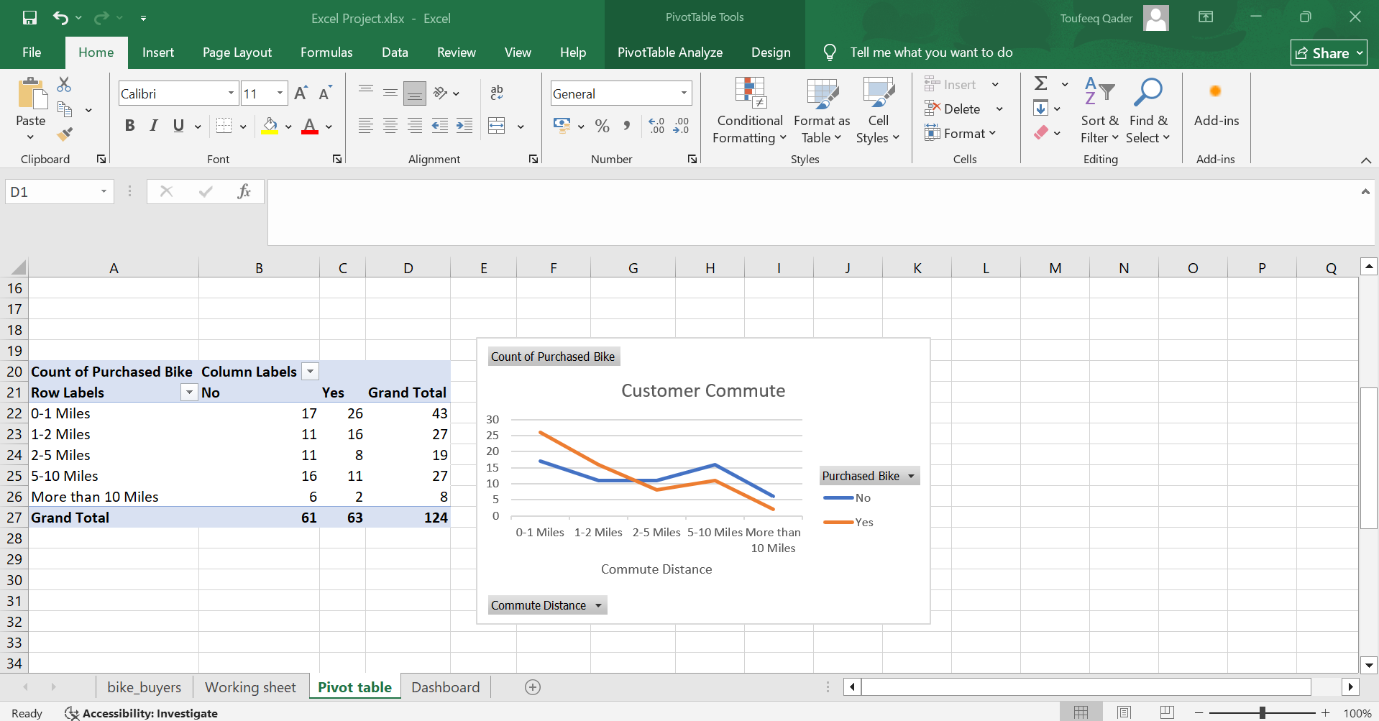

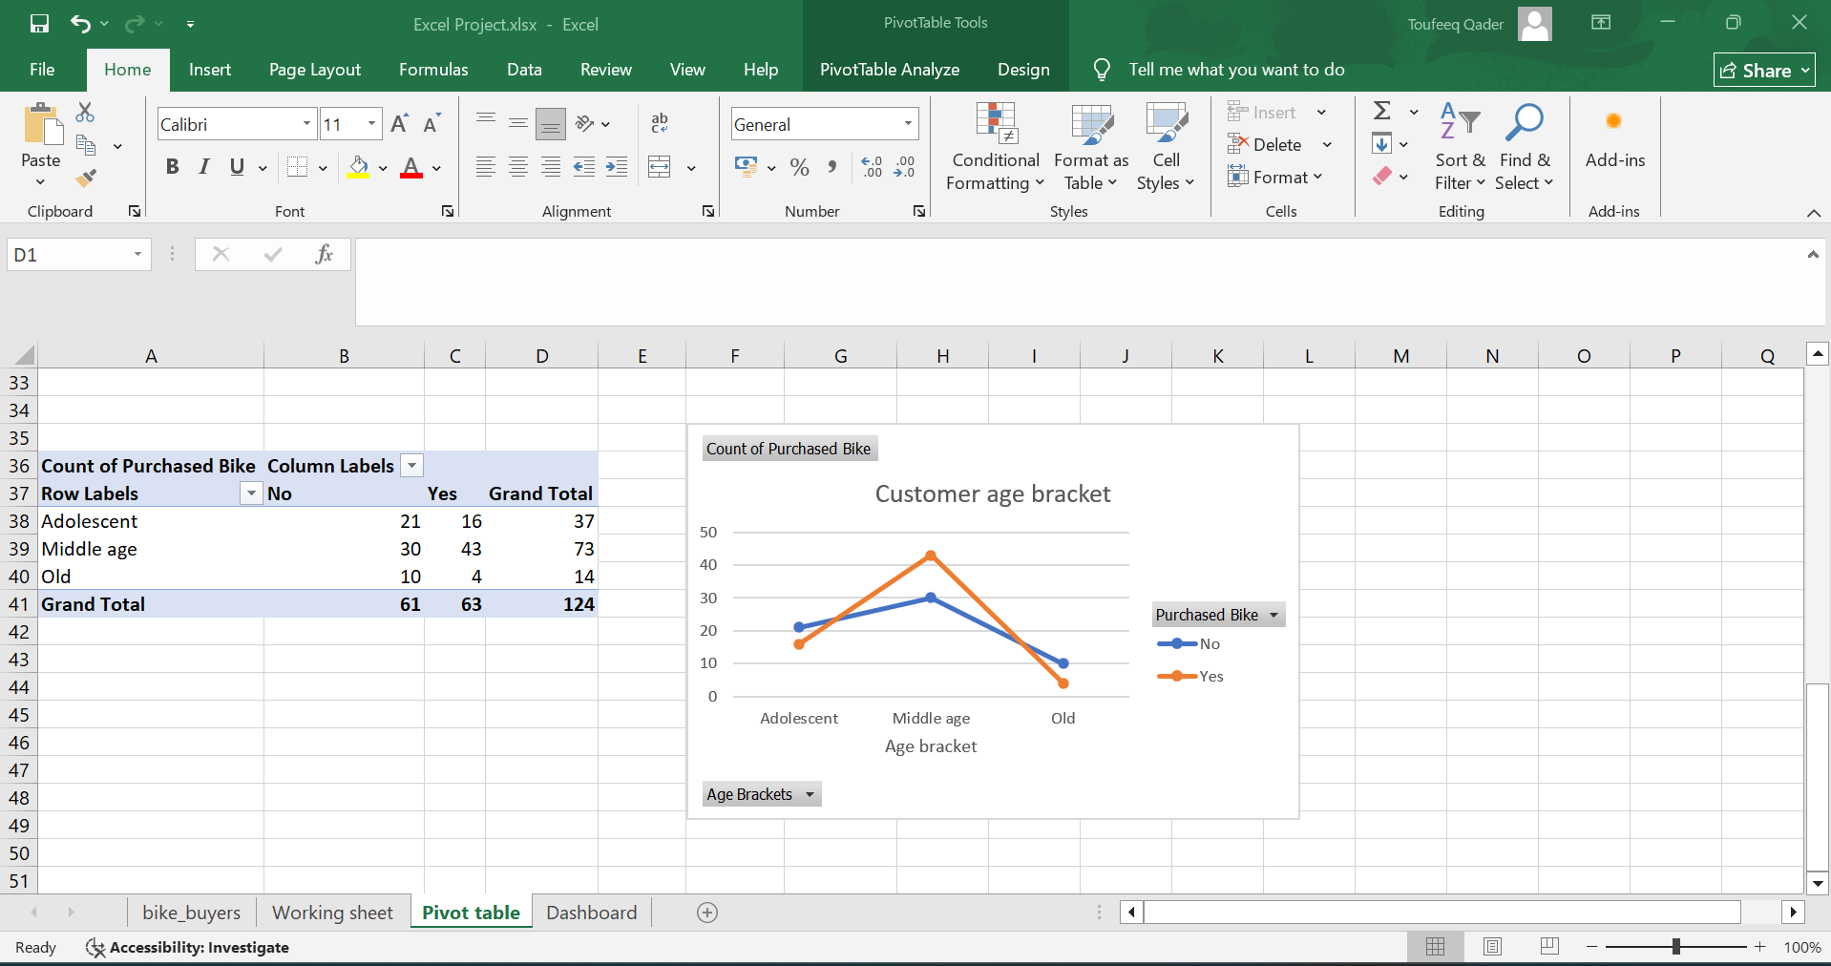

# 5. Dashboard Design

The dashboard was designed with an executive audience in mind, combining high-level KPIs with interactive elements for deeper exploration.

Dashboard components include:

* - Dynamic KPI cards for total sales, purchase rate, and average income.
* - Interactive slicers for gender, marital status, and age brackets.
* - Clustered column chart comparing purchase rates by gender.
* - Stacked bar chart illustrating purchase rates across age brackets.
* - Heat map table showing average income vs. purchase decisions.
* - Donut chart highlighting bike purchase breakdown (Yes vs No).

**Screenshot: Final Dashboard Overview**

