**Bangladesh University of Engineering and Technology**

**Department of Electrical and Electronic Engineering**



***Course Number:*** *EEE 414*

***Course Title:*** *Electrical Services Design*

**Project: 3-Storeyed Building Design**

**Submitted to:**

Ishtiak Mahmud and Rifat Shahriar

Lecturer, Dept. of EEE, BUET

**Submitted by:**

Group 3

Zafir Sadik (ID: 1606135)

Kanak Kanti Bhowmik (ID: 1606156)

Md. Toufiqur Rahman shuvo (ID: 1606159)

Tushar Roy (ID: 1606160)

Shovon Roy (ID: 1606166)

Partho Bhoumik (ID: 1606178)

Shahedul Hasan (ID: 1606179)

Swagata Goswami Utsha (ID: 1606192)

**Section:** C

**Fittings and Fixtures:**

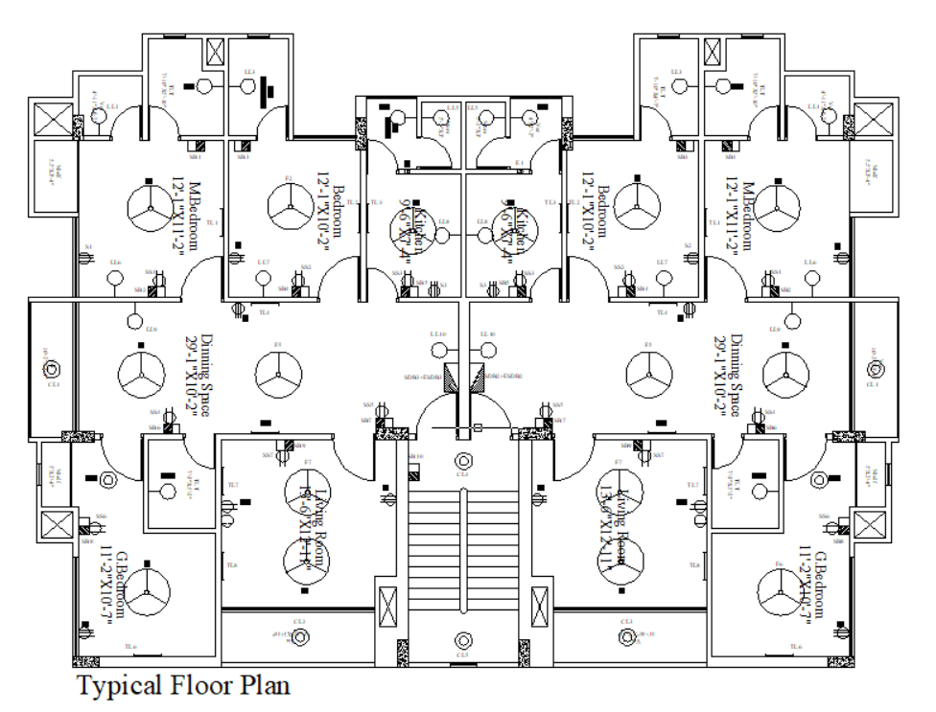

Fig: Typical Floor Plan without wiring

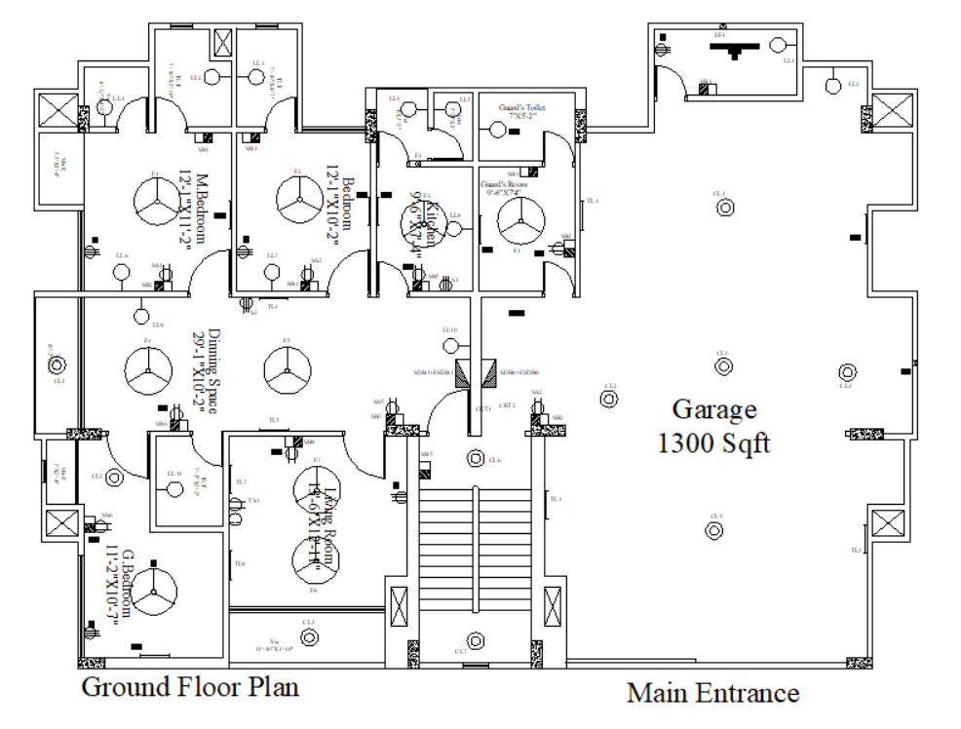

Fig: Typical Ground Floor Plan without wiring

**Conduit:**

Fig: Typical Ground Floor Plan with wiring

Fig: Typical Floor Plan with wiring

Calculation for Ground Floor:

**We know,**

$$E= \frac{n*N*F*UF*LLF}{A}, A in m^{2}$$

E = Illuminance

n = number of lights per illuminance

N = number of lights required

F = lumen of bulb

LLF = Light Loss Factor

UF = Utilization factor

A = area

$$F= \frac{A}{100}, A in sq-ft$$

Here,

F = number of fans required

**Veranda 1:**

Area = 4’11” x 4’7” = 22.5347 sqft = 2.0935 m2

Illuminance, E= 70 Lumen/m2

Light Loss Factor and Utilization Factor, LLF x UF = 0.7

Number of lights per illuminaire, n=1

Flux= 1250 Lumen

Number of Lights, N= 0.16748 ≈ 1

**So, 1 light bulb is required.**

**Toilet-1:**

Area= 7’10” x 5’10” = 45.6944 sqft = 4.245 m2

Illuminance, E= 100 Lumen/m2

Light Loss Factor and Utilization Factor, LLF x UF = 0.7

Number of lights per illuminaire, n=1

Flux= 1250 Lumen

Number of Lights, N= 0.485 ≈ 1

**So, 1 light bulb is required.**

**Toilet-2:**

Area= 7’10” x 4’7” = 35.9028 sqft = 16.26 m2

Illuminance, E= 100 Lumen/m2

Light Loss Factor and Utilization Factor, LLF x UF = 0.7

Number of lights per illuminaire, n=1

Flux= 1250 Lumen

Number of Lights, N= 0.38 ≈ 1

**So, 1 Light bulb is required.**

**Master Bedroom:**

Area= 12’1” x 11’2” = 134.93 sqft = 12.53546 m2

Illuminance, E= 100 Lumen/m2

Light Loss Factor and Utilization Factor, LLF x UF = 0.7

Number of lights per illuminaire, n=1

Flux= 1250 Lumen

Number of Lights, N= 1.4326 ≈ 2

**So, 1 light bulb and 1 tube light are required.**

Number of Fans= 1.3493 ≈ 1

**So, 1 Fan is required.**

**Bedroom 1:**

Area= 12’1” x 10’2” = 11.41288 m2

Illuminance, E= 70 Lumen/m2

Light Loss Factor and Utilization Factor, LLF x UF = 0.7

Number of lights per illuminaire, n=1

Flux= 1250 Lumen

Number of Lights, N= 1.30433 ≈ 2

**So, 1 light bulb and 1 tube light are required.**

Number of Fans= 1.22847 ≈ 1

**So, 1 Fan is required.**

**Dinning Space1,2:**

Area= 29’1” x 10’2” =295.6806 sqft = 27.4696 m2

Illuminance, E= 100 Lumen/m2

Light Loss Factor and Utilization Factor, LLF x UF = 0.7

Number of lights per illuminaire, n=1

Flux= 1250 Lumen

Number of Lights, N= 3.134 ≈ 4

**So, 2 light bulbs and 2 tube lights are required.**

Number of Fans= 2.956806 ≈ 2

**So, 2 Fans are required.**

**Kitchen:**

Area= 9’6” x 7’4” = 69.6667 sqft = 6.4722 m2

Illuminance, E= 100 Lumen/m2

Light Loss Factor and Utilization Factor, LLF x UF = 0.7

Number of lights per illuminaire, n=1

Flux= 1250 Lumen

Number of Lights, N= 1.48 ≈ 2

**So, 1 light bulb and 1 tube light are required.**

**G Bedroom:**

Area= 118.1806 sqft=10.979 m2

Illuminance, E= 100 Lumen/m2

Light Loss Factor and Utilization Factor, LLF x UF = 0.7

Number of lights per illuminaire, n=1

Flux= 1250 Lumen

Number of Lights, N= 1.2547

**So, 1 Tube Light Bulb and 1 ceiling light is required.**

Number of Fans= 1.181806 ≈ 1

**So, 1 Fan is required.**

**Toilet 3:**

Area= 7’3” x 5’2” = 37.4583 sqft

Illuminance, E= 200 Lumen/m2

Light Loss Factor and Utilization Factor, LLF x UF = 0.7

Number of lights per illuminaire, n=1

Flux= 1250 Lumen (20W Energy Saving Bulb and Fluorescent Tube Light)

Number of Lights, N= 0.4 ≈ 1

**So, 1 Light Bulb is required.**

**Living Room 1,2:**

Area= 13’6” x 12’11” =174.375 sqft

Illuminance, E= 100 Lumen/m2

Light Loss Factor and Utilization Factor, LLF x UF = 0.7

Number of lights per illuminaire, n=1

Flux= 1250 Lumen

Number of Lights, N= 1.296 ≈ 2

**So, 1 light bulb and 1 tube light are required.**

**Veranda 2:**

Area= 45.3611 sqft = 4.21 m2

Illuminance, E= 100 Lumen/m2

Light Loss Factor and Utilization Factor, LLF x UF = 0.7

Number of lights per illuminaire, n=1

Flux= 1250 Lumen (20W Energy Saving Bulb and Fluorescent Tube Light)

Number of Lights, N = 0.48

**So, 1 Light Bulb is required.**

**Guard’s Room:**

Area= 9’6” x 7’4” = 69.6667 sqft = 6.47225 m2

Illuminance, E= 100 Lumen/m2

Light Loss Factor and Utilization Factor, LLF x UF = 0.7

Number of lights per illuminaire, n=1

Flux= 1250 Lumen (20W Energy Saving Bulb)

Number of Lights, N = 0.74 ≈ 1

**So, 1 light bulb is required.**

**Store Room:**

Area= 5’2” x 3’ = 15.5 sqft = 1.439997 m2

Illuminance, E= 100 Lumen/m2

Light Loss Factor and Utilization Factor, LLF x UF = 0.7

Number of lights per illuminaire, n=1

Flux= 1250 Lumen (20W Energy Saving Bulb)

Number of Lights, N = 0.1646 ≈ 1

**So, 1 light bulb is required.**

Number of Fans= 0.155 ≈ 1

**So, 1 Exhaust Fan is required.**

**Guard’s Toilet:**

Area= 7’ x 5’2” = 36.167 sqft = 3.36 m2

Illuminance, E= 100 Lumen/m2

Light Loss Factor and Utilization Factor, LLF x UF = 0.7

Number of lights per illuminaire, n=1

Flux= 1250 Lumen (20W Energy Saving Bulb)

Number of Lights, N = 0.384 ≈ 1

**So, 1 light bulb is required.**

**Generator and Pump room:**

Area= 10’10” x 5’ = 54.167 sqft = 5.0322 m2

Illuminance, E= 100 Lumen/m2

Light Loss Factor and Utilization Factor, LLF x UF = 0.7

Number of lights per illuminaire, n=1

Flux= 1250 Lumen (20W Energy Saving Bulb)

Number of Lights, N = 0.575 ≈ 1

**So, 1 light bulb is required.**

Number of Fans= 0.54167 ≈ 1

**So, 1 Exhaust Fan is required.**

**Garage:**

Area=1350 sqft = 125.42 m2

Illuminance, E= 100 Lumen/m2

Light Loss Factor and Utilization Factor, LLF x UF = 0.7

Number of lights per illuminaire, n=1

Flux= 1250 Lumen

Number of Lights, N = 9.66192 ≈ 10

**So, 5 ceiling light bulbs, 4 tube lights and 1 light bulb are required.**

**And 1 Exhaust Fan is required.**

Calculation for First Floor:

**Veranda 1:**

Area = 4’11” x 4’7” = 22.5347 sqft = 2.0935 m2

Illuminance, E= 70 Lumen/m2

Light Loss Factor and Utilization Factor, LLF x UF = 0.7

Number of lights per illuminaire, n=1

Flux= 1250 Lumen

Number of Lights, N= 0.16748 ≈ 1

**So, 1 light bulb is required.**

**Toilet-1:**

Area= 7’10” x 5’10” = 45.6944 sqft = 4.245 m2

Illuminance, E= 100 Lumen/m2

Light Loss Factor and Utilization Factor, LLF x UF = 0.7

Number of lights per illuminaire, n=1

Flux= 1250 Lumen

Number of Lights, N= 0.485 ≈ 1

**So, 1 light bulb is required.**

**Toilet-2:**

Area= 7’10” x 4’7” = 35.9028 sqft = 16.26 m2

Illuminance, E= 100 Lumen/m2

Light Loss Factor and Utilization Factor, LLF x UF = 0.7

Number of lights per illuminaire, n=1

Flux= 1250 Lumen

Number of Lights, N= 0.38 ≈ 1

**So, 1 Light bulb is required.**

**Master Bedroom:**

Area= 12’1” x 11’2” = 134.93 sqft = 12.53546 m2

Illuminance, E= 100 Lumen/m2

Light Loss Factor and Utilization Factor, LLF x UF = 0.7

Number of lights per illuminaire, n=1

Flux= 1250 Lumen

Number of Lights, N= 1.4326 ≈ 2

**So, 1 light bulb and 1 tube light are required.**

Number of Fans= 1.3493 ≈ 1

**So, 1 Fan is required.**

**Bedroom 1:**

Area= 12’1” x 10’2” = 11.41288 m2

Illuminance, E= 70 Lumen/m2

Light Loss Factor and Utilization Factor, LLF x UF = 0.7

Number of lights per illuminaire, n=1

Flux= 1250 Lumen

Number of Lights, N= 1.30433 ≈ 2

**So, 1 light bulb and 1 tube light are required.**

Number of Fans= 1.22847 ≈ 1

**So, 1 Fan is required.**

**Dinning Space1,2:**

Area= 29’1” x 10’2” =295.6806 sqft = 27.4696 m2

Illuminance, E= 100 Lumen/m2

Light Loss Factor and Utilization Factor, LLF x UF = 0.7

Number of lights per illuminaire, n=1

Flux= 1250 Lumen

Number of Lights, N= 3.134 ≈ 4

**So, 2 light bulbs and 2 tube lights are required.**

Number of Fans= 2.956806 ≈ 2

**So, 2 Fans are required.**

**Kitchen:**

Area= 9’6” x 7’4” = 69.6667 sqft = 6.4722 m2

Illuminance, E= 100 Lumen/m2

Light Loss Factor and Utilization Factor, LLF x UF = 0.7

Number of lights per illuminaire, n=1

Flux= 1250 Lumen

Number of Lights, N= 1.48 ≈ 2

**So, 1 light bulb and 1 tube light are required.**

**G Bedroom:**

Area= 118.1806 sqft=10.979 m2

Illuminance, E= 100 Lumen/m2

Light Loss Factor and Utilization Factor, LLF x UF = 0.7

Number of lights per illuminaire, n=1

Flux= 1250 Lumen

Number of Lights, N= 1.2547

**So, 1 ceiling light and 1 tubelight is required.**

Number of Fans= 1.181806 ≈ 1

**So, 1 Fan is required.**

**Toilet 3:**

Area= 7’3” x 5’2” = 37.4583 sqft

Illuminance, E= 200 Lumen/m2

Light Loss Factor and Utilization Factor, LLF x UF = 0.7

Number of lights per illuminaire, n=1

Flux= 1250 Lumen (20W Energy Saving Bulb and Fluorescent Tube Light)

Number of Lights, N= 0.4 ≈ 1

**So, 1 Light Bulb is required.**

**Living Room 1,2:**

Area= 13’6” x 12’11” =174.375 sqft

Illuminance, E= 100 Lumen/m2

Light Loss Factor and Utilization Factor, LLF x UF = 0.7

Number of lights per illuminaire, n=1

Flux= 1250 Lumen

Number of Lights, N= 1.296 ≈ 2

**So, 1 light bulb and 1 tube light are required.**

**Veranda 2:**

Area= 45.3611 sqft = 4.21 m2

Illuminance, E= 70 Lumen/m2

Light Loss Factor and Utilization Factor, LLF x UF = 0.7

Number of lights per illuminaire, n=1

Flux= 1250 Lumen (20W Energy Saving Bulb and Fluorescent Tube Light)

Number of Lights, N = 0.3368

**So, 1 Ceiling Light Bulb is required.**

**Store Room:**

Area= 5’2” x 3’ = 15.5 sqft = 1.439997 m2

Illuminance, E= 100 Lumen/m2

Light Loss Factor and Utilization Factor, LLF x UF = 0.7

Number of lights per illuminaire, n=1

Flux= 1250 Lumen (20W Energy Saving Bulb)

Number of Lights, N = 0.1646 ≈ 1

**So, 1 light bulb is required.**

Number of Fans= 0.155 ≈ 1

**So, 1 Exhaust Fan is required.**

Calculation for Second Floor:

**Veranda 1:**

Area = 4’11” x 4’7” = 22.5347 sqft = 2.0935 m2

Illuminance, E= 70 Lumen/m2

Light Loss Factor and Utilization Factor, LLF x UF = 0.7

Number of lights per illuminaire, n=1

Flux= 1250 Lumen

Number of Lights, N= 0.16748 ≈ 1

**So, 1 light bulb is required.**

**Toilet-1:**

Area= 7’10” x 5’10” = 45.6944 sqft = 4.245 m2

Illuminance, E= 100 Lumen/m2

Light Loss Factor and Utilization Factor, LLF x UF = 0.7

Number of lights per illuminaire, n=1

Flux= 1250 Lumen

Number of Lights, N= 0.485 ≈ 1

**So, 1 light bulb is required.**

**Toilet-2:**

Area= 7’10” x 4’7” = 35.9028 sqft = 16.26 m2

Illuminance, E= 100 Lumen/m2

Light Loss Factor and Utilization Factor, LLF x UF = 0.7

Number of lights per illuminaire, n=1

Flux= 1250 Lumen

Number of Lights, N= 0.38 ≈ 1

**So, 1 Light bulb is required.**

**Master Bedroom:**

Area= 12’1” x 11’2” = 134.93 sqft = 12.53546 m2

Illuminance, E= 100 Lumen/m2

Light Loss Factor and Utilization Factor, LLF x UF = 0.7

Number of lights per illuminaire, n=1

Flux= 1250 Lumen

Number of Lights, N= 1.4326 ≈ 2

**So, 1 light bulb and 1 tube light are required.**

Number of Fans= 1.3493 ≈ 1

**So, 1 Fan is required.**

**Bedroom 1:**

Area= 12’1” x 10’2” = 11.41288 m2

Illuminance, E= 70 Lumen/m2

Light Loss Factor and Utilization Factor, LLF x UF = 0.7

Number of lights per illuminaire, n=1

Flux= 1250 Lumen

Number of Lights, N= 1.30433 ≈ 2

**So, 1 light bulb and 1 tube light are required.**

Number of Fans= 1.22847 ≈ 1

**So, 1 Fan is required.**

**Dinning Space1,2:**

Area= 29’1” x 10’2” =295.6806 sqft = 27.4696 m2

Illuminance, E= 100 Lumen/m2

Light Loss Factor and Utilization Factor, LLF x UF = 0.7

Number of lights per illuminaire, n=1

Flux= 1250 Lumen

Number of Lights, N= 3.134 ≈ 4

**So, 2 light bulbs and 2 tube lights are required.**

Number of Fans= 2.956806 ≈ 2

**So, 2 Fans are required.**

**Kitchen:**

Area= 9’6” x 7’4” = 69.6667 sqft = 6.4722 m2

Illuminance, E= 100 Lumen/m2

Light Loss Factor and Utilization Factor, LLF x UF = 0.7

Number of lights per illuminaire, n=1

Flux= 1250 Lumen

Number of Lights, N= 1.48 ≈ 2

**So, 1 light bulb and 1 tube light are required.**

**G Bedroom:**

Area= 118.1806 sqft=10.979 m2

Illuminance, E= 100 Lumen/m2

Light Loss Factor and Utilization Factor, LLF x UF = 0.7

Number of lights per illuminaire, n=1

Flux= 1250 Lumen

Number of Lights, N= 1.2542

**So, 1 Ceiling light and 1 tubelight is required.**

Number of Fans= 1.181806 ≈ 1

**So, 1 Fan is required.**

**Toilet 3:**

Area= 7’3” x 5’2” = 37.4583 sqft

Illuminance, E= 200 Lumen/m2

Light Loss Factor and Utilization Factor, LLF x UF = 0.7

Number of lights per illuminaire, n=1

Flux= 1250 Lumen (20W Energy Saving Bulb and Fluorescent Tube Light)

Number of Lights, N= 0.4 ≈ 1

**So, 1 Light Bulb is required.**

**Living Room 1,2:**

Area= 13’6” x 12’11” =174.375 sqft

Illuminance, E= 100 Lumen/m2

Light Loss Factor and Utilization Factor, LLF x UF = 0.7

Number of lights per illuminaire, n=1

Flux= 1250 Lumen

Number of Lights, N= 1.296 ≈ 2

**So, 1 light bulb and 1 tube light are required.**

**Veranda 2:**

Area= 45.3611 sqft = 4.21 m2

Illuminance, E= 100 Lumen/m2

Light Loss Factor and Utilization Factor, LLF x UF = 0.7

Number of lights per illuminaire, n=1

Flux= 1250 Lumen (20W Energy Saving Bulb and Fluorescent Tube Light)

Number of Lights, N = 0.48

**So, 1 Light Bulb is required.**

**Store Room:**

Area= 5’2” x 3’ = 15.5 sqft = 1.439997 m2

Illuminance, E= 100 Lumen/m2

Light Loss Factor and Utilization Factor, LLF x UF = 0.7

Number of lights per illuminaire, n=1

Flux= 1250 Lumen (20W Energy Saving Bulb)

Number of Lights, N = 0.1646 ≈ 1

**So, 1 light bulb is required.**

Number of Fans= 0.155 ≈ 1

**So, 1 Exhaust Fan is required.**

Calculation for Conduit:

**Legends:**

C1= 2 x 1.5rm BYM

C2= 4 x 1.5rm BYM

C3= 6 x 1.5rm BYM

C4= 8 x 1.5rm BYM

C5= 2 x 1.5rm BYM + 1.5 rm BYA ECC

C6= 2 x 2.5rm BYM + 2.5 rm BYA ECC

C7= 4 x 2.5rm BYM + 2.5 rm BYA ECC

C8= 2 x 4rm BYM + 4 rm BYA ECC

C10= 4 x 4rm BYM + 2 x 4 rm BYA ECC

C12= 2 x 10rm BYM + 10 rm BYA ECC

C13= 2 x 16rm BYM + 16 rm BYA ECC

5A → 1.5rm  (6 Cable for ¾” , 10 Cable for 1”)

10A → 2.5rm (4 Cable for ¾” , 7 Cable for 1”)

15A → 4rm(3 Cable for ¾” , 5 Cable for 1”)

20A → 6rm (2 Cable for ¾” , 4 Cable for 1”)

Formula for ampere rating, $I = PV*pf (A)PV*pf (A)$

pf= 0.7

Energy saving bulb = 20W

Tubelight =20W

Ceiling Light = 20W

Ceiling Fan = 100W

Switchboard Socket= 100W

Exhaust Fan = 40W

All internal wires are below 5A rating, so 2 x 1.5 rm BYM is used in all internal wiring.

Ground Floor:

**To Sub Distribution Board (SDB1) of Ground Floor Unit:**

**CKT1 Rating**

I = $\frac{20+20}{220*0.7}$ (A)

=0.26 A

So, **2 x 1.5 rm BYM + 1.5 BYA ECC are used.**

**CKT3 Rating**

I = $\frac{20+20+100}{220*0.7}$ (A)

=0.9091 A

So, **2 x 1.5 rm BYM + 1.5 BYA ECC are used.**

**CKT5 Rating**

I = $\frac{20+100+20+100}{220*0.7}$ (A)

=1.55844 A

So, **2 x 1.5 rm BYM + 1.5 BYA ECC are used.**

**CKT7 Rating**

I = $\frac{20+100+100+20+20}{220*0.7}$ (A)

=1.6883 A

So, **2 x 1.5 rm BYM + 1.5 BYA ECC are used.**

**CKT9 Rating**

I = $\frac{20+100}{220*0.7}$ (A)

=0.77922 A

So, **2 x 1.5 rm BYM + 1.5 BYA ECC are used.**

**CKT11 Rating**

I = $\frac{20+100+20+100}{220*0.7}$ (A)

=1.55844 A

So, **2 x 1.5 rm BYM + 1.5 BYA ECC are used.**

**SDB 3 and 5 have same wiring connection**

**To Emergency Sub Distribution Board (ESDB1) of Ground Floor Unit:**

**CKT1 Rating**

I = $\frac{20+100+100+20}{220*0.7}$ (A)

=1.55844 A

So, **2 x 1.5 rm BYM + 1.5 BYA ECC are used.**

**CKT2 Rating**

I = $\frac{20+100+20+40+20}{220*0.7}$ (A)

=1.2987 A

So, **2 x 1.5 rm BYM + 1.5 BYA ECC are used.**

**CKT3 Rating**

I = $\frac{20+20+20+100+100}{220*0.7}$ (A)

=1.6883 A

So, **2 x 1.5 rm BYM + 1.5 BYA ECC are used.**

**CKT4 Rating**

I = $\frac{20+100}{220*0.7}$ (A)

=0.77922A

So, **2 x 1.5 rm BYM + 1.5 BYA ECC are used.**

**CKT5 Rating**

I = $\frac{20+100+100}{220*0.7}$ (A)

=1.42857 A

So, **2 x 1.5 rm BYM + 1.5 BYA ECC are used.**

**ESDB 3 and 5 have same wiring connection**

Calculations for SDB0 (Garage):

SDB1 LOAD = TOTAL LOAD*0.8+ TOTAL P SOCKET LOAD*0.4

TOTAL LOAD=CKT1 LOAD + CKT2 LOAD +CKT3 LOAD

20A SOCKET LOAD = 4000W

CKT1 LOAD=40W

CKT2 LOAD=480W

CKT3 LOAD=240W

TOTAL LOAD=760W

SDB LOAD = (760*.8) + (4000*.4) =2208W

SDB CURRENT = $\frac{SDB LOAD}{V*pf} (A)$ = $\frac{2208}{220*0.7} (A)$ =14.35 A

So, **2 x 4 rm BYM + 4 rm BYA ECC are used.**

Calculations for SDB1/SDB3/SDB5 :

SDB1 LOAD = TOTAL LOAD*0.8+ TOTAL P SOCKET LOAD*0.4

TOTAL LOAD=(CKT1 LOAD + CKT3 LOAD +CKT5 +CKT7+CKT9 + CKT11) LOAD

20A SOCKET LOAD = 4000W

15A SOCKET LOAD = 3000W

CKT1 LOAD=40W

CKT3 LOAD=140W

CKT5 LOAD=240W

CKT7 LOAD=260W

CKT9 LOAD=120W

CKT11 LOAD=240W

TOTAL LOAD=1040W

SDB LOAD = (1040*.8) + (4*4000*.4) + (2*3000*.4) =9632W

SDB CURRENT = $\frac{SDB LOAD}{V*pf} (A)$ = $\frac{9632}{220*0.7} (A)$ =62.545 A

So, **2 x 50 rm BYM + 25 rm BYA ECC are used.**

Calculations for SDB2/SDB4:

SDB1 LOAD = TOTAL LOAD*0.8+ TOTAL P SOCKET LOAD*0.4

TOTAL LOAD=(CKT1 LOAD + CKT3 LOAD +CKT5 +CKT7+CKT9 + CKT11) LOAD

20A SOCKET LOAD = 4000W

15A SOCKET LOAD = 3000W

CKT1 LOAD=40W

CKT3 LOAD=140W

CKT5 LOAD=240W

CKT7 LOAD=260W

CKT9 LOAD=120W

CKT11 LOAD=240W

CKT12 LOAD =40W

TOTAL LOAD=1080W

SDB LOAD = (1080*.8) + (4*4000*.4) + (2*3000*.4) =9664W

SDB CURRENT = $\frac{SDB LOAD}{V*pf} (A)$ = $\frac{9664}{220*0.7} (A)$ =62.75 A

So, **2 x 50 rm BYM + 25 rm BYA ECC are used.**

Calculations for ESDB0 (Garage):

ESDB0 LOAD = TOTAL LOAD*0.8

TOTAL LOAD=CKT1 LOAD + CKT2 LOAD

CKT1 LOAD=40W

CKT2 LOAD=200W

TOTAL LOAD=240W

ESDB0 LOAD = 240*0.8=192W

ESDB0 CURRENT = $\frac{SDB LOAD}{V*pf} (A)$ = $\frac{192}{220*0.7} (A)$ =1.247 A

So, 2 x 1.5 rm BYM + 1.5 rm BYA ECC are used.

Calculations for ESDB1/ ESDB3/ ESDB5 :

ESDB1 LOAD = TOTAL LOAD*0.8

TOTAL LOAD=CKT1 LOAD + CKT2 LOAD + CKT3 LOAD + CKT4 LOAD + CKT5 LOAD

CKT1 LOAD=240W

CKT2 LOAD=200W

CKT3 LOAD = 260W

CKT4 LOAD = 120W

CKT5 LOAD = 220W

TOTAL LOAD=1040W

ESDB1 LOAD = 1040*0.8=832W

ESDB1 CURRENT = $\frac{SDB LOAD}{V*pf} (A)$ = $\frac{832}{220*0.7} (A)$ =5.40 A

So, 2 x 2.5 rm BYM + 2.5 rm BYA ECC are used.

Calculations for ESDB2/ ESDB4 :

ESDB2 LOAD = TOTAL LOAD*0.8

TOTAL LOAD=CKT1 LOAD + CKT2 LOAD + CKT3 LOAD + CKT4 LOAD + CKT5 LOAD + CKT6 LOAD

CKT1 LOAD=240W

CKT2 LOAD=200W

CKT3 LOAD = 260W

CKT4 LOAD = 120W

CKT5 LOAD = 220W

CKT6 LOAD = 40W

TOTAL LOAD=1080W

ESDB2 LOAD = 1080*0.8=864W

ESDB2 CURRENT = $\frac{SDB LOAD}{V*pf} (A)$ = $\frac{864}{220*0.7} (A)$ =5.61 A

So, 2 x 2.5 rm BYM + 2.5 rm BYA ECC are used

* **Calculations for EMDB:**

EMDB Load = Total ESDB Load x 0.7

Total ESDB Load = (ESDB0 + 3*ESDB1 + 2*ESDB2)

= (192 + 3*832 + 2*864)

= 4416 W

EMDB Current = $\frac{EMDB Load}{\sqrt{3}*Line Voltage*pf}$

Phase Voltage = 220 V

Line Voltage = $\sqrt{3}$* 220 V = 381.05 V

Power Factor, pf = 0.7

EMDB Load = 4416 x 0.7 = 3091.2 W

$EMDB current= \frac{3091.2}{\sqrt{3} ×381.05×0.7}=6.69 A$

So, 15 A TP MCCB is needed from EMDB to MDB

A 5 KW Generator is used to supply the EMDB Load through an ATS.

**Calculations for MDB**

MDB load = Total SDB load x 0.7 + (EMDB load + Pump load) x 0.7

Total SDB load = (SDB0 + 3*SDB1 + 2*SDB2)

=50432 W

$$MDB current= \frac{MDB Load}{\sqrt{3}*Line Voltage*pf}$$

Phase Voltage = 220 V

Line Voltage = $\sqrt{3}$ x 220 V = 381.05 V

Power Factor, pf = 0.7

Pump Load = 5kW

MDB load = 50532*.7 + 5000 = 40372.4W

$MDB current= \frac{40372.4}{\sqrt{3} ×381.05×0.7}=87.386 A$

So, 150A TP MCCB is needed from MDB to Main Line

**Switchboard Diagram:**

