Main information

[ALGORITHM] ConjugateGradient

[OPTION] verbose = True

[OPTION] epoch_end_signal = None

[OPTION] show_epoch = 25

[OPTION] shuffle_data = False

[OPTION] step = 0.1

[OPTION] train_end_signal = None

[OPTION] error = mse

[OPTION] addons = ['LinearSearch']

[OPTION] update_function = fletcher_reeves

[OPTION] maxiter = 10

[OPTION] search_method = golden

[OPTION] tol = 0.1

[THEANO] Initializing Theano variables and functions.

[THEANO] Initialization finished successfully. It took 0.38 seconds

Start training

[TRAINING DATA] shapes: (838860, 9)

[TRAINING] Total epochs: 10

------------------------------------------------

| Epoch # | Train err | Valid err | Time |

------------------------------------------------

| 1 | 0.02494 | - | 9.5 sec |

| 10 | 0.02426 | - | 00:00:12 |

------------------------------------------------



￼

[ 31.81 26.7 31.13 ..., 30.13 24.61 24.55]

[[ 99999.9]

[ 99999.9]

[ 0. ]

...,

[ 0. ]

[ 0. ]

[ 0. ]]

209715

209715

4.4866501085037545

24610903606.559933

156878.62699093187

[[ 0.48023036]

[-1.5032572 ]

[-1.15054085]

...,

[-0.74071615]

[-0.66144944]

[-0.04406338]]

[-0.94024881]

Main information

[ALGORITHM] ConjugateGradient

[OPTION] verbose = True

[OPTION] epoch_end_signal = None

[OPTION] show_epoch = 25

[OPTION] shuffle_data = False

[OPTION] step = 0.1

[OPTION] train_end_signal = None

[OPTION] error = mse

[OPTION] addons = ['LinearSearch']

[OPTION] update_function = fletcher_reeves

[OPTION] maxiter = 10

[OPTION] search_method = golden

[OPTION] tol = 0.1

[THEANO] Initializing Theano variables and functions.

[THEANO] Initialization finished successfully. It took 0.38 seconds

Start training

[TRAINING DATA] shapes: (838859, 9)

[TRAINING] Total epochs: 10

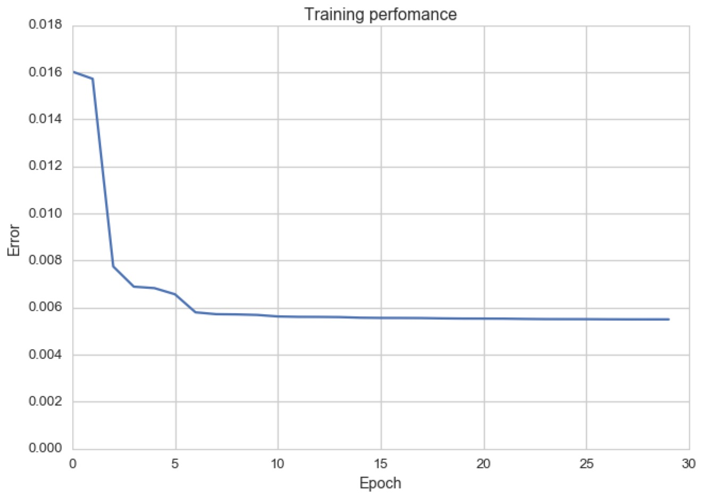

￼

[ 518.81 420.84 1105.53 ..., 1040.11 406.66 614.62]

[[ 448.906]

[ 448.906]

[ 448.906]

...,

[ 448.906]

[ 448.906]

[ 448.906]]

209715

209715

0.4791631316941596

65003.8322515917

254.95849123257634

[[-0.35568885]

[-0.50817737]

[-0.30793254]

...,

[ 0.18125154]

[ 0.08247891]

[ 0.02111142]]

[-0.12395373]