Chapter 6:

Input & Output Design

6.1 Introduction:

The UI of the project will be given as for a desktop application. The presented UI for the presentation had some scroll pages, which were marked as inappropriate in terms of SOLID principle. The corrected UIs are now categorized in six categories as:

1. Common UIs
2. UI for case filing sub-system
3. UI for Cause List Generation sub-system
4. UI for Magistrate Assignment sub-system
5. UI for Document Collection sub-system
6. UI for Judgment Documentation sub-system

6.2 Common UIs:

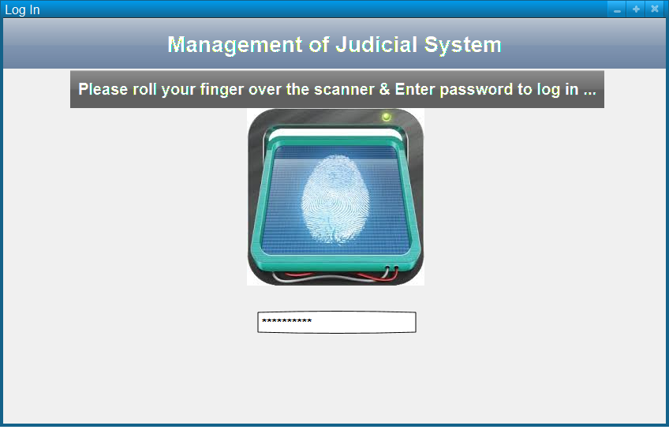6.2.1: Log in UI:

The log in will be done using the fingerprint scan of any user of the system. The system will be able to identify the finger print of any user distinctly and for extra security measures, a password will also be prompted out from the user.

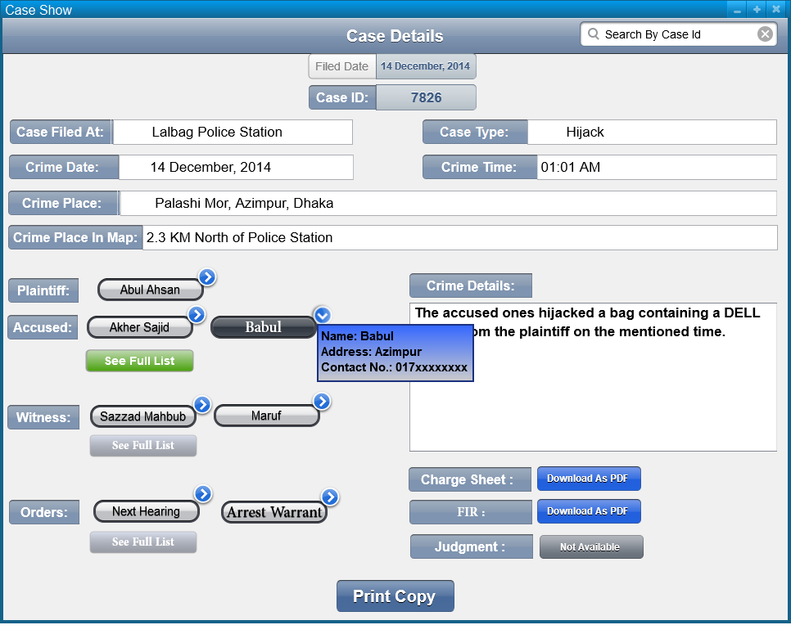6.2.2 Case Details Show:

This UI will be shown to OC, GRO, CLO, copy maker, comparer, Magistrate and CMM when they prompt to see any case. Here, the necessary fields are shown with self-explanatory labels, while the plaintiff, accused persons, witnesses and orders are shown by name buttons with a side arrow, which will show a dialog with the entered details of the person or order on click. There will be download buttons for downloading the FIR, charge sheet and other judgment documents when available. These downloads will give PDF of the document those can be of hundreds of pages. The print button at the bottom of the UI will print out the case with well formatted details.

6.3 UIs for Case Filing Sub-system:

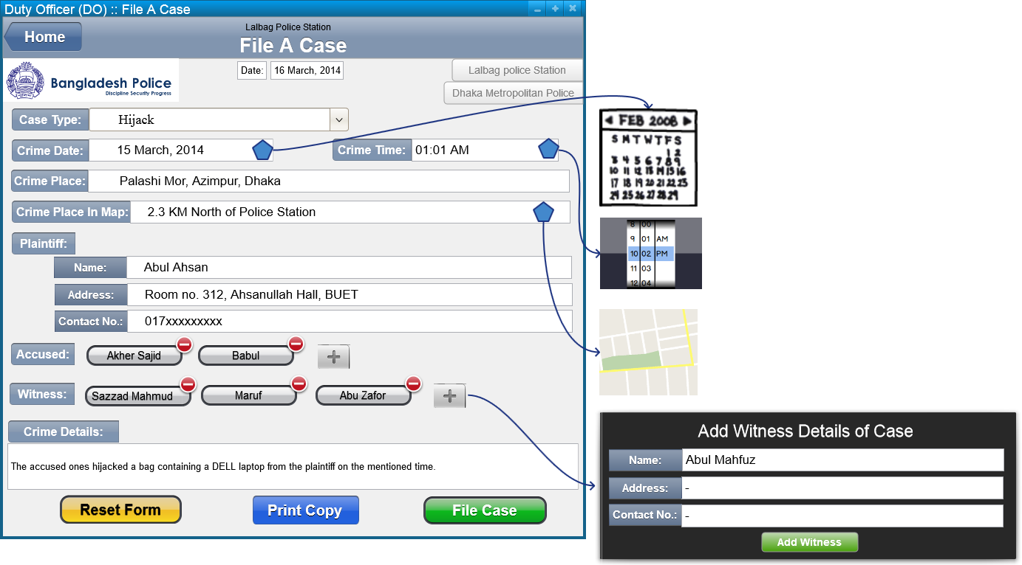6.3.1 Case Filing:

The DO of the police station will use this UI to input the case details as described the plaintiff. The case type will be selected from a drop down and the crime date and time will be selected through pickers. Crime place will take a manual input, while the crime place in map will provide a map to identify the specific location of the crime place with respect to the police station. The plaintiff details are must, so the fields are shown explicitly. But the accused and witness list will be populated through an addition dialog. At last there will be a text input field for the crime details. When the form is completely filled up, a copy can be printed out as well as the case filing process will be succeeded by clicking on file case prompt button.

6.3.2 Charge Sheet Submission:

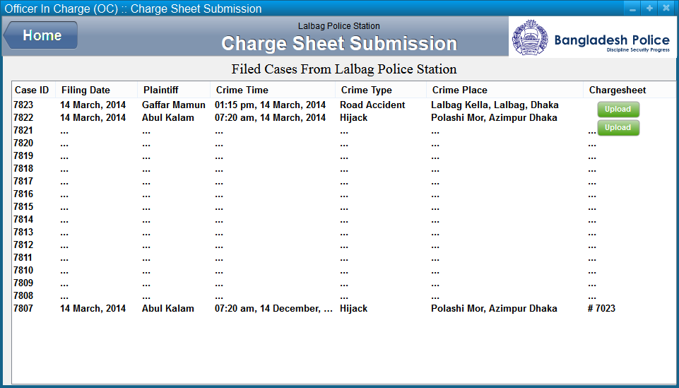The officer in charge (OC) will use this UI to see the cases filed at that police station. An upload charge sheet button will be available at the charge sheet column of the case list if this is yet to be submitted. On clicking this button, the OC can upload the scanned PDF or the typed document of the charge sheet. If the case has the charge sheet already uploaded, then the shown charge sheet id will download the PDF when clicked on. Moreover, clicking on the case row, the OC can see the details of the case.

6.4 UI for Cause List Generation Sub-system:

6.4.1 Case List Sending UI:

The General Record Officer (GRO) of the local magistrate office will use this UI to see the filed cases at the police stations of that locality. The list rows, when clicked on, will show the GRO the case details. There will be a check button, which the GRO can check if the details are ok and then he can forward the cases to the clerk office of the magistrate office.

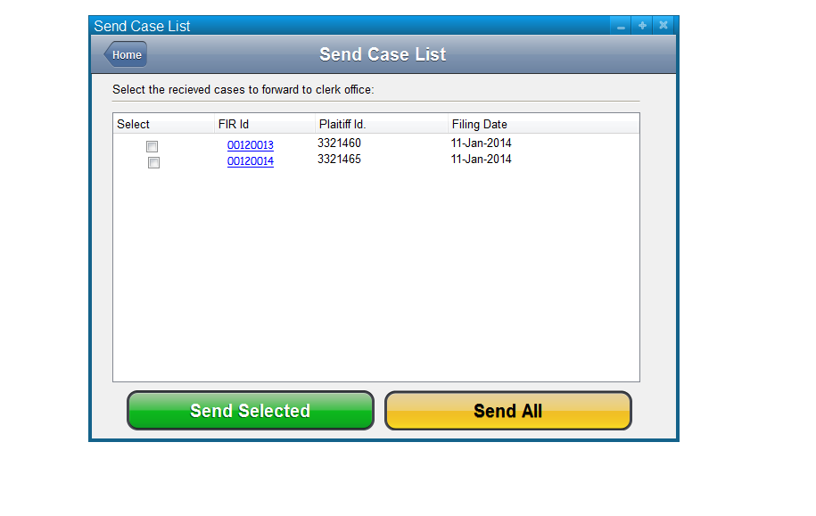

6.4.2 Cause List Show UI: 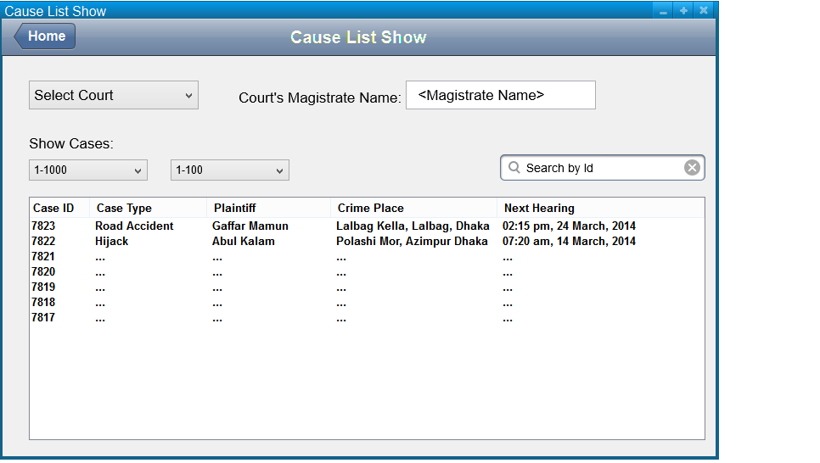

The clerk office will use this UI to see the cases under the Magistrate and the respective order notice will also be shown as a column in the list. As there may thousands of cases, there are two dropdowns to select the thousand and hundred volumes of the cases. Any case can also be searched out from the list by the id.

6.4.3 Magistrate Home UI: 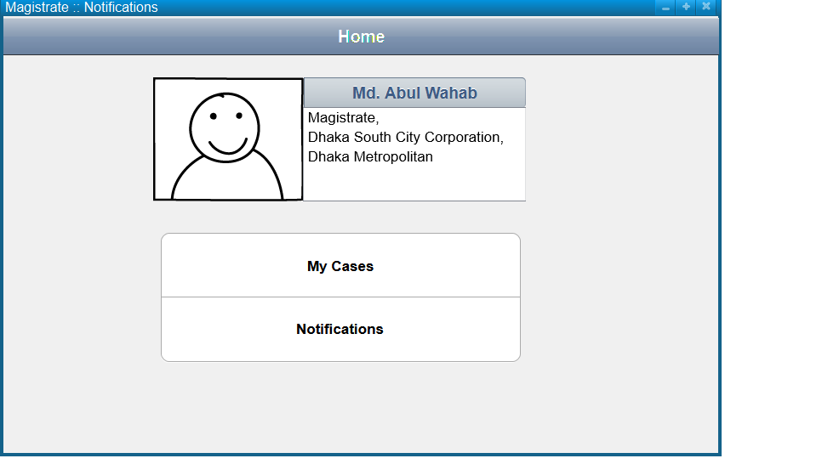

A magistrate can log in to the system and see this UI to navigate to his case list and notification list from this UI.

6.4.4 Magistrate Case List Show: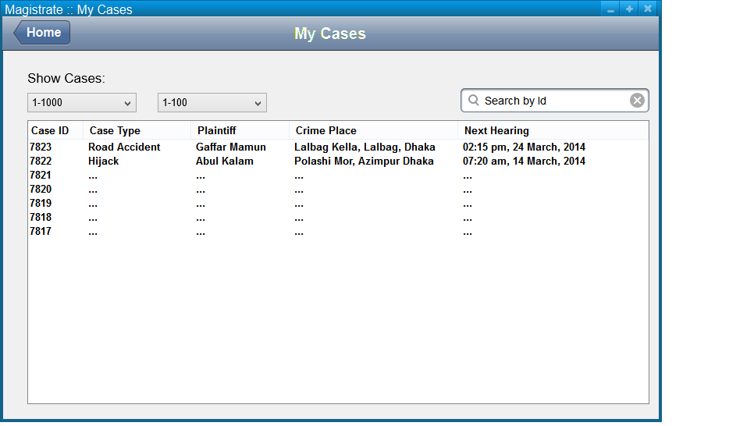

The magistrate can see the cases under his judgment in this UI. ONclicking any row, he will be able to see the details of the case. He can also search out any case by the id from this UI.

6.4.5 Magistrate Notification UI: 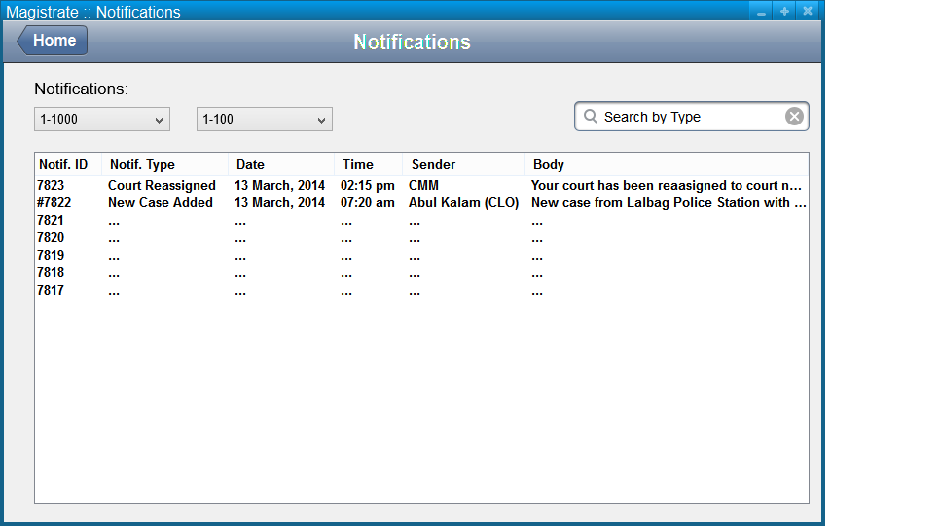

A magistrate can receive notifications from the CMM about the new court assignment after a new court list generation. He may also get notification after recepetion of a new case under his judgment. He can see the details of the case by clicking on the row from the list.

6.5 UI for Magistrate Assignment Sub-system:

6.5.1 Court List Generation UI:

The Chief Metropolitan Magistrate (CMM) can use this UI to shuffle the magistrates among the courts which will generate a new court list. The CMM will see all courts listed with the assigned magistrate details. There will be a drop down list to select another magistrate for the respective court. When another magistrate is selected, the previous magistrate will be swapped with the new magistrate between the two courts. After swapping magistrates, the CMM can save the new court list which will also notify the respective magistrates about the new court list.

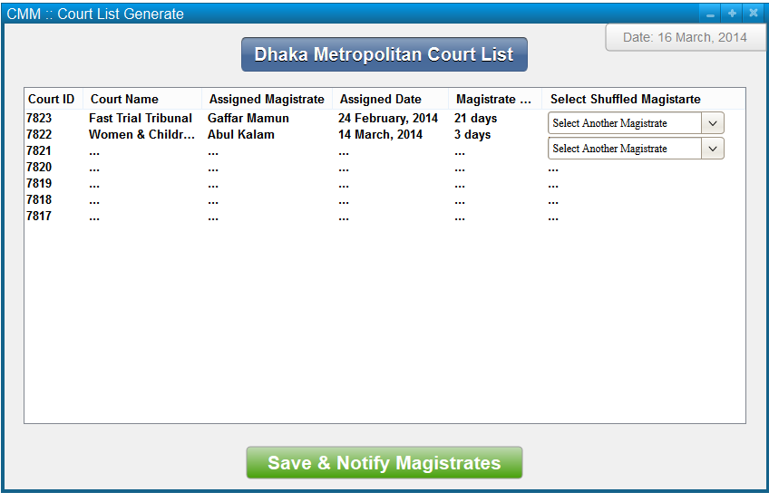

6.6 UI for Document Collection:

6.6.1 Document Copying UI: 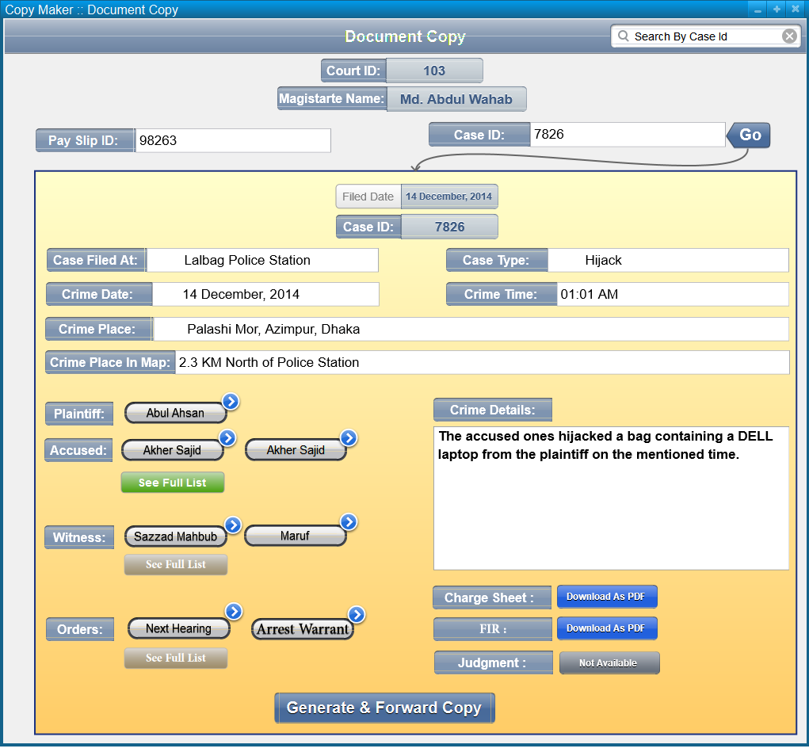

After checking the provided payment slip, copy maker will search out the requested case details which will set an exact case show UI described above. Then he will prompt to generate and forward the reuqested copy to the compare for further comparison.

6.6.2 Document Comaprison UI: 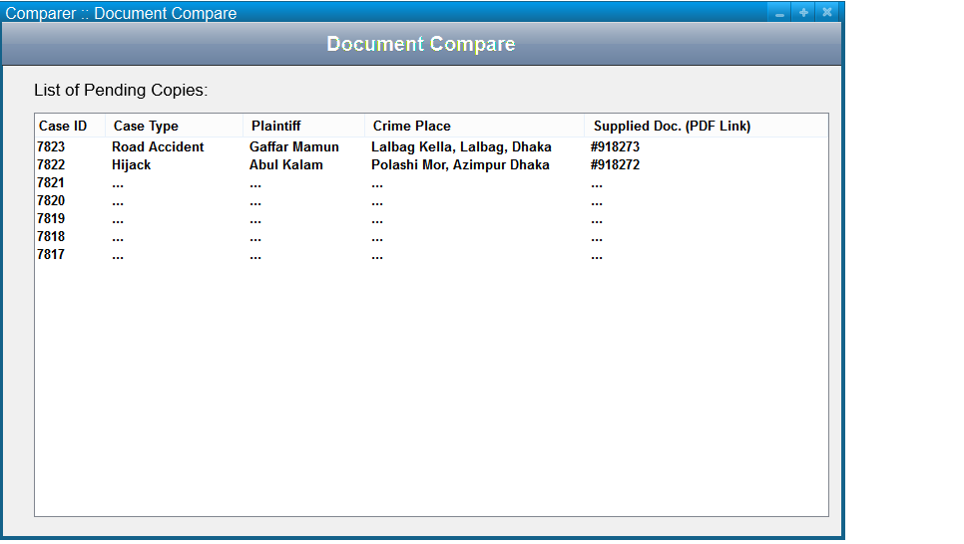

Comparer will see the pending cases to be compared in this UI, where he may download the supplied copy and then click on the row to see the main details of the case.

6.7 UI for Trial Documentation:

6.7.1 Order Posting UI:

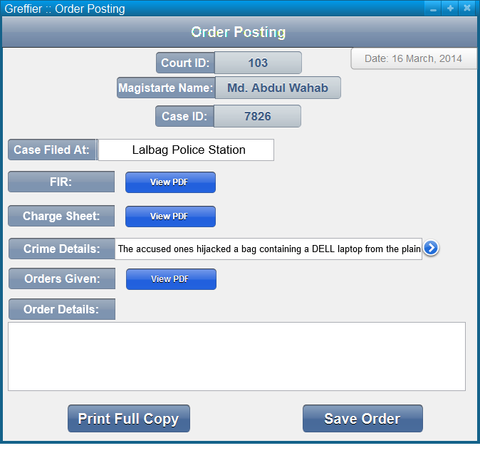

When a case receives any order as arrest warrant, witness presence, next hearing date and so on, then the greffier will use this UI to document that. The FIR, charge sheet and previous orders of the case can also be seen from this UI as downloaded PDF format. After completion of the order input, the copy can be printed out for any other uses readily.

6.7.2 Judgment Documentation UI:

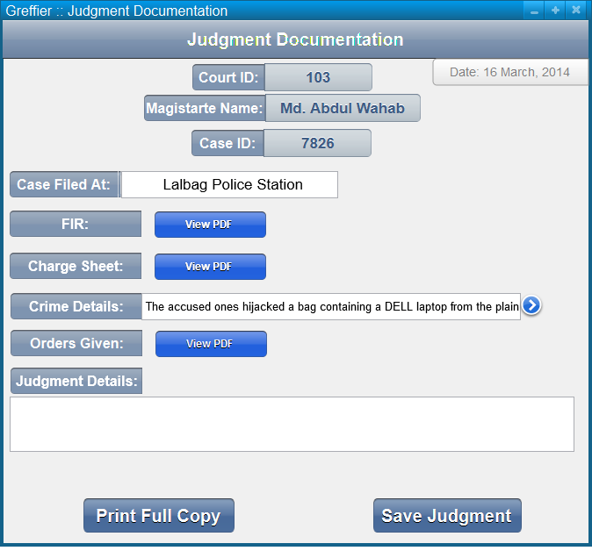

This UI will be invoked when the final judgment needs to be documented. The greffier will use this UI as the previous order posting UI.

6.8 Conclusion: These are the basic UIs of the system. TheseUIs include the total active users of the system as the duty officer, OC, GRO, clerks, magistrates, CMM and greffiers of the courts.