Toumas Naeim Nesir Shinouda 77960

1. Create a new remote repository.

1. Push all commits from Exercise 6a/6b to the remote repository.

Play with the git remote, git fetch, git push, git pull, git branch

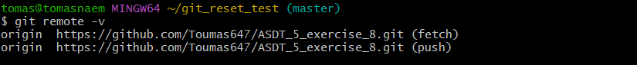

1. Execute fast-forward merge.

