Sound Vibes Festival

**Afbeelding met cd

Beschrijving is gegenereerd met hoge betrouwbaarheid**

**Team members:**

Mate o Iliev

Angel Mishkov

Blendi Kovani

Imran Touqi

Contents

Global Work Division 5

Week 1 5

Minutes Meeting – Group 5

Who Did What? 5

Week 2 6

Minutes Meeting – Mentor 6

Who Did What? 6

Week 3 7

Minutes Meeting – Mentor and Client 7

Who Did What? 7

Week 4 8

Minutes Meeting – Group 8

Who Did What? 8

Week 5 9

Minutes Meeting – Group 9

Who Did What? 9

Week 6 10

Minutes Meeting – Mentor 10

Who Did What? 10

Week 7 11

Minutes Meeting – Client 11

Who Did What? 11

Week 8 – 10 12

Exam weeks and preparation for exams 12

Week 11 12

Minutes Meeting – Group 12

Who Did What? 12

Week 12 13

Minutes Meeting – Mentor 13

Who Did What? 13

Minutes Meeting – Client 14

Who Did What? 14

Week 13 15

Minutes Meeting – Group 15

Who Did What? 15

Week 14 16

Minutes Meeting – Group 16

Who Did What? 16

Week 15 17

Minutes Meeting – Group 17

Who Did What? 17

Week 16 18

Minutes Meeting – Group 18

Who Did What? 18

Week 17 19

Minutes Meeting – Mentor 19

Who Did What? 19

Minutes Meeting – Client 20

Who Did What? 20

Peer Assesment 21

Mateo Peer Assessment: 21

Angel Peer Assessment: 23

Blendi Peer Assessment: 24

Imran Peer Assessment: 26

Appendix A: Report of the interview with the Client 27

# Global Work Division

## Week 1

### Minutes Meeting – Group

31 August 2018 – 12:00 PM – Fontys R1

Attendance

Mateo Iliev, Angel Mishkov, Blendi Kovani, Imran Touqi

Agenda

1. Get familiar with each other
2. Get to know what is asked from us to do regarding this course
3. Divide the work for the first block between us

Notes

* Brainstorm ideas about the logo and the theme of the event

Action Items

Assign a team leader

Assign people which will take part in making the project plan

### Who Did What?

Every member did research about the theme we choose and started preparing for the next meeting with the mentor.

## Week 2

### Minutes Meeting – Mentor

07 September 2018 – 12:00 PM – Fontys R1 room 2.50

Attendance

Mateo Iliev, Angel Mishkov, Blendi Kovani, Imran Touqi, Frank Henning

Agenda

1. Talked about the theme of the event
2. Asked questions about the project plan and client
3. Scheduled a meeting with the client
4. Talked about the deliverables

Notes

* Communication with mentor was discussed.
* How to present the deliverables was clarified.

Action Items

Gathered information regarding requirements and preferences of the mentor.

### Who Did What?

Collectively as a group we agreed on a theme and logo for the event.

Mateo Iliev was chosen to be the team leader for the project.

The project plan was divided between the team members:

* Mateo Iliev did the formal structure of the document (Gantt Chart, Phasing, MoSQuiTO)
* Blendi Kovani did the project statement (Current situation, Problem Description)
* Angel Mishkov did the deliverables and non-deliverables (Constraints, Client, Project participants)
* Imran Touqi did the risks regarding the project (Project risks, Product goal)

Mentor, client and team members were added in GIT repository.

## Week 3

### Minutes Meeting – Mentor and Client

14 September 2018 – 11:00 AM – Fontys R1 room 2.40

Attendance

Mateo Iliev, Angel Mishkov, Blendi Kovani, Imran Touqi, Matthijs Kuiper, Frank Henning

Agenda

1. Discussed how we should improve the project plan
2. We talked about the product and how it should work
3. We got through answers what the client wants from us to do
4. Present the logo and the theme of the event

Notes

* The project plan was incomplete. There are stuff we have to rewrite and add.
* We discussed that there were 8 applications, site and a database to be done.

Action Items

Client confirmed the logo and the theme for the event.

Client approved different approach towards some applications.

### Who Did What?

Mateo Iliev changed the phasing chart.

Angel Mishkov fixed the Client section, added more information regarding the client and fixed some of the non-deliverables.

Blendi Kovani added more to the project statement.

Imran Touqi fixed the project risks based on the client opinion on them.

## Week 4

### Minutes Meeting – Group

22 September 2018 – 12:00 PM – Fontys R1 room 2.80

Attendance

Mateo Iliev, Angel Mishkov, Blendi Kovani, Imran Touqi

Agenda

1. Discussed how we should improve the project plan
2. Discussed the progress of the project.

Notes

* Mateo Iliev – Project plan problems fixed based on feedback from mentor.
* Angel Mishkov – Visual design on the applications
* Blendi Kovani – Website wireframe
* Imran Touqi – ERD design

Action Items

Continue to improve the Project plan, Setup Document and Process Document

Uploaded documentation in GIT.

Designed the applications and added them to the Setup Document.

### Who Did What?

Mateo Iliev changed the Project Plan Gantt Chart and deliverables and non-deliverables. Made changes to the Setup Document regarding the use case scenarios.

Angel Mishkov had to make the visual design of the applications.

Blendi Kovani did the wireframes for the website.

Imran Touqi designed the ERD with the help of the others.

## Week 5

### Minutes Meeting – Group

27 August 2018 – 12:00 PM – Fontys R1 room 2.80

Attendance

Mateo Iliev, Angel Mishkov, Blendi Kovani, Imran Touqi

Agenda

1. Discussed how we should improve the project plan – follow up from last meeting
2. Split workload between the members.
3. Discuss the client and mentor feedback

Notes

* Website – Blendi and Mateo
* Applications - Angel and Imran
* ERD – Imran
* Documentation – the whole team

Action Items

Continue to improve the Project plan, Setup Document and Process Document

Begin with HTML & CSS for the website.

Uploaded improved documentation in GIT.

### Who Did What?

Mateo Iliev improved the Gantt Chart based on feedback from mentor and added visual representation to the Setup Document for the Use Case scenarios.

Angel Mishkov fixed the GUI’s based on the feedback from client.

Blendi Kovani started working on the CSS and HTML.

Imran Touqi changed the ERD based on the feedback we got from the mentor.

## Week 6

### Minutes Meeting – Mentor

5 October 2018 – 11:00 AM – Fontys R1 room 2.40

Attendance

Mateo Iliev, Angel Mishkov, Blendi Kovani, Imran Touqi, Frank Henning

Agenda

1. Discussed if we are on the right track with the documentations.
2. Asked about the use case scenarios if they are correct.

Notes

* Mentor approved work division, just wants to be sure that everyone knows what the others are doing
* Talk about the changes made to the ERD diagram

Action Items

Decided to use RFID cards instead of barcodes for the event.

### Who Did What?

Mateo Iliev uploaded the final version of the Project Plan in the GIT repository.

Angel Mishkov continued working on his GUI for further improvement.

Blendi Kovani uploaded the website online.

Imran Touqi had to make more changes for the ERD, because it was still incomplete.

## Week 7

### Minutes Meeting – Client

9 October 2018 – 12:10 PM – Fontys R1 room 2.40

Attendance

Mateo Iliev, Angel Mishkov, Blendi Kovani, Imran Touqi, Matthijs Kuiper

Agenda

1. Presented the Project Plan to the client and informed him that it is in GIT.
2. Discussed the progress of the project.

Notes

* The client said he want an easy way to add and fire employees.

(We can add it in the Statistics Application)

* We asked what type of products the renting stores should offer.

(USB chargers, power banks, headphones)

* We discussed that a person should be allowed to buy only one ticket to his name
* We talked about what kind of food the stores should offer.

Action Items

Make sure everything is uploaded in the GIT repository.

Send email regarding the latest information for the project to the mentor and client.

### Who Did What?

Mateo Iliev is the project leader so he is the one responsible for the communication with the mentor and the client. He sent the email to both of them.

Angel Mishkov finalized his GUIs and added them to the Setup Document.

Blendi Kovani finalized the static part of the website and uploaded it.

Imran Touqi finalized the ERD diagram and added it to the Setup Document.

## Week 8 – 10

22 October – 10 November 2018

### Exam weeks and preparation for exams

No meetings were conducted through this period.

## Week 11

### Minutes Meeting – Group

16 November 2018 – 13:00 PM – Fontys R1 room 2.40

Attendance

Mateo Iliev, Angel Mishkov, Blendi Kovani, Imran Touqi

Agenda

1. Finalized all of the documentation and uploaded it.
2. Check progress with applications and website.

Notes

* We discussed some problems with had with the applications and the connection with database.
* We discussed which application to do next.

Action Items

Upload everything in GIT.

Schedule meeting with mentor for next week to show progress of the applications.

### Who Did What?

HTML, CSS & Jscript – Blendi and Mateo

Buy ticket, check in application – Angel and Imran

## Week 12

### Minutes Meeting – Mentor

20 November 2018 – 13:00 AM – Fontys R1 room 2.40

Attendance

Mateo Iliev, Angel Mishkov, Blendi Kovani, Imran Touqi, Frank Henning

Agenda

1. Presented the applications we have done so far.
2. Discussed the finalized version of the project plan and setup document.
3. Ask about Process Report documentation.

Notes

* The mentor reviewed our documentation and approved it.
* We discussed with him our plan of action.
* We discussed the GIT upload situation (if only one-person uploads).

Action Items

Tested out the applications.

Scheduled meeting with client for next day to show progress of the application.

### Who Did What?

Mateo sent an email to the client to schedule a meeting and searched for some backround pictures for the website.

Blendi fixed the CSS of the website, the font of the letters and their position.

Angel and Imran ran some tests on the programs, the database was giving errors.

### Minutes Meeting – Client

22 November 2018 – 11:30 AM – Fontys R1 room 2.40

Attendance

Mateo Iliev, Angel Mishkov, Blendi Kovani, Imran Touqi, Matthijs Kuiper

Agenda

1. Presented the applications we have done so far.
2. Presented the website.

Notes

* The client wants the receive every 2 weeks’ report of what we have done.
* We discussed how we s should improve our website and applications.
* We discussed employees and access of the application.

Action Items

Make sure everything is uploaded in the GIT repository.

Work on process report document.

### Who Did What?

Blendi making some changes in the line-up section of the website. We decided to add more artists.

Angel and Imran continued their work on the applications.

Mateo updated the Process report document.

## Week 13

### Minutes Meeting – Group

30 November 2018 – 12:00 PM – Fontys R1 room 2.40

Attendance

Mateo Iliev, Angel Mishkov, Blendi Kovani, Imran Touqi

Agenda

1. Talk about problems with applications and website.
2. Check progress with applications and website.

Notes

* We discussed problems that have occurred while working with the applications.
* We discussed the feedback we got from client and mentor

Action Items

Worked the RFID cards.

Schedule meeting with each other for next week.

### Who Did What?

Visual improvisation of the website with new background and better positioning of text – Blendi and Mateo

Check in application and borrow – Angel and Imran

Improve Process report document - Mateo

## Week 14

### Minutes Meeting – Group

7 December 2018 – 12:00 PM – Fontys R1 room 2.40

Attendance

Mateo Iliev, Angel Mishkov, Blendi Kovani, Imran Touqi

Agenda

1. Discuss progress with apps and website.
2. Improve applications and website.
3. Send email to client with progress.

Notes

* We made a few changes in the application.
* We discussed the check-out application and borrowed items.

Action Items

Continue improving Process report.

Continues improving applications and website.

Upload everything in GIT.

### Who Did What?

Angel created a new application for the RFID scanner to assign cards to people.

Imran finalized the borrow application and started the shop application.

Blendi continued working on the website and improving it visually based on the client feedback.

Mateo updated the Process report, sent an email to the client with current progress and helped Blendi with the website.

## Week 15

### Minutes Meeting – Group

14 December 2018 – 12:00 PM – Fontys R1 room 2.40

Attendance

Mateo Iliev, Angel Mishkov, Blendi Kovani, Imran Touqi

Agenda

1. Talk about glitches in programs and problems in the website.
2. Help each other with problems we have regarding applications and website.

Notes

* We discussed some problems with had with the applications.
* We discussed which application to do next and what more should we add to the website.

Action Items

Upload everything in GIT.

Schedule meeting with each other for next week.

Worked on website and apps.

### Who Did What?

Blendi started PHP for the website.

Angel created a main menu for all of the applications and started the camp site application.

Imran continued his work on the shop application.

Mateo helped Angel with the camp site application and updated the Process report document.

## Week 16

### Minutes Meeting – Group

19 December 2018 – 12:00 PM – Fontys R1 room 2.40

Attendance

Mateo Iliev, Angel Mishkov, Blendi Kovani, Imran Touqi

Agenda

1. Split work for holidays.
2. Discuss problems regarding applications and work on them

Notes

* We split the work for holidays and made a plan of communication.
* We discussed which application to do next and who does what.

Action Items

Upload everything in GIT.

Schedule meeting with mentor and client for after the holidays.

### Who Did What?

Mateo updated the Process report and helped Angel with the applications.

Imran finalized the shop application.

Blendi made a successful connection between database and PHP.

Angel, Imran and Mateo started the statistics application.

## Week 17

### Minutes Meeting – Mentor

11 January 2019 – 11:00 AM – Fontys R1 room 2.40

Attendance

Mateo Iliev, Angel Mishkov, Blendi Kovani, Imran Touqi, Frank Henning

Agenda

1. Show final version of website and application.
2. Ask for feedback on finalized work.

Notes

* We got positive feedback on website and applications.
* Make some design changes in website.
* Add some pop-up messages in the website.

Action Items

Upload everything in GIT.

Change design of the website, font and more noticeable textboxes.

### Who Did What?

Mateo finalized the Process Report and gave some ideas about the app design.

Imran & Angel modified the applications.

Blendi changed the design of the website.

### Minutes Meeting – Client

11 January 2019 – 13:00 PM – Fontys R1 room 2.40

Attendance

Mateo Iliev, Angel Mishkov, Blendi Kovani, Imran Touqi, Matthijs Kuiper

Agenda

1. Show final version of website and application.
2. Ask for feedback on finalized work.

Notes

* We got positive feedback on website and applications.
* Make some design changes in application and website.

Action Items

Upload everything in GIT.

Change design of the website, font and more noticeable textboxes.

Change design on application, show “Balance” on some of the applications.

### Who Did What?

Mateo finalized the Process Report and gave some ideas about the app design.

Imran & Angel modified the applications.

Blendi changed the design of the website.

## Week 18 – 20

14 January – 26 January 2019

### Exam weeks and preparation for exams

No meetings were conducted through this period.

# Peer Assesment

## Mateo Peer Assessment:

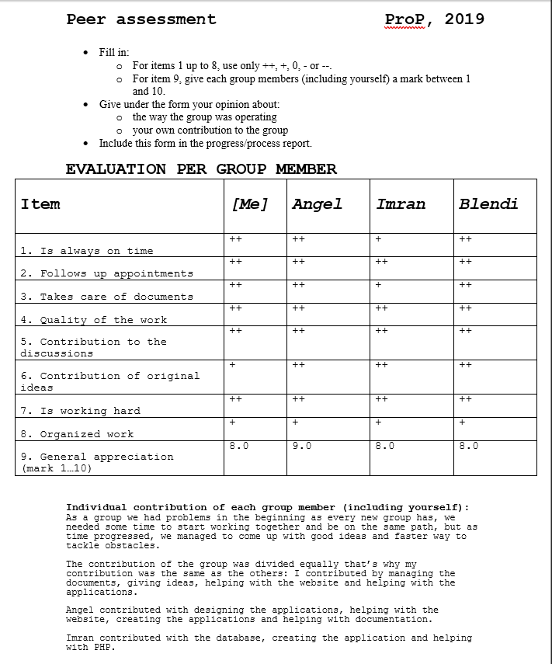

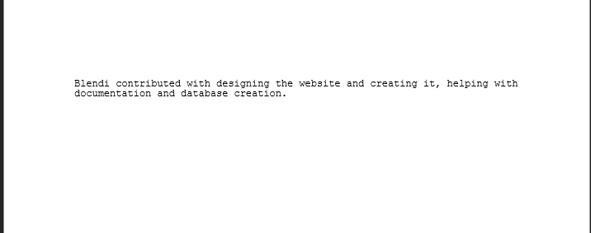

## Angel Peer Assessment:

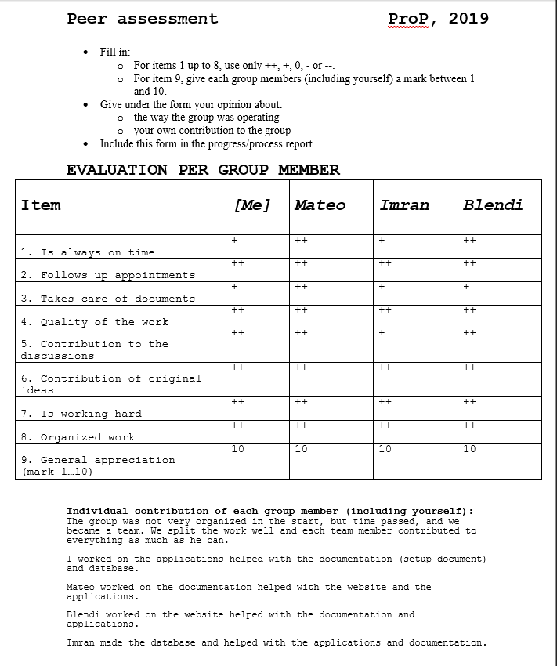

## Blendi Peer Assessment:

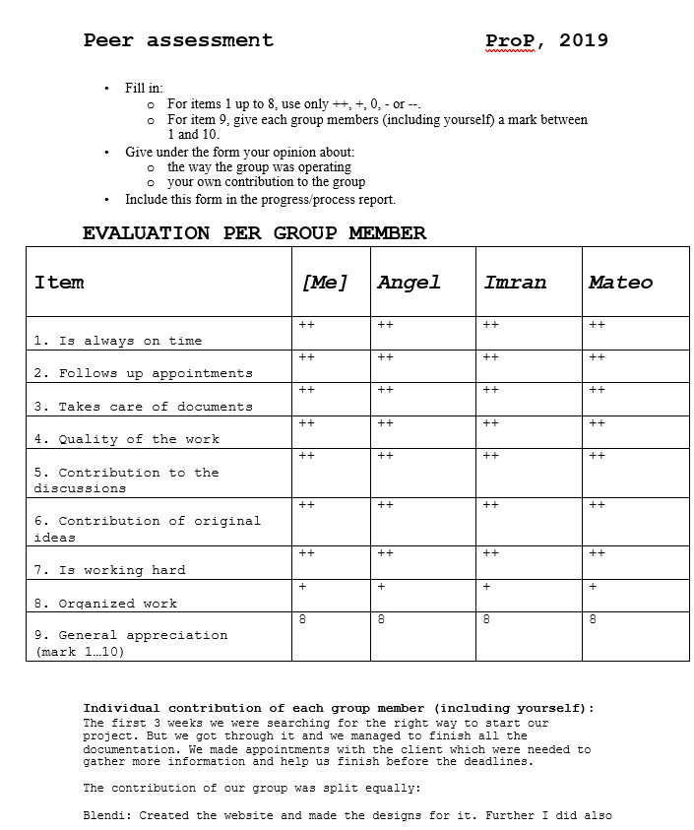

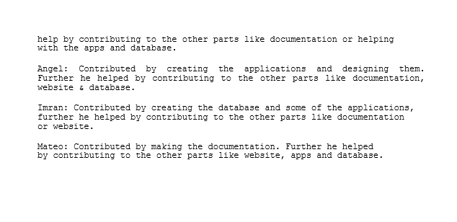

## Imran Peer Assessment:

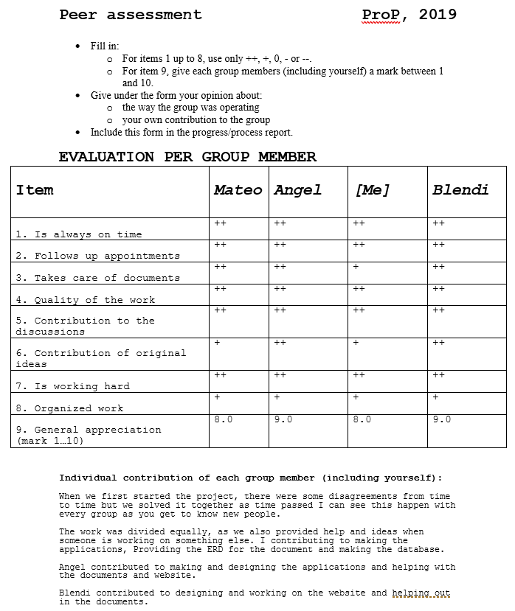

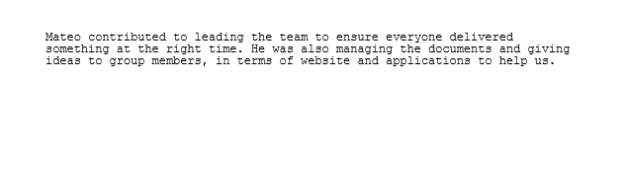

# Appendix A: Report of the interview with the Client

During the meeting with our client, Mr. Matthijs Kuiper, we talked about how he wants to make everything automated, because he wants to hire less employees for the event. He hired us for a software solution, to make application for the event which would result in a profit for his company. We do not have a limit budget for the applications, but we should be reasonable with our expenses. The team has twenty weeks to deliver a fully functional website, and seven applications that will be used in the event. We have to provide documentation with the deliverables explaining how they work and how they should be used.