**Afbeelding met cd

Beschrijving is gegenereerd met hoge betrouwbaarheid**

**Project plan**

Group 11

Content

**Project Statement** 3

**Client** 3

**Project leader** 4

**Current situation** 4

**Problem Description** 4

**Project participants** 5

**Product goal** 5

**Project Deliverables and Non-Deliverables** 5

**1.** **Final Deliverables:** 5

**2.** **Non-Deliverables:** 6

**Project Risk** 6

**Risk 1: The budget is inaccurate!** 6

**Risk 2: The team misunderstand the requirements!** 6

**Risk 3: Client is not satisfied with the result!** 6

**Risk 4: losing code for the applications or website** 7

**Risk 5: The websites might crash if to many users log-in at the same time!** 7

**Risk 6: Deadline risk: the project might not be done before the start of the festival!** 7

**Constraints** 8

**Constraint 1: Time** 8

**Constraint 2: Budget** 8

**Constraint 3: Website** 8

**Constraint 4: Software** 8

**Phasing** 9

**Gantt Chart** 10

**Phase 1: Start** 10

**Activity: On-site meetings** 10

**Activity: Discussions with Client** 10

**Activity: Documentation** 11

**Phase 2: Design** 11

**Activity: Design Database** 11

**Activity: Software Design** 11

**Activity: Website Wireframe** 11

**Phase 3: Development** 11

**Activity: Website** 12

**Activity: Software applications** 12

**Activity: Database implementation & creation** 12

**Phase 4: Testing** 13

**Activity: Performing system test** 13

**Activity: Documentation issues found** 13

**Management (MoSQuiTO)** 13

**The website** 13

**The database** 13

**The application** 13

**Artists** 14

**Skills** 14

**Quality** 14

# **Project Statement**

In this chapter we state why our project is started and what we will achieve. The following topics will be described: the client, the project leader, the initial situation, the problem description, the goal of our project, the deliverables and non-deliverables, the constraints and the risks.

## **Client**

The client’s name is Matthijs Kuiper, he is a representative from a company which specializes in organizing musical festivals.

We made a verbal agreement with the client to provide functional website from which you could buy tickets, applications regarding exchange of money for goods, application showing the status of the event and an application for checking in and out.

**Contact information**

Matthijs Kuiper

Rachelsmolen 1, Eindhoven

Room 2.42

[matthijs.kuiper@fontys.nl](mailto:matthijs.kuiper@fontys.nl)

Working days: Monday-Friday

## **Project leader**

Mateo Iliev, studying ICT in Fontys University of Applied Sciences and is the project leader for this project.

**Contact information**

Mateo Iliev

Rachelsmolen 1, Eindhoven

[m.lliev@student.fontys.nl](mailto:m.lliev@student.fontys.nl)

06-32452345

## **Current situation**

We were hired by a client to organize a music event where we develop 7 software applications and a website where visitors can buy their tickets. The music festival named “Sound Vibe”, will take place in Drenthe, the duration of the festival will be 3 days, from 8th of July until 11th of July. The event is organized by a commercial company. So the reason for doing the event is to make more profit and also to let people enjoy the Electric vibes of the music. We will have some big names on stage like David Guetta and the Dutch DJ Martin Garrix. There will also be some big hip-hop artist like Dua Lipa and Russ.

Location: Oranjekanaal Noordzijde 10, 7853 TA Wezuperbrug

Province: Drenthe

## **Problem Description**

The main activity of the company is organizing music festivals, but each time the visitors multiply and the company wants a system that would make everything automated. There is also a need for specific applications, which will be used for running the shops inside the event, to buy tickets, a system to verify the tickets with RFID scanner, a system for the clients to be able to rent items, one for camping spots and also one for exiting from the festival.

## **Project participants**

* Blendi Kovani
* Imran Touqi
* Angel Mishkov
* Mateo Iliev

## **Product goal**

The goal of this project is to develop an assisting software for Mr. Kuiper with the organization of his event for him to able to:

* Sell tickets and camping spots from website
* Check tickets at entry
* View the status of the event
* Functional applications for the shops (lending/buying products)
* RFID card which is applicable with all software programs
* Check out for guest’s application

## **Project Deliverables and Non-Deliverables**

After a meeting with our client we discussed what applications he wants from us to develop in the next two blocks:

### **Final Deliverables:**

* Website for the users where they will be able to purchase tickets from the website, check-in their tickets and log-in
* An application to be used at the entrance of the event (Check-in)
  + When visitors come to the entrance of the event they need to check in so we can make sure they bought a ticket and verify their identity and assign and RFID card to them which they can use in any of the applications later on.
* An application to be used at the entrance of the camping (Check-in)
  + When visitors come to the entrance of the camping-side, they need to check in so we can make sure they bought a ticket with a camping spot.
* An application to be used at the stand, where you can lend materials
  + If a visitor wants to lend something for example ear-plugs, they first need to scan their card. When the card is scanned we know who it is and we will assign the item to that person.
* An application to be used when a visitor leaves the event (Check-Out)
  + This app will make sure the visitor will be checked out of the event.
* An application for the organization to inspect the status of the event
  + This app will be only for our client. The client can see different stats on this app about the event. Example: how many visitors are currently.
* An application to be used at the shops (Buy food)
  + This app will allow the visitors to buy food with their card.
* An application to convert the information in the transaction-log-file to the database
  + The visitor buys food or a visitor puts money on their card. All these stats will be converted into the transaction-log-file which will be saved in the database.

### **Non-Deliverables:**

* We will be delivering only software applications without any machinery supporting it.
* We will not deliver any manuals on how to use the software or the website.
* Camping spots will be randomized and cannot be selected by the guests.

## **Project Risk**

### **Risk 1: The budget is inaccurate!**

**Probability:** Very low.

**Impact on project:** High.

**Steps to prevent:** Try to calculate all the costs

**Clean up action:** Cut some unnecessary expenses

### **Risk 2: The team misunderstand the requirements!**

**Probability:** Medium.

**Impact on project:** High.

**Steps to prevent:** Ask the client accurate questions**.** And keep on discussing if the milestones are going the right way!

**Clean up action:** Talk with the client and make sure that the misunderstood requirements will be done/made.

### **Risk 3: Client is not satisfied with the result!**

**Probability:** Low.

**Impact on project:** High.

**Steps to prevent:** Having review meetings for making important decisions and talk about what could be changed to have a good result at every meeting.

**Clean up action:** Talk with the client and make sure that the results which were not good enough will be good results in the upcoming time!

**Risk 4: losing code for the applications or website**

**Probability:** Very low

**Impact on project:** Veryhigh.

**Steps to prevent:** Make use of GitLab, and save code as much as possible so you won’t lose it when something shuts down!

**Clean up action:** Go to git and get the old version of code you have committed.

### **Risk 5: The websites might crash if to many users log-in at the same time!**

**Probability:** Medium.

**Impact on project:** Medium.

**Steps to prevent:** Checking every piece of code, trying out the code and the website before launching.

**Clean up action:** Take from the old working versions for the website and replace it with the current one.

### **Risk 6: Deadline risk: the project might not be done before the start of the festival!**

**Probability:** Medium.

**Impact on project:** High.

**Steps to prevent:** Try to consider every possible way to finish the project. Making over hours when needed. Talk with the client if somethings or not working.

**Clean up action:** Talk with the client to have some important applications done for the event and take the less important applications out if possible

## **Constraints**

### **Constraint 1: Time**

The project must be completed within 20 weeks from start.

### **Constraint 2: Budget**

The budget for this project is 60 000 euro for software and database.

### **Constraint 3: Website**

The website must be coded in: Html, CSS and PHP

### **Constraint 4: Software**

The software must be coded in: C#

# **Phasing**

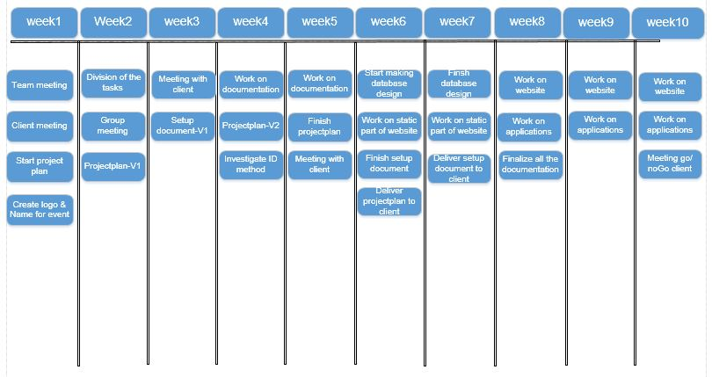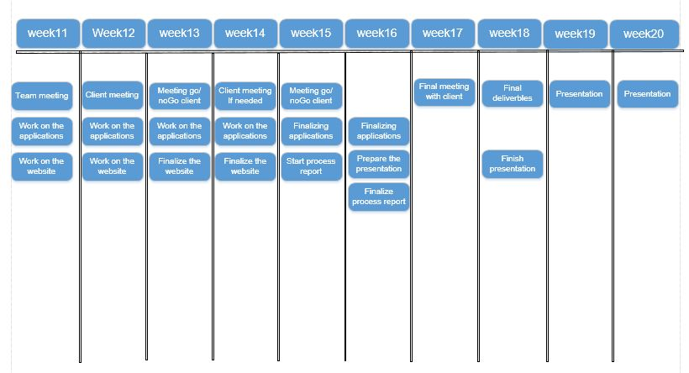

# **Gantt Chart**

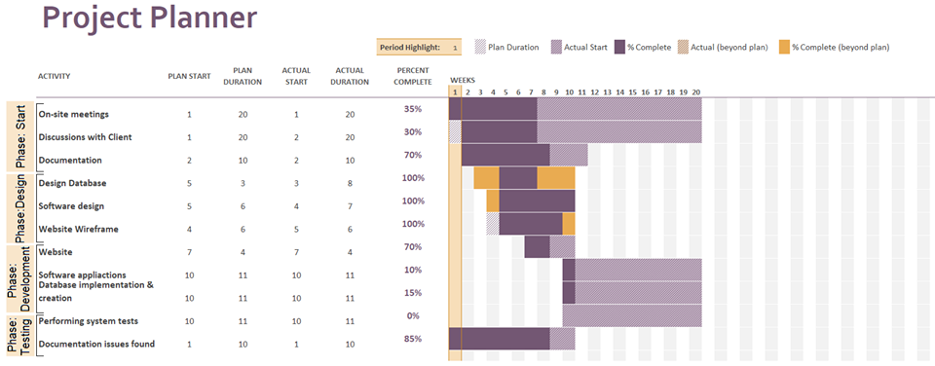

## **Phase 1: Start**

The on-site meetings phase is made from one activity the initiation.

### **Activity: On-site meetings**

1. Get a general idea about the situation.
2. Form a group to start the project with.
3. Create name and logo for the group project.
4. Discuss members roles and contribution skills
5. Meetings with the group every week.
6. Organize team communication environment.

Estimated duration: 20 weeks and 60 man hours.

### **Activity: Discussions with Client**

1. Interview with the client.
2. Clarify the client’s main goals and wanted project deliverables.
3. Prepare agenda for next meeting.

Estimated duration: 20 weeks and 10 man hours.

### **Activity: Documentation**

1. Begin project plan documentation
2. Name deliverables and non-deliverables
3. Begin the setup document
4. Communicate with client and mentor through it
5. Discuss with group members about the phases

Estimated duration: 10 weeks and 120 man hours.

## **Phase 2: Design**

This phase consists of three activities. First the creation and designing of the database, followed by the software design and its functionalities and lastly the website wireframe and its features.

### **Activity: Design Database**

1. Choose a database system suitable for the task
2. Discuss ERD with team members
3. Create the ERD

Estimated duration: 7 weeks and 40 man hours.

### **Activity: Software Design**

1. Discuss the functionalities of each application
2. Create GUI’s for each one of them
3. Take screenshots and put them in the setup document
4. Discuss with the client if he wants any changes

Estimated duration: 6 weeks and 10 man hours.

### **Activity: Website Wireframe**

1. Discuss functions and features
2. Positioning of the elements in the website
3. Create a wireframe and discuss it with the client

Estimated duration: 6 weeks and 30 man hours.

## **Phase 3: Development**

The third phase of this project will be the most important one, because it’s about implementing all the information and design with technical skills and knowledge. The most crucial is creating the website back-end and connecting it to the database, because website is the face of the event and part the of critical path of the project. Very important are also the applications that will manage the whole festival and will be responsible for control and observe the results. The database needs to work properly also with each one of the applications. During the implementation of the project the main documentation will be filled with additional information and the process report will track all progress on the activities that the members are working on.

### **Activity: Website**

1. Use HTML to create the structure of the first version
2. CSS added for styling and better design
3. The group will use JavaScript to make the website more user-friendly.
4. Discuss where we can implement JavaScript.
5. Discuss how PHP should be used for the back end of the website.
6. Implement PHP.

Estimated duration: 10 weeks and 150 man hours.

### **Activity: Software applications**

1. Build the application which will be used at the event entrance.
2. Build the application which will be used when visitors leave the event.
3. Build the application which will be used at the loan shops.
4. Build the application which will be used at the merchandise/food/drinks shops.
5. Build the application which will be used to convert the logs from the ATM.
6. Build the application which will be used from managers to summarize information about the whole event.
7. Build the application to enter in the camping spots.

Estimated duration: 10 weeks and 180 man hours.

### **Activity: Database implementation & creation**

1. Use the already made ER design to create the different tables for the database.
2. Check if all attributes are created properly.
3. Check if all connections to the tables are active.
4. Discuss with team members the progress and try to find a weak spot.

Estimated duration: 10 weeks and 120 man hours.

## **Phase 4: Testing**

The test phase consists of two activities: testing the applications, database and website functionalities and features and adding additional information to the process report.

### **Activity: Performing system test**

1. Each member has to test each of the use case scenarios.
2. Observe whether the applications are acting weird in any way.
3. If there are any bugs within the system, the team has to fix it.
4. If there needs to be a change in the application, we need to talk with the client.

Estimated duration: 10 weeks and 70 man hours.

### **Activity: Documentation issues found**

1. Read the feedback given from the client.
2. Fix all the issues in the documentation based on the feedback received
3. All information must be updated

Estimated duration: 10 weeks and 50 man hours.

# **Management (MoSQuiTO)**

### **The website**

* Development, wireframe, design and coding: 9000€
* Maintenance: €6000 for 3 days

### **The database**

* Design for the database: €10000
* Maintenance: €15000 for 3 days
* Setup: €2000€

### **The application**

* Construct the GUI: €13000
* Creating all applications: €22000
* Maintenance: €18000 for 3 days

### **Artists**

* Martin Garrix - €20.000 for 3 hours
* David Guetta - €25.000 for 3 hours
* Dua Lipa - €18.000 for 3 hours
* Russ - €14.000 for 3 hours

## **Skills**

* Designers – Designing the website apps to make it user-friendly
* C# programmers
* MySQL experts
* HTML & CSS coding experts
* JavaScript programmers

## **Quality**

**How to deliver the wanted product with the best quality?**

* Meet the client’s criteria
* Test the products as much as possible
* Easily usable software and website, so that the client nor the users have problems using it
* Maintenance
* Discussing all the deliverables and non-deliverables with the client
* Coordinate the festival well