|  |  |
| --- | --- |
| My portfolio  Smart Mobile | Abstract  I’m a second year student taking Smart mobile specialization. Hope you will enjoy my portfolio as I share what I have covered throughout this course.  Imran Al-Touqi  ICT-English Stream |

Contents

About myself: 2

Why I Choose Smart Mobile: 2

What I expect from this course: 2

UX WorkShop 1: 3

Assignment 1: 3

Assignment 2: 3

Android Workshop 1: 5

Basic App: 5

POC: Login App 8

CSI Application: 10

UX Workshop 2: 12

Assignment 1: 12

Assignment 2: 13

Android Workshop 2: 15

Hardware: 15

Data Persistence: 15

Ux Workshop 3: 17

Android Workshop 3: 19

Ux Workshop 4: 22

Fragments 25

# About myself:

My name is Imran I’m an Omani Student in fontys taking the ICT Software stream. In my free time I like to chat with friends, draw and read books. I have a background in programming mainly C# as it was covered in the first year and WEB coding like HTML, CSS, PHP ETC…

I like meeting new people, I find this an opportunity in group works in this field as we tend to meet and work from new people from different backgrounds.

## Why I Choose Smart Mobile:

I chose this specialization because I see it being it applied in the near future. As mobile use is a part of our everyday lives, as we all use our phone for many hours a day so it would be interesting to build a for my own and even others to help them. The thought of someone using your app and liking it is something to be happy about.

## What I expect from this course:

I am very curious about this course, mainly because I haven’t programmed or developed anything for mobile ever. But I expect to get basic knowledge of how to make an android through practice from android studio and workshop assignments both from Android And UX.

# UX WorkShop 1:

**Workshop user goals assignment:**

## Assignment 1:

*What’s the “put a man on the moon in ten years” proposition of:*

Microsoft: Establish a computer in every household and make computing more personal

Air B’n’b: Make people feel at home wherever they are

Fontys FHICT: Bring new ICT experts to life from different fields

Deezer: Find songs that matches a person’s interest

Tesla: Convince people to transition to sustainable energy

Starbucks: inspire and nurture human spirit

## Assignment 2:

Company: Starbucks

The company Starbucks wants to offer a coffee shop that quite unique from its competitors. The goal of this is to change the environment and mood of the customer into a better state to boost them up. This is proven by them providing coffee which is known to wake up people. Some unique aspects like naming the cup helps nurture the customer in such a way that the drink belongs to them and make them feel special as the drink is made special for them rather than just another number in the system like many other competitors. The Environment in Starbucks is made to make them feel relaxed and at home by offering varieties of seats like mini sofas, chairs and benches so the customer chooses what they prefer.

Assignment 3:

Company: Starbucks

1. Starbucks doesn’t store coffee that has been sitting for more than 30 minutes
2. Starbucks can handle large customer orders with only two registers
3. Starbucks employees must go under 30 hours training before working.
4. Starbucks has no restriction on device being able to use in the coffee shop.
5. Starbucks has over 80 thousand drink combinations that they can serve without hesitation
6. Starbucks offers an app that can be used to make your own drink and use it for payment
7. Ability to track when order is ready through mobile app.
8. Not letting the customer wait for more than 3 minutes without being served
9. They make sure what the customer are ordering
10. Open environment

I See that everyone will be tempted by these features, as everyone wants something different and better alternative place to spend their money on if they can. I can also see people who like to try new things and are curious would love Starbucks as they serve a lot of varieties of drinks, so it’s pretty certain that they will visit the store plenty of times until they tried the whole menu.

In conclusion, when working on an app ,organization or anything in general that involves people in using it. We need to ask ourselves why are we doing it and what is our main goal. If we focus on this question throughout the journey not only will it improve our work but also the user experience is the user will gain the most out if it as that was their goal of using your app in the first place.

I Read the following Link:  [https://www.interaction-design.org/literature/article/a-simple-introduction-to-lean-ux (Links to an external site.)](https://www.interaction-design.org/literature/article/a-simple-introduction-to-lean-ux)

# Android Workshop 1:

## Basic App:

Today I started working on Android studio which is an IDE for creating android mobile apps. It was my first experience so I followed some guides from the official android developer website. First of all, the guide explained some XML files like activity main and Android manifest, it looked confusing at first but with progress I’ll get how to use it with some practice.

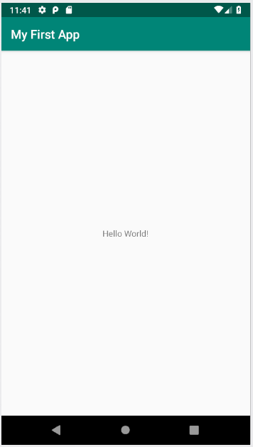After looking through the app, I created a simple app with the “Hello World!” text and tried running in the emulator which as a virtual phone on screen to grasp an idea how your work would look on the mobile or other devices

The screenshot above displays the emulator being run on google device known as Pixel API 28.

After testing to run the app on the emulator, I created a new app with a simple user interface by playing around with the Layout editor. The app consists of a textbox and button in the main activity that would send the message from the textbox to a new activity card.

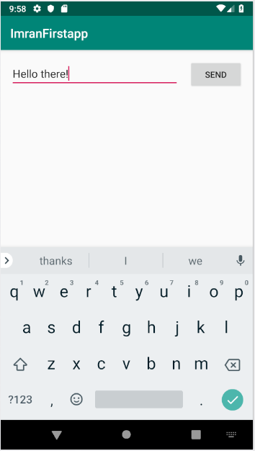

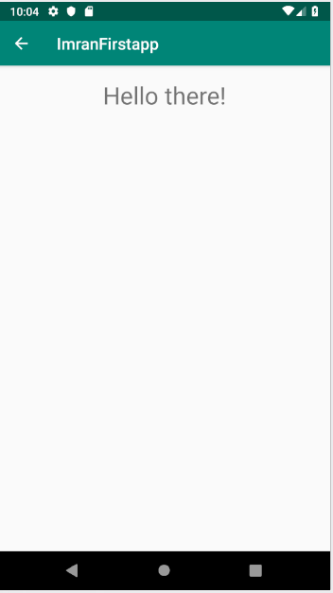For instance, a typed a message “Hello there!” in the textbox and after clicking the send button the apps switch to a new activity displaying the message from the previous activity. The main activity is set as the parent of the new activity so a back button appears at the top left of the application.

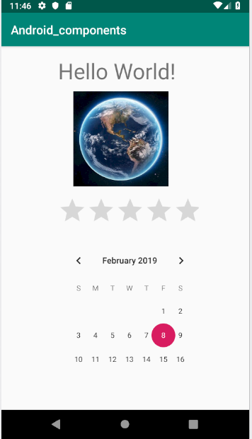After that, I created another application to explore the UI components further and familiarize with it. I called the application Android_components as seen below the look of the app.

I also learned how to add new resources to a specific ad I had to add the image of the world as a resource for the image view component.

Here are some of the links of the Components I used from the android developer website:

https://developer.android.com/reference/android/widget/TextView

<https://developer.android.com/reference/android/widget/ImageView>

<https://developer.android.com/reference/android/widget/RatingBar>

<https://developer.android.com/reference/android/widget/CalendarView>

## POC: Login App

I have played with the styling and design to create a simple login app. Where the user types his Username and password and Opens a new activity displaying a text “Welcome” along with the username. I also designed the button giving it rounded shape border and changed it’s color by adding a new a drawable in the drawable folder.

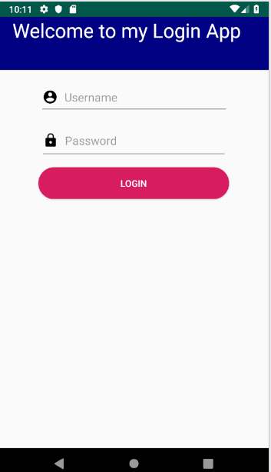

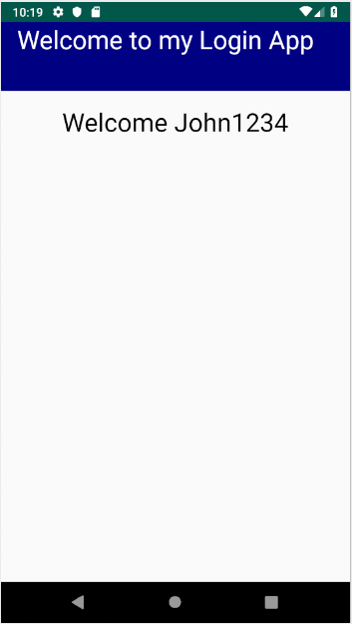

## CSI Application:

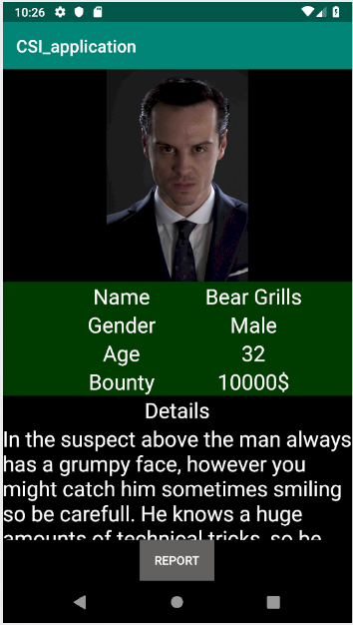I also worked on the CSI assigned provided to use. I learned new methods of designing apps using linear and table layouts, also used scroll bar for the first time to display content in my case was text that wasn’t able to fit the screen.

Pressing the REPORT button will open a new activity with various buttons however not all of them work, but I did work on the back button which will take the user back to the main activity which is the first screen.

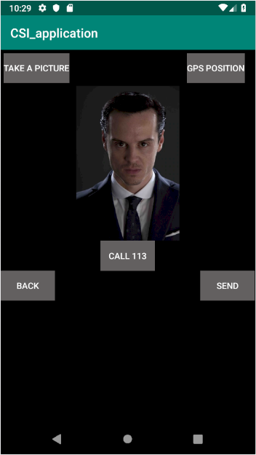

# UX Workshop 2:

## Assignment 1:

In the last week I described about a company called Starbucks. They specialize in serving coffee and other variety of food in common areas like malls, neighborhood and a shopping districts. Many people tend to visit Starbucks but do they really have the same purpose? You could say that they want coffee or a small snack but that’s too vague.

In my perspective, I Generally visit Starbucks to relax after a long day of work or shopping as they are common in these areas. Which is perfect to refresh your mood of all the energy draining from work. So visit Starbucks, order my favorite drink, and relax on the sofa enjoying my drink with some internet from my laptop if I desire. So this is just a typical scenario to grasp what is the purpose to visit a place like Starbucks and what do I benefit from it.

Now other people have different purposes of visiting, perhaps someone visits Starbucks for a business meeting to discuss with their fellow peers about their work in a relaxing environment like Starbucks. Some people are sleepy and want to wake up from the coffee. And some just visit for the free WIFI.

I provided some story boards for some different situations as why people tend to visit Starbucks.

Scenario 1:

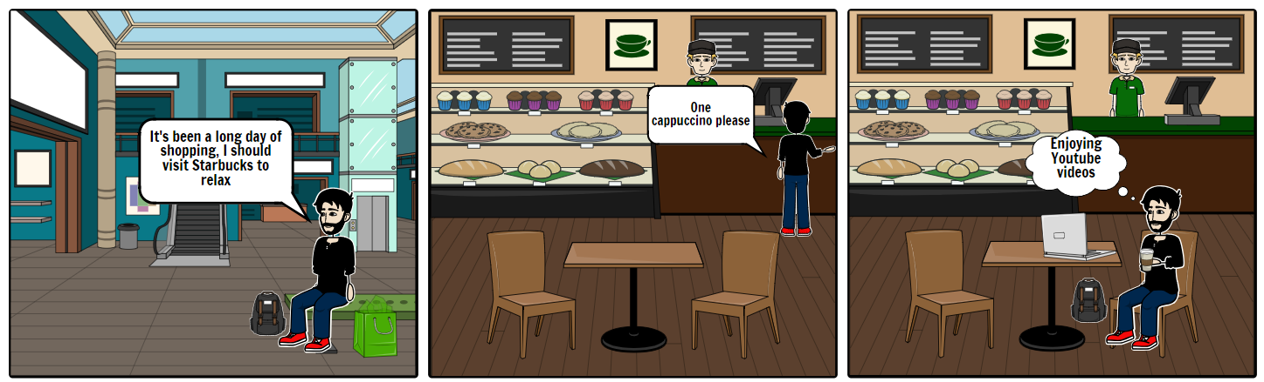

Scenario 2:

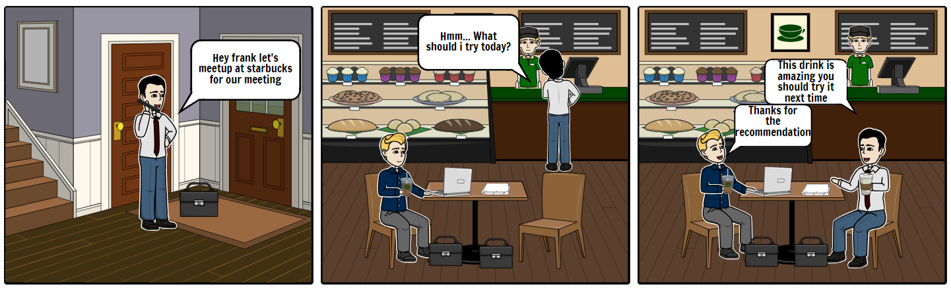

## Assignment 2:

Nike:

Do Goal: Sale of high quality sports equipment

Be Goal: expanding human potential with sports

Apple:

Do Goal: Providing Updated technology products every year

Be Goal: Make users unite in a single technology environment

Post-it notes:

Do Goal: Providing sticky notes in all variations for various uses

Be Goal: Make reminders essential to daily lives with style

HelloFresh:

Do Goal: Provide healthy meal within a Kit

Be Goal: provide Opportunity to enjoy healthy home-cooked food easier

IKEA:

Do Goal: Sale of house equipment/furniture

Be Goal: Create a better every day live for people by providing furniture that everyone can afford

Snapchat:

Do Goal: Picture and video related social media

Be Goal: Provide unique social media platform that Deletes messaging after being viewed

Starbucks:

Do Goal: Provide Coffee and various snacks for relaxation

Be Goal: Inspire and nurture human spirit

In conclusion, I learned that user experience can’t be designed. Lets just say that a customer visits a shop or uses a certain site. A lot of people have in mind that people only use of visits a certain a shop for one purpose only, that may be the case sometimes but not always. People have different goals of visiting a certain place they may be identical but they are different. Thus we must provide a unique experience for our audience, an experience that cannot be found anywhere else.

I Read the following article:  [https://www.interaction-design.org/literature/article/a-simple-introduction-to-lean-ux (Links to an external site.)](https://www.interaction-design.org/literature/article/a-simple-introduction-to-lean-ux)

# Android Workshop 2:

## Hardware:

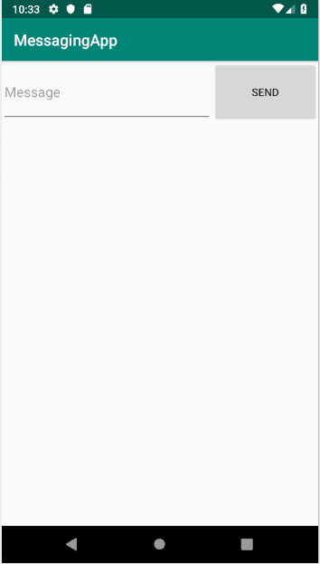Today I worked on the hardware to be able to send an SMS message to phone number. This was done by adding the permission required in the manifest file, And while the app runs it requests the user to use the hardware required to complete the task in our case was requesting the device to be able to send messages. The user types the message he wants to send and clicks on the Send button and a small Toast will appear on the bottom of the screen will notify if the message has been sent.

## Data Persistence:

Saving data is essential to every application, in my previous apps if the user types or make changes within an application the data is not saved after the app has been closed. I made a simple app the the user will type a simple text and click the save button to save the text. After clicking the save button a small toast will appear on the bottom of the screen displaying the location of where the txt file has been saved along with its message. To update the app the user clicks the load button and loads up the text that has previously been saved to the file.

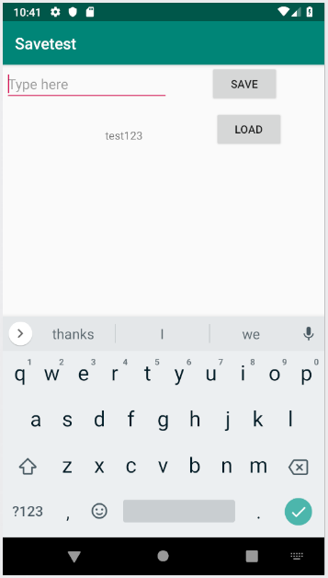

In conclusion, I have learned new features in android studio. And how we can extend our app by using our mobile’s devices hardware and uses app permissions to uses them. I can see why they make a request as it’s to provide more security as it wouldn’t make sense lets say for a file manager app to use a camera, the user would be suspicious and it wouldn’t make sense for the app to use the camera. And they are many ways to save data in our apps cache, saving locally or using database. But for this week I tried saving in a local file.

Links: <https://developer.android.com/training/permissions/requesting.html>

<https://developer.android.com/guide/topics/data/data-storage>

# Ux Workshop 3:

Assignment 1:

Use case: Organizing a trip to mystery land for 5

Actors: Customer, Cashier, Gateway

1. Customer Goes to location
2. Customer heads to cashier
3. Customer Selects ticket package
4. Customer fills in billing information
5. Cashier displays full pricing information and details
6. Customer confirms payment
7. Customer Receives tickets and confirmation in email
8. Customer heads to check in
9. Gateway checks tickets and check customer in

Extensions:

3:a Package not available

1. Cashier informs customer about available packages if available
2. End of use case

7b: Payment Unsuccessful

1. Cashier informs about payment and request for other payment method
2. Customer proceed with new payment

Assignment 2: Use case diagram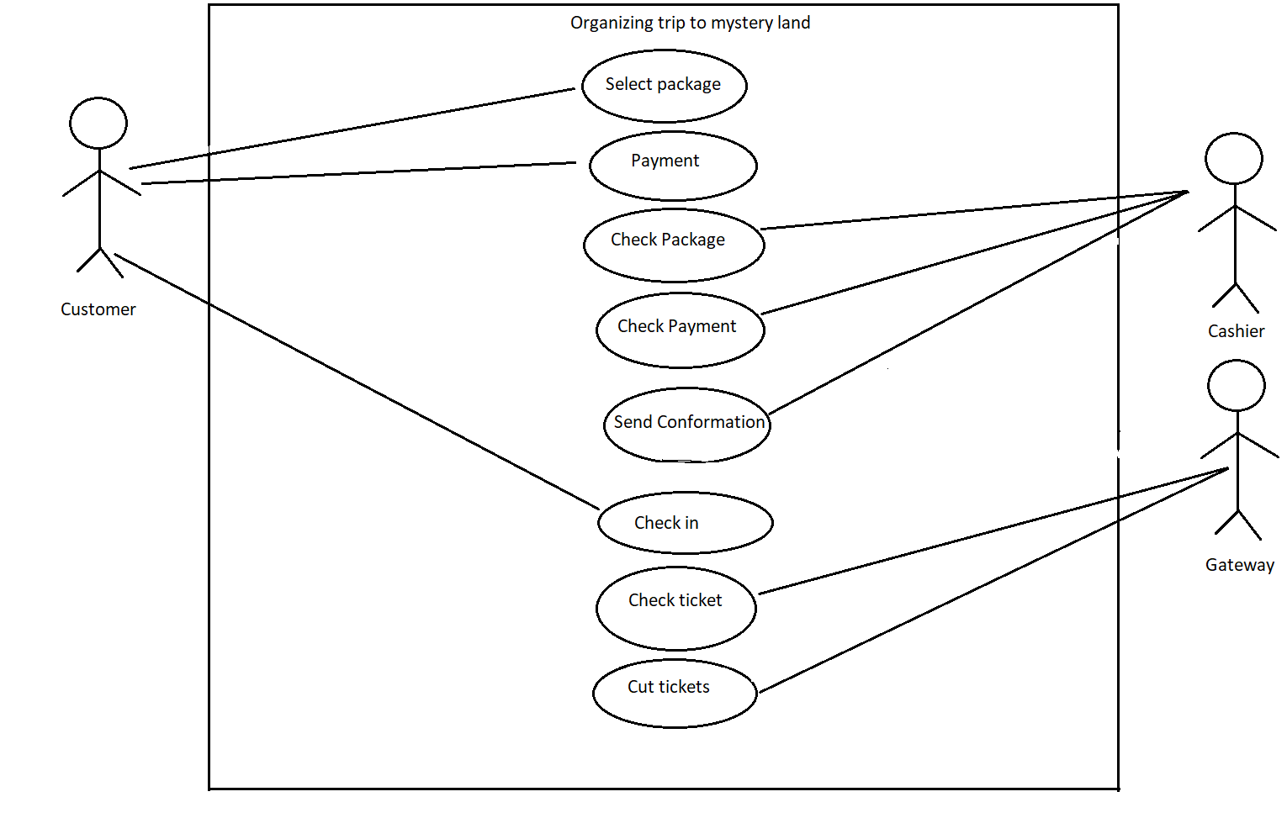

# Android Workshop 3:

Today I started working on webservice and practicing on it, to save time I implemented the workshop on our TRIO application. I used firebase for this workshop as it contains a guide to their official website.

As our application will have a Log in and Register feature, I implemented the register feature for this week which will register new users using email and password and the server would get the new user in the database.

When the user heads to the Sign up section, It will ask for the email, password and confirmation of password

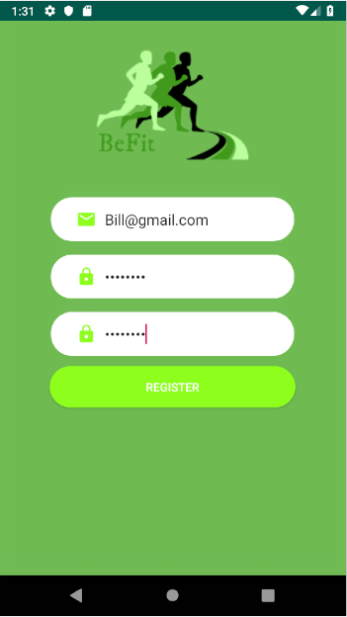

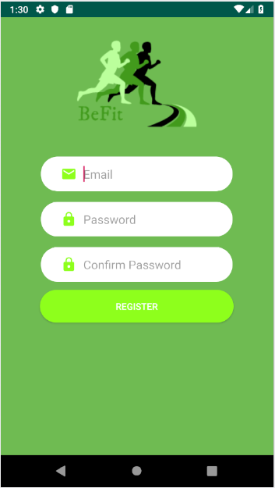

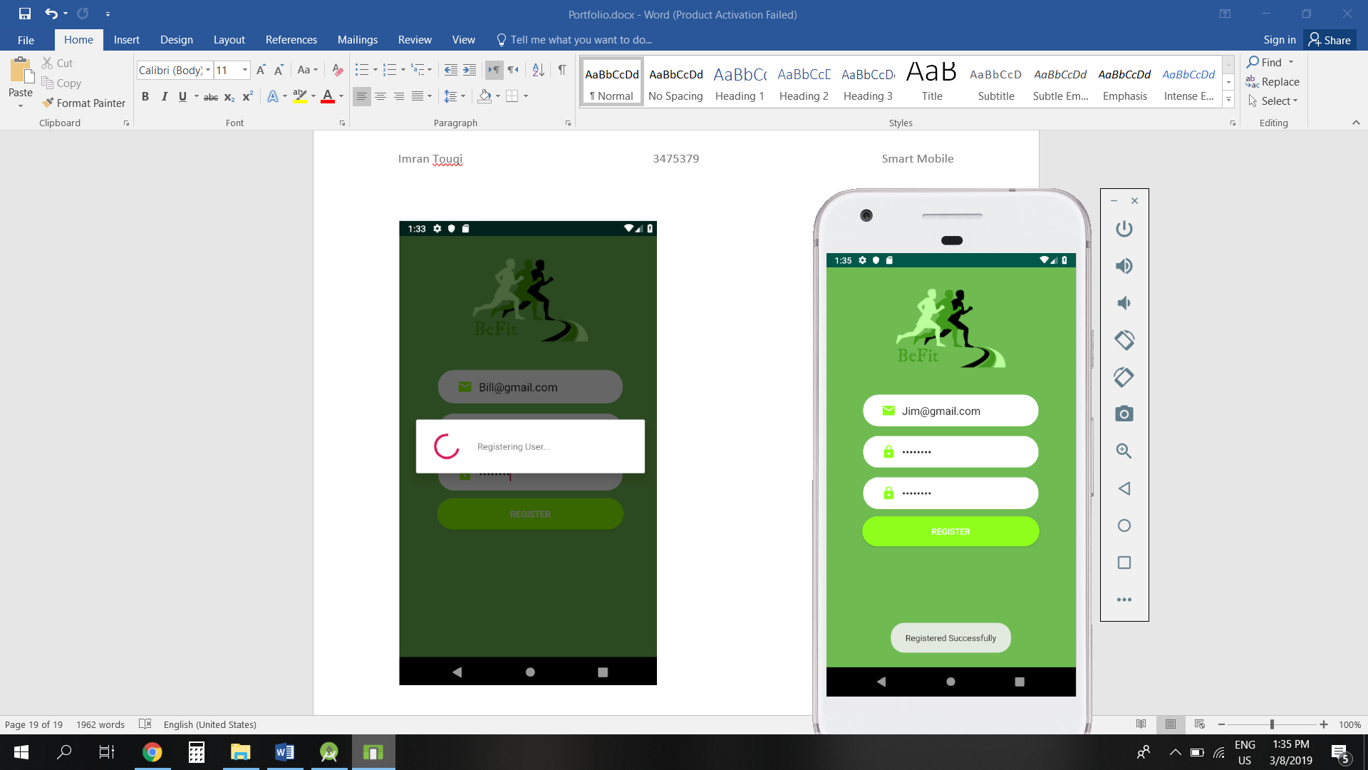

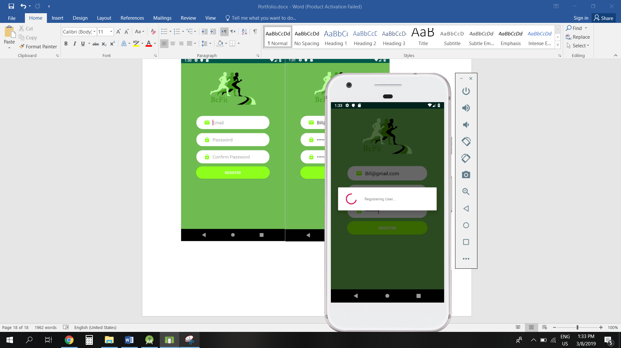

After Registering, the firebase website gets the information of the registered user.

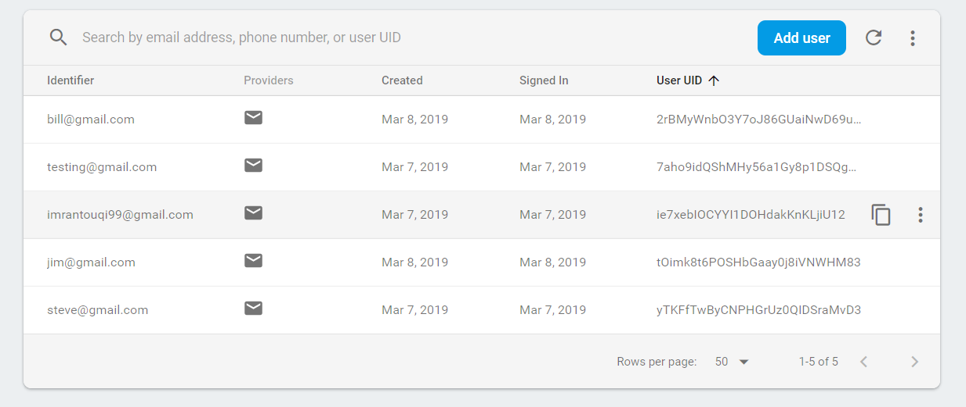

This is just to get familiar with the web service and how it works, of course we extend the application further by providing more features of web service like log in, storing extra info etc…

But I got a good idea on how firebase works and how to work on it.

After registering, the user then proceeds to the login page where they enter their credentials.

Then the app does a check if the user exists on the firebase server, Then logs the user in to the main menu page

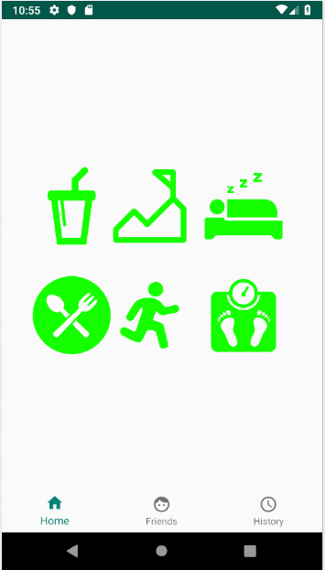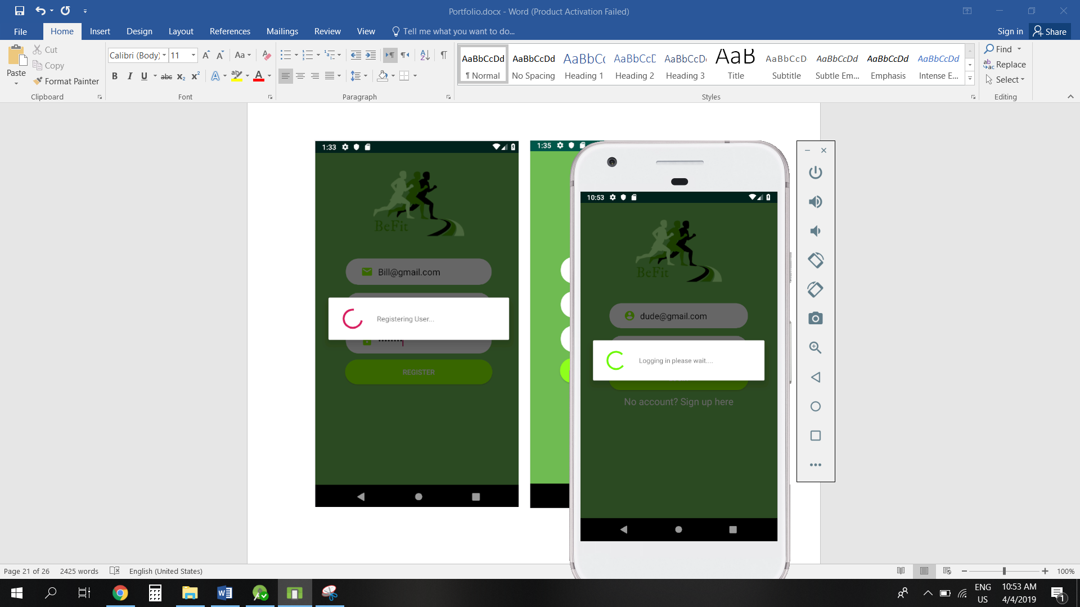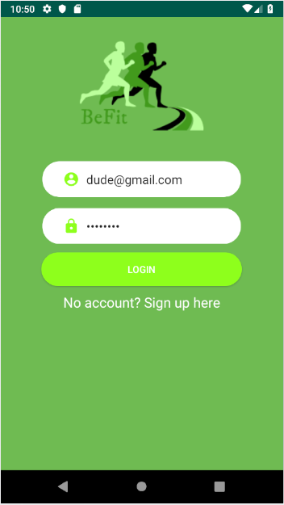

# Ux Workshop 4:

For today we worked with our TRIO application teammates to creates some wireframes for our application, After some brainstorming we managed create some wireframes on the PC after drawing some sketches on a piece of paper to make them more appealing and be able to work with easier.

We might make some changes of course in our main app, but this is to grasp an idea of how our app might look like.

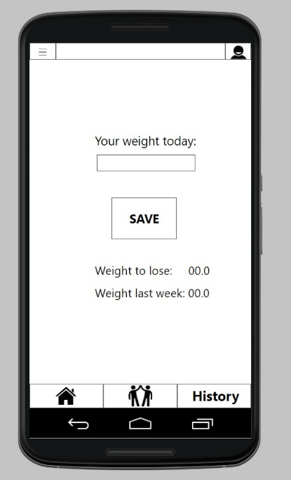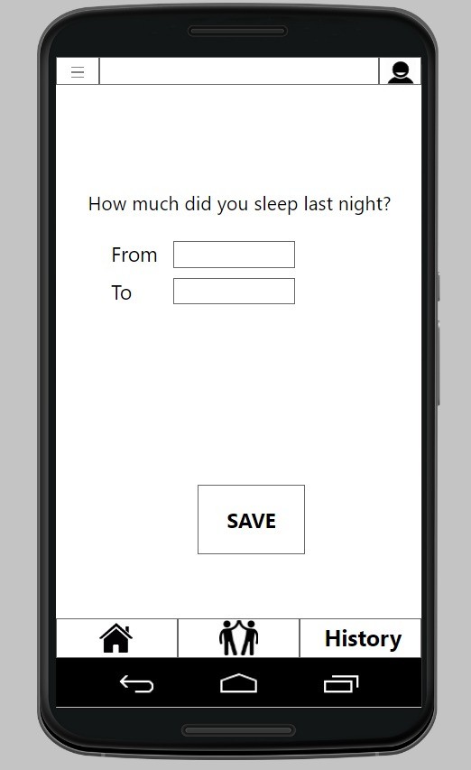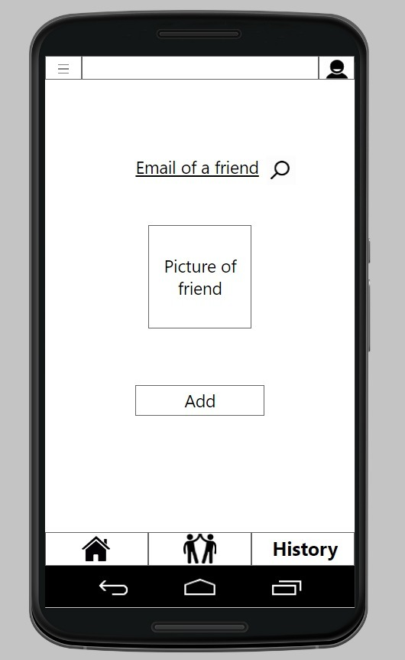

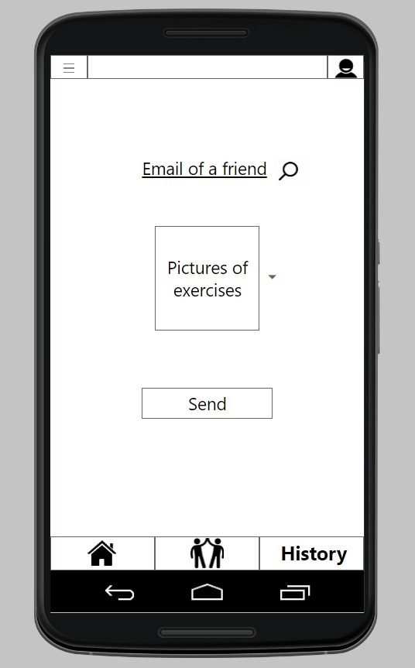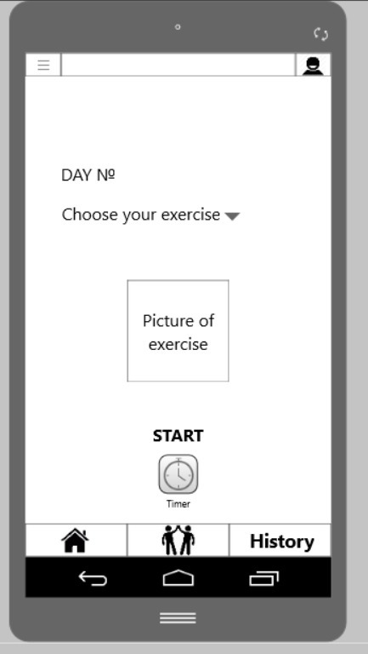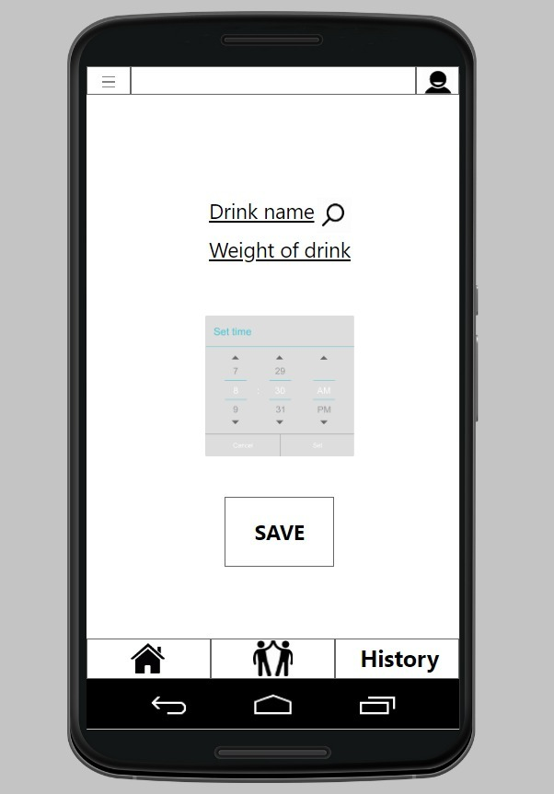

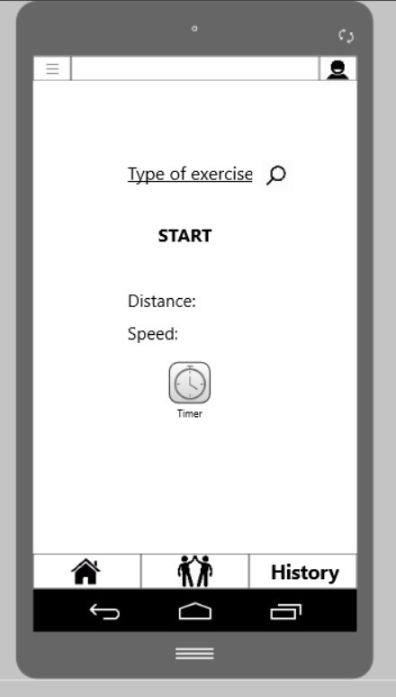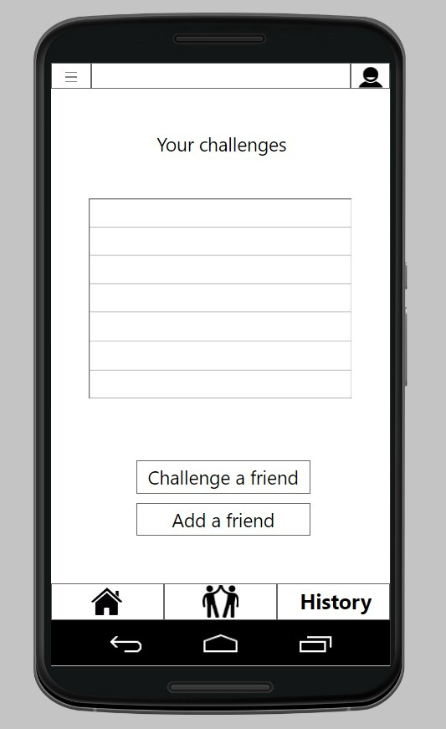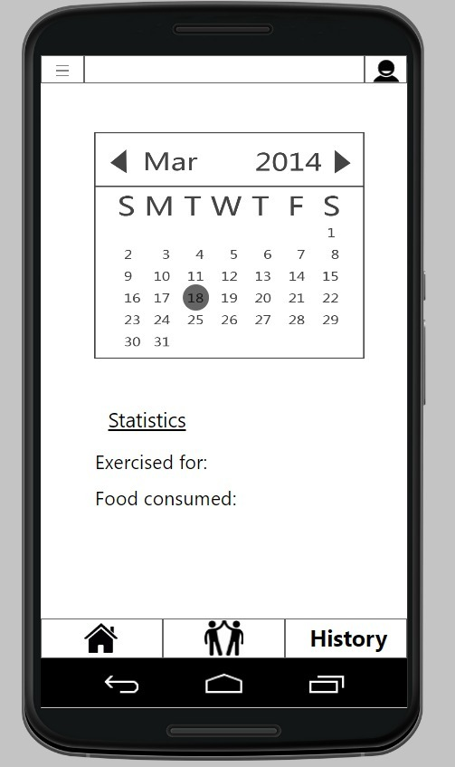

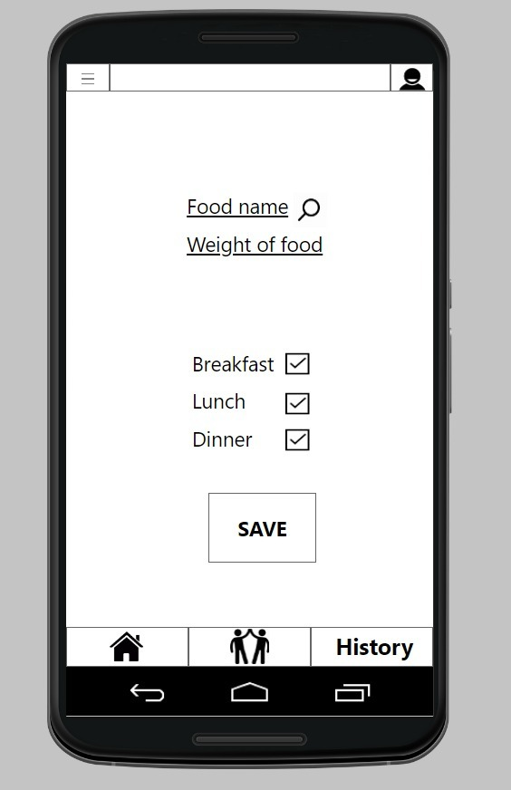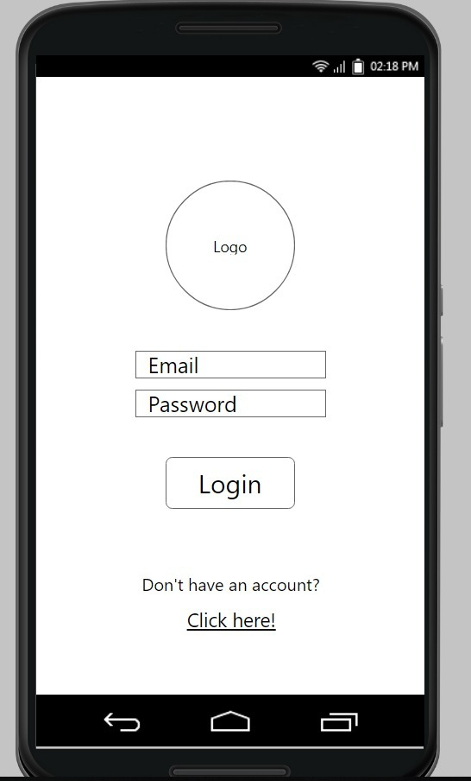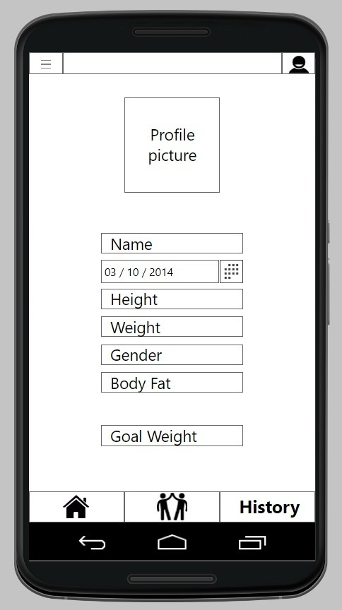

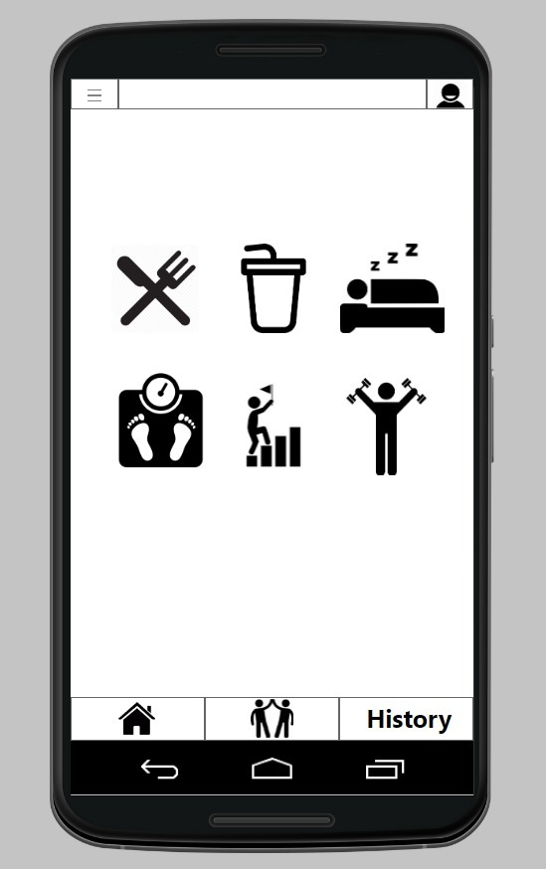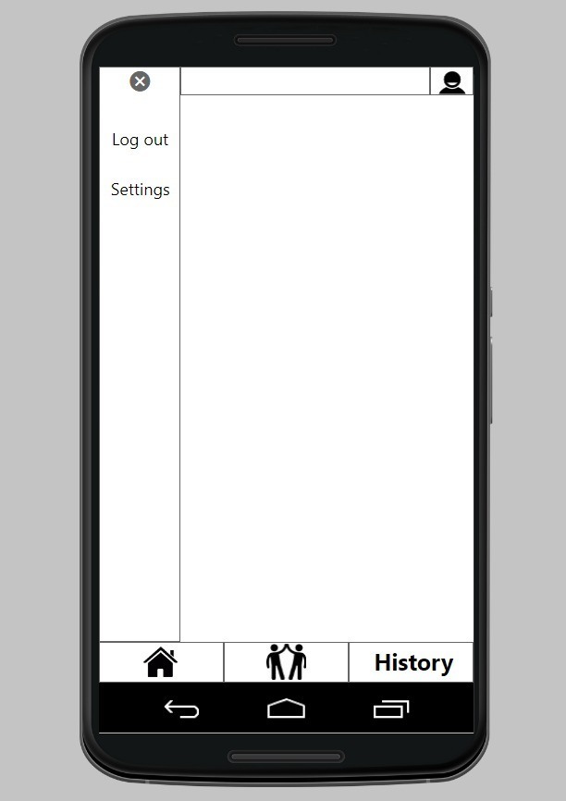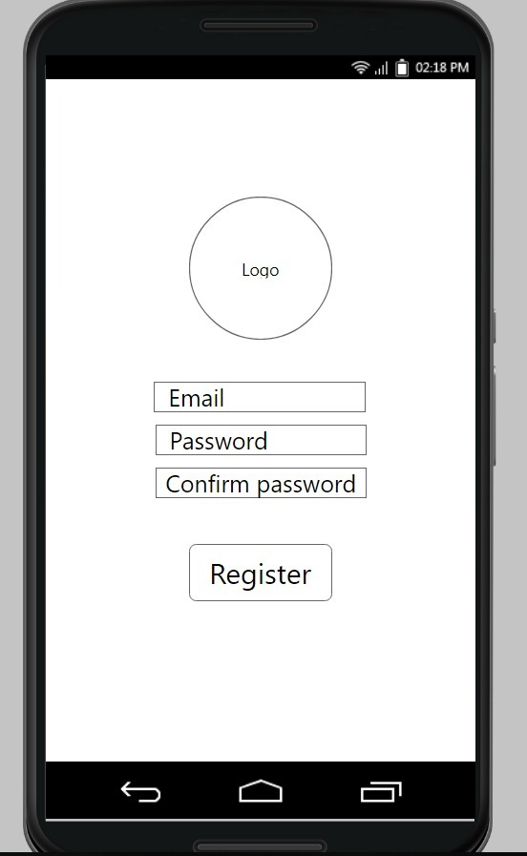

# Fragments

Based on our designs, we planned on adding on adding a bottom navigation bar that would switch to different fragments on the Main menu page. The pages switches from Home, Friends and History fragment.

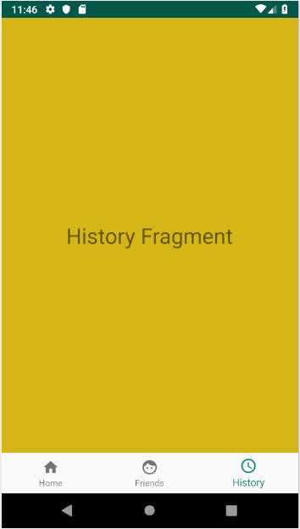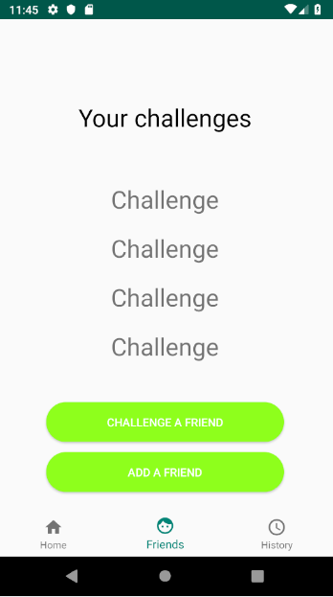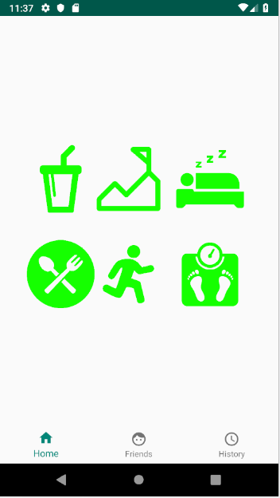

So I made I implemented it as seen above it switches between the three sections of the main page. Was considering switching between fragments or activities but through some research I decided fragments would be appropriate.