XYPHORA AI
Brand Identity Guide

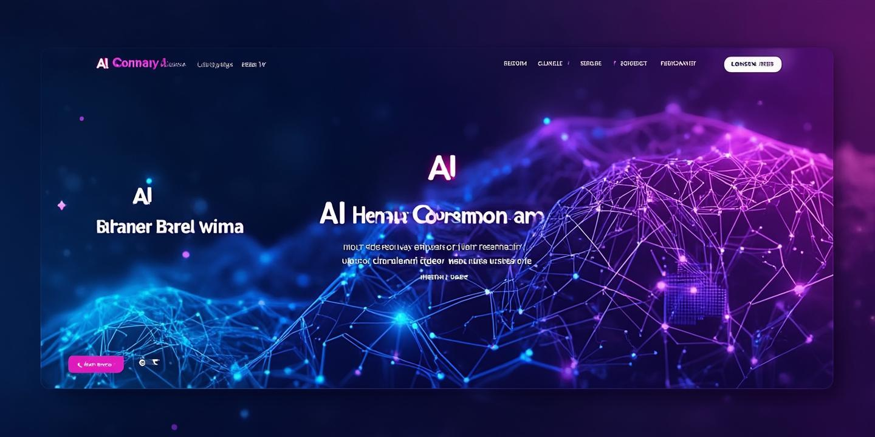

Intelligence Evolved

Version 1.0 | 2025

1. Brand Overview
Xyphora AI is a cutting-edge artificial intelligence development company specializing in building intelligent web applications, software solutions, and AI-powered digital products. The name combines the futuristic prefix 'Xy' with 'Phora' (from Greek, meaning movement or carrying forward), symbolizing the company's mission to propel AI innovation into the future. This brand identity guide establishes the visual standards and guidelines for consistent brand representation across all touchpoints and communications.

2. Logo Concepts
The Xyphora AI logo represents the convergence of artificial intelligence and innovative technology. Each concept has been carefully designed to be unique, memorable, and copyright-safe. The logos utilize abstract geometric forms that suggest neural networks, connectivity, and intelligence while maintaining a premium, professional appearance suitable for enterprise clients and innovative startups alike.

2.1 Abstract Neural Symbol
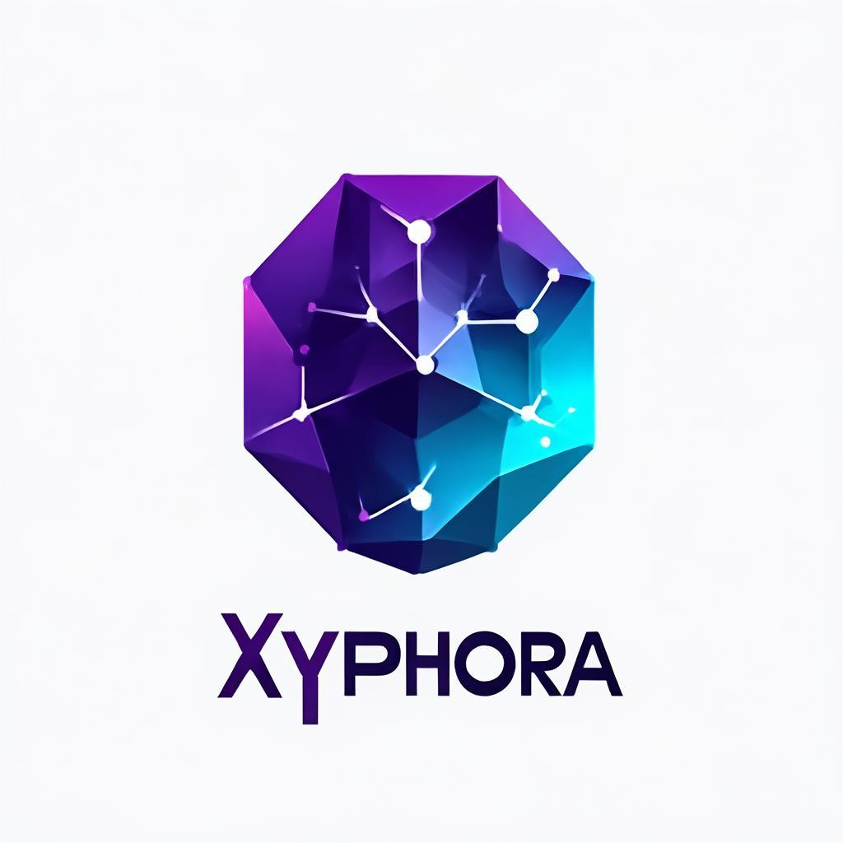
This primary logo concept features a geometric abstract form that suggests neural network connectivity and advanced intelligence. The purple and cyan gradient creates a futuristic, premium feel that immediately communicates innovation and cutting-edge technology. The clean, minimalist design ensures versatility across digital and print applications, from app icons to large-format displays.

2.2 Stylized Letter X
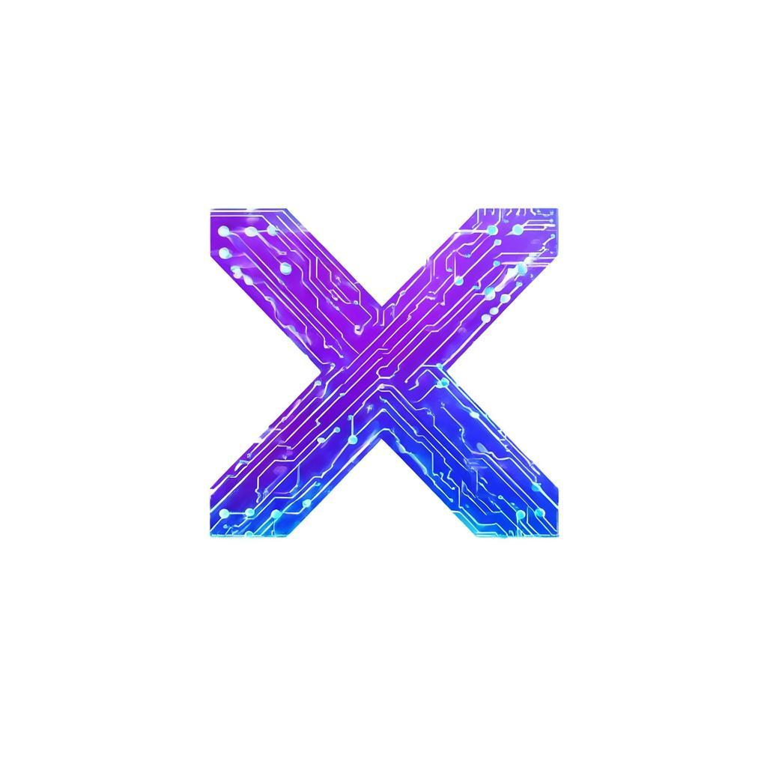
This concept transforms the letter 'X' from Xyphora into a dynamic circuit-based design. The interweaving paths represent data flow and neural connections, while the holographic purple-cyan gradient adds depth and dimension. This logo works exceptionally well for digital applications, social media avatars, and situations where brand recognition is paramount.

2.3 Hexagon Neural Icon (Dark Theme)

Designed specifically for dark mode interfaces and applications, this hexagonal icon features glowing neural pathways against a deep background. The neon cyan and purple glow effects create a striking, memorable appearance perfect for app icons, loading screens, and any context where a bold statement is desired. This variant demonstrates the brand's adaptability to modern UI trends.

2.4 Corporate Premium Mark

The corporate variant uses metallic silver and deep blue tones to convey professionalism and trustworthiness. The interlocking geometric shapes symbolize the integration of multiple technologies and intelligence systems. This logo is ideal for enterprise presentations, investor materials, and formal business communications where a more conservative yet sophisticated appearance is required.

3. Brand Color Palette
The Xyphora AI color palette has been carefully curated to convey innovation, trust, and technological sophistication. The primary purple and cyan combination creates a distinctive visual identity that stands out in the competitive AI landscape while remaining professional and approachable. These colors work harmoniously across all digital and print applications.
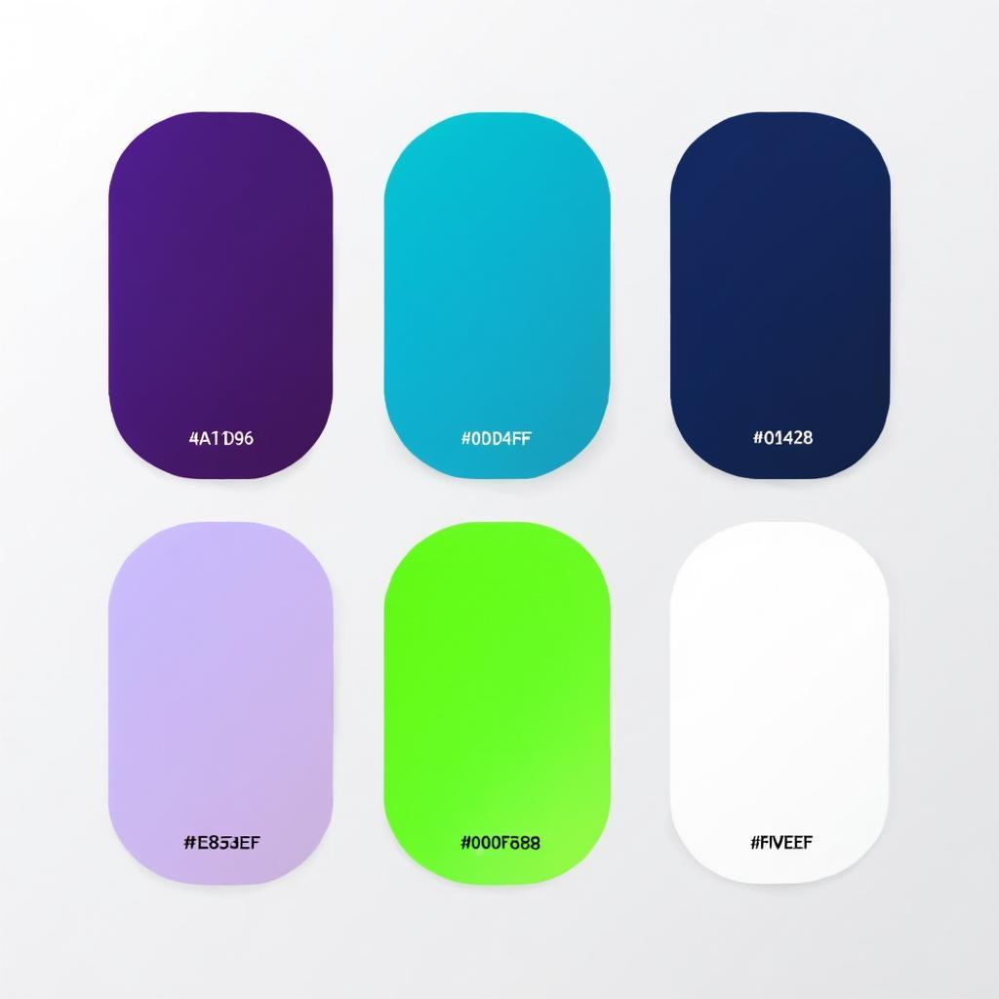

3.1 Color Specifications
Color Name | HEX | RGB | Usage
Deep Purple | #4A1D96 | 74, 29, 150 | Primary Brand
Electric Cyan | #00D4FF | 0, 212, 255 | Accent / Highlights
Dark Navy | #0A1628 | 10, 22, 40 | Backgrounds
Soft Lavender | #E8D5FF | 232, 213, 255 | Subtle Backgrounds
Neon Green | #00FF88 | 0, 255, 136 | Success States

4. Typography Guidelines
Typography plays a crucial role in maintaining brand consistency and ensuring clear communication across all touchpoints. The recommended typefaces balance modern aesthetics with excellent readability across both digital and print applications.

4.1 Primary Typeface
Inter or Roboto - Modern sans-serif typefaces that convey clarity and technological sophistication. These fonts are highly legible at all sizes and work excellently for both headlines and body text in digital applications.

4.2 Secondary Typeface
Space Grotesk or JetBrains Mono - Used for technical content, code snippets, and specialized applications where a more distinctive, tech-focused appearance is desired.

5. Tagline Options
The brand tagline should capture the essence of Xyphora AI's mission and value proposition. Below are recommended taglines for different contexts and audiences:
Tagline | Best For
Intelligence Evolved | Primary brand tagline - all applications
The Future, Coded | Marketing campaigns, social media
AI Built for Tomorrow | Enterprise clients, investor presentations
Build the Future | Developer-focused content, technical docs

6. Business Card Design
The business card design extends the brand identity to physical touchpoints, maintaining consistency with the digital presence while ensuring a premium feel appropriate for client-facing interactions.
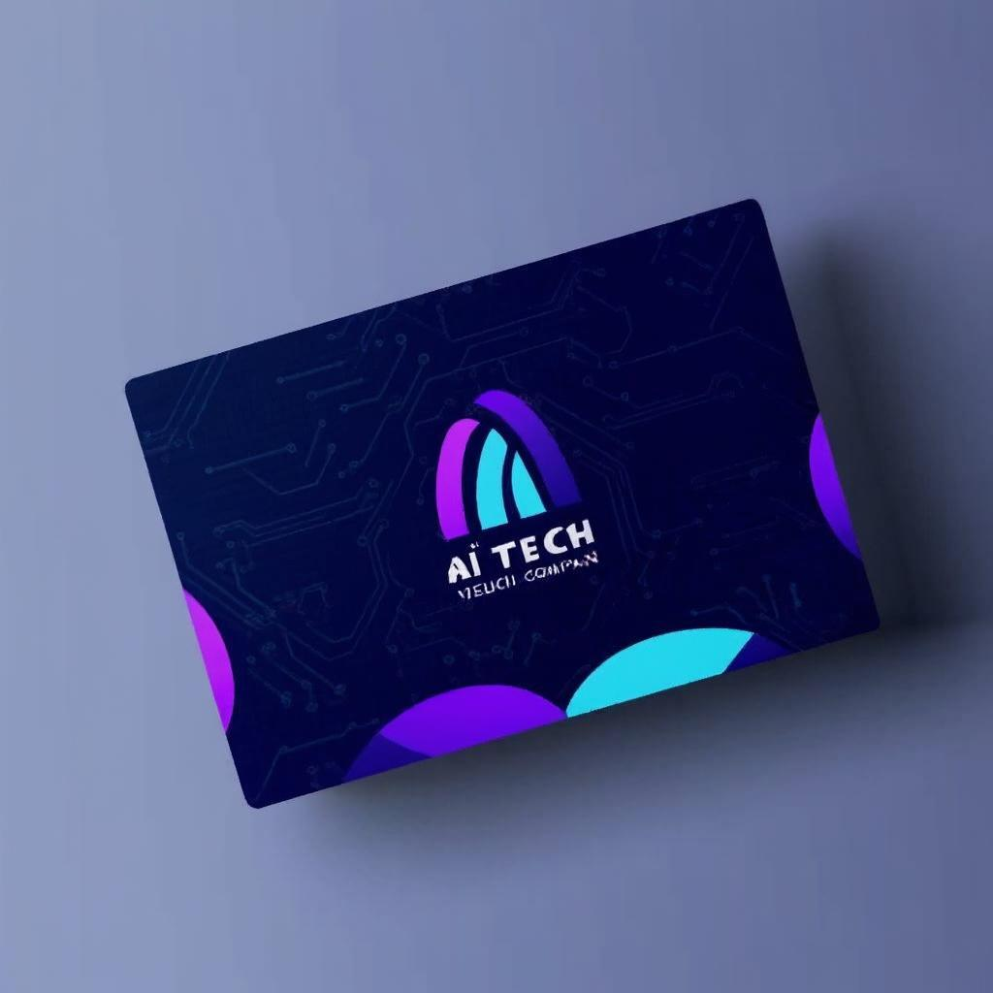

7. Usage Guidelines

7.1 Logo Usage Rules
- Always maintain clear space around the logo equal to the height of the 'X' in Xyphora
- Never stretch, distort, or rotate the logo from its original proportions
- Use the dark theme version only on dark backgrounds with sufficient contrast
- Minimum logo size: 32px for digital, 1 inch for print applications
- Never apply drop shadows, gradients, or other effects not specified in this guide

7.2 Color Application
- Primary purple should dominate brand communications and headers
- Electric cyan is reserved for accent elements, CTAs, and interactive components
- Dark navy serves as the primary background for digital applications
- Maintain WCAG AA contrast ratios for accessibility compliance

7.3 Trademark Protection
As 'Xyphora' is a coined word, it offers strong trademark protection potential. The following steps are recommended to secure and protect the brand: First, conduct a comprehensive trademark search in your target markets through the USPTO or relevant national trademark offices. Second, file trademark applications for both the name 'Xyphora AI' and the chosen logo design in all relevant classes (primarily Class 9 for software and Class 42 for technology services). Third, secure domain names including xyphora.ai, xyphora.com, and relevant social media handles. Finally, document all brand usage and maintain records of first commercial use to support potential enforcement actions.

