Solution to ST361 Quiz 3, 3/12/2009

Name:________________________ | Student ID:_____________________

Show your work in order to earn the full credit. This means that you have to present your steps or explain your reasoning for the answers you obtain, rather than just to write down the answer itself.

- (60pts) Suppose X is a random variable that has normal distribution with mean = 4 and standard deviation (SD) = 2. Do the following:
- Find 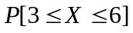 = 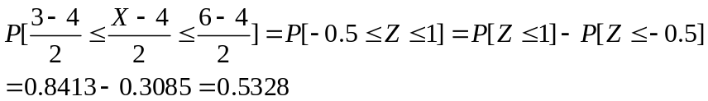

- Find 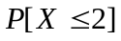=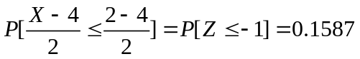

- Find 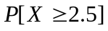=

- Find constant c such that X will be in the interval [4 - c, 4 + c] with probability 90%
So

- Find x* such that 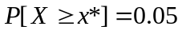.
Since 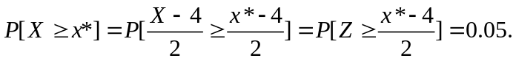But 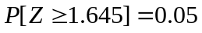. So (x*-4)/2=1.645 and x* = 7.29.

- Suppose a constant c makes 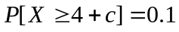. What is 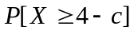?
Due to symmetry of the distribution of X around the mean 4,

(40pts) The defective rate of some chips produced by a manufacture is known to be 5%. Suppose an inspector randomly select 20 chips from the warehouse that has thousands of such chips for examination. Do the following:
- How many defective chips will the inspector expect to find. The probability mass function is given by 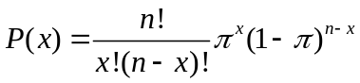

The expected number of defective chips is 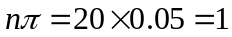

- Find the probability that the inspector will find at least 1 defective chip.

- Find the probability that there are at most 2 defective chips out of 20 chips.

- Is the inspector likely to see all 20 defective chips?
Since 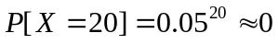. So it is not likely to see all 20 defective chips.

