DLCV HW2 Report

B07502071 陳志臻

P1-GAN

1. Model architecture (I put it in the end of report)

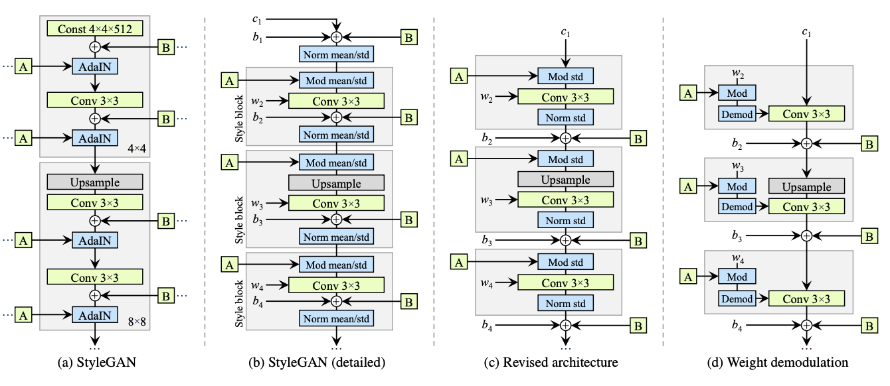

1. First 32 images

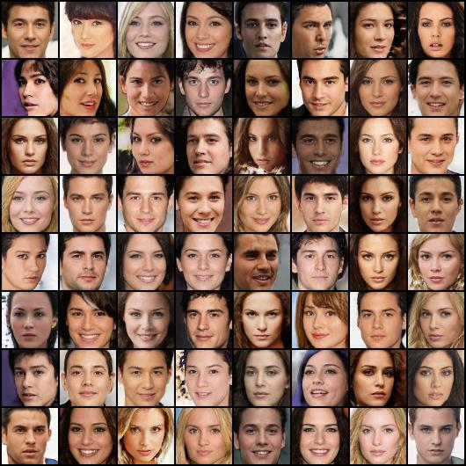

3&4. Results

FID: 28.158576252243705

Inception Score: 2.001824013042993

1. Implementing GAN

I chose to use the stylegan2 model architecture. I trained my model for 68000 steps on colab pro with P100 GPU for about 22 hours. Besides, I added one attention-layer in my training. According to my collaborators’ experience, if I didn’t use the attention-layer, it would be hard to pass the original baseline. We also found that if the model architecture is too big, it would be hard to be trained well.

P2-ACGAN

1. Model architecture

Generator(

(label_emb): Embedding(10, 100)

(l1): Sequential(

(0): Linear(in_features=100, out_features=8192, bias=True)

)

(conv_blocks): Sequential(

(0): BatchNorm2d(128, eps=1e-05, momentum=0.1, affine=True, track_running_stats=True)

(1): Upsample(scale_factor=2.0, mode=nearest)

(2): Conv2d(128, 128, kernel_size=(3, 3), stride=(1, 1), padding=(1, 1))

(3): BatchNorm2d(128, eps=0.8, momentum=0.1, affine=True, track_running_stats=True)

(4): LeakyReLU(negative_slope=0.2, inplace=True)

(5): Upsample(scale_factor=2.0, mode=nearest)

(6): Conv2d(128, 64, kernel_size=(3, 3), stride=(1, 1), padding=(1, 1))

(7): BatchNorm2d(64, eps=0.8, momentum=0.1, affine=True, track_running_stats=True)

(8): LeakyReLU(negative_slope=0.2, inplace=True)

(9): Conv2d(64, 3, kernel_size=(3, 3), stride=(1, 1), padding=(1, 1))

(10): Tanh()

)

)

Discriminator(

(conv_blocks): Sequential(

(0): Conv2d(3, 16, kernel_size=(3, 3), stride=(2, 2), padding=(1, 1))

(1): LeakyReLU(negative_slope=0.2, inplace=True)

(2): Dropout2d(p=0.25, inplace=False)

(3): Conv2d(16, 32, kernel_size=(3, 3), stride=(2, 2), padding=(1, 1))

(4): LeakyReLU(negative_slope=0.2, inplace=True)

(5): Dropout2d(p=0.25, inplace=False)

(6): BatchNorm2d(32, eps=0.8, momentum=0.1, affine=True, track_running_stats=True)

(7): Conv2d(32, 64, kernel_size=(3, 3), stride=(2, 2), padding=(1, 1))

(8): LeakyReLU(negative_slope=0.2, inplace=True)

(9): Dropout2d(p=0.25, inplace=False)

(10): BatchNorm2d(64, eps=0.8, momentum=0.1, affine=True, track_running_stats=True)

(11): Conv2d(64, 128, kernel_size=(3, 3), stride=(2, 2), padding=(1, 1))

(12): LeakyReLU(negative_slope=0.2, inplace=True)

(13): Dropout2d(p=0.25, inplace=False)

(14): BatchNorm2d(128, eps=0.8, momentum=0.1, affine=True, track_running_stats=True)

)

(adv_layer): Sequential(

(0): Linear(in_features=512, out_features=1, bias=True)

(1): Sigmoid()

)

(aux_layer): Sequential(

(0): Linear(in_features=512, out_features=10, bias=True)

(1): Softmax(dim=None)

)

)

1. Accuracy : 82.5%
2. Sample output

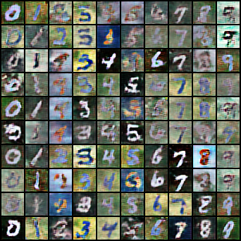

P3-DANN

1. Accuracy

|  |  |  |  |
| --- | --- | --- | --- |
|  | SVHN-Mnistm | Mnistm-USPS | USPS-SVHN |
| Trained on source | 48.91% | 75.49% | 25.64% |
| Adaption | 57.99% | 88.19% | 31.63% |
| Trained on target | 97.58% | 96.71% | 89.64% |

1. Visualization t-sne

|  |  |
| --- | --- |
|  |  |
| Svhn-mnistm class0-9 | Svhn-mnistm domain |
|  |  |
| Mnistm-Usps class0-9 | Mnistm-Usps domain |
|  |  |
| Usps-Svhn class0-9 | Usps-Svhn domain |

1. Observation of DANN

First, I found that it’s possible to pass the simple baseline just training on source dataset for SVHN-Mnistm and Mnistm-USPS。Look at the table above, we implemented t-sne visualization on target domain, and the best one is Mnistm-Usps, which has 0.8819% of accuracy. The second one is Svhn-mnistm, which has 0.5799% of accuracy, and the worst one is Usps-Svhn which has 0.3163%. The results of accuracy is same with the pictures. I think the most important reason for the difference is the amount of data for both source domain and target domain. In conclusion, the amount of source domain data should not be much more than target domain.

Bonus

1. Improved model: DSN

|  |  |  |  |
| --- | --- | --- | --- |
|  | SVHN-Mnistm | Mnistm-USPS | USPS-SVHN |
| Original model | 57.99% | 88.19% | 31.63% |
| Improved model | 62.28% | 88.34% | 42.82% |

1. Observation of DSN

I implemented the DSN model structure as my improved model. When I was training DANN, it was almost convergent when I had trained it for 14000 iterations with batch size 32. However, when I was training DSN, it converged much slower than DANN. I trained it for 29000 iterations to get a higher performance. In the training of USPS-SVHN, DSN got a obviously higher accuracy than DANN. However, it is hard for DSN to get a higher accuracy in training Mnistm-USPS, which has the most amount of data.

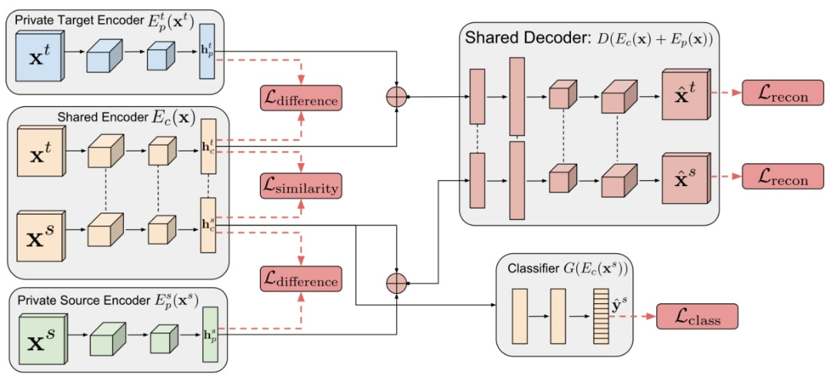

DSN

References

<https://github.com/lucidrains/stylegan2-pytorch>

<https://drive.google.com/file/d/1fnF-QsiQeKaxF-HbvFiGtzHF_Bf3CzJu/view>

<https://github.com/kai860115/DLCV2020-FALL/tree/main/hw3>/dann

<https://github.com/kai860115/DLCV2020-FALL/tree/main/hw3/dsn>

<https://github.com/eriklindernoren/PyTorch-GAN#auxiliary-classifier-gan>

<https://github.com/fungtion/DSN>

Collaborators

B08902134 曾揚哲

B08502141 石旻翰

Stylegan2 model architecture

Generator

Generator(

(initial_conv): Conv2d(512, 512, kernel_size=(3, 3), stride=(1, 1), padding=(1, 1))

(blocks): ModuleList(

(0): GeneratorBlock(

(to_style1): Linear(in_features=512, out_features=512, bias=True)

(to_noise1): Linear(in_features=1, out_features=512, bias=True)

(conv1): Conv2DMod()

(to_style2): Linear(in_features=512, out_features=512, bias=True)

(to_noise2): Linear(in_features=1, out_features=512, bias=True)

(conv2): Conv2DMod()

(activation): LeakyReLU(negative_slope=0.2, inplace=True)

(to_rgb): RGBBlock(

(to_style): Linear(in_features=512, out_features=512, bias=True)

(conv): Conv2DMod()

(upsample): Sequential(

(0): Upsample(scale_factor=2.0, mode=bilinear)

(1): Blur()

)

)

)

(1): GeneratorBlock(

(upsample): Upsample(scale_factor=2.0, mode=bilinear)

(to_style1): Linear(in_features=512, out_features=512, bias=True)

(to_noise1): Linear(in_features=1, out_features=256, bias=True)

(conv1): Conv2DMod()

(to_style2): Linear(in_features=512, out_features=256, bias=True)

(to_noise2): Linear(in_features=1, out_features=256, bias=True)

(conv2): Conv2DMod()

(activation): LeakyReLU(negative_slope=0.2, inplace=True)

(to_rgb): RGBBlock(

(to_style): Linear(in_features=512, out_features=256, bias=True)

(conv): Conv2DMod()

(upsample): Sequential(

(0): Upsample(scale_factor=2.0, mode=bilinear)

(1): Blur()

)

)

)

(2): GeneratorBlock(

(upsample): Upsample(scale_factor=2.0, mode=bilinear)

(to_style1): Linear(in_features=512, out_features=256, bias=True)

(to_noise1): Linear(in_features=1, out_features=128, bias=True)

(conv1): Conv2DMod()

(to_style2): Linear(in_features=512, out_features=128, bias=True)

(to_noise2): Linear(in_features=1, out_features=128, bias=True)

(conv2): Conv2DMod()

(activation): LeakyReLU(negative_slope=0.2, inplace=True)

(to_rgb): RGBBlock(

(to_style): Linear(in_features=512, out_features=128, bias=True)

(conv): Conv2DMod()

(upsample): Sequential(

(0): Upsample(scale_factor=2.0, mode=bilinear)

(1): Blur()

)

)

)

(3): GeneratorBlock(

(upsample): Upsample(scale_factor=2.0, mode=bilinear)

(to_style1): Linear(in_features=512, out_features=128, bias=True)

(to_noise1): Linear(in_features=1, out_features=64, bias=True)

(conv1): Conv2DMod()

(to_style2): Linear(in_features=512, out_features=64, bias=True)

(to_noise2): Linear(in_features=1, out_features=64, bias=True)

(conv2): Conv2DMod()

(activation): LeakyReLU(negative_slope=0.2, inplace=True)

(to_rgb): RGBBlock(

(to_style): Linear(in_features=512, out_features=64, bias=True)

(conv): Conv2DMod()

(upsample): Sequential(

(0): Upsample(scale_factor=2.0, mode=bilinear)

(1): Blur()

)

)

)

(4): GeneratorBlock(

(upsample): Upsample(scale_factor=2.0, mode=bilinear)

(to_style1): Linear(in_features=512, out_features=64, bias=True)

(to_noise1): Linear(in_features=1, out_features=32, bias=True)

(conv1): Conv2DMod()

(to_style2): Linear(in_features=512, out_features=32, bias=True)

(to_noise2): Linear(in_features=1, out_features=32, bias=True)

(conv2): Conv2DMod()

(activation): LeakyReLU(negative_slope=0.2, inplace=True)

(to_rgb): RGBBlock(

(to_style): Linear(in_features=512, out_features=32, bias=True)

(conv): Conv2DMod()

)

)

)

(attns): ModuleList(

(0): None

(1): None

(2): None

(3): None

(4): Sequential(

(0): Residual(

(fn): PreNorm(

(fn): LinearAttention(

(nonlin): GELU()

(to_q): Conv2d(64, 512, kernel_size=(1, 1), stride=(1, 1), bias=False)

(to_kv): DepthWiseConv2d(

(net): Sequential(

(0): Conv2d(64, 64, kernel_size=(3, 3), stride=(1, 1), padding=(1, 1), groups=64, bias=False)

(1): Conv2d(64, 1024, kernel_size=(1, 1), stride=(1, 1), bias=False)

)

)

(to_out): Conv2d(512, 64, kernel_size=(1, 1), stride=(1, 1))

)

(norm): ChanNorm()

)

)

(1): Residual(

(fn): PreNorm(

(fn): Sequential(

(0): Conv2d(64, 128, kernel_size=(1, 1), stride=(1, 1))

(1): LeakyReLU(negative_slope=0.2, inplace=True)

(2): Conv2d(128, 64, kernel_size=(1, 1), stride=(1, 1))

)

(norm): ChanNorm()

)

)

)

)

)

Discriminator

Discriminator(

(blocks): ModuleList(

(0): DiscriminatorBlock(

(conv_res): Conv2d(3, 64, kernel_size=(1, 1), stride=(2, 2))

(net): Sequential(

(0): Conv2d(3, 64, kernel_size=(3, 3), stride=(1, 1), padding=(1, 1))

(1): LeakyReLU(negative_slope=0.2, inplace=True)

(2): Conv2d(64, 64, kernel_size=(3, 3), stride=(1, 1), padding=(1, 1))

(3): LeakyReLU(negative_slope=0.2, inplace=True)

)

(downsample): Sequential(

(0): Blur()

(1): Conv2d(64, 64, kernel_size=(3, 3), stride=(2, 2), padding=(1, 1))

)

)

(1): DiscriminatorBlock(

(conv_res): Conv2d(64, 128, kernel_size=(1, 1), stride=(2, 2))

(net): Sequential(

(0): Conv2d(64, 128, kernel_size=(3, 3), stride=(1, 1), padding=(1, 1))

(1): LeakyReLU(negative_slope=0.2, inplace=True)

(2): Conv2d(128, 128, kernel_size=(3, 3), stride=(1, 1), padding=(1, 1))

(3): LeakyReLU(negative_slope=0.2, inplace=True)

)

(downsample): Sequential(

(0): Blur()

(1): Conv2d(128, 128, kernel_size=(3, 3), stride=(2, 2), padding=(1, 1))

)

)

(2): DiscriminatorBlock(

(conv_res): Conv2d(128, 256, kernel_size=(1, 1), stride=(2, 2))

(net): Sequential(

(0): Conv2d(128, 256, kernel_size=(3, 3), stride=(1, 1), padding=(1, 1))

(1): LeakyReLU(negative_slope=0.2, inplace=True)

(2): Conv2d(256, 256, kernel_size=(3, 3), stride=(1, 1), padding=(1, 1))

(3): LeakyReLU(negative_slope=0.2, inplace=True)

)

(downsample): Sequential(

(0): Blur()

(1): Conv2d(256, 256, kernel_size=(3, 3), stride=(2, 2), padding=(1, 1))

)

)

(3): DiscriminatorBlock(

(conv_res): Conv2d(256, 512, kernel_size=(1, 1), stride=(2, 2))

(net): Sequential(

(0): Conv2d(256, 512, kernel_size=(3, 3), stride=(1, 1), padding=(1, 1))

(1): LeakyReLU(negative_slope=0.2, inplace=True)

(2): Conv2d(512, 512, kernel_size=(3, 3), stride=(1, 1), padding=(1, 1))

(3): LeakyReLU(negative_slope=0.2, inplace=True)

)

(downsample): Sequential(

(0): Blur()

(1): Conv2d(512, 512, kernel_size=(3, 3), stride=(2, 2), padding=(1, 1))

)

)

(4): DiscriminatorBlock(

(conv_res): Conv2d(512, 512, kernel_size=(1, 1), stride=(2, 2))

(net): Sequential(

(0): Conv2d(512, 512, kernel_size=(3, 3), stride=(1, 1), padding=(1, 1))

(1): LeakyReLU(negative_slope=0.2, inplace=True)

(2): Conv2d(512, 512, kernel_size=(3, 3), stride=(1, 1), padding=(1, 1))

(3): LeakyReLU(negative_slope=0.2, inplace=True)

)

(downsample): Sequential(

(0): Blur()

(1): Conv2d(512, 512, kernel_size=(3, 3), stride=(2, 2), padding=(1, 1))

)

)

(5): DiscriminatorBlock(

(conv_res): Conv2d(512, 512, kernel_size=(1, 1), stride=(1, 1))

(net): Sequential(

(0): Conv2d(512, 512, kernel_size=(3, 3), stride=(1, 1), padding=(1, 1))

(1): LeakyReLU(negative_slope=0.2, inplace=True)

(2): Conv2d(512, 512, kernel_size=(3, 3), stride=(1, 1), padding=(1, 1))

(3): LeakyReLU(negative_slope=0.2, inplace=True)

)

)

)

(attn_blocks): ModuleList(

(0): Sequential(

(0): Residual(

(fn): PreNorm(

(fn): LinearAttention(

(nonlin): GELU()

(to_q): Conv2d(64, 512, kernel_size=(1, 1), stride=(1, 1), bias=False)

(to_kv): DepthWiseConv2d(

(net): Sequential(

(0): Conv2d(64, 64, kernel_size=(3, 3), stride=(1, 1), padding=(1, 1), groups=64, bias=False)

(1): Conv2d(64, 1024, kernel_size=(1, 1), stride=(1, 1), bias=False)

)

)

(to_out): Conv2d(512, 64, kernel_size=(1, 1), stride=(1, 1))

)

(norm): ChanNorm()

)

)

(1): Residual(

(fn): PreNorm(

(fn): Sequential(

(0): Conv2d(64, 128, kernel_size=(1, 1), stride=(1, 1))

(1): LeakyReLU(negative_slope=0.2, inplace=True)

(2): Conv2d(128, 64, kernel_size=(1, 1), stride=(1, 1))

)

(norm): ChanNorm()

)

)

)

(1): None

(2): None

(3): None

(4): None

(5): None

)

(quantize_blocks): ModuleList(

(0): None

(1): None

(2): None

(3): None

(4): None

(5): None

)

(final_conv): Conv2d(512, 512, kernel_size=(3, 3), stride=(1, 1), padding=(1, 1))

(flatten): Flatten()

(to_logit): Linear(in_features=2048, out_features=1, bias=True)

)