Name: Touseef Bhatti
Roll No 231370223
Section-D
HCI-LAB Assignment-1
Task 1: Task Analysis
Selected App: Easypaisa
User Goal: Send money to another user

Step No | User Action | Purpose
1 | Open Easypaisa app | Send Money
2 | Login using PIN / biometrics | Access Account
3 | Select Send Money | Start transaction
4 | Choose transfer option | Select Wallet, bank or other option
5 | Enter Account number | Identify receiver
6 | Enter amount | Specify transfer amount
7 | Check transaction details | To avoid mistakes
8 | Confirm transaction | Complete transection
9 | Receive confirmation message | Ensure money is sent

Task 2: Personas & Usability Issues
Persona 1: Elderly User
- Small font size
Difficult to read balance and transaction details
- Too many steps
Makes sending money confusing
- Icons without labels
Hard to understand options
- Small buttons
Difficult to tap correctly

Persona 2: First-Time User
- No clear guidance
User does not know how to start
- Difficult terms
Confusing for new users
- No preview before sending
Fear of sending wrong amount
- Payment options not clear
Makes the process confusing

Task 3: Low-Fidelity Wireframes
Screens Designed
- Home Screen
- Send Money

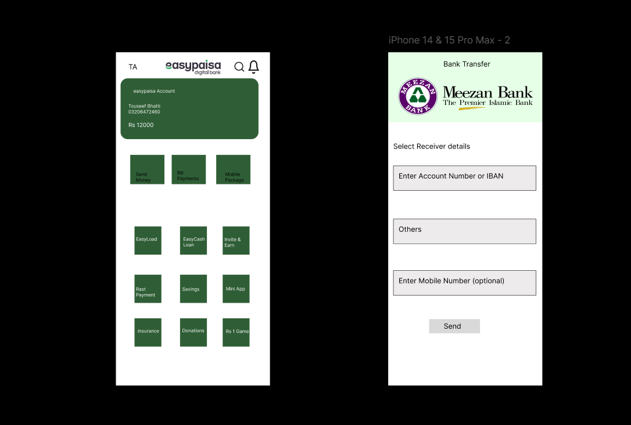

Link =>
https://www.figma.com/design/X6M085xAAFYHO8kaofbIgi/Hci-Lab-Assignment-1?node-id=0-1&t=k7ZNz9lPcAEjq4C6-1

Task 4: UI Redesign Based on Personas
Improvements:
- Increased Font size
- Added proper Icons and Labels
- Clear Buttons
- Improve clarity and navigation

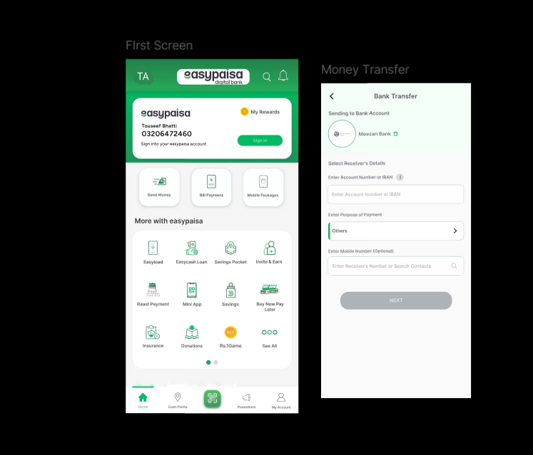

Link=>
https://www.figma.com/design/pSbt7ys97eaJmNsIq6LLkD/Hci-Lab-Assignment-1-Fix-design?node-id=0-1&p=f&t=k7ZNz9lPcAEjq4C6-0
Task 5: Perception & Affordance Improvements
Before | After
Low contrast text | Better contrast for text and buttons
Poor grouping of elements | Related items grouped together
Buttons not clearly visible | Main buttons highlighted clearly
Flat design without depth | Use of shadows to show clickable areas
Low contrast text | Better contrast for text and buttons

