

Software Requirements Specification

for

Online Store

Version 1.1 approved

Prepared by Touseef Ghazanfar

Registration No. 58897

Advisor Name Sir M. Suffiyan

23 April, 2018

Contents

1 Introduction 4

1.1 Overview 4

1.2 Intended Audience and Reading Suggestions. 4

1.3 Project Scope 5

1.4 References 5

2 Project Overview 5

2.1 Context Diagram 5

2.2 Project Perspective 5

2.3 Project Roles 5

2.4 Project Features 5

2.5 DFD diagram 6

2.6 Project Assumptions and Dependencies 6

3 Functional Requirements 6

3.1 Features Descriptions 6

3.2 Use Case Diagrams 6

3.3 Use Case Descriptions 6

3.4 Activity Diagrams 6

3.5 ERD 6

4 Non-Functional Requirements 6

4.1 Performance Requirements 6

4.2 Reliability 6

4.3 Security 6

5 System Specifications 6

5.1 User Interfaces 6

5.2 Hardware Interfaces 6

5.3 Software Interfaces 6

5.4 Design Constraints 6

6 Future Enhancements 6

7 Appendix 6

**Revision History**

|  |  |  |  |
| --- | --- | --- | --- |
| **Name** | **Date** | **Reason for Changes** | **Version** |
| Touseef Ghazanfar | 23-04-18 | Creation | 1.0 |
| Touseef Ghazanfar | 28-04-18 | Upgradation of DFD, Context Diagram, Activitiy Diagram of Customer and few Use Case Description | 1.1 |

# Introduction

## Overview

MyShop is a marketplace where we make shopping easy by allowing shoppers access to millions of products from hundreds of products and thousands of name brands with the use of our shopping cart. MyShop, your favorite online shopping site, is sure to spoil you with a wide range of products.

Shop smarter with the help of price comparison, best deals and discount coupon. Find great products with help of advanced navigation system and search options. Browse the products, view photos or images of the products, along with information about the product specifications, features and prices. An online store that offers you great deals on clothes, nutrition, electronics, beauty, health, shoes, and more.

## Intended Audience and Reading Suggestions.

We are making this project "Online Store" document by keeping in mind different types of personnel. This document will be useful for different audience in various ways. People like project manager, developer, coder, tester and documentation writer should read and understand this document.

**Customer**

They can ensure their self by reading the SRS that their needs being met in the online store or not.

**Project Manager**

They will see the constraints all cover properly. Time and cost is within limits or not.

**Project Developer**

They will use this document for guidance for design and implementation phase.

**Tester**

They will test the implementation of the project according to the SRS base.

**Document Writer**

They will use this document during the documentation of the project. It will be really helpful for them.

**Marketing Staff**

They can use this document to make advertisements for this web store because by reading this document they will know what the system will do? How this system is different from others.

**Suggestions**

* 1.The user can read the whole SRS document but for him Introduction, Overall description and System features is much required the software performance.
* 2.For the project manager the system features is very important.
* 3.The developer must go through the whole SRS for understanding therequirement and functioning of software.
* 4.The designer and coder must see the class and object diagram and statetransmission diagram for coding the modules.
* 5.A tester must be aware of coding language and visit through the code section and check the required output.
* 6.The document writer should write the qualitative document so that it becomes easy and understand to everyone.

## Project Scope

Purchasing and selling of products and services from big brands. Saving money and time by finding your product with advance navigation on a competitive price.

## References

Bourque, P.; Fairley, R.E. (2014). "Guide to the Software Engineering Body of Knowledge (SWEBOK)". IEEE Computer Society. Retrieved 17 July 2014.

Software requirements specification helps to protect IT projects from failure. Retrieved 19 December 2016.

Pressman, Roger (2010). Software Engineering: A Practitioner's Approach. Boston: McGraw Hill. p. 123. ISBN 9780073375977.

# Project Overview

## Context Diagram

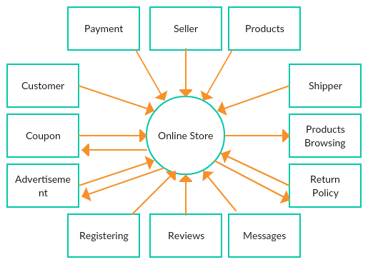

## Project Perspective

The project an "Online store" will be developed completely independent and dynamic website. Customer must have an account to purchase the product. The application saves all the information in the database that can be retrieved whenever needed and all the validations are performed during the entry of the data by the user thus ensuring that the user cannot enter any wrong data which could cause problem later.

## Project Roles

There are four actors in the application.

Admin: It is a super user who has all the rights of viewing, adding and manipulating any data in the system.

Customer: A customer can view products, add them to cart, make payments, review products and can also track his order.

Shipper: It is a third party service provider which collects item from seller and shipped it to customer.

PayPal: A third party online payments system that supports online money transfers from one party to another.

## Project Features

MyShop is a marketplace where we make shopping easy by allowing shoppers access to millions of products from hundreds of products and thousands of name brands with the use of our shopping cart and for customers whether he/she wants to buy a stuff from a big brand or from a local shop in his locality he/she can browse or buy through the platform.

Shop smarter with the help of price comparison, best deals and discount coupon. Find great products with help of advanced navigation system and search options. Browse the products, view photos or images of the products, along with information about the product specifications, features and prices. An online store that offers you great deals on electronics and its accessories.

## DFD diagram

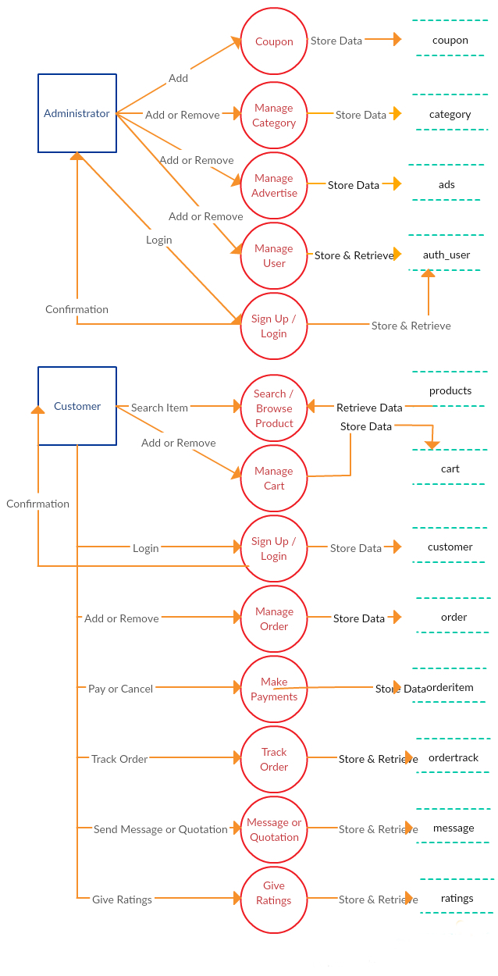

## Project Assumptions and Dependencies

* The details related to the product, customer, payment and service transaction provided.
* Administrator is already created in the system.
* Roles and tasks are predefined.

# Functional Requirements

## Features Descriptions

* Online registration for buyer

Buyers can register online for free by filling an online form available on website. Once registered, buyers are able to buy products.

* Recommendation engine

While shopping online recommendation system will suggest customers about a product which they might want to buy so it’s a win win condition for both buyer and seller.

* Language translation

A customer can switch language between English and Urdu according to their needs to get better understanding of the content.

* Online payment methods

Customer can pay online with their credit cards or any third party online payments system.

* Cash on delivery (COD)

If customer wants to pay for the product when delivered the option for that is also available.

* Sending message or quotation to seller

If customer want to contact vendor personally he can do that by sending message to the vendor via website.

* Products Advertisement on Website

Vendors can advertise their product on website and can attract more customers.

* Advance navigation and search function

Customers can search their desire products on search bar and the application will search entire site and return desire product if available.

* Responsive design for all devices

Mobile-first, responsive design for all devices mobile, tablet, desktop PC etc.

* Special offers and coupons

By applying coupons customer can get further more discount on purchased product

## Use Case Diagrams

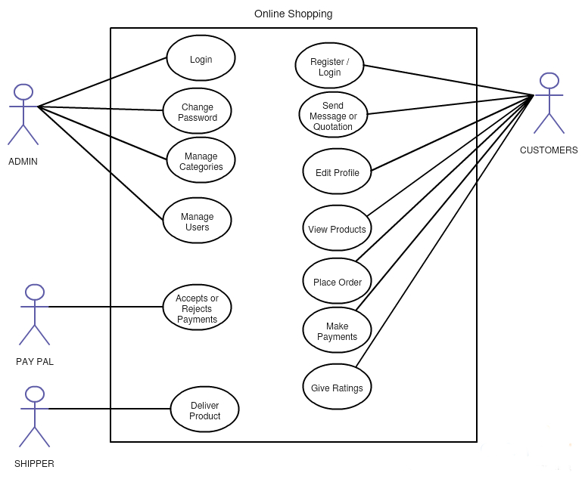

## Use Case Descriptions

|  |  |
| --- | --- |
| Use Case | Login |
| Description | This use case is about how the admin will be login in the online store. |
| Actors | Admin |
| Preconditions | Super user already created. |
| steps | 1. Enter URL in URL bar.  2. Enter user name and password. |
| Post Conditions | Authentication successful and admin logged in successfully. |
| Non functional | System should respond within 5 seconds. |
| Issues |  |

|  |  |
| --- | --- |
| Use Case | Change Password |
| Description | This use case is about how the admin will change password. |
| Actors | Admin |
| Preconditions | Admin already logged in. |
| steps | 1. Click change password link.  2. Enter current password.  3. Enter new password.  4. Enter confirm new password. |
| Post Conditions | Current password is correct. New and confirm new password matched. |
| Non functional | System should respond within 5 seconds. |
| Issues |  |

|  |  |
| --- | --- |
| Use Case | Manage Categories |
| Description | This use case will describe how admin can create, read, update and delete categories. |
| Actors | Admin |
| Preconditions | Admin already logged in. Admin have all the rights. |
| steps | 1. Add new category.  2. Edit existing category.  3. Remove categories. View all categories. |
| Post Conditions | Task perform correctly as directed. |
| Non functional | System should respond within 5 seconds. |
| Issues |  |

|  |  |
| --- | --- |
| Use Case | Manage Users |
| Description | This use case is about how admin can create, read, update and delete users. |
| Actors | Admin |
| Preconditions | Admin already logged in. Admin have all the rights. |
| steps | 1. Add new user.  2. Edit existing user.  3. Remove users. View all users. |
| Post Conditions | Task perform correctly as directed. |
| Non functional | System should respond within 5 seconds. |
| Issues |  |

|  |  |
| --- | --- |
| Use Case | Register / Login |
| Description | This use case is about how the customer will be register or login in the online store. |
| Actors | Customer |
| Preconditions | For Login: Customer already created.  For Register: Customer not already created. |
| steps | 1. Customer should click login or sign up.  2. He / She should fill his details and then proceed. |
| Post Conditions | For Login: Authentication successful and customer logged in successfully.  For Register: Same customer should not exist in the database. |
| Non functional | System should respond within 5 seconds. |
| Issues |  |

|  |  |
| --- | --- |
| Use Case | Send Message or Quotation |
| Description | This use case is about how the customer can send message or quotation to seller. |
| Actors | Customer |
| Preconditions | Customer already logged in. |
| steps | 1. Select seller to contact.  2. Write message and send. |
| Post Conditions | Message or quotation sent successfully to seller. |
| Non functional | System should respond within 5 seconds. |
| Issues |  |

|  |  |
| --- | --- |
| Use Case | Edit Profile |
| Description | This use case is about how the customer will change his profile information. |
| Actors | Customer |
| Preconditions | Customer already logged in. |
| steps | 1. Change first name, last name, password, address, postal code or city.  2. Proceed and review the changed information. |
| Post Conditions | All fields are filled correctly and profile info changed successfully. |
| Non functional | System should respond within 5 seconds. |
| Issues |  |

|  |  |
| --- | --- |
| Use Case | View Products |
| Description | This use case is about how the customer will view products in online store. |
| Actors | Customer |
| Preconditions | Working Internet connection. |
| steps | 1. Search product.  2. Browse product. |
| Post Conditions | Searched or browsed product is available. |
| Non functional | System should respond within 5 seconds. |
| Issues |  |

|  |  |
| --- | --- |
| Use Case | Place Order |
| Description | This use case is about how the customer can place order in online store. |
| Actors | Customer |
| Preconditions | Product stock is available. |
| steps | 1. Add to cart.  2. View cart.  3. Edit cart. |
| Post Conditions | Order placed successfully. |
| Non functional | System should respond within 5 seconds. |
| Issues |  |

|  |  |
| --- | --- |
| Use Case | Make Payments |
| Description | This use case defines how customer should make payments in online store. |
| Actors | Customer |
| Preconditions | Fill all the credit details in PayPal form and proceed. |
| steps | 1. Review your purchase.  2. Choose to pay with PayPal.  3. Confirm your payment. |
| Post Conditions | Payment successful. |
| Non functional | System should respond within 5 seconds. |
| Issues |  |

|  |  |
| --- | --- |
| Use Case | Give Ratings |
| Description | This use case describe how customer can give ratings to different products. |
| Actors | Customer |
| Preconditions | Customer already logged in. |
| steps | 1. Select desire product.  2. Give ratings between 1 to 5. |
| Post Conditions | Ratings saved successfully. |
| Non functional | System should respond within 5 seconds. |
| Issues |  |

|  |  |
| --- | --- |
| Use Case | Deliver Products |
| Description | This use case describe how shipper shipped products. |
| Actors | Shipper |
| Preconditions | Slot should be available for new order. |
| steps | 1. Receive order from seller.  2. Generate tracking ID.  3. Transfer the order to destination place.  4. Give product to customer . |
| Post Conditions | Customer should be available to receive order. |
| Non functional | Products should be shipped within 4 working days. |
| Issues |  |

|  |  |
| --- | --- |
| Use Case | Accepts or Rejects Payments |
| Description | This use case describe how PayPal receives or rejects payments. |
| Actors | PayPal |
| Preconditions | Customer should have an account on PayPal. |
| steps | 1. Receive request.  2. Authenticate and validate.  3. Check if balance is available.  4. Add service charges amount on transaction.  5. Transfer amount to another party. |
| Post Conditions | All the financial conditions should be met. |
| Non functional | System should respond within 10 seconds. |
| Issues |  |

## Activity Diagrams

ADMIN

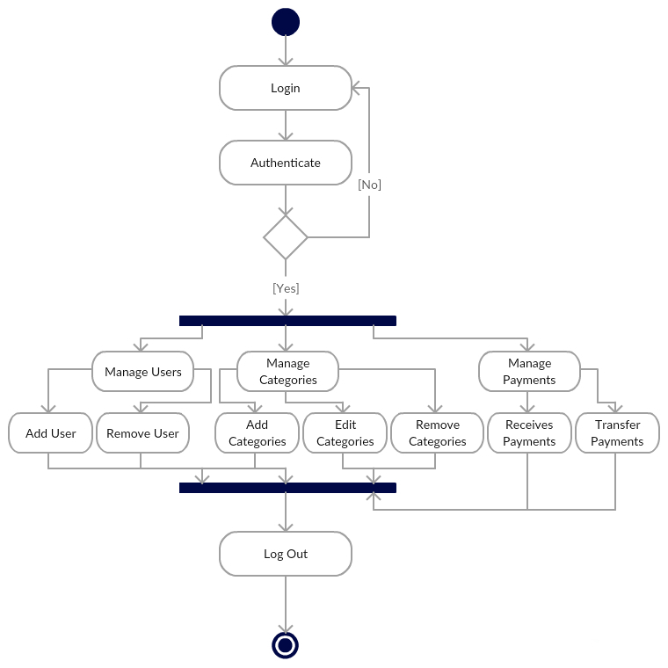

CUSTOMER

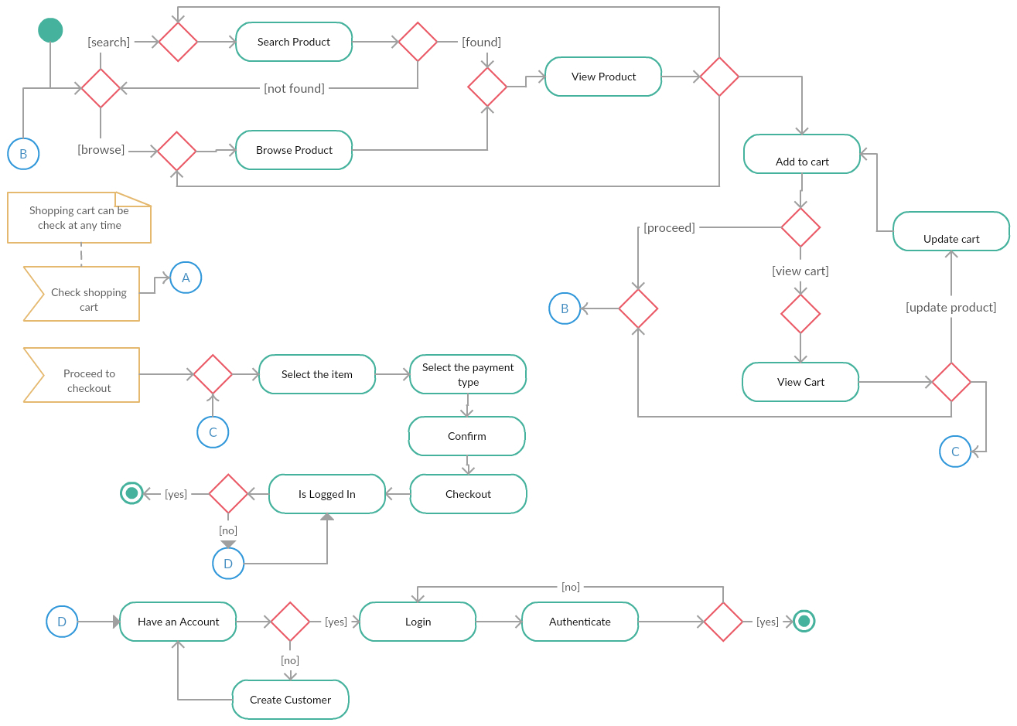

SHIPPER

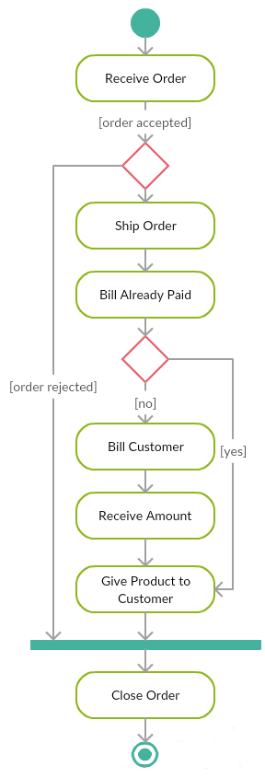

RECOMMENDATION ENGINE

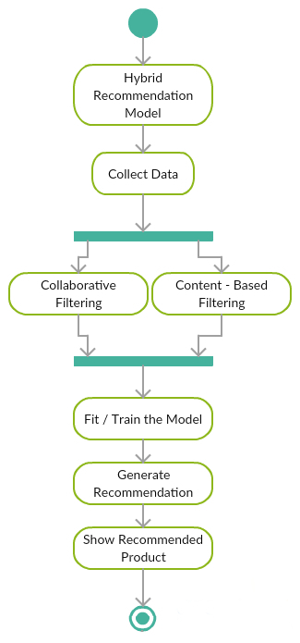

## ERD

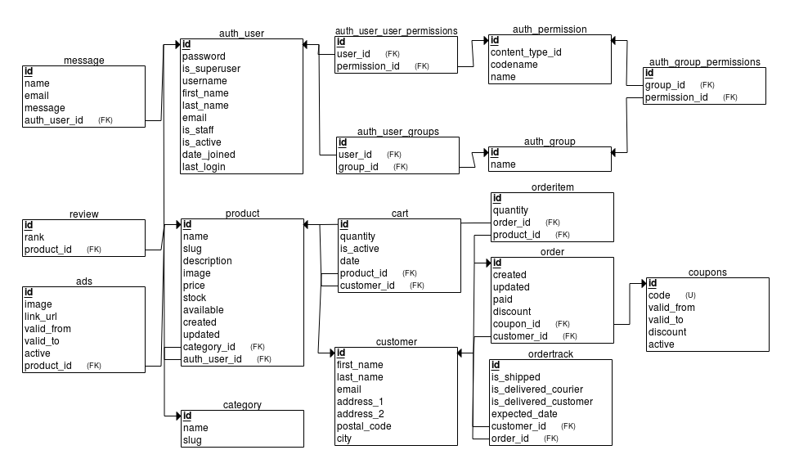

# Non-Functional Requirements

## Performance Requirements

1. You will be sign in within 5 sec.
2. If customer make new account, then he will receive confirmation email within 6 minutes.
3. Search results shown within 15 sec.
4. Credit cart validate within 10 sec.
5. Web support 200 customers logged at the same time.

## Reliability

1. The project is built on top python best framework Django which is built and maintained by a large community of developers who make sure to make it fast, secure and reliable.

## Security

1. Application will make payments through PayPal to protect against fraud.
2. It will keep the information of the customers and seller safe.
3. The application protects against all security threats like SQL injection, Cross-Site Scripting (XSS), Cross-Site Request Forgery (CSRF), Clickjacking, Denial of Service (DoS), etc.
4. It will also protect against command injection attacks allow a malicious user to execute arbitrary system commands on the host operating system. By sanitizing user input before it might be used in system calls.

# System Specifications

## User Interfaces

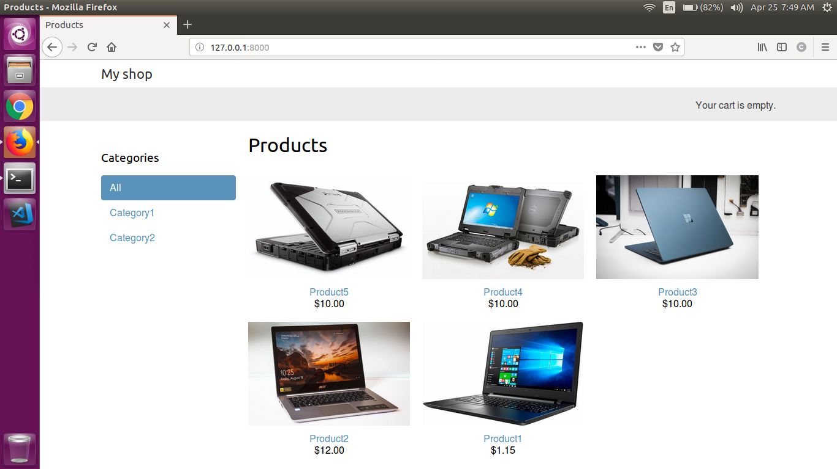

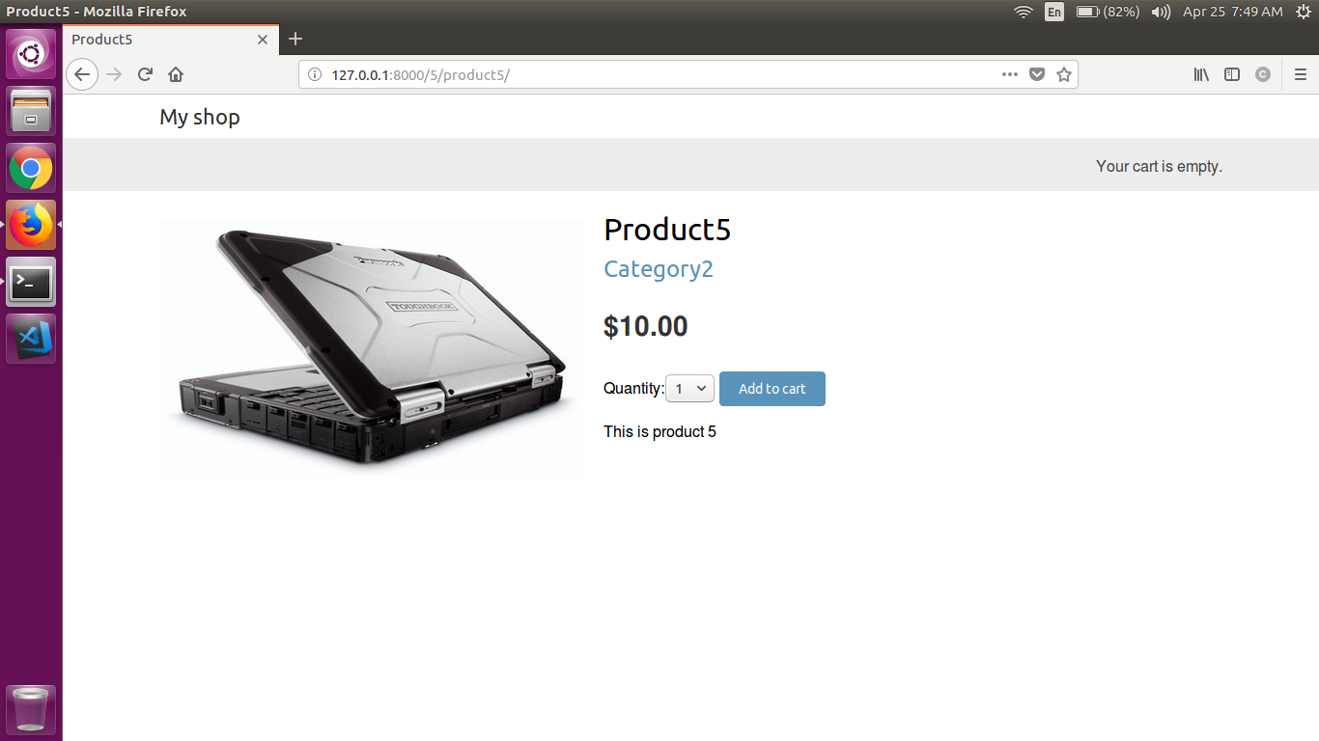

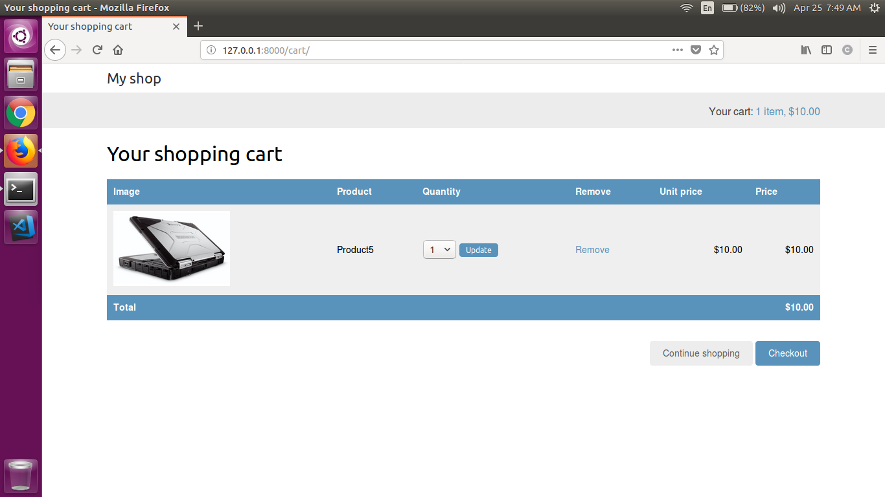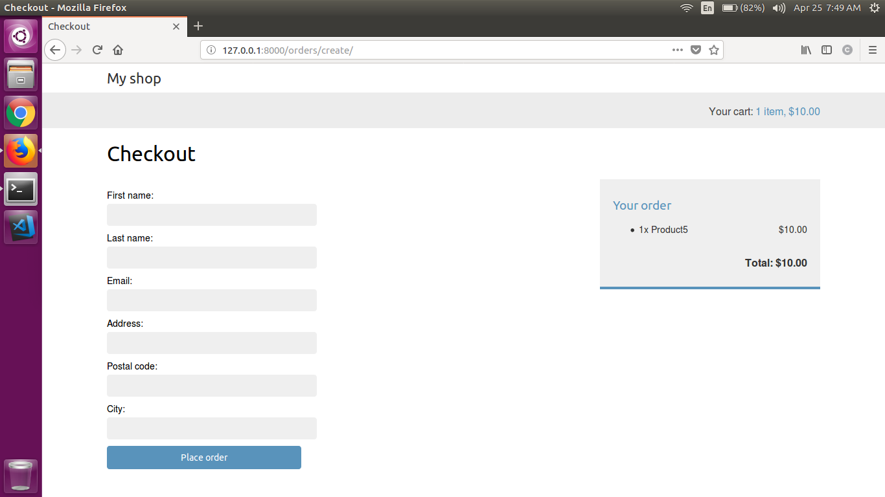

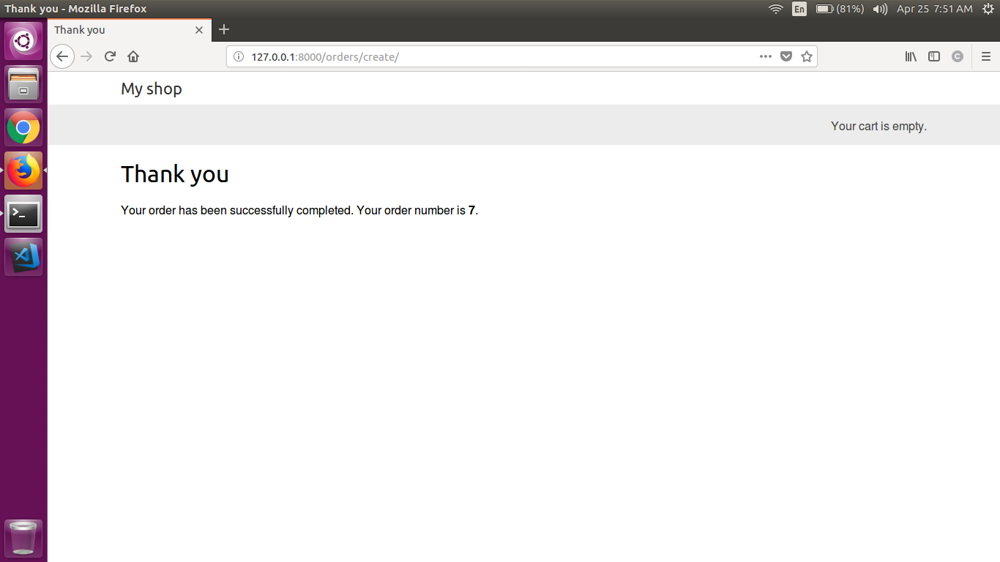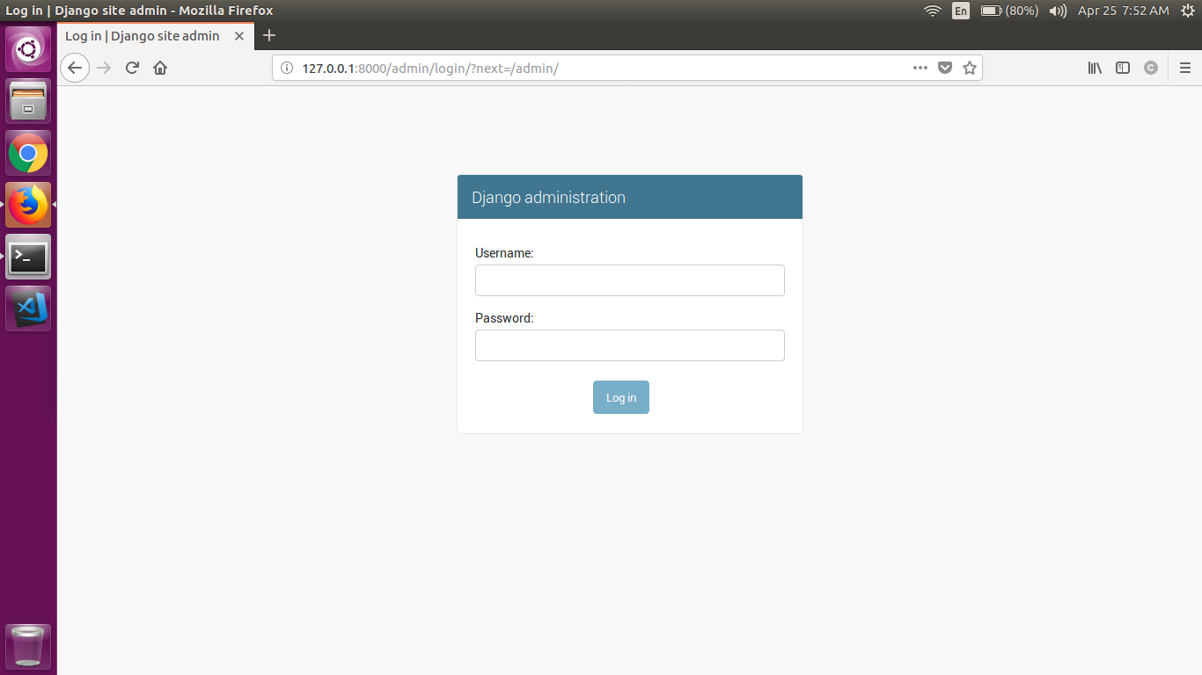

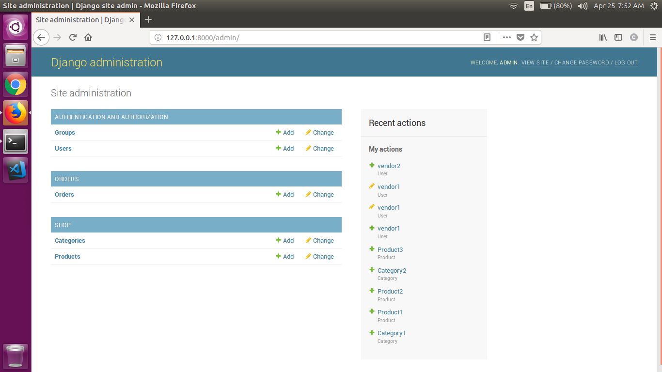

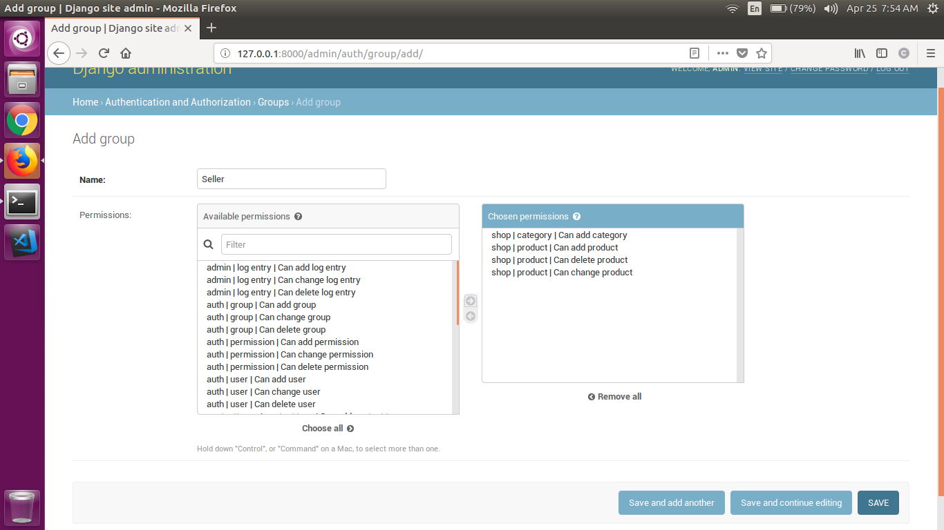

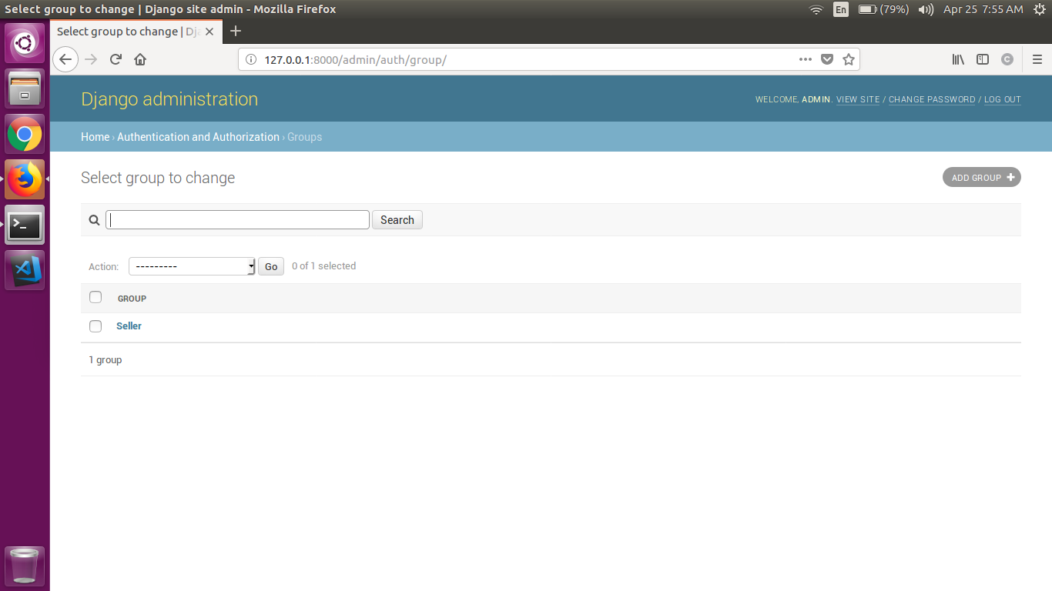

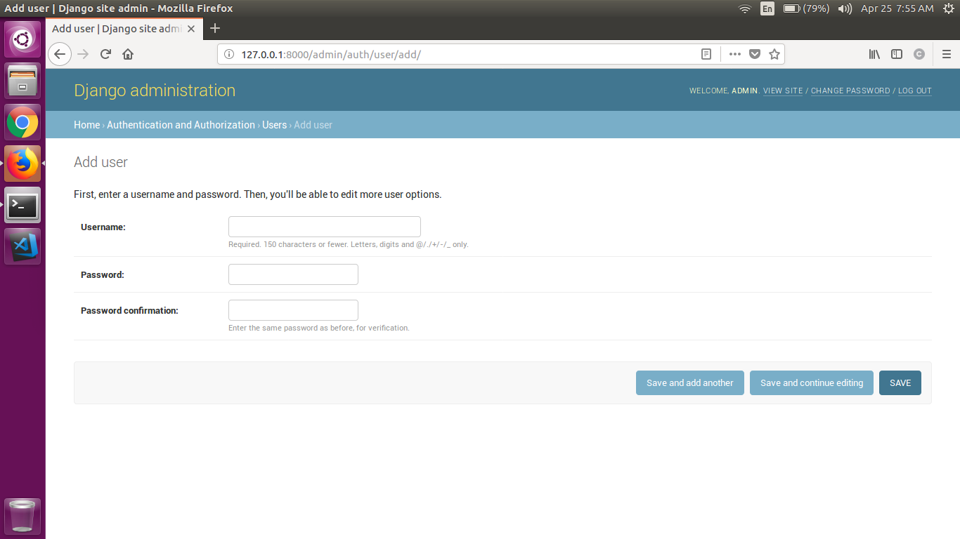

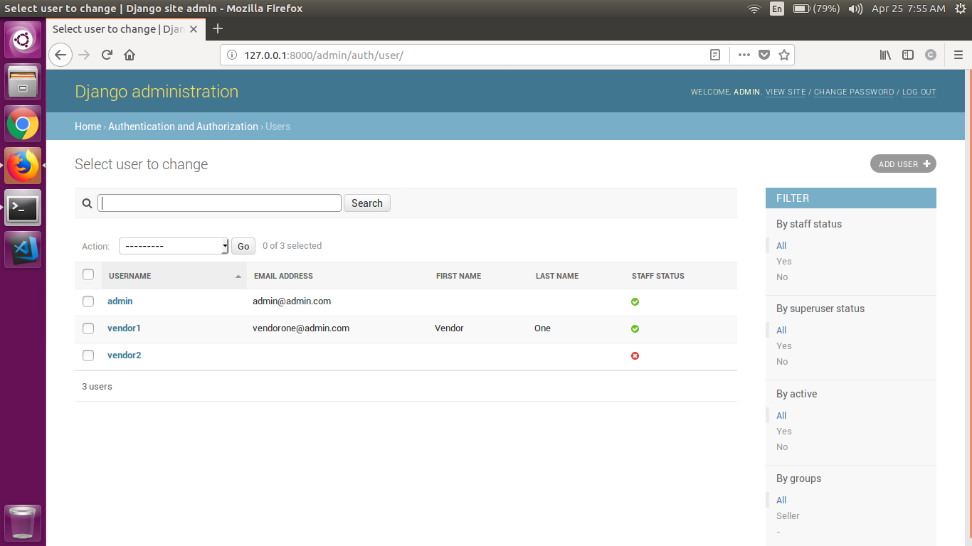

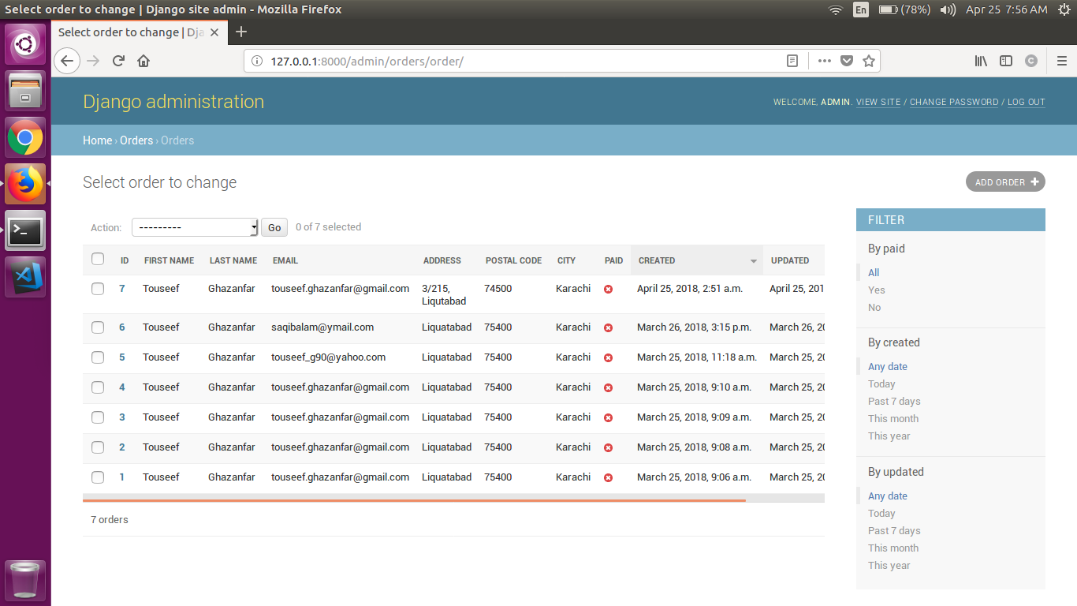

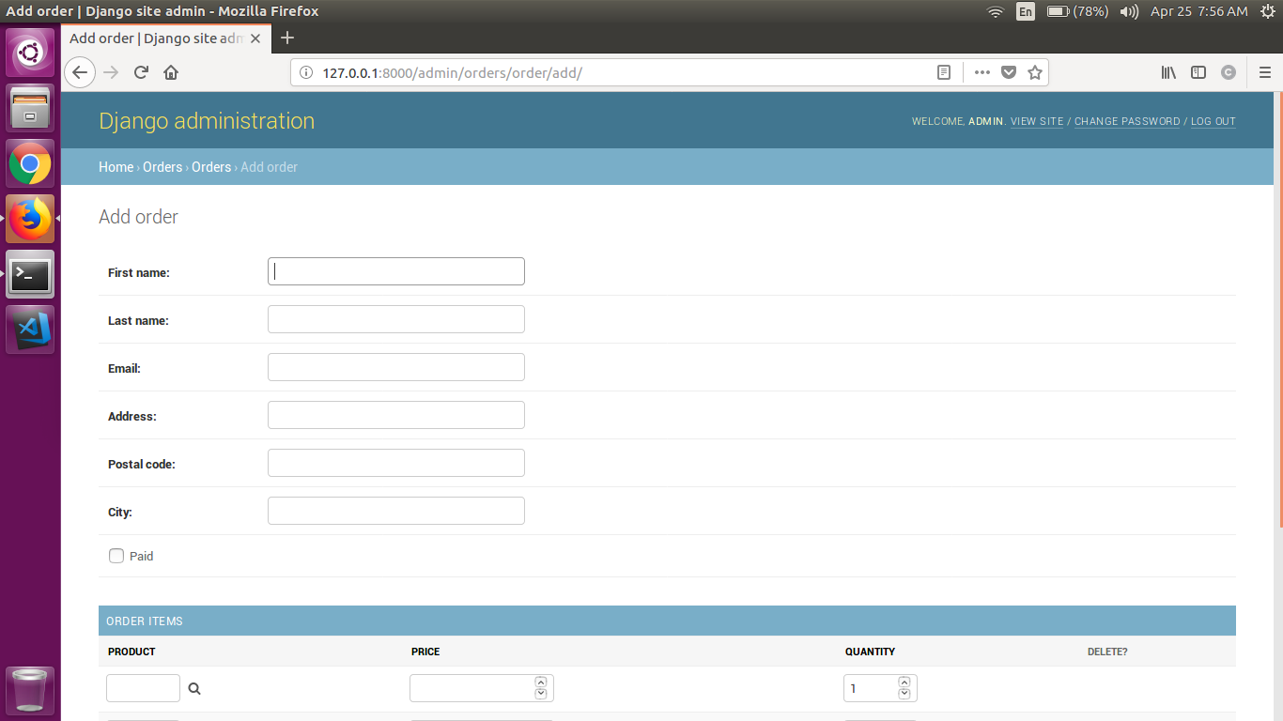

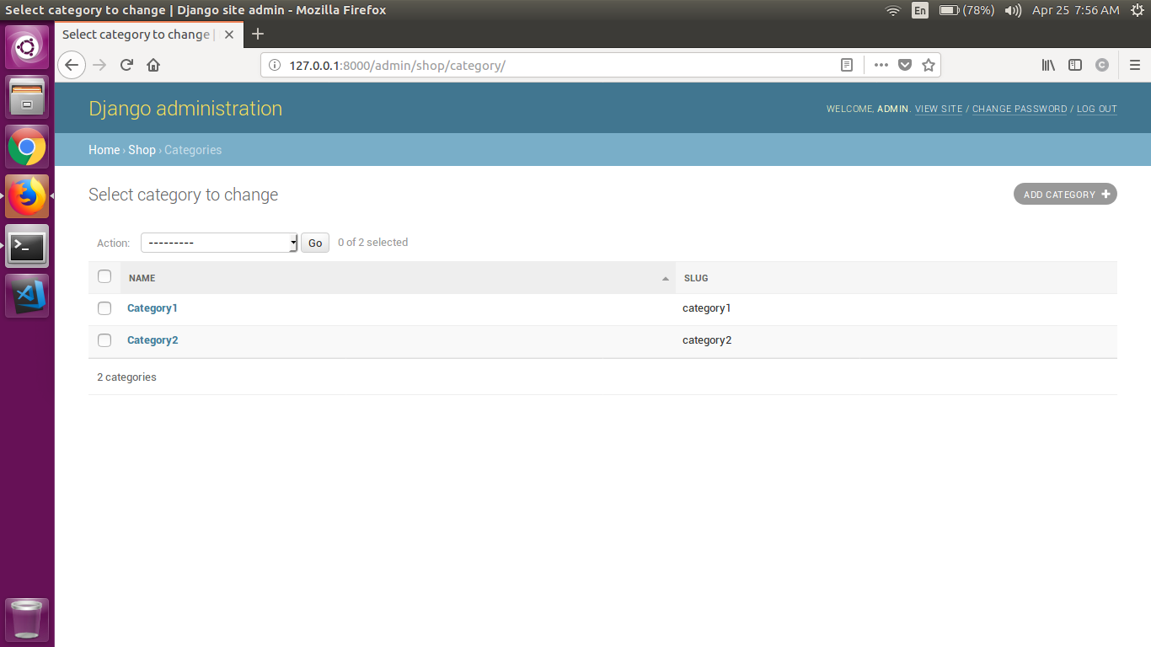

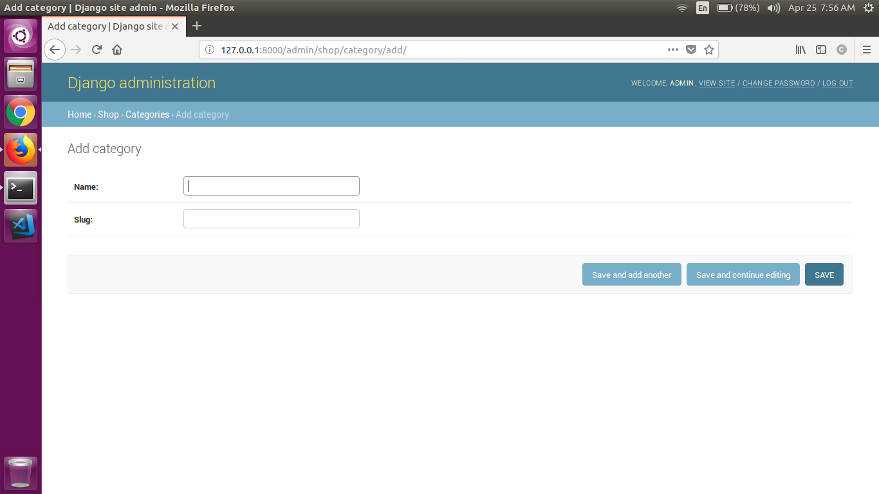

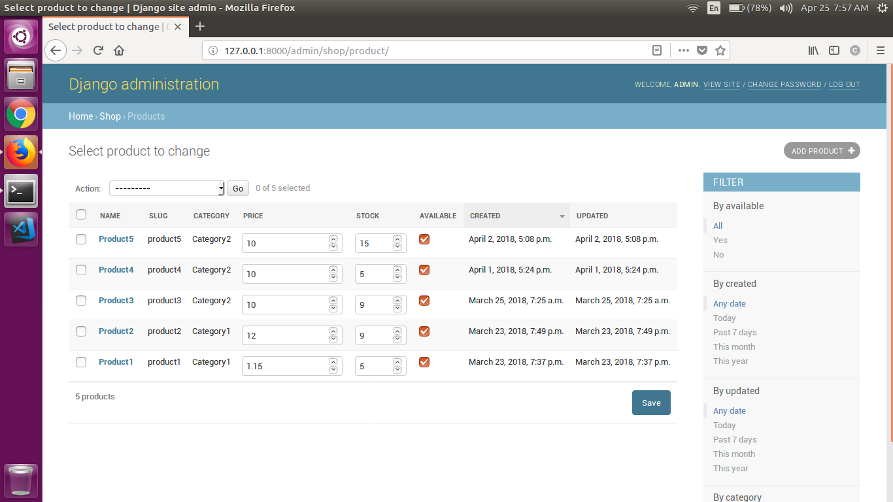

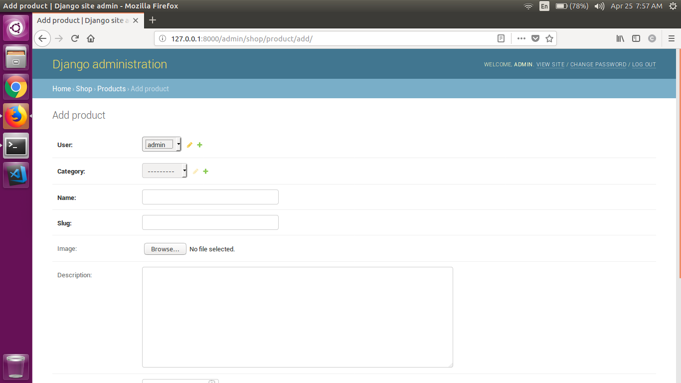

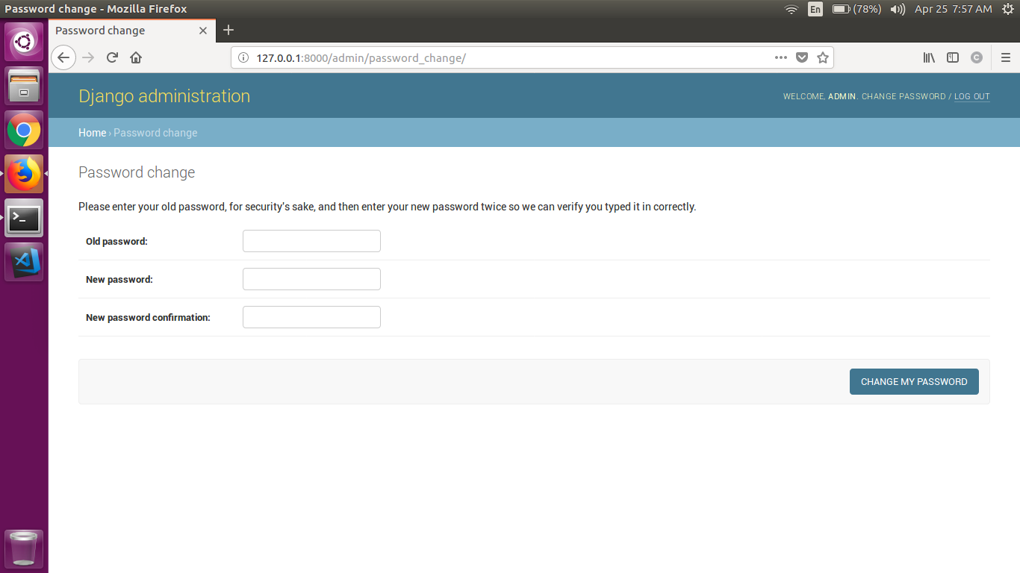

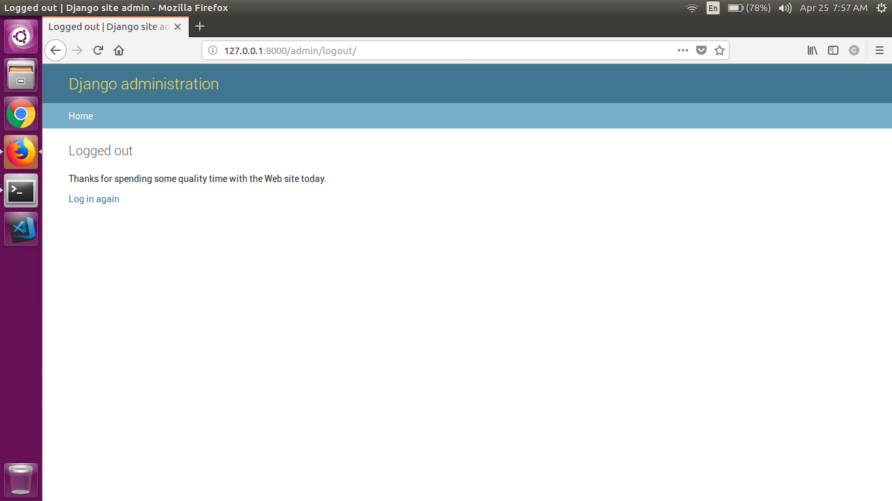

## Hardware Interfaces

1. Computer.

## Software Interfaces

1. Python
2. Django Framework
3. PyCharm IDE

## Design Constraints

## Ubuntu (OS)

1. Network (Localhost, IP address: 127.0.0.1, Port: 8000)

# Future Enhancements

1. A product should be deliver in different chunks to avoid custom duty.
2. After making 10 purchases or making a purchase of amount greater than $5,000. A customer should be eligible for coupon.
3. Coupon can be of specific category.
4. Order is lock for specific time after which it gets cancel automatically.
5. If both sellers enter a same category simultaneously then the system should be able to handle such kind of scenarios.

# Appendix

**ADMIN**: Admin is a person who have all the rights to perform any task in the system.

**ADVERTISEMENT**: Advertisement an announcement in a public medium promoting a product.

**CART**: A virtual online shopping cart in which holds the information of purchases.

**COUPON**: Coupon is a ticket or document that can be redeemed for a financial discount.

**CUSTOMER**: Customer is a person who buys goods or services from a shop or business.

**FRAMEWORK**: Framework or web application framework is a software framework that is designed to support the development of web applications.

**NETWORK**: A computer network, or data network, is a digital telecommunications network which allows nodes to share resources.

**PayPal**: PayPal Holdings, Inc. is an American company operating a worldwide online payments system that supports online money transfers and serves as an electronic alternative to traditional paper methods like checks and money orders.

**PYTHON**: Python is an interpreted high-level programming language.

**PyCharm**: An Integrated Development Environment used in computer programming, specifically for the Python language.

**QUOTATION**: A request for quotation is a standard business process whose purpose is to invite suppliers into a bidding process to bid on specific products or services.

**RECOMMENDATION**: It is a suggestion or proposal as to the best course of action.

**SELLER**: A person who sells something.

**SHIPPER**: A person or company that transports or receives goods by sea, land, or air.

**UBUNTU**: Ubuntu is an open source operating system for computers. It is a Linux distribution based on the Debian architecture.