RAAFIA

AL & ML

ASSIGNMENT

DTAE: 30 JULY 2024

mkdir command is used to create new directory

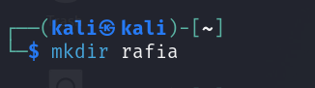

Cd command is used to go back to the main directory

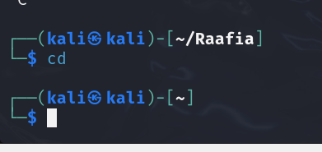

Cd <directoryname> … you will go to the directory <directory name>

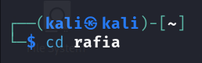

Pwd command is used to display the current working directory

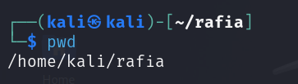

CTRL+C is used to terminate the command (if we got stuck at some command )

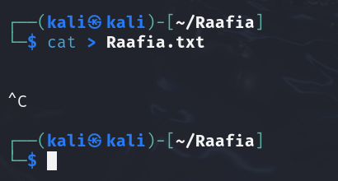

Date command is used to show today’s date , date and time

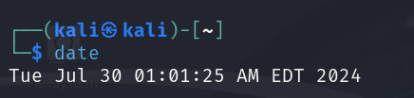

rmdir is used to remove the directory

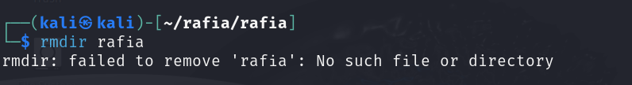

To remove a directory , first take your self out of the directory by using cd command . only 1 directory back from the required deleted directory.

You cant delete a directory if you are using it .

You cant delete a directory if it is not empty.

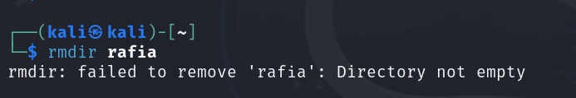

By passing all these steps you can remove the directory successfully

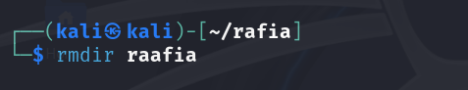

rm <filename> is used to remove the file in the directory

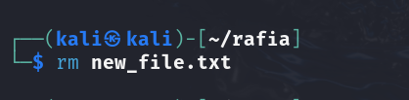

rm -rf \*/ is used to remove all directories in the current directory

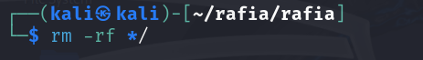

ls -l command is used to show all the contents in the current directory.

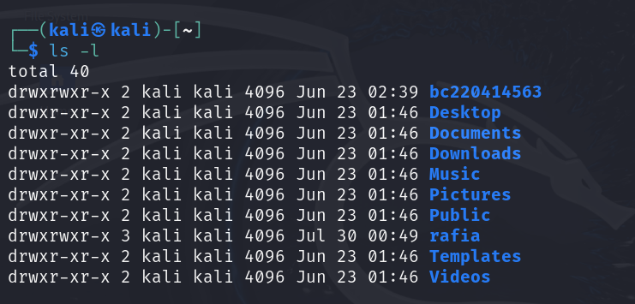

Clear command is used to clear all the commands in the linux terminal .

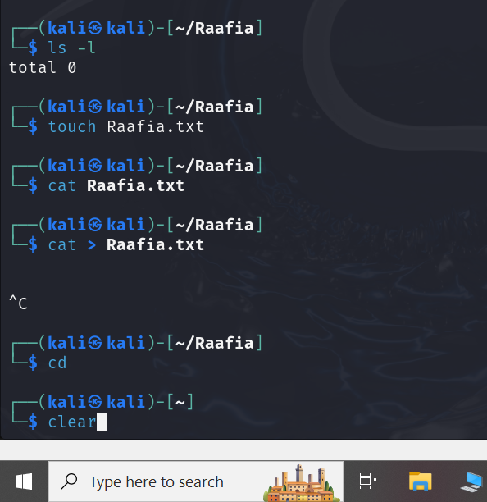

Output:

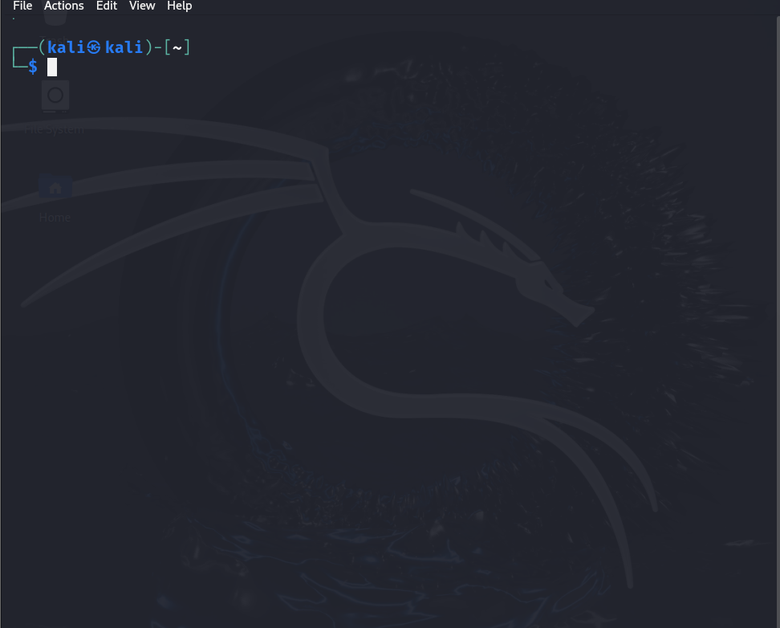

Writing of right command is shown by having blue color on the text of the command.

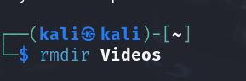

If command is not blue it means there must be a mistake in writing a command

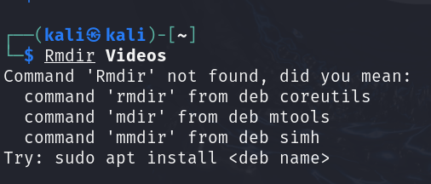

If command with true file name is written then file name will get bold.

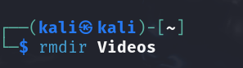

If file name will not get bold it means there must be an issue with that filename.

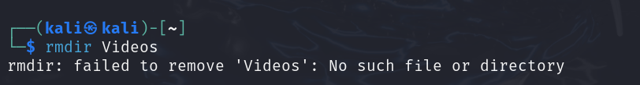

Touch <filename> command is used to create a new file in the current directory.

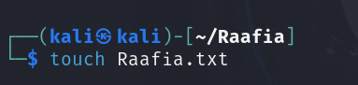

Cat <filename> command is used to read the contents of a file

First we have created some content of the file Raafia.txt by using echo command

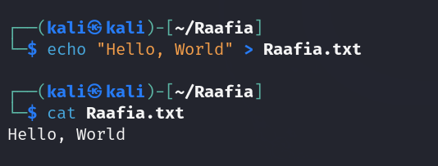

Ifconfig

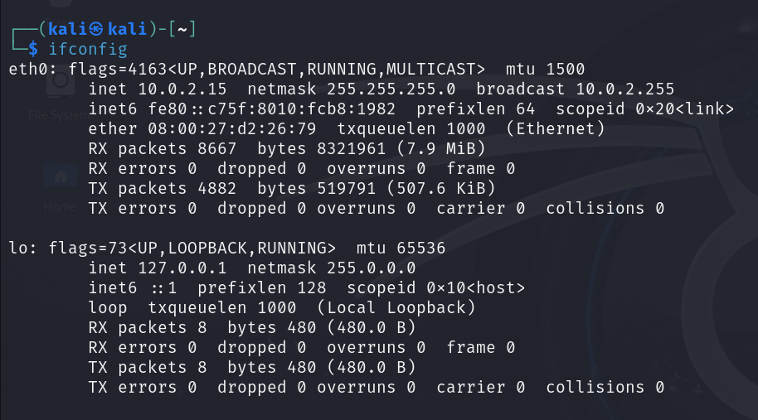

Echo

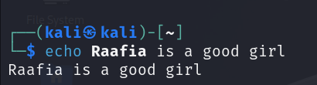

Time

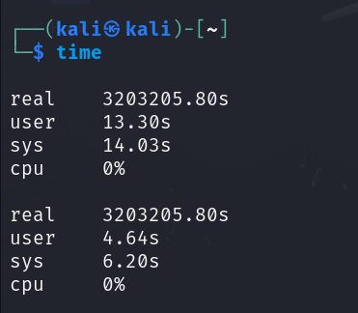

History

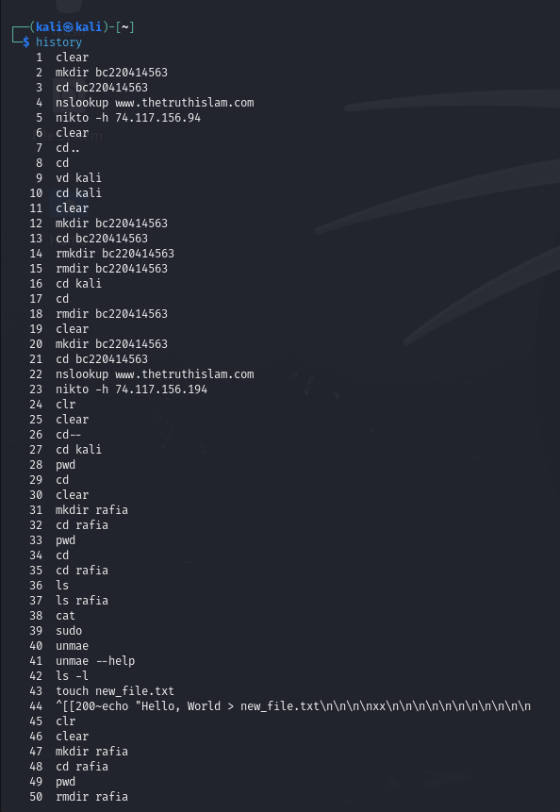

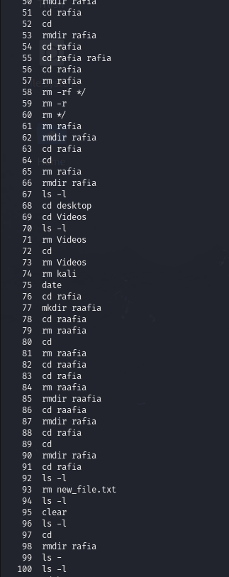

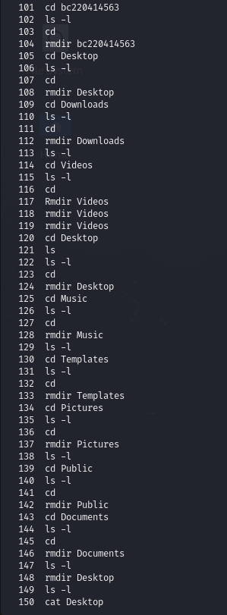

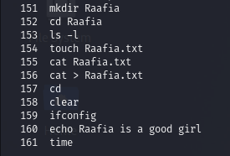

Ls -x

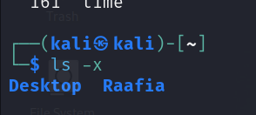

Ls -z

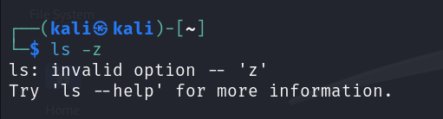

Ls –help

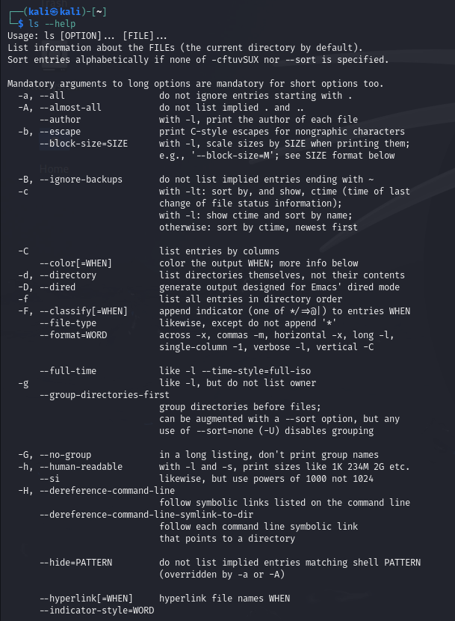

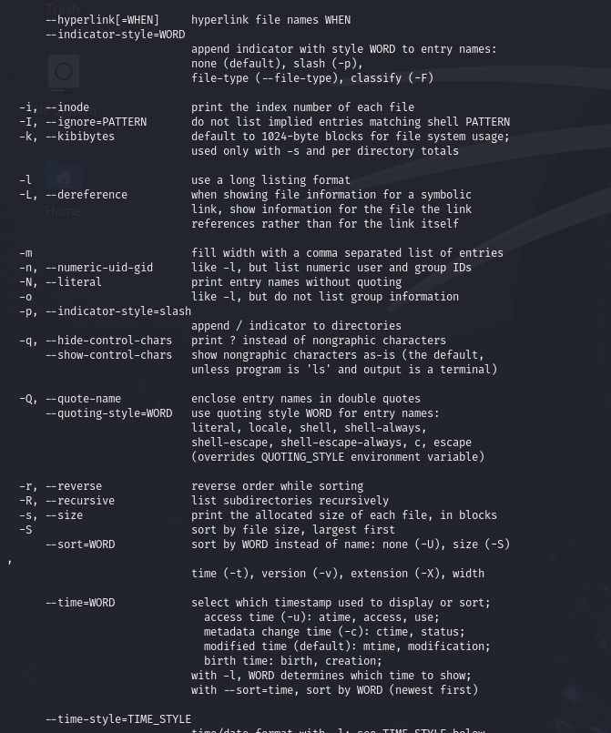

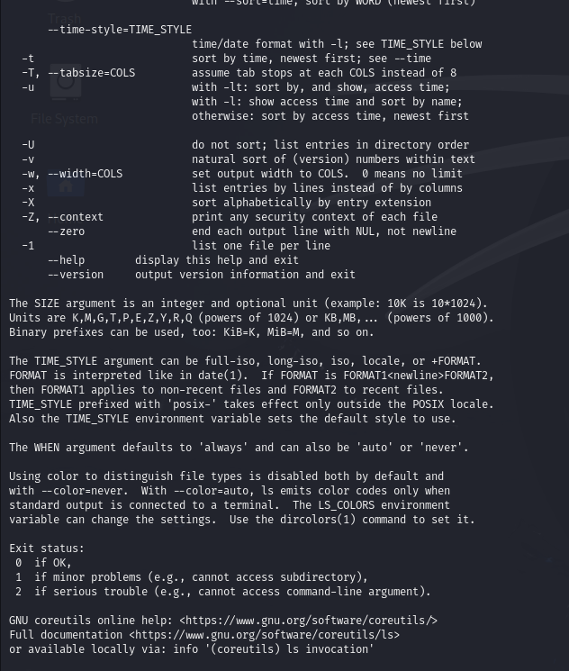

Ls -r



Ls /home/

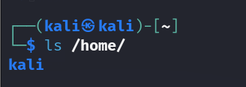

Sudo apt update

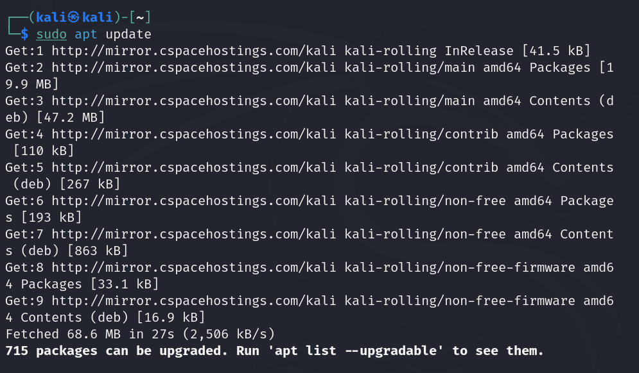

Uname

