**Experiment name: Random Access Memory(RAM)**

**Determine the amount of RAM:**

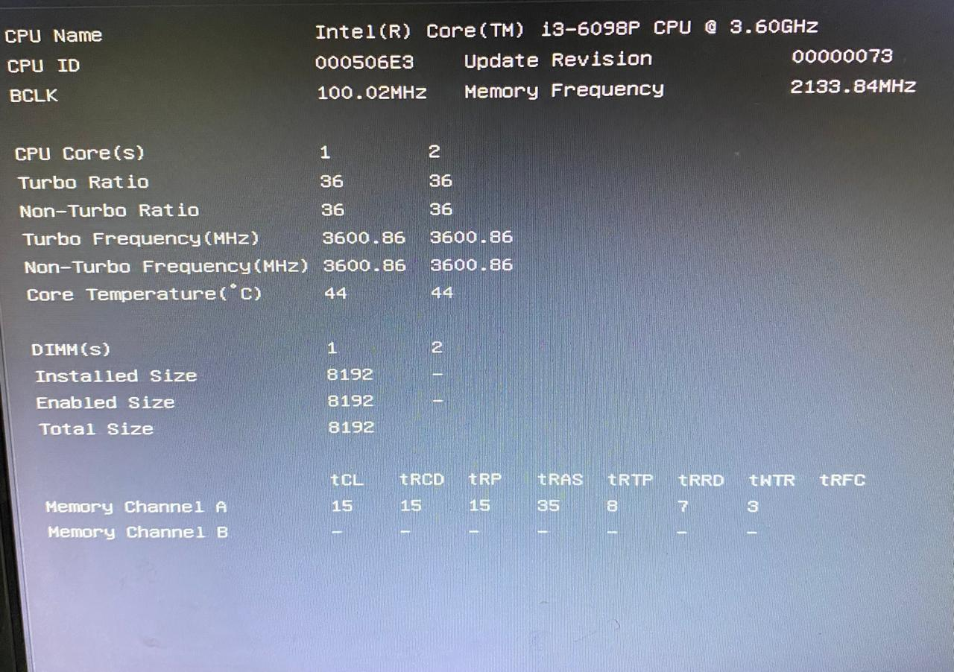

To determine the amount of RAM in my PC, I checked the system’s BIOS information screen, which displayed that a total of **8192 MB (8 GB) of RAM** is installed. It shows that **one DIMM slot is occupied with an 8 GB module**, while the second slot is empty. The memory operates at a frequency of **2133.84 MHz** and uses specific timing configurations such as **CAS Latency (tCL) of 15**, along with other values like **tRCD, tRP, and tRAS**. I have also verified this information from the operating system’s system information section, confirming that **32 GB of physical memory is available on another system configuration**.

**Figure: Device Specification section**

The device name is **DESKTOP-AU13K3B**, is equipped with an **Intel(R) Core(TM) i3-6098P CPU running at 3.60GHz**, a dual-core processor designed for basic computing tasks. It has **8.00 GB of installed RAM,** providing sufficient memory for everyday productivity like web browsing, office work, and light multitasking. The system runs on a **64-bit operating system with an x64-based processor architecture**, offering modern compatibility and performance benefits. Unique **Device and Product IDs** are assigned for activation and support purposes. It lacks **pen and touch input** capability, confirming it is not a touchscreen device. Additionally, the system is **monitored and protected by Windows Security**, ensuring basic system protection, with a convenient option to copy these details for troubleshooting or support. Overall, this setup is suitable for general tasks but may face limitations when handling demanding applications or multitasking at a higher level.

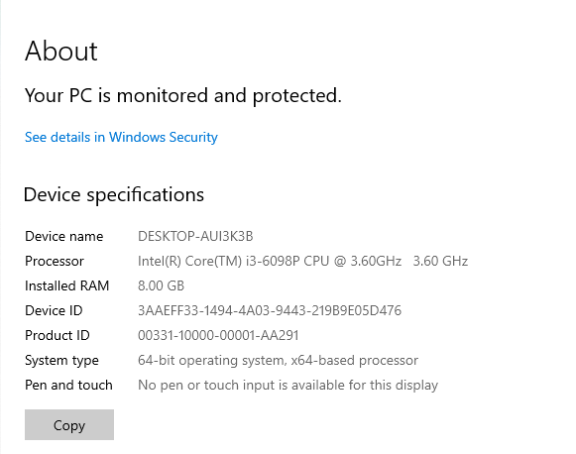

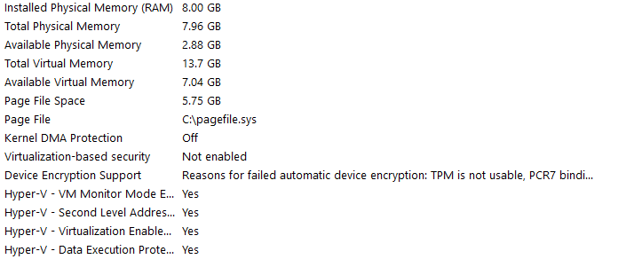

**Figure: The system information section**

This panel provides a detailed overview of the system's memory usage, virtual memory setup, and security configurations. The **physical memory (RAM)** totals **8.00 GB**, with **7.96 GB usable** and only **2.88 GB currently available**, indicating heavy memory usage and potential multitasking strain. **Virtual memory** supplements physical RAM, with a total of **13.7 GB** combining RAM and a **5.75 GB page file** located at C:\pagefile.sys, of which **7.04 GB remains available**. On the security side, **Kernel DMA Protection is turned off,** exposing the system to potential direct memory access attacks through ports like Thunderbolt. **Virtualization-based Security (VBS)** is also disabled, preventing advanced memory protections, while **device encryption is unsupported** due to issues with the Trusted Platform Module (TPM) and secure boot misconfiguration (PCR7 binding error). However, **Hyper-V virtualization features are fully enabled**, allowing the use of virtual machines at the possible cost of gaming or real-time performance.

**Identifying the type of RAM:**

* **Type:** DDR4 (Double Data Rate 4).
* **Capacity:** 8GB (single or dual module, depending on motherboard slots — from system info, total available is 7.96GB).
* **Speed:** Typically **DDR4-2133 to DDR4-3200** for 6th generation Intel processors.
* **Timings:** Common for DDR4-2133 would be around **CL15-15-15-36.**
* **Voltage:** **1.2V** (standard for DDR4).
* **Pins:** **288-pin DIMM** (standard size for desktop DDR4 modules).

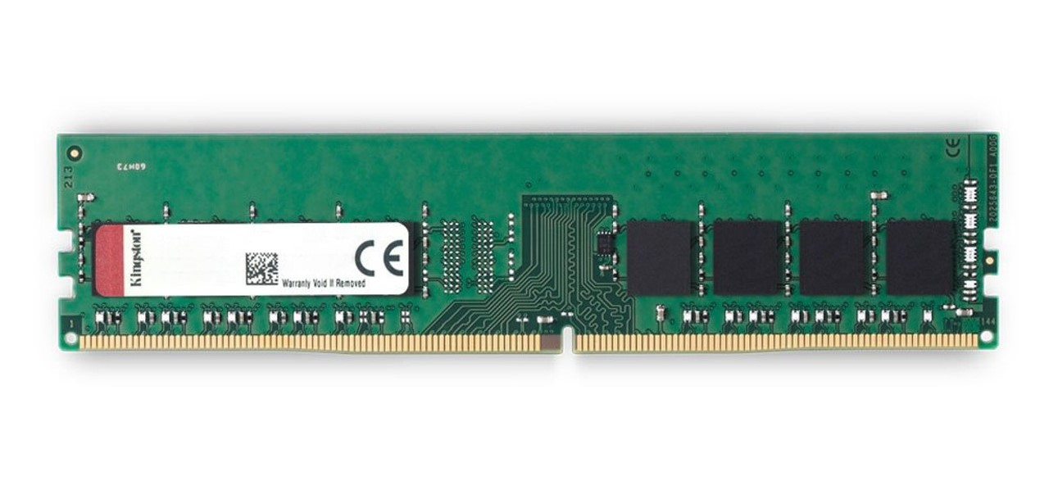

**Removing and Installing RAM:**

1. **Get your workspace ready** by clearing the area and ensuring it’s free of anything like plastic or paper that might cause static. For added safety, consider wearing an anti-static wrist strap.

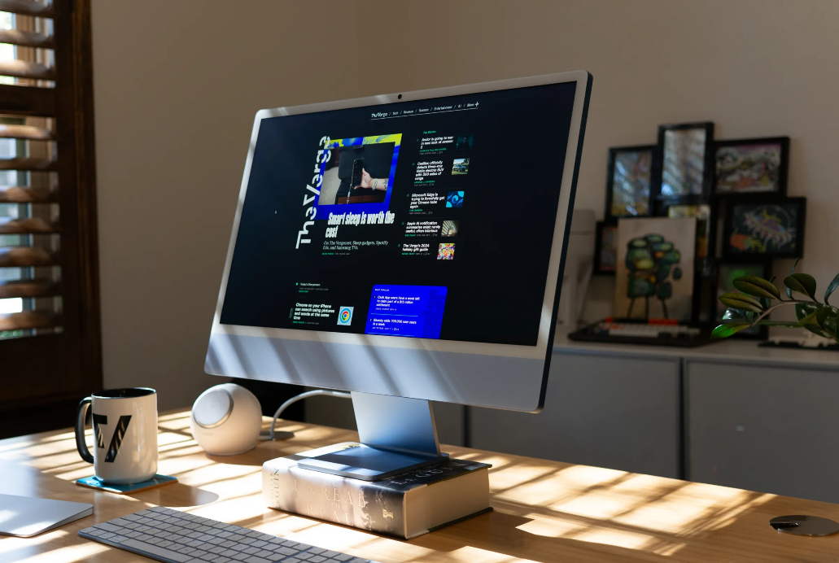

1. **Turn off your desktop computer** completely. There’s no need to back up files — your storage drive keeps them safe, not the RAM.

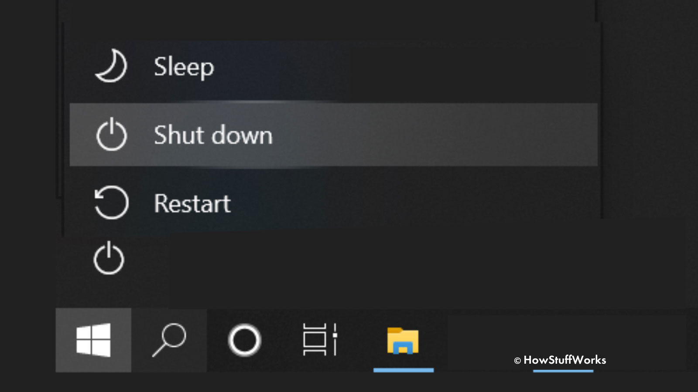

1. **Unplug the computer’s power cable** along with any connected accessories to prevent electrical hazards.

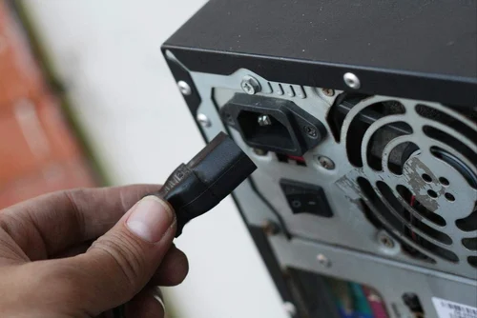

1. **Hold the power button for about 5 seconds** to discharge any remaining electricity in the system.
2. **Open your computer case** carefully by following the instructions in your system’s manual. Taking photos of the layout as you go can help with reassembly.

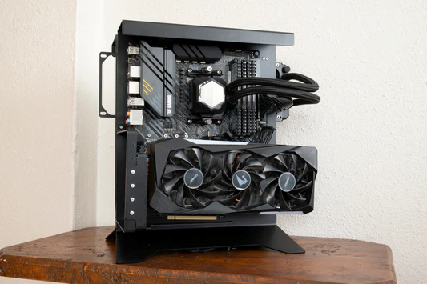

1. **Touch an unpainted metal part** of the case to ground yourself and prevent static from damaging sensitive components.
2. **Remove the old memory modules** by pushing down on the clips beside each one. The module will pop up, allowing you to gently pull it out.

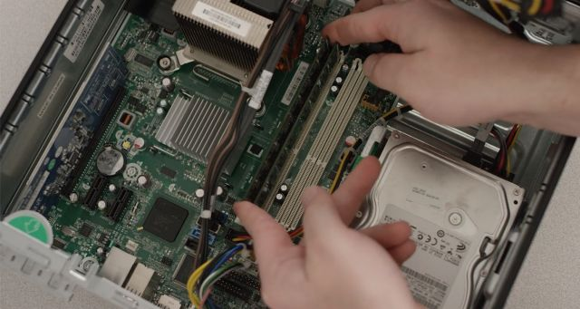

1. **Install your new RAM sticks** by holding them at the edges, lining up the notch with the slot’s ridge, and pressing down firmly until they snap into place.

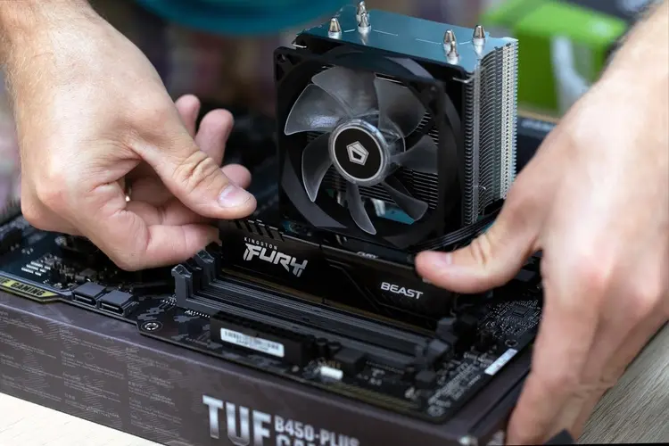

1. **Close up the computer case** and use your earlier photos to reconnect everything correctly.
2. **Reconnect the power cable** and turn your computer back on to complete the installation.

**Exploring RAM specifications with CPU-Z:**

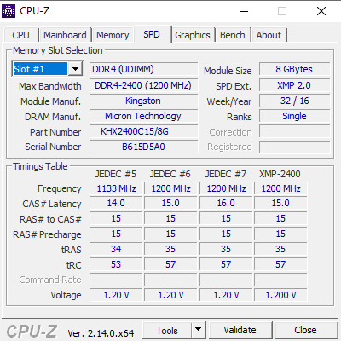

1. **Type**: DDR4 UDIMM (Unbuffered DIMM, typical for desktops/laptops)
2. **Capacity**: 8GB (single module)
3. **Manufacturer**: Kingston (module brand) / Micron (DRAM chips)
4. **Model**: KHX2400C15/8G
5. **Serial Number**: B615D5A0
6. **Production Date**: Week 32 of 2016
7. **XMP Support**: XMP 2.0 (for easy overclocking)

This computer currently uses a single 8GB RAM stick, which means it’s running in single-channel mode. By adding another identical 8GB stick, the system can switch to dual-channel mode, improving memory performance by around 15%. The installed RAM is a bit older, manufactured in 2016, and operates at a DDR4-2400 speed, which is slower compared to newer DDR4-3200 or faster modules available today. However, it supports XMP 2.0, a feature in the BIOS that allows users to easily enable its full rated speed of 2400 MHz with a simple setting, making the most of its performance.