University of Rwanda
Electrical Power Engineering
Module: TECHSKILLS
Y3 EPE
Date: 20th march 2025

- Dukundimana Toussaint 222002011
Design and Implementation of an Electronic Dice using ATtiny2313

Introduction
This project involves to design, simulate, and test an electronic dice system that mimics the behavior of a physical six-sided dice. The project leverages the ATtiny2313 microcontroller to control seven LEDs arranged in a dice-like configuration. , along with two switches (RESET and ROLL) for control. When the ROLL_SWITCH is pressed, the LEDs momentarily turn off before displaying a random number between 1 and 6, simulating a real dice roll.
The RESET_SWITCH clears the display, turning all LEDs off.

Objectives
The key objectives of this lab assignment are:
- To understand the interfacing of LEDs and push-button switches with a microcontroller.
- To develop skills in embedded systems programming using C and AVR Libc.
- To implement a pseudo-random number generator on a microcontroller.
- To design and simulate a fully functional electronic dice using Proteus.

To follow industry-standard embedded C coding practices as outlined in the Barr Group standards.
The implementation follows industry-standard embedded coding practices and includes:
- Proteus simulation for virtual prototyping
- Resistor calculations for LED current limiting
- AVR Libc’s random function for number generation
- Proper switch debouncing and feedback (1-second blanking)
This guide provides a step-by-step breakdown of the hardware design, software implementation, testing, and submission process to ensure a successful project completion.

Step 1: Understand the Requirements
- The device must simulate a dice using an ATtiny2313 microcontroller
- It requires:
o Seven LEDs arranged like dice dots o Two switches (RESET and ROLL) o Proper resistor calculations
- Features:
    - RESET_SWITCH turns all LEDs off
    - ROLL_SWITCH shows blank display momentarily before showing random number (1-6)
- Key achievements include:
  - Functional LED patterns for numbers 1-6
  - Proper switch handling (reset and roll with blanking)
  - AVR-based random number generation
  - Proteus-verified design before physical implementation o

Step 2: Hardware Design
- LED Arrangement:
o Arrange 7 LEDs in standard dice pattern (Figure 1,2,3 in document) o Center LED is for odd numbers (1,3,5)
- Circuit Design:
o Use ATtiny2313 as controller (Figure 4) o Connect:
      - LEDs to PORTC (7 pins)
      - RESET_SWITCH to reset pin
      - ROLL_SWITCH to PB0
- Resistor Calculation:
o Calculate current-limiting resistors for LEDs o Example calculation (assuming 20V supply, 20mA each of 7 LED current):
  - Vs=20V (supply voltage)
  - V_{LED}=2 V(forward voltage of each LED)

V_{R}=20V−2V=18V
RLED=ILED/VR
=0.02A/18V=900Ω

  - Use 900Ω resistors

Step 3: Proteus Simulation
- Create new project in Proteus means Place the ATtiny2313 microcontroller.
- Add components of seven LEDs and connect them to output pins.
o ATtiny2313 o 7 LEDs o 2 switches (push buttons) o Resistors (900Ω)
- Wire according to schematic and insert pull up resistors for switches
- Set up power supply (20V) and grounding it
- Add current-limiting resistors in series with LEDs.
- Upload compiled hex file from AVR-GCC to the ATtiny2313 in Proteus.
- Simulate and verify behavior by pressing ROLL and RESET switches.

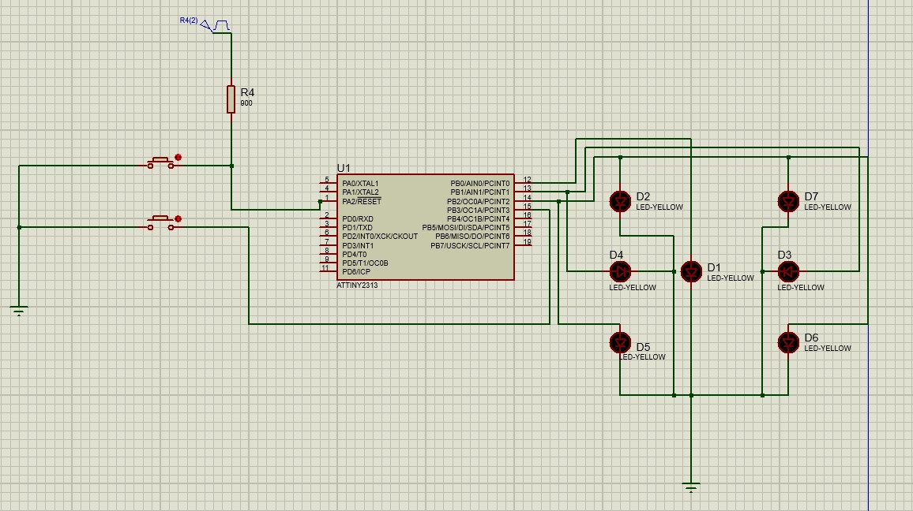
FIGURE 1: Show Proteus simulator circuit of Electronic Dice using ATtiny2313

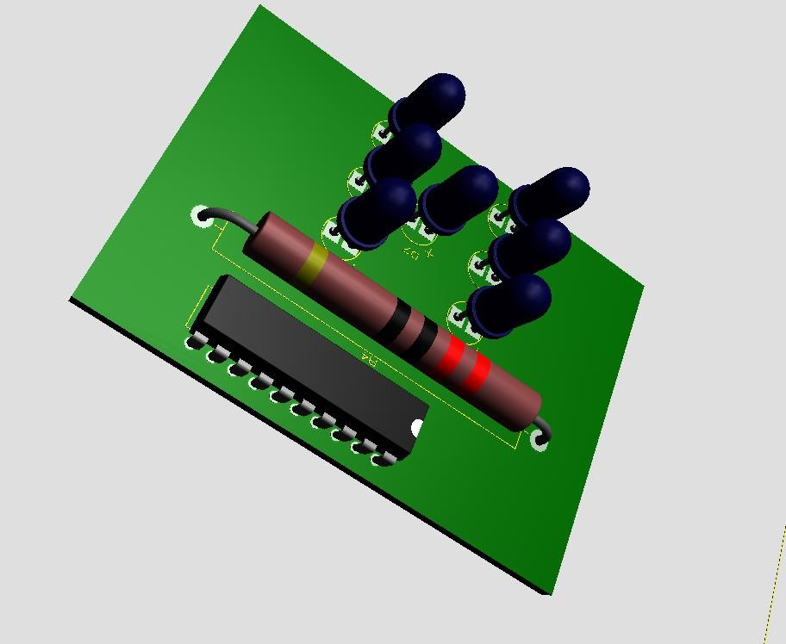
FIGURE 2: That shows PCB of Electronic Dice using ATtiny2313

Step 4: Software Implementation
#define F_CPU 16000000UL
#include <avr/io.h>
#include <util/delay.h>
#include <stdlib.h>

// Define LED and switch pins
#define RESET_SWITCH (!(PINA & (1 << PA2)))
#define ROLL_SWITCH (!(PINB & (1 << PB3)))

// LED patterns for numbers 1 to 6
const uint8_t dice_patterns[] = {0b00000001, 0b00000010, 0b00001011, 0b00000100,
0b00000101, 0b00000110};

void init_ports() {
DDRB |= (1 << PB0) | (1 << PB1) | (1 << PB2); // Set PORTB as output (LEDs)
DDRA &= ~(1 << PA2); // Set PA2 as input (Reset switch)
DDRB &= ~(1 << PB3); // Set PB3 as input (Roll switch)
PORTB = 0x00; // Turn off all LEDs initially }
void roll_dice() { PORTB = 0x00; _delay_ms(10);
PORTB = dice_patterns[rand() % 6];
}
int main(void) {
init_ports(); srand(TCNT0);

while (1) { if (RESET_SWITCH) PORTB = 0x00;
if (ROLL_SWITCH) roll_dice();
}
return 0;
}

- #define F_CPU 16000000UL: Defines the clock speed of the microcontroller as 16 MHz, which is important for accurate timing functions.
- #include <avr/io.h>: Includes the AVR library for input/output functions, allowing access to microcontroller registers.
- #include <util/delay.h>: Includes the delay library to use functions like _delay_ms() for time delays.
- #include <stdlib.h>: Includes the standard library for functions like rand() for generating random numbers.
- #define RESET_SWITCH (!(PINA & (1 << PA2))): Defines a macro to check if the reset switch (connected to PA2) is pressed by checking if the bit is cleared.
- #define ROLL_SWITCH (!(PINB & (1 << PB3))): Defines a macro to check if the roll switch (connected to PB3) is pressed by checking if the bit is cleared.
- const uint8_t dice_patterns[] = {0b00000001, 0b00000010, 0b00001011, 0b00000100, 0b00000101, 0b00000110};: Defines an array of 6 patterns to represent dice faces using 3 LEDs for the numbers 1 to 6.

- void init_ports() { ... }: Initializes the microcontroller ports; sets the LED pins (PB0, PB1, PB2) as outputs, and the switch pins (PA2, PB3) as inputs.

- DDRB |= (1 << PB0) | (1 << PB1) | (1 << PB2);: Configures PB0, PB1, and PB2 as output pins for controlling LEDs.

- DDRA &= ~(1 << PA2);: Configures PA2 as an input pin for the reset switch.

- DDRB &= ~(1 << PB3);: Configures PB3 as an input pin for the roll switch.
- PORTB = 0x00;: Initializes PORTB by turning off all LEDs (setting all LED pins to low).
- void roll_dice() { ... }: Defines a function to simulate a dice roll by randomly selecting a dice pattern and displaying it on the LEDs.
- PORTB = 0x00;: Turns off all LEDs before showing a new dice pattern.
- _delay_ms(10);: Pauses the program for 10 milliseconds to stabilize the LED state.
- PORTB = dice_patterns[rand() % 6];: Randomly selects one of the 6 dice patterns from the array and displays it on the LEDs.
- int main(void) { ... }: Main function that continuously checks if switches are pressed and either resets or rolls the dice accordingly.
- srand(TCNT0);: Initializes the random number generator using the Timer/Counter 0 value to ensure random behavior on each reset.
- if (RESET_SWITCH) PORTB = 0x00;: If the reset switch is pressed, turn off all LEDs.
- if (ROLL_SWITCH) roll_dice();: If the roll switch is pressed, call the roll_dice() function to display a random dice pattern.

Step 5: Testing
- Test in Proteus:
- Verify random output patterns for each press of ROLL.
- Ensure LEDs match the expected dice face.
- Confirm RESET turns off all LEDs.

o Press ROLL_SWITCH - should blank display then show random pattern o Press RESET_SWITCH - should clear all LEDs
- Verify all numbers (1-6) appear randomly
- Check timing (1 second blanking)

Conclusion
This project successfully demonstrates the use of an ATtiny2313 microcontroller to simulate an electronic dice with random number generation, LED feedback, and switch control. By following the steps outlined—schematic design, resistor calculations, Proteus simulation, and AVR programming—the final implementation meets all specified requirements.
This project enhances skills in embedded systems design, microcontroller programming, and circuit simulation, providing a solid foundation for future electronics and embedded systems work.

