Analyses
Response variables:
- New_nests_os: number of new osmia nests for each trapnest and date combination.
- New_nests_meg: number of new megachile nests for each trapnest and date combination.
- Prop_filled: proportion of the straw filled with cells, used as a measure of investment into a nest.
Predictor variables:
- Available_cavities_prior: number of available cavities that could have had a new nest built between visits.
- Osmia_ps_prior: number of existing osmia in each trapnest per date, including pseudo nests.
- Osmia_no_ps_prior: number of existing osmia in each trapnest per date, excluding pseudo nests.
- Meg_ps_prior: number of existing megachile in each trapnest per date, including pseudo nests.
- Meg_no_ps_prior: number of existing megachile in each trapnest per date, excluding pseudo nests.
- Par_in_trapnest: number of parasites present in the trapnest when I log new bee nests (Bee_choice).
Additional variables:
- Good_days: number of days between visits with good enough weather for bee activity.
- Day_of_year: the day of the year, a stand in for date.
- Site: three sites in total.
- Subsite: six subsites for each site, unique to each site.
- Trapnest: 72 trapnests total, ach subsite contains three, unique to each subsite.

Nesting per Available Cavities
# MODEL 1
### New nests per available cavities Osmia ###
mod_choice_cav_os <- glmer(cbind(New_nests_os, Available_cavities_prior - New_nests_sum) ~ scale(Available_cavities_prior) + scale(Good_days) + poly(Day_of_year,2) + Site + (1|Subsite/Trapnest), data = nesting_os_xs, family = binomial(), control = glmerControl(optimizer = "bobyqa", optCtrl = list(maxfun = 1000000))) # ignore boudnary singular fit warning, means random effects don't account for much
boundary (singular) fit: see help('isSingular')
plot(simulateResiduals(mod_choice_cav_os)) # fine
DHARMa:testOutliers with type = binomial may have inflated Type I error rates for integer-valued distributions. To get a more exact result, it is recommended to re-run testOutliers with type = 'bootstrap'. See ?testOutliers for details
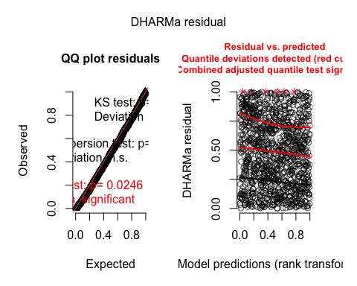
check_model(mod_choice_cav_os) # fine
testDispersion(mod_choice_cav_os, type = 'DHARMa') # good
DHARMa nonparametric dispersion test via sd of residuals fitted vs.
simulated
data: simulationOutput
dispersion = 0.98742, p-value = 0.768
alternative hypothesis: two.sided
testZeroInflation(mod_choice_cav_os) # good
DHARMa zero-inflation test via comparison to expected zeros with
simulation under H0 = fitted model
data: simulationOutput
ratioObsSim = 1.0396, p-value = 0.064
alternative hypothesis: two.sided
vif(mod_choice_cav_os) # good
GVIF Df GVIF^(1/(2*Df))
scale(Available_cavities_prior) 1.052882 1 1.026100
scale(Good_days) 1.063262 1 1.031146
poly(Day_of_year, 2) 1.661585 2 1.135352
Site 1.571018 2 1.119555
summary(mod_choice_cav_os) # Significant effect of good days, site, day of year
Generalized linear mixed model fit by maximum likelihood (Laplace
Approximation) [glmerMod]
Family: binomial ( logit )
Formula: cbind(New_nests_os, Available_cavities_prior - New_nests_sum) ~
scale(Available_cavities_prior) + scale(Good_days) + poly(Day_of_year,
2) + Site + (1 | Subsite/Trapnest)
Data: nesting_os_xs
Control: glmerControl(optimizer = "bobyqa", optCtrl = list(maxfun = 1e+06))
AIC BIC logLik deviance df.resid
962.1 1007.1 -472.0 944.1 1089
Scaled residuals:
Min 1Q Median 3Q Max
-1.1733 -0.3941 -0.2062 -0.0787 19.8231
Random effects:
Groups Name Variance Std.Dev.
Trapnest:Subsite (Intercept) 0.9578 0.9787
Subsite (Intercept) 0.0000 0.0000
Number of obs: 1098, groups: Trapnest:Subsite, 72; Subsite, 24
Fixed effects:
Estimate Std. Error z value Pr(>|z|)
(Intercept) -4.8865 0.2931 -16.670 < 2e-16 ***
scale(Available_cavities_prior) -0.2619 0.1793 -1.461 0.1440
scale(Good_days) 0.3317 0.0807 4.110 3.96e-05 ***
poly(Day_of_year, 2)1 -42.0683 7.1993 -5.843 5.11e-09 ***
poly(Day_of_year, 2)2 -48.6395 5.6734 -8.573 < 2e-16 ***
SiteCP 1.5051 0.9843 1.529 0.1263
SiteNN -1.2269 0.3950 -3.106 0.0019 **
---
Signif. codes: 0 '***' 0.001 '**' 0.01 '*' 0.05 '.' 0.1 ' ' 1
Correlation of Fixed Effects:
(Intr) s(A__) sc(G_) p(D__,2)1 p(D__,2)2 SiteCP
scl(Avlb__) -0.009
scl(Gd_dys) -0.105 0.010
ply(D__,2)1 0.461 0.080 -0.053
ply(D__,2)2 0.494 -0.045 -0.195 0.742
SiteCP -0.493 -0.107 0.088 -0.546 -0.500
SiteNN -0.480 -0.117 -0.046 0.071 0.092 0.155
optimizer (bobyqa) convergence code: 0 (OK)
boundary (singular) fit: see help('isSingular')
ggpredict(mod_choice_cav_os, c('Available_cavities_prior')) %>% plot(rawdata = TRUE, jitter = .04)
Model contains splines or polynomial terms. Consider using
`terms="Available_cavities_prior [all]"` to get smooth plots. See also
package-vignette 'Marginal Effects at Specific Values'.
Could not compute variance-covariance matrix of predictions. No
confidence intervals are returned.
Raw data not available.
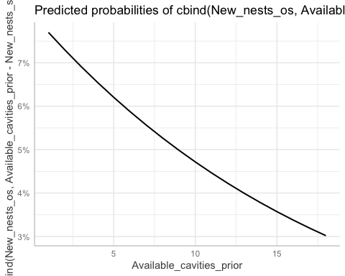
# MODEL 2
### New nests per available cavities Megachile ###
mod_choice_cav_meg <- glmer(cbind(New_nests_meg, Available_cavities_prior - New_nests_sum) ~ scale(Available_cavities_prior) + scale(Good_days) + poly(Day_of_year,2) + Site + (1|Subsite/Trapnest), data = nesting_meg_xs, family = binomial(), control = glmerControl(optimizer = "bobyqa", optCtrl = list(maxfun = 1000000)))
plot(simulateResiduals(mod_choice_cav_meg)) # fine
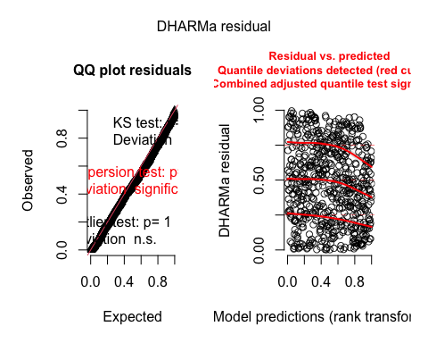
check_model(mod_choice_cav_meg) # fine
testDispersion(mod_choice_cav_meg, type = 'DHARMa') # fine
DHARMa nonparametric dispersion test via sd of residuals fitted vs.
simulated
data: simulationOutput
dispersion = 0.043829, p-value = 0.04
alternative hypothesis: two.sided
testZeroInflation(mod_choice_cav_meg) # good
DHARMa zero-inflation test via comparison to expected zeros with
simulation under H0 = fitted model
data: simulationOutput
ratioObsSim = 1.0575, p-value = 0.128
alternative hypothesis: two.sided
summary(mod_choice_cav_meg) # significant effect of site
Generalized linear mixed model fit by maximum likelihood (Laplace
Approximation) [glmerMod]
Family: binomial ( logit )
Formula: cbind(New_nests_meg, Available_cavities_prior - New_nests_sum) ~
scale(Available_cavities_prior) + scale(Good_days) + poly(Day_of_year,
2) + Site + (1 | Subsite/Trapnest)
Data: nesting_meg_xs
Control: glmerControl(optimizer = "bobyqa", optCtrl = list(maxfun = 1e+06))
AIC BIC logLik deviance df.resid
294.2 334.2 -138.1 276.2 621
Scaled residuals:
Min 1Q Median 3Q Max
-1.030 -0.088 -0.037 -0.014 4.277
Random effects:
Groups Name Variance Std.Dev.
Trapnest:Subsite (Intercept) 1.597e+01 3.9961979
Subsite (Intercept) 1.359e-07 0.0003686
Number of obs: 630, groups: Trapnest:Subsite, 72; Subsite, 24
Fixed effects:
Estimate Std. Error z value Pr(>|z|)
(Intercept) -6.84559 1.57788 -4.338 1.43e-05 ***
scale(Available_cavities_prior) 0.94173 0.83888 1.123 0.2616
scale(Good_days) 0.02879 0.14606 0.197 0.8438
poly(Day_of_year, 2)1 7.64936 6.29737 1.215 0.2245
poly(Day_of_year, 2)2 -2.33264 5.72424 -0.408 0.6836
SiteCP -3.91313 1.79581 -2.179 0.0293 *
SiteNN -2.88360 1.82366 -1.581 0.1138
---
Signif. codes: 0 '***' 0.001 '**' 0.01 '*' 0.05 '.' 0.1 ' ' 1
Correlation of Fixed Effects:
(Intr) s(A__) sc(G_) p(D__,2)1 p(D__,2)2 SiteCP
scl(Avlb__) -0.618
scl(Gd_dys) -0.046 0.048
ply(D__,2)1 -0.227 0.288 0.331
ply(D__,2)2 0.301 -0.452 -0.410 -0.580
SiteCP 0.102 -0.455 -0.073 -0.311 0.355
SiteNN -0.134 -0.149 0.014 0.012 0.069 0.260
vif(mod_choice_cav_meg)
GVIF Df GVIF^(1/(2*Df))
scale(Available_cavities_prior) 1.471433 1 1.213026
scale(Good_days) 1.262943 1 1.123807
poly(Day_of_year, 2) 1.686686 2 1.139616
Site 1.351690 2 1.078250
# Plot model
ggpredict(mod_choice_cav_meg, c('Available_cavities_prior')) %>% plot(rawdata = TRUE, jitter = .04)
Model contains splines or polynomial terms. Consider using
`terms="Available_cavities_prior [all]"` to get smooth plots. See also
package-vignette 'Marginal Effects at Specific Values'.
Could not compute variance-covariance matrix of predictions. No
confidence intervals are returned.
Raw data not available.
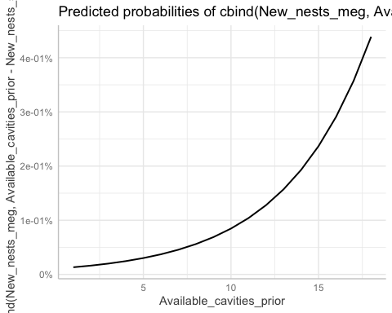

Nesting per Conspecific Presence
# MODEL 3
### New nests per conspecifics Osmia, with pseudo ###
mod_choice_consp_os_ps <- glmer(cbind(New_nests_os, Available_cavities_prior - New_nests_sum) ~ scale(Osmia_ps_prior) + scale(Good_days) + poly(Day_of_year,2) + Site + (1|Subsite/Trapnest), data = nesting_os_xs, family = binomial) # ignore boundary singular warning, means little to no influence of random effects
Warning in checkConv(attr(opt, "derivs"), opt$par, ctrl = control$checkConv, :
Model failed to converge with max|grad| = 0.0364542 (tol = 0.002, component 1)
plot(simulateResiduals(mod_choice_consp_os_ps)) # fine
DHARMa:testOutliers with type = binomial may have inflated Type I error rates for integer-valued distributions. To get a more exact result, it is recommended to re-run testOutliers with type = 'bootstrap'. See ?testOutliers for details
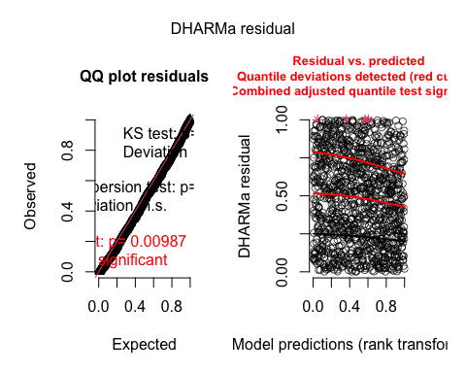
check_model(mod_choice_consp_os_ps) # fine
testDispersion(mod_choice_consp_os_ps, type = 'DHARMa') # good
DHARMa nonparametric dispersion test via sd of residuals fitted vs.
simulated
data: simulationOutput
dispersion = 0.99654, p-value = 0.736
alternative hypothesis: two.sided
testZeroInflation(mod_choice_consp_os_ps) # some zero-inflation, but not detrimental
DHARMa zero-inflation test via comparison to expected zeros with
simulation under H0 = fitted model
data: simulationOutput
ratioObsSim = 1.0428, p-value = 0.104
alternative hypothesis: two.sided
summary(mod_choice_consp_os_ps) # significant effect of conspecifics, good days, date, and site
Generalized linear mixed model fit by maximum likelihood (Laplace
Approximation) [glmerMod]
Family: binomial ( logit )
Formula: cbind(New_nests_os, Available_cavities_prior - New_nests_sum) ~
scale(Osmia_ps_prior) + scale(Good_days) + poly(Day_of_year,
2) + Site + (1 | Subsite/Trapnest)
Data: nesting_os_xs
AIC BIC logLik deviance df.resid
944.4 989.4 -463.2 926.4 1089
Scaled residuals:
Min 1Q Median 3Q Max
-1.2423 -0.3850 -0.2022 -0.0706 15.2261
Random effects:
Groups Name Variance Std.Dev.
Trapnest:Subsite (Intercept) 1.008e+00 1.00411
Subsite (Intercept) 1.739e-05 0.00417
Number of obs: 1098, groups: Trapnest:Subsite, 72; Subsite, 24
Fixed effects:
Estimate Std. Error z value Pr(>|z|)
(Intercept) -4.99697 0.30818 -16.214 < 2e-16 ***
scale(Osmia_ps_prior) 0.82690 0.20452 4.043 5.27e-05 ***
scale(Good_days) 0.31861 0.08073 3.947 7.93e-05 ***
poly(Day_of_year, 2)1 -37.64228 7.36455 -5.111 3.20e-07 ***
poly(Day_of_year, 2)2 -44.69145 5.80269 -7.702 1.34e-14 ***
SiteCP 2.09276 1.01673 2.058 0.03956 *
SiteNN -1.17718 0.40292 -2.922 0.00348 **
---
Signif. codes: 0 '***' 0.001 '**' 0.01 '*' 0.05 '.' 0.1 ' ' 1
Correlation of Fixed Effects:
(Intr) s(O__) sc(G_) p(D__,2)1 p(D__,2)2 SiteCP
scl(Osm_p_) -0.140
scl(Gd_dys) -0.100 -0.032
ply(D__,2)1 0.461 0.084 -0.061
ply(D__,2)2 0.473 0.151 -0.198 0.760
SiteCP -0.524 0.137 0.087 -0.535 -0.490
SiteNN -0.498 -0.057 -0.036 0.046 0.045 0.158
optimizer (Nelder_Mead) convergence code: 0 (OK)
Model failed to converge with max|grad| = 0.0364542 (tol = 0.002, component 1)
vif(mod_choice_consp_os_ps) # good
GVIF Df GVIF^(1/(2*Df))
scale(Osmia_ps_prior) 1.106355 1 1.051834
scale(Good_days) 1.064243 1 1.031621
poly(Day_of_year, 2) 1.671303 2 1.137009
Site 1.594242 2 1.123669
# specify my range of values for Osmia_ps_prior
values_osmia_ps <- seq(min(nesting_os_xs$Osmia_ps_prior),
max(nesting_os_xs$Osmia_ps_prior),
length.out = 100)
# compute marginal effects at specific values of Osmia_ps_prior
marginal_effects_os_ps <- ggpredict(mod_choice_consp_os_ps,
terms = "Osmia_ps_prior [all]",
conditions = list(Osmia_ps_prior = values_osmia_ps))
Could not compute variance-covariance matrix of predictions. No
confidence intervals are returned.
# plot
plot(marginal_effects_os_ps, rawdata = TRUE, jitter = 0.04)
Raw data not available.
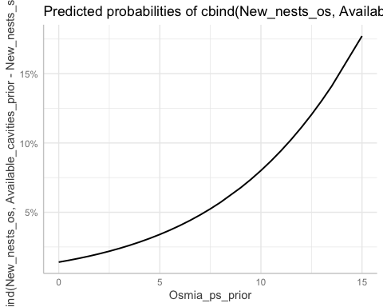
# MODEL 4
### New nests per conspecifics Osmia, without pseudo ###
# Fit the GLMM model with custom glmerControl
mod_choice_consp_os_no_ps <- glmer(cbind(New_nests_os, Available_cavities_prior - New_nests_sum) ~ scale(Osmia_no_ps_prior) + scale(Good_days) + poly(Day_of_year, 2) + Site + (1|Subsite) + (1|Trapnest), data = nesting_os_xs, family = binomial(), control = glmerControl(optimizer = "nloptwrap", optCtrl = list(maxeval = 100000)))
boundary (singular) fit: see help('isSingular')
plot(simulateResiduals(mod_choice_consp_os_no_ps)) # fine
DHARMa:testOutliers with type = binomial may have inflated Type I error rates for integer-valued distributions. To get a more exact result, it is recommended to re-run testOutliers with type = 'bootstrap'. See ?testOutliers for details
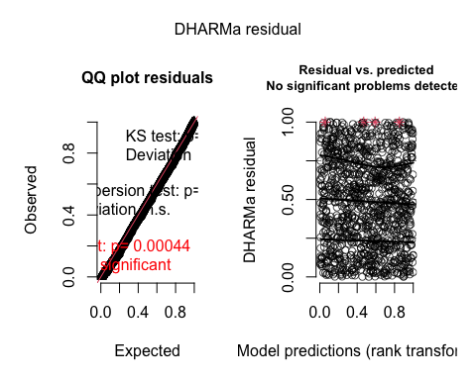
testDispersion(mod_choice_consp_os_no_ps) # good
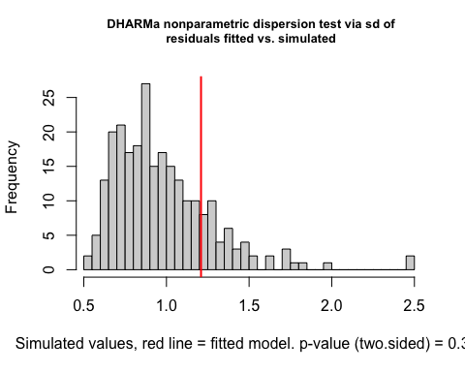
DHARMa nonparametric dispersion test via sd of residuals fitted vs.
simulated
data: simulationOutput
dispersion = 1.2395, p-value = 0.352
alternative hypothesis: two.sided
testZeroInflation(mod_choice_consp_os_no_ps) # fine
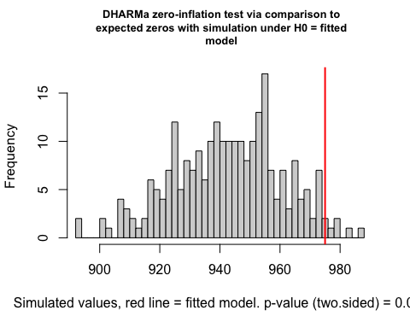
DHARMa zero-inflation test via comparison to expected zeros with
simulation under H0 = fitted model
data: simulationOutput
ratioObsSim = 1.0338, p-value = 0.056
alternative hypothesis: two.sided
summary(mod_choice_consp_os_no_ps) # significant effect of conspecifics, good days, date, and site
Generalized linear mixed model fit by maximum likelihood (Laplace
Approximation) [glmerMod]
Family: binomial ( logit )
Formula: cbind(New_nests_os, Available_cavities_prior - New_nests_sum) ~
scale(Osmia_no_ps_prior) + scale(Good_days) + poly(Day_of_year,
2) + Site + (1 | Subsite) + (1 | Trapnest)
Data: nesting_os_xs
Control: glmerControl(optimizer = "nloptwrap", optCtrl = list(maxeval = 1e+05))
AIC BIC logLik deviance df.resid
949.8 994.8 -465.9 931.8 1089
Scaled residuals:
Min 1Q Median 3Q Max
-1.3154 -0.3867 -0.2200 -0.0770 17.1243
Random effects:
Groups Name Variance Std.Dev.
Trapnest (Intercept) 0.5945 0.771
Subsite (Intercept) 0.0000 0.000
Number of obs: 1098, groups: Trapnest, 72; Subsite, 24
Fixed effects:
Estimate Std. Error z value Pr(>|z|)
(Intercept) -5.01960 0.27028 -18.572 < 2e-16 ***
scale(Osmia_no_ps_prior) 0.36480 0.09842 3.706 0.00021 ***
scale(Good_days) 0.32699 0.08063 4.055 5.01e-05 ***
poly(Day_of_year, 2)1 -46.51196 7.67137 -6.063 1.34e-09 ***
poly(Day_of_year, 2)2 -42.27456 5.85697 -7.218 5.28e-13 ***
SiteCP 1.93130 0.99089 1.949 0.05129 .
SiteNN -0.97117 0.34493 -2.816 0.00487 **
---
Signif. codes: 0 '***' 0.001 '**' 0.01 '*' 0.05 '.' 0.1 ' ' 1
Correlation of Fixed Effects:
(Intr) s(O___ sc(G_) p(D__,2)1 p(D__,2)2 SiteCP
scl(Osm___) -0.179
scl(Gd_dys) -0.114 -0.018
ply(D__,2)1 0.582 -0.210 -0.042
ply(D__,2)2 0.508 0.276 -0.194 0.659
SiteCP -0.548 0.193 0.085 -0.599 -0.465
SiteNN -0.464 0.282 -0.051 0.001 0.125 0.168
optimizer (nloptwrap) convergence code: 0 (OK)
boundary (singular) fit: see help('isSingular')
vif(mod_choice_consp_os_no_ps) # good
GVIF Df GVIF^(1/(2*Df))
scale(Osmia_no_ps_prior) 1.681989 1 1.296915
scale(Good_days) 1.072758 1 1.035740
poly(Day_of_year, 2) 2.639147 2 1.274577
Site 1.814767 2 1.160661
# specify my range of values for Osmia_no_ps_prior
values_osmia_no_ps <- seq(min(nesting_os_xs$Osmia_no_ps_prior),
max(nesting_os_xs$Osmia_no_ps_prior),
length.out = 100)
# compute marginal effects at specific values of Osmia_ps_prior
marginal_effects_os_no_ps <- ggpredict(mod_choice_consp_os_no_ps,
terms = "Osmia_no_ps_prior [all]",
conditions = list(Osmia_no_ps_prior = values_osmia_no_ps))
Could not compute variance-covariance matrix of predictions. No
confidence intervals are returned.
# plot
plot(marginal_effects_os_no_ps, rawdata = TRUE, jitter = 0.04)
Raw data not available.
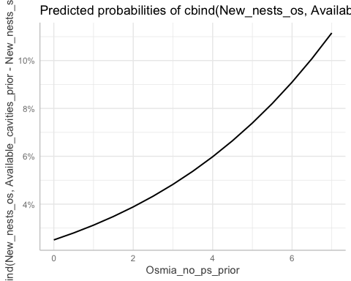

# MODEL 5
### New nests per conspecifics Megachile, with pseudo ###
mod_choice_consp_meg_ps <- glmer(cbind(New_nests_meg, Available_cavities_prior - New_nests_sum) ~ scale(Meg_ps_prior) + scale(Good_days) + poly(Day_of_year,2) + Site + (1|Subsite/Trapnest), data = nesting_meg_xs, family = binomial(), control = glmerControl(optimizer = "bobyqa", optCtrl = list(maxfun = 1000000)))
plot(simulateResiduals(mod_choice_consp_meg_ps)) # great
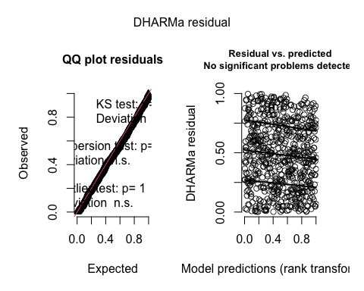
check_model(mod_choice_consp_meg_ps) # good
testDispersion(mod_choice_consp_meg_ps, type = 'DHARMa') # good
DHARMa nonparametric dispersion test via sd of residuals fitted vs.
simulated
data: simulationOutput
dispersion = 0.14636, p-value = 0.248
alternative hypothesis: two.sided
testZeroInflation(mod_choice_consp_meg_ps) # good
DHARMa zero-inflation test via comparison to expected zeros with
simulation under H0 = fitted model
data: simulationOutput
ratioObsSim = 1.0384, p-value = 0.248
alternative hypothesis: two.sided
summary(mod_choice_consp_meg_ps) # significant effect of site (CP) and day of year
Generalized linear mixed model fit by maximum likelihood (Laplace
Approximation) [glmerMod]
Family: binomial ( logit )
Formula: cbind(New_nests_meg, Available_cavities_prior - New_nests_sum) ~
scale(Meg_ps_prior) + scale(Good_days) + poly(Day_of_year,
2) + Site + (1 | Subsite/Trapnest)
Data: nesting_meg_xs
Control: glmerControl(optimizer = "bobyqa", optCtrl = list(maxfun = 1e+06))
AIC BIC logLik deviance df.resid
296 336 -139 278 621
Scaled residuals:
Min 1Q Median 3Q Max
-1.0891 -0.1114 -0.0485 -0.0325 4.3642
Random effects:
Groups Name Variance Std.Dev.
Trapnest:Subsite (Intercept) 7.2612 2.6947
Subsite (Intercept) 0.9114 0.9547
Number of obs: 630, groups: Trapnest:Subsite, 72; Subsite, 24
Fixed effects:
Estimate Std. Error z value Pr(>|z|)
(Intercept) -5.98364 1.00161 -5.974 2.32e-09 ***
scale(Meg_ps_prior) -0.01396 0.58199 -0.024 0.9809
scale(Good_days) 0.02589 0.14354 0.180 0.8569
poly(Day_of_year, 2)1 6.29997 6.09866 1.033 0.3016
poly(Day_of_year, 2)2 0.09511 5.37409 0.018 0.9859
SiteCP -3.19322 1.31323 -2.432 0.0150 *
SiteNN -2.76104 1.59240 -1.734 0.0829 .
---
Signif. codes: 0 '***' 0.001 '**' 0.01 '*' 0.05 '.' 0.1 ' ' 1
Correlation of Fixed Effects:
(Intr) s(M__) sc(G_) p(D__,2)1 p(D__,2)2 SiteCP
scl(Mg_ps_) 0.252
scl(Gd_dys) -0.029 -0.029
ply(D__,2)1 -0.125 -0.247 0.331
ply(D__,2)2 0.109 0.345 -0.420 -0.574
SiteCP -0.181 -0.016 -0.086 -0.290 0.248
SiteNN -0.180 0.231 0.020 -0.014 0.092 0.192
vif(mod_choice_consp_meg_ps)
GVIF Df GVIF^(1/(2*Df))
scale(Meg_ps_prior) 1.259620 1 1.122328
scale(Good_days) 1.264363 1 1.124439
poly(Day_of_year, 2) 1.620504 2 1.128269
Site 1.210051 2 1.048820
# plot
values_meg_ps <- seq(min(nesting_meg_xs$Meg_ps_prior),
max(nesting_meg_xs$Meg_ps_prior),
length.out = 100)
marginal_effects_meg_ps <- ggpredict(mod_choice_consp_meg_ps,
terms = "Meg_ps_prior [all]",
conditions = list(Meg_ps_prior = values_meg_ps))
Could not compute variance-covariance matrix of predictions. No
confidence intervals are returned.
plot(marginal_effects_meg_ps, rawdata = TRUE, jitter = 0.04)
Raw data not available.
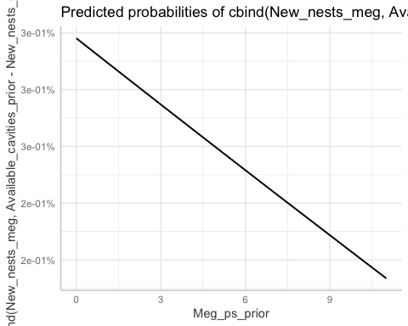
# MODEL 6
### New nests per conspecifics Megachile, without pseudo ###
mod_choice_consp_meg_no_ps <- glmer(cbind(New_nests_meg, Available_cavities_prior - New_nests_sum) ~ scale(Meg_no_ps_prior) + scale(Good_days) + poly(Day_of_year,2) + Site + (1|Subsite/Trapnest), data = nesting_meg_xs, family = binomial(), control = glmerControl(optimizer = "bobyqa", optCtrl = list(maxfun = 1000000)))
plot(simulateResiduals(mod_choice_consp_meg_no_ps)) # great
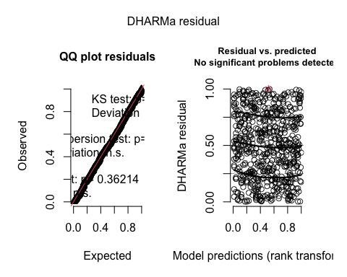
check_model(mod_choice_consp_meg_no_ps) # good
testDispersion(mod_choice_consp_meg_no_ps, type = 'DHARMa') # good
DHARMa nonparametric dispersion test via sd of residuals fitted vs.
simulated
data: simulationOutput
dispersion = 0.85743, p-value = 0.752
alternative hypothesis: two.sided
testZeroInflation(mod_choice_consp_meg_no_ps) # good
DHARMa zero-inflation test via comparison to expected zeros with
simulation under H0 = fitted model
data: simulationOutput
ratioObsSim = 1.013, p-value = 0.616
alternative hypothesis: two.sided
summary(mod_choice_consp_meg_no_ps) # significant effect of conspecifics, sites and day of year
Generalized linear mixed model fit by maximum likelihood (Laplace
Approximation) [glmerMod]
Family: binomial ( logit )
Formula: cbind(New_nests_meg, Available_cavities_prior - New_nests_sum) ~
scale(Meg_no_ps_prior) + scale(Good_days) + poly(Day_of_year,
2) + Site + (1 | Subsite/Trapnest)
Data: nesting_meg_xs
Control: glmerControl(optimizer = "bobyqa", optCtrl = list(maxfun = 1e+06))
AIC BIC logLik deviance df.resid
291.7 331.7 -136.8 273.7 621
Scaled residuals:
Min 1Q Median 3Q Max
-1.4121 -0.1614 -0.0959 -0.0646 5.7387
Random effects:
Groups Name Variance Std.Dev.
Trapnest:Subsite (Intercept) 2.0106 1.4179
Subsite (Intercept) 0.6709 0.8191
Number of obs: 630, groups: Trapnest:Subsite, 72; Subsite, 24
Fixed effects:
Estimate Std. Error z value Pr(>|z|)
(Intercept) -5.4355 0.5790 -9.387 <2e-16 ***
scale(Meg_no_ps_prior) 0.2578 0.1142 2.257 0.0240 *
scale(Good_days) 0.1077 0.1439 0.748 0.4543
poly(Day_of_year, 2)1 -2.2747 6.0283 -0.377 0.7059
poly(Day_of_year, 2)2 0.8984 4.7293 0.190 0.8493
SiteCP -2.1181 1.0398 -2.037 0.0417 *
SiteNN -2.5396 1.2605 -2.015 0.0439 *
---
Signif. codes: 0 '***' 0.001 '**' 0.01 '*' 0.05 '.' 0.1 ' ' 1
Correlation of Fixed Effects:
(Intr) s(M___ sc(G_) p(D__,2)1 p(D__,2)2 SiteCP
scl(Mg_n__) 0.183
scl(Gd_dys) 0.015 0.234
ply(D__,2)1 -0.001 -0.496 0.156
ply(D__,2)2 -0.075 0.037 -0.404 -0.380
SiteCP -0.145 0.397 0.008 -0.427 0.289
SiteNN -0.175 0.105 0.071 0.007 0.010 0.194
vif(mod_choice_consp_meg_no_ps) # good
GVIF Df GVIF^(1/(2*Df))
scale(Meg_no_ps_prior) 1.632941 1 1.277866
scale(Good_days) 1.340492 1 1.157796
poly(Day_of_year, 2) 1.989080 2 1.187580
Site 1.382494 2 1.084341
# plot
values_meg_no_ps <- seq(min(nesting_meg_xs$Meg_no_ps_prior),
max(nesting_meg_xs$Meg_no_ps_prior),
length.out = 100)
marginal_effects_meg_no_ps <- ggpredict(mod_choice_consp_meg_no_ps,
terms = "Meg_no_ps_prior [all]",
conditions = list(Meg_no_ps_prior = values_meg_no_ps))
Could not compute variance-covariance matrix of predictions. No
confidence intervals are returned.
plot(marginal_effects_meg_no_ps, rawdata = TRUE, jitter = 0.04)
Raw data not available.
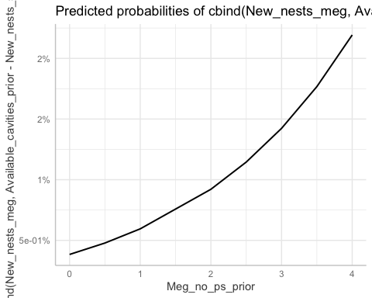

Parasitism
# Relation between parasites and aggregation densities
# MODEL 7
# Relation between parasites and aggregation densities, with pseudo
mod_par_agg_ps <- glmer(cbind(Sum_cell_parasitized, Sum_cell_not_parasitized) ~ scale(Osmia_ps_no_iw) + poly(Day_of_year,2) + Site + (1|Subsite/Trapnest/Nest_ID), data = nesting_cells_os, family = binomial)
Warning in checkConv(attr(opt, "derivs"), opt$par, ctrl = control$checkConv, :
unable to evaluate scaled gradient
Warning in checkConv(attr(opt, "derivs"), opt$par, ctrl = control$checkConv, :
Hessian is numerically singular: parameters are not uniquely determined
plot(simulateResiduals(mod_par_agg_ps)) # good
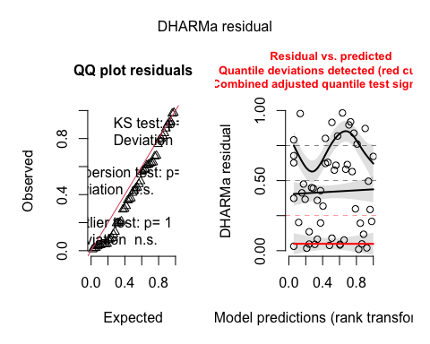
check_model(mod_par_agg_ps) # good
testDispersion(mod_par_agg_ps, type = 'DHARMa') # good
DHARMa nonparametric dispersion test via sd of residuals fitted vs.
simulated
data: simulationOutput
dispersion = 0.73427, p-value = 0.576
alternative hypothesis: two.sided
testZeroInflation(mod_par_agg_ps) # good
DHARMa zero-inflation test via comparison to expected zeros with
simulation under H0 = fitted model
data: simulationOutput
ratioObsSim = 1.0605, p-value = 0.664
alternative hypothesis: two.sided
summary(mod_par_agg_ps) # no detected effects
Warning in vcov.merMod(object, use.hessian = use.hessian): variance-covariance matrix computed from finite-difference Hessian is
not positive definite or contains NA values: falling back to var-cov estimated from RX
Warning in vcov.merMod(object, correlation = correlation, sigm = sig): variance-covariance matrix computed from finite-difference Hessian is
not positive definite or contains NA values: falling back to var-cov estimated from RX
Generalized linear mixed model fit by maximum likelihood (Laplace
Approximation) [glmerMod]
Family: binomial ( logit )
Formula:
cbind(Sum_cell_parasitized, Sum_cell_not_parasitized) ~ scale(Osmia_ps_no_iw) +
poly(Day_of_year, 2) + Site + (1 | Subsite/Trapnest/Nest_ID)
Data: nesting_cells_os
AIC BIC logLik deviance df.resid
75.2 92.8 -28.6 57.2 43
Scaled residuals:
Min 1Q Median 3Q Max
-1.02640 -0.18846 -0.03459 0.00000 1.54787
Random effects:
Groups Name Variance Std.Dev.
Nest_ID:(Trapnest:Subsite) (Intercept) 5.436436 2.3316
Trapnest:Subsite (Intercept) 0.001037 0.0322
Subsite (Intercept) 8.740129 2.9564
Number of obs: 52, groups:
Nest_ID:(Trapnest:Subsite), 31; Trapnest:Subsite, 12; Subsite, 11
Fixed effects:
Estimate Std. Error z value Pr(>|z|)
(Intercept) -5.636e+00 2.222e+00 -2.536 0.0112 *
scale(Osmia_ps_no_iw) 1.445e-01 6.502e-01 0.222 0.8242
poly(Day_of_year, 2)1 2.500e+01 1.450e+01 1.723 0.0848 .
poly(Day_of_year, 2)2 -3.469e+01 2.357e+01 -1.472 0.1411
SiteCP -9.386e+01 1.733e+07 0.000 1.0000
SiteNN 4.487e+00 2.745e+00 1.635 0.1021
---
Signif. codes: 0 '***' 0.001 '**' 0.01 '*' 0.05 '.' 0.1 ' ' 1
Correlation of Fixed Effects:
(Intr) s(O___ p(D__,2)1 p(D__,2)2 SiteCP
scl(Osm___) -0.154
ply(D__,2)1 -0.301 0.281
ply(D__,2)2 0.458 0.044 -0.290
SiteCP 0.000 0.000 0.000 0.000
SiteNN -0.665 0.162 0.084 -0.070 0.000
optimizer (Nelder_Mead) convergence code: 0 (OK)
unable to evaluate scaled gradient
Hessian is numerically singular: parameters are not uniquely determined
vif(mod_par_agg_ps)
Warning in vcov.merMod(mod): variance-covariance matrix computed from finite-difference Hessian is
not positive definite or contains NA values: falling back to var-cov estimated from RX
GVIF Df GVIF^(1/(2*Df))
scale(Osmia_ps_no_iw) 1.133024 1 1.064436
poly(Day_of_year, 2) 1.113728 2 1.027294
Site 1.033520 2 1.008277
# plot
values_osmia_ps_no_iw <- seq(min(nesting_cells_os$Osmia_ps_no_iw, na.rm = TRUE),
max(nesting_cells_os$Osmia_ps_no_iw, na.rm = TRUE),
length.out = 100)
marginal_effects_os_ps_no_iw <- ggpredict(mod_par_agg_ps,
terms = "Osmia_ps_no_iw [all]",
conditions = list(Osmia_ps_no_iw = values_osmia_ps_no_iw))
Could not compute variance-covariance matrix of predictions. No
confidence intervals are returned.
plot(marginal_effects_os_ps_no_iw, rawdata = TRUE, jitter = 0.04)
Raw data not available.
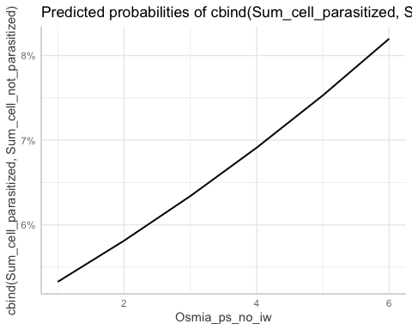
# MODEL 8
# Relation between parasites and aggregation densities, without pseudo
mod_par_agg_no_ps <- glmer(cbind(Sum_cell_parasitized, Sum_cell_not_parasitized) ~ scale(Osmia_no_ps_no_iw) + poly(Day_of_year,2) + Site + (1|Subsite/Trapnest/Nest_ID), data = nesting_cells_os, family = binomial)
Warning in checkConv(attr(opt, "derivs"), opt$par, ctrl = control$checkConv, :
Model failed to converge with max|grad| = 0.0207006 (tol = 0.002, component 1)
plot(simulateResiduals(mod_par_agg_no_ps)) # WEIRD!
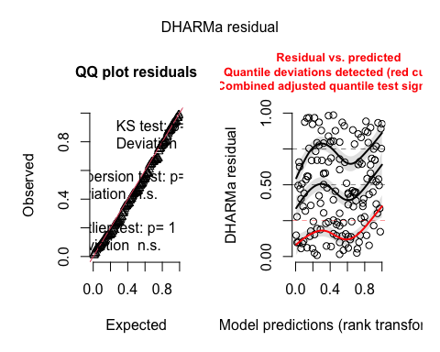
check_model(mod_par_agg_no_ps) # fine
testDispersion(mod_par_agg_no_ps, type = 'DHARMa') # good
DHARMa nonparametric dispersion test via sd of residuals fitted vs.
simulated
data: simulationOutput
dispersion = 0.6421, p-value = 0.208
alternative hypothesis: two.sided
testZeroInflation(mod_par_agg_no_ps) # good
DHARMa zero-inflation test via comparison to expected zeros with
simulation under H0 = fitted model
data: simulationOutput
ratioObsSim = 0.99741, p-value = 0.952
alternative hypothesis: two.sided
summary(mod_par_agg_no_ps) # no detected effects
Generalized linear mixed model fit by maximum likelihood (Laplace
Approximation) [glmerMod]
Family: binomial ( logit )
Formula:
cbind(Sum_cell_parasitized, Sum_cell_not_parasitized) ~ scale(Osmia_no_ps_no_iw) +
poly(Day_of_year, 2) + Site + (1 | Subsite/Trapnest/Nest_ID)
Data: nesting_cells_os
AIC BIC logLik deviance df.resid
235.7 262.8 -108.8 217.7 142
Scaled residuals:
Min 1Q Median 3Q Max
-1.17734 -0.29319 -0.19220 0.09371 1.72269
Random effects:
Groups Name Variance Std.Dev.
Nest_ID:(Trapnest:Subsite) (Intercept) 6.463e+00 2.542311
Trapnest:Subsite (Intercept) 1.709e-04 0.013074
Subsite (Intercept) 3.961e-05 0.006294
Number of obs: 151, groups:
Nest_ID:(Trapnest:Subsite), 90; Trapnest:Subsite, 29; Subsite, 15
Fixed effects:
Estimate Std. Error z value Pr(>|z|)
(Intercept) -3.1058 0.6389 -4.861 1.17e-06 ***
scale(Osmia_no_ps_no_iw) -0.5888 0.4095 -1.438 0.151
poly(Day_of_year, 2)1 2.0054 5.5232 0.363 0.717
poly(Day_of_year, 2)2 -5.1188 5.8747 -0.871 0.384
SiteCP -11.4741 186.9629 -0.061 0.951
SiteNN 1.1815 0.8334 1.418 0.156
---
Signif. codes: 0 '***' 0.001 '**' 0.01 '*' 0.05 '.' 0.1 ' ' 1
Correlation of Fixed Effects:
(Intr) s(O___ p(D__,2)1 p(D__,2)2 SiteCP
scl(Os____) 0.122
ply(D__,2)1 0.192 -0.252
ply(D__,2)2 0.141 0.315 -0.086
SiteCP -0.004 0.002 -0.005 -0.005
SiteNN -0.527 0.077 -0.269 0.147 0.002
optimizer (Nelder_Mead) convergence code: 0 (OK)
Model failed to converge with max|grad| = 0.0207006 (tol = 0.002, component 1)
vif(mod_par_agg_no_ps)
GVIF Df GVIF^(1/(2*Df))
scale(Osmia_no_ps_no_iw) 1.177602 1 1.085174
poly(Day_of_year, 2) 1.283819 2 1.064452
Site 1.097761 2 1.023592
table(nesting_cells_os$Site) # very few CP
BP CP NN
105 5 41
# plot
values_osmia_no_ps_no_iw <- seq(min(nesting_cells_os$Osmia_no_ps_no_iw, na.rm = TRUE),
max(nesting_cells_os$Osmia_no_ps_no_iw, na.rm = TRUE),
length.out = 100)
marginal_effects_os_no_ps_no_iw <- ggpredict(mod_par_agg_no_ps,
terms = "Osmia_no_ps_no_iw [all]",
conditions = list(Osmia_no_ps_no_iw = values_osmia_no_ps_no_iw))
Could not compute variance-covariance matrix of predictions. No
confidence intervals are returned.
plot(marginal_effects_os_no_ps_no_iw, rawdata = TRUE, jitter = 0.04)
Raw data not available.
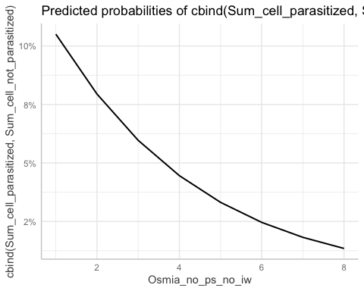
# MODEL 9
# Relation between parasites and aggregation densities, unsealed
mod_par_agg_unsealed_os <- glmer(cbind(Sum_cell_parasitized, Sum_cell_not_parasitized) ~ scale(Sum_unsealed_os_no_iw) + poly(Day_of_year,2) + Site + (1|Subsite/Trapnest/Nest_ID), data = nesting_cells_os, family = binomial)
boundary (singular) fit: see help('isSingular')
plot(simulateResiduals(mod_par_agg_unsealed_os)) # good
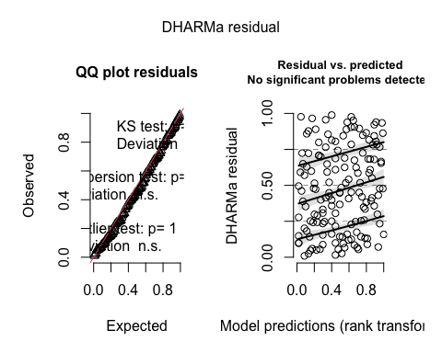
check_model(mod_par_agg_unsealed_os) # fine
testDispersion(mod_par_agg_unsealed_os, type = 'DHARMa') # good
DHARMa nonparametric dispersion test via sd of residuals fitted vs.
simulated
data: simulationOutput
dispersion = 0.70641, p-value = 0.328
alternative hypothesis: two.sided
testZeroInflation(mod_par_agg_unsealed_os) # good
DHARMa zero-inflation test via comparison to expected zeros with
simulation under H0 = fitted model
data: simulationOutput
ratioObsSim = 1.0051, p-value = 1
alternative hypothesis: two.sided
summary(mod_par_agg_unsealed_os)
Warning in vcov.merMod(object, use.hessian = use.hessian): variance-covariance matrix computed from finite-difference Hessian is
not positive definite or contains NA values: falling back to var-cov estimated from RX
Warning in vcov.merMod(object, use.hessian = use.hessian): variance-covariance matrix computed from finite-difference Hessian is
not positive definite or contains NA values: falling back to var-cov estimated from RX
Generalized linear mixed model fit by maximum likelihood (Laplace
Approximation) [glmerMod]
Family: binomial ( logit )
Formula:
cbind(Sum_cell_parasitized, Sum_cell_not_parasitized) ~ scale(Sum_unsealed_os_no_iw) +
poly(Day_of_year, 2) + Site + (1 | Subsite/Trapnest/Nest_ID)
Data: nesting_cells_os
AIC BIC logLik deviance df.resid
234.8 261.9 -108.4 216.8 142
Scaled residuals:
Min 1Q Median 3Q Max
-1.20844 -0.30893 -0.21896 0.03529 1.53874
Random effects:
Groups Name Variance Std.Dev.
Nest_ID:(Trapnest:Subsite) (Intercept) 5.386e+00 2.321e+00
Trapnest:Subsite (Intercept) 2.692e-10 1.641e-05
Subsite (Intercept) 1.916e-15 4.377e-08
Number of obs: 151, groups:
Nest_ID:(Trapnest:Subsite), 90; Trapnest:Subsite, 29; Subsite, 15
Fixed effects:
Estimate Std. Error z value Pr(>|z|)
(Intercept) -3.053e+00 4.454e-01 -6.853 7.21e-12 ***
scale(Sum_unsealed_os_no_iw) -4.833e-01 2.695e-01 -1.794 0.0729 .
poly(Day_of_year, 2)1 -1.451e+00 5.291e+00 -0.274 0.7839
poly(Day_of_year, 2)2 -3.200e+00 5.725e+00 -0.559 0.5762
SiteCP -3.112e+01 9.765e+06 0.000 1.0000
SiteNN 1.401e+00 7.548e-01 1.856 0.0635 .
---
Signif. codes: 0 '***' 0.001 '**' 0.01 '*' 0.05 '.' 0.1 ' ' 1
Correlation of Fixed Effects:
(Intr) s(S___ p(D__,2)1 p(D__,2)2 SiteCP
scl(Sm____) 0.148
ply(D__,2)1 0.222 0.172
ply(D__,2)2 0.218 0.091 0.123
SiteCP 0.000 0.000 0.000 0.000
SiteNN -0.567 -0.098 -0.251 0.118 0.000
optimizer (Nelder_Mead) convergence code: 0 (OK)
boundary (singular) fit: see help('isSingular')
vif(mod_par_agg_unsealed_os) # no detected effects
Warning in vcov.merMod(mod): variance-covariance matrix computed from finite-difference Hessian is
not positive definite or contains NA values: falling back to var-cov estimated from RX
GVIF Df GVIF^(1/(2*Df))
scale(Sum_unsealed_os_no_iw) 1.040917 1 1.020253
poly(Day_of_year, 2) 1.127322 2 1.030415
Site 1.098853 2 1.023847
# plot
values_unsealed_os_no_iw <- seq(min(nesting_cells_os$Sum_unsealed_os_no_iw, na.rm = TRUE),
max(nesting_cells_os$Sum_unsealed_os_no_iw, na.rm = TRUE),
length.out = 100)
marginal_effects_unsealed_os_no_iw <- ggpredict(mod_par_agg_unsealed_os,
terms = "Sum_unsealed_os_no_iw [all]",
conditions = list(Sum_unsealed_os_no_iw = values_unsealed_os_no_iw))
Could not compute variance-covariance matrix of predictions. No
confidence intervals are returned.
plot(marginal_effects_unsealed_os_no_iw, rawdata = TRUE, jitter = 0.04)
Raw data not available.
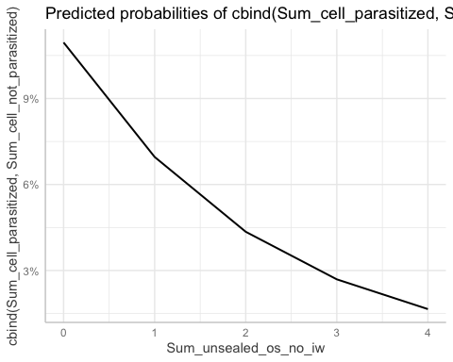
# MODEL 10
# How the presence of parasites effects nesting preferences, with pseudo
mod_choice_par_ps_os <- glmer(cbind(New_nests_os, Available_cavities_prior - New_nests_sum) ~ scale(Par_nests_unsealed_os) * scale(Other_nests_ps_os) + scale(Good_days) + poly(Day_of_year,2) + Site + (1|Subsite/Trapnest), data = nesting_os_xs, family = binomial, control = glmerControl(optimizer = "bobyqa", optCtrl = list(maxfun = 1000000)))
boundary (singular) fit: see help('isSingular')
# having subsite doesnt change model
plot(simulateResiduals(mod_choice_par_ps_os)) # fine
DHARMa:testOutliers with type = binomial may have inflated Type I error rates for integer-valued distributions. To get a more exact result, it is recommended to re-run testOutliers with type = 'bootstrap'. See ?testOutliers for details
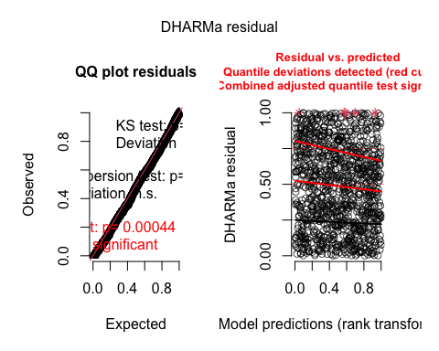
check_model(mod_choice_par_ps_os) # fine
testDispersion(mod_choice_par_ps_os, type = 'DHARMa') # good
DHARMa nonparametric dispersion test via sd of residuals fitted vs.
simulated
data: simulationOutput
dispersion = 1.197, p-value = 0.416
alternative hypothesis: two.sided
testZeroInflation(mod_choice_par_ps_os) # good
DHARMa zero-inflation test via comparison to expected zeros with
simulation under H0 = fitted model
data: simulationOutput
ratioObsSim = 1.0329, p-value = 0.104
alternative hypothesis: two.sided
summary(mod_choice_par_ps_os) # significant effect of parasitized unsealed nests, conspecifics, good days, day of year, and site
Generalized linear mixed model fit by maximum likelihood (Laplace
Approximation) [glmerMod]
Family: binomial ( logit )
Formula: cbind(New_nests_os, Available_cavities_prior - New_nests_sum) ~
scale(Par_nests_unsealed_os) * scale(Other_nests_ps_os) +
scale(Good_days) + poly(Day_of_year, 2) + Site + (1 |
Subsite/Trapnest)
Data: nesting_os_xs
Control: glmerControl(optimizer = "bobyqa", optCtrl = list(maxfun = 1e+06))
AIC BIC logLik deviance df.resid
933.1 988.1 -455.5 911.1 1087
Scaled residuals:
Min 1Q Median 3Q Max
-1.1879 -0.3721 -0.2083 -0.0763 16.2528
Random effects:
Groups Name Variance Std.Dev.
Trapnest:Subsite (Intercept) 0.7027 0.8383
Subsite (Intercept) 0.0000 0.0000
Number of obs: 1098, groups: Trapnest:Subsite, 72; Subsite, 24
Fixed effects:
Estimate Std. Error
(Intercept) -4.99879 0.28303
scale(Par_nests_unsealed_os) 0.25846 0.04958
scale(Other_nests_ps_os) 0.68883 0.17848
scale(Good_days) 0.34460 0.08149
poly(Day_of_year, 2)1 -38.37465 7.40360
poly(Day_of_year, 2)2 -43.28856 5.83078
SiteCP 2.17370 0.99569
SiteNN -1.09750 0.35027
scale(Par_nests_unsealed_os):scale(Other_nests_ps_os) -0.07413 0.05854
z value Pr(>|z|)
(Intercept) -17.662 < 2e-16 ***
scale(Par_nests_unsealed_os) 5.213 1.86e-07 ***
scale(Other_nests_ps_os) 3.859 0.000114 ***
scale(Good_days) 4.229 2.35e-05 ***
poly(Day_of_year, 2)1 -5.183 2.18e-07 ***
poly(Day_of_year, 2)2 -7.424 1.14e-13 ***
SiteCP 2.183 0.029027 *
SiteNN -3.133 0.001729 **
scale(Par_nests_unsealed_os):scale(Other_nests_ps_os) -1.266 0.205378
---
Signif. codes: 0 '***' 0.001 '**' 0.01 '*' 0.05 '.' 0.1 ' ' 1
Correlation of Fixed Effects:
(Intr) sc(P___) s(O___ sc(G_) p(D__,2)1 p(D__,2)2 SiteCP SiteNN
scl(Pr_n__) -0.048
scl(Oth___) -0.148 0.141
scl(Gd_dys) -0.124 0.064 -0.023
ply(D__,2)1 0.530 0.013 0.071 -0.050
ply(D__,2)2 0.536 0.129 0.108 -0.194 0.754
SiteCP -0.543 0.047 0.146 0.094 -0.560 -0.514
SiteNN -0.465 0.024 -0.033 -0.031 0.029 0.040 0.143
s(P___):(O_ 0.092 0.004 0.006 -0.132 0.084 0.132 -0.093 -0.047
optimizer (bobyqa) convergence code: 0 (OK)
boundary (singular) fit: see help('isSingular')
vif(mod_choice_par_ps_os) # good
GVIF Df
scale(Par_nests_unsealed_os) 1.069924 1
scale(Other_nests_ps_os) 1.098195 1
scale(Good_days) 1.091137 1
poly(Day_of_year, 2) 1.792623 2
Site 1.661784 2
scale(Par_nests_unsealed_os):scale(Other_nests_ps_os) 1.034176 1
GVIF^(1/(2*Df))
scale(Par_nests_unsealed_os) 1.034371
scale(Other_nests_ps_os) 1.047948
scale(Good_days) 1.044575
poly(Day_of_year, 2) 1.157104
Site 1.135386
scale(Par_nests_unsealed_os):scale(Other_nests_ps_os) 1.016944
interact_plot(mod_choice_par_ps_os, pred = Other_nests_ps_os, modx = Par_nests_unsealed_os, data = nesting_os_xs)
Warning: -0.278400526859184 is outside the observed range of
Par_nests_unsealed_os
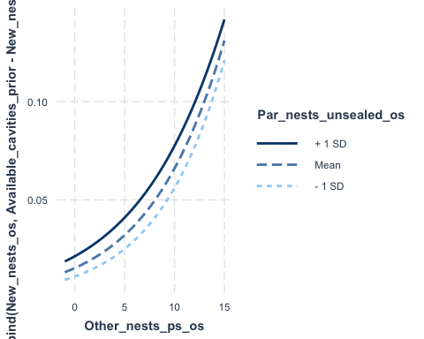
# Model 11
# How the presence of parasites effects nesting preferences, without pseudo
mod_choice_par_no_ps_os <- glmer(cbind(New_nests_os, Available_cavities_prior - New_nests_sum) ~ scale(Par_nests_unsealed_os) * scale(Other_nests_no_ps_os) + scale(Good_days) + poly(Day_of_year,2) + Site + (1|Subsite/Trapnest), data = nesting_os_xs, family = binomial, control=glmerControl(optimizer="bobyqa", optCtrl=list(maxfun=1000000)))
boundary (singular) fit: see help('isSingular')
plot(simulateResiduals(mod_choice_par_no_ps_os)) # good
DHARMa:testOutliers with type = binomial may have inflated Type I error rates for integer-valued distributions. To get a more exact result, it is recommended to re-run testOutliers with type = 'bootstrap'. See ?testOutliers for details
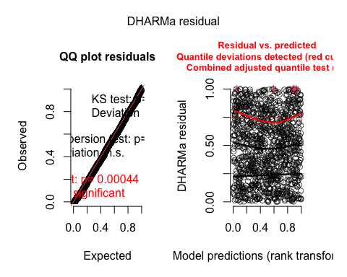
check_model(mod_choice_par_no_ps_os) # fine
testDispersion(mod_choice_par_no_ps_os, type = 'DHARMa') # good
DHARMa nonparametric dispersion test via sd of residuals fitted vs.
simulated
data: simulationOutput
dispersion = 1.2195, p-value = 0.352
alternative hypothesis: two.sided
testZeroInflation(mod_choice_par_no_ps_os) # good
DHARMa zero-inflation test via comparison to expected zeros with
simulation under H0 = fitted model
data: simulationOutput
ratioObsSim = 1.0269, p-value = 0.136
alternative hypothesis: two.sided
summary(mod_choice_par_no_ps_os) # significant effect of parasitized unsealed nests, conspecifics, parasitized unsealed nests*conspecifics, good days, day of year, and site
Generalized linear mixed model fit by maximum likelihood (Laplace
Approximation) [glmerMod]
Family: binomial ( logit )
Formula: cbind(New_nests_os, Available_cavities_prior - New_nests_sum) ~
scale(Par_nests_unsealed_os) * scale(Other_nests_no_ps_os) +
scale(Good_days) + poly(Day_of_year, 2) + Site + (1 |
Subsite/Trapnest)
Data: nesting_os_xs
Control: glmerControl(optimizer = "bobyqa", optCtrl = list(maxfun = 1e+06))
AIC BIC logLik deviance df.resid
924.7 979.7 -451.3 902.7 1087
Scaled residuals:
Min 1Q Median 3Q Max
-1.4232 -0.3669 -0.2236 -0.0773 16.4429
Random effects:
Groups Name Variance Std.Dev.
Trapnest:Subsite (Intercept) 0.4778 0.6912
Subsite (Intercept) 0.0000 0.0000
Number of obs: 1098, groups: Trapnest:Subsite, 72; Subsite, 24
Fixed effects:
Estimate Std. Error
(Intercept) -5.08839 0.26465
scale(Par_nests_unsealed_os) 0.30598 0.05138
scale(Other_nests_no_ps_os) 0.39655 0.09656
scale(Good_days) 0.31583 0.08127
poly(Day_of_year, 2)1 -46.35429 7.75945
poly(Day_of_year, 2)2 -39.31728 5.86464
SiteCP 2.08059 0.98827
SiteNN -0.82973 0.32303
scale(Par_nests_unsealed_os):scale(Other_nests_no_ps_os) -0.16971 0.04210
z value Pr(>|z|)
(Intercept) -19.227 < 2e-16 ***
scale(Par_nests_unsealed_os) 5.956 2.59e-09 ***
scale(Other_nests_no_ps_os) 4.107 4.01e-05 ***
scale(Good_days) 3.886 0.000102 ***
poly(Day_of_year, 2)1 -5.974 2.32e-09 ***
poly(Day_of_year, 2)2 -6.704 2.03e-11 ***
SiteCP 2.105 0.035267 *
SiteNN -2.569 0.010211 *
scale(Par_nests_unsealed_os):scale(Other_nests_no_ps_os) -4.031 5.56e-05 ***
---
Signif. codes: 0 '***' 0.001 '**' 0.01 '*' 0.05 '.' 0.1 ' ' 1
Correlation of Fixed Effects:
(Intr) sc(P___) s(O___ sc(G_) p(D__,2)1 p(D__,2)2 SiteCP SiteNN
scl(Pr_n__) -0.114
scl(Ot____) -0.228 0.378
scl(Gd_dys) -0.094 0.029 -0.046
ply(D__,2)1 0.625 -0.060 -0.234 -0.001
ply(D__,2)2 0.526 0.193 0.241 -0.174 0.654
SiteCP -0.566 0.085 0.206 0.063 -0.611 -0.476
SiteNN -0.462 0.130 0.311 -0.059 -0.031 0.107 0.173
s(P___):(O_ 0.127 -0.094 -0.164 0.052 0.082 0.002 -0.062 -0.064
optimizer (bobyqa) convergence code: 0 (OK)
boundary (singular) fit: see help('isSingular')
vif(mod_choice_par_no_ps_os)
GVIF Df
scale(Par_nests_unsealed_os) 1.205699 1
scale(Other_nests_no_ps_os) 1.757746 1
scale(Good_days) 1.079496 1
poly(Day_of_year, 2) 2.655227 2
Site 1.881627 2
scale(Par_nests_unsealed_os):scale(Other_nests_no_ps_os) 1.034801 1
GVIF^(1/(2*Df))
scale(Par_nests_unsealed_os) 1.098043
scale(Other_nests_no_ps_os) 1.325800
scale(Good_days) 1.038988
poly(Day_of_year, 2) 1.276514
Site 1.171206
scale(Par_nests_unsealed_os):scale(Other_nests_no_ps_os) 1.017252
interact_plot(mod_choice_par_no_ps_os, pred = Other_nests_no_ps_os, modx = Par_nests_unsealed_os, data = nesting_os_xs)
Warning: -0.278400526859184 is outside the observed range of
Par_nests_unsealed_os
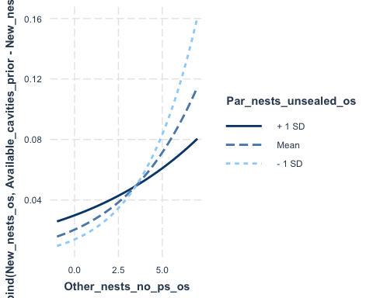
# MODEL 12
# Likelyhood of of terminating nest investment after a cell was parasitized
mod_last_cell <- glmer(Last_cell ~ Cell_parasitized + Day_of_year + Site + (1|Nest_ID), data = nesting_cells_os, family = binomial)
boundary (singular) fit: see help('isSingular')
plot(simulateResiduals(mod_last_cell)) # good
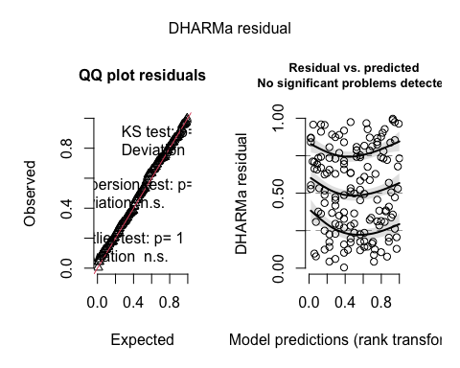
summary(mod_last_cell) # significant effect of day of year
Warning in vcov.merMod(object, use.hessian = use.hessian): variance-covariance matrix computed from finite-difference Hessian is
not positive definite or contains NA values: falling back to var-cov estimated from RX
Warning in vcov.merMod(object, correlation = correlation, sigm = sig): variance-covariance matrix computed from finite-difference Hessian is
not positive definite or contains NA values: falling back to var-cov estimated from RX
Generalized linear mixed model fit by maximum likelihood (Laplace
Approximation) [glmerMod]
Family: binomial ( logit )
Formula: Last_cell ~ Cell_parasitized + Day_of_year + Site + (1 | Nest_ID)
Data: nesting_cells_os
AIC BIC logLik deviance df.resid
155.5 173.6 -71.7 143.5 145
Scaled residuals:
Min 1Q Median 3Q Max
-1.1476 -0.4991 -0.4034 0.0000 3.8354
Random effects:
Groups Name Variance Std.Dev.
Nest_ID (Intercept) 0 0
Number of obs: 151, groups: Nest_ID, 90
Fixed effects:
Estimate Std. Error z value Pr(>|z|)
(Intercept) -1.087e+01 2.783e+00 -3.907 9.35e-05 ***
Cell_parasitized -1.436e-01 5.344e-01 -0.269 0.788110
Day_of_year 6.079e-02 1.754e-02 3.467 0.000527 ***
SiteCP -3.205e+01 3.100e+06 0.000 0.999992
SiteNN 2.891e-01 4.478e-01 0.646 0.518477
---
Signif. codes: 0 '***' 0.001 '**' 0.01 '*' 0.05 '.' 0.1 ' ' 1
Correlation of Fixed Effects:
(Intr) Cll_pr Dy_f_y SiteCP
Cell_prstzd 0.099
Day_of_year -0.995 -0.127
SiteCP 0.000 0.000 0.000
SiteNN 0.102 -0.162 -0.151 0.000
optimizer (Nelder_Mead) convergence code: 0 (OK)
boundary (singular) fit: see help('isSingular')
vif(mod_last_cell) # good
Warning in vcov.merMod(mod): variance-covariance matrix computed from finite-difference Hessian is
not positive definite or contains NA values: falling back to var-cov estimated from RX
GVIF Df GVIF^(1/(2*Df))
Cell_parasitized 1.052223 1 1.025779
Day_of_year 1.048462 1 1.023944
Site 1.059401 2 1.014531
ggpredict(mod_last_cell, c('Cell_parasitized')) %>% plot(rawdata = TRUE, jitter = .04)
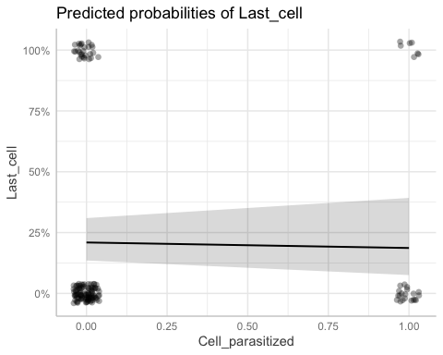
# MODEL 13
# Investment into a nest if other active nests or the nest itself is parasitized
mod_invest_filled <- glmer(cbind(Filled_length, Straw_length) ~ scale(Par_nests_unsealed_os_calc) * Nest_parasitized + poly(Day_of_year,2) + Site + (1|Subsite/Trapnest), data = investment_os, family = binomial, control=glmerControl(optimizer="bobyqa", optCtrl=list(maxfun=1000000)))
boundary (singular) fit: see help('isSingular')
plot(simulateResiduals(mod_invest_filled)) # fine
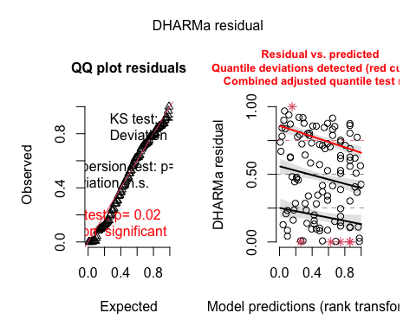
check_model(mod_invest_filled) # best i can do
summary(mod_invest_filled) # significant effect of parasitized unsealed nests, if focal nest is parasitized, good days, day of year, and site
Generalized linear mixed model fit by maximum likelihood (Laplace
Approximation) [glmerMod]
Family: binomial ( logit )
Formula:
cbind(Filled_length, Straw_length) ~ scale(Par_nests_unsealed_os_calc) *
Nest_parasitized + poly(Day_of_year, 2) + Site + (1 | Subsite/Trapnest)
Data: investment_os
Control: glmerControl(optimizer = "bobyqa", optCtrl = list(maxfun = 1e+06))
AIC BIC logLik deviance df.resid
1752.5 1779.8 -866.3 1732.5 103
Scaled residuals:
Min 1Q Median 3Q Max
-6.4225 -2.3213 -0.2029 1.7821 10.2457
Random effects:
Groups Name Variance Std.Dev.
Trapnest:Subsite (Intercept) 0.4104 0.6406
Subsite (Intercept) 0.0000 0.0000
Number of obs: 113, groups: Trapnest:Subsite, 29; Subsite, 15
Fixed effects:
Estimate
(Intercept) -1.18547
scale(Par_nests_unsealed_os_calc) -0.14803
Nest_parasitizedparasitized -0.16605
poly(Day_of_year, 2)1 -6.46210
poly(Day_of_year, 2)2 -0.99285
SiteCP 1.96692
SiteNN -0.15678
scale(Par_nests_unsealed_os_calc):Nest_parasitizedparasitized 0.11596
Std. Error
(Intercept) 0.15981
scale(Par_nests_unsealed_os_calc) 0.02398
Nest_parasitizedparasitized 0.04181
poly(Day_of_year, 2)1 0.35791
poly(Day_of_year, 2)2 0.32335
SiteCP 0.51345
SiteNN 0.26412
scale(Par_nests_unsealed_os_calc):Nest_parasitizedparasitized 0.03862
z value Pr(>|z|)
(Intercept) -7.418 1.19e-13
scale(Par_nests_unsealed_os_calc) -6.173 6.70e-10
Nest_parasitizedparasitized -3.971 7.15e-05
poly(Day_of_year, 2)1 -18.055 < 2e-16
poly(Day_of_year, 2)2 -3.071 0.002137
SiteCP 3.831 0.000128
SiteNN -0.594 0.552788
scale(Par_nests_unsealed_os_calc):Nest_parasitizedparasitized 3.002 0.002679
(Intercept) ***
scale(Par_nests_unsealed_os_calc) ***
Nest_parasitizedparasitized ***
poly(Day_of_year, 2)1 ***
poly(Day_of_year, 2)2 **
SiteCP ***
SiteNN
scale(Par_nests_unsealed_os_calc):Nest_parasitizedparasitized **
---
Signif. codes: 0 '***' 0.001 '**' 0.01 '*' 0.05 '.' 0.1 ' ' 1
Correlation of Fixed Effects:
(Intr) sc(P____) Nst_pr p(D__,2)1 p(D__,2)2 SiteCP SiteNN
scl(Pr____) 0.019
Nst_prstzdp -0.070 0.035
ply(D__,2)1 -0.018 -0.002 -0.134
ply(D__,2)2 -0.035 0.198 -0.047 0.467
SiteCP -0.302 -0.014 0.052 -0.235 -0.220
SiteNN -0.601 0.005 -0.016 0.004 0.041 0.180
s(P____):N_ 0.000 -0.582 -0.151 -0.096 -0.056 0.012 0.003
optimizer (bobyqa) convergence code: 0 (OK)
boundary (singular) fit: see help('isSingular')
vif(mod_invest_filled) # good
GVIF Df GVIF^(1/(2*Df))
scale(Par_nests_unsealed_os_calc) 1.650618 1 1.284764
Nest_parasitized 1.056181 1 1.027707
poly(Day_of_year, 2) 1.213384 2 1.049541
Site 1.085291 2 1.020673
scale(Par_nests_unsealed_os_calc):Nest_parasitized 1.624447 1 1.274538
interact_plot(mod_invest_filled, pred = Par_nests_unsealed_os_calc, modx = Nest_parasitized, data = investment_os)
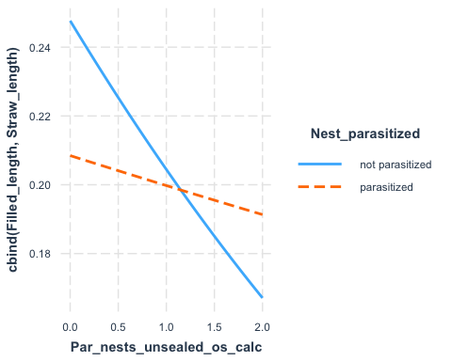
## how related are my treatments to the number of available cavities?
mod_treatment_validation <- lm(Available_cavities_prior ~ Treatment, data = nesting)
summary(mod_treatment_validation)
Call:
lm(formula = Available_cavities_prior ~ Treatment, data = nesting)
Residuals:
Min 1Q Median 3Q Max
-6.6026 -0.3716 0.3583 0.6284 2.3974
Coefficients:
Estimate Std. Error t value Pr(>|t|)
(Intercept) 6.64173 0.01092 608.1 <2e-16 ***
TreatmentLow 10.72984 0.01544 695.1 <2e-16 ***
TreatmentMid 4.96084 0.01548 320.5 <2e-16 ***
---
Signif. codes: 0 '***' 0.001 '**' 0.01 '*' 0.05 '.' 0.1 ' ' 1
Residual standard error: 1.019 on 26058 degrees of freedom
Multiple R-squared: 0.9489, Adjusted R-squared: 0.9489
F-statistic: 2.42e+05 on 2 and 26058 DF, p-value: < 2.2e-16
ggpredict(mod_treatment_validation, c('Treatment')) # predicted number of cavities is excellent
# Predicted values of Available_cavities_prior
Treatment | Predicted | 95% CI
--------------------------------------
Low | 17.37 | [17.35, 17.39]
Mid | 11.60 | [11.58, 11.62]
High | 6.64 | [ 6.62, 6.66]
## checking unscaled estimates
mean_meg_no_ps_prior <- mean(nesting_meg_xs$Meg_no_ps_prior)
sd_meg_no_ps_prior <- sd(nesting_meg_xs$Meg_no_ps_prior)
scaled_estimate_meg <- 0.2578
unscaled_estimate_meg <- scaled_estimate_meg * sd_meg_no_ps_prior + mean_meg_no_ps_prior
unscaled_estimate_meg
[1] 0.3350737
mean_os_no_ps_prior <- mean(nesting_os_xs$Osmia_no_ps_prior)
sd_os_no_ps_prior <- sd(nesting_os_xs$Osmia_no_ps_prior)
scaled_estimate_os <- 0.36480
unscaled_estimate_os <- scaled_estimate_os * mean_os_no_ps_prior + mean_os_no_ps_prior
unscaled_estimate_os
[1] 1.187053
# ## Check that cbind() is identical to manually making the response matrix
# # make two columns with cbind that I will use in my models, as an example
# testing_cbind <- cbind(nesting_os_xs$New_nests_os, nesting_os_xs$Available_cavities_prior - nesting_os_xs$New_nests_sum)
# testing_cbind <- as.data.frame(testing_cbind)
# # manually calculate columns
# testing_manual <- nesting_os_xs %>% mutate(Successes = New_nests_os, Failures = Available_cavities_prior - New_nests_sum)
# # compare them, should be identical
# table(testing_manual$Successes == testing_cbind$V1) # great
# table(testing_manual$Failures == testing_cbind$V2) # great
# ## Models I didn't use
# ### New nests per available cavities Osmia POISSON ### Model 1
# mod_choice_cav_os_POISSON <- glmer(New_nests_os ~ scale(Available_cavities_prior) + scale(Good_days) + poly(Day_of_year,2) + Site + (1|Subsite/Trapnest), data = nesting_os_xs, family = poisson())
# plot(simulateResiduals(mod_choice_cav_os_POISSON))
# summary(mod_choice_cav_os_POISSON)
# vif(mod_choice_cav_os_POISSON)
# ### New nests per conspecifics Osmia, without pseudo ### Model 4
# mod_choice_consp_os_no_ps_POISSON <- glmer(New_nests_os ~ offset(log(Available_cavities_prior - New_nests_sum))+ scale(Osmia_no_ps_prior) + scale(Good_days) + poly(Day_of_year,2) + Site + (1|Subsite) + (1|Trapnest), data = nesting_os_xs, family = poisson(), control=glmerControl(optimizer="bobyqa",optCtrl=list(maxfun=1000000)))
# plot(simulateResiduals(mod_choice_consp_os_no_ps_POISSON)) #
# summary(mod_choice_consp_os_no_ps_POISSON)
# vif(mod_choice_consp_os_no_ps_POISSON)
# # effects of poisson and bnomial identical
# plot(allEffects(mod_choice_consp_os_no_ps))
# plot(allEffects(mod_choice_consp_os_no_ps_POISSON))
# ### New nests per conspecifics Megachile, without pseudo ### Model 6
# mod_choice_consp_meg_no_ps_POISSON <- glmer(New_nests_meg ~ offset(log(Available_cavities_prior - New_nests_sum))+ scale(Meg_no_ps_prior) + scale(Good_days) + poly(Day_of_year,2) + Site + (1|Subsite/Trapnest), data = nesting_os_xs, family = poisson())
# plot(simulateResiduals(mod_choice_consp_meg_no_ps_POISSON)) #
# summary(mod_choice_consp_meg_no_ps_POISSON)
# vif(mod_choice_consp_meg_no_ps_POISSON)
# # effects of poisson and bnomial identical
# plot(allEffects(mod_choice_consp_meg_no_ps))
# plot(allEffects(mod_choice_consp_meg_no_ps_POISSON))

