Statistical Evaluation of GDP Growth in Indonesia and the Philippines

A hypothesis testing activity submitted by

Tovi R. Macalipsay
T09-A

Engr. Gyro A. Madrona
Instructor

Computer Engineering Technology
TECHNOLOGICAL UNIVERSITY OF THE PHILIPPINES VISAYAS
February 2026

1. About the Dataset
The dataset used in this analysis contains annual Gross Domestic Product (GDP) growth values (measured as percentages) for Indonesia and the Philippines, where each record represents the yearly economic expansion or contraction for a given year between 2000 and 2024.
Source: https://www.kaggle.com/datasets/abidhussai512/global-economic-indicators-dataset

2. Statistical Question
Is the annual GDP growth percentage of Indonesia significantly higher than that of the Philippines between the years 2000 and 2024?
3. Hypotheses
$$H_{o}: μ_{IDN}=μ_{PHL}$$
$$H_{a}: μ_{IDN}>μ_{PHL}$$

4. Test Statistic
4.1 Summary of statistics
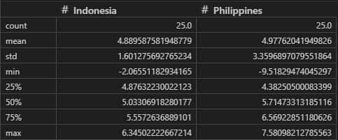
4.2 Boxplot
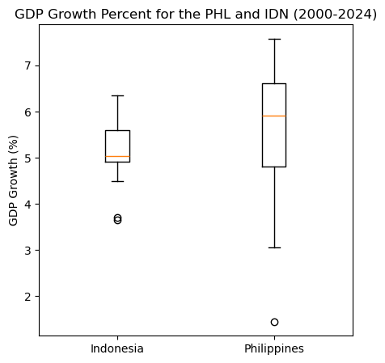
4.3 Normality Test
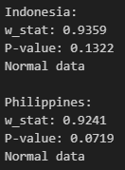
4.4 F-Test
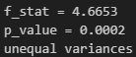
4.5 2-Sample t-Test
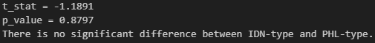
4.6 Power of the Test


5. Conclusion
This statistical analysis aimed to determine if Indonesia's historical GDP growth (2000-2024) was significantly greater than that of the Philippines, but ultimately found no significant difference between the two economies. After confirming the data was normally distributed but exhibited strictly unequal variances—highlighting that the Philippine economy is significantly more volatile with higher peaks and deeper recessions than the steadier Indonesian economy—a Welch's t-test was conducted. The resulting p-value of 0.8797 vastly exceeded the 0.05 threshold, meaning we confidently fail to reject the null hypothesis; both nations share a nearly identical long-term average growth rate of approximately 4.9%. Furthermore, the incredibly small effect size (0.2675) combined with an underpowered sample size of roughly 24 years (resulting in only 35.45% statistical power) mathematically confirms that their historical economic trajectories are simply too similar to definitively declare one as outperforming the other without decades of additional data.

