OV7670 Camera — DE10-Lite FPGA Connection Schematic
640 × 480 VGA, RGB565, real-time streaming • MAX10 10M50DAF484C7G

1 Signal connection schematic
All 14 signal lines between the OV7670 and the DE10-Lite GPIO_0 header pass through a TXS0108E 8-channel bidirectional level shifter (1.8V side A, 3.3V side B). The SCCB bus (SIOC, SIOD) additionally requires 4.7 kΩ open-drain pull-up resistors to 3.3V.
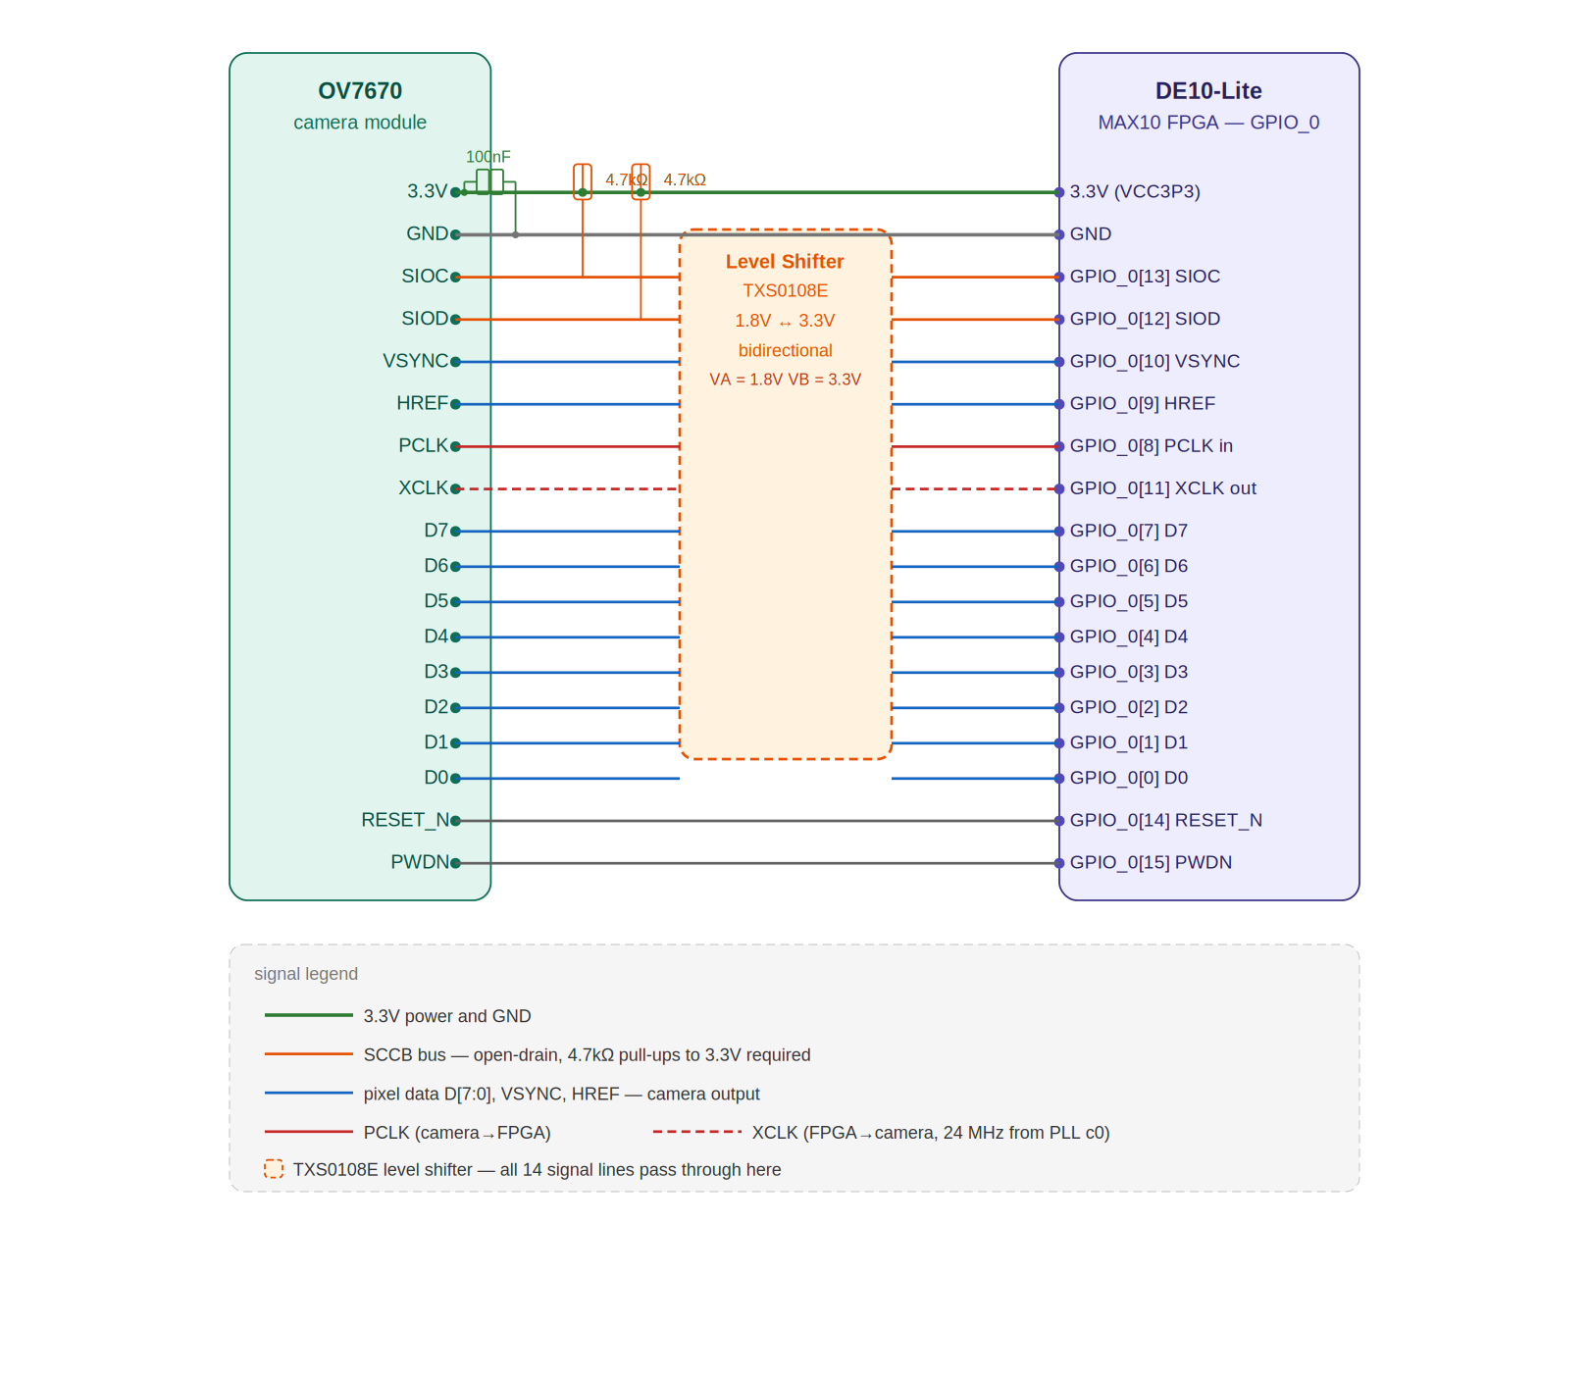
Figure 1 — Signal schematic: OV7670 ↔ TXS0108E level shifter ↔ DE10-Lite GPIO_0

2 Power supply schematic
The OV7670 requires three separate supply rails. None of these are available directly from the DE10-Lite GPIO header — they must be generated by external LDO regulators.
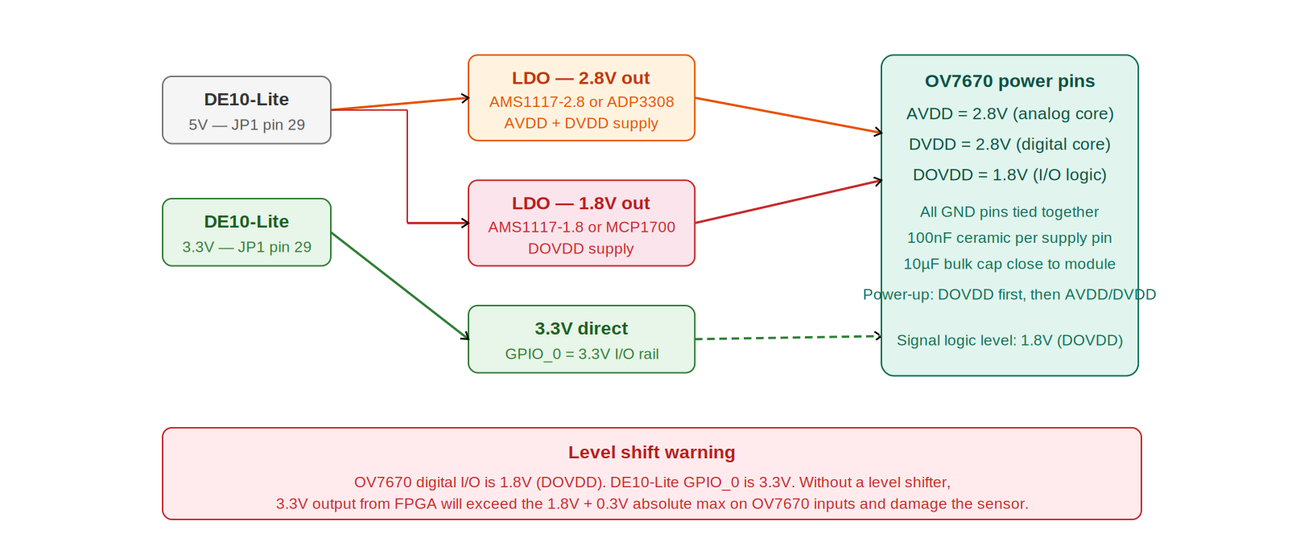
Figure 2 — Power supply: LDO regulators generating 2.8V and 1.8V from the DE10-Lite 5V rail

3 Power supply requirements
Pin | Voltage | Function | Source | Decoupling
AVDD | 2.8V | Analog pixel array power | AMS1117-2.8 from 5V | 100 nF + 10 µF
DVDD | 2.8V | Digital core power | AMS1117-2.8 shared | 100 nF + 10 µF
DOVDD | 1.8V | Digital I/O power | AMS1117-1.8 from 5V | 100 nF + 10 µF
GND | 0V | All grounds tied together | DE10-Lite GND | Star point near module

Power-up sequence: apply DOVDD (1.8V) before AVDD/DVDD (2.8V). Hold RESET_N low until both supplies are stable. The i2c_top.vhd firmware already enforces this by keeping RESET_N low for 5 ms after global rst_n releases.

4 Pin-by-pin wiring table
JP1 is the 40-pin GPIO_0 header on the DE10-Lite board. All signal lines must pass through the TXS0108E before reaching the camera module.
JP1 | GPIO_0 index | Direction | OV7670 | Signal | Notes
1 | VCC3P3 | power | VCC | 3.3V | 100 nF + 10 µF decoupling near module
2 | GND | power | GND | Ground | Common ground
3 | GPIO_0[0] | FPGA ← cam | D0 | D0 | Pixel bit 0
4 | GPIO_0[1] | FPGA ← cam | D1 | D1 | Pixel bit 1
5 | GPIO_0[2] | FPGA ← cam | D2 | D2 | Pixel bit 2
6 | GPIO_0[3] | FPGA ← cam | D3 | D3 | Pixel bit 3
7 | GPIO_0[4] | FPGA ← cam | D4 | D4 | Pixel bit 4
8 | GPIO_0[5] | FPGA ← cam | D5 | D5 | Pixel bit 5
9 | GPIO_0[6] | FPGA ← cam | D6 | D6 | Pixel bit 6
10 | GPIO_0[7] | FPGA ← cam | D7 | D7 MSB | Pixel bit 7 (most significant)
11 | GPIO_0[8] | FPGA ← cam | PCLK | PCLK | Pixel clock from OV7670 (~24 MHz)
12 | GPIO_0[9] | FPGA ← cam | HREF | HREF | Line valid (high = valid pixel)
13 | GPIO_0[10] | FPGA ← cam | VSYNC | VSYNC | Frame sync (high = blanking)
14 | GPIO_0[11] | FPGA → cam | XCLK | XCLK | Master clock to camera — 24 MHz from PLL c0
15 | GPIO_0[12] | bidirectional | SIOD | SIOD | SCCB data — 4.7 kΩ pull-up to 3.3V
16 | GPIO_0[13] | FPGA → cam | SIOC | SIOC | SCCB clock — 4.7 kΩ pull-up to 3.3V
17 | GPIO_0[14] | FPGA → cam | RESET_N | RESET_N | Hardware reset (active low)
18 | GPIO_0[15] | FPGA → cam | PWDN | PWDN | Power-down (tie low / drive 0 to enable camera)

5 Critical design notes

5.1 Level shifting — mandatory
The OV7670 digital I/O operates at 1.8V (DOVDD rail). The DE10-Lite GPIO_0 header is 3.3V. Connecting directly will present 3.3V to OV7670 inputs whose absolute maximum is 1.8V + 0.3V = 2.1V — this will permanently damage the sensor.
- Use a TXS0108E (Texas Instruments) — 8-channel auto-direction, 1.8V ↔ 3.3V.
- VA pin → 1.8V (DOVDD), VB pin → 3.3V, OE pin → 3.3V (always enabled).
- You need 2 × TXS0108E (or 1 × TXS0102 for SCCB + 1 × TXS0108E for 8 data+sync lines).
- Place the level shifter as close to the camera module as possible to minimise trace length on the 1.8V side.

5.2 SCCB pull-up resistors
- SIOC and SIOD are open-drain. Both lines require 4.7 kΩ pull-up resistors to 3.3V.
- Place resistors on the 3.3V side of the level shifter (between the TXS0108E B-side and the FPGA).
- Without pull-ups, the SCCB bus will not reach logic-high and no registers will be written.

5.3 XCLK — 24 MHz master clock
- XCLK is driven from pll_main output c0 (24 MHz, 0°) via GPIO_0[11].
- This is a standard FPGA output — no external buffer is needed.
- The OV7670 will generate its own PCLK output after SCCB configuration is complete.
- PCLK frequency = XCLK / 2 when CLKRC register is set to 0x01 (pre-scalar = /2).

5.4 Decoupling capacitors
- Place one 100 nF ceramic capacitor and one 10 µF electrolytic capacitor at each power pin (AVDD, DVDD, DOVDD) directly on the camera module PCB.
- Power supply noise is the most common cause of unstable colour and image flickering.
- Add a 100 nF cap on the 3.3V line at the GPIO_0 header connector.

5.5 FPGA QSF pin assignments
The following assignments correspond to the GPIO_0 header on the DE10-Lite. Verify against the DE10-Lite User Manual (Rev. C) before programming.
Signal | GPIO_0 index | QSF assignment example
D[7:0] | GPIO_0[7:0] | PIN_AG28..PIN_AH27
PCLK | GPIO_0[8] | PIN_AH26
HREF | GPIO_0[9] | PIN_AH24
VSYNC | GPIO_0[10] | PIN_AH23
XCLK out | GPIO_0[11] | PIN_AG23
SIOD | GPIO_0[12] | PIN_AF23
SIOC | GPIO_0[13] | PIN_AG24
RESET_N | GPIO_0[14] | PIN_AF24
PWDN | GPIO_0[15] | PIN_AH25

These pin numbers are based on the standard DE10-Lite GPIO_0 header mapping. Always cross-reference with the Physical Constraints File in your Quartus project and the board schematic.

