# Train：

训练集语音时长：

train: avg :2.9215892401918437, max:15.1120625 , min :1.092375，totalnumber: 11572

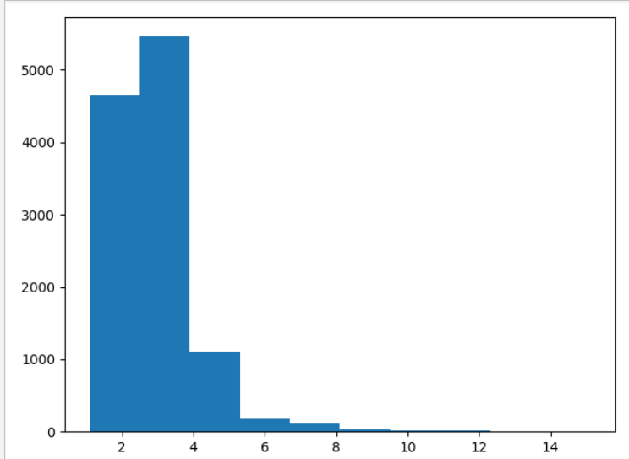

# Test

测试集语音时长：

test: avg :2.514601031553396, max:9.768875 , min :1.2375625，totalnumber: 824

