VIETNAM GENERAL CONFEDERATION OF LABOR
TON DUC THANG UNIVERSITY
FACULTY OF INFORMATION TECHNOLOGY



NGO LAM TIEN – 524H0195
NGUYEN CONG THANH – 524H0191
NGUYEN LE NHAT TAM – 524H0186
NGO BINH MINH – 524H0169
Group: VibeCoding_Expert

MIDTERM REPORT

DATA ANALYSIS AND VISUALIZATION
SOCIAL-MEDIA SENTIMENT ANALYSIS FOR A NEW F&B PRODUCT LAUNCH

HO CHI MINH CITY, 2026

VIETNAM GENERAL CONFEDERATION OF LABOR
TON DUC THANG UNIVERSITY
FACULTY OF INFORMATION TECHNOLOGY

NGO LAM TIEN – 524H0195
NGUYEN CONG THANH – 524H0191
NGUYEN LE NHAT TAM – 524H0186
NGO BINH MINH – 524H0169
Group: VibeCoding_Expert

MIDTERM REPORT

DATA ANALYSIS AND VISUALIZATION
SOCIAL-MEDIA SENTIMENT ANALYSIS FOR A NEW F&B PRODUCT LAUNCH
Advised by
Ho Thi Linh, Ph.D.

HO CHI MINH CITY, 2026
ACKNOWLEDGEMENT

We would like to thank Dr. Ho Thi Linh, our lecturer in Data Analysis and Visualization, for the lectures and feedback that shaped this project. The course gave us the framework we used from the first page to the last: start from the decision, describe the data honestly, look for causes before predicting, and only then recommend what to do. We are also grateful to the teaching assistants and lab instructors, whose weekly exercises on charts, confidence intervals and regression turned into the tools of this report. Any remaining errors are our own.

Ho Chi Minh City, 15th October 2026
Author
(Signature and full name)

Tien  Ngo Lam Tien | Thanh  Nguyen Cong Thanh
Tam  Nguyen Le Nhat Tam | Minh  Ngo Binh Minh

DECLARATION OF AUTHORSHIP
We hereby declare that this report is our own work, carried out under the guidance of Dr. Ho Thi Linh. The analysis, code, figures and conclusions in it have not been published in any form before. All data used for the analysis come from the public Sentiment140 dataset, and every other source is cited in the References section.
In addition, the report uses ideas and methods from other authors and organisations, always with a citation. The manual spot-check of 210 tweets described in Section 2.5 was carried out with the help of an AI assistant, and we say so wherever the result is used.
If anything in this report proves to be wrong, we take full responsibility for its content. Ton Duc Thang University is not involved in any copyright infringement that may arise from our work (if any).
Ho Chi Minh City, 15th October 2026
Author
(Signature and full name)

Tien  Ngo Lam Tien | Thanh  Nguyen Cong Thanh
Tam  Nguyen Le Nhat Tam | Minh  Ngo Binh Minh

TABLE OF CONTENT
CHAPTER 1. INTRODUCTION 1
1.1 Background and business problem 1
1.2 Objectives and analytical questions 1
1.3 Hypotheses 2
1.4 Scope and the proxy approach 3
1.5 Structure of the report 3
CHAPTER 2. DATA 4
2.1 Data source 4
2.2 Data profile and quality problems 4
2.3 Cleaning and preparation 6
2.4 Building the F&B conversation stream 7
2.5 Checking the dictionary by reading a sample 8
2.6 Train, validation and test design 9
CHAPTER 3. DESCRIPTIVE ANALYSIS 11
3.1 How large and how negative is the F&B conversation? 11
3.2 What do people talk about? 12
3.3 How do people write? 14
3.4 How did sentiment move over time? 15
3.5 Which parts of the experience are discussed? 16
3.6 Summary of the descriptive findings 16
CHAPTER 4. DIAGNOSTIC ANALYSIS 17
4.1 Method 17
4.2 Which aspects are associated with negative tweets? 18
4.3 Testing the hypotheses 19
4.4 Holding other factors constant: logistic regression 19
4.5 When do complaints happen? 21
4.6 The words behind negative tweets 22
4.7 Main discussion topics 22
4.8 Summary and caveats 24
CHAPTER 5. PREDICTIVE ANALYSIS 25
5.1 Problem formulation 25
5.2 How the data are split, and why by time 25
5.3 Features and models 26
5.4 Tuning on the validation week 27
5.5 Results on the test week 27
5.6 Robustness checks 30
5.7 Interpreting the model 31
5.8 Error analysis 33
CHAPTER 6. PRESCRIPTIVE ANALYSIS 34
6.1 Decision rule 34
6.2 Expected sentiment next week 34
6.3 Priority matrix 35
6.4 What-if simulation and alert rule 36
6.5 Recommendations 37
6.6 Action plan for next week 38
6.7 Monitoring dashboard 39
CHAPTER 7. CONCLUSION 41
7.1 Answers to the research questions 41
7.2 Limitations 41
7.3 Future work 42
CHAPTER 8. TASK ALLOCATION 43
REFERENCES 44

LIST OF FIGURES
Figure 2.1. Tweets per day and label in the raw file (grey bands: no data collected) 5
Figure 2.2. From the raw file to the analysis-ready F&B stream 7
Figure 3.1. Share of the F&B conversation by primary category 12
Figure 3.2. Pareto chart of brand mentions (the line is the cumulative share) 13
Figure 3.3. Distribution of tweet length by sentiment (vertical lines: medians) 14
Figure 3.4. Daily negative share of F&B tweets and of all tweets (shaded band: 95% CI for F&B) 15
Figure 3.5. Share of F&B tweets mentioning each aspect 16
Figure 4.1. Negative share by aspect with 95% confidence intervals (labels: lift vs the rest of F&B) 18
Figure 4.2. Negative lift by aspect and time of day (pp vs all F&B tweets in the same daypart) 21
Figure 4.3. Words that best separate negative from positive F&B tweets (weighted log-odds z-scores) 22
Figure 5.1. Model comparison on the test week (error bars: 95% bootstrap CIs) 28
Figure 5.2. ROC curves on the test week (dots: thresholds chosen on validation) 29
Figure 5.3. Confusion matrix of Logistic Regression on the test week (row percentages) 29
Figure 5.4. The 15 strongest Logistic Regression coefficients in each direction 31
Figure 5.5. Local explanation of two F&B test tweets: contribution of each term to the log-odds 32
Figure 6.1. Priority matrix: share of voice, negative lift and expected negative tweets next week 35
Figure 6.2. Left: what-if simulation. Right: daily alert rule back-tested on all observed weeks 36
Figure 6.3. Dashboard, overview tab (KPI tiles, daily trend and share of voice) 39
Figure 6.4. Dashboard, "try the model" tab with the term-by-term explanation 40

LIST OF TABLES
Table 1.1. Analytical questions and methods for each type of analytics 2
Table 2.1. Data dictionary of the raw file 4
Table 2.2. Cleaning log 6
Table 2.3. Aspect dictionary 8
Table 2.4. Precision of the F&B dictionary in the manual review 9
Table 2.5. Time-based split of the clean corpus 10
Table 3.1. All tweets and F&B tweets by period 11
Table 4.1. Hypothesis tests H1-H4 (Holm-adjusted p-values) 19
Table 4.2. Odds ratios from the logistic regression (n = 84,632; 38 day effects not shown) 19
Table 4.3. Topics found by NMF (k = 8) and their negative lift vs the rest of F&B 23
Table 5.1. Hyper-parameter tuning on the validation week 27
Table 5.2. Test-week results at the thresholds chosen on validation (95% bootstrap CIs, 200 resamples) 27
Table 5.3. Robustness of Logistic Regression 30
Table 6.1. Recommendations and the evidence behind them 37
Table 6.2. Action plan for the coming week 38
Table 8.1. Task allocation 43

LIST OF ABBREVIATIONS
ACC | Adjusted classify-and-count (correction of a predicted share for the model's error rates)
AUC | Area under the ROC curve
CI | Confidence interval (95% unless stated otherwise)
F&B | Food and beverage
FPR / TPR | False positive rate / true positive rate
LR | Logistic Regression
MNB / NB | Multinomial Naive Bayes
NMF | Non-negative Matrix Factorisation
OR | Odds ratio
PDT | Pacific Daylight Time, the time zone of every timestamp in the dataset
pp | Percentage points (difference between two percentages)
ROC | Receiver operating characteristic
SD | Standard deviation
TF-IDF | Term frequency - inverse document frequency
UCL | Upper control limit (alert limit)

INTRODUCTION

Background and business problem
The first week after a product launch is when a brand finds out whether its message has landed. For a food and beverage (F&B) brand this conversation happens quickly and informally on social media: people tweet about their lunch, complain about a long queue or tell friends to try a new drink. In our scenario we are the Social Listening team of an F&B brand that has just launched a new product. During launch week the reactions online are mixed, and the marketing team has to decide, within days, whether the campaign message for the coming week should change.
This report answers that question with data. It follows the five-step process of data analytics taught in Chapter 1 of the course (define the problem, collect the data, clean and explore it, analyse it, report the findings) and the four types of analytics: descriptive, diagnostic, predictive and prescriptive. Each type has its own chapter, and the prescriptive chapter only recommends actions that can be traced back to a specific number found in the three chapters before it.

Objectives and analytical questions
Following the advice to "reframe broad questions into actionable, data-driven queries" (Chapter 1), we split the marketing question, should we adjust the message next week, and if so where?, into four questions, one for each type of analytics (Table 1.1).
Table 1.1. Analytical questions and methods for each type of analytics
Type | Question in this project | Main methods
Descriptive: what happened? | How large is the F&B conversation, what is it about, and how negative is it compared with all tweets? | Counts, shares, donut, Pareto, histogram, line chart
Diagnostic: why did it happen? | Which aspects of the experience and which moments are associated with negative tweets? | CIs for proportions, z-tests, logistic regression, distinctive words, topic model
Predictive: what is likely to happen? | Can a model trained on past weeks label next week's tweets reliably? | Time-based split, Naive Bayes vs Logistic Regression, model interpretation
Prescriptive: what should we do? | Which message changes should be made, how much can they move the KPI, and when should the team be alerted? | Decision rule, priority matrix, what-if simulation, alert rule

Four indicators run through the report. The negative lift is the share of negative tweets in a group minus the share in its comparison group, expressed in percentage points (pp). The odds ratio from a logistic regression measures the same association while holding other factors constant. The negative-class F1 and ROC-AUC measure how well the classifier finds negative tweets. Finally, the number of days on which the daily lift breaks an alert limit tells the team when to act.

Hypotheses
We wrote four hypotheses down before looking at any result. All are two-sided, tested at α = 0.05, and corrected with the Holm procedure because four tests are run together (Holm, 1979):
- H1. Tweets about service and waiting have a different negative share from the rest of the F&B conversation.
- H2. Tweets about price and value have a different negative share from the rest of the F&B conversation.
- H3. Morning-caffeine tweets have a different negative share from the rest of the F&B conversation.
- H4. The F&B negative lift during launch week differs from the lift in the baseline weeks.
With tens of thousands of tweets almost any difference becomes statistically significant, a point Chapter 5 of the course makes explicitly. We therefore also fixed a practical threshold in advance: a difference matters for the business only if it is at least 5 pp, or if an odds ratio falls outside the range 0.8 to 1.25.

Scope and the proxy approach
The dataset assigned to our topic is Sentiment140, 1.6 million English tweets posted between April and June 2009. It is not about one brand, and no real product launch in that period left enough tweets to study (for example, only 17 tweets mention McCafé). We therefore treat the tweets that talk about food and drink as a proxy for the category conversation in which a new F&B product would be discussed. The sentiment model is trained on the whole cleaned corpus, because more text teaches it more language, and is then applied to the F&B stream.
To match the scenario, we give the calendar three roles. The weeks from 6 April to 31 May are the baseline, 1 to 7 June plays the role of launch week, and 14 to 16 June is the next week, the period the marketing team is planning for. These roles are a simulation device: they let us ask whether launch week looked different from normal and whether a model trained on the past can monitor the future. Chapter 7 returns to the limits of this choice.

Structure of the report
Chapter 2 describes the data, the quality problems we found and how we cleaned it. Chapters 3 to 6 contain the four layers of analysis. Chapter 7 summarises the answers, the limitations and possible next steps, and Chapter 8 shows how the work was shared within the group. The notebook, the dashboard and all exported tables are submitted together with this report, so every number here can be reproduced.

DATA

Data source
Sentiment140 was built by Go, Bhayani and Huang (2009) at Stanford University by searching the Twitter API for tweets that contained a happy or a sad emoticon. The emoticon became the label (0 = negative, 4 = positive) and was then removed from the text, so a model has to learn sentiment from the words alone. This idea is called distant supervision: nobody labelled the tweets by hand. We use the Kaggle copy published by Michailidis (2017), a single CSV file of 238.8 MB without a header row and in Latin-1 encoding. Table 2.1 lists its six columns.
Table 2.1. Data dictionary of the raw file
Column | Type | Meaning | Example
target | Integer (0 / 4) | Polarity from the emoticon: 0 = negative, 4 = positive | 0
ids | Integer | Tweet id | 1467810369
date | Text timestamp | Posting time, always in Pacific Daylight Time (PDT) | Mon Apr 06 22:19:45 PDT 2009
flag | Text | Search query used by the collector | NO_QUERY (the only value)
user | Text | Twitter user name | _TheSpecialOne_
text | Text | Tweet text with the emoticon removed | @switchfoot http://twitpic.com/... Awww, that's a bummer.

The Kaggle description mentions a neutral label (2), but the file contains none. The dataset therefore forces every tweet into one of two classes, which matters later when we read the model's mistakes.

Data profile and quality problems
The file has exactly 1,600,000 rows and no missing values, split 800,000 negative and 800,000 positive, written by 659,775 different users. The timestamps run from 6 April to 25 June 2009, an 81-day span, but only 48 days contain any tweet. Nothing at all was collected on 08 Apr to 16 Apr, 22 Apr to 30 Apr, 05 May to 08 May, 12 May, 15 May, 19 May to 20 May, 24 May, 08 Jun to 13 Jun. Before cleaning anything we counted tweets per day and per label to check whether both labels were collected in the same way. Figure 2.1 shows what we found.
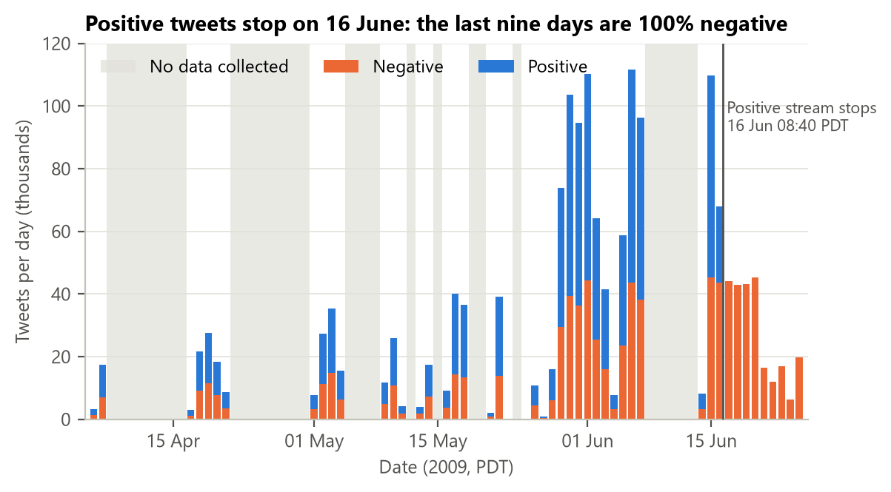
Figure 2.1. Tweets per day and label in the raw file (grey bands: no data collected)
Until the morning of 16 June both labels arrive every day in a similar ratio. After the last positive tweet, posted at 08:40:50 PDT on 16 June, the file still contains 275,225 tweets, and every one of them is negative. People did not suddenly become unhappy; the collector simply stopped searching for positive emoticons. An hour-by-hour check showed that the positive stream ran at its normal pace (about 2,800 tweets per hour) right up to that minute, so we cut exactly at the last positive tweet. Keeping these rows would have produced a fake collapse in sentiment on any trend chart and a test week containing a single class.
Two smaller problems appeared as well. 1,685 tweet ids occur twice with both labels (3,370 rows), probably tweets that contained a happy and a sad emoticon at the same time. And 18,534 rows repeat an earlier text exactly; the most repeated one, "isPlayer Has Died! Sorry", appears 210 times and is clearly produced by a game bot.
The most important consequence of the collection method concerns how we read percentages. Because positive and negative tweets were gathered by separate searches, the overall 50/50 split, or the 60/40 split after cleaning, tells us about the collector rather than about Twitter users. Comparisons between groups collected in the same way remain meaningful: odds ratios, in particular, are unaffected when sampling depends on the outcome, the same property that makes case-control studies work (Prentice and Pyke, 1979). This is also the "raw numbers versus rates" lesson of Chapter 3. Throughout the report we therefore compare groups with each other (lifts and odds ratios) and never read an absolute negative share as "how negative people were".

Cleaning and preparation
Chapter 1 asks analysts to "ensure data integrity and document all changes for transparency and reproducibility". We cleaned the data in five logged steps (Table 2.2). The text was first normalised: HTML codes such as "&quot;" were converted back to characters, links and @usernames were replaced by the placeholder tokens _url_ and _user_, everything was lower-cased, and letters repeated three or more times were shortened ("soooo" becomes "soo"). We deliberately kept negations, exclamation and question marks, because they carry sentiment.
Table 2.2. Cleaning log
Step | Rows before | Removed | Rows after | Kept | Reason
Consistent labels | 1,600,000 | 3,370 | 1,596,630 | 99.8% | Same tweet id labelled both positive and negative
Collection window | 1,596,630 | 275,225 | 1,321,405 | 82.6% | After 16 Jun 08:40:50 only negative tweets were collected
Readable text | 1,321,405 | 3,179 | 1,318,226 | 82.4% | No words left after removing links and @usernames
Unambiguous text | 1,318,226 | 14,139 | 1,304,087 | 81.5% | Identical normalised text appears with both labels
Unique texts | 1,304,087 | 30,053 | 1,274,034 | 79.6% | Later copies of the same text (bots, spam, repeated posts)

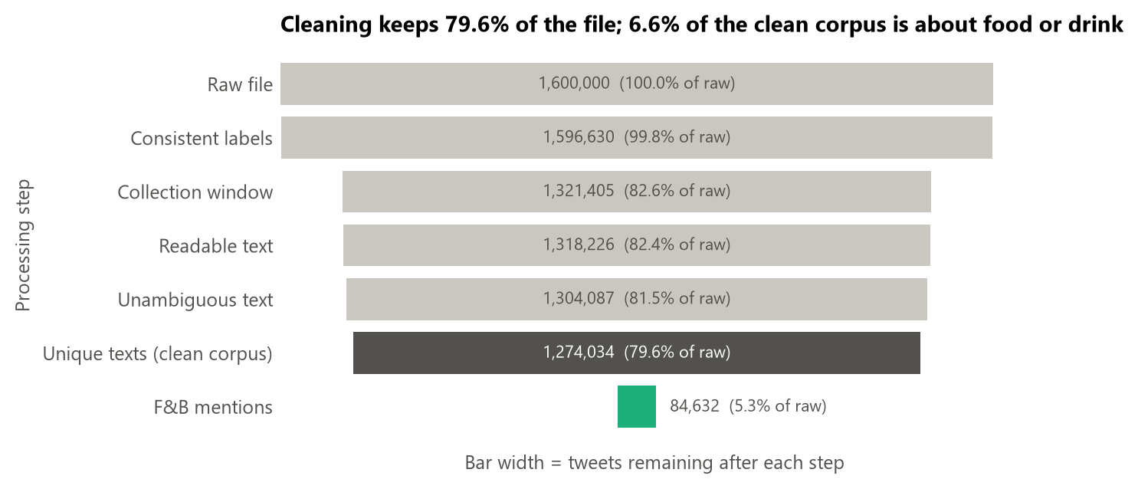
Figure 2.2. From the raw file to the analysis-ready F&B stream
Figure 2.2 summarises the cleaning as a funnel. Cleaning removes 325,966 rows, 20.4% of the file, and 84% of them are the negative-only tail. Dropping ambiguous and repeated texts costs another 2.8%. The clean corpus contains 1,274,034 tweets, of which 60.1% are positive, and it is the input for the predictive model. Keeping only the earliest copy of each text also guarantees that no test tweet has an identical twin in the training data.
From the timestamp and the text we derived the features used later: number of words and characters, whether the tweet contains a link, a mention or a hashtag, the number of exclamation marks, the hour, the weekday, the part of the day (night 0-5h, morning 6-11h, afternoon 12-17h, evening 18-23h, all in PDT) and the period (baseline, launch week, next week).

Building the F&B conversation stream
To find the tweets about food and drink we wrote a dictionary of regular expressions with word boundaries, organised in six categories: Chains & brands (41 named restaurant chains and drink or snack brands), Coffee & tea, Sweets & desserts, Drinks, Dishes and Meals & hunger. A tweet can match several categories; for the share-of-voice chart it is assigned to the most specific one, with brands first and generic meal words last. Ambiguous words were handled with explicit rules. Subway counts only when the tweet also mentions food, Sonic only together with words such as "drive-in" or "slush", and phrases such as "tea party", "piece of cake", "cutie pie" and the band name "Jimmy Eat World" are removed before matching. The dictionary captures 84,632 tweets, 6.6% of the clean corpus, written by 69,033 users.
Inside the F&B stream we also tagged aspects, the parts of the experience a tweet talks about. Sentiment words were kept out of these lists on purpose: an aspect defined by "delicious" or "disgusting" would simply restate the label. We split the aspects into two groups, because only the first can be influenced by a brand message (Table 2.3).
Table 2.3. Aspect dictionary
Aspect | Group | Example keywords
Taste & quality | Product-directed | taste, flavour, recipe, quality, fresh, spicy, soggy, portion
Price & value | Product-directed | price, expensive, cheap, money, deal, coupon, $ + number
Service & wait | Product-directed | service, staff, barista, line, waiting, drive-thru, order, delivery ("can't wait" excluded)
Availability | Product-directed | sold out, ran out, closed, no more, discontinued, couldn't find
Novelty & trial | Product-directed | new, tried the ..., first time, never had, limited edition, launch
Hunger & cravings | Context | hungry, starving, craving, munchies, haven't eaten
Health & diet | Context | diet, calories, healthy, gym, sick, stomach, junk food
Morning caffeine | Context | a caffeine word together with morning, woke, tired, Monday, "need my coffee"
Social occasions | Context | friends, family, mom, date, party, BBQ, birthday

Checking the dictionary by reading a sample
A keyword filter is only useful if what it catches is really about food. We drew a stratified random sample of 210 F&B tweets, 35 per category, and read every one of them, recording whether the tweet is genuinely about food or drink and what sentiment a human reader would give it (positive, negative or neutral). Disclosure: this review was carried out with the help of an AI assistant by a single reviewer, so it has no inter-rater agreement figure and should be read as a spot-check rather than a gold standard. The labelled file is submitted with the notebook.
Table 2.4. Precision of the F&B dictionary in the manual review
Category | Really about food or drink | Precision
Chains & brands | 34 / 35 | 97.1%
Drinks | 33 / 35 | 94.3%
Coffee & tea | 32 / 35 | 91.4%
Meals & hunger | 30 / 35 | 85.7%
Sweets & desserts | 29 / 35 | 82.9%
Dishes | 29 / 35 | 82.9%
All categories | 187 / 210 | 89.0% (CI 84.8% to 93.3%)

187 of the 210 sampled tweets are really about food or drink, a precision of 89.0%. Using the confidence interval for one proportion from Chapter 4, p̂ ± 1.96·√(p̂(1 − p̂)/n), the true precision lies between 84.8% and 93.3% with 95% confidence. Most misses are figurative uses: pet names ("my cupcake", "love muffin"), idioms ("I'll drink to that", "starving artist") and meal words used only as a time reference ("signing off until lunch"). On the tweets with a clear sentiment, the emoticon label agrees with the reader 96.9% of the time, while 15% of on-topic tweets read as neutral, a reminder that the dataset has no neutral class.

Train, validation and test design
The predictive model will be used on tweets that do not exist yet, so we split the data by time rather than at random (Table 2.5). The model learns from the baseline weeks, its settings and decision threshold are chosen on launch week, and the next week is kept aside and used only once, at the very end. The six days without data between 8 and 13 June act as a natural buffer between tuning and testing. Chapter 5 explains the choice in detail and compares it with a random split.
Table 2.5. Time-based split of the clean corpus
Set | Dates (2009) | Tweets | Share | Negative | F&B tweets | Role
Train | 06 Apr - 31 May | 653,345 | 51.3% | 39.6% | 44,184 | Fit the models
Validation | 01 Jun - 07 Jun | 469,953 | 36.9% | 39.9% | 30,921 | Choose hyper-parameters and threshold
Test | 14 Jun - 16 Jun 08:40 | 150,736 | 11.8% | 40.9% | 9,527 | Final evaluation, used once

DESCRIPTIVE ANALYSIS
Descriptive analytics answers "What happened?" and "How many?" with counts, percentages and charts (Chapter 1). Each chart in this chapter was chosen for the job it does, following Chapter 2 of the course: a donut for a part-to-whole split, a Pareto chart to find the few brands that matter, a histogram for a distribution, a line chart for change over time and a bar chart to compare categories.

How large and how negative is the F&B conversation?
Table 3.1. All tweets and F&B tweets by period
Period | All tweets | F&B tweets | F&B share | Negative, all | Negative, F&B | Lift (pp)
Baseline | 653,345 | 44,184 | 6.8% | 39.6% | 34.5% | -5.1
Launch week | 469,953 | 30,921 | 6.6% | 39.9% | 34.5% | -5.4
Next week | 150,736 | 9,527 | 6.3% | 40.9% | 36.8% | -4.2
All periods | 1,274,034 | 84,632 | 6.6% | 39.9% | 34.8% | -5.1

About one tweet in fifteen (6.6%) is about food or drink, and that share is stable across the three periods. F&B tweets are 34.8% negative against 39.9% for all tweets, a lift of -5.1 pp. The lift during launch week (-5.4 pp) is almost the same as in the baseline weeks (-5.1 pp) and narrows slightly to -4.2 pp in the next week. The raw counts per period mainly reflect how long the collector ran each week, so from here on we compare shares, not counts.

What do people talk about?
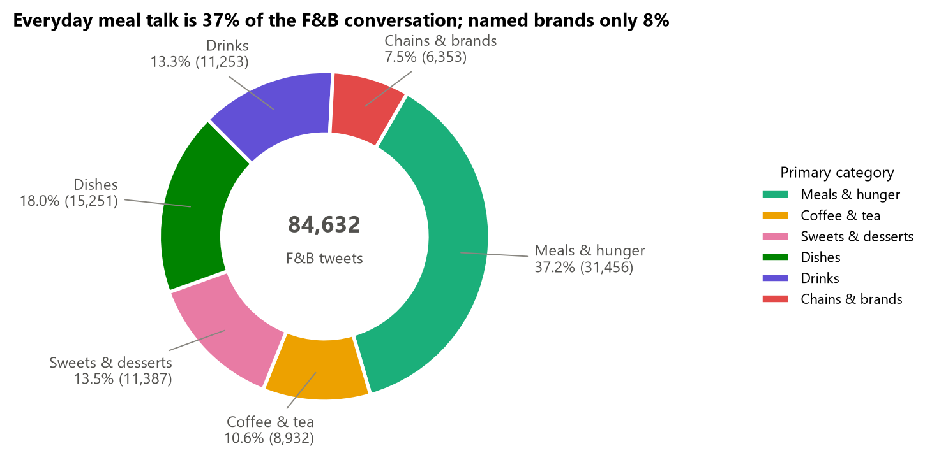
Figure 3.1. Share of the F&B conversation by primary category
Figure 3.1 shows that more than a third of the F&B conversation (37.2%) is everyday meal talk such as "lunch", "dinner" or "so hungry", while only 7.5% of the tweets name a chain or a brand. A brand that listened only for its own name would miss most of the category conversation in which its product is actually discussed.
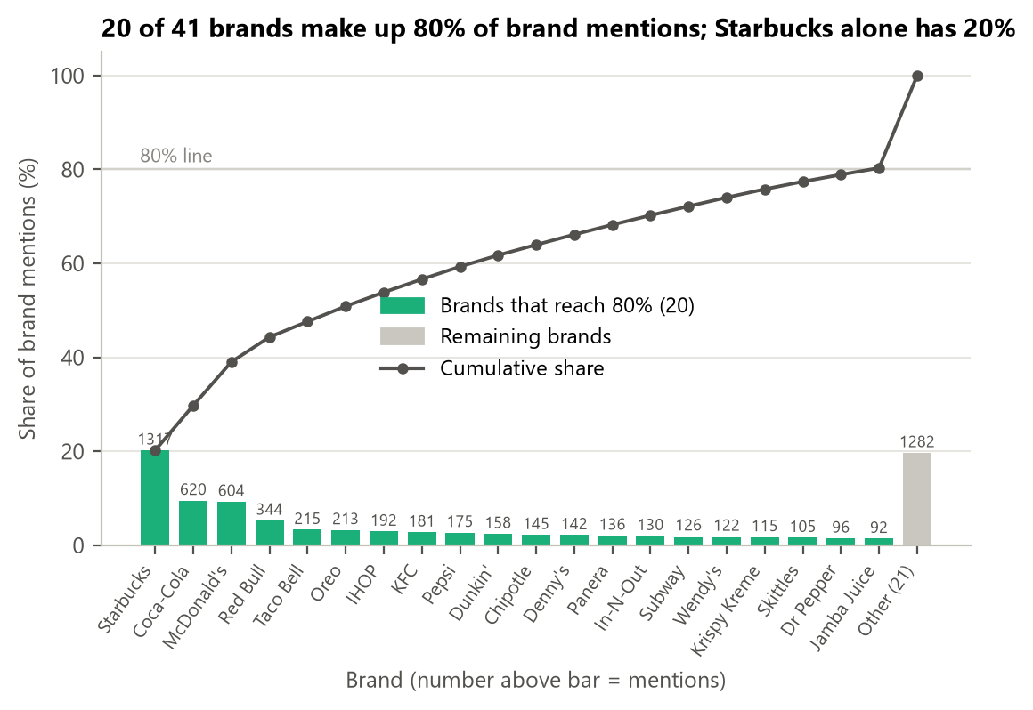
Figure 3.2. Pareto chart of brand mentions (the line is the cumulative share)
Brand mentions have a long tail (Figure 3.2): 20 of the 41 brands in our list account for 80% of them, and Starbucks alone has 20% (1,317 mentions), ahead of Coca-Cola (620) and McDonald's (604). Among brands with more than 100 mentions, Krispy Kreme (55% negative) and Wendy's (52%) are the most negative, although these samples are small.

How do people write?
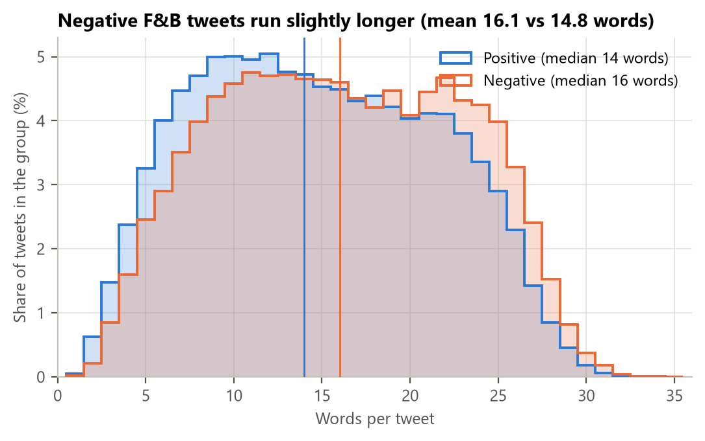
Figure 3.3. Distribution of tweet length by sentiment (vertical lines: medians)
Both distributions in Figure 3.3 are close to symmetric (skewness 0.02 for negative and 0.13 for positive tweets) and are capped by the 140-character limit of 2009. Negative tweets are about 1.3 words longer on average (16.1 against 14.8 words; medians 16 and 14). With 84,632 tweets, Welch's t-test from Chapter 5 is highly significant (t′ = 27.3), yet Cohen's d is only 0.20, a small effect. People explain a bad experience slightly more than a good one, but length alone says little about sentiment.

How did sentiment move over time?
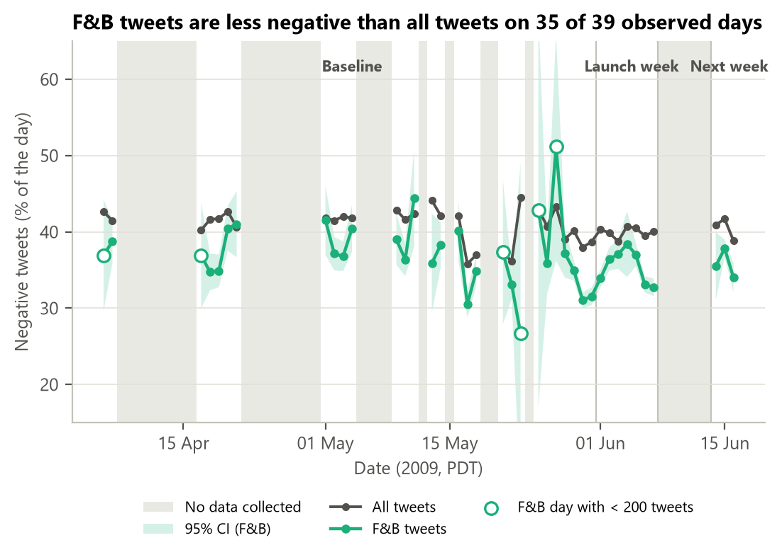
Figure 3.4. Daily negative share of F&B tweets and of all tweets (shaded band: 95% CI for F&B)
The F&B line in Figure 3.4 sits below the all-tweets line on 35 of the 39 observed days, by 3.9 pp on average. The few spikes, for example 51% on 27 May, happen on days with fewer than 200 F&B tweets, where the confidence band is very wide, so they are noise rather than events. Line breaks mark the days without data, as Chapter 3 recommends not to draw a trend across missing points. Nothing unusual happens during launch week: the gap between the two lines stays inside its usual range.

Which parts of the experience are discussed?
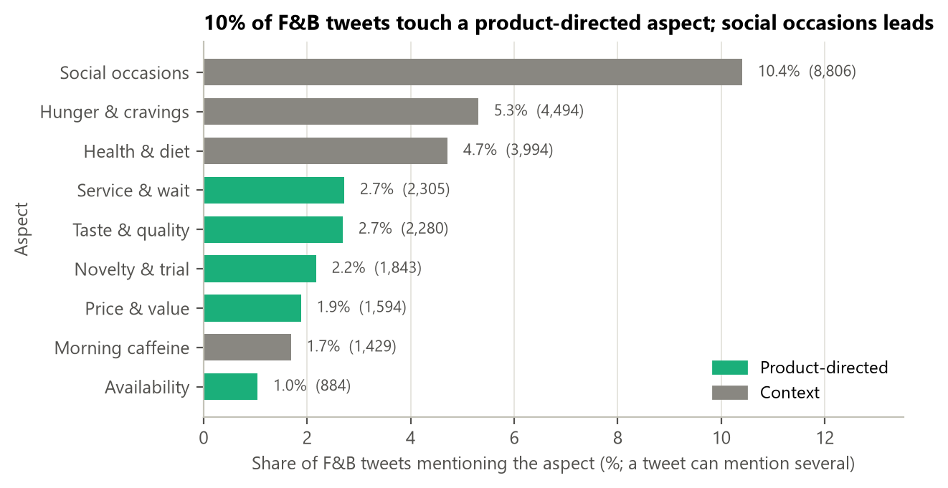
Figure 3.5. Share of F&B tweets mentioning each aspect
Only 10.1% of F&B tweets touch a product-directed aspect (Figure 3.5). Context aspects are more common, led by social occasions (10.4%), and 70.5% of tweets match no aspect at all, which is normal for messages of 140 characters. Service and waiting (2.7%) and taste (2.7%) are the most discussed product aspects; availability is the rarest (1.0%).

Summary of the descriptive findings
The F&B conversation is large, everyday and somewhat more positive than Twitter as a whole. It is mostly about meals and moments rather than about brands, and only one tweet in ten touches something a brand could change, such as taste, price, service or availability. Launch week does not stand out in any of these views. The next chapter asks which of these aspects and moments go together with negative tweets.

DIAGNOSTIC ANALYSIS
Diagnostic analytics looks for the reasons behind what the descriptive chapter showed: "Why did it happen? What caused it?" Chapter 1 names regression analysis and hypothesis testing as its main tools, and we use both. Because Sentiment140 is observational data, every result in this chapter is an association. A word or an aspect that goes together with negative tweets is a lead to investigate, not proof of a cause (Chapter 1 warns explicitly against "attributing cause-and-effect relationships to spurious associations").

Method
For each aspect we compare the negative share of the tweets that mention it (p̂₁, n₁) with the rest of the F&B stream (p̂₂, n₂). Following Chapter 4, the 95% confidence interval for the difference is
(p̂₁ − p̂₂) ± 1.96 · √[ p̂₁(1 − p̂₁)/n₁ + p̂₂(1 − p̂₂)/n₂ ]
and, following Chapter 5, the two-sided z-test uses the pooled proportion p̂ = (y₁ + y₂)/(n₁ + n₂):
z = (p̂₁ − p̂₂) / √[ p̂(1 − p̂)(1/n₁ + 1/n₂) ]
Since large samples make even trivial differences significant, we report Cohen's h, h = 2·arcsin√p̂₁ − 2·arcsin√p̂₂, as an effect size (values below 0.2 are conventionally small; Cohen, 1988), and we flag a difference as practically important only if it is at least 5 pp. To judge each factor while holding the others constant, we also fit a logistic regression of the negative label on all aspects, the time of day, tweet length, links, mentions and one indicator per day. The day indicators absorb any change in the way the collector worked from one day to the next.
log[ P(negative) / (1 − P(negative)) ] = β₀ + β₁·aspect₁ + … + β_k·x_k + day effects

Which aspects are associated with negative tweets?
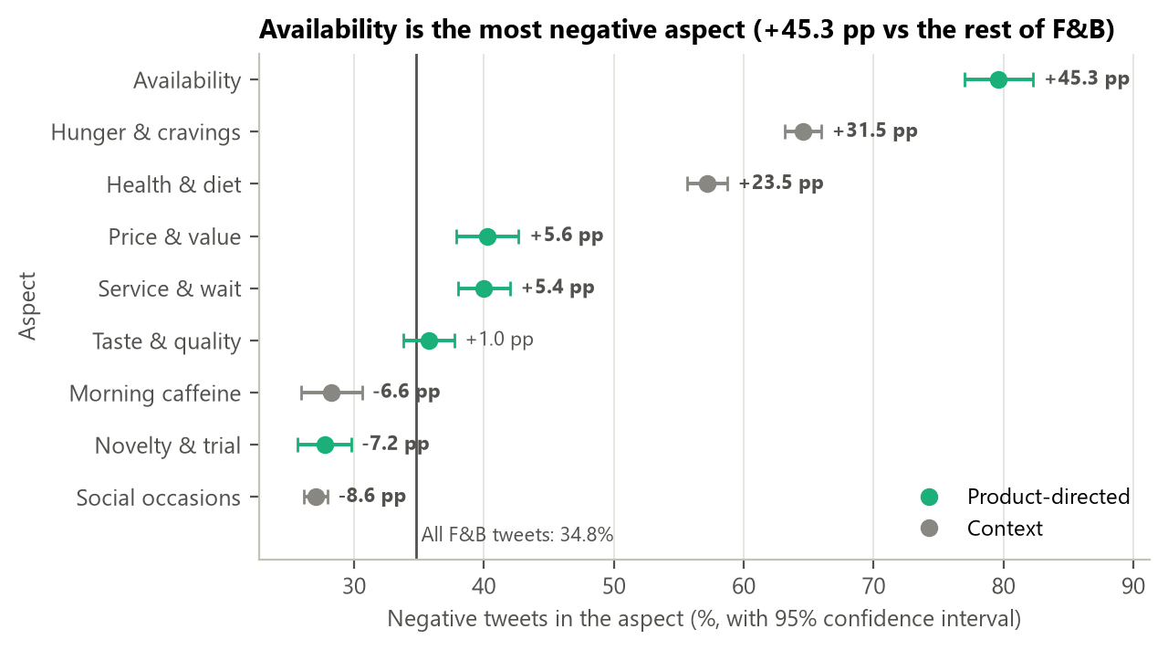
Figure 4.1. Negative share by aspect with 95% confidence intervals (labels: lift vs the rest of F&B)
Figure 4.1 places every aspect against the overall F&B negative share of 34.8%. Availability problems stand far apart: 79.6% of tweets about something being sold out, closed or unavailable are negative, +45.3 pp above the rest. Hunger (+31.5 pp) and health (+23.5 pp) follow, but these describe the customer's state rather than the product. Among product-directed aspects, price and value (+5.6 pp) and service and waiting (+5.4 pp) pass the 5 pp threshold, while taste and quality is not different from the rest (+1.0 pp, the interval crosses zero).
The other side of the chart matters just as much for a launch. Tweets about trying something new are less negative than average (-7.2 pp), as are social occasions (-8.6 pp) and morning caffeine (-6.6 pp). When people talk about trying a product or sharing it, they tend to be in a good mood.

Testing the hypotheses
Table 4.1. Hypothesis tests H1-H4 (Holm-adjusted p-values)
 | Comparison | Diff. (pp) | 95% CI (pp) | z | Holm p | h | Significant and ≥ 5 pp
H1 | Service & wait vs rest of F&B | +5.4 | +3.3 to +7.4 | 5.34 | 3.7e-07 | +0.11 | Yes
H2 | Price & value vs rest of F&B | +5.6 | +3.2 to +8.0 | 4.66 | 6.4e-06 | +0.12 | Yes
H3 | Morning caffeine vs rest of F&B | -6.6 | -9.0 to -4.3 | -5.21 | 5.8e-07 | -0.14 | Yes
H4 | F&B lift, launch week vs baseline (diff-in-diff) | -0.3 | -1.0 to +0.4 | -0.89 | 0.37 | n/a | No

H1, H2 and H3 remain significant after the Holm correction, and each difference exceeds 5 pp in absolute value, so they are significant both statistically and practically. The effect sizes are small (|h| between 0.11 and 0.14), which is consistent with these aspects being only part of the story. H4 is clearly not supported: the F&B lift during launch week differs from the baseline by only -0.3 pp (95% CI -1.0 to +0.4 pp, p = 0.37). In plain words, launch week did not make the category conversation more negative than usual. The "mixed reactions" the marketing team noticed are the normal mix of this conversation, not a launch-specific backlash.

Holding other factors constant: logistic regression
Table 4.2. Odds ratios from the logistic regression (n = 84,632; 38 day effects not shown)
Factor | Odds ratio | 95% CI | p-value | Practically important
Availability | 7.18 | 6.08 - 8.49 | < 0.001 | Yes
Hunger & cravings | 3.72 | 3.49 - 3.97 | < 0.001 | Yes
Health & diet | 2.36 | 2.21 - 2.52 | < 0.001 | Yes
Topic: work and breaks | 1.57 | 1.43 - 1.72 | < 0.001 | Yes
log(words) | 1.55 | 1.51 - 1.60 | < 0.001 | Yes
Price & value | 1.21 | 1.09 - 1.34 | < 0.001 | No
Service & wait | 1.11 | 1.02 - 1.21 | 0.021 | No
Taste & quality | 1.01 | 0.93 - 1.11 | 0.790 | No
Daypart: Morning (6-11h) | 0.98 | 0.93 - 1.02 | 0.336 | No
Daypart: Evening (18-23h) | 0.95 | 0.91 - 1.00 | 0.046 | No
Daypart: Night (0-5h) | 0.79 | 0.75 - 0.83 | < 0.001 | Yes
Morning caffeine | 0.71 | 0.63 - 0.80 | < 0.001 | Yes
Mentions a user | 0.69 | 0.66 - 0.71 | < 0.001 | Yes
Novelty & trial | 0.66 | 0.60 - 0.74 | < 0.001 | Yes
Social occasions | 0.64 | 0.61 - 0.67 | < 0.001 | Yes
Contains a link | 0.60 | 0.55 - 0.66 | < 0.001 | Yes

An odds ratio is read like a regression slope in Chapter 7, only on the odds scale. Holding the other factors and the day constant, a tweet that mentions availability has 7.2 times the odds of being negative. Hunger (3.7) and health (2.4) follow, and tweets in the work-and-breaks topic (Section 4.7) keep an odds ratio of 1.57. Price (1.21) and service (1.11) remain significant but shrink once the other factors are in the model, so part of their raw gap comes from overlap with hunger and the time of day; neither passes the practical range on its own. Novelty (0.66), social occasions (0.64) and morning caffeine (0.71) lower the odds of a negative tweet.
The McFadden pseudo R² of the model is only 0.05. Aspects and timing explain a small part of sentiment; most of it lives in the wording of the tweet itself, which is exactly what the classifier in Chapter 5 uses.

When do complaints happen?
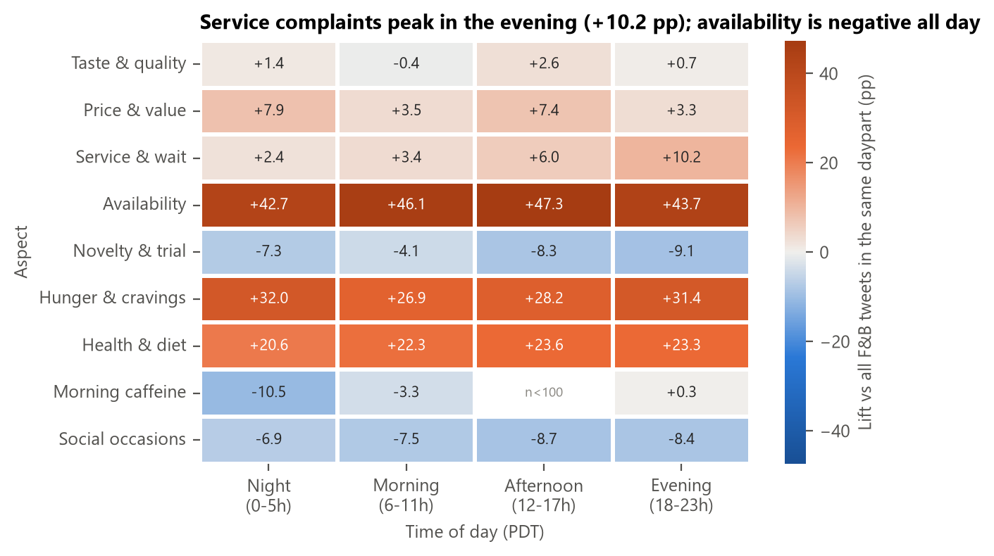
Figure 4.2. Negative lift by aspect and time of day (pp vs all F&B tweets in the same daypart)
Figure 4.2 shows when each aspect turns negative. Service complaints are most negative in the evening (+10.2 pp), when queues and delivery delays are most likely, and price complaints at night and in the afternoon (+7.9 and +7.4 pp). Availability is strongly negative at every time of day. Morning-caffeine tweets posted at night are the most positive (−10.5 pp). Since all timestamps are in Pacific time, many of these are probably morning tweets from Europe, which is a good reason not to over-read time-of-day effects in this dataset.

The words behind negative tweets
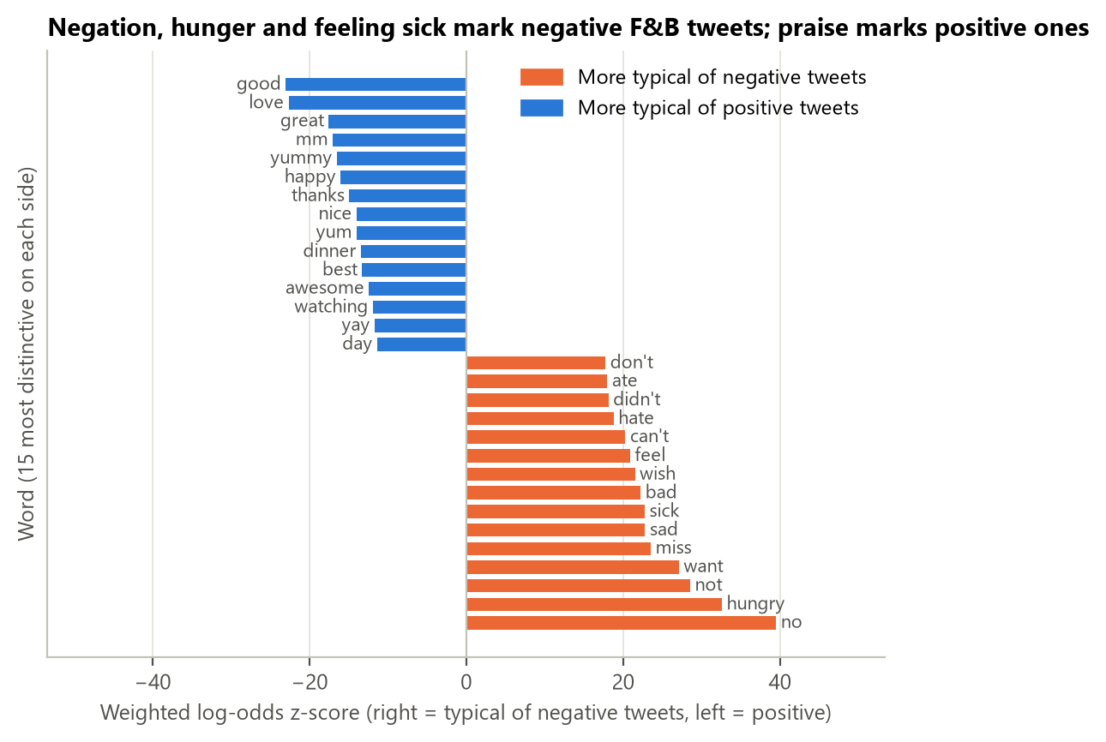
Figure 4.3. Words that best separate negative from positive F&B tweets (weighted log-odds z-scores)
To find the vocabulary of complaint we used the weighted log-odds ratio with an informative Dirichlet prior (Monroe, Colaresi and Quinn, 2008), with the whole clean corpus as the prior. Unlike a raw frequency count, it does not simply rank common words first. The words most typical of negative F&B tweets (Figure 4.3) are negations (no, not, can't, don't), wanting and missing (hungry, want, miss, wish) and feeling unwell (sick, sad, feel). Positive tweets are dominated by praise (good, love, great, yummy) and thanks. Negative F&B talk is therefore mostly about unmet wants (no food, no time, nothing open) rather than about a product that tastes bad, which agrees with the weak result for taste and quality above.

Main discussion topics
The aspect dictionary reflects what we expected people to discuss. To let the data speak, we also ran a Non-negative Matrix Factorisation (NMF; Lee and Seung, 1999) on TF-IDF weights of the F&B tweets. NMF splits the tweet-term matrix into a small number of topics, each described by its highest-weighted words. We removed stop words and the dictionary keywords themselves, otherwise the topics would just return our own word list, and compared 6, 8 and 10 topics; eight gave the clearest set. A tweet is assigned to a topic only when its weight is clearly above zero, so 74.9% of the tweets, mostly very short ones, have no clear topic.
Table 4.3. Topics found by NMF (k = 8) and their negative lift vs the rest of F&B
Topic | Top terms | Tweets | Negative | Lift (pp) | 95% CI
Work and breaks | work, break, tomorrow, ready, hours, work tomorrow | 1,950 | 48.2% | +13.7 | +11.5 to +16.0
Family and weekend fun | having, family, having fun, sunday, late, mom | 1,972 | 27.6% | -7.3 | -9.3 to -5.3
Morning start | morning, sunday, early, start, sunday morning, beautiful | 2,185 | 28.1% | -6.9 | -8.8 to -5.0
Coming home and waiting | home, waiting, finally, came home, mom, came | 2,471 | 38.3% | +3.6 | +1.7 to +5.6
Cooking at home | making, mom, stop, watching, mac, start | 1,396 | 26.4% | -8.6 | -10.9 to -6.2
Late nights | night, late, late night, sleep, friday, friday night | 2,587 | 34.0% | -0.8 | -2.6 to +1.1
Plans and anticipation | tonight, looking, forward, looking forward, party, movie | 2,007 | 29.2% | -5.7 | -7.7 to -3.6
Everyday mood (generic words) | watching, house, fun, ready, tomorrow, happy | 6,700 | 33.3% | -1.6 | -2.7 to -0.4

With the food words removed, the topics describe the moments in which people mention food rather than the food itself. One moment stands out: food mentioned around work and breaks is 48.2% negative, +13.7 pp above the rest (95% CI +11.5 to +16.0 pp). Cooking at home, family weekends, morning starts and plans for the evening are clearly more positive (−5.7 to −8.6 pp). For a brand, the lesson is that sentiment depends as much on the moment of consumption as on the product. The eighth topic is built from general mood words and does not describe a situation; we report it as such.

Summary and caveats
Three product-directed aspects are associated with negative tweets: availability (very strongly), price and service (moderately, and with service concentrated in the evening). Trial, sharing and morning moments are associated with positive tweets. Launch week itself did not change the picture. These are associations in observational data with noisy emoticon labels; a confounder such as the user's mood, or the 2009 user population, could explain part of them. They are strong enough to guide where a message should be adjusted, but the size of any effect of a new message should be confirmed with an A/B test, one of the analysis approaches listed in Chapter 1.

PREDICTIVE ANALYSIS
Predictive analytics answers "What is likely to happen?" (Chapter 1). In our case the marketing team needs to follow next week's conversation without reading every tweet, so the predictive task is a classifier that labels each new tweet as negative or not. As Chapter 7 puts it, "prediction refers to future values": the model must be judged on tweets from a period it has never seen.

Problem formulation
The input is the normalised text of a tweet and the output is the probability that the tweet is negative. We treat negative as the positive class of the classifier because that is the class the team wants to catch. The labels are the emoticon labels of Sentiment140. Section 2.5 showed that they agree with a human reader on 96.9% of clearly polar F&B tweets, which is a rough ceiling for any model.

How the data are split, and why by time
Table 2.5 gave the split: training on 653,345 tweets from 6 April to 31 May, validation on 469,953 tweets from launch week, and a final test on 150,736 tweets from 14 to 16 June. We chose a time-based split for three reasons:
- It matches how the model will be used. In practice the model is trained on the past and applied to next week. Testing it on a later period measures exactly that.
- It avoids leakage between days. Tweets from the same day share topics, events and conversations. A random split puts some of them in training and some in testing, so the model is partly tested on things it has already seen.
- It reveals drift. If language or topics change over time, a time-based test shows the drop in performance; a random split hides it.
Hyper-parameters and the decision threshold are chosen on the validation week only. The test week is used once, after every choice has been frozen. For comparison only, we also re-ran the final model with a random, stratified 80/20 split (Section 5.6).

Features and models
Three models are compared. A dummy classifier that always predicts the majority class sets the floor. The baseline is Multinomial Naive Bayes on word counts, the standard baseline for this dataset (Go et al., 2009). It uses a vocabulary of 47,118 words that occur at least three times in the training weeks. Naive Bayes assumes that words are independent given the class and simply multiplies their class-conditional probabilities (Manning, Raghavan and Schütze, 2008).
The more advanced model is Logistic Regression on TF-IDF weights of single words and word pairs (bigrams). TF-IDF gives a term a high weight when it is frequent in the tweet but rare in the corpus:
tf-idf(t, d) = (1 + log tf(t, d)) · log[(1 + N) / (1 + df(t))] + 1, then each tweet vector is scaled to unit length
We keep the 300,000 most frequent terms that appear in at least three training tweets, and we do not remove stop words, because words such as not and no carry sentiment. Logistic Regression is more advanced than Naive Bayes in four ways that matter here: it is discriminative, so it learns how much each term matters given all the others; word pairs let it capture negation ("not bad", "no coffee"); its regularisation strength C is tuned on held-out data; and its probabilities are well suited to choosing a threshold. Classes are weighted so that both count equally during training. Both models were built with scikit-learn (Pedregosa et al., 2011).

Tuning on the validation week
Table 5.1. Hyper-parameter tuning on the validation week
Model | Setting | Validation ROC-AUC | Validation negative F1 (threshold 0.5)
Naive Bayes | alpha = 0.1 | 0.842 | 0.722
Naive Bayes | alpha = 0.3 | 0.844 | 0.723
Naive Bayes | alpha = 1.0 | 0.847 | 0.724
Naive Bayes | alpha = 3.0 | 0.848 | 0.724
Naive Bayes | alpha = 10.0 | 0.846 | 0.713
Logistic Regression | C = 0.5 | 0.894 | 0.777
Logistic Regression | C = 1.0 | 0.897 | 0.781
Logistic Regression | C = 2.0 | 0.897 | 0.781
Logistic Regression | C = 4.0 | 0.895 | 0.777

Table 5.1 shows that Logistic Regression is ahead of Naive Bayes at every setting. We chose the setting with the highest ROC-AUC, alpha = 3 for Naive Bayes and C = 2 for Logistic Regression. We then chose, for each model, the decision threshold that maximises the F1 score of the negative class on the validation week: 0.37 for Naive Bayes and 0.44 for Logistic Regression. A threshold below 0.5 means that the team accepts a few more false alarms in exchange for missing fewer complaints.

Results on the test week
Table 5.2. Test-week results at the thresholds chosen on validation (95% bootstrap CIs, 200 resamples)
Model | Accuracy (95% CI) | Neg. precision | Neg. recall | Neg. F1 | Macro F1 | ROC-AUC (95% CI)
Dummy (majority) | 0.591 | 0.000 | 0.000 | 0.000 | 0.371 | 0.500
Naive Bayes (baseline) | 0.766 (0.764-0.768) | 0.683 | 0.800 | 0.737 | 0.763 | 0.846 (0.844-0.848)
Logistic Regression (advanced) | 0.810 (0.808-0.812) | 0.733 | 0.843 | 0.785 | 0.808 | 0.896 (0.894-0.897)

On the held-out week Logistic Regression reaches 81.0% accuracy (95% CI 80.8% to 81.2%), a negative-class F1 of 0.785 and a ROC-AUC of 0.896, against 76.6%, 0.737 and 0.846 for Naive Bayes. The dummy classifier reaches 59.1% accuracy without finding a single negative tweet, which is why accuracy alone would be misleading here. The validation and test AUC of Logistic Regression are almost identical (0.897 and 0.896), so the model did not degrade from one week to the next.
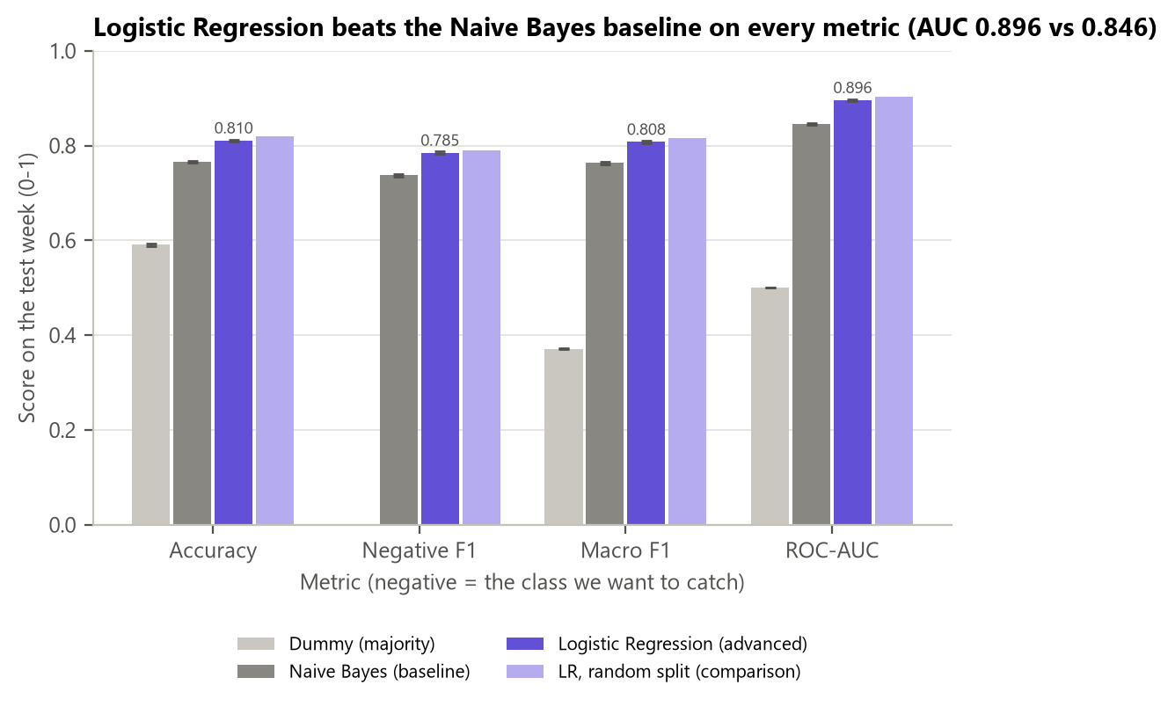
Figure 5.1. Model comparison on the test week (error bars: 95% bootstrap CIs)
Figure 5.1 shows the same comparison: Logistic Regression is ahead on every metric and the bootstrap intervals do not overlap. The light violet bars are the random-split comparison discussed in Section 5.6.
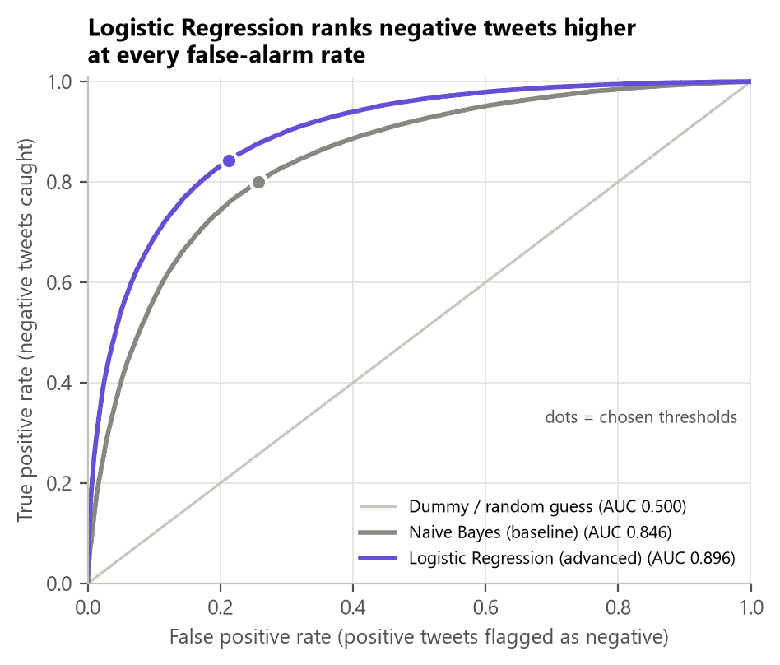
Figure 5.2. ROC curves on the test week (dots: thresholds chosen on validation)
The ROC curve of Logistic Regression lies above that of Naive Bayes everywhere (Figure 5.2), so whatever false-alarm rate the team accepts, Logistic Regression catches more negative tweets.
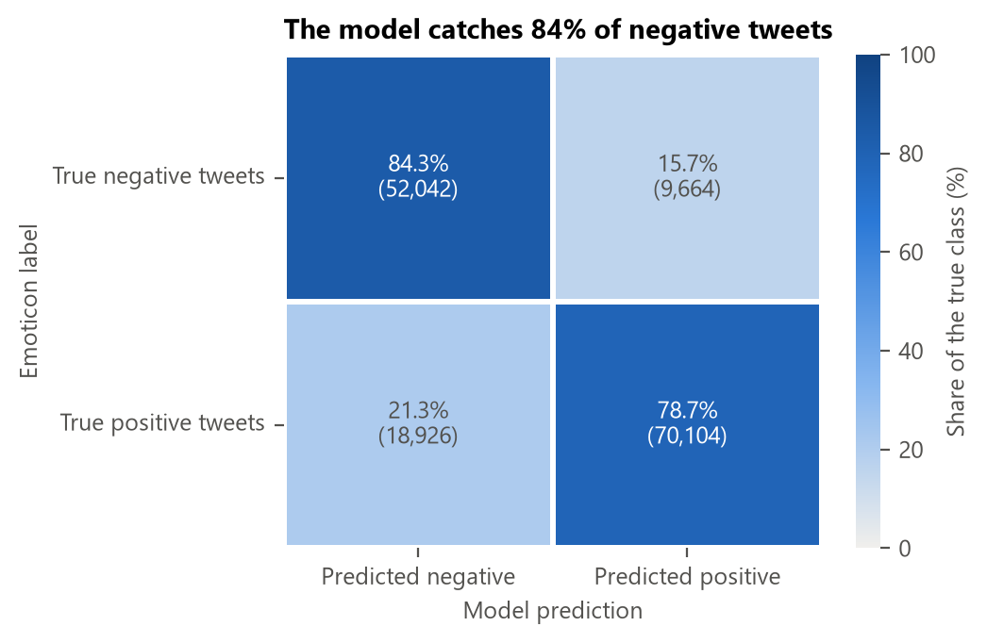
Figure 5.3. Confusion matrix of Logistic Regression on the test week (row percentages)
The model catches 84.3% of the negative tweets and wrongly flags 21.3% of the positive ones (Figure 5.3). Missing a complaint costs a brand more than taking a second look at a harmless tweet, so this balance is intended.
Because both models label the same test tweets, their accuracies are not independent samples, and the two-proportion z-test of Chapter 5 does not apply. The correct paired test is McNemar's test (Dietterich, 1998), which looks only at the tweets on which the models disagree: 13,871 are labelled correctly only by Logistic Regression and 7,241 only by Naive Bayes (χ² = 2081, p < 0.001). The paired accuracy gain is +4.4 pp (95% CI +4.2 to +4.6 pp), about 440 fewer mislabelled tweets per 10,000. The gain is both significant and large enough to justify the slightly more complex model.

Robustness checks
Table 5.3. Robustness of Logistic Regression
Evaluation | Tweets | Accuracy | Negative F1 | ROC-AUC
Main result: time split, all test tweets | 150,736 | 0.810 | 0.785 | 0.896
Random 80/20 split (comparison only) | 254,807 | 0.820 | 0.789 | 0.903
Time split, F&B test tweets only | 9,527 | 0.811 | 0.758 | 0.886
Time split, other test tweets | 141,209 | 0.810 | 0.786 | 0.896
Users already seen in training | 88,298 | 0.811 | 0.778 | 0.896
Users never seen in training | 62,438 | 0.809 | 0.793 | 0.895
Model trained on F&B tweets only | 9,527 | 0.774 | 0.726 | 0.862

Table 5.3 answers four practical doubts. First, a random 80/20 split gives a slightly higher AUC (0.903 against 0.896): mixing days lets the model see the same week's topics, so a random split would have overstated its performance a little. Second, the general model works on F&B tweets (AUC 0.886) and beats a model trained only on F&B tweets (0.862), because 653,000 general tweets teach it more language than 44,000 F&B ones. Third, users already seen in training (58.6% of the test tweets) and new users get the same scores, so the model is not memorising people. Fourth, results at the default threshold of 0.5 (reported in the notebook) lead to the same ranking of the models.

Interpreting the model
A model that the marketing team cannot read will not be trusted, so we explain it at two levels.
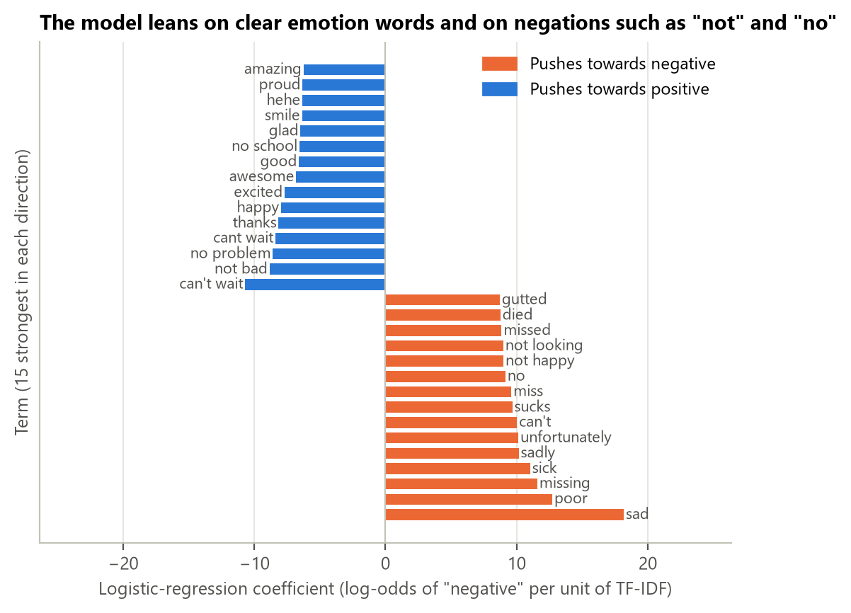
Figure 5.4. The 15 strongest Logistic Regression coefficients in each direction
Globally, each coefficient is the change in the log-odds of "negative" for one unit of TF-IDF weight of a term, holding the other terms constant (Figure 5.4). The strongest negative terms are clear emotion words (sad, poor, missing, sick, sucks) and negated phrases (not happy). The word pairs show why bigrams matter: not bad and no problem push a tweet towards positive, the opposite of not and no on their own, and can't wait is the most positive term in the whole model.
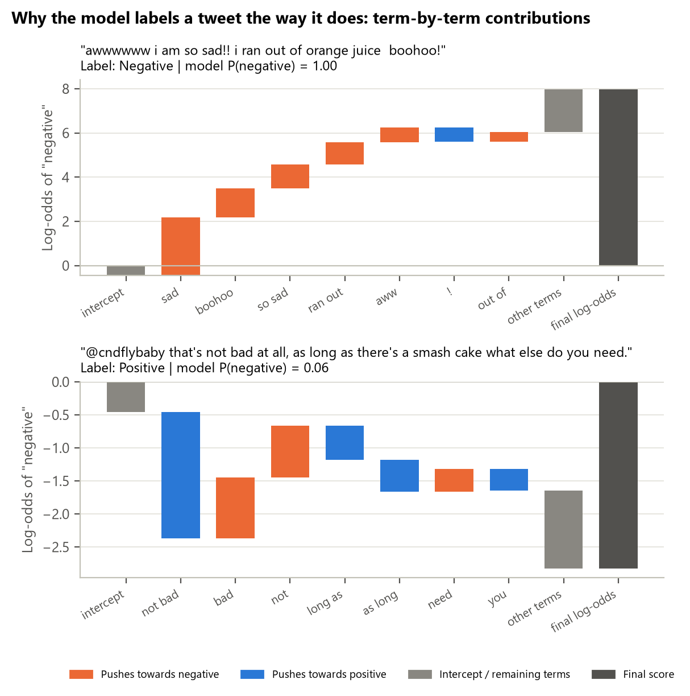
Figure 5.5. Local explanation of two F&B test tweets: contribution of each term to the log-odds
Locally, because the model is linear, the predicted log-odds of one tweet is exactly the intercept plus the sum of coefficient × TF-IDF weight over the terms it contains. Figure 5.5 draws these contributions as a waterfall, which is the linear version of a SHAP explanation (Lundberg and Lee, 2017) measured from an empty tweet rather than from an average one. In the first tweet ("i am so sad!! i ran out of orange juice boohoo!"), sad, boohoo, so sad and ran out push the score to a near-certain negative. In the second ("that's not bad at all..."), the pair not bad outweighs bad and not on their own, something a single-word model cannot do. This is the explanation a community manager would see next to a flagged tweet.

Error analysis
Reading the most confident mistakes on F&B test tweets shows that many are label noise rather than model errors. "Tired....hungry....still dreading orchestra" carries a positive emoticon, and "Amazing wedding cakes is on!" a negative one; the model disagrees with the label but agrees with a human reader. Other mistakes mix two moods in one tweet ("happy but disappointed my car is messing up"). Irony and very short tweets ("LUNCH.....finally") are hard for any bag-of-words model. A larger pre-trained language model could handle some of these cases, but not the noisy labels.

PRESCRIPTIVE ANALYSIS
Prescriptive analytics answers "What should we do?" by combining the earlier insights and simulating scenarios (Chapter 1). This chapter turns the evidence into a decision, checks how much each action could move the KPI, and sets up the monitoring the team needs for next week.

Decision rule
To keep the recommendation honest, we wrote the decision rule down before looking at the results of this chapter:
- Rewrite the campaign message only if launch week is significantly and practically more negative than the baseline (H4 rejected with a difference of at least 5 pp).
- Make targeted adjustments if at least one product-directed aspect is at least 5 pp more negative than the rest of the F&B conversation, with its whole 95% CI above zero.
- Otherwise keep the message and keep monitoring.
H4 was not supported (Section 4.3), and three product-directed aspects meet the second condition: price & value, service & wait, availability. The decision is therefore: keep the core message, make targeted adjustments.

Expected sentiment next week
In real time the team will not have emoticon labels, only the model's predictions. Simply counting the tweets the model flags would put next week's F&B negative share at 41.4%, because the threshold was set to favour catching complaints. Adjusted classify-and-count (Forman, 2008) corrects the raw share q̂ with the true and false positive rates measured on launch week:
p̂ = (q̂ − FPR) / (TPR − FPR)
With TPR = 79.5% and FPR = 17.8%, the estimate becomes 38.2%, within 1.4 pp of the true share of 36.8% that we held back. This adjusted figure is the number the team should report each day.

Priority matrix
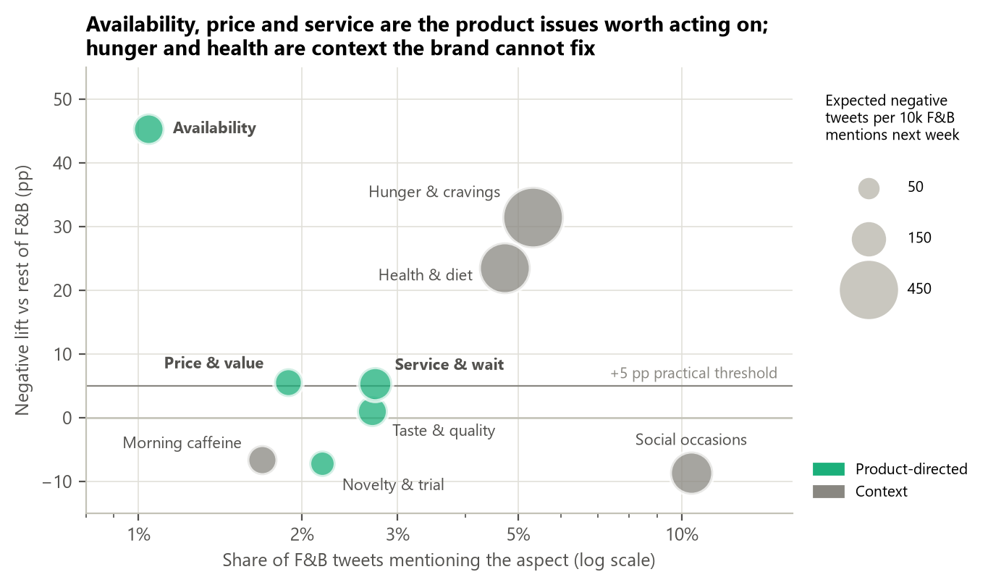
Figure 6.1. Priority matrix: share of voice, negative lift and expected negative tweets next week
Figure 6.1 combines the three earlier layers in one view: the share of voice of each aspect (descriptive), its negative lift (diagnostic) and the number of negative tweets the model expects it to produce next week per 10,000 F&B mentions (predictive, bubble size). Availability is a small slice of the conversation (1.0%) but by far the most negative. Service and waiting (2.7%) and price (1.9%) sit about 5 pp above the rest and together are expected to produce around 216 negative tweets per 10,000 mentions. Hunger and health produce the most negative tweets in volume, but they describe the customer's situation, which no message can fix. Social occasions, novelty and morning caffeine sit below zero: these are the moments a campaign can lean on.

What-if simulation and alert rule
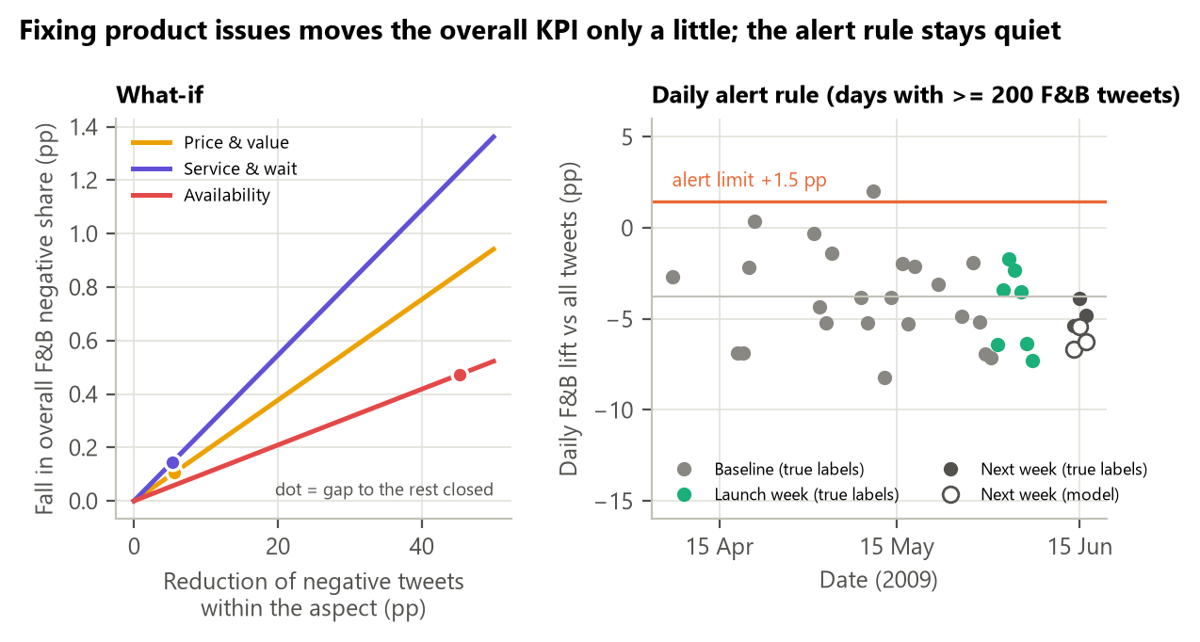
Figure 6.2. Left: what-if simulation. Right: daily alert rule back-tested on all observed weeks
The left panel of Figure 6.2 simulates a message change that turns k% of an aspect's tweets from negative to not negative. Because each aspect is a small share of the conversation, even closing the whole gap would lower the overall F&B negative share only a little: 0.47 pp for availability, 0.15 pp for service and 0.11 pp for price, about 0.7 pp in total. This is an important, honest result: the benefit of acting is local (fewer unhappy customers in specific situations), not a large movement of the headline KPI. Targets should therefore be set per aspect.
The right panel defines the alert rule. On days with at least 200 F&B tweets, the daily lift in the baseline weeks averaged -3.8 pp with a standard deviation of 2.6 pp. Using the empirical rule from Chapter 4 (about 95% of values lie within two standard deviations), we set the alert limit at the mean plus two standard deviations, +1.5 pp. Back-tested, the limit was crossed on 1 of 23 baseline days and on none of the launch-week or next-week days, whether we use the true labels or the model's predictions. We added the minimum of 200 tweets after seeing that very small days are too noisy; this choice was made on the data and should be reviewed once real brand data are available.

Recommendations
Table 6.1 lists the recommendations. As required, each one quotes a number from each of the three previous layers, so it can be checked against the evidence.
Table 6.1. Recommendations and the evidence behind them
Recommendation | Descriptive evidence | Diagnostic evidence | Predictive evidence
R1. Keep the core campaign message (no rewrite) | Launch-week F&B lift -5.4 pp vs baseline -5.1 pp | H4 diff-in-diff -0.3 pp (CI -1.0 to +0.4), not significant | Next-week negative share estimated 38.2% (true 36.8%); 0 alert days
R2. Add an availability message: where to find the product, restock times, apology when sold out | 1.0% of F&B tweets | 79.6% negative (+45.3 pp), OR 7.2 | ~108 negative tweets per 10k mentions expected next week
R3. Answer service and waiting complaints, especially in the evening (order-ahead, wait-time message) | 2.7% of F&B tweets | +5.4 pp (CI +3.3 to +7.4); evening +10.2 pp; OR 1.11 | ~129 negative tweets per 10k mentions next week (largest product issue)
R4. Reframe price as value (trial offer, bundle, coupon) | 1.9% of F&B tweets | +5.6 pp (CI +3.2 to +8.0); OR 1.21 | ~87 negative tweets per 10k mentions next week
R5. Build creative around trying it, sharing it and morning moments; avoid "work stress" framing | Social occasions are the largest aspect (10.4%) | Novelty -7.2 pp (OR 0.66), social -8.6 pp; work-and-breaks topic +13.7 pp | "can't wait" is the most positive term in the model
R6. Monitor daily with the classifier and the alert rule | Daily F&B lift averages -3.9 pp | Baseline SD 2.6 pp gives an alert limit of +1.5 pp | AUC 0.896, catches 84% of negative tweets

R1. Keep the core campaign message. Nothing in the data points to a launch-specific backlash: the launch-week lift is the same as in the baseline, H4 is not significant, the model expects next week to be in line with the past and the alert rule stayed quiet. Rewriting the message now would mean reacting to normal noise.
R2. Add an availability message. Being unable to get the product is the strongest driver of negative tweets (odds ratio 7.2). Posts that say where the product can be found, when it will be restocked, and that apologise quickly when it sells out address the issue directly. This also needs a supply-side check with operations.
R3. Answer service and waiting complaints, especially in the evening. Service complaints are +10.2 pp more negative in the evening. An "order ahead" or "skip the line" message timed for the evening, plus faster community-manager replies after 18:00, targets the moment when it matters most.
R4. Reframe price as value. Price talk is 5.6 pp more negative than the rest. A trial offer, a bundle or a coupon for first-time buyers turns price into a reason to try the product rather than a reason to complain.
R5. Build the creative around trying and sharing. Tweets about trying something new, social occasions and morning moments are 6.6 to 8.6 pp less negative than average, while food mentioned around work and breaks is +13.7 pp more negative. The campaign should show the product being tried and shared, and avoid "survive your workday" framing.
R6. Monitor every day with the model and the alert rule. The classifier is accurate enough (AUC 0.896, 84% of complaints caught) to track the conversation daily, report the adjusted negative share, and escalate when the lift crosses +1.5 pp.

Action plan for next week
Table 6.2. Action plan for the coming week
Action | Owner | When | KPI and target
R2 availability posts and restock alerts | Content team + operations | Mon-Tue | Availability negative share down from 79.6%; replies within 2 hours
R3 evening "order ahead" message, evening reply shift | Content + community team | From Mon, 18:00-23:00 | Service lift in the evening below +5 pp
R4 trial offer / bundle message | Brand + promotions team | Wed | Price lift below +5 pp
R5 creative on trying and sharing | Brand team | Wed-Fri | Share of novelty and social talk up; their lift stays negative
R6 daily monitoring with the dashboard | Social listening team | Daily, 09:00 | Adjusted negative share reported; escalate if lift > +1.5 pp

Monitoring dashboard
To make R6 practical we built an interactive dashboard with Streamlit and Plotly. It reads the scored F&B tweets and the fitted model exported by the notebook, so it starts in a few seconds and does not need the raw 239 MB file. A single filter panel (date range, period, category, aspect, brand and the source of sentiment, either the emoticon label or the model's prediction) controls every chart. The dashboard has five tabs: an overview with KPI tiles, the daily trend, share of voice, a listening funnel and a box plot of daily negativity by category; an aspect tab with confidence intervals, a Sankey diagram and the time-of-day heatmap; a brand tab with a treemap; a searchable tweet explorer; and a "try the model" tab that scores any typed tweet and explains it term by term. It is started with the command streamlit run dashboard/app.py from the project folder.
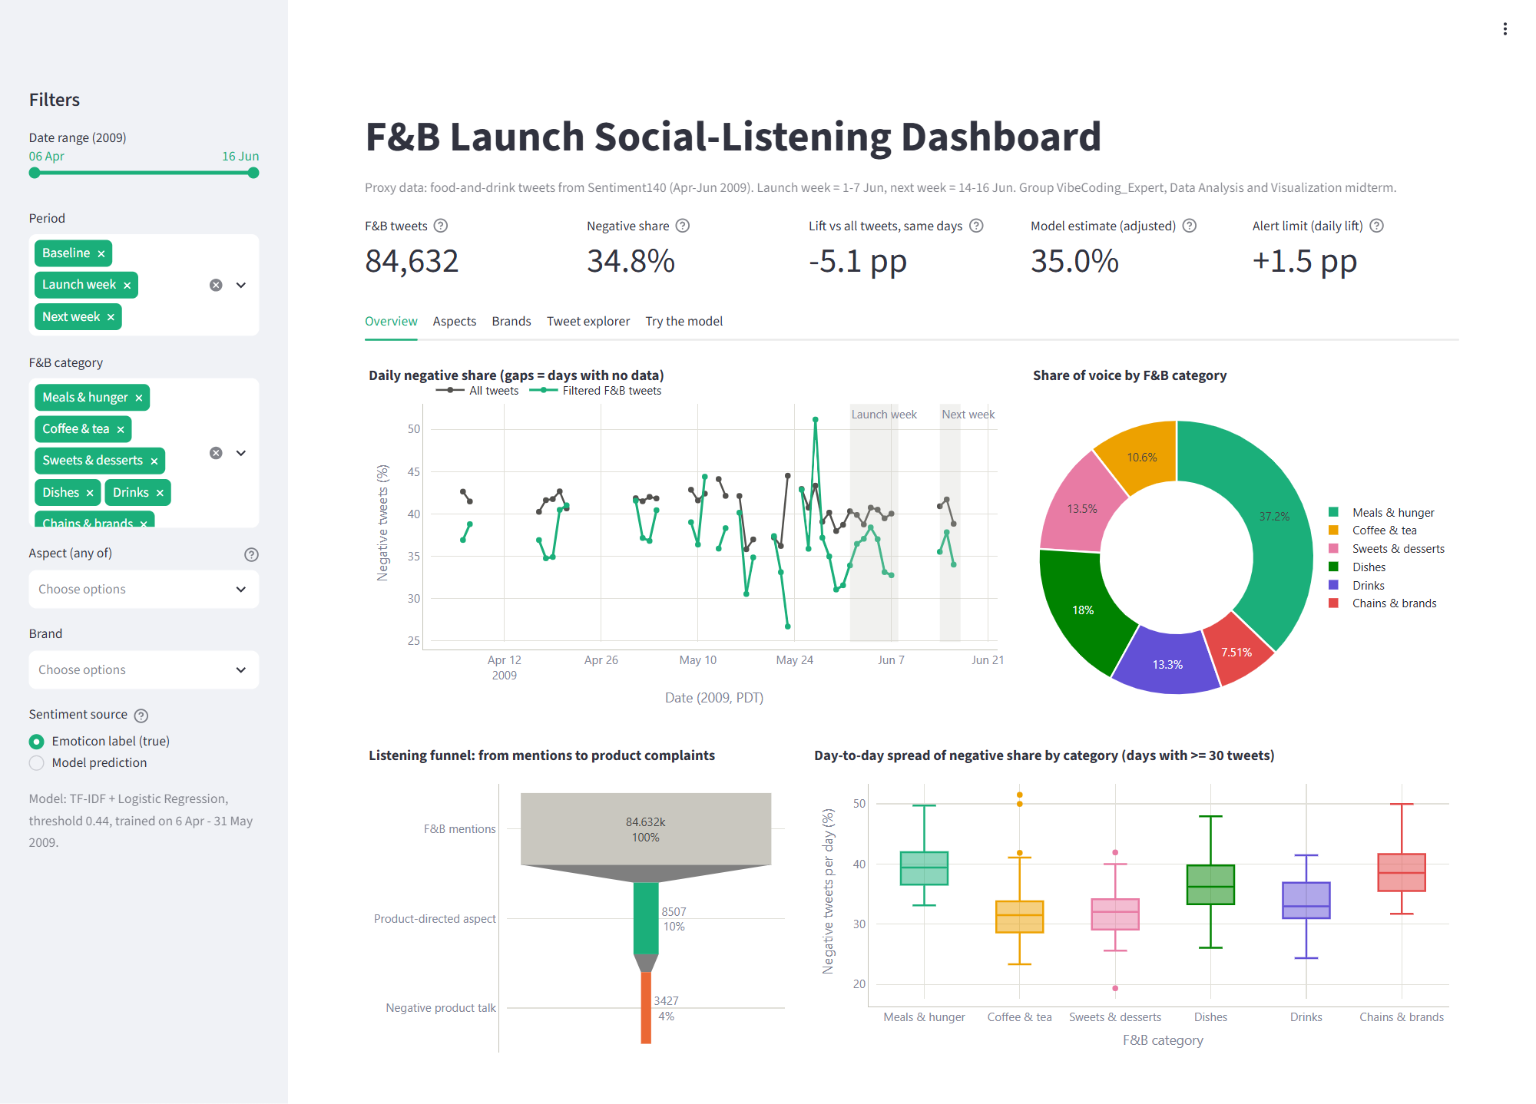
Figure 6.3. Dashboard, overview tab (KPI tiles, daily trend and share of voice)
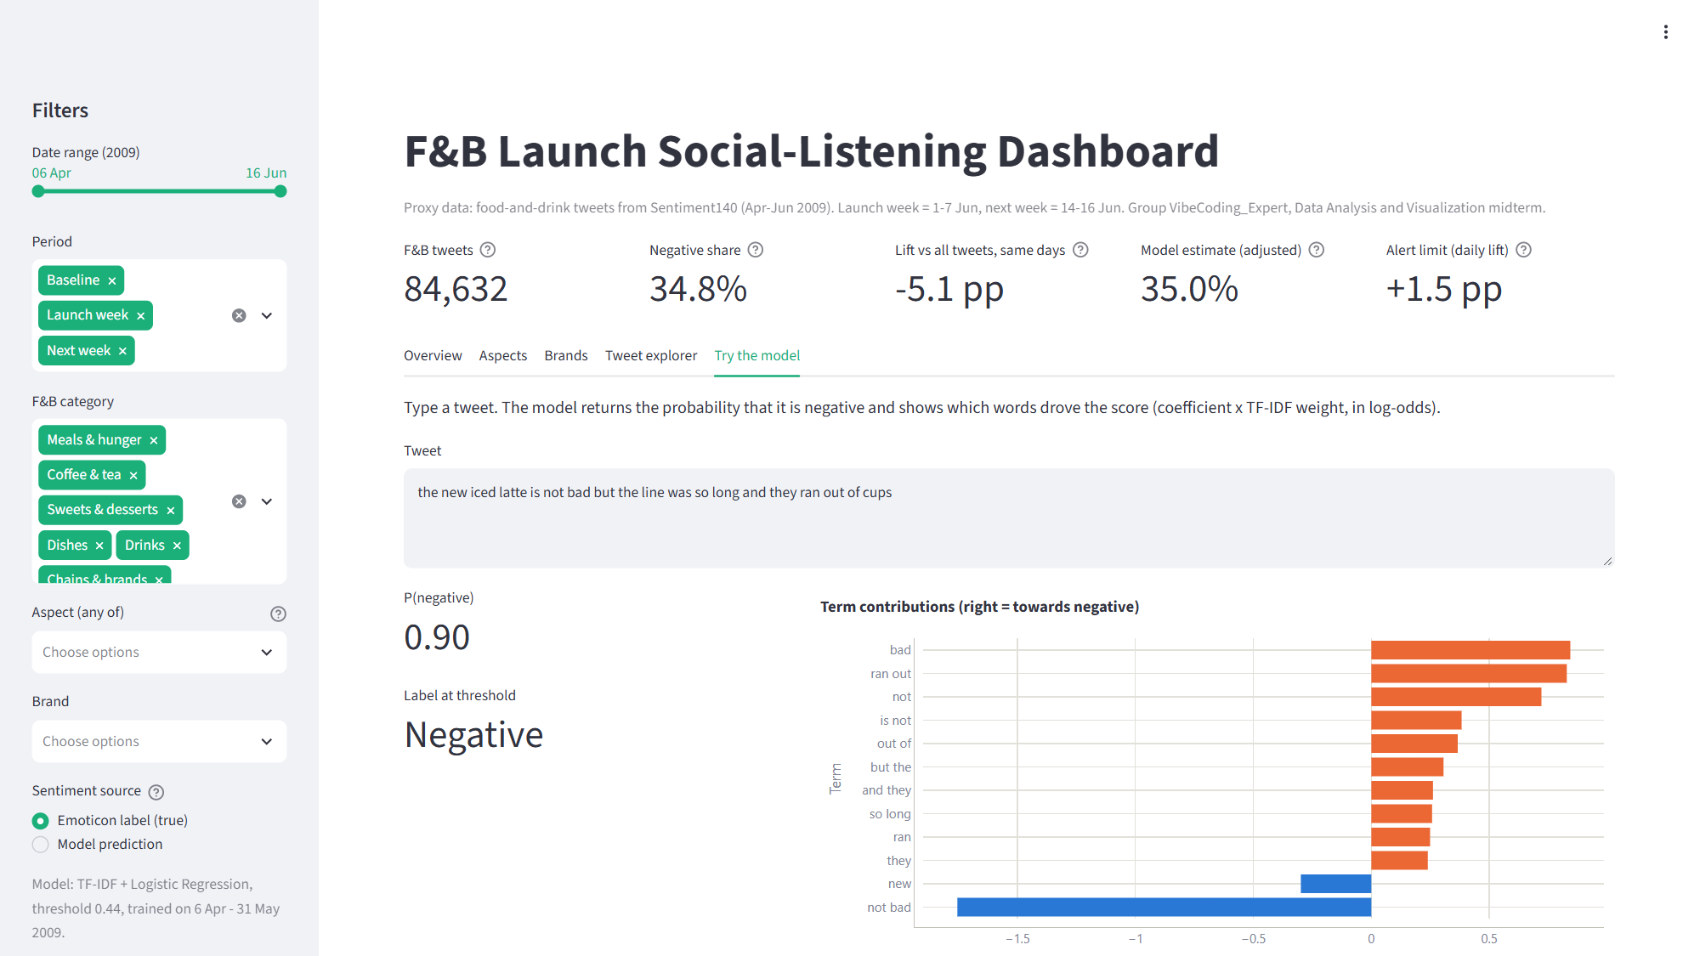
Figure 6.4. Dashboard, "try the model" tab with the term-by-term explanation

CONCLUSION

Answers to the research questions
We set out to tell a marketing team whether to change its campaign message after a launch week with mixed reactions. Descriptively, the F&B conversation is 5.1 pp less negative than Twitter as a whole, and launch week looked like any other week. Diagnostically, H1 to H3 are supported: service and price talk is more negative than the rest and morning caffeine talk is less negative, while availability problems are the strongest single driver of negative tweets. H4 is not supported: the launch week did not shift the lift. Predictively, Logistic Regression on words and word pairs labels next week's tweets with an AUC of 0.896 and clearly beats the Naive Bayes baseline, and a time-based test confirms that it holds up on a new period. Prescriptively, the answer to the marketing team is to keep the core message, adjust it around availability, service and price, build the creative around trying and sharing, and monitor daily with an alert limit.

Limitations
- Proxy data. Sentiment140 is not about one brand or one launch. The F&B stream stands in for the category conversation, and the launch and next-week roles are given to calendar weeks by design.
- Labels. Emoticon labels are noisy and have no neutral class; 15% of on-topic tweets read as neutral in our review.
- Collection artifacts. Absolute shares reflect the collector; 33 of 81 days are missing; timestamps are in Pacific time for users around the world.
- Dictionary. The F&B filter has a precision of about 89%, checked on 210 tweets by a single, AI-assisted reviewer.
- Observational design. All diagnostic results are associations, and the user population of 2009 differs from today's social media users.

Future work
With real brand data, the same pipeline could be extended in three directions: a three-class model (negative, neutral, positive) trained on manually labelled tweets or a fine-tuned pre-trained language model; an aspect-based sentiment model that scores each aspect within a tweet rather than the whole tweet; and A/B tests of the recommended messages, which would turn the associations of Chapter 4 into causal evidence.

TASK ALLOCATION
The work was split evenly by layer of analysis, with every member also owning one deliverable. All members reviewed the final report and slides together.
Table 8.1. Task allocation
Member | Student ID | Role | Main tasks | Contribution
Ngo Lam Tien | 524H0195 | Leader | Coordination and timeline; Chapter 1 (problem, KPIs, hypotheses); Chapter 6 (decision rule, priority matrix, recommendations); slide deck and presentation flow | 25%
Nguyen Cong Thanh | 524H0191 | Member | Chapter 2 (profiling, collection-artifact check, cleaning, F&B dictionary and review sample); Chapter 3 (descriptive charts) | 25%
Nguyen Le Nhat Tam | 524H0186 | Member | Chapter 4 (confidence intervals, hypothesis tests, logistic regression, distinctive words, NMF topics); Chapter 7; references and formatting | 25%
Ngo Binh Minh | 524H0169 | Member (technical lead) | Chapter 5 (time-based split design, Naive Bayes and Logistic Regression, evaluation, interpretation); Streamlit dashboard; notebook integration and reproducibility checks | 25%

REFERENCES
[1] Cohen, J., [1988], Statistical Power Analysis for the Behavioral Sciences, 2nd edition, Lawrence Erlbaum Associates, Hillsdale, NJ.
[2] Dietterich, T. G., [1998], Approximate statistical tests for comparing supervised classification learning algorithms, Neural Computation, 10(7), 1895-1923.
[3] Forman, G., [2008], Quantifying counts and costs via classification, Data Mining and Knowledge Discovery, 17(2), 164-206.
[4] Go, A., Bhayani, R., Huang, L., [2009], Twitter Sentiment Classification using Distant Supervision, CS224N Project Report, Stanford University.
[5] Hammond, T., [2023], 20 Types of Charts and Graphs for Data Visualization, ThoughtSpot.
[6] Ho Thi Linh, [2025], Data Analysis and Visualization: Chapter 2 Data Visualization, Chapter 4 Probability and Sampling Distributions, Chapter 5 Analysing the Data and Interpreting the Analyses, Chapter 7 Simple Linear Regression, lecture slides, Ton Duc Thang University.
[7] Holm, S., [1979], A simple sequentially rejective multiple test procedure, Scandinavian Journal of Statistics, 6(2), 65-70.
[8] Lee, D. D., Seung, H. S., [1999], Learning the parts of objects by non-negative matrix factorization, Nature, 401(6755), 788-791.
[9] Lundberg, S. M., Lee, S.-I., [2017], A unified approach to interpreting model predictions, Advances in Neural Information Processing Systems 30, 4765-4774.
[10] Manning, C. D., Raghavan, P., Schütze, H., [2008], Introduction to Information Retrieval, Cambridge University Press, Cambridge.
[11] Michailidis, M. (KazAnova), [2017], Sentiment140 dataset with 1.6 million tweets, Kaggle, https://www.kaggle.com/datasets/kazanova/sentiment140.
[12] Monroe, B. L., Colaresi, M. P., Quinn, K. M., [2008], Fightin' words: Lexical feature selection and evaluation for identifying the content of political conflict, Political Analysis, 16(4), 372-403.
[13] Ott, R. L., Longnecker, M., [2016], An Introduction to Statistical Methods and Data Analysis, 7th edition, Cengage Learning, Boston.
[14] Pedregosa, F., Varoquaux, G., Gramfort, A., et al., [2011], Scikit-learn: Machine learning in Python, Journal of Machine Learning Research, 12, 2825-2830.
[15] Prentice, R. L., Pyke, R., [1979], Logistic disease incidence models and case-control studies, Biometrika, 66(3), 403-411.
[16] Seabold, S., Perktold, J., [2010], Statsmodels: Econometric and statistical modeling with Python, Proceedings of the 9th Python in Science Conference, 92-96.
[17] Tran Luong Quoc Dai, [2025], Data Analysis and Visualization: Chapter 1 Introduction to Data Analysis, Chapter 3 Data Description, Chapter 4 Categorical Data, Chapter 7 Linear Regression and Correlation, lecture slides, Ton Duc Thang University.

