**(1)**

**Code:**

x=[-2 5 7 3 0 -5];

stem(x)

xlabel('n')

ylabel('x(n)')

grid on

**Figure:**

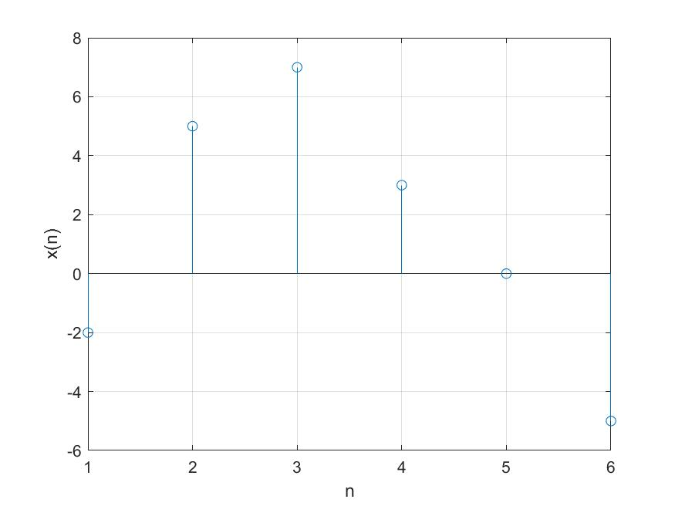

**Description:**

It is a graphical representation of simple discrete-time signal keeping time variable in X-axis and amplitude in Y-axis where first amplitude value is for time value 0.

**(2)**

**Code:**

x=[2 -5 -3 0 -1 -4 2 4];

n=-2:1:5;

stem(n,x)

xlabel('n')

ylabel('x(n)')

grid on

**Figure:**

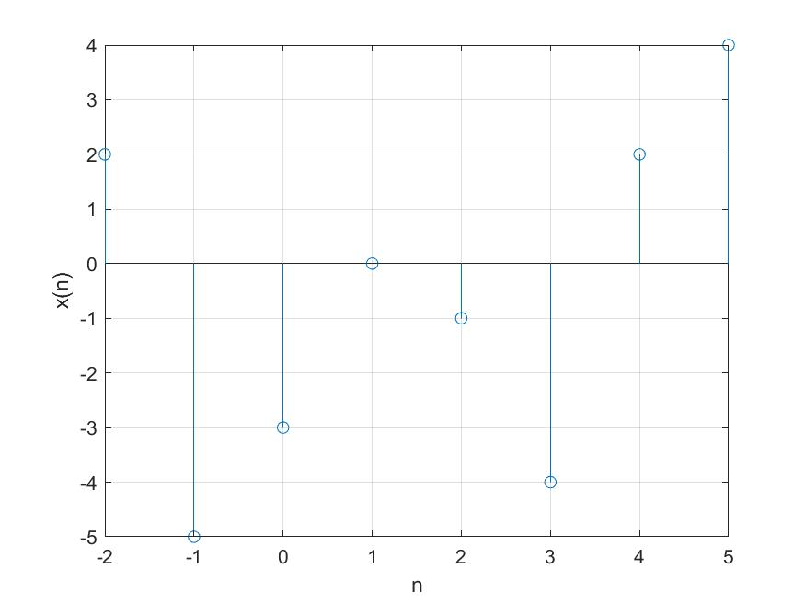

**Description:**

It is a graphical representation of simple discrete-time signal keeping time variable in X-axis and amplitude in Y-axis where first amplitude value is for time value -2.

**(3)**

**Code:**

n=0:1:20;

a=2;

r=0.8;

y=a*r.^n;

stem(n,y)

**Figure:**

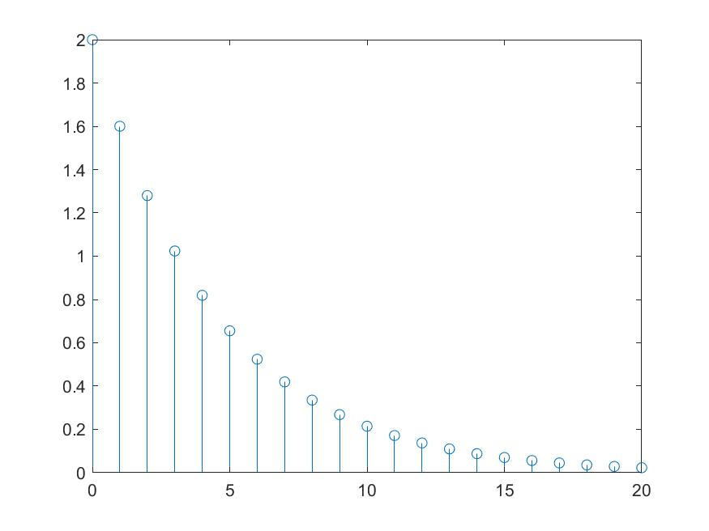

**Description:**

It is a graphical representation of exponential signal (y=arn ) keeping time variable in X-axis and amplitude in Y-axis where first amplitude value is for time value 0;

**(4)**

**Code:**

subplot(3,1,1);

n=0:1:20;

a=2;

r=0.8;

y=a*r.^n;

stem(n,y, 'b*')

subplot(3,1,2);

r=1.2;

y=a*r.^n;

stem(n,y, 'rs')

subplot(3,1,3);

r=1;

y=a*r.^n;

stem(n,y, 'bs')

**Figure:**

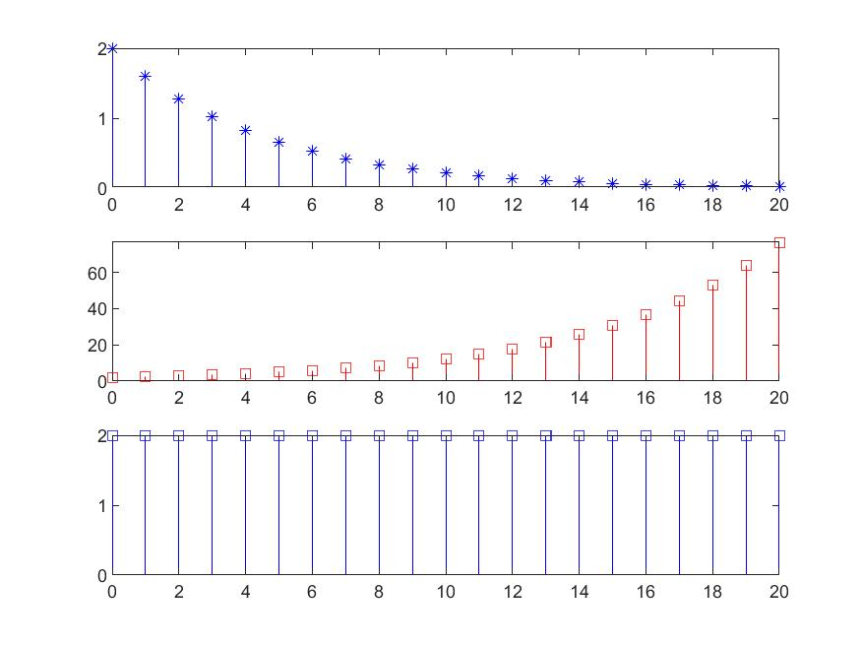

**Description:**

These are graphical representation of exponential signal (y=arn ) keeping time variable in X-axis and amplitude in Y-axis for different value of r.

These three signals are represented using subplot function (3 row,1 column).

**(5)**

**Code:**

n=0:1:50;

subplot(2,2,1);

y=2*sin(0.3*pi*n+pi/3);

stem(n,y,'bs')

subplot(2,2,2);

y=2*sin(2*pi*(1/20)*n+pi/3);

stem(n,y,'rs')

subplot(2,2,3);

y=2*sin(2*pi*(sqrt(2))*n+pi/3);

stem(n,y,'b*')

subplot(2,2,4);

y=2*sin(2*pi*(sqrt(3))*n+pi/3);

stem(n,y,'r*')

**Figure:**

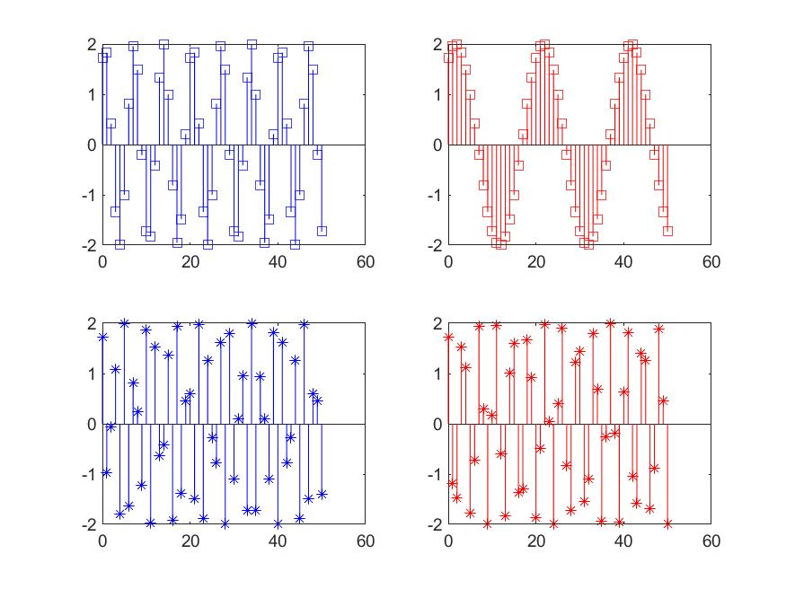

**Description:**

These are graphical representation of sinusoidal signal keeping time variable in X-axis and amplitude in Y-axis for different frequency. These four signals are represented using subplot function (2 row,2 column) where first two signals are periodic and last two signals are non-periodic.

**(6)**

**Code:**

n=-5:1:5;

x=[0 0 0 0 0 1 1 1 1 1 1];

stem(n,x,'b*')

**Figure:**

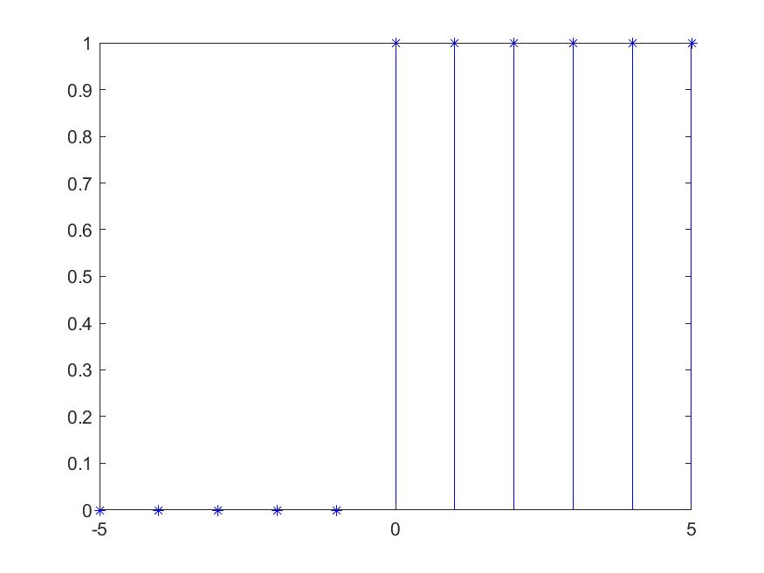

**Description:**

It is a graphical representation of unit step signal keeping time variable in X-axis and amplitude in Y-axis.

**(7)**

**Code:**

n=-5:1:5;

x=[0 0 0 0 0 1 0 0 0 0 0];

stem(n,x,'r*')

**Figure:**

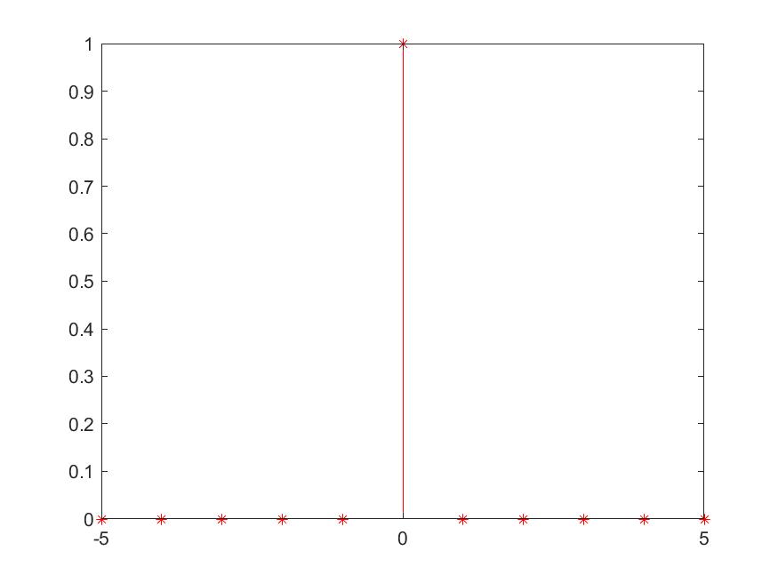

**Description:**

It is a graphical representation of unit sample signal keeping time variable in X-axis and amplitude in Y-axis.

**(8)**

**Code:**

for n = -20:1:20

if (n>=-5)&&(n<2)

x=sin(0.31*pi*n)

elseif (n>=2)&&(n<7)

x=n

elseif (n>=7)&&(n<12)

x=0.8.^n

else

x=0

end

stem(n,x,'g*')

hold on

end

**Figure:**

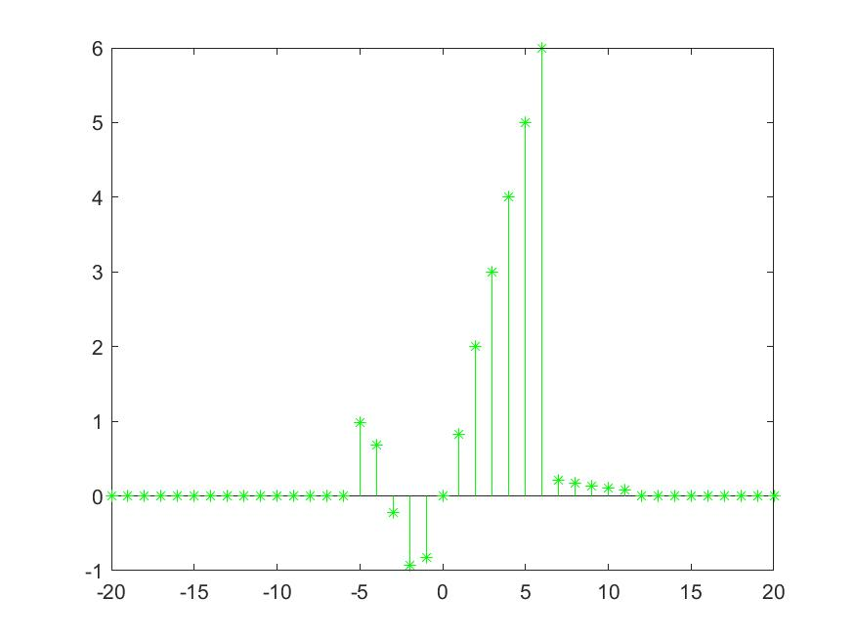

**Description:**

It is a graphical representation of simple discrete-time signal keeping time variable in X-axis and amplitude in Y-axis where-

x(n)=sin(0.31πn), for -5<=n<2;

x(n)=n, for 2<=n<7;

x(n)=0.8n, for 7<=n<12;

x(n)=0, elsewhere;