***Code:***

a=0.5;

r=0.96;

N=100; %Number of samples

for n=1:N,

y(n)=a*r.^n;

yn(n)=y(n)+0.04*rand();

end

n=1:1:N;

stem(n,y,'k*')

hold on

stem(n,yn,'rd')

xlabel('n')

ylabel('y(n)andyn(n)')

grid on

***Figure:***

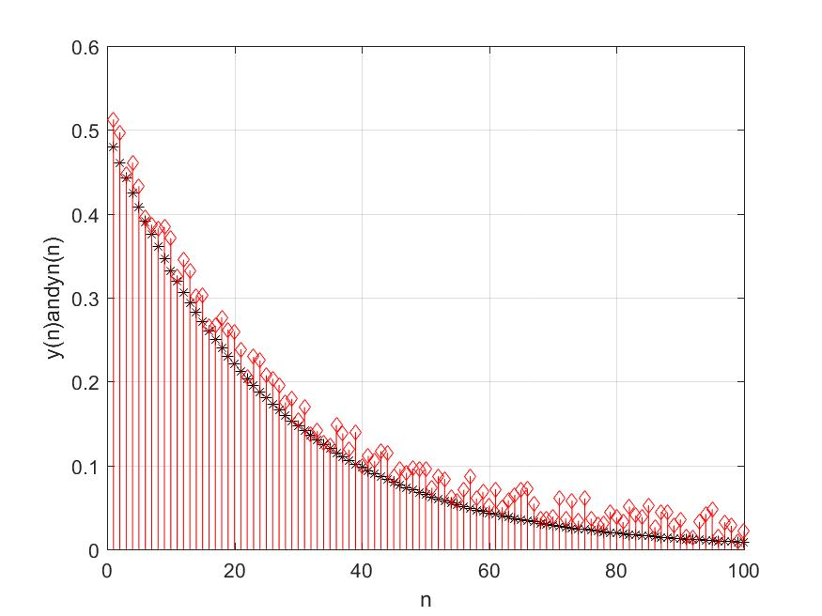

***Code:***

a=0.5;

r=0.96;

N=100; %Number of samples

for n=1:N,

y(n)=2*n*(0.9.^n);

yn(n)=y(n)+rand()-0.5;

end

n=1:1:N;

subplot(2,2,1)

stem(n,y)

title('Original Sequence')

subplot(2,2,2)

stem(n,yn)

title('Noisy Sequence')

subplot(2,2,3)

plot(n,y)

title('Original Signal')

subplot(2,2,4)

plot(n,yn)

title('Noisy Signal')

***Figure:***

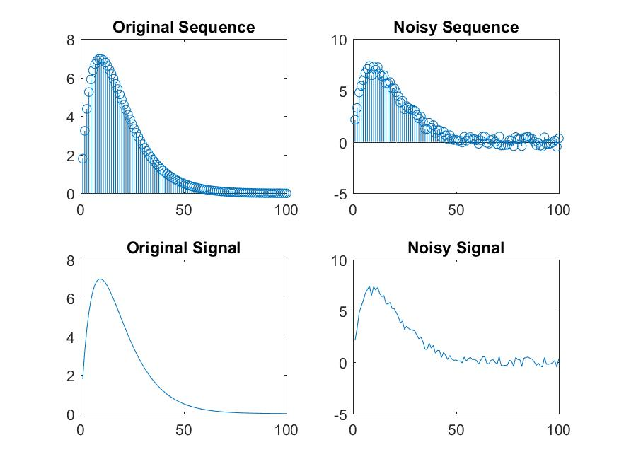

***Code:***

a=0.5;

r=0.96;

N=100; %Number of samples

for n=1:N,

y(n)=2*n*(0.9.^n);

yn(n)=y(n)+rand()-0.5;

end

n=1:1:N;

subplot(2,2,1)

stem(n,y)

title('Original Sequence')

subplot(2,2,2)

stem(n,yn)

title('Noisy Sequence')

subplot(2,2,3)

plot(n,y)

title('Original Signal')

subplot(2,2,4)

plot(n,yn)

title('Noisy Signal')

M=5;

b=ones(M,1)/M;

z=filter(b,1,yn);

figure

plot(n,yn,'r',n,z,'b')

legend('Noisy signal','Filtered signal')

***Figure:***

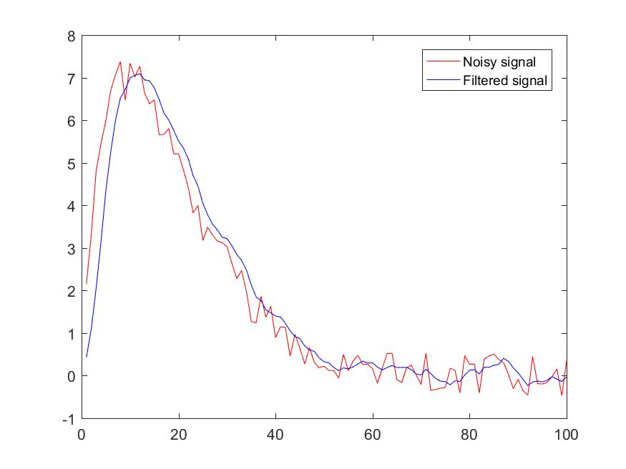

***Code:***

load handel %load a audio signal

u=y(1:20000);

sound(u)

x=u+0.5*rand(length(u),1)-0.5; %adding noise

sound(x)

M=5;

b=ones(M,1)/M;

Z=2*filter(b,1,x);

sound(z)

subplot(3,1,1)

plot(u)

title('Original signal')

subplot(3,1,2)

plot(x)

title('Noisy signal')

subplot(3,1,3)

plot(z)

title('Filtered signal')

***Figure:***

