

Department of Computer Science and Engineering

3rd Year 2nd Semester

COURSE NAME:  Digital Signal Processing Lab

COURSE CODE: CSE-356

DATE:  13-03-2019

**SUBMITTED TO :**

Dr. Md. Imdadul Islam

Professor, Department of Computer Science and Engineering

Jahangirnagar University

**SUBMITTED BY:**

Towfiqul Hoque

Roll no: 379

**Objectives:**

Knowing about DFT, magnitude and phase of signal, rectangular pulse etc.

**Experimiment-01**

**Description:**

Discrete Fourier Transform(DFT) of x=[1 0 0 1] and the magnitude and phase of the transformed sequence.

**Code:**

x=[1 0 0 1];

X=fft(x);

subplot(2,1,1)

stem(abs(X))

xlabel('n')

ylabel('X(n)')

title('Absolute value of DFT sequence')

subplot(2,1,2)

stem(angle(X))

xlabel('n')

ylabel('Angle(X(n))')

title('Angle of DFT sequence')

**Figure:**

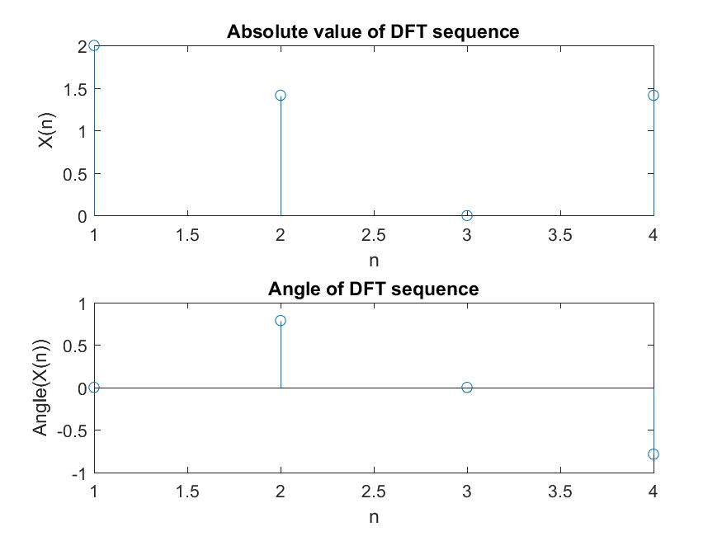

**Experimiment-02**

**Description:**

Discrete Fourier Transform(DFT) of x=sin(α)+a*sin(β) and the magnitude and phase of the transformed sequence.

**Code:**

N=8; Fs=8000; Ts=1/Fs;

n=0:1:N-1;

x=sin(2*pi*1000*n*Ts)+0.5*sin(2*pi*2000*n*Ts+3*pi/4);

subplot(3,1,1)

stem(n,x)

xlabel('n')

ylabel('x')

title('Original Sequence')

X=fft(x)

subplot(3,1,2)

stem(abs(X))

xlabel('n')

ylabel('X(n)')

title('Absolute value of DFT sequence')

subplot(3,1,3)

stem(angle(X))

xlabel('n')

ylabel('Angle(X(n))')

title('Angle of DFT sequence')

**Figure:**

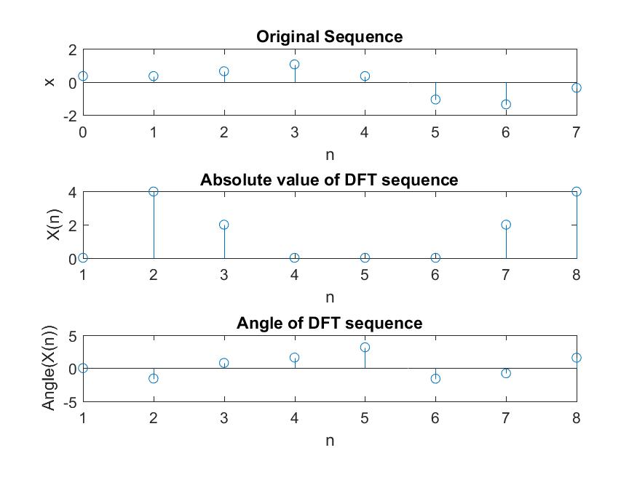

**Experimiment-03**

**Description:**

Discrete Time Fourier Transform(DTFT) on a rectangle pulse.

**Code:**

fs = 500;

t = -1 : 1/fs : 1;

x=rectpuls(t,0.12);

subplot(2,2,1)

plot(t,x)

grid on

X=fft(x);

X=fftshift(X);

subplot(2,2,2)

plot(abs(X))

grid on

x=rectpuls(t,0.02);

subplot(2,2,3)

plot(t,x)

grid on

X=fft(x);

X=fftshift(X);

subplot(2,2,4)

plot(abs(X))

grid on

**Figure:**

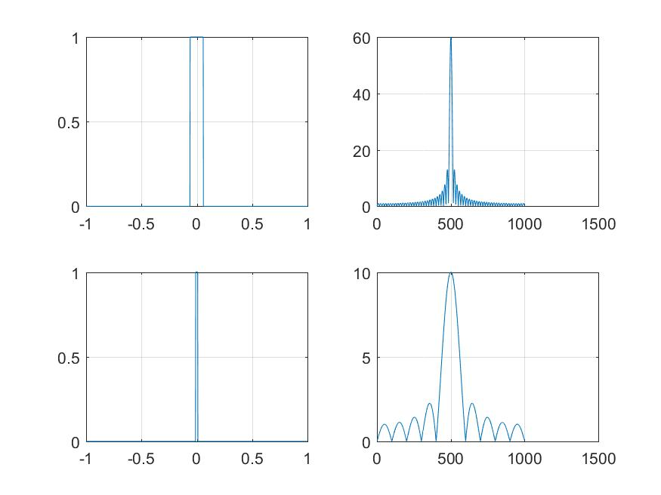

**Experimiment-04**

**Description:**

3D rectangular pulse and 3D sinc in frequency domain.

**Code:**

x=zeros(32);

x(12:17,12:17)=ones(6);

subplot(2,1,1)

mesh(x)

title('3D rectangular pulse')

x=fft2(x);

x=fftshift(x);

subplot(2,1,2)

mesh(abs(x))

title('3D sinc in frequency domain')

**Figure:**

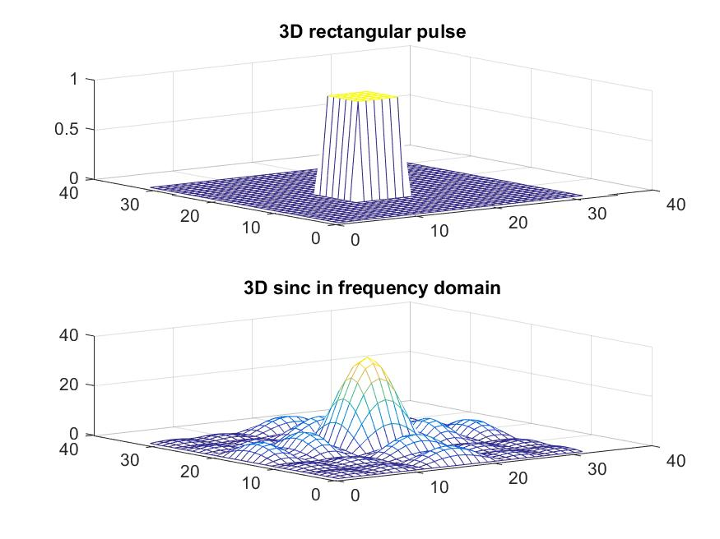

**Experimiment-05**

**Description:**

Evaluating and plotting the function $f\left(x,y\right)=x^{2}+y^{2}$  over 2D grid.

**Code:**

[X,Y] = meshgrid(-8:0.5:8);

z=X.^2+Y.^2;

subplot(2,1,1)

mesh(z)

subplot(2,1,2)

surf(z)

**Figure:**

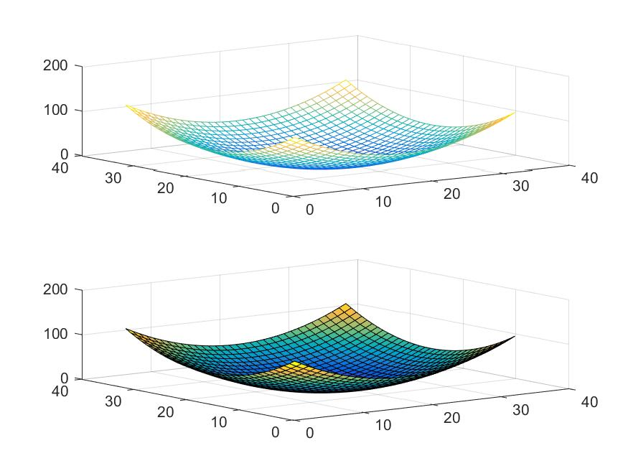

**Experimiment-06**

**Description:**

Evaluating and plotting the function $f\left(x,y\right)=e^{{(-x^{2}-y^{2})}/3}$  over 2D grid.

**Code:**

[X,Y] = meshgrid(-8:0.5:8);

z=exp(-(X.^2+Y.^2)/3);

subplot(2,1,1)

mesh(z)

subplot(2,1,2)

surf(z)

**Figure:**

