

Department of Computer Science and Engineering

3rd Year 2nd Semester

Course Name: Digital Signal Processing Lab

Course Code: CSE-356

Lab No: 05

**Submitted by:**

Towfiqul Hoque

Roll: 379

**Submitted to:**

Dr. Imdadul Islam

Professor, Dept. of CSE, JU

Sarnali Basak

Assistant Professor, Dept of CSE, JU\

Submission Date:  22-10-2019

**Objectives:**

**Experiment No: 01**

Fs = 1000;

FN = Fs/2;

N = 73;

beta = 5.65;

fc1 = 125/FN;

fc2 = 275/FN;

Fc = [fc1 fc2];

hn = fir1( N-1, Fc, kaiser( N, beta) );

[H, f] = freqz( hn,1, 512, Fs);

mag = 20*log10( abs(H) );

plot(f,mag);

grid on

xlabel('f')

ylabel('H(h) (db)')

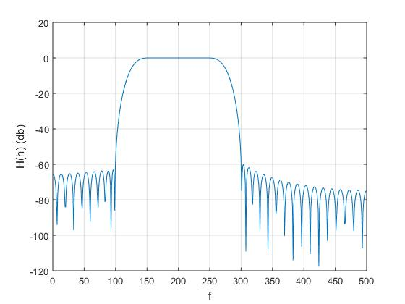

**Experiment No: 02**

Fs = 1000;

FN = Fs/2;

N = 73;

beta = 5.65;

fc1 = 125/FN;

fc2 = 275/FN;

Fc = [fc1 fc2];

hn = fir1( N-1, Fc, kaiser( N, beta) );

[H, f] = freqz( hn,1, 512, Fs);

mag = 20*log10( abs(H) );

plot(f,mag,'r');

hold on

hn = fir1(N-1, Fc, hamming(N) );

[H, f] = freqz( hn,1, 512, Fs);

mag = 20*log10( abs(H) );

plot(f,mag,'b');

grid on

xlabel('f')

ylabel('H(h) (db)')

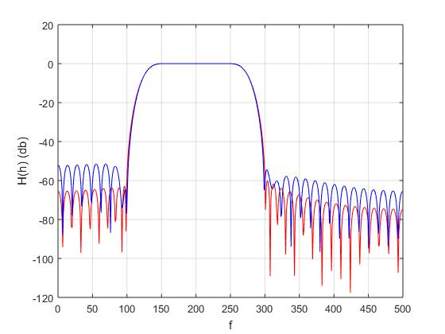

**Experiment No: 03**

Fs = 2000;

FN = Fs/2;

N = 73;

beta = 5.65;

fc1 = 112/FN;

fc2 = 150/FN;

Fc = [fc1 fc2];

hn = fir1(N-1, Fc, kaiser(N, beta));

t = 0 : 1/Fs : 0.2;

y = 2*sin(2*pi*120*t) + 2*sin(2*pi*125*t);

subplot(3, 1, 1);

plot(t, y);

yn = awgn(y, -4);

subplot(3, 1, 2)

plot(t, yn);

out = filter(hn, 1, yn);

subplot(3, 1, 3);

plot(t, out);

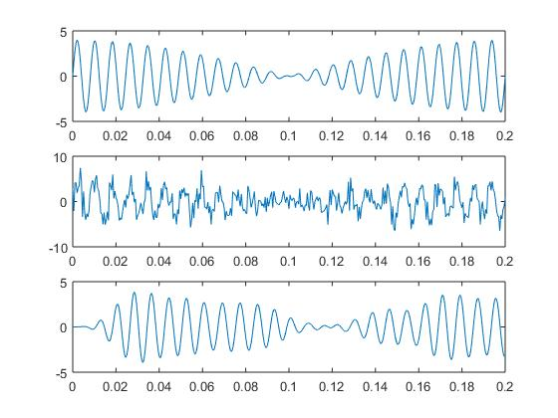

**Conclusion:**