

Department of Computer Science and Engineering

3rd Year 2nd Semester

Course Name: Digital Signal Processing Lab

Course Code: CSE-356

Lab No: 04

Date:  15-10-2019

**Submitted by:**

Towfiqul Hoque

Roll: 379

**Submitted to:**

Dr. Imdadul Islam

Professor, Dept. of CSE, JU

Sarnali Basak

Assistant Professor, Dept of CSE, JU

**Objectives:** Knowing about Kaiser Window, Hamming Window, LP FIR filter etc.

**Task1:** Plot Hamming, Hann and Kaiser window functions used in design of a FIR filter.

**Kaiser Window:** w = kaiser(N,beta) returns an N-point Kaiser window with shape factor beta.

beta=5.2; N=20; n=1:1:20;

y=hamming(N);

y1=hann(N);

y2=kaiser(N,beta);

plot(n,y,'r-^',n,y1,'kd:',n,y2,'b*:')

xlabel('n')

ylabel('h(n)')

legend('Hamming','Hann','Kaiser')

grid on



**Task2:** Design a low pass filter using hamming window.

**Hamming window:** w = hamming(N) returns an N-point symmetric Hamming window.

fc=.21875;

N=53;

Fs=8000;

wn=hamming(N);

hn=fir1(N-1,2*fc,wn);

[H,f]=freqz(hn,1,800,Fs); %time domain to freq domain

mag=20*log10(abs(H));

plot(f,mag);

grid on

xlabel('f')

ylabel('|H(h)|(db)')



**Task3:** Random noise elimination with LP FIR filter

t=0:1/Fs:2*pi;

x=sin(3*pi*t); %original

xn=x+0.4*rand(1,length(t)); %noisy

out=filter(hn,1,xn); %filter

subplot(3,1,1);

plot(t,x);

subplot(3,1,2);

plot(t,xn);

subplot(3,1,3);

plot(out)



**Task 4:** Awgn elimination with LP FIR filter

t=0:1/Fs:2*pi;

x=sin(3*pi*t); %original

xn=awgn(x,20); %noisy

out=filter(hn,1,xn); %filter

subplot(3,1,1);

plot(t,x);

subplot(3,1,2);

plot(t,xn);

subplot(3,1,3);

plot(out)

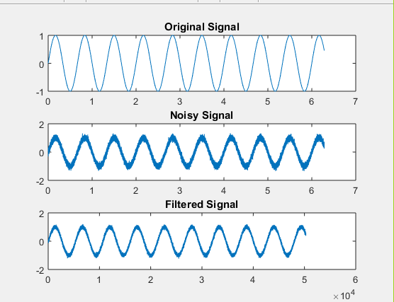

**Task 5:** Band pass filter hamming window

Fs=1000;

FN=Fs/2;

N=67;

fc1=125/FN;

fc2=275/FN;

Fc=[fc1 fc2];

hn=fir1(N-1,Fc,hamming(N));

[H,f]=freqz(hn,1,512,Fs);

mag=20*log10(abs(H));

plot(f,mag,'b')

grid on

xlabel('f')

ylabel('|H(h)|(db)')

