**AHSANULLAH UNIVERSITY OF SCIENCE AND TECHNOLOGY**



**Course No: CSE 4238**

**Course Name: Soft Computing Lab**

**Section: C**

**Semester: Fall 2020**

**Submitted to: Submitted by:**

**Sanjana Karim Lora Name: Towkir Ahmed**

**Lecturer, ID: 17.01.04.110**

**Department of CSE, AUST. Group: C1**

**Email:** **170104110@aust.edu**

**Experiment using RNN:**

**Hyperparameters:**

lr = 0.0001

epoch_num = 5

unit1 = 64

unit2 = 128

unit3 = 256

embedding_output = 32

**After Preprocessing:**

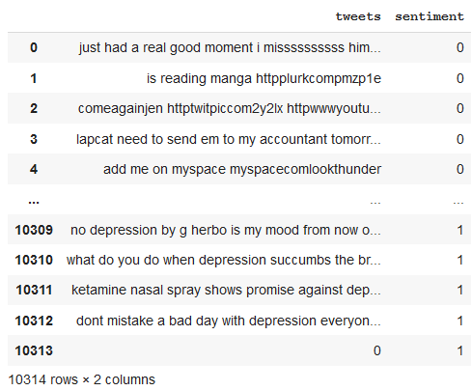

**Model Summary:**

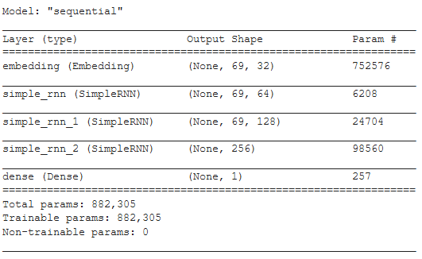

**Training Dataset and Performance Evaluation:**

**Training Dataset:**

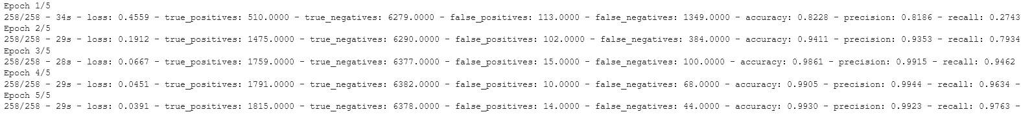

**Loss vs Accuracy:**

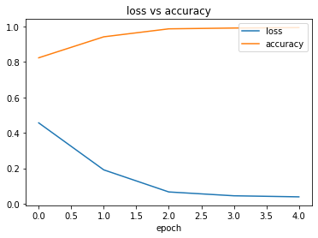

**Confusion Matrix:**

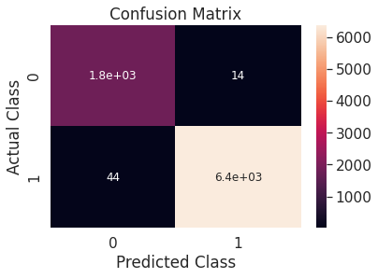

Github Link:

https://github.com/Towkir7970/Softcom-Assignment-3