Zen Fragrances — GTM Master Plan
Go-To-Market Strategy · Consolidated 2026-08-08
Zen Fragrances enables anyone in South Africa with a WhatsApp phone to own a perfume business — zero upfront cost, instant activation, two ways to earn. We eliminate barriers (no starter pack), reduce complexity (lean 20-SKU launch), raise agent autonomy (own pricing, team building, earnings transparency) and create new capabilities (WhatsApp-as-store, agent network as distribution). Our market isn't existing perfume buyers — it's the millions of South Africans looking for flexible income.

1. Strategy Canvas — where we don't compete
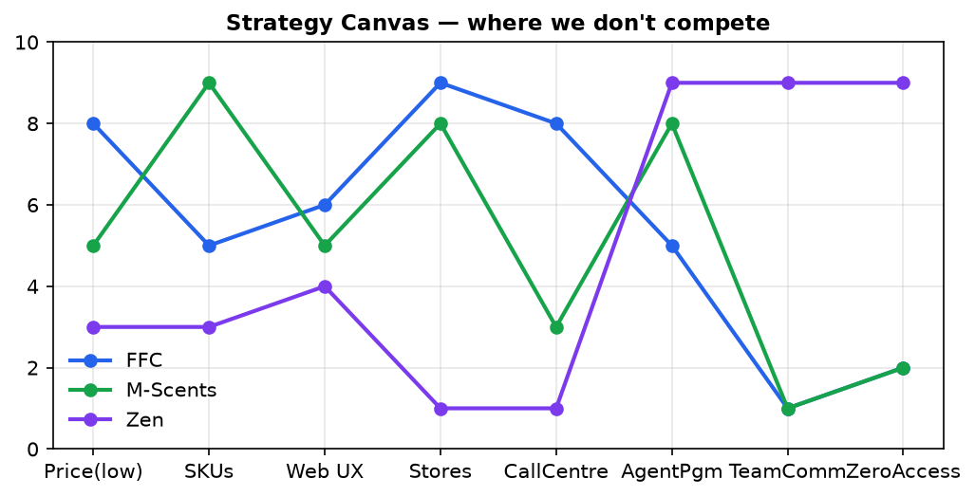
Legend: FFC (national warehouses) · M-Scents (KZN stores) · Zen (people-network). We under-invest in what they compete on and own accessibility + team economics.

2. Channel Strategy
Channel | Verdict | Capital | Courier | Role
WhatsApp (agents) | ✅ Core | R0 | Bulk drop | Ordering + communication (the moat)
Web store | ✅ Keep | R0 | Min R500 | Discovery, SEO, agent locator
Agents | ✅ Core | R0 | — | The distribution army
Wholesalers | ✅ Push | R0 | Free-ship | Bulk volume
Hawkers | ✅ Budget tier | R0 | Hand-sell | Township impulse + penetration
Stores (consignment) | 🟡 Defer | R5–20K/store | Bulk | Only after profitable

3. Pricing — 3-Tier Ladder (20 launch SKUs)
Tier | Sizes | Wholesale | Retail (2×) | SKUs | Role
🟢 Budget | 30ml | R30–50 | R60–100 | 6 | Acquisition / impulse / hand-sell
🟡 Signature | 80–100ml | R80–100 | R160–200 | 10 | The revenue engine
🔴 Premium/Oud | 100ml | R150–200 | R300–400 | 4 | Margin + gifting
🎁 Add-ons | sets/spritzers | R8–45 | R20–90 | — | Upsell, gift trigger

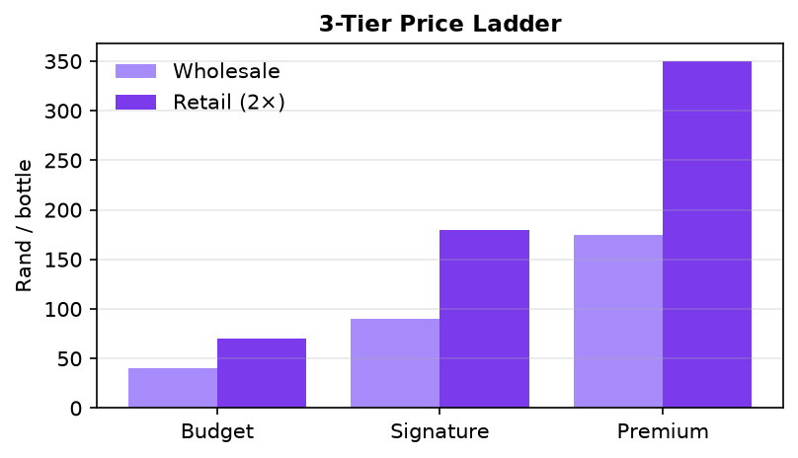
Budget-tier rule: never shipped alone (courier = 186% of value). It is a hand-sell acquisition tool, not a profit engine.
INITIAL LAUNCH STRATEGY (2026-08-08): lead with the BUDGET tier at a starting price point of R30. Agents get 5% off this price (agent cost R28.50) and sell at ~2× (R60 retail, agent-set). Budget-first = lowest entry barrier, fastest agent recruitment, and hand-sell friendly (no courier on single budget bottles). Signature/premium tiers are added as agents grow.

4. Courier Economics — the math that picks the channel
Order | Value | Courier | % of value | Viable?
1 budget | R35 | R65 | 186% | ❌ loss
1 mid | R95 | R65 | 68% | ❌
5 mid | R475 | R65 | 14% | 🟡
10 mid | R950 | R65 | 7% | ✅
20+ bottles | R2,000+ | R0 | 0% | ✅ best

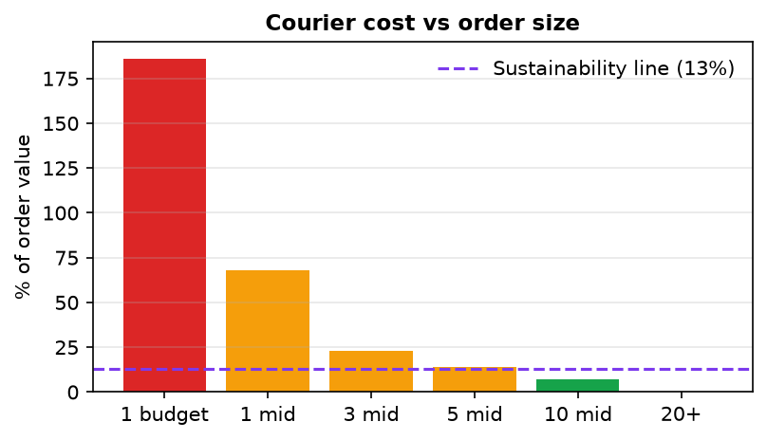
Rule: courier sustainable at ≤10–13% of value → minimum shipped order ≈ R500 / 5 bottles. The agent is the last-mile courier (one bulk drop, local hand-sell).

5. Distribution — Penetration Ladder
Level | What | Capital | Timing
L1 — Agent hubs | Option 1: 1 hub per township, hawkers via agent code, Zen absorbs courier ≥R2k | R0 | Month 1–3
L2 — Buffer stock | Hub agents hold 20–50 bottles, same-day local fulfillment | R0 | Month 3–6
L3 — Every town | Every town has an agent; hub agents run depots | R0–15K | Month 6+
L4 — Zen DCs | Regional DCs (R50–150K each) | R50–150K | Year 2 (revenue-funded)

Payment flow — no agent money handling
1) Hawker orders via WhatsApp (agent code) → 2) Zen sends Yoco/EFT/PayShap link → 3) Hawker pays ZEN directly → 4) Zen ships one bulk drop to agent → 5) Agent distributes locally → 6) Zen pays agent 5% commission by bank transfer. Agents never touch money.

6. Geography — where we enter
Priority | Region | Why | Status
1 | Gauteng townships (Soweto, Tembisa, Mamelodi, Alexandra, Katlehong) | FFC = city warehouses only; M-Scents absent | Wave 1
2 | Eastern Cape (Mthatha, Mdantsane, Gqeberha) | Both competitors thin; M-Scents Mthatha signal | Wave 2
⛔ | KZN (Durban, PMB) | Saturated — M-Scents 14 stores + FFC | Avoid

Only competitor overlap is KZN. Everywhere else is contested by one player or none.

7. Pre-Launch + 90-Day Launch Plan
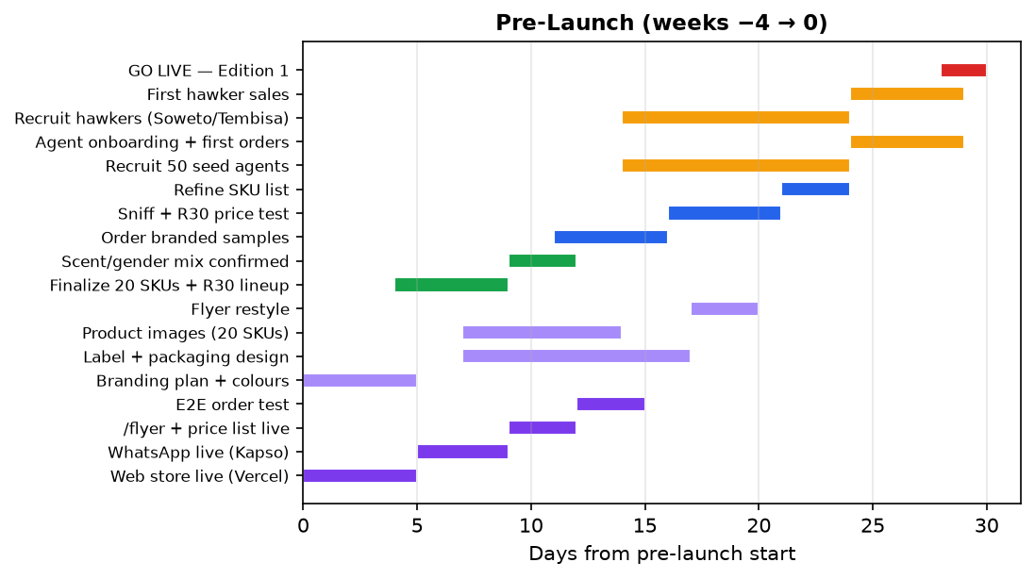
# | Track | Deliverable | Week | Exit criteria (Gate)
1 | Site & WA ready | Web store + WhatsApp + /flyer + price list live | −4→−3 | E2E order test passes + UX audit (checklist.design)
2 | Branding plan | Colours + logo + brand kit (tasteskill brandkit) | −4 | Founder sign-off
3 | Branding | Label, packaging, product images, flyer restyle; no-ai-slop copy pass | −3→−2 | 20 SKUs have branded images; copy sounds human
4 | Fast movers | Finalize 20 SKUs (6/10/4) + R30 lineup | −3 | SKU list frozen
5 | Samples / market test | Branded samples; sniff + R30 price test | −2→−1 | SKU list refined from feedback
6 | Activate agents | 50 seed agents; onboarding + first orders | −1→0 | 50 active · ≥10 pilot orders
7 | Activate hawkers | Hawkers (Soweto/Tembisa); first taxi-rank sales | −1→0 | First hawker sales recorded
8 | GO LIVE | Edition-1 flyer + broadcasts; transitions.dev polish | 0 | Live

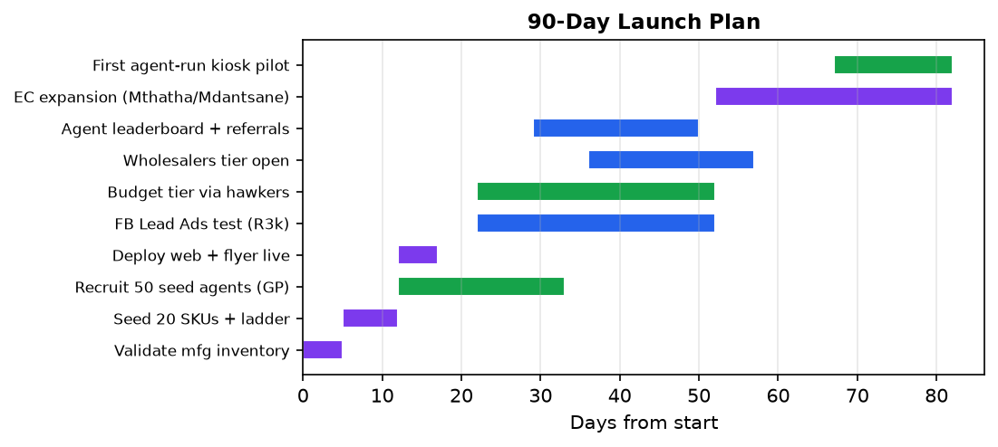

8. KPI Dashboard (North Star)
Metric | M1 | M3 | M6
Active agents | 100 | 500 | 2,000
Monthly orders | 200 | 1,500 | 6,000
Monthly GMV | R70K | R600K | R2.7M
Courier % of revenue | < 8% | < 6% | < 5%
Budget tier share | < 60% | < 40% | < 20%
Avg agent order | R1,500 | R1,800 | R2,000+
CAC / active agent | < R80 | < R60 | < R50

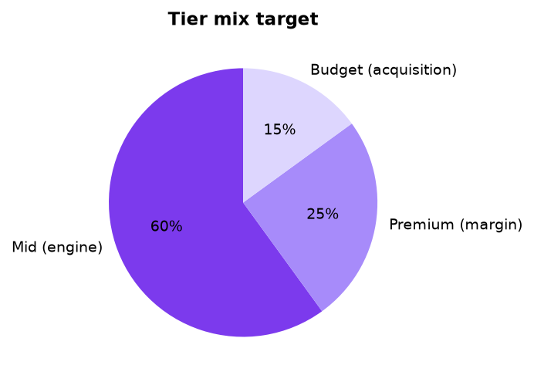

9. GTM Approaches Considered (strengths & weaknesses)
Approach | Strengths | Weaknesses | Verdict
WhatsApp-first agent platform | Lowest friction in SA; no app/login; network effects; low-literacy friendly | No physical sniff test; needs agent recruitment; courier forces bulk | ✅ Core
National warehouse + web + call centre (FFC) | National reach; proven; brand recognition | R960 barrier; web-only friction; high capex; shallow in communities | ❌ Not ours
Physical retail stores (M-Scents) | Community trust; sniff test; cash sales | Capital-heavy; regional; rent/staff; slow scale | 🟡 Defer — agent hubs replace stores
Direct-to-consumer web | Full margin; SEO | Single-bottle courier kills economics; needs ad spend | ⚠️ Weakest channel
Branded distribution (license Motala/P2D) | Instant brand trust; gift sets; price ladder | Thin margin; no brand equity for US; replaceable middleman | 🟡 Later, optional licensing
Own-brand manufacturing (private label) | Full margin; full brand equity; owns the vertical; not replaceable | Needs own packaging/brand investment; brand trust builds over time | ✅ Chosen (day 1)
Hawker / micro-retail network | Zero courier; impulse; township penetration | Small per-unit margin; management heavy | ✅ Budget-tier channel

Why the AGENT route initially: (1) courier economics make single-bottle direct-to-consumer unviable (R65 courier on a R95 bottle); (2) retail stores need capital we don't have; (3) wholesaling makes us a replaceable middleman; (4) agents give zero-capital, WhatsApp-native, network-effect distribution AND build the army that later supports own-brand retail. Fastest path to first revenue while defending our moat.

10. SWOT (readable summary)
💪 Strengths (internal) | 🩸 Weaknesses (internal)
Zero barrier (no R960 starter pack) | No physical presence / no sniff test
WhatsApp-first (95% of SA have it) | No brand recognition yet — own-brand must be built
Two-sided earning (margin + 5% team) | Single manufacturer (Focus Logic) — dual-source mandatory
6 role dashboards + agent locator | No card payments on WhatsApp yet
Confirmation-before-cart; click-through links | 0 of 99 SKUs seeded; single-size plan
Automated mfg forwarding; lean iteration | Budget-first means thin per-unit margin initially

🚀 Opportunities (external) | ⚠️ Threats (external)
R750B township economy + side-hustle culture | FFC adds WhatsApp / drops starter price
WhatsApp = SA super-app (join habit, not build) | Copycat entrants (speed is the moat)
FFC's R960 barrier = our lead source | WhatsApp policy changes (Kapso buffers)
Social commerce boom → agents = free sales force | Manufacturer failure (dual-source by mth 3)
Agent network = last-mile distribution (no rent) | Pyramid perception (commission on orders only)
Corporate gifting; SADC; data monetization | Courier theft; counterfeit stigma; rand volatility

11. Competitor Landscape (factual)
Competitor | SKUs | Sizes | Wholesale | Retail | Starter | Footprint | Ordering
FFC | 42 | 30ml only | R19–94 | R40–190 | R960 | 15 warehouses (national) + kiosks | Web + call centre
M-Scents | 241 | 15ml–200ml | R15–200 | R30–400+ | R800–3,750 | 21 stores (ALL KZN) | Web only
Fragrance Boutique | 40+ | 50/100ml | — | R219–419 | Application | 1 store (CPT) | Web + WhatsApp + physical
Perfumes for Africa | 40+ | 5ml–100ml | — | R12–133 | — | 1 store (CPT) | Web + WhatsApp + physical
SensoryFX / Sensetek | B2B | — | — | — | — | Centurion / Sandton | —

Facts that drive the plan: only competitor overlap is KZN (Durban + PMB); Gauteng townships have NO competitor community presence; both leaders (FFC, M-Scents) are web-only with high entry barriers; no competitor has team commissions, WhatsApp-first ordering, or agent-as-distribution.

12. Owning the Vertical — Own-Brand First
DECISION (2026-08-08): we PRODUCE and SELL perfumes under our OWN brand (Zen) from day 1, via contract manufacturer. Licensing third-party brands (Motala/P2D/Parfumo) is a LATER, optional expansion — not the launch path.
Assumption | Impact of own-brand-first
Moat | Stronger — we're a platform + a brand, not a replaceable distributor
Brand | Critical from day 1 — build Zen equity ourselves (packaging, quality, brand colours). No borrowed trust
Margin ceiling | Higher from day 1 — full margin, no distributor/licensing cut
Manufacturer dependency | Critical — contract manufacturer makes our oil. Dual-source (SensoryFX/Sensetek) mandatory
Zero-capital launch | Mostly unchanged — contract manufacturer holds inventory; own-label packaging is the launch cost
Counterfeit perception | More relevant — our own brand must not look fake; quality packaging non-negotiable

13. Payment Pathways & Collection / Courier
Payment pathways (hawker/agent pays ZEN directly — agents never handle money):
Payment method | How it works | Clears
Yoco card link | Payment link sent on WhatsApp / web checkout | Instant
EFT + POP | Bank transfer, then send proof-of-payment image | 1–2 working days (manual verify)
PayShap / mobile money | Instant bank-to-bank via phone | Instant
Cash (exception) | Cash-only hawkers — collected by agent, capped per agent | Paid by agent to Zen (exception only)

Collection / courier once payment is made:
1) Payment confirmed (POP verified / idempotency)
2) Zen consolidates the agent's group of paid orders
3) Courier Guy to agent (R65 flat; FREE over R2,000) OR Pargo/Pudo pickup point (rural — agent collects)
4) Agent distributes locally (hand-sell)
Rule: budget bottles are hand-sold or bundled — never couriered alone.

14. Competitive Positioning
vs | Our line
FFC | Start with 1 bottle, R65 — vs their R960 starter pack + web-only
M-Scents | No starter pack, WhatsApp-first, team commissions, Gauteng — vs their R800–R3,750 + KZN-only
Fragrance Boutique | Become an agent instantly — vs application-based

15. Open Items
- Verify M-Scents Mthatha store (not on their locator yet)
- Set FLYER_WHATSAPP in Railway for the flyer CTA
- Confirm Focus Logic can private-label (our Zen brand) + holds inventory (the model depends on it)
- Define Zen own-brand identity: name/bottle/packaging/brand colours (launch-critical)
- Confirm dual-source private-label capability (SensoryFX/Sensetek) — mandatory hedge
- Consider licensing Motala/P2D/Parfumo LATER (optional expansion, not launch)
- Confirm R30 budget price point + 5% agent discount mechanics
- Seed 20 SKUs under the Zen brand with thumbnail_url images
- Refine flyer styling once brand colours are chosen

Zen Fragrances — GTM Master Plan · generated 2026-08-08 · editable & shareable

