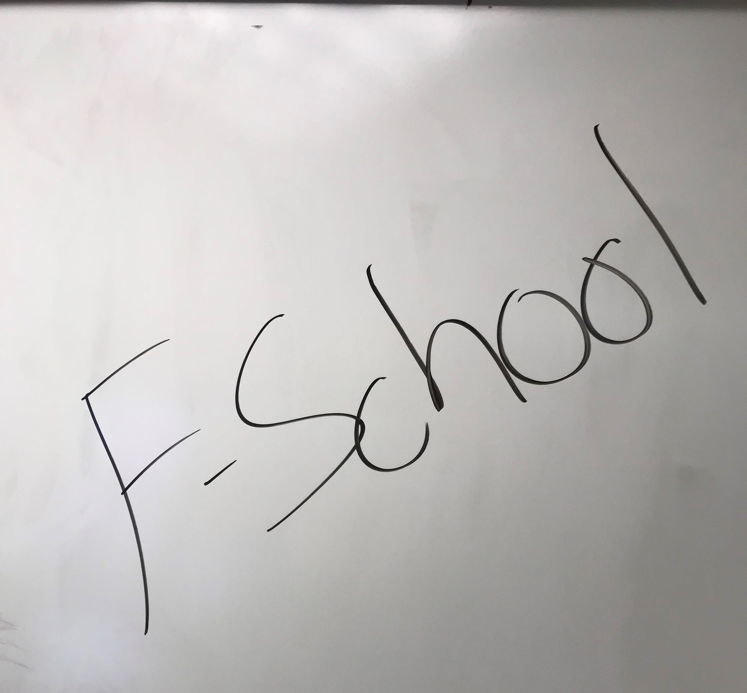

Image of Jimmy Drawing on board 1