Management Accounts
Sample report — the shape every month, quarter and year will arrive in
Period covered: FY2024 – FY2026 year-to-date (through July 2026) · Currency: GBP · Basis: management information

At a glance
Thread & Salt is profitable and growing. Full-year 2025 revenue reached £638,802 — up 8.5% on 2024 — at a healthy and stable net margin. The figures below are the automated snapshot that would head every monthly pack.

Revenue FY2025  £638,802  ▲ 8.5% vs FY2024 | Gross margin  58%  Steady, all periods | Net profit FY2025  £147,823  23.1% net margin | Rev / unit  ≈ £64  Stable pricing power

Profit & loss summary
Revenue, cost of goods, operating costs and profit, at annual level. FY2026 is year-to-date through July, so it is a part-year figure and not directly comparable to the full years.
£ | FY2024 | FY2025 | FY2026 YTD
Revenue | £588,800 | £638,802 | £347,342
Cost of goods sold | £247,296 | £268,297 | £145,884
Gross profit | £341,504 | £370,505 | £201,458
Gross margin | 58% | 58% | 58%
Marketing & advertising | £82,432 | £89,432 | £48,628
Fulfilment & shipping | £52,992 | £57,492 | £31,261
Platform & payment fees | £20,608 | £22,358 | £12,157
Founders' compensation | £38,400 | £42,000 | £25,900
Software & other overhead | £10,200 | £11,400 | £6,650
Total operating expenses | £204,632 | £222,683 | £124,596
Net profit | £136,872 | £147,823 | £76,863
Net margin | 23.2% | 23.1% | 22.1%

Read this: gross margin is rock-steady at 58%, so the business keeps a consistent slice of every sale. Because some costs are fixed, a soft revenue month squeezes net margin a little harder than the revenue drop alone — worth remembering when a quiet month lands.

Revenue trend
Monthly revenue since the order system went live in January 2024. The rhythm is clear: a strong Q4 lift each November–December, softer summers, and steady year-on-year growth — until the most recent month.
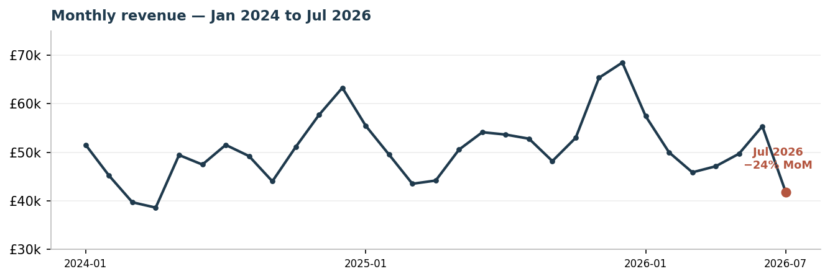

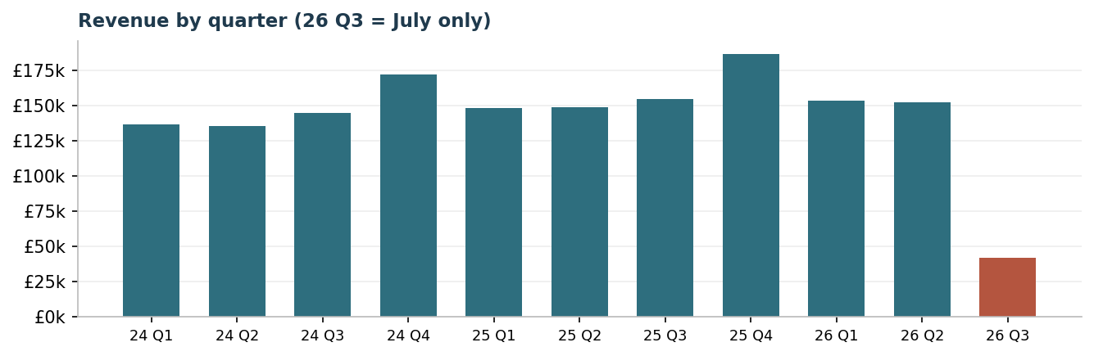

Quarter | FY2024 | FY2025 | FY2026
Q1 | £136,431 | £148,518 | £153,302
Q2 | £135,531 | £148,876 | £152,190
Q3 | £144,768 | £154,628 | £41,850 *
Q4 | £172,070 | £186,780 | —
* FY2026 Q3 = July only (one month), not a full quarter.

What the agent flagged this month
This is the kind of proactive signal the stretch agent surfaces automatically — observe, analyse, recommend:
⚠ Watch — July revenue broke trend
July 2026 came in at £41,850 — down 24.4% on June and down 22.0% on July last year. Every previous July grew year-on-year; this is the first month to fall below the same month a year earlier.
Context: first-half 2026 revenue (£305,492) grew only 2.7% over first-half 2025 — well below the 8.5% full-year pace of 2024→2025. Growth was already cooling before July's drop.
Recommended action: treat July as a signal, not noise. Check whether a hero line (e.g. the Corail Linen Wrap Dress) sold through or stocked out, confirm marketing spend didn't pause, and line up an August mailing-list drop ahead of the reliable Q4 lift. The agent will re-check next month and tell you if the trend continues.

Notes. Management information for internal decisions — not audited or statutory accounts. Monthly detail begins Jan 2024 (the order system's start); earlier years are annual-only. COGS modelled at 42% of revenue per the company's product costing. This is a sample built from the shared history to show format and rigour; the live monthly pack regenerates automatically in this same shape.

