- INTRODUCTION

A detailed description of the project titled " E-COMMERCE ORDER AND PAYMENT MANAGEMENT SYSTEM" , prepared to meet the requirements of the Database Systems Course , is provided. This report includes the scenario, ER diagram, assumptions, schema design, program screenshots, all queries and their results, populated database tables, and report screenshots. During the implementation phase of the project, we used a relational database management system Oracle Live SQL .
The main functions of the E-commerice system can be listed as:
- Creating a new order for a user with order informations

- Searching for a user, order, product, or payment from the database.

- To manage and track user information, product inventory, orders, payments, and shipping details in an organized and efficient way.

- User, order, and product informations in this e-commerce system , can be updating .

- Users can register and manage their account information such as name, email and phone number.

- The system can list orders, products, and users

2.THE SCENARIO

This scenario is designed for an e-commerce order management system. Its purpose is to model the relationships between users, their addresses, orders, payments, products, and product categories in a structured way. It helps ensure accurate order tracking, efficient payment processing, and organized product management. The system supports better database design, easier maintenance, and scalability
This ER diagram represents an e-commerce order management system with seven entities: USERS, ADDRESSES, ORDER, ORDER DETAILS, PAYMENTS, PRODUCTS, CATEGORIES, and the associative relationships between them. Each USER (with attributes like UserID [PK], FirstName, LastName, Email, UserPassword,PhoneNumber,UserRole.) can own multiple ADDRESSES (AddressID [PK],UserID[FK] , AddressTitle,ContactFirstName, ContactLastName, ContactPhoneNumber,City,District,Neighborhood, PostalCode , AddressDetails), but each address belongs to only one user. A user can place multiple ORDERS (OrderID [PK], UserID [FK], OrderDate, TotalAmount,OrderStatus , ShippingAddressID[FK].), and each order has one SHIPPING ADDRESS (ShippingAddressID [FK] from ADDRESSES). Each order has one or more ORDER DETAILS entries (OrderDetailID [PK], OrderID [FK], ProductID [FK], Quantity, SalePrice), and each ORDER DETAIL is linked to a single PRODUCT (ProductID [PK],CatagoryID[FK] ProductName, Description, UnitPrice, StockQuantity, DateAdded,IsActive.). Products belong to one CATEGORY (CategoryID [PK],CatagoryName]), and categories can form a hierarchy using ParentCategoryID [FK], allowing subcategories. PAYMENTS are associated one-to-one with ORDERS (PaymentID [PK], OrderID [FK], PaymentDate,PaymentMethod, PaymentAmount, PaymentStatus.). Cardinalities are as follows: USERS to ADDRESSES (1:N), USERS to ORDERS (1:N), ADDRESSES to ORDERS (1:N via ShippingAddressID), ORDERS to ORDER DETAILS (1:N), ORDER DETAILS to PRODUCTS (1:N), PRODUCTS to CATEGORIES (N:1), and CATEGORIES to themselves through a PARENT relationship (1:N). Lastly, ORDERS and PAYMENTS are in a 1:1 relationship.

  - Entities and Attributes:
    - USERS
Attributes: UserID [PK], FirstName, LastName, Email, UserPassword, PhoneNumber, UserRole
    - ADDRESSES
Attributes: AddressID [PK],UserID[FK] , AddressTitle,ContactFirstName, ContactLastName, ContactPhoneNumber,City,District,Neighborhood, PostalCode , AddressDetails
    - ORDER
Attributes: OrderID [PK], UserID [FK], OrderDate, TotalAmount,OrderStatus , ShippingAddressID[FK]
    - PAYMENTS
Attributes: PaymentID [PK], OrderID [FK], PaymentDate,PaymentMethod, PaymentAmount, PaymentStatus
    - ORDER DETAILS
Attributes : OrderDetailID [PK], OrderID [FK], ProductID [FK], Quantity, SalePrice
    - PRODUCTS
Attributes: ProductID [PK],CatagoryID[FK] ProductName, Description, UnitPrice, StockQuantity, DateAdded,IsActive
    - CATAGORİES
Attributes: CategoryID [PK],, ParentCategoryID [FK] CatagoryName

  - Relationships Between Entities:

a) User – Address (1:N) → One user can have multiple addresses.
b) User – Order (1:N) → One user can place multiple orders.
c) Address – Order (1:N) → One address can be used for shipping multiple orders.
d) Order – OrderDetail (1:N) → One order can contain multiple order details.
e) OrderDetail – Product (1:N) → One order detail can include multiple products.
f) Product – Category (N:1) → Each product belongs to one category, but a category can include many products.
g) Category – Category (1:N) → A category can have multiple subcategories.
h) Order – Payment (1:1) → Each order has exactly one payment associated with it.

3.THE ER DIAGRAM

Entity-Relationship Diagrams (ERDs) help visualize the structure of a database clearly. They show the relationships between tables, making it easier to understand data flow. ERDs help in designing efficient and organized databases. They reduce redundancy by identifying key entities and their attributes. Overall, ERDs improve communication between developers and ensure better database planning.

3. Entity-Relationship Diagram (ERD)
The Entity-Relationship Diagram (ERD) provides a visual blueprint of the e-commerce order management system's data structure. It highlights the main entities, their key attributes, and the relationships

3.1 Entities
USERS This entity represents all registered users of the system, typically customers. It holds personal and contact information such as names, email addresses, phone numbers, and login credentials. Each user can interact with various components of the platform, including placing orders and managing addresses.
ADDRESSES Contains detailed shipping information for users. A user can have multiple addresses saved), each with details like city, postal code, and contact name. These addresses are later used for order delivery.
ORDER Represents a purchase transaction made by a user. Each order is linked to the user who placed it and includes details such as the order date, total amount, and shipping address. It serves as the central point connecting various parts of the purchase process.
ORDER_DETAILS Acts as a junction between orders and products, capturing the specifics of each item in an order. It includes product quantity, sale price at the time of purchase, and a reference to the product itself. This entity enables support for multi-product orders.
PRODUCTS Represents the items available for sale within the system. Each product has attributes such as name, price, stock quantity, and a link to its category. Products are the core of the ordering process.
CATEGORIES Provides a hierarchical classification for products. Each product belongs to one category, and categories can have subcategories through a self-referencing structure. This improves product organization and enables more efficient navigation and search.
PAYMENTS Stores payment information corresponding to each order. It includes the payment method, amount, and current payment status. Each order is associated with exactly one payment record, ensuring transactional integrity.

3.2 Attributes
USERS(UserID [PK], FirstName, LastName, Email, UserPassword,PhoneNumber,UserRole)
ADDRESSES(AddressID [PK],UserID[FK] , AddressTitle,ContactFirstName, ContactLastName, ContactPhoneNumber,City,District,Neighborhood, PostalCode , AddressDetails)
ORDER(OrderID [PK], UserID [FK], OrderDate, TotalAmount,OrderStatus , ShippingAddressID[FK])
PAYMENTS (PaymentID [PK], OrderID [FK], PaymentDate,PaymentMethod, PaymentAmount, PaymentStatus)
ORDER DETAILS(OrderDetailID [PK], OrderID [FK], ProductID [FK], Quantity, SalePrice)
PRODUCTS(ProductID [PK],CatagoryID[FK] ProductName, Description, UnitPrice, StockQuantity, DateAdded,IsActive)
CATAGORİES(CategoryID [PK],, ParentCategoryID [FK] CatagoryName )

3.3 Relationship Types

Relationship | Entities Involved | Type | Explanation
Users – Addresses | USERS → ADDRESSES | 1:N | One user can have multiple addresses.
Users – Orders | USERS → ORDER | 1:N | One user can place multiple orders.
Addresses – Orders | ADDRESSES → ORDER | 1:N | One address can be used in multiple orders as a shipping address.
Orders – OrderDetails | ORDER → ORDER_DETAILS | 1:N | One order includes multiple order details
OrderDetails – Products | ORDER_DETAILS → PRODUCTS | 1:N | One order detail can include multiple products
Products – Categories | PRODUCTS → CATEGORIES | N:1 | Each product belongs to one category.
Categories – Categories | CATEGORIES → CATEGORIES | 1:N | A category can have subcategories via ParentCategoryID.
Orders – Payments | ORDER → PAYMENTS | 1:1 | Each order is associated with exactly one payment.

 | Types
Places | Users (1) – Order (N)
Owns | Users (1) – Addresses (N)
Pays | Order (1) – Payments (1)
Details | Order (1) – Order Details (N)
Includes | Order Details (1) – Product (N)
Groups | Products (N) – Categories (1)
Parent | Categories (1) – Categories (N)

ERD DIAGRAM

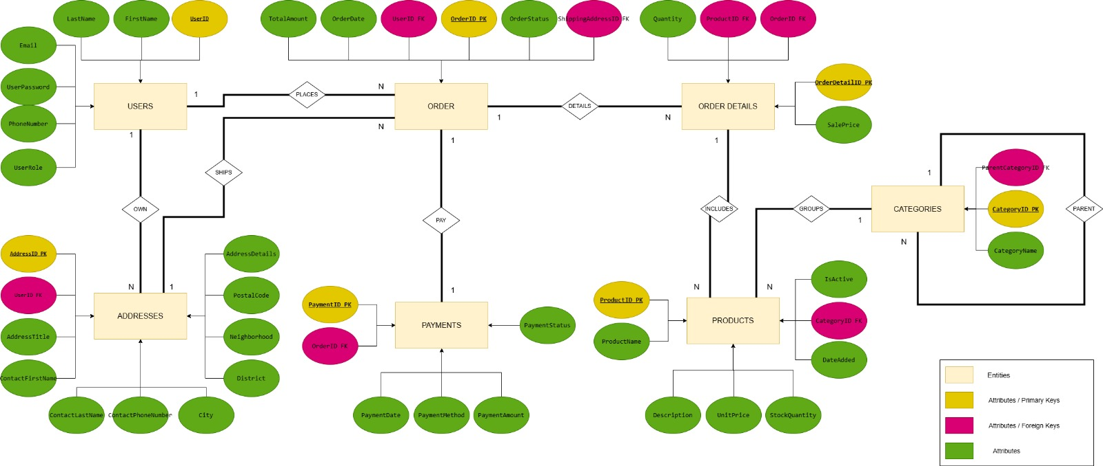

4.THE RELATIONAL MODEL

The 7-Step Mapping is used to convert an entity relationship diagram into a relational database schema. It provides clear rules to map entities, relationships, and attributes into tables with primary and foreign keys. This process ensures the ER model can be implemented correctly in a relational database system. It makes much better diagram

Relational models

Users
UserID | FirstName | LastName | Email | UserPassword | PhoneNumber | UserRole

Addresses
AddressID | UserID | AddressTitle | ContactFirstName | ContactLastName | ContactPhoneNumber | City | District | Neighborhood | StreetAddress | PostalCode | AddressDetails

Orders
OrderID | UserID | OrderDate | TotalAmount | OrderStatus | ShippingAddressID

Payments
PaymentID | OrderID | PaymentDate | PaymentMethod | PaymentAmount | PaymentStatus

Order Details
OrderDetailID | OrderID | ProductID | Quantity | SalePrice

Products
ProductID | ProductName | Description | UnitPrice | StockQuantity | DateAdded | CategoryID | IsActive

Categories
CategoryID | CategoryName | ParentCategoryID

- Step 1: Mapping of Regular (Strong) Entity Types:
USERS(UserID [PK], FirstName, LastName, Email, UserPassword,PhoneNumber,UserRole)
ADDRESSES(AddressID [PK],UserID[FK] , AddressTitle, ContactFirstName, ContactLastName, ContactPhoneNumber, City, District, Neighborhood, PostalCode, AddressDetails)
ORDER(OrderID [PK], UserID [FK], OrderDate, TotalAmount,OrderStatus, ShippingAddressID[FK])
PAYMENTS (PaymentID [PK], OrderID [FK], PaymentDate, PaymentMethod, PaymentAmount, PaymentStatus)
ORDER DETAILS(OrderDetailID [PK], OrderID [FK], ProductID [FK], Quantity, SalePrice)
PRODUCTS(ProductID [PK], CatagoryID[FK], ProductName, Description, UnitPrice, StockQuantity, DateAdded, IsActive)
CATAGORIES(CategoryID [PK], ParentCategoryID [FK], CatagoryName)

- Step 2: Mapping of Weak Entity Types
There are no weak entities in this ER diagram. All entities have their own primary keys and can exist independently.

- Step 3: Mapping of Binary 1:1 Relation Types
1:1 relationship is implemented by placing the primary key of one entity as a foreign key in the other.
There is a 1:1 relation between ORDER and PAYMETS entities .
Each order has exactly one payment. This is implemented by adding OrderID as a foreign key in the PAYMENTS table.

- Step 4: Mapping of Binary 1: N Relationship Types
USERS (1) and ADDRESSES (N):
A user can have multiple addresses. UserID is added as a foreign key in the ADDRESSES table.
USERS (1) and ORDERS (N):
A user can place many orders. UserID is added as a foreign key in the ORDER table.
ADDRESSES (1) and ORDERS (N):
An order has one shipping address. ShippingAddressID is a foreign key referencing the ADDRESSES table.
ORDERS (1) and ORDER_DETAILS (N):
An order can include many order details. OrderID is added as a foreign key in the ORDER_DETAILS table.
CATEGORIES (1) and PRODUCTS (N):
A product belongs to one category. CategoryID is added to the PRODUCTS table.
CATEGORIES (1) and CATEGORIES (N):
Categories can have subcategories.

- Step 5: Mapping of Binary M: N Relationship Types

There are no direct M:N relationships in the ER diagram .

- Step 7: Mapping of N-ary Relationship Types
There are no direct N-ary relationships in the ER diagram .

Releationship between tables:

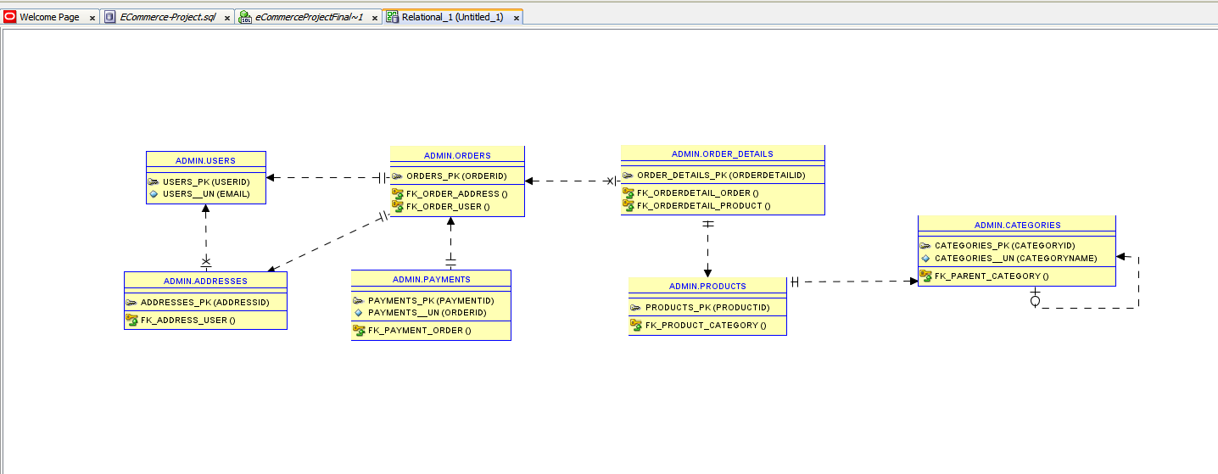
5. NORMALIZATION OF THE RELATIONAL MODEL

1NF :

TABLE | COMPATIBILITY
USERS | Compatible*
CATEGORIES | Compatible*
ADDRESSES | Compatible*
PRODUCTS | Compatible*
ORDERS | Compatible*
ORDER_DETAILS | Compatible*
PAYMENTS | Compatible*
*All columns contain atomic values. There is no repeating groups. All tables fully compatible for 1NF normalization.
2NF (Second Normal Form):
TABLE | COMPATIBILITY
USERS | Compatible**
CATEGORIES | Compatible**
ADDRESSES | Compatible**
PRODUCTS | Compatible**
ORDERS | Compatible**
ORDER_DETAILS | Compatible**
PAYMENTS | Compatible**

**Since their primary keys consist of a single column, there is no partial dependency.

3NF (Third Normal Form):
TABLE | COMPATIBILITY
USERS | Compatible
CATEGORIES | Compatible
ADDRESSES | Partially Compatible
PRODUCTS | Compatible
ORDERS | Compatible
ORDER_DETAILS | Compatible
PAYMENTS | Compatible

USERS: Each piece of info about a user only depends on the UserID. Nothing depends on something else that isn't the main key.

CATEGORIES: Info about a category only depends on the CategoryID.

ADDRESSES: Info like City, District, and Neighborhood might depend on each other (like Neighborhood depends on District, which depends on City). This is often done to make things easier to use, even if it's not perfect 3NF.
PRODUCTS: All info about a product only depends on the ProductID.
ORDERS: The TotalAmount of an order depends on the items in ORDER_DETAILS. So, it indirectly depends on the OrderID. This is often done to make the system faster and to save the total price at the time of the order.
ORDER_DETAILS: Info like Quantity and SalePrice only depends on the main key for that order detail. The TotalProductPrice is calculated, which is good for 3NF.
PAYMENTS: All info about a payment only depends on the PaymentID.

Overall Summary
- 1NF: All columns have single, basic values. There are no repeating groups. All tables fully follow the 1NF rule.
- 2NF: Because the main keys are single columns, there's no way for info to depend on only part of a key.
- 3NF: For most tables, non-key information doesn't depend on other non-key information (except for the ADDRESSES table, which were made simpler on purpose). This means fewer data problems.
  - ADDRESSES: In this table, putting geographic info like city and district together in one address (instead of separate tables) is a not efficient way to keep data. It can be fixed with creating new table like LOCATIONS and moving attributes like “city, district”. In that way we can gain storage efficiency.

    - THE DATABASE SCHEMA

6.1 Overview

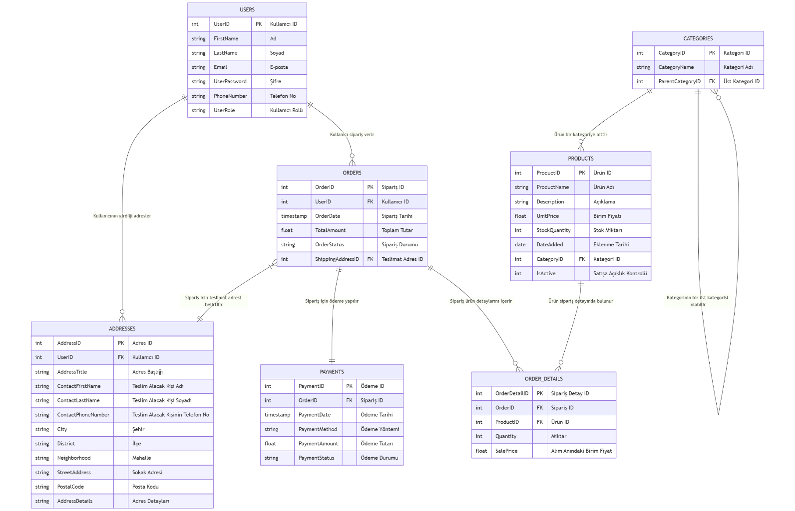

6.2 Tables

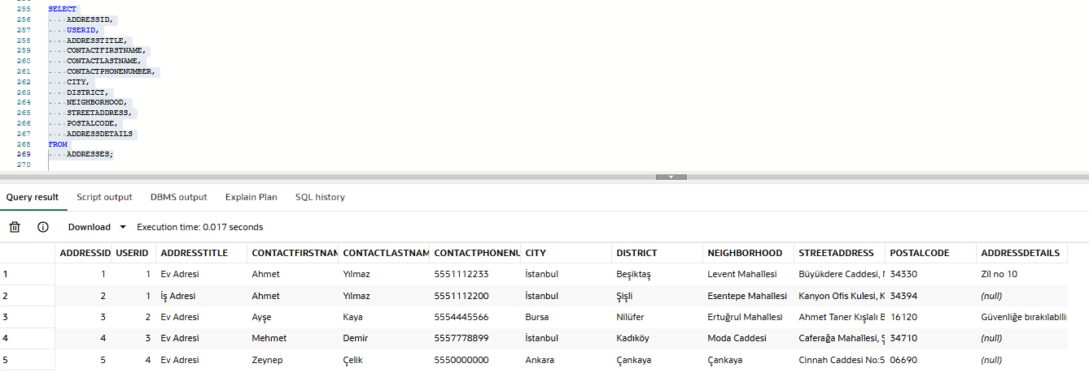
- Addresses Table

- Categories Table

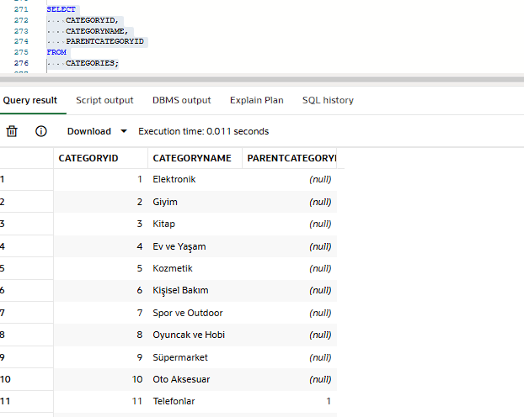

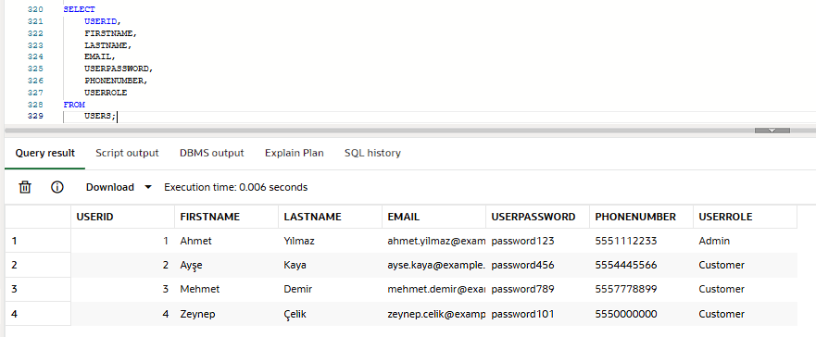
- Users Table

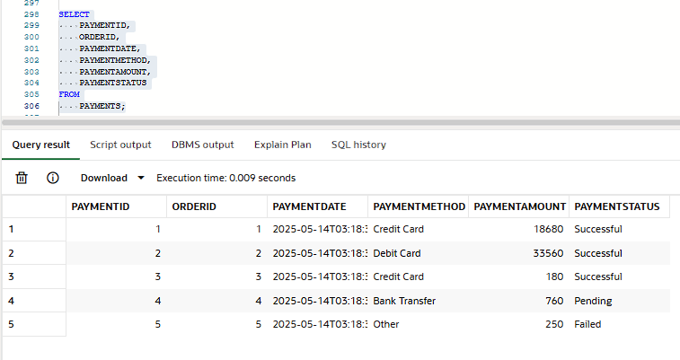
- Payments Table

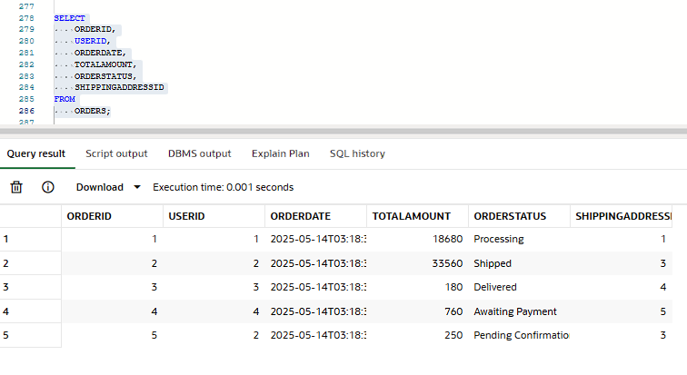
- Orders Table

- Order Details Table
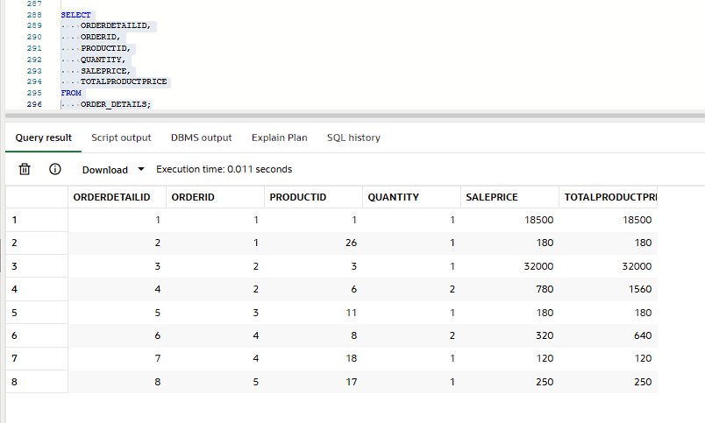

- Products Table
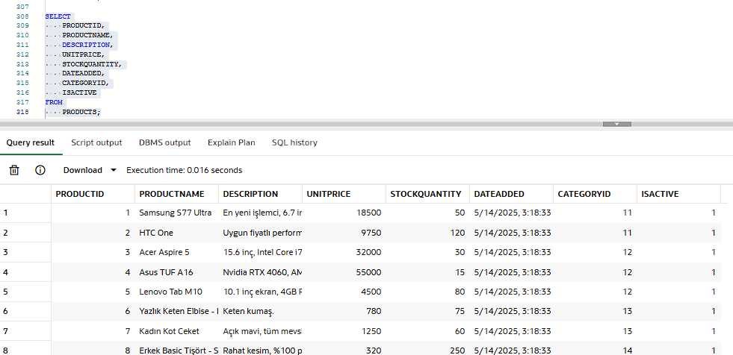

    - QUERYS
- List all orders created in May 2025.
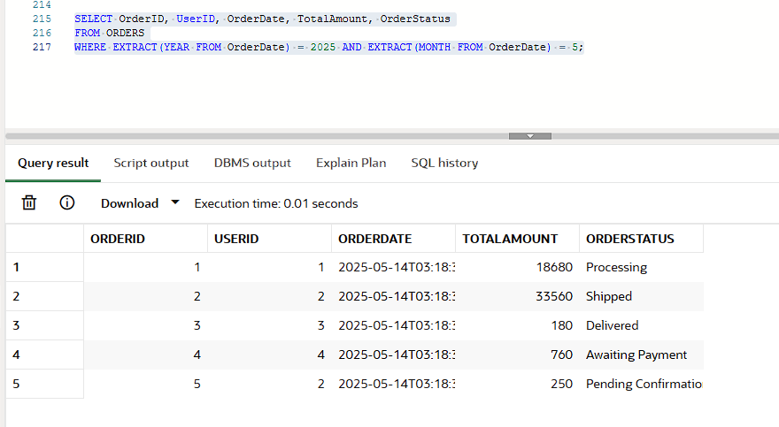

- Listing All Orders of a Spesific Customer
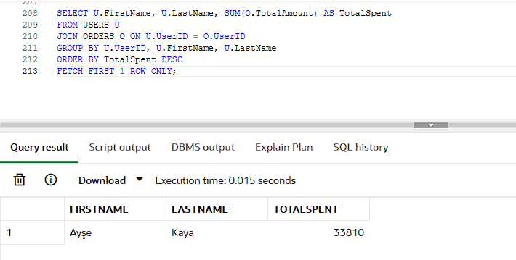
- Finding the Customer with the Highest Total Order Amount
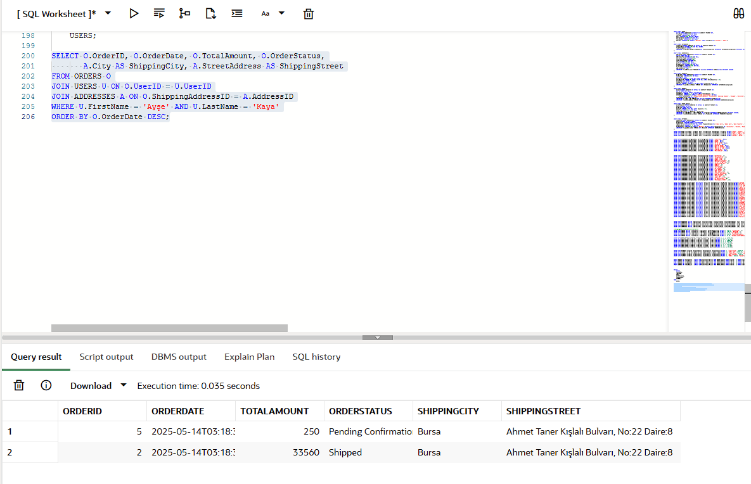

- Ranking Customers by the Highest Total Order Amount
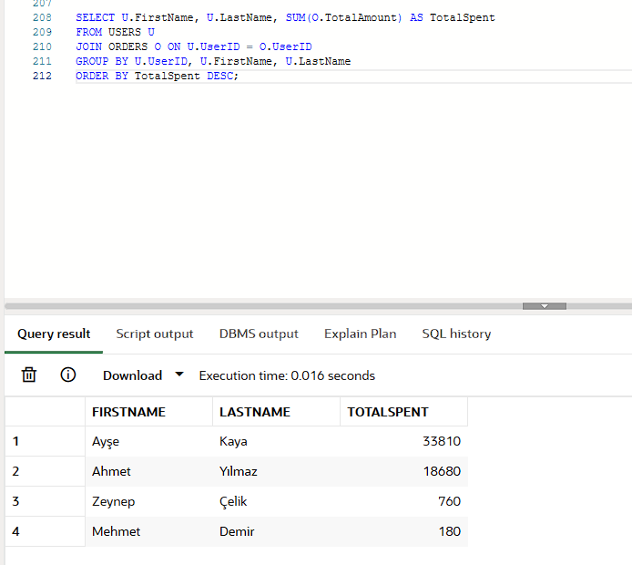
- Listing the Top 5 Best-Selling Products
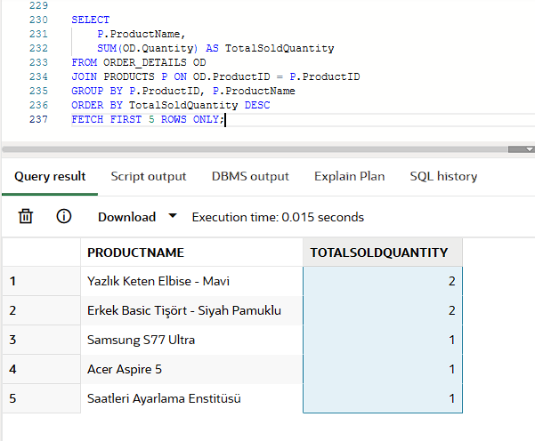

- Listing Orders with Incomplete Payments
