CHAPTER I
INTRODUCTION
This chapter presents an overview of the project. It includes the project context, purpose and description, statement of objectives, scope and limitations, significance of the project, conceptual framework, and definition of terms.
Project Context
Public transportation plays a vital role in urban mobility, providing efficient and accessible transport solutions to commuters. In the Philippines, tricycles have become a dominant mode of transportation due to their affordability, adaptability to narrow roads, and convenience for short-distance travel. However, traditional hailing methods for tricycles often suffer from inefficiencies, lack of safety measures, and regulatory challenges. Studies indicate that integrating digital solutions into public transport systems enhances operational efficiency, improves safety, and promotes sustainable urban mobility (Mishra & Mishra, 2021). Mobile-based ride-hailing applications have proven to enhance transport services by enabling structured ride allocation, passenger verification, and real-time monitoring, addressing many of the common issues in informal transport networks (Dillahunt et al., 2020).
The Tricycle Franchise and Regulatory Office (TFRO) is responsible for overseeing tricycle operations to ensure compliance with local transportation policies. Despite regulatory efforts, both passengers and drivers face challenges due to the absence of a structured ride-hailing system. Passengers experience difficulties in finding available tricycles, while drivers face unfair ride distribution, leading to income disparities among members of the Tricycle Operators and Drivers Associations (TODA). Additionally, the lack of a centralized driver verification system poses safety concerns, as unauthorized drivers can operate without proper oversight. Addressing these challenges requires a modernized approach that improves passenger security, enhances ride assignments, and strengthens regulatory enforcement.
To resolve these issues, this study proposes TODA Go, a mobile-based tricycle ride-hailing application designed to enhance efficiency, safety, and regulatory compliance. The system will incorporate TODA tagging, ensuring equal ride distribution among registered drivers while preventing unfair monopolization of ride requests. It will also include a franchise and driver verification mechanism to allow only registered tricycles to operate, ensuring that all drivers comply with TFRO regulations. Additionally, the system will adhere to the local ordinance for fare calculation, ensuring fair pricing for passengers and standardized earnings for drivers. Studies have shown that implementing digital ride-hailing solutions can improve transportation efficiency by reducing idle time, refining ride allocation, and minimizing security risks (Shaheen & Cohen, 2020). By utilizing geo-tagging and route enhancement, the app will further improve convenience for both drivers and commuters, creating a more organized and transparent transport system.
The primary objective of this study is to develop TODA Go as a structured, technology-driven solution for tricycle transportation in Lucena City. The system aims to provide efficient and secure ride-hailing experience through driver verification, ride improvement, and fair distribution mechanisms. By incorporating digital innovations, the project seeks to address existing challenges in tricycle operations, improve overall commuter experience, and support the TFRO in implementing an organized, safe, and regulated transportation network.
Purpose and Description
The TodaGo system is designed to manage and verify tricycle drivers within Lucena City, ensuring efficiency, safety, and accountability in transportation services. At its core, the system provides a centralized and secure database where drivers can register and have their information stored for Tricycle Franchise and Regulatory Office (TFRO) records. This enables a fast and reliable verification process, ensuring that only registered and franchised tricycle drivers can legally operate, thereby strengthening compliance with local regulations and improving public safety.
In Lucena City, the tricycle franchising plays a vital role in ensuring that only authorized vehicles and qualified drivers can operate. Helping to prevent unauthorized and unregulated operations. However, the current system lacks a structured digital verification process, making it difficult to monitor compliance effectively. TodaGo addresses this by integrating a franchise verification system, allowing only registered tricycles with valid permits to accept ride requests. This significantly enhances passenger safety, as commuters can be assured that the tricycles they book through the app are properly registered and compliant with TFRO regulations.
Another major concern in tricycle transportation is the lack of standardized fare implementation, which often leads to fare disputes between drivers and passengers. The local franchise ordinance regulates fare calculation, ensuring that tricycle fares follow a structured and fair pricing system. Traditional hailing methods, however, often involve manual fare negotiations, which can result in overcharging or inconsistent pricing. TodaGo fix this issue by automating fare calculation based on the ordinance, ensuring that passengers are charged fairly and transparently, while drivers receive appropriate compensation. This system reduces fare disputes, enhances trust in public transport, and ensures fair earnings for tricycle operators.
Statement of Objectives
The main objective of this study is to design and develop a tricycle hailing application for Lucena City that enhances safety, efficiency, and fairness in local transportation. The study aims to achieve the following:
- Identify the requirements of the Tricycle Franchise and Regulatory Office (TFRO) in ensuring a secure and well-regulated tricycle hailing system.
- Design a mobile-based hailing application that aligns with the identified requirements of the TFRO and the needs of passengers and drivers.
- Develop a mobile-based tricycle hailing system with the following features for the TFRO administrators:
a. Complaint and feedback management
b. Franchise-based driver database management
c. Driver registration and verification
d. Updating fare calculation system
e. Report and analytics dashboard
f. TODA location management
- Develop a mobile-based tricycle hailing system interface for both passengers and registered tricycle drivers.
- Integrate the following functionalities for drivers only:
a. Trip status update
b. Ride request notification
c. Earnings summary
d. Passenger information display
- Integrate the following functionalities for passengers only:
a. Tricycle booking system
b. Complaint and rating system
c. Booking confirmation
- Integrate the following functionalities for both passengers and drivers:
a. User authentication
b. Driver and vehicle information display
c. Ride status tracking
d. Estimated fare calculation
- Assess the proposed study based on the ISO 25010 standard for software quality evaluation:
a. Compatibility
b. Functional suitability
c. Maintainability
d. Performance efficiency
e. Portability
f. Reliability
g. Security
h. Usability
Scope and Limitations
This study focuses on designing and developing TodaGo, a tricycle hailing application for Lucena City. The system aims to improve transportation efficiency, safety, and fairness by providing a platform that connects passengers with registered tricycle drivers while ensuring compliance with local transport regulations. The system integrates key features such as driver registration and verification, geo-tagging for ride allocation, and automated fare calculation based on the city's franchise ordinance. The system ensures that only registered and franchised tricycles can operate, strengthening transport regulations and preventing unauthorized drivers from accepting bookings. It also enforces standardized fare computation, ensuring transparent pricing for passengers and fair compensation for drivers. The system's geo-tagging functionality maps TODA locations and distributes ride requests fairly among registered drivers, preventing ride hoarding and promoting equal earning opportunities. Additionally, real-time traffic monitoring is incorporated to enhance route efficiency and improve overall trip planning. Passengers can book rides through the app and receive an estimated fare based on distance. The system allows the TFRO to maintain a centralized database of registered tricycle drivers and operators, enabling faster verification and improved monitoring of regulatory compliance. This enhances oversight and reduces unauthorized tricycle operations.
However, the system has certain limitations. It is exclusively available to registered tricycle drivers within Lucena City, excluding independent or non-affiliated drivers from the platform. The app also relies on internet connectivity and smartphone accessibility, which may pose challenges for users with limited digital access. While the system provides basic route optimization, it does not include features such as dynamic fare adjustments based on external factors (e.g., weather conditions or peak hours). Additionally, the system cannot detect if a tricycle changes its operator, potentially allowing unverified drivers to use the platform. Lastly, the platform is limited to tricycle transportation and does not support other modes of public transport.
Significance of the Project
The development of this tricycle hailing app is crucial for improving transportation efficiency and safety in Lucena City. It directly addresses key challenges faced by passengers, drivers, the Tricycle Franchise and Regulatory Office (TFRO), and other stakeholders.
For passengers, the system enhances safety by ensuring that only verified and registered drivers can accept ride requests. This reduces the risks associated with unregulated operators and provides a secure, reliable means of commuting.
For tricycle drivers, the system promotes fair ride distribution through geo- tagging and availability-based assignments. This prevents unfair advantages in traditional hailing methods, ensuring that the drivers receive equitable trip opportunities.
For the Tricycle Franchise and Regulatory Office (TFRO), the project strengthens oversight by maintaining a centralized database of franchised tricycles and their operators. This ensures compliance with transportation regulations, simplifies verification processes, and deters unauthorized operations.
For Lucena City, the implementation of this system supports the modernization of local transportation, making public commuting safer and more efficient. The project aligns with the city’s efforts to enhance public transport infrastructure through technology-driven solutions.
For the researchers, this project offers a valuable opportunity to apply their technical knowledge in a real-world context, enhancing their skills in software development, systems analysis, and user-centered design. It also allows them to contribute meaningfully to their local community by addressing an existing transportation issue through innovative, practical solutions.
For future researchers, the study provides a foundation for further advancements in transport management systems. It offers insights into the integration of digital solutions in traditional public transportation and highlights challenges in regulating small-scale transport networks.

Conceptual Framework

Figure 1. Input-Process-Output (IPO) Model of the Proposed Study
Figure 1 shows the conceptual framework of the TodaGo tricycle hailing app, detailing the essential stages of the study. The input phase involves identifying the key transportation challenges faced in Lucena City, such as safety concerns, inefficiencies in ride distribution, and regulatory issues. It also includes analyzing existing hailing methods, reviewing current regulations set by the Tricycle Franchise and Regulatory Office (TFRO), and gathering comprehensive user requirements from both passengers and drivers. In the process stage, the system’s features are carefully defined to address these needs, focusing on enhancing safety, ensuring equitable ride distribution, and supporting regulatory compliance. This is followed by the design, development, and thorough testing of the system to ensure its functionality, security, usability, and overall reliability. The phase results in the deployment of the TodaGo app, which offers a safer, more efficient, and well-regulated tricycle hailing system. The app ensures that only verified drivers are available for hire, optimizes ride assignments through geo-tagging and route planning, and promotes a smooth experience for both drivers and passengers.
Definition of Terms
The following terms are categorized into two groups: technical and non-technical terms. These are important in the context of academic and research environments, and they are as follows:
Technical Terms
Application Programming Interface (API) – A set of protocols and tools that allow mobile applications and web systems to communicate with external services or databases.
Booking System – The feature in the mobile application that allows passengers to request a ride, which is then assigned to the nearest available tricycle driver. The system manages ride requests, driver availability, estimated arrival times, and trip confirmations to ensure an efficient and seamless hailing process.
Data Synchronization – The process of continuously updating and maintaining consistency between the TodaGo system's database and real-time user activities, such as ride requests, driver availability, and fare calculations. This ensures that passengers see the most up-to-date information when booking rides and that drivers receive accurate ride assignments without delays. It also helps the Tricycle Franchise and Regulatory Office (TFRO) monitor active drivers and enforce regulations efficiently.
Digital Registry – A centralized database used in the study to store and manage information about registered tricycle drivers. This allows the Tricycle Franchise and Regulatory Office to conduct fast and reliable verification.
Dispatching System – The process used to assign available drivers to passenger ride requests based on factors such as distance and demand.
Driver Earnings Dashboard – A feature in the mobile application that provides tricycle drivers with a real-time summary of their daily, weekly, and monthly earnings.
Driver Verification System – A security measure implemented in the study to ensure that only registered and authorized tricycle drivers can accept ride requests. This system helps improve passenger safety and regulatory compliance.
Geo Tagging – Refers to the process used in the study to identify and map the locations of Tricycle Operators and Drivers Associations. This feature allows for optimized ride assignments by ensuring that passengers are connected to the nearest available driver.
Native Mobile Application – An application developed specifically for a particular operating system. The study uses a native mobile application to ensure optimal performance, efficiency, and user experience.
Ride History – A record of past trips taken by passengers, including details such as fare, time, distance, and driver information for reference and dispute resolution.
Route Optimization – A feature in the study that enhances travel efficiency by minimizing travel time and fuel consumption. It also ensures fair ride distribution among tricycle drivers.
Operational Terms
City Ordinance Fare Rate – the official fare structure mandated by the Lucena City government. The minimum fare is ₱20 for regular passengers and ₱16 for students, senior citizens, and persons with disabilities (PWDs) for the first 2 kilometers, with an additional charge of ₱5 per succeeding kilometer. This ordinance ensures standardized and regulated fare rates for the tricycle rides within the city.
Driver Registration – in the system refers to the process where tricycle operators apply for verification to ensure they meet the necessary requirements before being allowed to accept ride requests.
Fare Calculation – the process of computing the total fare for a tricycle ride based on the set base fare and additional charges per kilometer. The system ensures accurate pricing, transparency, and fairness between drivers and passengers
Franchising – the process by which tricycle operators obtain legal authorization from the Tricycle Franchise and Regulatory Office (TFRO) to operate within designated routes in Lucena City. This ensures that the tricycles meet regulatory standards, including safety, fare compliance, and operational guidelines.
Hailing – in the study refers to the process of booking or requesting a tricycle ride through the mobile application instead of the traditional method of flagging down a driver on the street.
Passenger – is a person who uses the tricycle hailing application to request and complete a ride with a registered tricycle driver.
Passenger Safety – is the set of measures implemented in the system to ensure the security and well-being of passengers. This includes driver verification, real-time tracking, ride history records, and compliance with city regulations to provide a safe and reliable tricycle-hailing experience.
Tricycle – in this study refers to a three-wheeled motorized vehicle used for short-distance public transportation within Lucena City.
Tricycle Franchise and Regulatory Office (TFRO) – the governing body responsible for regulating and overseeing tricycle operations within Lucena City. TFRO manages driver and vehicle registration, franchise approvals, compliance with city ordinances, and enforcement of transport policies to ensure safe and efficient public transportation.
Tricycle Operators and Drivers Association or TODA – refers to the officially recognized groups of tricycle operators and drivers in Lucena City. The study uses their locations for efficient ride allocation and management.

Chapter II

REVIEW OF RELATED LITERATURE AND SYSTEMS
This chapter presents an examination of the relevant literature and studies related to the project. It covers different topics, providing a comprehensive understanding of the subject matter.
The Influence of Ride-Hailing Services on Urban Traffic and Mobility
The rise of ride-hailing services has significantly transformed urban mobility in Southeast Asia and the Philippines, resulting in both beneficial and adverse effects on traffic conditions and commuter experiences. In Metro Manila, the growing use of Transport Network Vehicle Services (TNVS) such as Grab has altered commuter behavior patterns. Bandojo (2025) found that users’ continued intention to utilize TNVS is shaped by perceived economic value, service safety, and platform trust—factors that correlate with increased reliance on ride-hailing and, consequently, influence traffic dynamics.
Similarly, Desabelle, Dailisan, and Lim (2022) identified that idle and cruising ride-hailing vehicles often contribute to traffic congestion in dense urban areas, particularly in narrow or single-lane corridors. Their simulation-based study highlighted that ride-hailing demand surges can cause clustering behavior in high-traffic zones, thereby exacerbating road bottlenecks.
On a broader scale, Regidor (2023) examined urban carpooling initiatives within condominium communities in Metro Manila, emphasizing the potential of shared mobility to mitigate congestion by reducing the volume of individually owned cars. This aligns with the work of Shaheen and Cohen (2019), who found that ride-sharing models, when implemented efficiently, reduce vehicle miles traveled (VMT) and encourage modal shifts toward shared mobility in urban contexts.
In the wider Southeast Asian setting, Tayar et al. (2022) conducted a meta-analysis of ride-hailing impacts in ASEAN cities, noting that while these platforms have improved mobility in underserved areas, they also tend to increase traffic density where public transportation infrastructure is inadequate. Icasiano and Taeihagh (2021) similarly observed that low entry barriers and aggressive platform incentives have resulted in elevated vehicle volumes across Southeast Asian capitals. Their findings emphasized the need for coherent governance strategies across borders to manage platform-based mobility services.
Empirical studies provide mixed evidence on ride-hailing's effect on congestion. Garg and Mishra (2022) analyzed traffic flow data during ride-hailing service strikes and observed that travel times improved by 10.1%–14.8% in high-density zones, suggesting these services can worsen peak-hour congestion. Conversely, Zhang et al. (2023) presented data showing that in cities with inadequate public transit systems, ride-hailing services may reduce private car dependency and support congestion mitigation through shared-use models.
Supporting this perspective, Pradana et al. (2022) found that in Greater Jakarta, ride-hailing services positively impacted the efficiency of public transit systems by enhancing first- and last-mile connectivity. Their study demonstrated how such integration can encourage mass transit usage, potentially offsetting traffic volumes.
Safety is another dimension covered in the literature. A study by Lee, Qian, and Park (2020) explored the relationship between ride-hailing driver behavior and urban accident patterns, suggesting that although platforms have introduced safety features, regulatory oversight remains critical. Meanwhile, Icasiano and Taeihagh (2021) identified a gap in liability frameworks in the Philippines, arguing that although driver accountability is emphasized, the responsibility of platform operators in ensuring service safety needs stronger legal reinforcement.
Franchise regulation also intersects with urban mobility outcomes. Rahman et al. (2022) analyzed the effects of multi-platform competition on ride-hailing performance in Kuala Lumpur and found that regulatory balance—ensuring market competitiveness while maintaining service standards—is essential to mitigate risks associated with oversupply and unregulated operations. These findings resonate with broader calls for harmonized transport network governance across the ASEAN region (Tan, Koh, & Low, 2021).
The Role of Mobile Applications in Ride-Hailing and Registration Systems
Mobile applications have become integral to modern life, influencing communication, business operations, and social interactions. Their widespread adoption has transformed how individuals interact with technology, allowing tasks such as browsing, managing files, and communication to be conducted seamlessly on handheld devices (Ali et al., 2021). This digital shift has redefined everyday routines and social behaviors.
In business, mobile applications play a pivotal role in enhancing operations by facilitating product promotion, customer interaction, and transactional efficiency. Mobile platforms enable companies to scale operations and personalize services, which improves customer satisfaction and financial performance (Li et al., 2022). Moreover, digital entrepreneurship through apps continues to grow, providing jobs and fostering innovation (Tan et al., 2023).
Mobile apps also raise significant societal considerations. They bridge gaps in communication and access to information across geographic and demographic boundaries. However, they also introduce concerns about data privacy, cybersecurity, and digital inequality. As noted by Al-Sharafi et al. (2022), the ethical management of user data remains a core challenge requiring ongoing policy attention and public education to ensure equity and trust in digital systems.
The entertainment and lifestyle sectors have likewise evolved with mobile applications. Apps focused on optimizing, health, and gaming have revolutionized how users engage in leisure and wellness, offering personalized features that increase long-term engagement and user satisfaction (Sanusi et al., 2023).
Regarding urban mobility, ride-hailing apps have reshaped transportation systems. In the Philippines, regulatory initiatives were developed to legalize and monitor ride-hailing services. These regulations aim to ensure safety, standardization, and the integration of these services into the broader transport network (International Transport Forum, 2023).
Across Southeast Asia, cities like Bangkok, Hanoi, and Manila are experiencing increased ride-hailing activity, which influences travel behavior. In ride-hailing platforms, comprehensive registration processes for drivers including verification of personal information, driving credentials, and vehicle details are essential for ensuring passenger safety. Such measures allow for the vetting of drivers and the maintenance of service quality standards. A study by Chalermpong et al. (2024) emphasizes that stringent registration protocols contribute to the overall safety and reliability of ride-hailing services in Southeast Asian cities.
Moreover, the integration of registration systems enables effective monitoring and regulation by authorities. The International Transport Forum (2023) highlights that proper registration facilitates data collection and analysis, which are crucial for policy development and the enforcement of safety regulations in the rapidly evolving landscape of app-based mobility services.
Beyond ride-hailing, registration mechanisms in mobile applications play a significant role in safeguarding user data and ensuring secure access to services. Aljedaani and Babar (2020) discuss the challenges in developing secure mobile health applications, noting that robust registration and authentication processes are vital for protecting sensitive health information and maintaining user trust.
Governance remains central to optimizing ride-hailing's societal value. Regulatory frameworks must adapt to balance innovation with equity and safety, as highlighted by the International Transport Forum (2023). Capacity-building among public agencies and consistent standards across ASEAN countries are key to effective oversight.
In terms of customer behavior, loyalty programs and app design strongly affect retention. Research by Rizky et al. (2024) indicates that information clarity, service consistency, and perceived value significantly contribute to continued use, showing how ride-hailing platforms must focus on usability and trust to succeed.
These studies emphasized the evolving role of mobile applications in modern society, particularly in ride-hailing and registration systems. As these technologies advance, continuous research and responsive governance are essential to harness their benefits while mitigating associated challenges.
Advancements in Mobile-Based and Geospatial Technologies for Enhancing Urban Transportation
Recent advancements in transportation systems have heavily relied on the integration of geospatial technologies and mobile applications. These technologies provide a significant opportunity to enhance operational efficiency, improve service quality, and address urban mobility challenges. The growing importance of mobile-based platforms in managing transportation services has been highlighted in several studies. In particular, mobile applications designed for real-time tracking, fare calculation, and feedback management have revolutionized how public transportation operates. A study by Bautista et al. (2022) examined the impact of mobile platforms in the context of ride-hailing services, including for tricycles, and found that such systems enable improved service delivery by facilitating better communication between passengers and drivers, thus enhancing the overall commuter experience.
In the context of the Philippines, research on the quality of tricycle services in Metro Manila by Dela Cruz et al. (2021) assessed key factors that influence commuter satisfaction. This study emphasized the role of mobile applications in ensuring service reliability through features such as real-time tracking, accurate fare calculation, and the display of driver information. The study found that passengers preferred systems that allowed them to track their rides and receive real-time updates, both of which contributed to a more seamless and transparent service. Furthermore, the integration of complaint and feedback management features in mobile applications was highlighted as essential for improving service quality and ensuring accountability among service providers.
In addition to improving commuter experience, mobile-based platforms also facilitate the regulation and management of transportation systems. A report by the Philippine Department of Transportation (DOTr, 2020) explored the potential of mobile-based solutions in modernizing traditional transport modes, particularly tricycles. The report emphasized the need for robust systems that allow for driver registration, verification, and performance monitoring. By enabling service providers to track driver behavior and ensure regulatory compliance, these systems play a key role in maintaining high standards of service, safety, and efficiency.
A regional perspective on the adoption of mobile-based transportation technologies can be found in the work of the Asian Development Bank (ADB, 2023). The ADB's report on urban mobility in ASEAN cities highlighted the growing trend of using geospatial technology to optimize transportation routes and manage traffic congestion. The study pointed out that by incorporating GIS-based analytics into transportation planning, authorities can create more efficient and safe transport networks. The integration of such technologies into mobile platforms allows for real-time updates, enhancing both operational efficiency and passenger satisfaction.
Furthermore, the application of geospatial technologies in transportation planning has been explored in various studies, with a focus on optimizing routes and improving safety measures. Lim et al. (2021) examined the role of Geographic Information Systems (GIS) in enhancing transportation planning, particularly in urban areas. They argued that GIS tools could provide valuable insights into traffic patterns, accident hotspots, and other factors affecting transportation efficiency. These insights can guide infrastructure improvements and help identify areas where additional safety measures are needed, contributing to overall transportation system optimization.
In conclusion, the integration of mobile-based applications and geospatial technologies has become an essential component of modern transportation systems. Studies highlight their effectiveness in improving operational efficiency, service quality, and safety. The ability to provide real-time updates and incorporate feedback mechanisms is crucial for ensuring that transportation services meet the evolving needs of commuters and are capable of adapting to the challenges posed by urban mobility.
Synthesis
The rise of mobile-based platforms and geospatial technologies has significantly reshaped urban transportation systems, particularly in Southeast Asia. The integration of these innovations has enhanced the operational efficiency and service quality of ride-hailing services, directly influencing commuter behavior and contributing to a more organized transportation framework. The benefits of mobile applications range from improved registration processes, real-time tracking, and service monitoring to increased customer satisfaction and safety. In Lucena City, the adoption of mobile-based solutions can particularly aid the Tricycle Franchising Regulatory Office (TFRO) in optimizing registration, ensuring service quality, and improving regulatory compliance.
Mobile applications offer several advantages that enhance both their operational efficiency and safety. Features such as real-time tracking, fare calculation, and trip management allow drivers to avoid congested areas, and reduce fuel consumption. Mobile apps also provide a transparent system for managing payments and earnings, reducing conflicts and ensuring a steady income. Additionally, safety features such as emergency assistance buttons and driver verification protocols improve driver security and trust in the platform.
The benefits are equally significant. Real-time tracking and access to driver information within mobile apps allow passengers to make informed decisions about their trips, increasing their overall sense of safety and control. This transparency boosts trust in the system and reduces perceived risks. Mobile applications also allow passengers to rate services, providing feedback that can be used to improve service quality and accountability.
Through mobile applications, the TFRO can implement robust systems for driver and vehicle registration, ensuring safety and transparency. These platforms enable regulatory bodies to efficiently monitor service standards and driver behavior, offering an accessible way to track compliance. Integrating geospatial tools within these mobile apps could further optimize service delivery by providing insights into traffic patterns and identifying areas that require better infrastructure or safety measures. This would allow the TFRO to develop more data-driven strategies for managing the tricycle sector, improving urban mobility while addressing congestion and inefficiency.
Furthermore, the integration of feedback and complaint management systems within mobile applications plays a crucial role in improving service accountability and addressing commuter concerns in real-time. By utilizing such platforms, the TFRO can create a more responsive and transparent regulatory environment, where users have a direct channel to report issues and track resolutions.
Overall, the advancements in mobile and geospatial technologies provide a significant opportunity to improve urban transportation management. For the TFRO, these innovations not only simplify administrative tasks but also create a safer, more efficient, and customer-centric transportation system. The advantages to both drivers and passengers such as transparent payment systems, real-time updates, and increased safety help foster a more balanced and effective transportation ecosystem. As the adoption of these technologies continues to grow, there is clear potential for transforming the regulatory landscape, driving innovation, and improving the overall commuter experience in Lucena City.

Chapter III
METHODOLOGY
This chapter presents the methodology used in the project. This includes research design, requirements analysis, requirements documentation, and design of the system.
Research Design
The researchers will use a descriptive research design to gather and analyze quantitative data through surveys and system evaluation. This design is selected to describe current practices in tricycle transportation and assess the effectiveness of the proposed tricycle-hailing application based on measurable user feedback.
The researchers will use purposive sampling to select participants. The target population includes stakeholders in tricycle operations within Lucena City, specifically commuters, registered tricycle drivers with franchises, and administrators from the Tricycle Franchise and Regulatory Office (TFRO). Since the population is clearly defined, purposive sampling ensures that only individuals directly involved in or affected by tricycle transport services participate in the evaluation.

Software Development Lifecycle

Figure 2. Agile Scrum Framework
Figure 2 illustrates how the researchers adopted the Agile-Scrum framework as the chosen Software Development Life Cycle (SDLC) in developing TodaGo: A Mobile Ride-Hailing and Driver Verification App. This iterative approach enabled effective collaboration with stakeholders, including the TFRO, drivers, and passengers, while ensuring timely delivery of functional increments and responsiveness to evolving requirements.
Product Backlog. The process began with collecting and organizing all required features from key stakeholders. These included functionalities such as the driver verification system, booking interface, complaint and feedback management, TODA tagging, and fare computation. All these were compiled into the product backlog, serving as the central source of requirements throughout development.
Sprint Planning. The team conducted planning sessions to select high-priority features from the product backlog. These features, such as login and registration, onboarding, and location services, were scheduled for implementation within a two-to-four-week sprint. This phase set clear development goals aligned with user needs and stakeholder expectations.
Sprint Backlog. The selected features will be broken down into manageable development tasks, forming the sprint backlog. Each task will be assigned specific timeframes and responsibilities to guide the team’s efforts throughout the sprint.
Development Phase. During the sprint, developers will build the chosen features using technologies such as Express.js, MongoDB, and Firebase Cloud Messaging. Modules such as real-time ride booking, trip status updates, and driver-passenger interaction will be developed during this stage.
Weekly Scrum. The team will hold internal discussions to track progress, resolve issues, and make minor adjustments. While optional in academic settings, these weekly check-ins will promote collaboration, transparency, and early problem-solving.
Testing. Upon completing the sprint’s development tasks, the team will conduct unit and integration testing. This will ensure that the implemented features such as the booking flow, messaging, and complaint handling function correctly and reliably.
Sprint Review. Finished features will be presented to stakeholders, particularly the TFRO and representative users, for evaluation. Feedback will be gathered to validate whether sprint goals were achieved and to identify areas for enhancement in upcoming sprints.
Sprint Retrospective. The development team will reflect on their performance, tools, and workflows. Lessons learned and improvement areas will be discussed to enhance team productivity and effectiveness in the next sprint.
Deployment. After successful testing and stakeholder approval, the functional increment will be deployed. This will ensure that the latest features are made accessible to users and that the application evolves progressively.
Requirements Analysis
In this section, the researchers identified both the functional and non-functional requirements of the proposed system. Additionally, the researchers defined all the functionalities of the proposed system.
Functional Requirements
User Authentication – Users (drivers and passengers) can create accounts, log in securely, and reset passwords, ensuring protected access to the system.
Passenger Booking Interface – Passengers can book rides through a simple and interactive interface by selecting destination, pickup location, and available driver/TODA options.
Driver Verification – Only pre-verified and registered tricycle drivers can access the system, ensuring that only legitimate drivers accept ride bookings.
Admin Dashboard – TFRO administrators can manage complaints, driver data, fare settings, reports, and oversee system performance through a centralized dashboard.
Operator Dashboard – TODA operators have limited administrative access to manage their group’s registered drivers and monitor bookings related to their assigned area.
Booking Management – The system handles per-driver and per-TODA ride requests, matching users accordingly and updating ride statuses in real-time.
Fare Computation – Automatically calculates fare based on fixed rates, distance, and TODA policies to ensure consistency and fairness in pricing.
Feedback and Rating System – Passengers and drivers can rate each other and provide feedback after rides, helping improve service quality.
Violation Reporting – The system supports submission and logging of passenger complaints and violations committed by drivers, which can be reviewed by the admin.
Notification System – Sends real-time updates and booking confirmations to passengers and drivers.
Ride History Tracking – Passengers and drivers can view their past ride activities for transparency and reference.
User Management – Admins can manage all user accounts, including suspension or deletion of accounts involved in repeated offenses or violations.
Report Generation – Admins and operators can generate summaries of ride transactions, violations, and feedback for regulatory purposes.
The functional requirements of the TodaGo system focus on ensuring efficient and secure tricycle hailing operations in Lucena City. Users can register, log in, and manage their profiles, while passengers can request rides and receive real-time updates. The system verifies drivers before allowing them to accept bookings, promoting passenger safety. An admin dashboard allows the TFRO to monitor activities, update fares, manage complaints, and oversee registrations. Operators manage their assigned TODAs, and both drivers and passengers can view ride history and submit feedback. The system also includes tools for report submission, violation tracking, and notification handling.
Non-Functional Requirements
Functional Suitability – The system is tailored to meet all user requirements of the TFRO, drivers, operators, and passengers, particularly in ensuring safe and efficient transport services.
Performance Efficiency – The app is optimized to handle multiple concurrent ride bookings and queries without delays or lags, ensuring smooth transactions at peak times.
Compatibility – The application supports Android and is compatible with most modern smartphones, ensuring access for a wide range of users.
Usability – The interface is designed with simplicity in mind, providing intuitive navigation and clearly labeled features for passengers, drivers, and administrators.
Reliability – The system is engineered to maintain uptime and stability during critical operations such as bookings, fare computation, and ride completion tracking.
Security – Implements encryption for password storage, secure login sessions, and restricts unauthorized access, protecting user data and ride records.
Maintainability – Built with a modular architecture to facilitate future updates, bug fixes, and feature enhancements without affecting the system as a whole.
Portability – Designed for flexible deployment across various hosting environments, the system can be adapted to local government servers or third-party cloud infrastructure when necessary.
The non-functional requirements, the system is designed for functional suitability and performance efficiency, handling multiple users without lag. It supports compatibility across Android devices and emphasizes usability with a simple interface. TodaGo ensures reliability by minimizing errors during operations, while security is maintained through encrypted login credentials and role-based access. Its modular code structure supports maintainability for future updates, and the system’s portability ensures smooth deployment across various hosting environments.
Requirements Documentation
In this section, data gathering procedure, respondents of the study, statistical treatment, and ethical considerations are discussed.
Data gathering procedure
The researchers will develop a questionnaire to assess the feasibility of a tricycle-hailing system in Lucena City. The questionnaire will aim to gather the perspectives of tricycle commuters, registered drivers, and TFRO administrators regarding the current transportation system and the proposed solution. The responses will provide insight into existing issues and help guide the design of the system, ensuring it addresses the needs of all involved parties.
The system evaluation questionnaire will use a Likert scale, with questions answerable on a scale from one to five (1–5). Each response will be interpreted with corresponding verbal descriptions, allowing for a quantitative analysis of attitudes and opinions. The questionnaires will be distributed both online (via Google Forms) and offline (via printed forms) to ensure broad accessibility for all target participants.
Respondents of the Study
This study will utilize purposive sampling to select respondents who will be directly involved in tricycle operations in Lucena City. The participants will include 30 registered tricycle drivers and 30 tricycle commuters from Barangays 1 to 11, which are areas near the city center known for having high concentrations of passengers and active tricycle routes. These locations will be selected due to their relevance and accessibility, ensuring that participants will have firsthand experience with the current transportation system. This approach will enable the researchers to gather meaningful insights from individuals who are most familiar with daily tricycle operations, thereby enhancing the accuracy and relevance of the study’s findings.
Statistical Treatment
The quantitative data analysis procedures were prepared to analyze the responses from the survey and provide insights into the perspectives of the participants. By presenting the results in tabular form, the researchers aimed to display the data clearly and effectively.
The researchers used the following statistical formulas to analyze the data gathered from the survey questionnaire:
- Andrew Fisher’s Formula
This formula will be used to calculate the required sample size, ensuring that the data collected will be statistically representative of the population under study:

Where:
- n = required sample size
- Z = Z-value
- p = estimated proportion of the population
- q = 1 – p
- e = margin of error
This formula will ensure that the number of participants selected is sufficient to provide reliable and accurate results for the study.
- Weighted Mean:
The researchers will use the weighted mean to evaluate and prioritize the responses based on their significance. The formula used was:

Where:
x̄ = weighted mean
x = response value
w = assigned weight
The option in the questionnaire uses different verbal interpretations, which are assigned to the computed means using the following scale:
- Likert Scale
After finding the weighted mean, the researchers used a five-point Likert scale to interpret the data gathered from the respondents and measure their attitudes, opinions, or perceptions. The five-point Likert scale used in the interpretation of data is as follows:
Table 1
The Likert Scale
Weighted Point | Range Interval | Verbal Interpretation
5 | 4.21 – 5.00 | Strongly Agree
4 | 3.41 – 4.20 | Agree
3 | 2.61 – 3.40 | Neutral
2 | 1.81 – 2.60 | Disagree
1 | 1.00 – 1.80 | Strongly Disagree

Ethical Considerations
Throughout the research, the researchers carefully protected the information provided by all participants, including tricycle drivers, passengers, and TFRO administrators. Privacy and confidentiality were strictly observed for both printed and online surveys. Printed questionnaires included a consent form, and online forms clearly explained the purpose of the study before participants answered any questions. This ensured that participants understood the goals of the research, which is to develop a safe, efficient, and fair tricycle hailing application for Lucena City.
Participation in the study was completely voluntary. All respondents were informed that they could stop at any time without facing any negative consequences.
To protect the identity and privacy of the participants, no personal information was shared. All responses were kept anonymous. Clear consent was obtained from everyone involved, making sure they were comfortable with how their information would be used. This process was followed to promote respect, honesty, and fairness throughout the study.

Design of Software, Systems, Product, and/or Processes
In this section, the diagrams for the proposed system are shown and discussed. The representation of the proposed system was used by the researchers in developing the system.

Figure 3. Data Flow Diagram of the Existing Process
Figure 3 shows the existing flow of processes involved in a traditional tricycle hailing and payment process. The interaction begins when a Passenger waits for the tricycle to arrive through process "1.0 Wait for Tricycle Arrival", after which a Driver acquires the passenger. Once contact is made, both parties proceed to "2.0 Agree with the Destination", where the passenger communicates their intended location. If the driver accepts, they continue to "3.0 Agree with the Fare", confirming the payment amount for the ride.
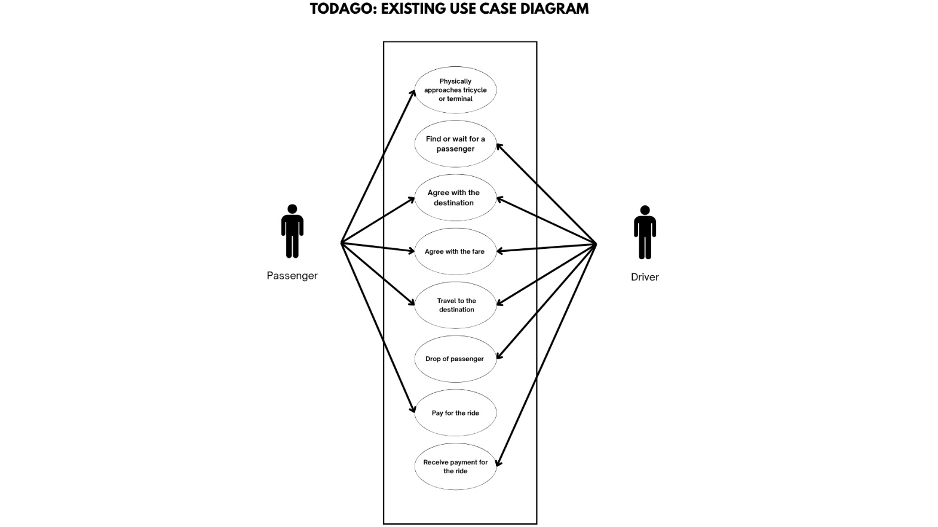
After agreeing, they proceed to travel, and upon arrival, the process "4.0 Drop off the Passenger" occurs. The next step involves the passenger making a payment through "5.0 Accept Payment for the Ride". If there is excess payment beyond the agreed fare, the final process "6.0 Give the Change/s" is carried out by the driver before the interaction concludes. This flow highlights manual negotiation, fare agreement, and cash handling without automation, which the proposed TodaGo system aims to improve.
Figure 4. Use Case Diagram of the Existing Process
Figure 4 illustrates the current manual tricycle hailing process between passengers and drivers without the use of a digital platform. The interaction begins when a Passenger physically approaches a tricycle or terminal to secure a ride. Simultaneously, the Driver finds or waits for a passenger. Once both parties engage, they proceed to agree on the destination and negotiate the fare before the trip begins.
Following the agreement, the Driver transports the passenger to the specified destination. Upon arrival, the Driver drops off the passenger, who then pays for the ride in cash. The Driver receives the payment, completing the transaction.
This use case diagram highlights the lack of systematization in the traditional method such as manual fare negotiations, absence of verification systems, and no centralized data recording which can lead to inefficiencies, safety risks, and fare disagreements. The proposed TodaGo system aims to digitize and streamline these processes, ensuring safer, more equitable, and regulated tricycle services in Lucena City.

Figure 5. The Context Diagram of the Proposed Study
Figure 5 illustrates the context diagram of the proposed Toda-Go tricycle ride-hailing system, providing an overarching view of the primary interactions between the system and its external entities. At the center of the diagram is the Toda-Go platform, which acts as the core processing unit that connects and manages all communications among the three key stakeholders: Passengers (app users), Tricycle Drivers/Operators, and the Tricycle Franchising and Regulatory Office (TFRO) Admin.
The diagram demonstrates that Passengers interact with the system by registering or logging in, booking rides, viewing fare estimates, confirming ride requests, and providing feedback or complaints after completing a ride. The system, in turn, provides passengers with confirmation notifications, estimated fares, driver information, booking status updates, ride histories, and channels for reporting issues. These interactions ensure that passengers experience a seamless, secure, and user-friendly means of accessing tricycle services, with transparent fare calculations and the ability to communicate directly with drivers through the app.
For Tricycle Drivers and Operators, the diagram shows that they use the Toda-Go system to register and verify their credentials, set their availability status, accept or decline incoming ride requests, update the status of ongoing trips, and access summaries of their daily or monthly earnings. The system supplies them with real-time notifications for booking requests, details about the passenger and pickup location, calculated fares, as well as ride histories and channels for submitting feedback. This interaction ensures that only authorized and verified drivers can operate within the platform, promoting fair ride distribution and compliance with local transport regulations.
The TFRO Admin, represented as a separate entity, manages and oversees the system through a web-based dashboard. Their interaction with the system involves verifying driver registrations, managing and updating TODA locations, configuring fare rates, monitoring and responding to complaints or feedback, and generating analytical reports on system performance. The system provides the TFRO Admin with access to centralized records of drivers and passengers, real-time activity logs, feedback summaries, and system analytics to support informed decision-making and regulatory enforcement.
Overall, Figure 5 encapsulates the centralization and digital transformation offered by the Toda-Go system. It highlights how the platform serves as the main hub for all information exchange and operational processes, ensuring that data flows efficiently and securely between passengers, drivers, and regulatory authorities. By digitizing these processes, Toda-Go enhances safety, fairness, and efficiency in Lucena City's tricycle transportation sector, as detailed in the system objectives and requirements outlined in the project documentation.

Figure 6. The Use Case Diagram of the Proposed Study
Actor: Passenger
Actions:
- Login/Signup: The passenger can create a new account or log into the system.
- Book Tricycle: The passenger can book a tricycle ride.
- View Driver Status: The passenger can view the availability or current status of drivers.
- View Estimated Fare: The passenger can check the estimated fare before booking.
- Give Feedback: The passenger can provide feedback about a ride or driver.
- View Feedback: The passenger can view feedback given by themselves or others.

Actor: Driver/Operator
Actions:
- Login/Register: The driver can register or log into the system.
- Receive Ride Request: The driver can receive ride requests from passengers.
- Accept: The driver can accept the incoming ride request.
- Decline: The driver can reject the incoming ride request.
- Update Ride Status: The driver can update the status of ongoing rides.
- Update Availability: The driver can set their availability status.
- Edit Information of Driver: The driver can update their personal or professional details.
- View Earnings: The driver can view their earnings in the system.
- Give Feedback: The driver can submit feedback regarding passengers.
- View Feedback: The driver can view feedback received from passengers.
Actor: TFRO Admin
Actions:
- Verify Franchise Compliance: The admin can verify if drivers or TODAs meet franchise requirements.
- Manage TODA Locations: The admin can add or update TODA service areas.
- Fare Calculation: The admin can calculate standard fares for different routes.
- Edit Fare Calculation: The admin can modify fare formulas or details.
- Handle Complaints/Feedback: The admin can manage and respond to feedback and complaints.
- Manage Driver Registration: The admin can oversee driver registration processes.
- Accept Application: The admin can approve registration applications.
- Reject Application: The admin can decline applications.
- Add Registered TODA: The admin can add TODAs to the system.
- Generate Reports and Analytics: The admin can generate usage and performance reports.

Figure 7. The Administrator’s Data Flow Diagram of the Proposed System
Figure 7 presents the User’s Data Flow Diagram (DFD) for the proposed Toda-Go application, specifically detailing the sequence of interactions and data exchanges between the passenger and the system during a typical ride-hailing transaction. This diagram breaks down the entire process from the perspective of the end user, mapping out how information flows as the passenger initiates and completes a booking within the mobile app.
The process begins when a passenger accesses the application to log in or register. Once authenticated, the passenger can initiate a ride request by inputting their pickup location and destination. This information is then transmitted to the system, which calculates the estimated fare based on the distance and current fare configuration established by the Tricycle Franchising and Regulatory Office (TFRO). The system uses real-time geo-tagging and the current availability status of registered drivers to match the ride request to the nearest eligible driver.
After a successful match, the system sends the booking details, including the driver’s profile, estimated fare, and expected arrival time, back to the passenger. Throughout the ride, the passenger can track the status and location of the assigned driver in real time via the app interface. Upon reaching the destination and completing the trip, the system processes the payment, which can include options for digital or cash transactions as configured in the app.
Following the completion of the ride, the system prompts the passenger to provide feedback and ratings for the driver, which are then stored in the feedback database for service quality monitoring. The ride details, including fare, route, and driver information, are also logged in the ride history, allowing passengers to review previous trips and resolve any disputes if needed. Should any issues arise, the passenger can submit complaints directly through the app, which are then forwarded to the admin for review and resolution.
Through this structured flow, Figure 8 emphasizes the user-centered design of Toda-Go, ensuring a transparent, efficient, and secure ride-hailing experience. It demonstrates how passenger actions are supported by automated backend processes, real-time communication, and continuous feedback loops, all contributing to improved service reliability and passenger safety. This DFD underlines the project’s commitment to streamlining tricycle transportation in Lucena City by providing a digital platform that responds directly to user needs and local regulatory requirements.

Figure 8. The User’s Data Flow Diagram of the Proposed System
Figure 8 presents the User’s Data Flow Diagram (DFD) for the proposed Toda-Go application, specifically detailing the sequence of interactions and data exchanges between the passenger and the system during a typical ride-hailing transaction. This diagram breaks down the entire process from the perspective of the end user, mapping out how information flows as the passenger initiates and completes a booking within the mobile app.
The process begins when a passenger accesses the application to log in or register. Once authenticated, the passenger can initiate a ride request by inputting their pickup location and destination. This information is then transmitted to the system, which calculates the estimated fare based on the distance and current fare configuration established by the Tricycle Franchising and Regulatory Office (TFRO). The system uses real-time geo-tagging and the current availability status of registered drivers to match the ride request to the nearest eligible driver.
After a successful match, the system sends the booking details, including the driver’s profile, estimated fare, and expected arrival time, back to the passenger. Throughout the ride, the passenger can track the status and location of the assigned driver in real time via the app interface. Upon reaching the destination and completing the trip, the system processes the payment, which can include options for digital or cash transactions as configured in the app.
Following the completion of the ride, the system prompts the passenger to provide feedback and ratings for the driver, which are then stored in the feedback database for service quality monitoring. The ride details, including fare, route, and driver information, are also logged in the ride history, allowing passengers to review previous trips and resolve any disputes if needed. Should any issues arise, the passenger can submit complaints directly through the app, which are then forwarded to the admin for review and resolution.
Through this structured flow, Figure 8 emphasizes the user-centered design of Toda-Go, ensuring a transparent, efficient, and secure ride-hailing experience. It demonstrates how passenger actions are supported by automated backend processes, real-time communication, and continuous feedback loops, all contributing to improved service reliability and passenger safety. This DFD underlines the project’s commitment to streamlining tricycle transportation in Lucena City by providing a digital platform that responds directly to user needs and local regulatory requirements.

Figure 9. Entity-Relationship Diagram of the Proposed System

Figure 9 shows the comprehensive structure of the proposed tricycle hailing system for Lucena City. The interconnected entities include Passenger, Driver, TFRO Admin, Super Admin, Applicant, Report, Request, Feedback, Chat, Fare, and History. Each entity is associated with a set of attributes and relationships designed to ensure safety, efficiency, and fairness in the booking process.
Passengers can register, log in, fill out ride request forms, and submit feedback or reports. Each request includes essential data like passenger location and destination, which is used to calculate distance and fare. Passengers can also view previous rides and chat with drivers, establishing a strong service feedback loop.
Drivers, verified and registered through a detailed account creation and approval process, can update their status and accept requests. Each driver is linked to a specific TODA affiliation, and their profile includes credentials such as franchise number, phone number, and location.
The TFRO Admin oversees fare updates, passenger reports, and the registration of both passengers and drivers. They can manage and verify driver accounts while tracking the number of registered users. Super Admins manage TFRO Admin accounts, ensuring secure and hierarchical access control.
Applicants who wish to become drivers submit detailed credentials, including valid IDs, photos, and licenses, which are reviewed before approval and account creation.
Fare calculations are handled by the system based on input distance, and the history of transactions containing timestamps, destinations, and fares is logged for both monitoring and user reference.
The structured and relational approach of the system ensures transparent communication, efficient request handling, and strong administrative oversight, aligning with the goals of a safe and equitable tricycle hailing experience in the city.

Figure 10. Database Schema of the Proposed System
Figure 10 shows the proposed system’s database structure, designed to handle the operations of TodaGo: A Mobile Ride-Hailing and Driver Verification App efficiently. The schema consists of multiple interconnected tables such as drivers, passengers, rides, ride_history, violations, reports, registrations, and feedbacks. These tables store essential information for managing ride transactions, verifying drivers, handling passenger feedback, regulating franchises, and ensuring passenger safety.
The schema also includes supporting tables like superadmins, admins, operators, and violators to facilitate secure system administration, regulatory compliance, and violation tracking. Time-related fields such as created_at, updated_at, and submitted_at across multiple tables ensure consistent tracking of activities and system changes, contributing to auditability and data reliability. This relational structure forms the backbone of the system, enabling smooth data flow and user management across passengers, drivers, and administrators.
Data Dictionary
Table 2
The Driver’s Table of the System
Column | Data Type | Description
id | int | Unique identifier for driver
profileID | varchar | Profile reference ID
email | varchar | Driver email
password | varchar | Driver password
franchiseNumber | varchar | Franchise number of the driver
driverName | varchar | Full name of the driver
driverBirthdate | varchar | Driver's date of birth
driverPhone | varchar | Driver's contact number
created_at | datetime | Timestamp of record creation
updated_at | datetime | Timestamp of last update
Table 2 contains driver-related records, including identification, contact information, and franchise credentials. Timestamps for creation and updates support system traceability and help maintain accurate records of registered and verified drivers.
Table 3
The Passenger’s Table of the System
Column | Data Type | Description
id | int | Passenger ID
birthday | date | Date of birth
contact | varchar | Contact information
email | varchar | Email address
password | varchar | Encrypted password

Table 3 stores passenger information such as personal details, contact data, and credentials. It enables secure user management and ensures accurate linkage of ride requests and feedback submissions to verified passenger accounts.

Table 4
The Ride’s Table of the System
Column | Data Type | Description
id | int | Ride ID
passenger_id | int | Linked passenger ID
driver_id | int | Linked driver ID
origin | varchar | Starting point of the ride
destination | varchar | Destination point
status | varchar | Ride status (e.g., completed, pending)
fare | decimal | Calculated fare for the ride
requested_at | datetime | Time of request
completed_at | datetime | Time of completion

Table 4 handles core ride transactions, capturing essential details like pickup and drop-off locations, fare computation, and timestamps. It is central to the booking process and supports performance tracking and auditing of ride activities.
Table 5
The ride_history_driver’s Table of the System
Column | Data Type | Description
id | int | History entry ID
driver_id | int | Reference to the driver
ride_id | int | Linked ride ID
viewed | boolean | Whether the ride was viewed

Table 5 logs driver-specific ride history, connecting individual drivers to their past rides. It includes a flag to indicate whether rides have been viewed, assisting in tracking trip reviews and promoting transparency.
Table 6
The ride_history_passenger’s Table of the System
Column | Data Type | Description
id | int | History entry ID
passenger_id | int | Reference to the passenger
ride_id | int | Linked ride ID
viewed | boolean | Whether the ride was viewed

Table 6 mirrors Table 4 for passengers, recording ride history per user. The structure enables passengers to review completed trips, supporting accountability and future feedback or complaint submissions.

Table 7
The report’s Table of the System
Column | Data Type | Description
id | int | Report ID
report_type | varchar | Type of report (e.g., complaint)
submitted_by | varchar | Reporter (user/admin)
ride_id | int | Ride ID associated with report
passenger_id | int | Passenger ID (if applicable)
driver_id | int | Driver ID (if applicable)
subject | varchar | Report subject
message | text | Detailed message
status | varchar | Status of the report
submitted_at | datetime | Time of submission
reviewed_at | datetime | Time of review

Table 7 manages passenger and driver reports, including complaints and incident logs. It tracks the status of each report, involved parties, and timestamps of submission and review, enabling systematic handling of issues and enforcement of disciplinary measures.

Table 8
The feedback’s Table of the System
Column | Data Type | Description
id | int | Feedback ID
user_type | varchar | User type (passenger/driver)
passenger_id | int | Linked passenger (if applicable)
driver_id | int | Driver being rated
rating | int | Numerical rating
message | text | Optional message
submitted_at | datetime | Time of feedback

Table 8 captures passenger or driver feedback about completed rides. Ratings and optional messages are recorded along with timestamps to support continuous service evaluation and help identify consistent performance trends.
Table 9
The registration’s Table of the System
Column | Data Type | Description
id | int | Registration ID
user_type | varchar | User role (driver/passenger/etc.)
passenger_id | int | Passenger ID (nullable)
driver_id | int | Driver ID (nullable)
operator_id | int | Operator ID
admin_id | int | Admin overseeing the registration
registered_at | datetime | Registration timestamp

Table 9 documents registration events of different user types. It links to responsible admins and operators, enabling oversight of onboarding processes and establishing accountability through detailed registration logs.
Table 10
The operator’s Table of the System
Column | Data Type | Description
id | int | Operator ID
profileID | varchar | Profile ID
email | varchar | Email address
password | varchar | Encrypted password
franchiseNumber | varchar | Operator's franchise number
operatorName | varchar | Name of the operator
operatorBirthdate | varchar | Date of birth
operatorPhone | varchar | Contact number
created_at | datetime | Record creation time
updated_at | datetime | Record update time

Table 10 stores operator profiles, including franchise and contact information. It facilitates the management of operator-level permissions and ensures each operator’s credentials are validated and auditable.

Table 11
The superadmin’s Table of the System
Column | Data Type | Description
id | int | Admin ID
name | varchar | Full name
email | varchar | Email
password | varchar | Encrypted password
Table 11 contains super administrator credentials for managing top-level access to the system. It ensures secure governance and central oversight of sensitive data and system configurations.
Table 12
The admin’s Table of the System
Column | Data Type | Description
id | int | Admin ID
name | varchar | Full name
email | varchar | Email
password | varchar | Encrypted password

Table 12 holds standard administrator information. These users are responsible for managing system activities such as user registration reviews, violation processing, and data monitoring within assigned jurisdictions.
Table 13
The Violation’s Table of the System
Column | Data Type | Description
violation_code | int | Unique violation code
violation_desc | varchar | Description of the violation
violation_fine | int | Fine amount for the violation

Table 13 defines standardized violation codes, descriptions, and associated fines. It supports regulatory enforcement by providing structured categories for infractions committed by drivers or operators.
Table 14
The Violator’s Table of the System
Column | Data Type | Description
violator_id | int | Unique identifier for violation record
reporter_id | int | ID of the reporting user
violation_code | int | Linked violation
violator_name | int | Name or ID of the violator
additional_driver | varchar | Additional parties involved
place | varchar | Location of violation
violation_date | date | Date of violation
payment_date | date | Date of fine payment
remarks | text | Additional notes

Table 14 logs specific violation incidents, linking reporters and violators with relevant details. It includes violation codes, involved parties, locations, and payment dates, supporting case tracking, fine resolution, and enforcement analytics.
Table 15
The ride_view’s Table of the System
Column | Data Type | Description
id | int | primary key
user_id | int | FK from users
ride_id | int | FK from users
ride_id | boolean | wether ride details were viewed

Table 15 tracks whether users have viewed specific ride records. It supports user experience features like notifications, history access, and read-status indicators.
Table 16
The chat_log’s Table of the System
Column | Data Type | Description
id | int | primary key
ride_id | int | FK from rides
sender_id | int | FK from users
receiver_id | int | FK from users
message | text | message content
sent_at | datetime | time message was sent
is_read | boolean | whether the message has been read

Table 16 captures in-ride conversations between drivers and passengers. It stores message content, sender-receiver relationships, timestamps, and read status, enabling dispute resolution, communication auditing, and support services.
Development and Testing
Visual Studio Code is used as the primary code editor for developing the Toda-GO mobile application. It provides tools for code editing, version control (via GitHub), and debugging across both frontend and backend projects.
The mobile application is developed using React Native with Expo, allowing for rapid cross-platform development and testing on Android devices. The frontend interacts with backend services through custom RESTful APIs built using Node.js and Express, which are hosted on Render.
MongoDB Atlas is used as the cloud database solution for storing all application data, including user profiles, ride information, booking history, feedback, and messages. The backend communicates with MongoDB using Mongoose, a schema-based ODM for Node.js.
OpenStreetMap is used to visualize real-time geolocation and routing data within the app. For navigation and shortest-path computation, OSRM (Open Source Routing Machine) is containerized and deployed using Docker, allowing the system to process Lucena map data and generate accurate directions between pickup and drop-off points.
The geolocation and mapping features are integrated using Leaflet.js rendered via WebView in the mobile app. The admin panel also includes interactive mapping for monitoring ongoing rides and dynamically blocking or unblocking roads in real time.
The application features a built-in real-time chat system between passengers and drivers to allow coordination before and during rides. The chat system is implemented using Socket.IO, enabling instant messaging within the app interface.
To keep users informed of important ride events, a push notification system is implemented using Firebase Cloud Messaging (FCM). Notifications are triggered for actions such as ride acceptance, arrival, cancellation, or admin alerts.
After completing each ride, passengers are prompted to submit a rating and feedback, which is stored in the system and visible to admins for quality monitoring. A ride history module is also included for both passengers and drivers, allowing them to view past rides and download digital receipts.
Laravel Jetstream-style authentication and session handling is replicated on the backend using Express sessions and JWT (JSON Web Tokens). The system supports different user roles — admin, passenger, driver, and operator — with role-based access control throughout the application.
Unit and integration testing are performed manually and with the help of tools like Postman for API testing, and Expo Go for real-time UI testing on devices. End-to-end testing is done to ensure that the complete ride-booking flow, user registration, messaging, feedback, and map navigation all work as intended.
Deployment is handled by pushing code to GitHub, with automated deployment to Render for the backend, and mobile app builds tested through Expo. Docker is used to manage and deploy the OSRM routing backend, ensuring reliable routing capabilities using Lucena's real geographic data.

Description of the Prototype
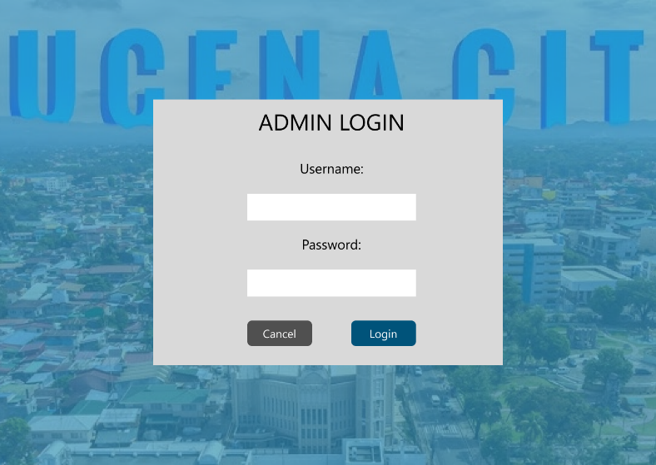
Figure 7. Admin Login Page
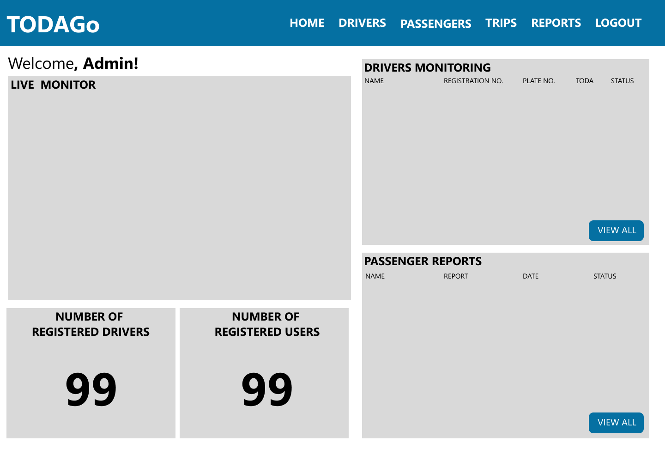
Figure 7 shows the login page of the admin before they can access the dashboard. They need to put their username and password before logging in.
Figure 8. Admin Dash Board
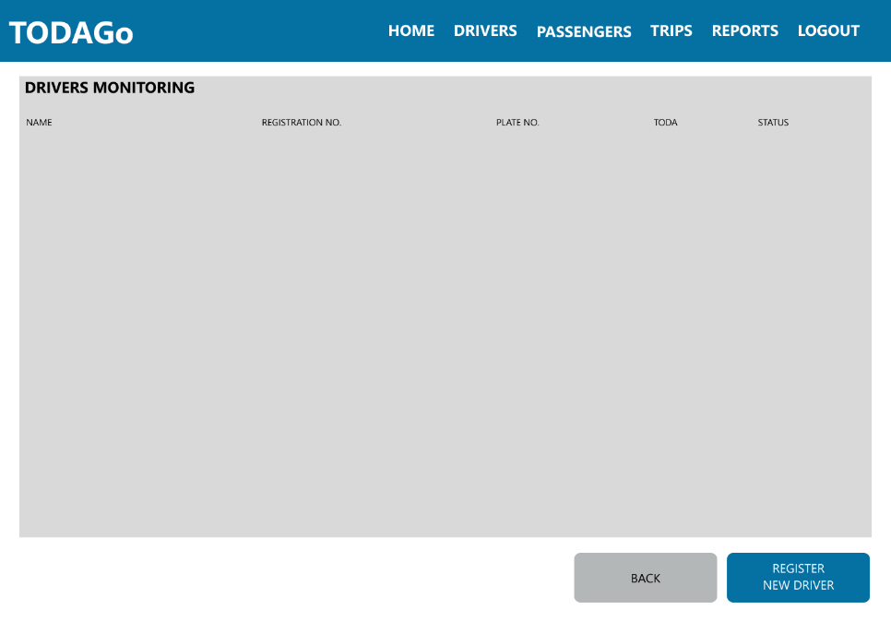
Figure 8 shows the admin Dashboard where they can easily see the live monitoring of online drivers and their location. Driver registration monitoring where they can see the information of the drivers. Total number of registered drivers and passengers. And passenger reports where they monitor the reports of the passenger.
Figure 9. Admin Drivers Page
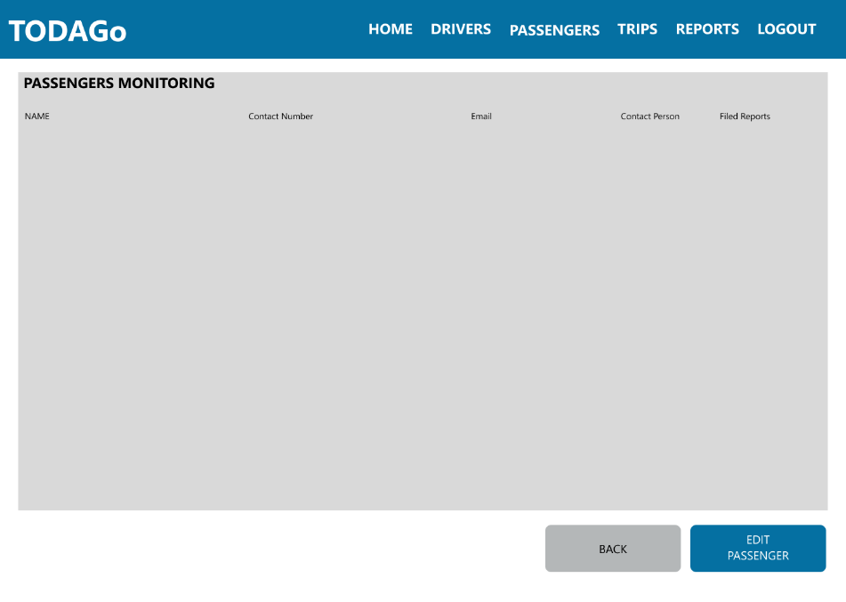
Figure 9 shows drivers monitoring where they can access the information of the drivers and can register a new driver.
Figure 10. Admin Passengers Page
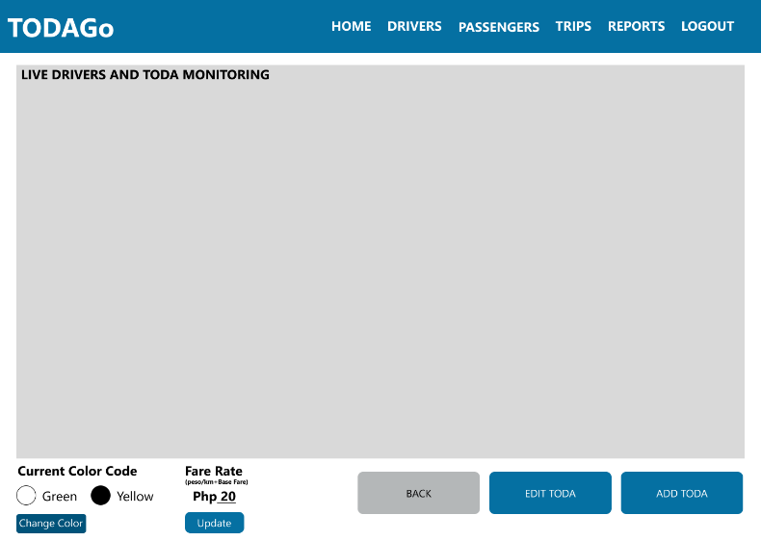
Figure 10 shows the passengers monitoring where they can access the information of the passengers and edit if needed to.

Figure 11. Admin Trips Page
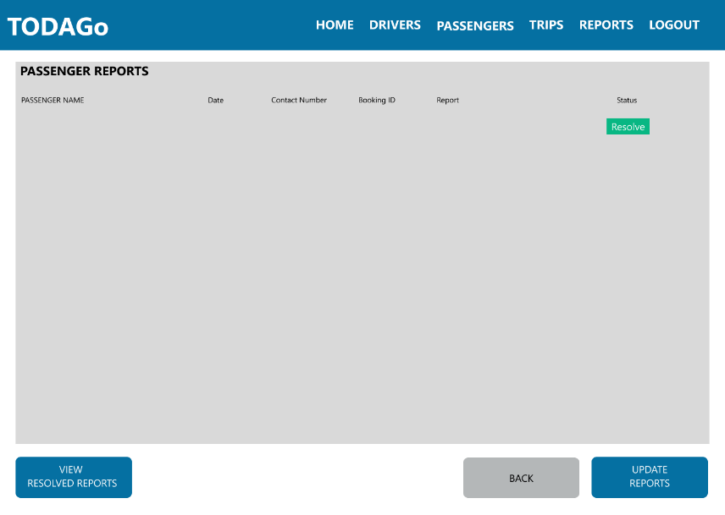
Figure 11 shows the monitoring of locations of registered TODAs where they can also edit the location and name of the TODA or add another TODA. They can edit also the current color of the tricycle who could use the app based on the color code and adjust or edit the fare.
Figure 12. Admin Reports Page
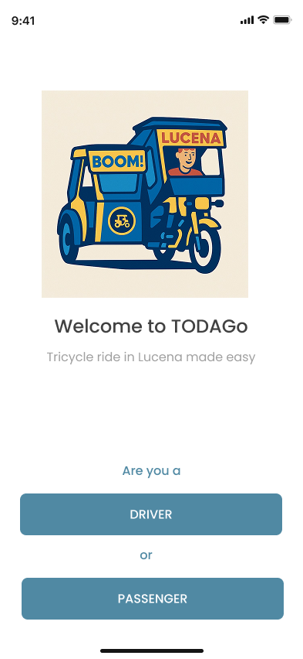
Figure 12 shows the monitoring of the reports of passengers. Once resolved they could edit the status of the reports.
Figure 12. Passenger and Driver Landing Page
Figure 12 shows the landing page of the app where user could choose whether they are a driver or passenger.
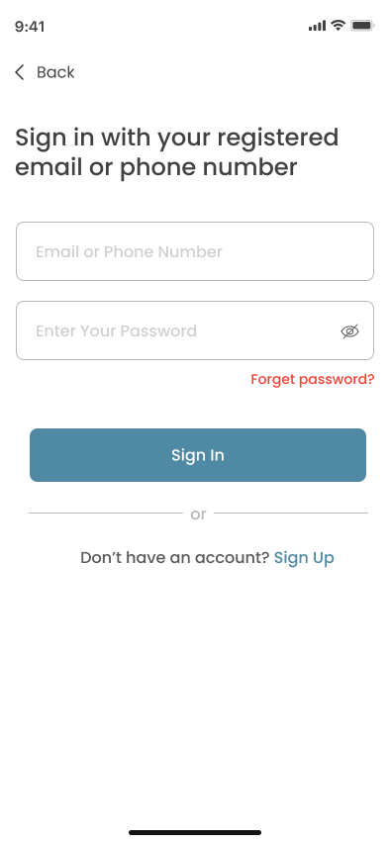
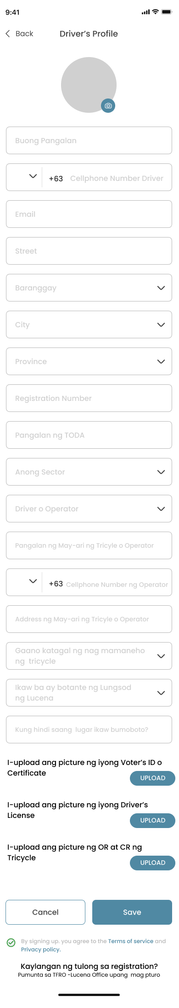

Figure 13. Driver Login and Registration Pages
Figure 14 shows the login and registration of driver where they can login using their number of email. Sign up using their email or phone number and answer credentials needed for the registration.
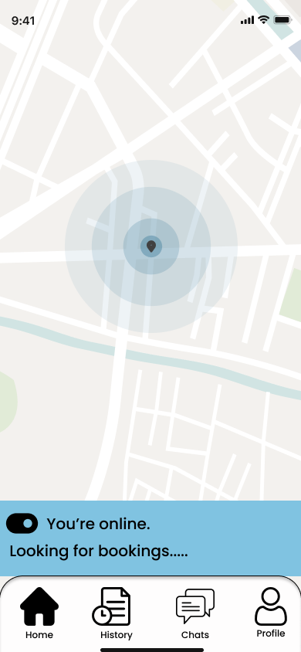
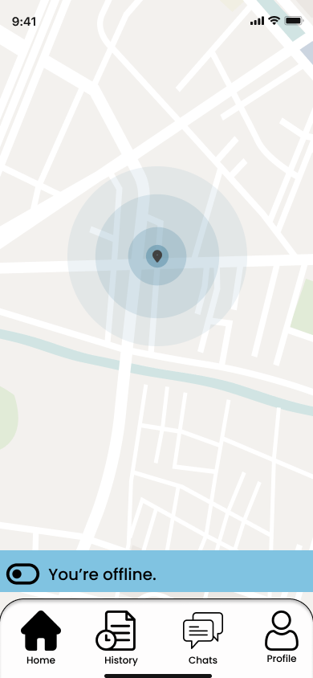
Figure 14. Driver Home Pages
Figure 14 shows the home page of the driver that has a toggle button where the turn on or off to accept bookings.

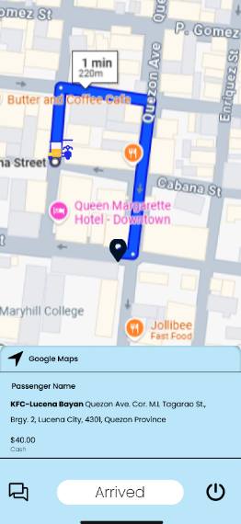
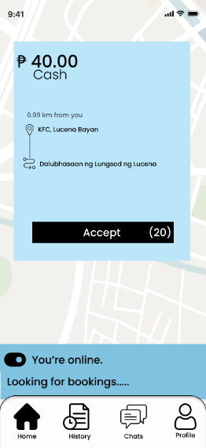
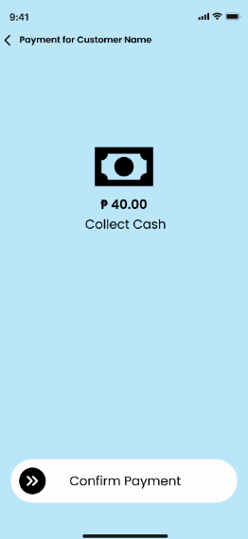
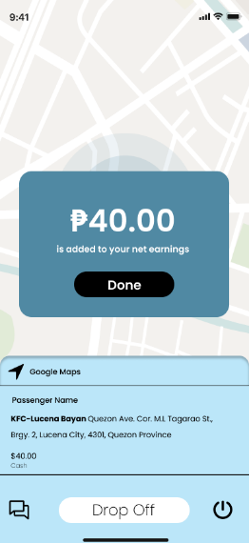
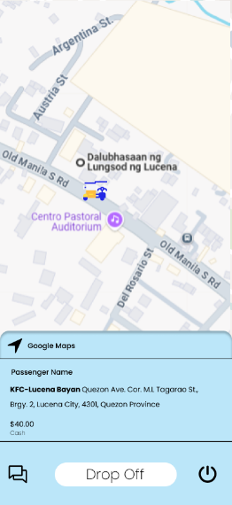
Figure 16. Driver Booking Landing Pages
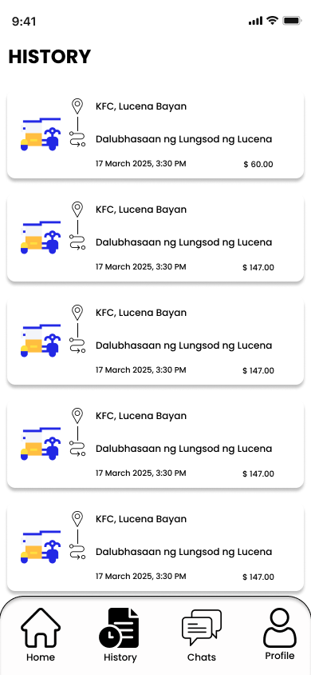
Figure 16 shows when driver got a booking request and once they accepted the booking. Showing the destination of the trip, fare, and location of the pickup point and end point of the trip.
Figure 17. Driver History Page
Figure 17 shows the drivers history of rides.
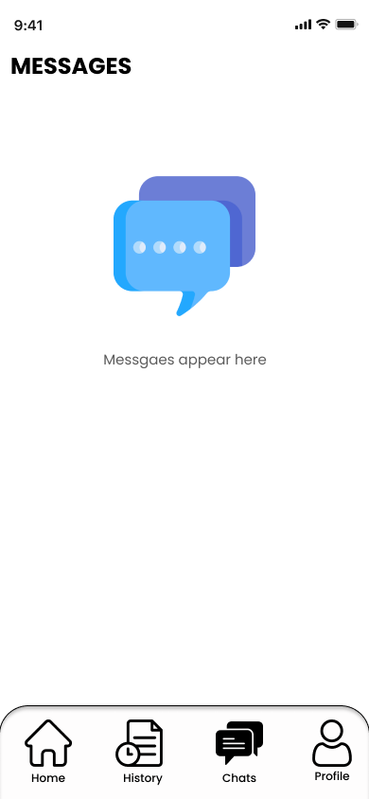
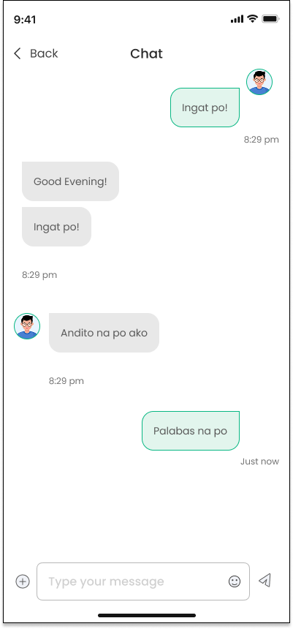
Figure 18. Driver Chat Page
Figure 18 shows the chat page where the driver can chat the passenger for easy conversation and communication.
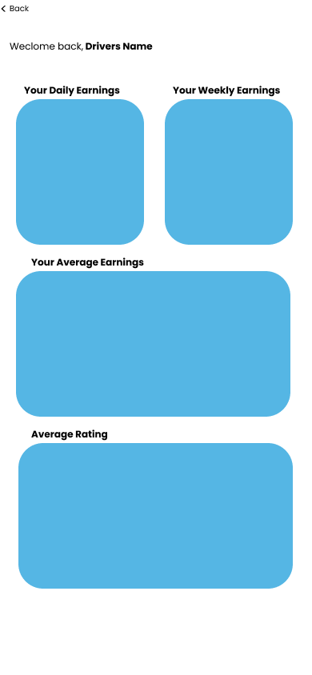

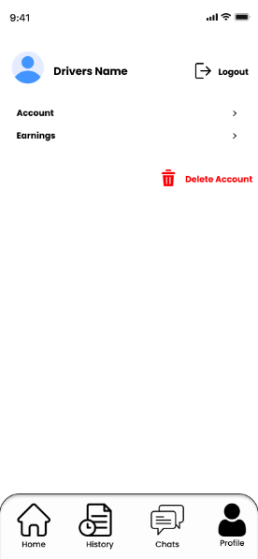
Figure 19. Driver Profile Page
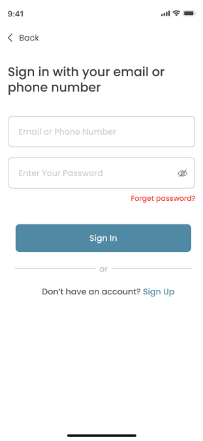
Figure 19 shows the profile page of the driver where he can edit his email or phone number and logout his account. They can also access and track their earnings.
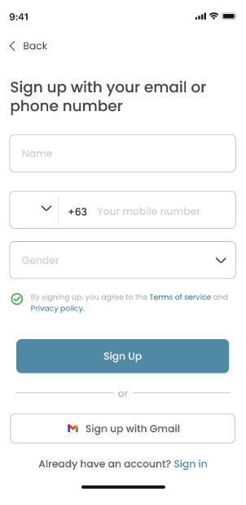
Figure 20. Passenger Sign In and Sign Up Page
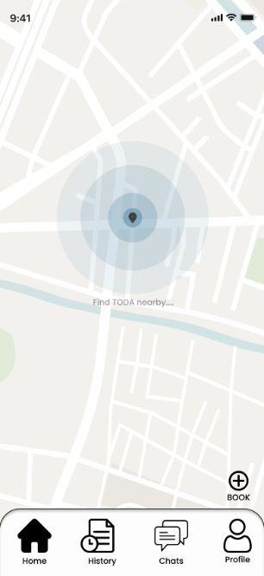
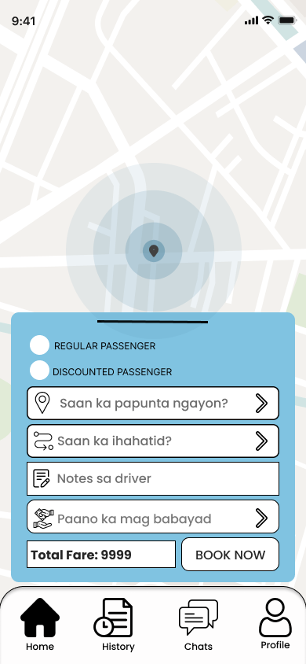
Figure 20 shows the passenger sign in and sign up page where they need to put their email or phone number and password. In sign up they just need to provide also the following and create their account.

Figure 21. Passenger Home Page
Figure 21 shows the passenger home page where passenger can see TODA locations around and a book button for the booking of rides.
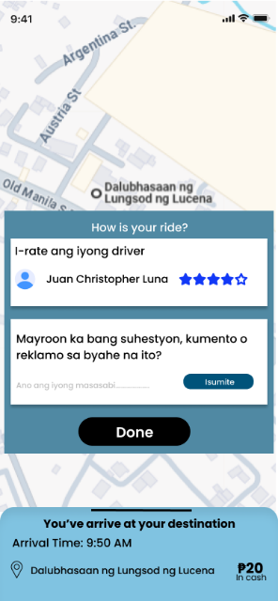
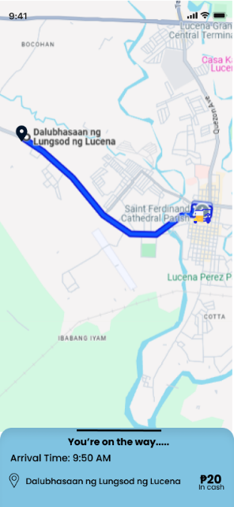
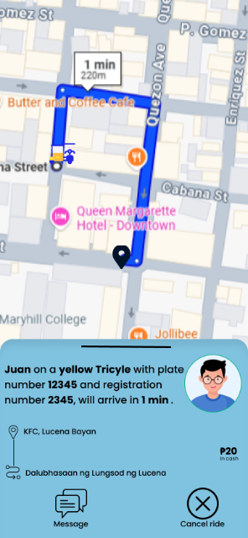
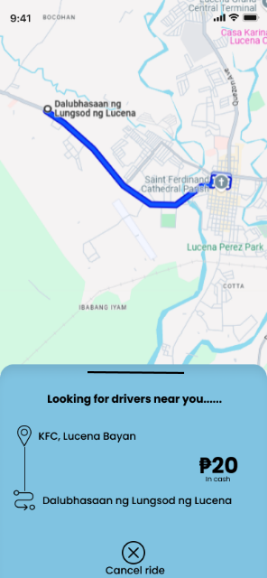
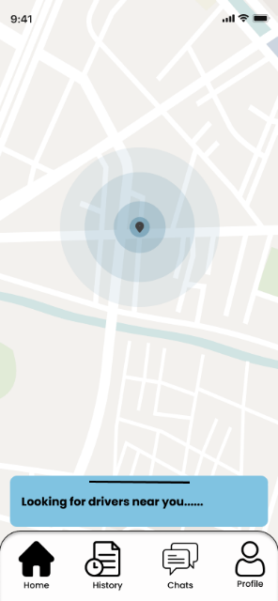
Figure 22. Passenger Booking Pages
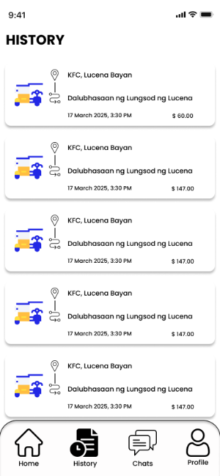
Figure 22 shoes the booing pages once the passenger book a ride and a driver accepts it. It calculates the fare of the ride base on the destination, shows the drivers profile and the distance of the location to the endpoint.

Figure 23. Passenger History Page
Figure 23 shows the history page of the passenger where they can access their previous rides.
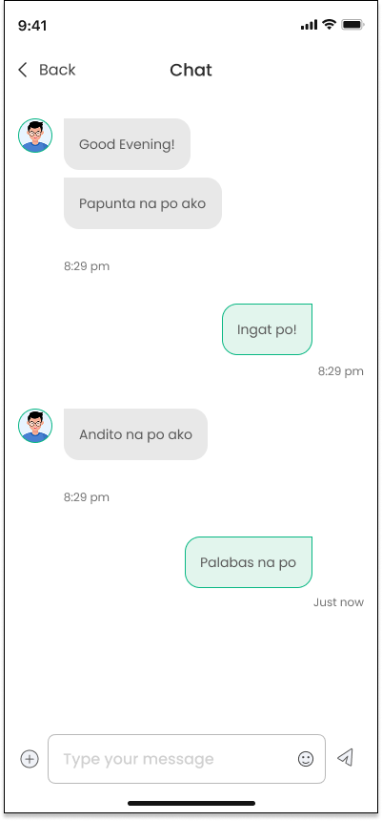


Figure 24. Passenger Chats Page
Figure 24 shows the chat page of the passenger where they could contact their drivers for fast communication.

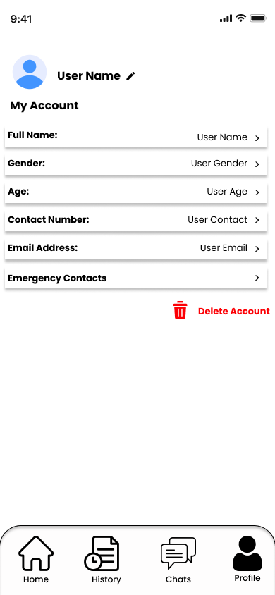
Figure 25. Passenger Profile Page
Figure 25 shows the profile page of the passenger where they could edit their information such as, name, gender, age, contact number and email. They could also add an emergency contact for emergency purposes.

Figure 25. Deployment Diagram of the Proposed System
Figure 25 illustrates the deployment architecture of TodaGo: A Mobile Ride-Hailing and Driver Verification App, detailing the interaction between system components to ensure real-time, secure, and efficient services for passengers, drivers, and administrators. The system includes mobile applications, a centralized application server, a database server, real-time messaging infrastructure, a push notification service, and a web-based admin panel.
Passengers and drivers can access the system through their respective mobile apps, which connect to the application server over the internet. The server is made using Express.js and hosted on Render, manages authentication, booking, fare calculation, complaints, trip updates, and user notifications. Data is stored in a MongoDB database, including profiles, bookings, feedback, and TODA fare records.
Administrators can use the web admin panel to oversee registrations, verify drivers, manage feedback, and adjust fare settings. Real-time messaging is enabled via Socket.IO, supporting instant updates between users, while Firebase Cloud Messaging (FCM) delivers timely push notifications.
ISO 25010
The ISO/IEC 25010 standard outlines the critical characteristics of software product quality. In alignment with this framework, the proposed Tricycle Hailing Application was evaluated across eight core characteristics to ensure the delivery of a system that is not only functional but also dependable, secure, and sustainable. Each characteristic was carefully examined based on how it supports the TFRO’s operational needs, driver and passenger experience, and the vision of a fair and modernized transportation system in Lucena City.
Functional Suitability
This characteristic will measure the system’s ability to perform the functions it is intended to perform. In the context of the capstone, this will reflect how effectively the system will handle booking, fare computation, complaints, driver verification, and real-time trip tracking.
a. Functional completeness – All required features (booking system, driver database, fare system, complaint and rating management, etc.) will be fully implemented based on TFRO guidelines.
b. Functional correctness – The system will provide accurate fare estimates, trip tracking, and registration processes based on pre-verified TFRO data.
c. Functional appropriateness – The app will be designed to handle real-world hailing tasks such as booking, earning summaries, and complaint filing to ensure safe and fair transportation.
Performance Efficiency
This characteristic will evaluate how the system uses resources relative to the level of performance it delivers—critical for a mobile application expected to function across a range of devices.
a. Time behavior – Booking confirmations, ride request notifications, and fare calculations will respond quickly to avoid passenger delays.
b. Resource utilization – The system will efficiently use mobile and server resources to ensure smooth operation across varying devices and connectivity levels.
c. Capacity – The system will be able to handle concurrent users from multiple TODAs without affecting responsiveness.
Compatibility
This describes how well the system will work in various environments and interact with other software systems.
a. Co-existence – The application will be designed to run alongside other local transport or TFRO administrative tools without conflict.
b. Interoperability – Seamless data exchange between modules (driver verification, trip logs, and complaint records) will allow coordinated operations among stakeholders.
Usability
This characteristic will focus on how easy and efficient it will be for users to operate the system—especially important for a public-use mobile app in Lucena City.
a. Appropriateness recognizability – Interfaces and functions will be tailored to match the needs and expectations of local users.
b. Learnability – The mobile app’s design will ensure new users can easily understand how to book rides or file complaints.
c. Operability – Simple and intuitive UI designs will be used for booking, feedback, and trip management.
d. User error protection – Alerts and form validations will help prevent incorrect inputs during booking or registration.
e. User interface aesthetics – A clean and modern interface with localized design elements will enhance user adoption.
f. Accessibility – Features like adjustable text and clear icons will improve access for a broader user base.
Reliability
This will ensure that the system consistently performs its functions under defined conditions critical for a transportation system that people depend on daily.
a. Maturity – The app will maintain steady performance even during peak usage, avoiding major disruptions.
b. Availability – The service will remain accessible with minimal downtime, which is critical for daily transportation use.
c. Fault tolerance – The system will be capable of continuing trip operations even in cases of minor failures (e.g., signal loss).
d. Recoverability – Critical user and booking data will be backed up and recoverable in case of system interruption.
Security
Security will be a top priority when handling sensitive information such as personal details, location history, and earnings.
a. Confidentiality – Only authenticated users will be able to access sensitive data like earnings or personal profiles.
b. Integrity – Passenger ratings, trip records, and complaints will be securely stored to prevent tampering.
c. Non-repudiation – All system actions (e.g., bookings, complaints) will be logged and traceable.
d. Accountability – Admin logs and driver/passenger actions will be monitored to ensure transparency.
e. Authenticity – The user login system will use TFRO-verified IDs for driver access to ensure legitimate use.
Maintainability
This will measure how easily the system can evolve in response to changing requirements essential for long-term use in a dynamic public transport system.
a. Modularity – Separate modules for passenger, driver, and admin functionalities will allow easier updates.
b. Reusability – Design elements (e.g., fare logic, booking modules) will be reusable in future transport systems.
c. Analyzability – Built-in analytics will help identify faults or inefficiencies in trip handling or fare issues.
d. Modifiability – The code based will allow rapid adaptation to regulatory changes or user feedback.
e. Testability – The app will undergo testing for every feature to ensure reliability before deployment.
Portability
This characteristic will determine how easily the application can be transferred to different environments, platforms, or hardware—a crucial quality for mobile applications.
a. Adaptability – The system will be designed to function on Android devices of varying versions and screen sizes.
b. Installability – The app will allow simple installation via APK or Play Store with minimal requirements.
c. Replaceability – It will be capable of replacing existing manual or text-based tricycle booking processes while offering more comprehensive features.

REFERENCES:
- Bandojo, M. (2025). Commuter behavior and the use of transport network vehicle services (TNVS) in Metro Manila: Economic benefits, safety, and service quality. Journal of Southeast Asian Urban Studies, 12(3), 234-245. https://www.ust.edu.ph/commuter-intentions-for-continued-use-of-ride-hailing-services-in-metro-manila-provide-insights-for-continued-public-transport-modernization/
- Desabelle, A., Dailisan, M., & Lim, J. (2022). Impact of idle ride-hailing vehicles on urban traffic: A case study of Metro Manila. Transportation Research Part D: Transport and Environment, 76, 98-106. https://doi.org/10.1016/j.trd.2022.103123
- Garg, P., & Mishra, V. (2022). The effects of ride-hailing strikes on urban traffic congestion: Evidence from Indian cities. Transport Policy, 98, 120-130. https://doi.org/10.1016/j.tranpol.2022.05.008
- Icasiano, M., & Taeihagh, A. (2021). Regulatory challenges and solutions for ride-hailing services in Southeast Asia. Journal of Transportation and Urban Development, 45(2), 192-207. https://doi.org/10.1016/j.tranpol.2021.04.011
- Lee, S., Qian, Z., & Park, H. (2020). Driver behavior and accident risk in ride-hailing services: A study in Seoul, South Korea. Accident Analysis & Prevention, 136, 105-112. https://doi.org/10.1016/j.aap.2019.105221
- Pradana, I., Jang, J., & Sari, A. (2022). Ride-hailing as a complement to public transit: A case study of Greater Jakarta. Journal of Urban Transport, 29(4), 341-350. https://doi.org/10.1016/j.jutrans.2022.03.007
- Rahman, M., Lim, L., & Tan, K. (2022). Competition and regulatory frameworks in Southeast Asian ride-hailing markets. Transport Economics & Policy, 39(1), 89-105. https://doi.org/10.1016/j.tep.2022.01.005
- Regidor, J. (2023). Carpooling and ride-sharing in urban condominium communities: A strategy to reduce traffic congestion in Metro Manila. Philippine Transport Journal, 12(1), 52-61. https://www.dmcihomes.com/whats-new/news/up-transportation-expert-advocates-for-carpooling-in-condos-to-ease-traffic-congestion
- Shaheen, S. A., & Cohen, A. P. (2019). Shared mobility and the future of transportation: Emerging trends in the sharing economy. Transportation Research Board Annual Meeting, 98, 22-37. https://doi.org/10.3141/2672-04
- Tan, W., Koh, W., & Low, Y. (2021). Southeast Asian ride-hailing governance: A comparative study of urban transport regulation. Asian Transport Studies, 7(2), 203-220. https://doi.org/10.1016/j.ats.2021.09.005
- Tayar, A., Chou, W., & Tan, R. (2022). Impacts of ride-hailing services in ASEAN cities: A systematic review. Journal of Transport Research, 61(1), 101-115. https://doi.org/10.1016/j.trres.2022.01.008
- Zhang, X., Zhou, Y., & Liang, Z. (2023). Ride-hailing services and urban congestion: A comparative analysis in cities with varying levels of public transit infrastructure. Transportation Research Part A: Policy and Practice, 148, 12-23. https://doi.org/10.1016/j.tra.2023.01.001
- Ali, A., Zhou, L., Miller, L., & Ieromonachou, P. (2021). Information and communication technology for sustainable development: Assessing the value of mobile applications. Telematics and Informatics, 59, 101561. https://doi.org/10.1016/j.tele.2021.101561
- Al-Sharafi, M. A., Baharudin, A. S., & Shuib, L. (2022). Exploring ethical challenges in mobile app usage: A socio-technical perspective. Technology in Society, 70, 102021. https://doi.org/10.1016/j.techsoc.2022.102021
- Chalermpong, S., Thaithatkul, P., Hoang-Tung, N., Fillone, A., & Kato, H. (2024). Impacts of Ride-Hailing Applications on Sustainable Mobility in Asian Cities: Bangkok, Hanoi, Manila. Journal of the Eastern Asia Society for Transportation Studies, 15, 3455–3474. https://doi.org/10.11175/easts.15.3455
- International Transport Forum. (2023). Regulating App-Based Mobility Services in ASEAN. OECD Publishing. https://www.itf-oecd.org/sites/default/files/docs/regulating-app-based-mobility-services-asean.pdf
- Li, F., Shen, W., & Li, D. (2022). Business model innovation in the digital era: Exploring the strategic role of mobile apps. Transportation Research Part A: Policy and Practice, 162, 325–340. https://doi.org/10.1016/j.tra.2022.05.012
- Rizky, R. D., Santosa, P. I., & Hidayat, R. (2024). The influence of ride hailing apps’ loyalty program on customer loyalty: A case study in Indonesia. Transportation Research Interdisciplinary Perspectives, 26, 101141. https://doi.org/10.1016/j.trip.2024.101141
- Sanusi, I. T., Omar, R., & Hashim, R. (2023). Personalized user experience in mobile wellness applications: A study of behavioral outcomes. International Journal of Human-Computer Studies, 173, 102969. https://doi.org/10.1016/j.ijhcs.2023.102969
- Tan, B., Lim, E. T., & Oo, Y. P. (2023). Digital entrepreneurship and mobile app development: Evidence from Southeast Asia. Journal of Business Research, 157, 113582. https://doi.org/10.1016/j.jbusres.2022.113582
- Chalermpong, S., Thaithatkul, P., Hoang-Tung, N., Fillone, A., & Kato, H. (2024). Impacts of Ride-Hailing Applications on Sustainable Mobility in Asian Cities: Bangkok, Hanoi, Manila. Journal of the Eastern Asia Society for Transportation Studies, 15, 3455–3474. https://doi.org/10.11175/easts.15.3455
- International Transport Forum. (2023). Regulating App-Based Mobility Services in ASEAN. OECD Publishing. https://www.itf-oecd.org/sites/default/files/docs/regulating-app-based-mobility-services-asean.pdf
- Aljedaani, B., & Babar, M. A. (2020). Challenges in Developing Secure Mobile Health Applications: A Systematic Review. arXiv preprint arXiv:2007.10876. https://arxiv.org/abs/2007.10876
- ADB. (2023). Urban mobility in ASEAN: Advancing sustainable and smart transport solutions. Asian Development Bank. https://www.adb.org
- Bautista, R., Garcia, M., & Reyes, L. (2022). The impact of mobile applications on urban transportation systems: A case study of tricycle services in Metro Manila. Philippine Journal of Transportation Research, 14(3), 115-130.
- Dela Cruz, F., Santos, J., & Padua, J. (2021). Evaluating service quality of on-demand tricycle services in Metro Manila. Journal of Transportation and Urban Planning, 9(4), 45-59.
- Department of Transportation (DOTr). (2020). Modernizing tricycle services in the Philippines: A roadmap for digital integration. Department of Transportation, Philippines. https://www.dotr.gov.ph
- Lim, P., & Tan, S. (2021). Geospatial technologies in transportation planning: GIS-based solutions for tricycle services. International Journal of Transportation Systems, 8(2), 78-90.

